**LAB -3: MASHUP APPLICATION**

I have created an web app which uses the Yahoo finance data to indicate the values of the yahoo finance. By seeing this user can analyze the data.

In the application, code was written in jsfiddle environment using HTML, JavaScript and CSS by using the API of Twitter, Facebook, Yahoo and Finance. The application being used is as shown in the screen shots below.

When the code executed:

We get the statistics of yahoo finance.

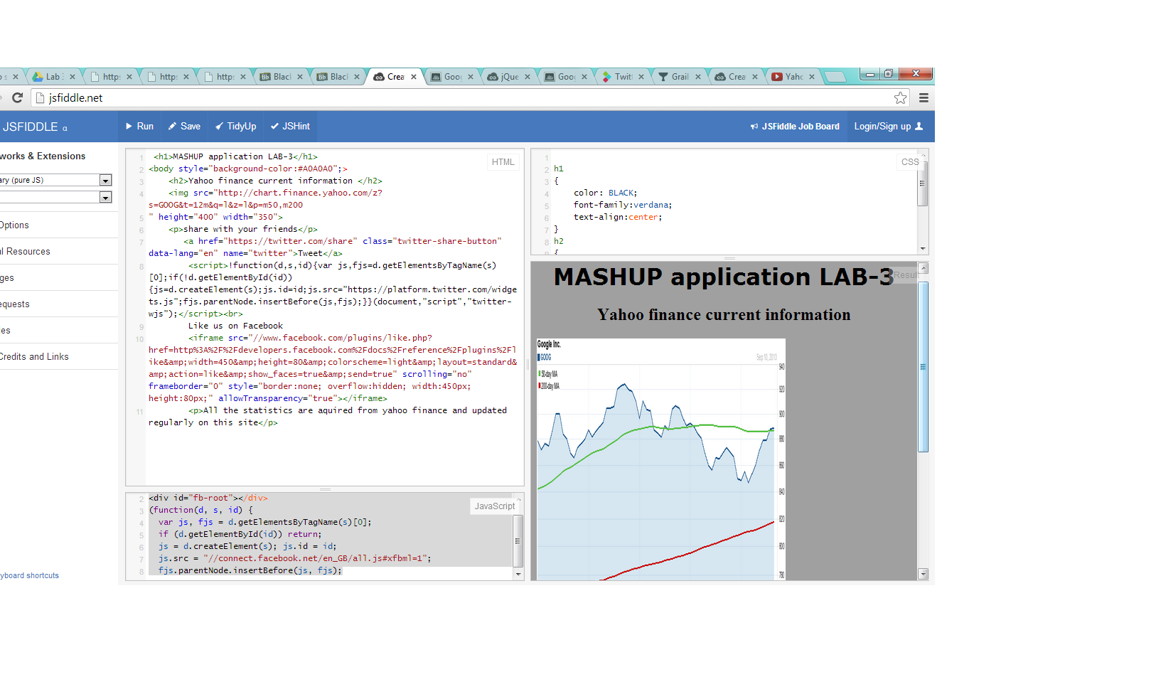

If he want to share anything with friends through twitter a link is provided using the Twitter API. Click on it and share.

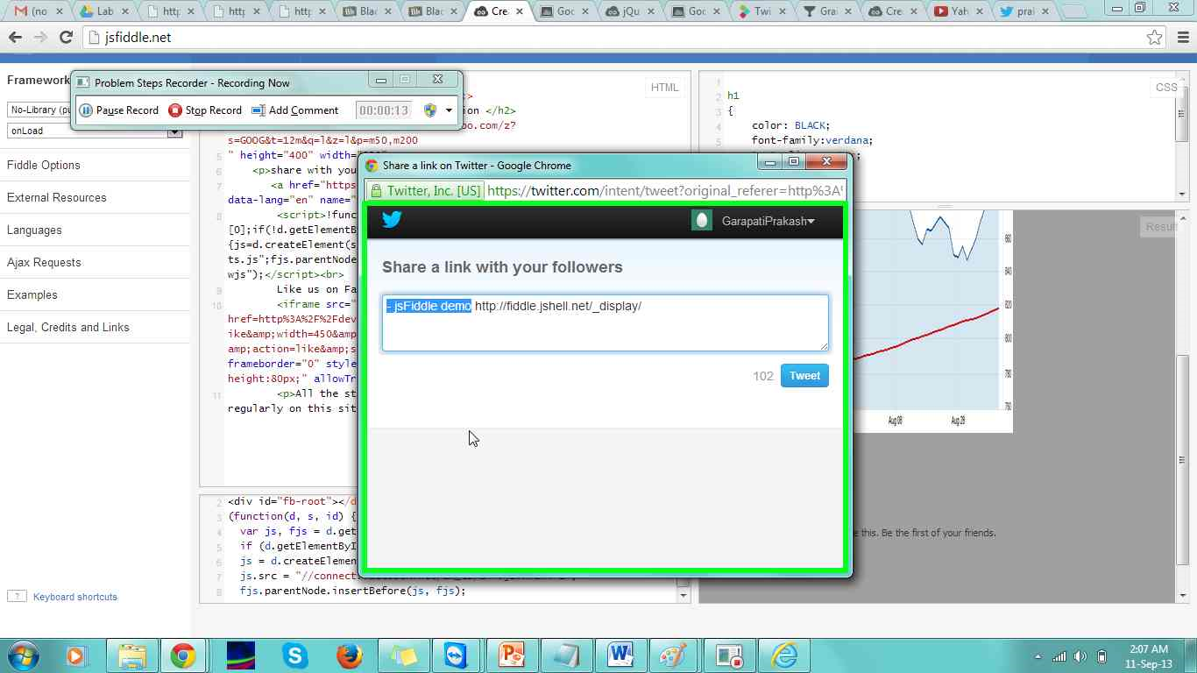

If the user want to like the page on Facebook a like button is provided using Facebook API.

