INCREMENT-3

SWINNEY-GENNIE

1) This is our home page:

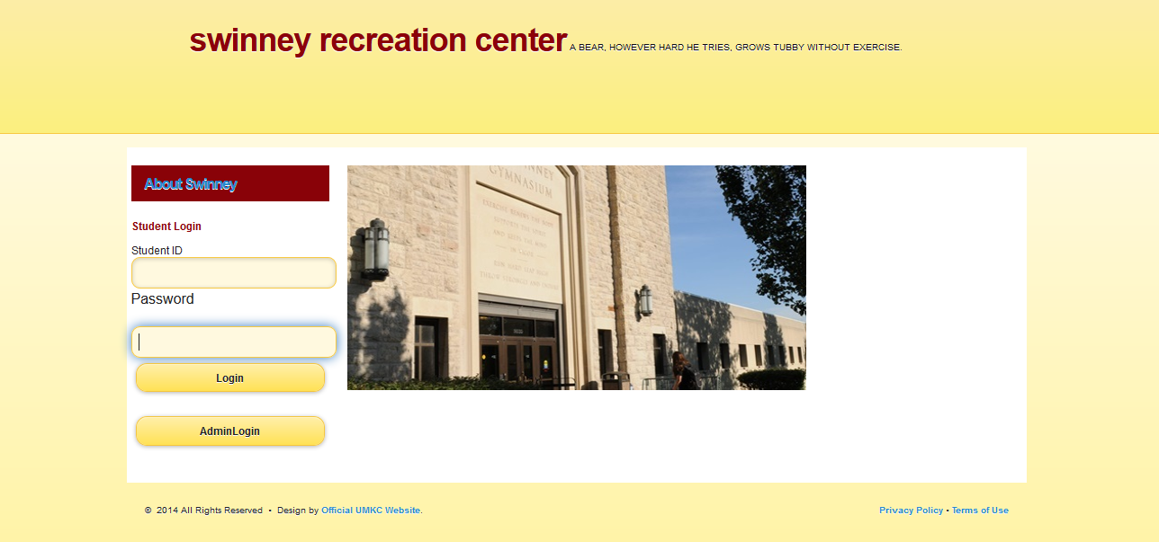

2) when the student logs in with the student details like this 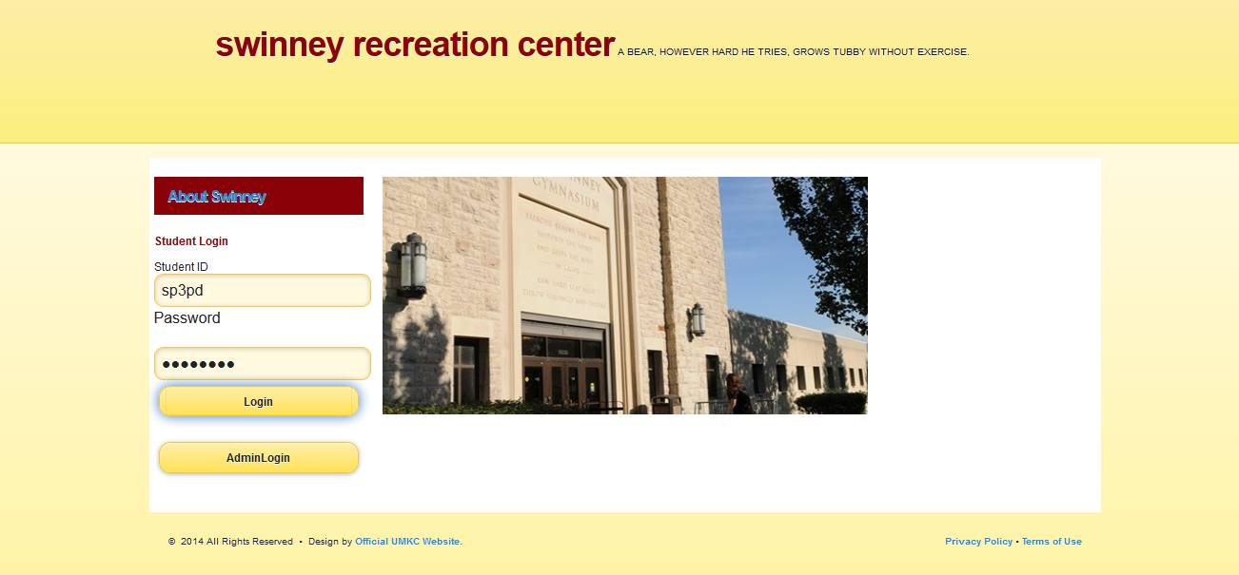

We will get the following page:

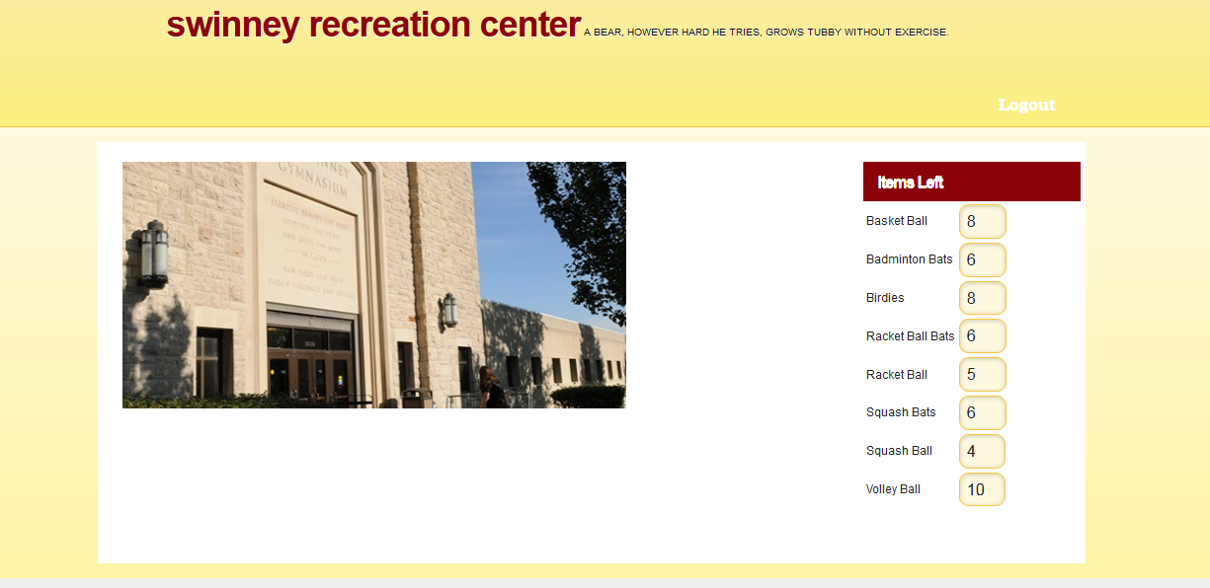

He will get a page where he can see the list of available items.

On seeing the available items he will go to swinney and tell the assistant what all the items he wants. Now the Admin (ie; the person at the desk of swinney) will click on the admin login in the home page.

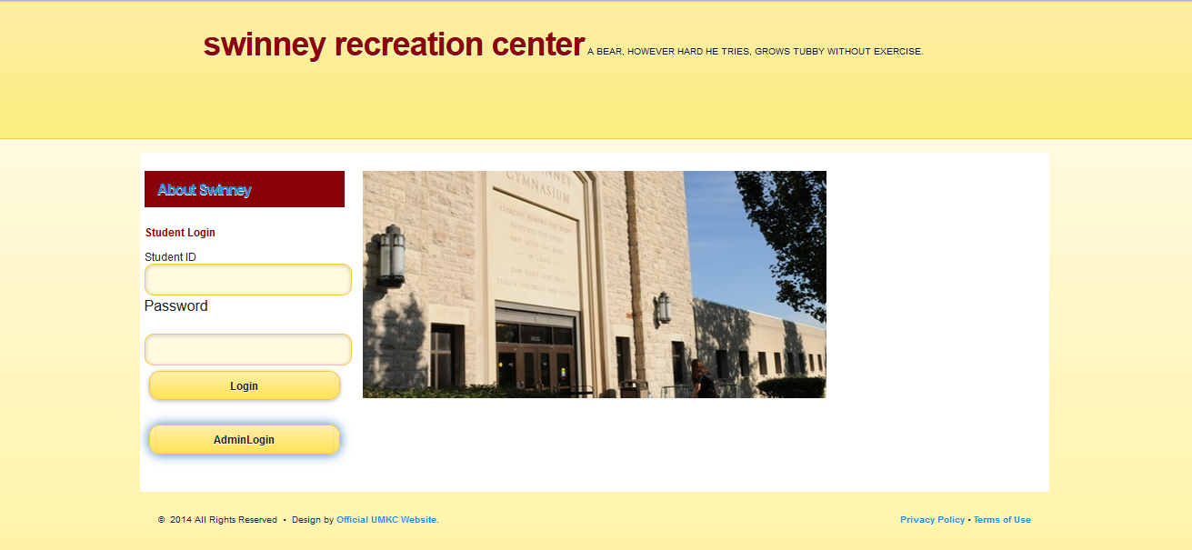

Now he will get this page where he can see the available list and he can enter the details of the student:

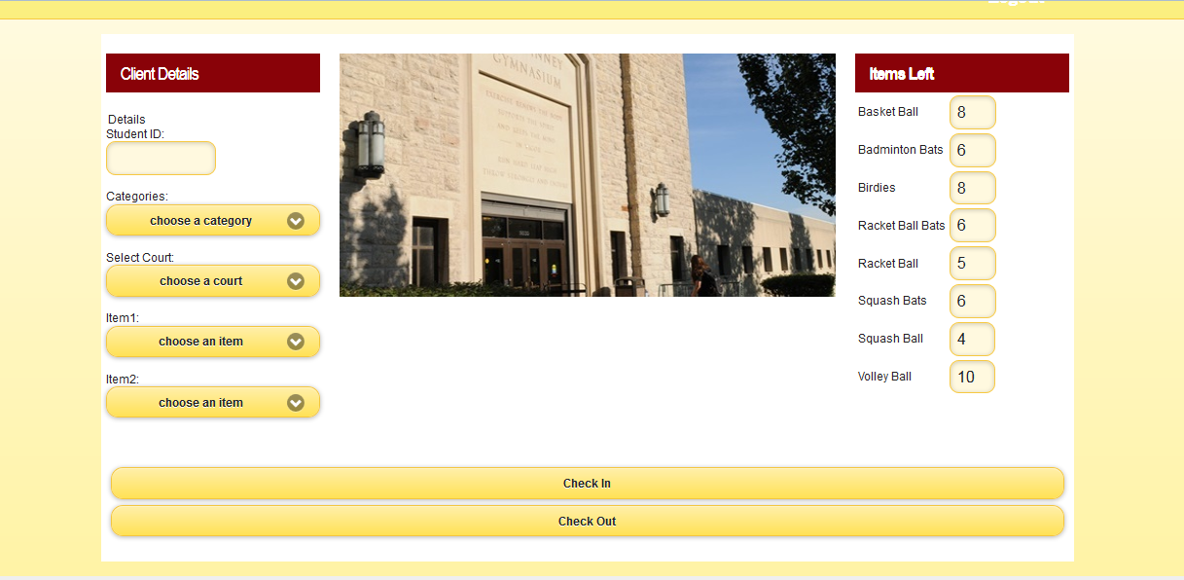

Now the admin enters the details of the student and then he checks in

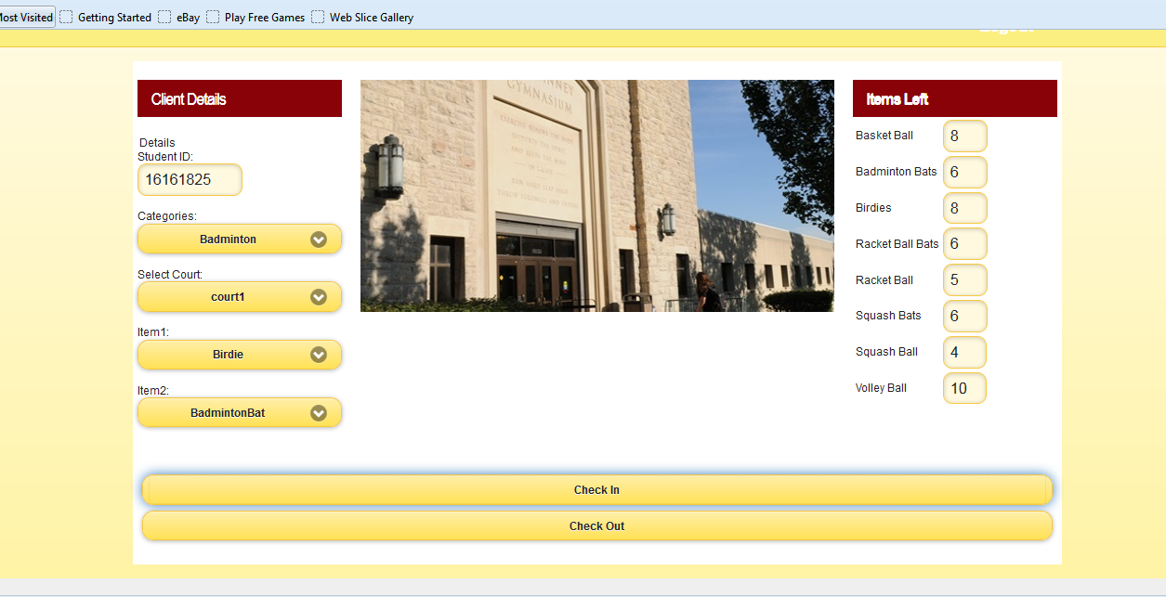

After he checks in then he will get the following screen:

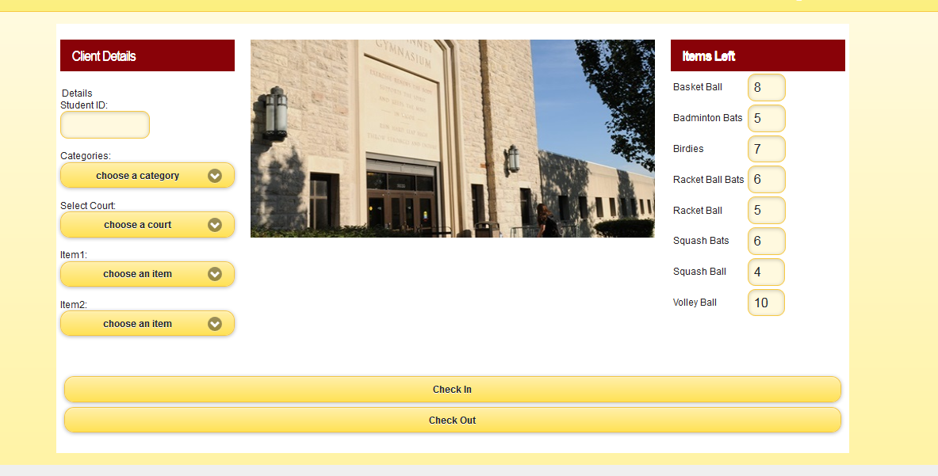

We are currently working on the check-out button. We have written our own web services for Login page and checkin. For the second increment we tried to create with rest web services, but we are getting some errors and we couldn’t implement those services. So, we have shifted to soap services. For the fourth increment we will get the output of checkout button and we will try to improve the student view.

This is the scrum do link of our project:

<https://www.scrumdo.com/organization/ase6/dashboard>