Table name: Client_Master

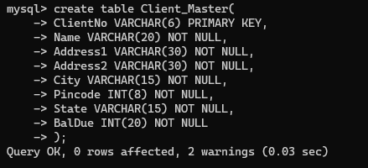

Inserting of data:

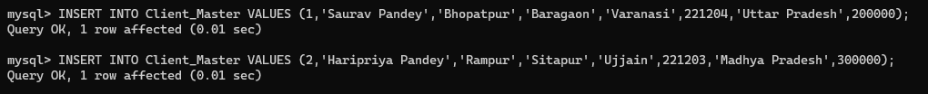

Exercise:

1. Find out the names of all clients.

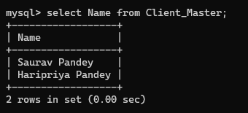

1. Retrieve the entire contents of the client_master table.

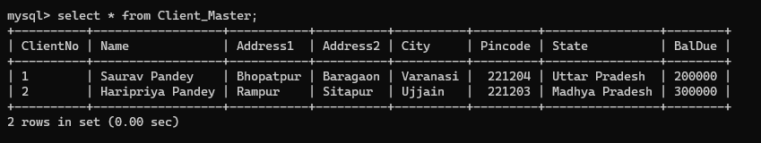

1. Retrieve the list of names, city and the state of all the clients.

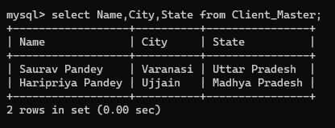

1. Destroy the table client_master along with its data.

