Employee name:S.HARI PRASAD

Emp id:28313

**Task 1-4**

<!DOCTYPE html>

<html>

<head>

<title>Training</title>

<script>

function checksubmit()

{alert("Submitted");}

</script>

</head>

<body>

<h2>My first day training</h2>

<p style="color:blue;">This is normal text.<br>

<b style="background-color:yellow;">This is bold text.</b><br>

<i style="background-color:red;">This is italic text.</i><br>

<u>This is underlined text.</u></p>

<img src="https://logos.flamingtext.com/Word-Logos/training-design-sketch-name.png" width="500" height="333">

<table>

<tr>

<th>Company name</th>

<th>Friend name</th>

<th>Phone number</th>

<th>State</th>

</tr>

<tr>

<td>A</td>

<td>Sushant</td>

<td>2369748404</td>

<td>Andhra</td>

</tr>

<tr>

<td>B</td>

<td>Challa</td>

<td>3423949389</td>

<td>Andhra</td>

</tr>

<tr>

<td>C</td>

<td>Sanjay</td>

<td>3423439389</td>

<td>Chennai</td>

</tr>

<tr>

<td>D</td>

<td>aryan</td>

<td>3434234389</td>

<td>Chennai</td>

</tr>

</table>

<br>

<form>

<label for="Ename">Employee Name:</label><br>

<input type="text" id="Ename" name="Ename"><br>

<label for="Eid">Employee id:</label><br>

<input type="text" id="Eid" name="Eid"><br>

<input type="submit" onclick="checksubmit();" value="Submit" />

</form>

</body>

</html>

OUTPUT

HTML elements are anything written within an HTML tag.HTML attributes are used to describe an HTML element's properties in depth.

Colour, typeface, size, and other styles may be added to an element using the HTML style property.

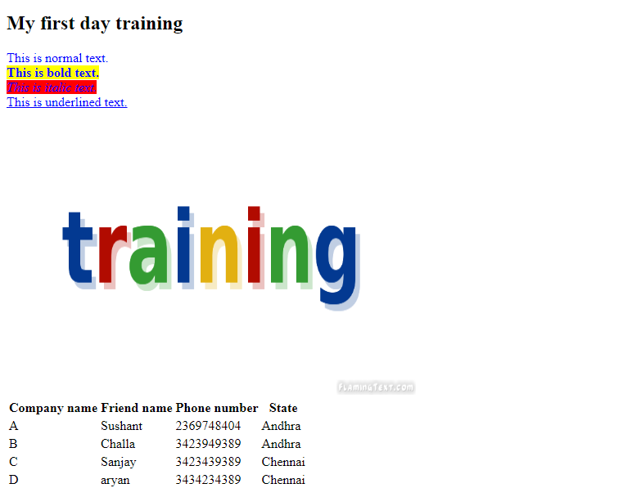

Task 5-10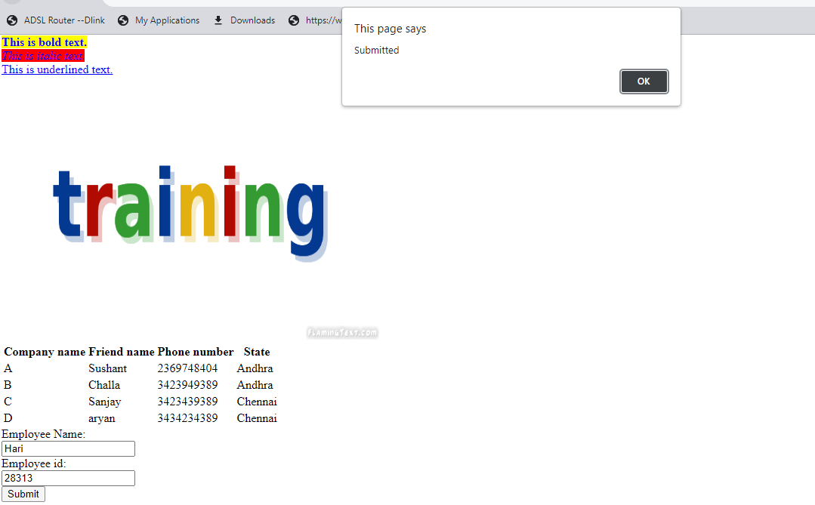

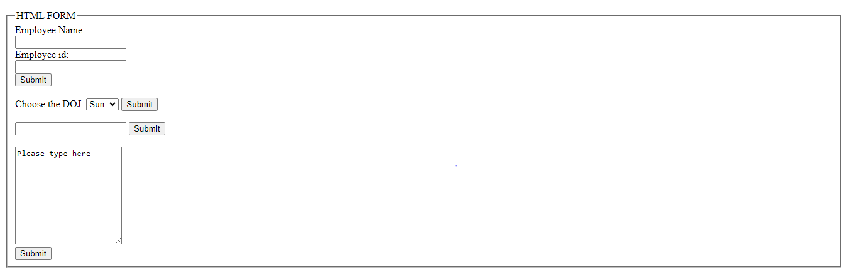

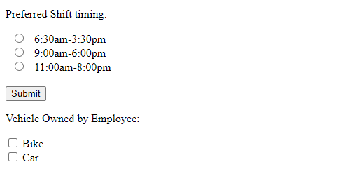

<form>

<fieldset>

<legend>HTML FORM</legend>

<label for="Ename">Employee Name:</label><br>

<input type="text" id="Ename" name="Ename"><br>

<label for="Eid">Employee id:</label><br>

<input type="text" id="Eid" name="Eid"><br>

<input type="submit" onclick="checksubmit();" value="Submit" />

<br><br>

<label for="day">Choose the DOJ:</label>

<select id="day" name="day">

<option value="Sun">Sun</option>

<option value="Mon">Mon</option>

<option value="Tue">Tue</option>

<option value="Wed">Wed</option>

<option value="Thr">Thr</option>

<option value="Fri">Fri</option>

<option value="Sat">Sat</option>

</select>

<input type="submit" onclick="checksubmit();" value="Submit" />

<br><br>

<input list="doj" name="doj">

<datalist id="doj">

<option value="Sun">

<option value="Mon">

<option value="Tue">

<option value="Wed">

<option value="Thr">

<option value="Fri">

<option value="Sat">

</datalist>

<input type="submit" onclick="checksubmit();" value="Submit" />

<br><br>

<textarea name="message" rows="10" cols="20">Please type here</textarea>

<br>

<input type="submit" onclick="checksubmit();" value="Submit" />

</fieldset>

<p>Preferred Shift timing:</p>

  <input type="radio" id="A" name="shift" value="A">

  <label for="A">6:30am-3:30pm</label><br>

  <input type="radio" id="B" name="shift" value="B">

  <label for="B">9:00am-6:00pm</label><br>

  <input type="radio" id="C" name="shift" value="C">

  <label for="C">11:00am-8:00pm</label><br><br>

<input type="submit" value="Submit">

<p>Vehicle Owned by Employee:</p>

<input type="checkbox" id="vehicle1" name="vehicle1" value="Bike">

<label for="vehicle1">Bike</label><br>

<input type="checkbox" id="vehicle2" name="vehicle2" value="Car">

<label for="vehicle2">Car</label><br>

</form>

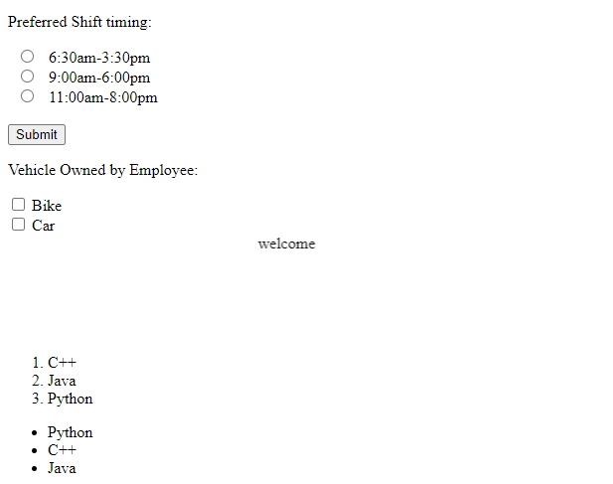

<marquee width="100%" direction="right" height="100px">

welcome

</marquee>

<ol>

<li>C++</li>

<li>Java</li>

<li>Python</li>

</ol>

<ul>

<li>Python</li>

<li>C++</li>

<li>Java</li>

</ul>

(TASK 6)

HTML5 includes a variety of new elements and characteristics that can aid in the development of contemporary websites like HTML additional tag characteristics,Server-Sent ,WebSocket Event,Canvas,Audio & Video ,Using drag and drop

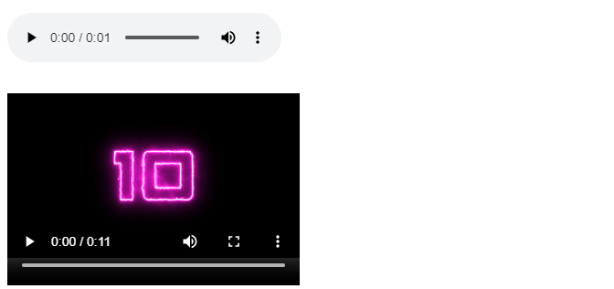

<audio src="./aud.mp3" controls></audio>

<br>

<video width="320" height="240" controls>

<source src="./vid.mp4">

</video>

<br>

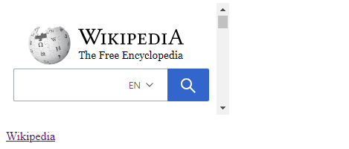

<iframe src="demo1.htm" style="border:none;" name="iframe_a" title="Iframe Example"></iframe>

<p><a href="https://www.wikipedia.org/" target="iframe_a">Wikipedia</a></p>

If text appears between a tag and its partner tag, the tags are said to be paired. The first tag in paired tags is known as the Opening Tag, while the second tag is known as the Closing Tag.

There is no companion tag or closing tag for an unpaired tag.

TASK 11

<!DOCTYPE HTML>

<html>

<head>

<style>

#div1 {

width: 350px;

height: 70px;

padding: 10px;

border: 1px solid #aaaaaa;

}

</style>

<script>

function allowDrop(ev) {

ev.preventDefault();

}

function drag(ev) {

ev.dataTransfer.setData("text", ev.target.id);

}

function drop(ev) {

ev.preventDefault();

var data = ev.dataTransfer.getData("text");

ev.target.appendChild(document.getElementById(data));

}

</script>

</head>

<body>

<p>Drag the W3Schools image into the rectangle:</p>

<div id="div1" ondrop="drop(event)" ondragover="allowDrop(event)"></div>

<br>

<img id="drag1" src="season.jpg" draggable="true" ondragstart="drag(event)" width="336" height="69">

</body>

</html>

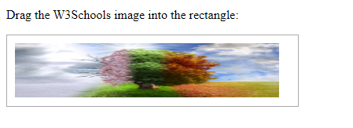

TASK 12

Autocomplete

<!DOCTYPE html>

<html>

<body>

<form action="/action_page.php" autocomplete="on">

<label for="name">Name:</label>

<input type="text" id="name" name="name"><br><br>

<label for="lname">Last name:</label>

<input type="text" id="lname" name="lname"><br><br>

<label for="email">Email:</label>

<input type="email" id="email" name="email" autocomplete="off"><br><br>

<input type="submit">

</form>

</body>

</html>

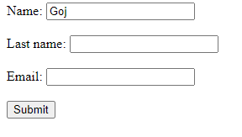

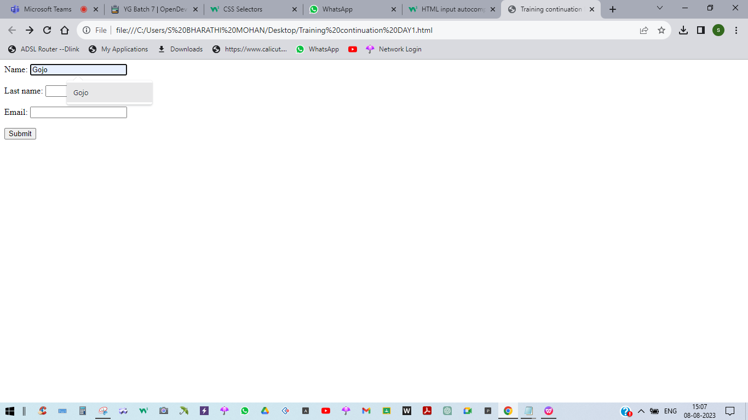

TASK 14

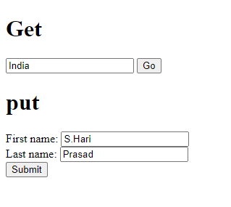

<!DOCTYPE html>

<html lang="en">

<head>

<title>Training</title>

</head>

<body>

<h1>Get</h1>

<form method="get" action="www.programiz.com/search">

<input type="search" name="location" placeholder="Search"/>

<input type="submit" value="Go"/>

</form>

<h1>put</h1>

<form method="get" action="www.programiz.com/search">

<label for="firstname">First name:</label>

<input type="text" name="firstname"/><br/>

<label for="lastname">Last name:</label>

<input type="text" name="lastname"/><br/>

<input type="submit"/>

</form>

</body>

</html>

CSS

TASK 1

CSS selectors are used to find the HTML elements to style.CSS selectors are classified into five types:

* Simple selectors
* Combinator selectors
* Pseudo-class selectors
* Pseudo-elements selectors
* Attribute selectors

TASK2

<style>

p{

        text-align: center;

          color: blue;

}

</style>

<title> CSS Selectors</title>

</head>

<body>

<h1> heading </h1>

<p id="para1" > hello  CSS styles </p>

<p> this is para </p>

</body>

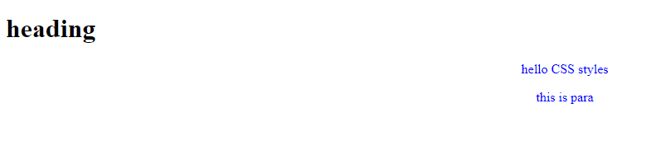

In this code we can observe heading word didn’t change or align because the selector was not used on it while for other two it was used and it was changed to blue color and center aligned.Only p tag has undergone change.

TASK3

<head>

        <style>

                #para1{

                        text-align: right;

                        color: green;

        }

        </style>

</head>

<body>

        <h1><p id="para1">  CSS id Selectors </p></h1>

        <p> this is a paragraph </p>

        <p> my paragraph </p>

</body>

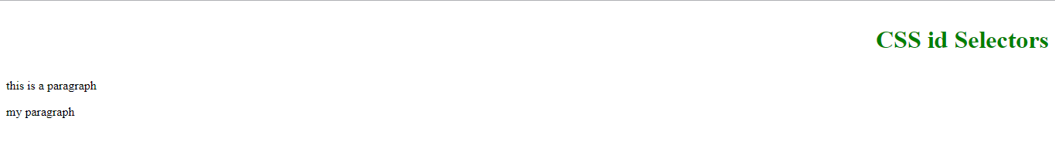

In this code we can observe CSS id Selectors was changed because id selector para1 was mentioned here only.While in other lines it was not mentioned so it was not changed.

TASK4

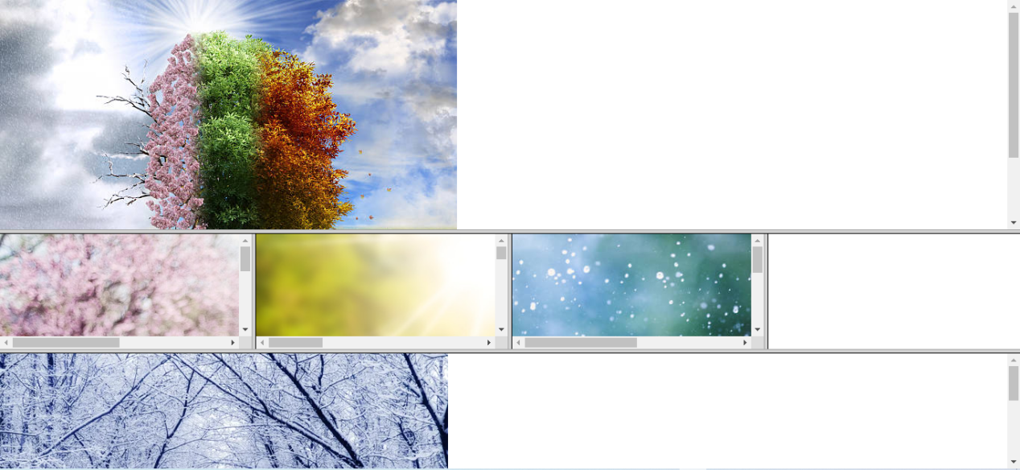

<!DOCTYPE html>

<html>

<head>

<title>HTML Nested Framesets</title>

</head>

<frameset rows="50%,*,*">

<frameset cols="100%">

<frame name="frame1" src="season.jpg">

</frameset>

<frameset cols="*, *, *,*">

<frame name="frame2" src="spring.jpg">

<frame name="frame3" src="summer.jpg">

<frame name="frame4" src="rainy.jpg">

</frameset>

<frame name="frame5" src="winter.jpg">

</frameset>

</html>

TASK 5

A style sheet can be inserted in three ways:

* External CSS
* Internal CSS
* Inline CSS

External CSS

With an external style sheet, you can change the look of an entire website by changing just one file.

Style.css

body {

background-color:blue;

}

h1 {

color: red;

margin-left: 20px;

}

Html page

<!DOCTYPE html>

<html>

<head>

<link rel="stylesheet" href="style.css">

</head>

<body>

<h1>This is a heading</h1>

<p>This is a paragraph.</p>

</body>

</html>



Internal CSS

An internal style sheet may be used if one single HTML page has a unique style.The internal style is defined inside the <style> element, inside the head section.

<!DOCTYPE html>

<html>

<head>

<style>

body {

background-color:blue;

}

h1 {

color: red;

margin-left: 20px;

}

</style>

</head>

<body>

<h1>This is a heading</h1>

<p>This is a paragraph.</p>

</body>

</html>



Inline CSS

To use inline styles, add the style attribute to the relevant element. The style attribute can contain any CSS property.

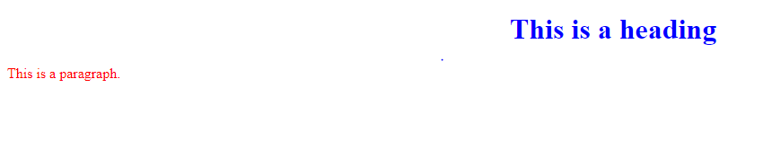

<!DOCTYPE html>

<html>

<head>

</head>

<body>

<h1 style="color:blue;text-align:center;">This is a heading</h1>

<p style="color:red;">This is a paragraph.</p>

</body>

</html>

BOOTSTRAP

TASK 1

Bootstrap is a free and open source front-end programming framework for building websites and online applications.Designed to enable responsive development of mobile-first websites, Bootstrap provides a collection of syntax for template designs.Bootstrap enables responsive web design. It allows a web page or app to recognise the visitor's screen size and orientation and automatically adjust the display.

TASK 2

<!DOCTYPE html>

<html lang="en">

<head>

<title>Sample Bootstrap Page</title>

<meta charset="utf-8">

<meta name="viewport" content="width=device-width, initial-scale=1">

<link rel="stylesheet" href="https://maxcdn.bootstrapcdn.com/bootstrap/3.4.1/css/bootstrap.min.css">

<script src="https://ajax.googleapis.com/ajax/libs/jquery/3.6.4/jquery.min.js"></script>

<script src="https://maxcdn.bootstrapcdn.com/bootstrap/3.4.1/js/bootstrap.min.js"></script>

</head>

<body>

<div class="jumbotron text-center">

<h1>Prasunamba's Bootstrap Page</h1>

<p>Use this responsive page to see the effect-it will resize!</p>

</div>

<div class="container">

<div class="row">

<div class="col-sm-4">

<h3>Column 1</h3?

<p>this is Paragraph 1....................</p>

<p>this is Paragraph 2....................</p>

</div><div class="col-sm-4">

<h3>Column 2</h3>

<p>this is Paragraph 3....................</p>

<p>This is Paragraph 4....................</p>

<div class="col-sm-4">

<h3>Column 3</h3>

<p>this is Paragraph 5....................</p>

<p>This is Paragraph 6....................</p>

</div></div></div>

</body>

</html>

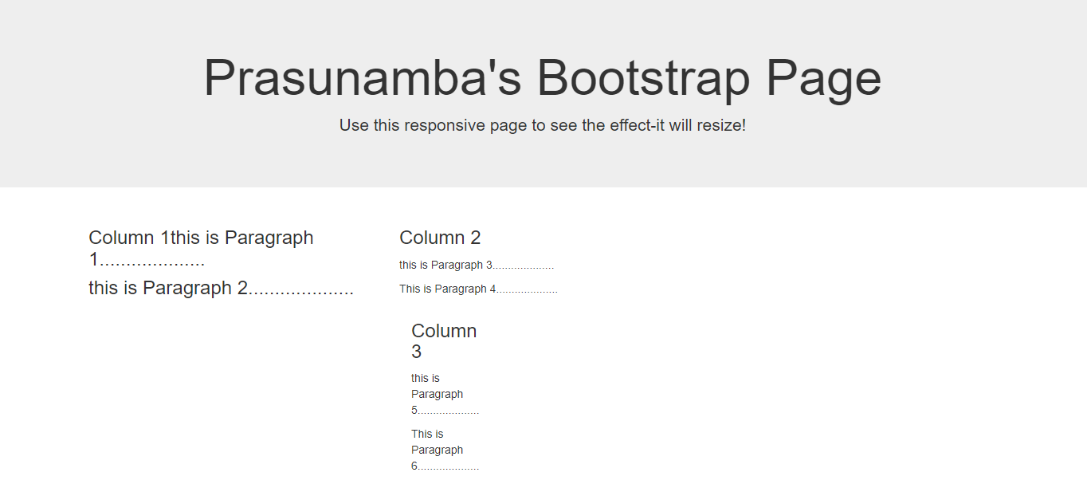

TASK 3

<!DOCTYPE html>

<html lang="en">

<head>

<title>Sample Bootstrap Page</title>

<meta charset="utf-8">

<meta name="viewport" content="width=device-width, initial-scale=1">

<link rel="stylesheet" href="https://maxcdn.bootstrapcdn.com/bootstrap/3.4.1/css/bootstrap.min.css">

<script src="https://ajax.googleapis.com/ajax/libs/jquery/3.6.4/jquery.min.js"></script>

<script src="https://maxcdn.bootstrapcdn.com/bootstrap/3.4.1/js/bootstrap.min.js"></script>

</head>

<body>

<button type="button" class="btn btn-primary">Primary</button>

<button type="button" class="btn btn-secondary">Secondary</button>

<button type="button" class="btn btn-success">Success</button>

<button type="button" class="btn btn-danger">Danger</button>

<button type="button" class="btn btn-warning">Warning</button>

<button type="button" class="btn btn-info">Info</button>

<button type="button" class="btn btn-light">Light</button>

<button type="button" class="btn btn-dark">Dark</button>

<button type="button" class="btn btn-link">Link</button>

</body>

</html>



TASK 4

<!DOCTYPE html>

<html lang="en">

<head>

<title>Training</title>

<meta charset="utf-8">

<meta name="viewport" content="width=device-width, initial-scale=1">

<link rel="stylesheet" href="https://maxcdn.bootstrapcdn.com/bootstrap/3.4.1/css/bootstrap.min.css">

<script src="https://ajax.googleapis.com/ajax/libs/jquery/3.6.4/jquery.min.js"></script>

<script src="https://maxcdn.bootstrapcdn.com/bootstrap/3.4.1/js/bootstrap.min.js"></script>

</head>

<body>

<div class="container">

<h2>Alerts in BOOSTRAP</h2>

<div class="alert alert-success">

<strong>Success!</strong> This alert box could indicate a successful or positive action.

</div>

<div class="alert alert-info">

<strong>Info!</strong> This alert box could indicate a neutral informative change or action.

</div>

<div class="alert alert-warning">

<strong>Warning!</strong> This alert box could indicate a warning that might need attention.

</div>

<div class="alert alert-danger">

<strong>Danger!</strong> This alert box could indicate a dangerous or potentially negative action.

</div>

</div>

</body>

</html>

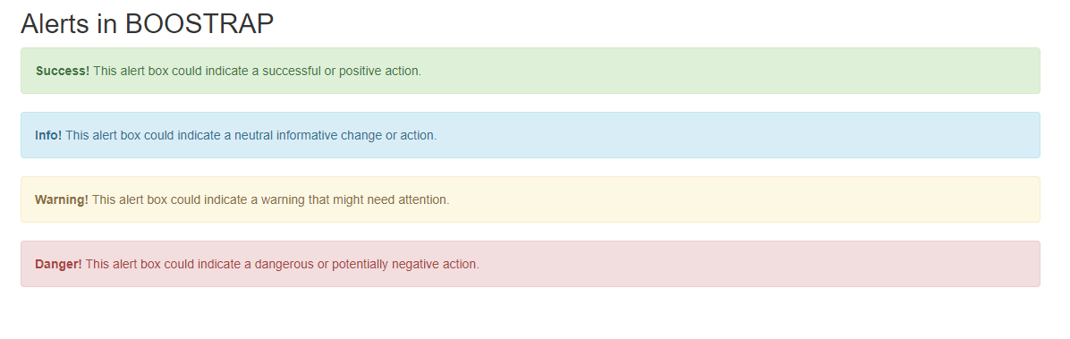

TASK 5

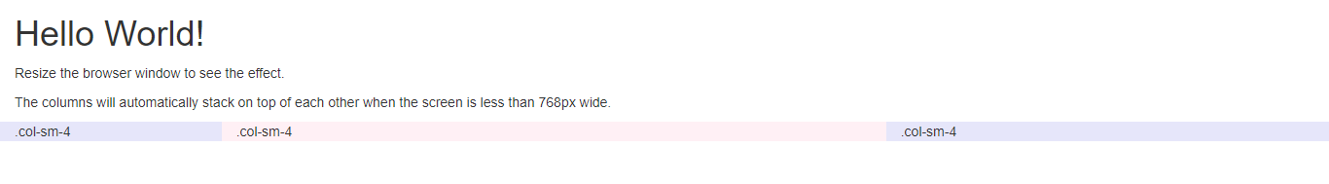

<!DOCTYPE html>

<html lang="en">

<head>

<title>Bootstrap Example</title>

<meta charset="utf-8">

<meta name="viewport" content="width=device-width, initial-scale=1">

<link rel="stylesheet" href="https://maxcdn.bootstrapcdn.com/bootstrap/3.4.1/css/bootstrap.min.css">

<script src="https://ajax.googleapis.com/ajax/libs/jquery/3.6.3/jquery.min.js"></script>

<script src="https://maxcdn.bootstrapcdn.com/bootstrap/3.4.1/js/bootstrap.min.js"></script>

</head>

<body>

<div class="container-fluid">

<h1>Hello World!</h1>

<p>Resize the browser window to see the effect.</p>

<p>The columns will automatically stack on top of each other when the screen is less than 768px wide.</p>

<div class="row">

<div class="col-lg-2" style="background-color:lavender;">.col-sm-4</div>

<div class="col-lg-6" style="background-color:lavenderblush;">.col-sm-4</div>

<div class="col-lg-4" style="background-color:lavender;">.col-sm-4</div>

</div>

</div>

</body>

</html>

TASK 6

<!DOCTYPE html>

<html lang="en">

<head>

<title>Bootstrap Example</title>

<meta charset="utf-8">

<meta name="viewport" content="width=device-width, initial-scale=1">

<link rel="stylesheet" href="https://maxcdn.bootstrapcdn.com/bootstrap/3.4.1/css/bootstrap.min.css">

<script src="https://ajax.googleapis.com/ajax/libs/jquery/3.6.3/jquery.min.js"></script>

<script src="https://maxcdn.bootstrapcdn.com/bootstrap/3.4.1/js/bootstrap.min.js"></script>

</head>

<body>

<div class="container-fluid"> <!-- <div class="container-fluid"> -->

<h1>My First Bootstrap Page</h1>

<p>This part is inside a .container class.The .container class provides a responsive fixed width container.

The .container class provides a responsive fixed width container.The .container class provides a responsive fixed width container.The .container class provides a responsive fixed width container.The .container class provides a responsive fixed width container.The .container class provides a responsive fixed width container.The .container class provides a responsive fixed width container.</p>

</div>

</body>

</html>

Task 7

<!DOCTYPE html>

<html>

<head>

<meta name="viewport" content="width=device-width, initial-scale=1">

<link rel="stylesheet" href="https://maxcdn.bootstrapcdn.com/bootstrap/3.4.1/css/bootstrap.min.css">

<script src="https://ajax.googleapis.com/ajax/libs/jquery/3.6.3/jquery.min.js"></script>

<script src="https://maxcdn.bootstrapcdn.com/bootstrap/3.4.1/js/bootstrap.min.js"></script>

</head>

<body>

<div class="container">

<h2>Table</h2>

<p>The .table-responsive class creates a responsive table which will scroll horizontally on small devices (under 768px). When viewing on anything larger than 768px wide, there is no difference:</p>

<div class="table-responsive">

<table class="table">

<thead>

<tr>

<th>#</th>

<th>Firstname</th>

<th>Lastname</th>

<th>Age</th>

<th>City</th>

<th>Country</th>

</tr>

</thead>

<tbody>

<tr>

<td>1</td>

<td>Anna</td>

<td>Pitt</td>

<td>35</td>

<td>New York</td>

<td>USA</td>

</tr>

</tbody>

</table>

</div>

</div>

</body>

</html>