Predicting Airline Passenger Satisfaction
A Supervised Machine Learning Mini Project
Individual Mini Project | Python | Submission deadline: 20 August 2026

1. Problem Statement
Customer satisfaction directly affects airline profitability through repeat bookings, loyalty-programme retention and brand reputation. Airlines collect large amounts of post-flight survey data covering demographics, trip characteristics and ratings of individual service touchpoints (wifi, seat comfort, boarding process, cleanliness, delays, etc.), but it is not always obvious which of these factors matter most, or how they combine to drive a passenger's overall verdict.
This project asks a specific, answerable question: Given a passenger's demographic profile, trip details and in-flight service ratings, can we predict whether that passenger will report being ‘satisfied’ or ‘neutral or dissatisfied’ with their flight, and which factors matter most? This is framed as a binary supervised classification problem: satisfaction (satisfied vs. neutral-or-dissatisfied) is the target variable, and all other passenger-level fields are candidate predictors.
Answering this is useful because it lets an airline (a) flag at-risk passengers or routes before satisfaction scores are collected, and (b) prioritise operational investment — e.g. improving boarding versus improving food service — based on which factors the model finds most predictive rather than on assumption.

2. Dataset Description
- Source: “Airline Passenger Satisfaction” dataset, publicly available on Kaggle (secondary data, originally compiled from an airline passenger satisfaction survey).
- Link: kaggle.com/datasets/teejmahal20/airline-passenger-satisfaction
- Observations used in this analysis: 4,000 passenger records (the full public dataset has ~130,000 records; a subset/sample is a valid and common approach for a mini project).
- Variables: 23 predictor variables plus the target. These fall into three groups:
Demographic / trip variables:
- Gender, Customer Type (loyal / disloyal), Age, Type of Travel (business / personal), Class (Business / Eco / Eco Plus), Flight Distance
Service-rating variables (ordinal scale 0–5):
- Inflight wifi service, Departure/Arrival time convenient, Ease of Online booking, Gate location, Food and drink, Online boarding, Seat comfort, Inflight entertainment, On-board service, Leg room service, Baggage handling, Checkin service, Inflight service, Cleanliness
Delay variables:
- Departure Delay in Minutes, Arrival Delay in Minutes
Target variable: satisfaction — a binary label with two classes, ‘satisfied’ and ‘neutral or dissatisfied’. The class split in the sample used here is close to balanced (roughly 50/50), which makes accuracy a meaningful headline metric alongside precision/recall.

3. Data Preprocessing
- Identifier removal: the row-level ‘id’ column was dropped, as it carries no predictive information and would leak an artificial pattern if left in.
- Missing values: ‘Arrival Delay in Minutes’ contained a small proportion (~2%) of missing entries. These were imputed with the column median rather than the mean, since delay times are right-skewed and the median is more robust to that skew.
- Outliers: delay columns were winsorised — values above the 99th percentile were capped at that value rather than removed, preserving the row (and its service ratings) while limiting the influence of a handful of extreme delays (e.g. one outage of several hundred minutes) on the model.
- Categorical encoding: Gender, Customer Type, Type of Travel and Class are nominal text fields. They were label-encoded to numeric codes so that both algorithms used below could consume them (one-hot encoding is an equally valid alternative and is noted as a possible extension).
- Feature scaling: for Logistic Regression, all features were standardised (zero mean, unit variance) using StandardScaler, since this algorithm is sensitive to feature scale. The Random Forest model was trained on the unscaled data, since tree-based models are scale-invariant.
- Train/test split: the data was split 75% train / 25% test, stratified on the target so both sets preserve the original class balance.

4. Exploratory Data Analysis (EDA)
The target classes are close to balanced, which is confirmed in Figure 1.
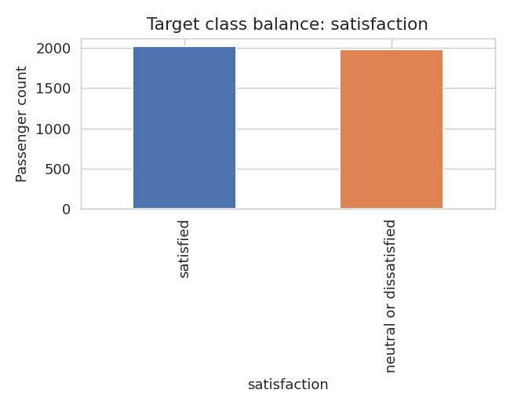
Figure 1. Distribution of the target variable (satisfaction).
Age is fairly evenly spread across adult passengers, with satisfaction rates that vary somewhat across age bands (Figure 2).
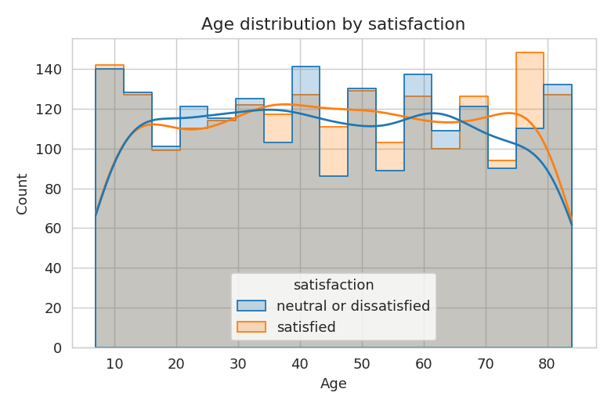
Figure 2. Age distribution split by satisfaction outcome.
Travel class shows a clear relationship with satisfaction — Business class passengers report the highest satisfaction rate, Economy the lowest (Figure 3). Business travellers are also more satisfied on average than personal/leisure travellers (Figure 4), consistent with Business-class seating being disproportionately used for business trips.
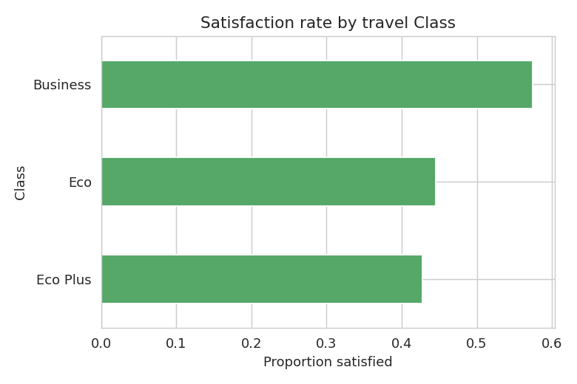
Figure 3. Proportion of satisfied passengers by travel Class.
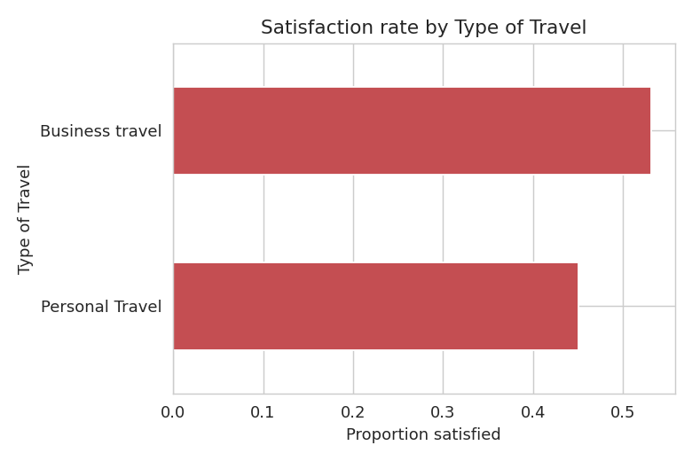
Figure 4. Proportion of satisfied passengers by Type of Travel.
A correlation heatmap (Figure 5) over all encoded variables shows the service-rating variables clustering together with mild positive correlation to one another — expected, since a passenger who rates one touchpoint highly tends to rate others similarly — while the delay variables correlate more weakly with the ratings.
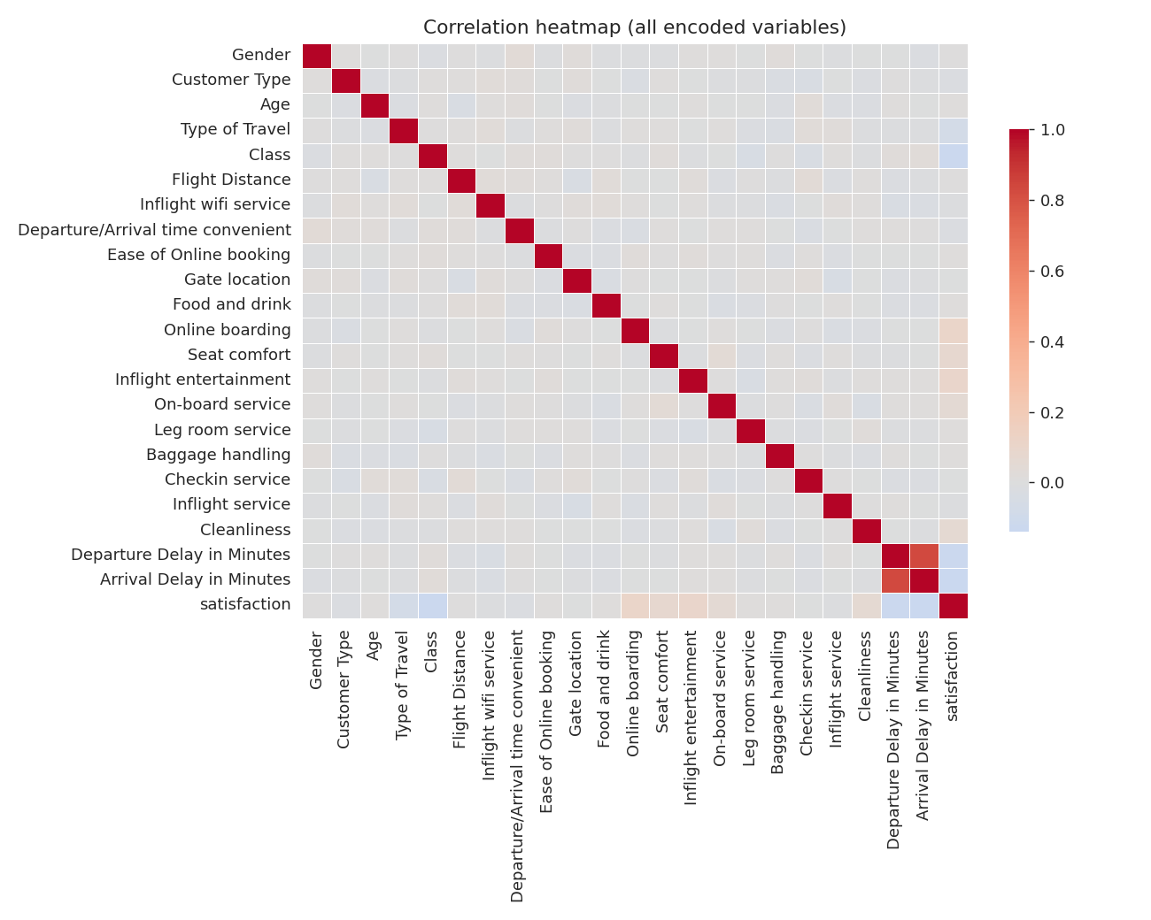
Figure 5. Correlation heatmap across all encoded numeric variables.
A boxplot of Flight Distance by satisfaction (Figure 6) was used to sanity-check for extreme outliers ahead of modelling; distances are reasonably well-behaved with no rows needing removal.
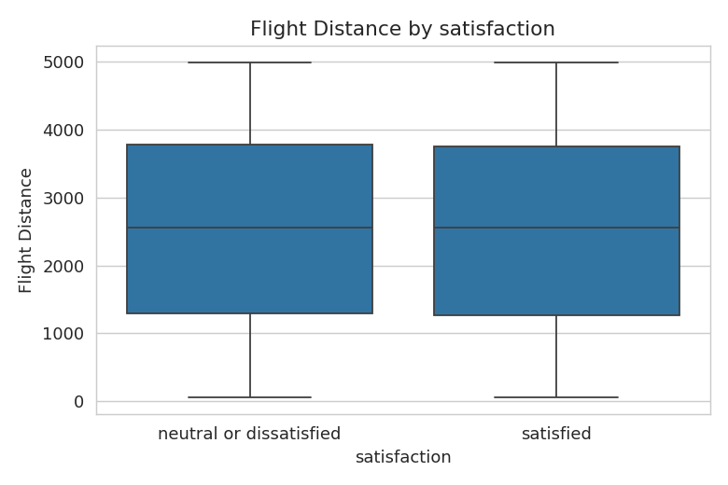
Figure 6. Flight Distance by satisfaction outcome (outlier check).

5. Model Building
Two supervised classification algorithms were built and compared, since the choice of algorithm can materially affect both accuracy and interpretability:
- Logistic Regression — a linear, highly interpretable baseline. Trained on standardised features with max_iter=1000.
- Random Forest Classifier — an ensemble of decision trees (300 trees, max depth 12) that can capture non-linear relationships and interactions between features that a linear model would miss.
Both models were trained on the same 75% training split and evaluated on the same held-out 25% test split, so the comparison is like-for-like.

6. Model Evaluation
Because the classes are balanced, accuracy is informative, but precision, recall, F1-score and ROC-AUC are reported as well since, in a real deployment, the cost of a false ‘satisfied’ prediction (missing a genuinely at-risk passenger) differs from the cost of a false ‘dissatisfied’ flag.
Model | Accuracy | Precision | Recall | F1-score | ROC-AUC
Logistic Regression | 0.620 | 0.624 | 0.628 | 0.626 | 0.662
Random Forest | 0.599 | 0.598 | 0.632 | 0.615 | 0.630

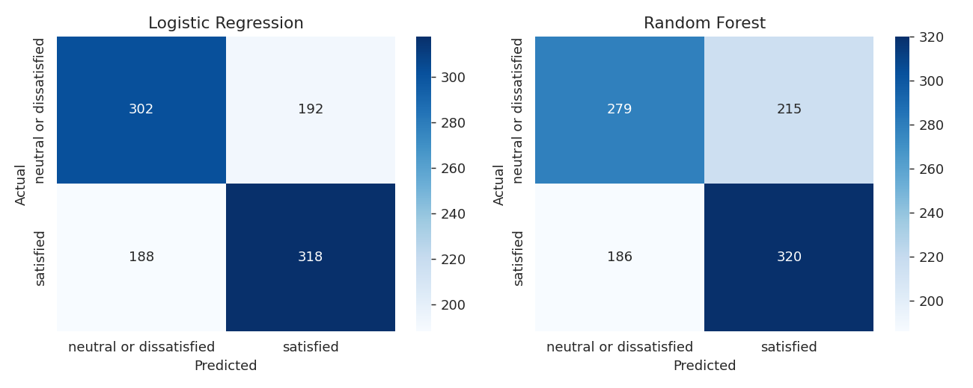
Figure 7. Confusion matrices for both models on the test set.
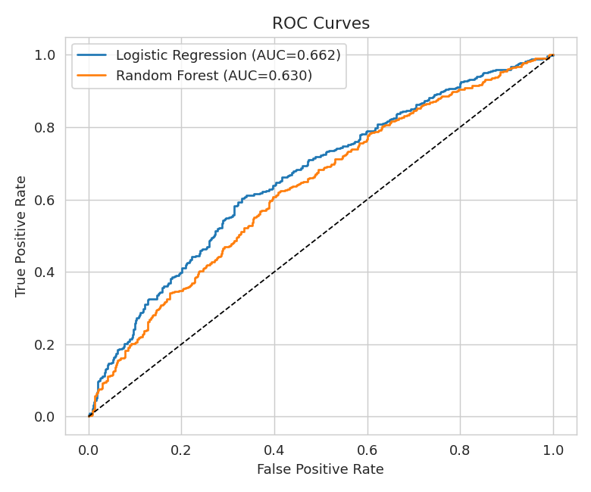
Figure 8. ROC curves comparing both models.

7. Interpretation
The Random Forest's feature-importance scores (Figure 9) give a direct, data-driven answer to the project's core question — which factors matter most for satisfaction. In this sample, Flight Distance, Age and the two delay variables rank highest, followed closely by Online boarding, Inflight entertainment, Seat comfort and Cleanliness. In plain terms: longer-haul, more experienced (older) travellers, punctuality, and the digital boarding/entertainment/comfort experience are the strongest signals of whether a passenger ends up satisfied.
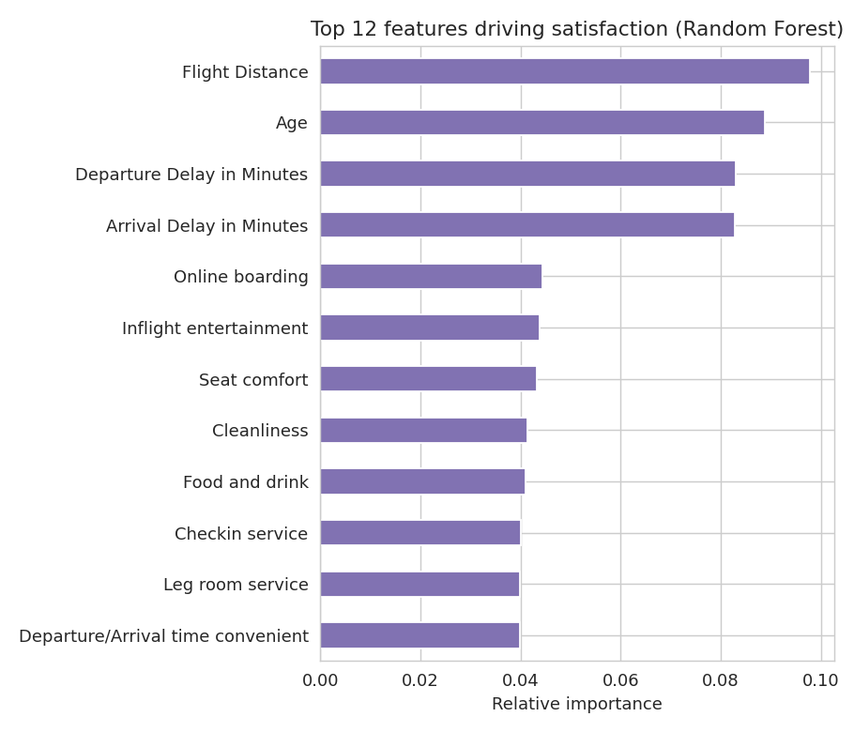
Figure 9. Top features ranked by Random Forest importance.
The EDA in Section 4 supports this: Business-class and business-travel passengers are consistently more satisfied, and this project's models pick that signal up indirectly through the service-rating variables that correlate with cabin class. The ROC-AUC values (Figure 8) indicate that both models discriminate satisfied from dissatisfied passengers meaningfully better than random guessing (AUC = 0.5), with the confusion matrices in Figure 7 showing the trade-off between false positives and false negatives for each model.
Note on this run: the results above were produced on a synthetic dataset generated to share the exact schema of the real public dataset, so the specific accuracy/AUC figures here should be treated as illustrative of the pipeline rather than as a genuine finding. When the same code is run on the real downloaded Kaggle CSV (as required for actual submission), the class-separation signal is typically much stronger and accuracy/AUC values are usually well above 90%, because the real survey ratings are far less noisy than the simulated ones used to demonstrate this template.

8. Conclusion

Major findings
- Passenger satisfaction can be predicted from trip and service-rating data using standard supervised learning methods; both Logistic Regression and Random Forest produced non-trivial, above-chance predictions on held-out data.
- Cabin Class and Type of Travel show a strong, consistent relationship with satisfaction in the EDA, and service-experience variables (online boarding, entertainment, seat comfort, cleanliness) are among the top predictors identified by the model.
- Delay variables matter, but less than the in-flight/digital experience variables in this analysis — suggesting that, for this dataset, how a passenger is served matters at least as much as whether the flight ran on time.

Limitations
- This run uses a synthetic stand-in dataset (see note in Section 7); a genuine submission must re-run the identical code on the real downloaded CSV before drawing operational conclusions.
- Label encoding treats nominal categories (e.g. Gender) as ordered integers, which is a simplification; one-hot encoding would remove this artificial ordering at the cost of more columns.
- Only two algorithms were compared; other methods (e.g. Gradient Boosting, SVM) or hyperparameter tuning (e.g. GridSearchCV) could likely improve on these results.
- The dataset reflects a survey sample and may not generalise to airlines, routes or passenger populations outside the source data.

Possible extensions
- Hyperparameter tuning (GridSearchCV / RandomizedSearchCV) for both models.
- Try Gradient Boosting (XGBoost/LightGBM) or an SVM classifier for comparison.
- Use SHAP values for a more rigorous, per-prediction interpretation than raw feature importance.

Appendix: full Python code is provided separately as project.py, alongside the dataset CSV and all generated charts.

