Respect Mode is on — this space is for genuine, courteous conversation only.
Photo Privacy

Choose who can view your profile photo.
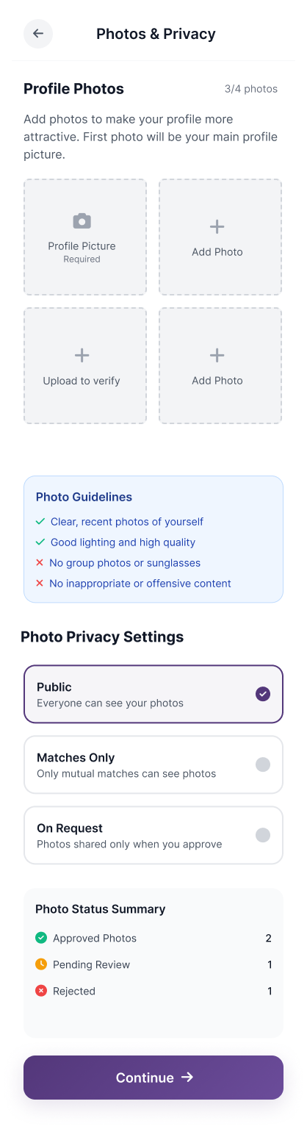

Safety Features
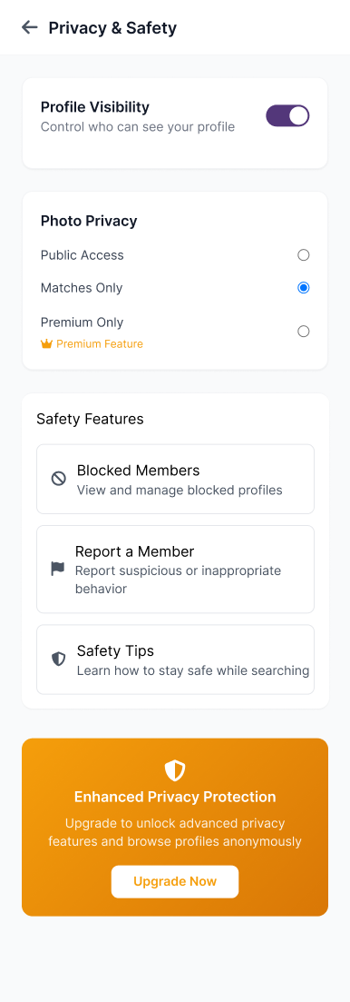

Blocked Members

Manage the profiles you’ve chosen to block.

Report a Member

Flag any behaviour that feels suspicious or inappropriate.

Safety Tips
Safety Tips

Protect Your Financial Information

Genuine connections never ask for money. Keep your bank details, passwords, and OTPs private at all times.

Meet with Intention, and Caution

When meeting someone new, choose elegant, public settings. Share your plans with someone you trust.

Verify Before You Trust

Use Biye Co.’s built-in verification tools and arrange a brief video chat before any in-person meeting. Authenticity is mutual.

Listen to Your Instincts

If a conversation feels uneasy, step back. You have the right to block or report without explanation.

Guard Your Personal Details

Hold back on sharing your address, workplace, or family details until trust has been built over time.

Keep Our Community Safe

If you come across suspicious or disrespectful behaviour, please report the profile.
Explore simple ways to stay safe and confident while connecting.
Public Access
Visible to all verified users on Biye Co.

Matches Only
Only shown to profiles you’ve matched or connected with.

Aalok (Premium) Only
Accessible exclusively to verified Aalok members — serious and trusted profiles.

Stealth View (Obhijaat Only)
Available only for Obhijaat members — your photo remains hidden until you decide to reveal it.
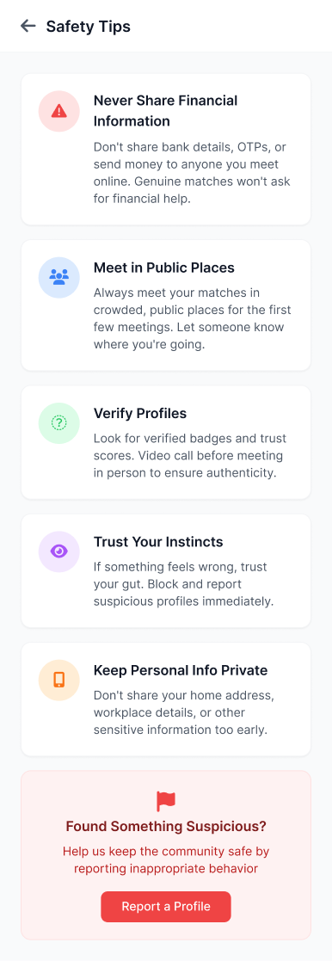

Alaap -1 month free if paying for 12 months

Jatra- 2 months free if paying for 12 months

Aalok- 2 months free if paying for 12 months plus

1. Stealth Privileges Boost
Extend their “Full Stealth Mode” visibility to include premium indicators — e.g., they can see “who liked me while I’m in stealth.” Small code tweak, big emotional payoff.

2. Invitation Priority for future events
They’re eligible (not guaranteed) for upcoming “Founder’s Circle” or “Elite Networking” invitations. Keeps aspiration alive without giving away Obhijaat benefits.

3. Smart Match Priority
Just a small backend tweak — their profiles get surfaced first to other verified users. Position it as:

“Aalok members appear first in compatible match suggestions.”

Mrs. Sunita Kumar
Mother • Verified
• Can view your full profile
• Can send interest on your behalf
• Cannot edit your profile

Note: For your privacy, parents or family members cannot view any messages or conversations you’ve exchanged.
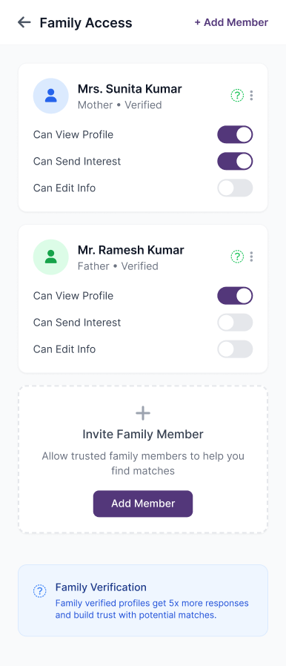

Thank You
Your report has been received.
Our Trust Team will review it within 24 hours.

[Back to Home]
