1. What is share ?

* ~~Small part of the company sold to public to raise money in order to develop the business.~~
* Face value: The value of one share of the company. Company has to decide this face value before issuing shares for public.

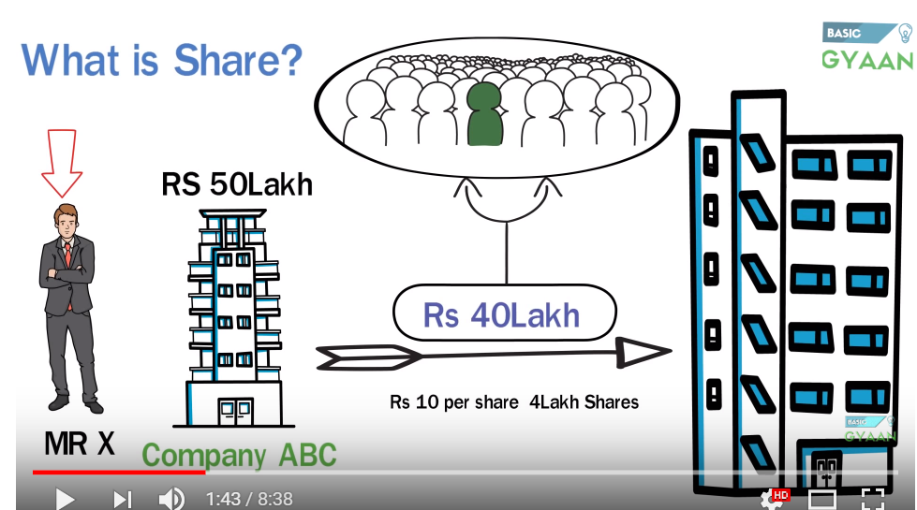

1. Share market:

* Place where we buy and sell share.
* It was done physically in old times.
* Not it can be one over the internet.
* Two most popular markets are:

1. NSE - National Stock Exchange
2. BSE - Bombay stock exchange

* Companies has to register themselves to NSE or BSE in order to sell their shares.
* Ups and downs in NSE are called NIFTY
* Ups and downs in BSE are called Sensex.
* The trading and investments in these markets are done based on the guidelines set up SEBI

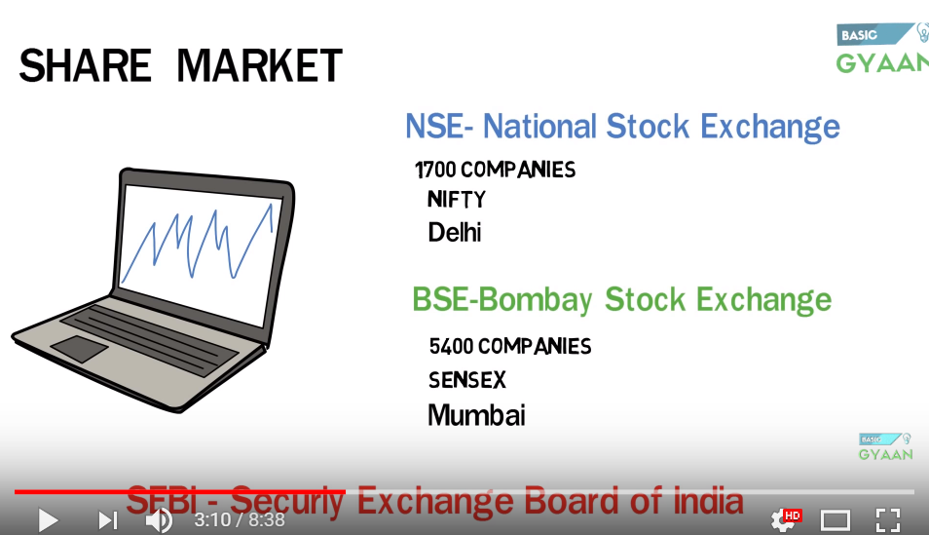

1. How share market works:

* Companies first register themselves to Share market (BSE or NSE, or both)
* The employees in NSE or BSE are called 'Financial Brokers'
* Financial Brokers give advice to people on how to buy and sell shares.
* Suppose I want to buy stock for Company A. I will go to the financial broker who will ask some other person having shares of Company A, if he wants to sell it.
* In this case we need to give some commission to the brokers.
* I can directly approach the other person to buy the shares

1. Profits in Share market:

* Suppose I buy 10 shares for a company at 1000 rupees per share.
* So I invested 10000 rupees.
* If the company makes profit, then it share price may increase to, say, 11 rs per share.
* So if I sell the share now, I will get a 1000 rs profit
* If the company is in loss, its market value and hence its share value will fall, and investor will lose money.
* So company never shares profit with the share holders. Share holders earn profit if the value of the shares that they have purchased increases.

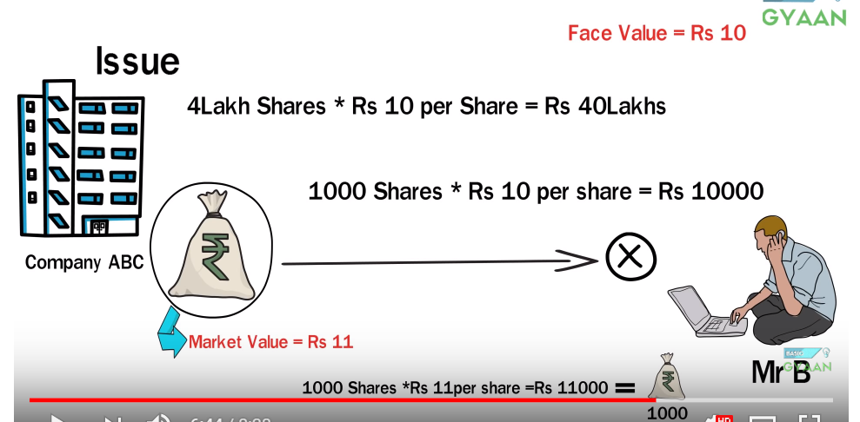

1. Things need to investing in Share Market :

* We need:

1. Savings account
2. Demat Account
3. Trading account:
4. Internet Connection

* Savings account is connected to demat account.
* Account where we see the details of our shares is the demat account.
* All the transactions done like buying and selling of shares is done using the trading account.
* Our profits and lose will show up in the trading account.

---------------------------------------------------------------------------------------------------

* Demat account:

1. What?

* Earlier we used to get a physical certificate of the shares that we have bought.
* With computer and internet all these info (shares and securities) are shared in account demat account in electronic/dematerialized format.
* The buying and selling of the shares happens through the trading account.
* Our demat account is linked with our savings account and trading account.
* Steps:

1. First we transfer money from the savings account to demat account.
2. From the demat account the money is used for selling or buying trades using the trading account.
3. Once we buy a share, the amount will be deducted from our demat account.
4. If we sell a share, the amount will be deposited to our demat account form the trading account.
5. We can transfer money from demat account back to the our saving account.

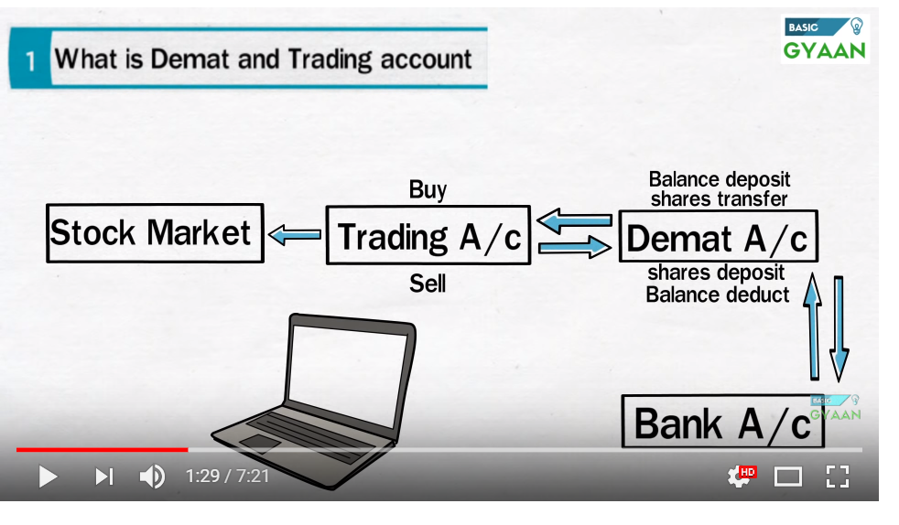

1. Always check for brokerage charges before opening a demat account:

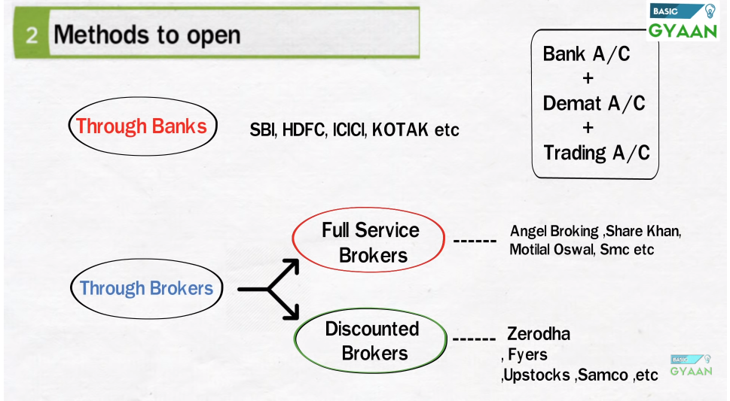

--------------------------------------

How to get profit using share market:

* 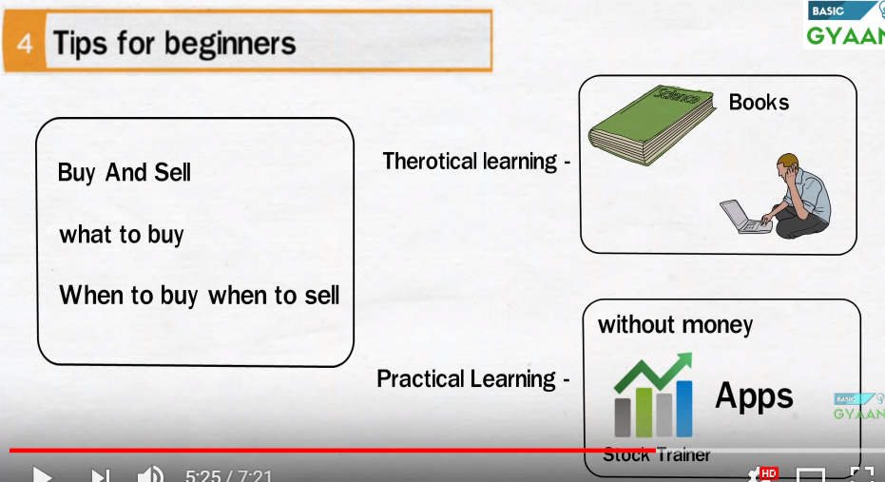
* Buy at lower price and sell at higher price.
* Know what to buy
* Know when to buy and when to sell.

-------------------------------------------------------

Nifty vs Sensex:

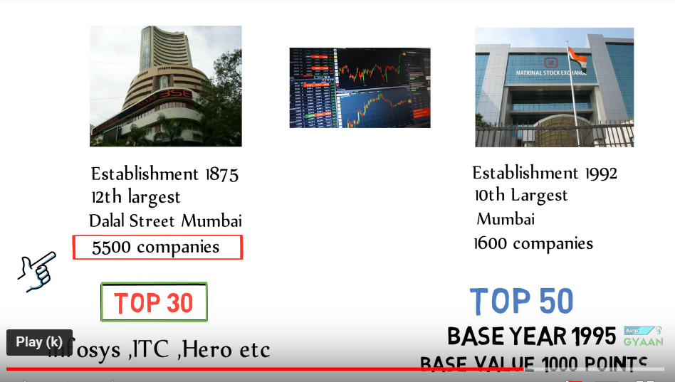

* NIFTY and Sensex are indexes for BSE and NSE respectively.
* One of the criteria to know the economic development of the country is the financial performance of the shares of a company.
* We usually take a sample of companies that represent the whole market.
* This small sample is known as index.
* BSE index is called sensex and NSE index is called NIFTY
* For Sensex we use index of top 30 companies.

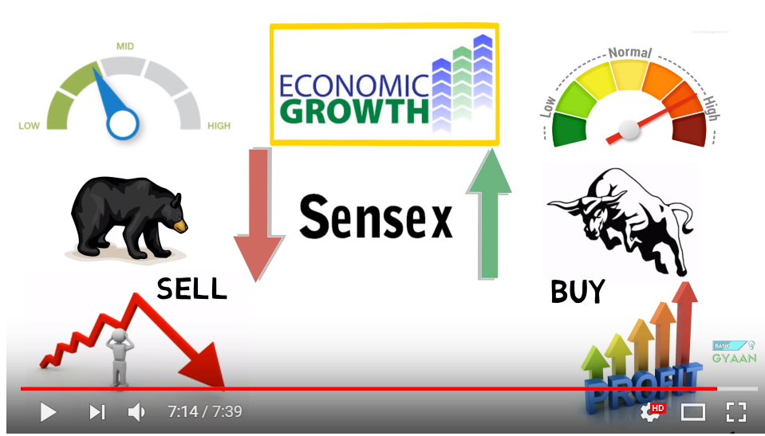

---------------------------------------------------------

Type of shares:

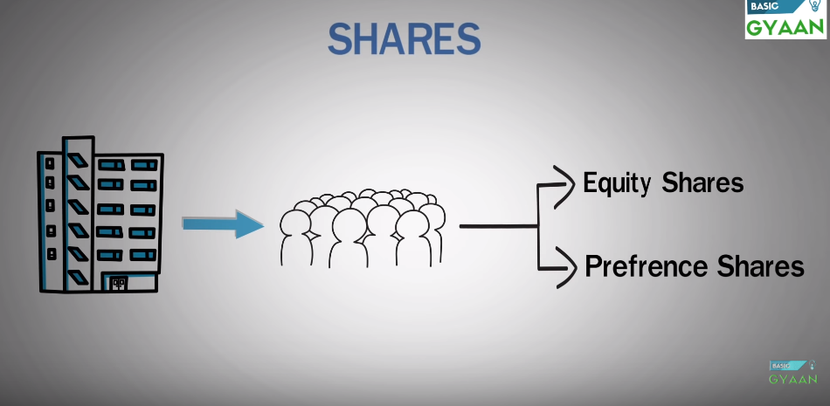

* Equity Shares:
* Preference shares:

|  |  |
| --- | --- |
| Equity | Preference |
| Gets dividend (profit) based on the profit. If the company does not make any profit, then share holders won't get any dividend. | Gets fixed rate of dividend (profit). They don't care if the company makes profit or lose. They will get there money back. |
| They will get the profit only after its distributed to the preference share holder. | Preference Share holder will get the profit first. The remaining amount will then be shared with the equity share holder. |
| During winding up, the equity share holder will get the money only after preference share holder. | During winding up, the preference share holder will get the money first. |
| They get voting rights example, to choose board of directors. | No such right. |
| Have the right to participate in the management. | No such right. |
| Comparatively easier to get these shares | Not easy to get preference shares. Preference shares are mostly given to financial institution, who don't want to lose money due to market changes, and companies give shares to them as they don't want to take loans. |
| These shares are traded in stock market. | Preference shares are not traded in stock market so chances of up and down are less. |
| Equity share can't be sold back to the company by the buyer directly. But in some cases, company can by the shares back from the holders. This is known as buyback. | Preference shares can be sold back to the company after some fixed time. |