Containers

1. Basics:

Resources:
https://www.youtube.com/watch?v=EnJ7qX9fkcU
https://www.youtube.com/watch?v=sK5i-N34im8&t=872s

Definition:
- A container is a sandbox for a process.
- That is, a way to run a process in an isolated environment which can only see the processes running inside that container.
- The processes running inside a container are not aware of the processes running outside it.
- A container :
a) has its own process namespace.
b) has cgroups ( resource limiting and adding certain capabilities)

Containers VS Virtual Machines:

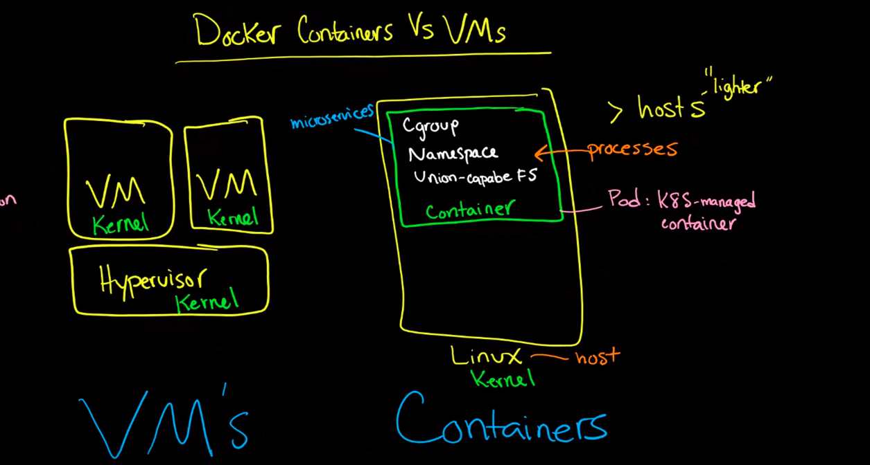

Virtual Machine:

- here we install an OS that has a software called a Hypervisor.
- with the help of hypervisior we can install multiple (virtual) machines on top of the original machine.
- here, each machine will have its own kernel which impacts the system’s performance.

Containers:
- only one kernel is used.
- Can’t boot a different OS.
- can’t have its own modules.
- does not need init as PID 1

- Containers are just a bunch of process visible on the host machine.
- A container contains :
a) cgroups.
- limits how much resource you can use
- Provides resource metering and limiting.
- Also provides device node (/dev/*) access control
b) Namespace
- it provides an isolation by limiting what you can see and therefore what you can use.
- there are separate namespace for:
- pid
- net
- mnt
- uts
- ipc
- Each process is in one name space of each type.

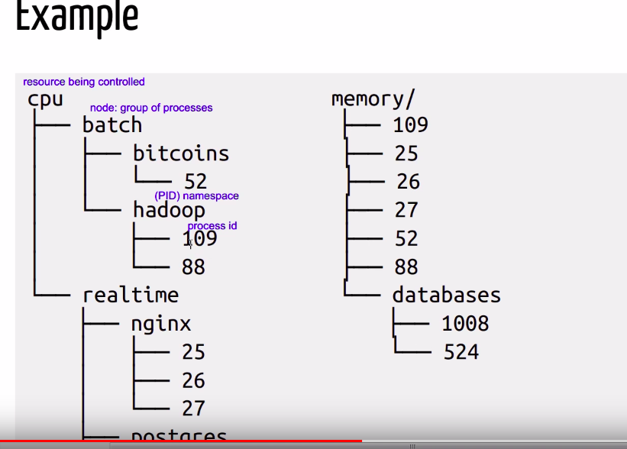
c) Union Capable File system
- a way on combining multiple file system into one.

Architectural Diagram:
