Operator

References:
Operators:
https://www.youtube.com/watch?v=cj5uk1uje_Y

What is kubernetes?
- A container orchestration tool.
- Open source, container centric management platform.
- Takes care of Orchestrating, computing, storage and network of your infrastructures and users network.
- Open sourced by Google In 2014 and is based on Google Internal Project Borg.

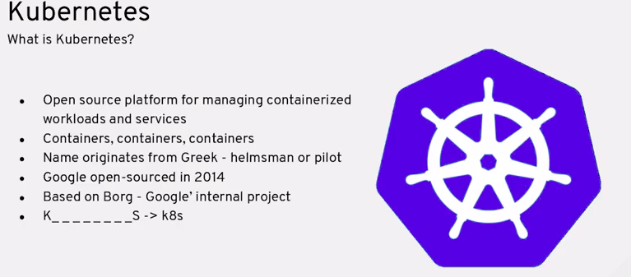

Advantages of Using K8s:
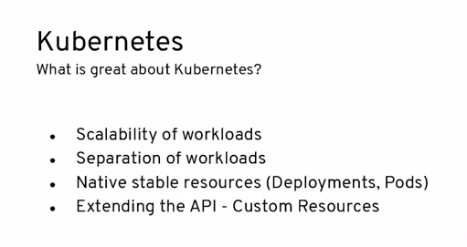

- k8s does not care about the language used in the app along as its under an image.

Kubernetes Architecture:

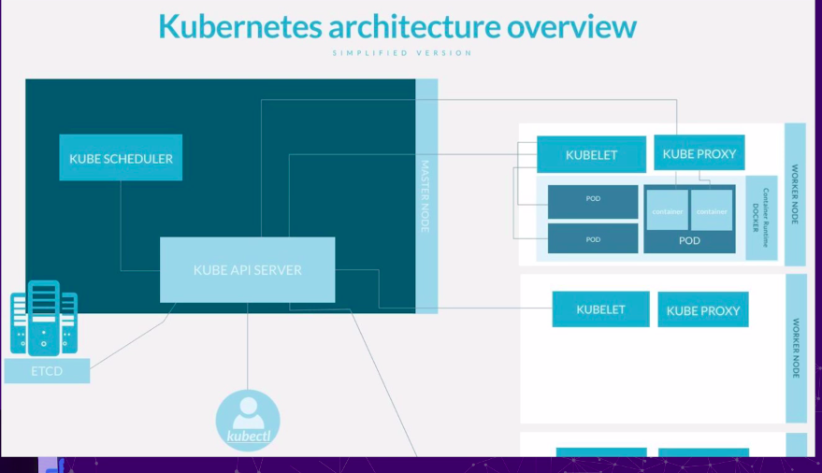
-

Master Node Components:
1. Kube API server:
- This is the main component
- Exposes the K8 API and behaves as the front end to the cluster.

2. ETCD:
- Consistent and highly available key value data store.
- That stores all the information about the cluster like the pods, number of resources, etc.

3. Kube Schedular:
- Creates PODs and assigns them to the Nodes.

Worker Node Component:
1. Kublet:
- Agent that runs on each of the worker node.
- Makes sure that PODs and Containers are actually Running.

2. KubeProxy:
- Performs Network forwarding and connecting the container to the outside world.

3. Container Run time. :
- Any run time interface that supports CRI can be used here, like docker.

Kubernetes Controllers.

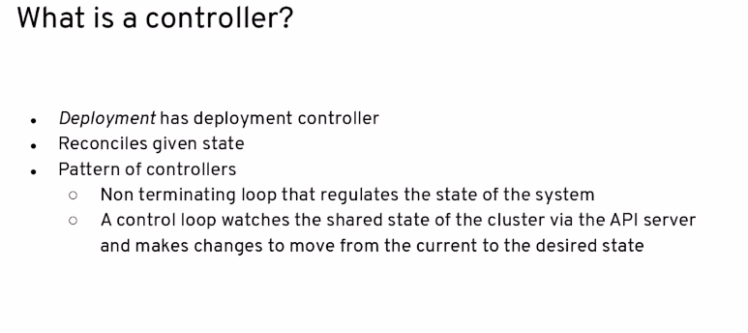
- Every Operator is controller but every controller is not an operator.
- An Operator other than having the controller logic, also has some business logic about the underlying application that it automates.
- Controllers are based on the level Trigger pattern- https://hackernoon.com/level-triggering-and-reconciliation-in-kubernetes-1f17fe30333d
- Operator can also be defined as a Kubernates native application or an application whose interface is the kubernetes API, that is wer are interacting with the application using the Kubernetes API

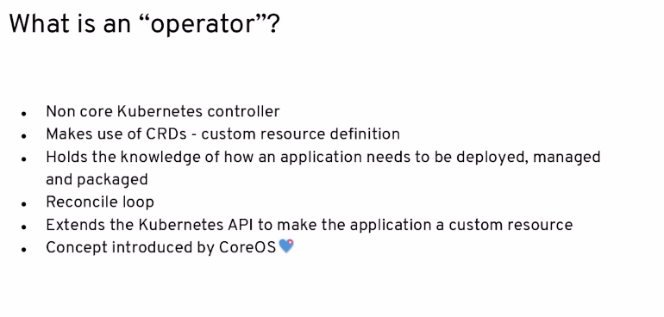
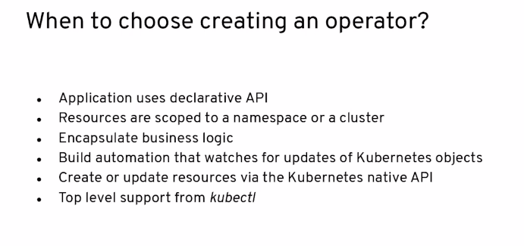
When not to use Operator:
- When you don’t want to reconcile.
- When the app is very simple.

Ways of building an Operator:

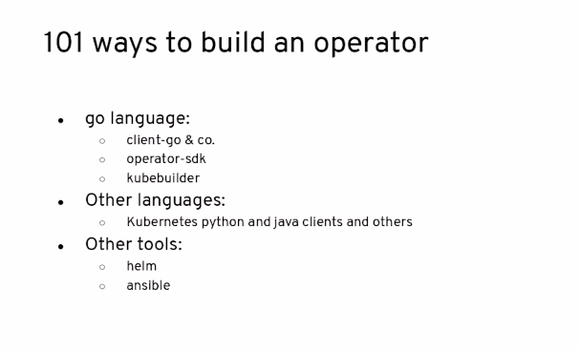

Using K8 native Clients to build the operators:

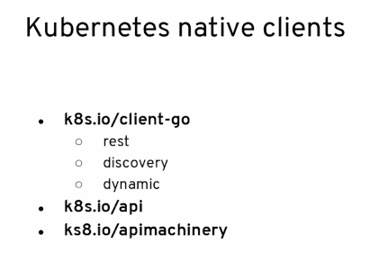

Operator-SDK:

Steps to create an operator boiler plate using Operator SDK
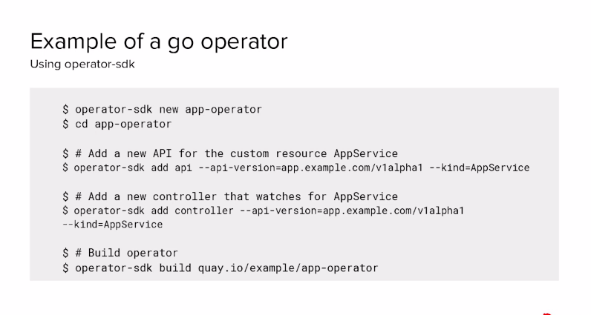

Operator SDK is code gen tool that creates the Operators.

Deploying operator on K8s:

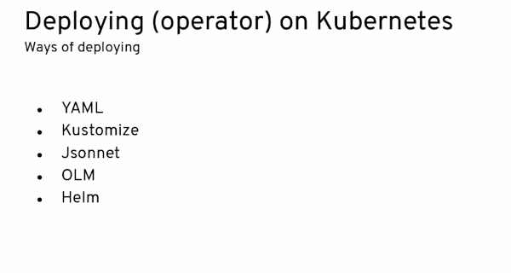

Steps to deploy operator with yaml:
1. Register the CRD.
2. Create an needed Role Based Access Control.
3. Deploy the operator
4. Create an instance.
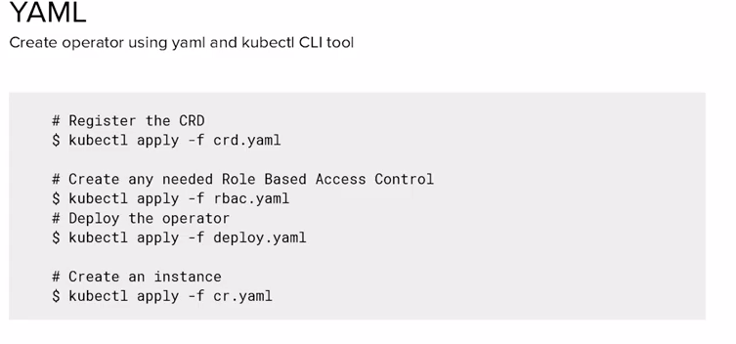

OLM: Operator Life cycle Manager

helps users install, update, and manage the lifecycle of all Operators and their associated services running across their cluster

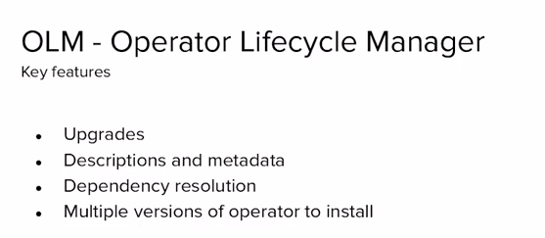

Operator lifecycle is:
- definition or specification of the operator.
- installation of the operator.
- dependency resolution.
- Upgrading of the operator.
- Removal of the operator.

OLM is the automation of the Operator Lifecycle.

- Goals of OLM:
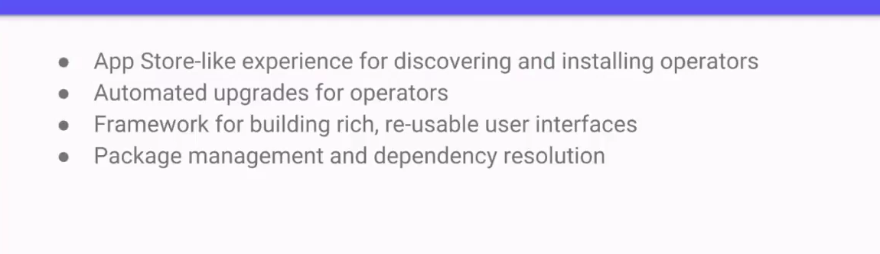

At high level, OLM is defined by two separate operators which are:
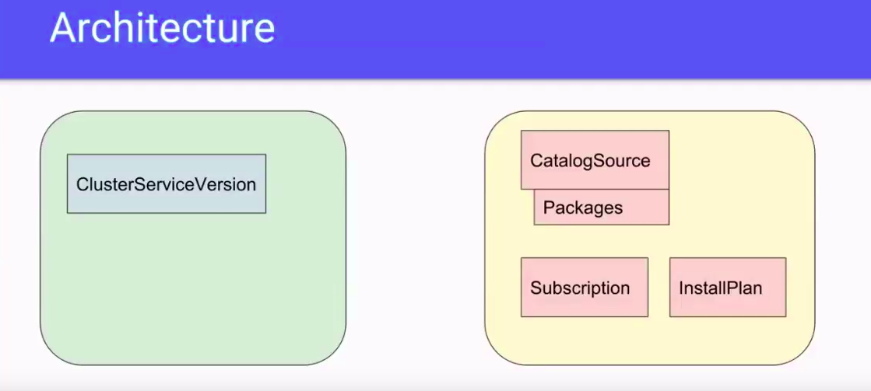
a) OLM
- Manages the ClusterServiceVersion within every namespace.
- CSV is the package manifest for the operator.
b) Catalog operator.
- Manages the catalog sources like – InstallPlan, Subscription.

Cluster Service Version:
- Specification file for what an operator is and how it should run.
- CSV can be described as being analogous to:

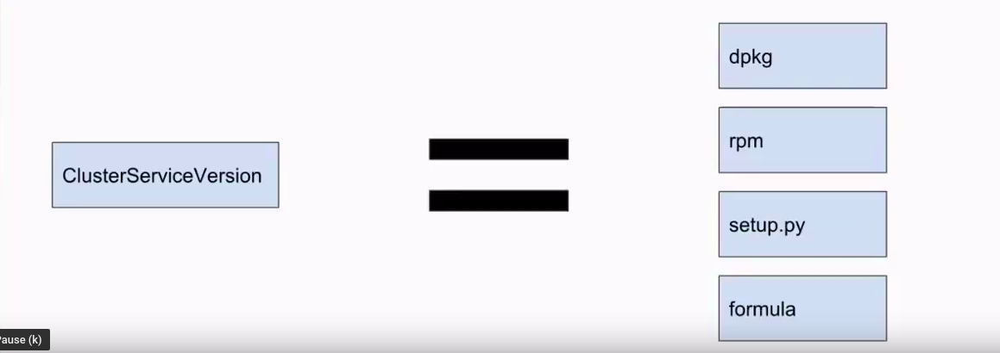

- CSV Architecture:
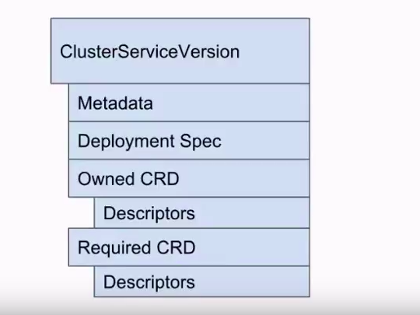

- CSV manifest consist of
a) Metadata
b) Deployment SPEC
- CRDs are the interface between operator application and kubernetes API.
- CSV describes two types of CRDs
a) Owned:
- Operator declares to the OLM that it will responsible for the lifecycle of particular CRDs.
b) Required:
- Not owned by the operator but will interact with them in some way
Operator, using CSV, tells the OLM that it will be responsible for the lifecycle of particular CRDs.
OLM uses descriptors to help drive some UI and CLI interaction.
Install Plan:
- Handled by catalog Operator.
- Install Plan is analogous to:
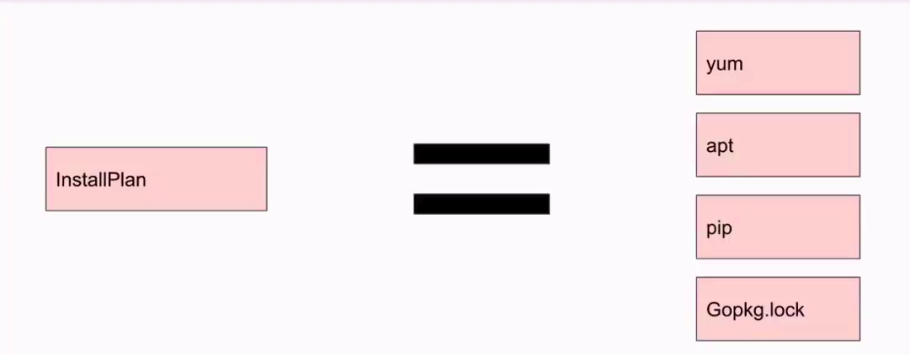
- Install Plan
-----------------------------------------------------------------------------------

- CatalogSource:
- A repository of CSVs, CRDs and and packages that define an application.
- The catalog operator watches the catalog sources for updates to packages in channels and upgrading them (optionally automatically) to the latest available versions.
- User can track a package in the channel by creating a subscription resource configuring the desired package, channel and the catalogsource from which to pull the updates.
- An installplan is written into the namespace, on behalf of the user, when updates are found.

Complete Graph of objects using in OLM:
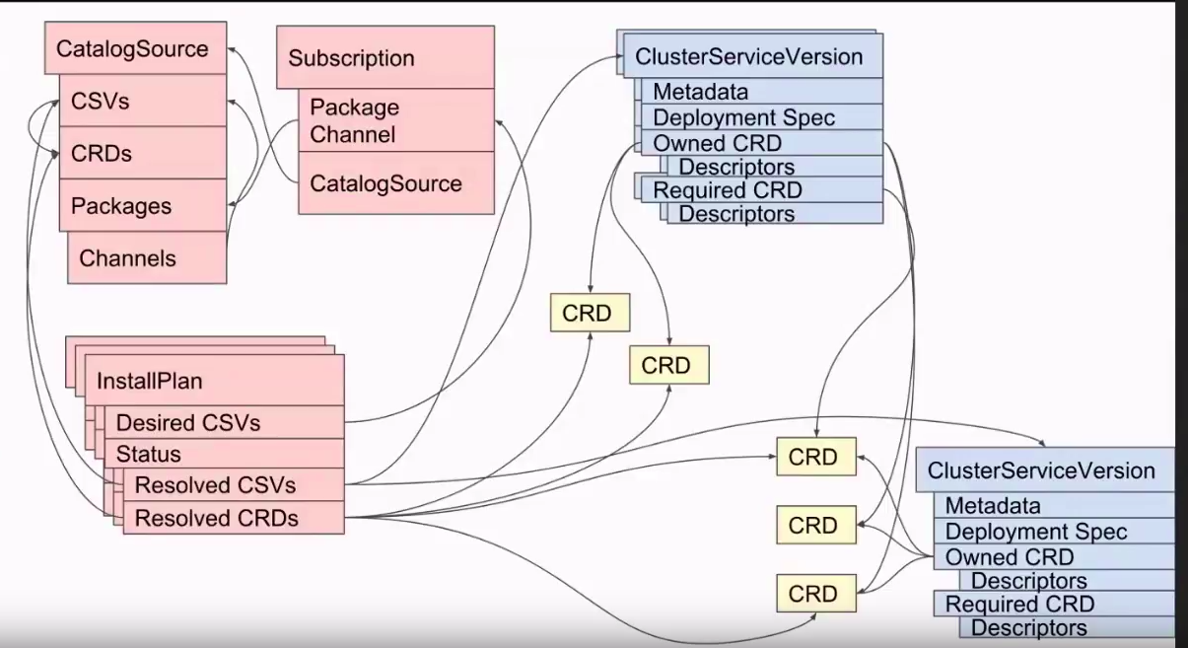

It’s control loop that watches the state of the cluster through api server and makes changes attempting to move from the current state to the desired state.

for {
desiredState := getDesiredState()
currentState := getCurrentState()
makeChanges (desired, current)
}

- Controllers consist of :
- Informer
- Queue
- Threads/workers that will be doing the work.

- Overview of the controller architecture:
