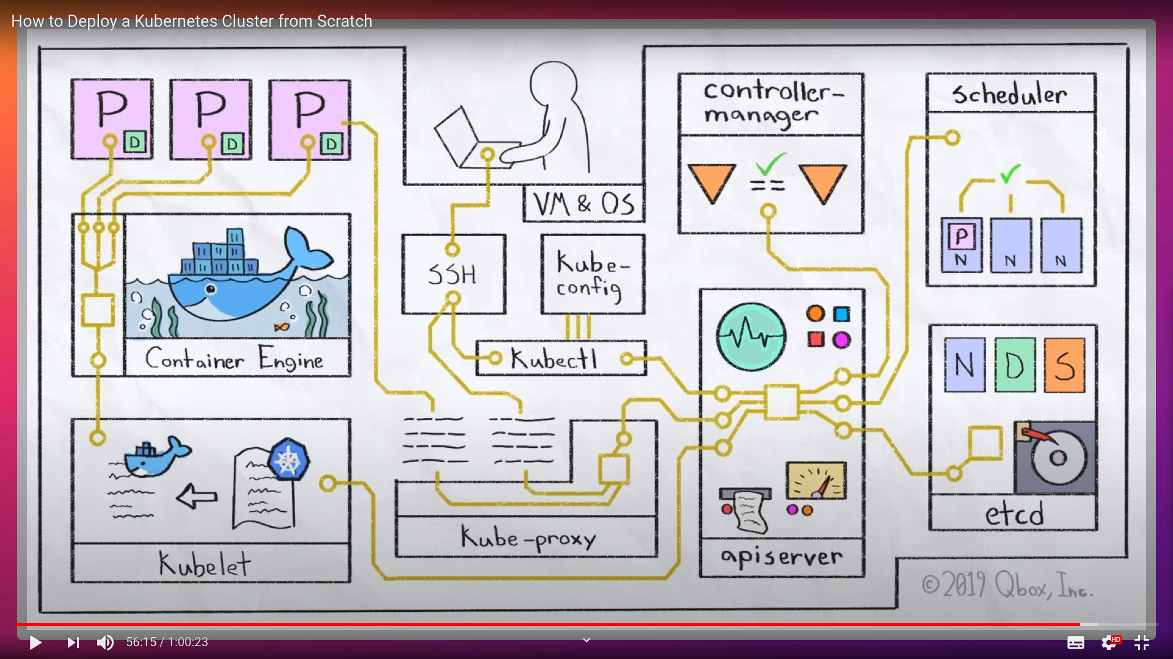
Kubernetes cluster and architecture

- Understanding K8s architecture by creating a k8s cluster from scratch
Resource: https://www.youtube.com/watch?v=t4H6hdvB9iQ&t=2s

1. k8s components: 3:40

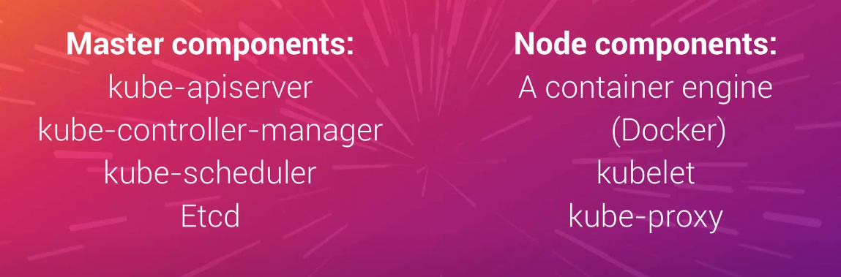
- Create a VM with vagrant:
- vagrant init ubuntu/xenial64
- SSH into the VM with root privileges.
- Install docker. 9:15
- Docker is the the container engine that we have chosen to use.
- Download k8s binary and extract them - 11:10
- Move kubectl, kube-api-server, kube-controller-manager, kube-scheduler, kube-proxy into /usr/bin to access them from the path.
- Remove the folders that we downloaded and extracted to keep things clean.

2. Kublet: (Node Component)
- Kublet is the component that takes to the container engine (like docker, podman etc) for creating containers.
- Run kubelet in standalone mode. 13:45
- Kubelet is a node component the facilitates workload on the kube : 16:50
- Its primary purpose is to talk to container-enginer (docker, podman) and tell them when and what to run
- mkdir -p /etc/kubernetes/manifests
- kubelet --pod-manifest-path /etc/kubernetes/manifests &> /etc/kubernetes/kubelet.log &

3. Etcd: 19:30 (Master Component)
- etcd is the database and state store for k8s. Its a third party tool not part of k8s so not comes packaged from it.
- Installing etcd:
- Download and extract binaries.
- Move etcd into /usr/bin
- Move etcdctl into /usr/bin/etcdctl
- remove the extracted folder to clean
- Start etcd using the command:
- etcd --listen-client-urls http://0.0.0.0:2379 --advertise -client -urls http://localhost:2379 &> /etc/kubernetes/etcd.log &
- Check etcd cluster health by:
- etcdctl cluster-health (this is the health of the etcd cluster and not the k9s cluster)
- running etcd cluster is required to start the api server as its requires etcd as one of the options.
4. Kube-apiserver: 23:45 (Master Component)
- Kube-apiserver is server for k8s apis.
- A central hub through which everything else should communicate. Every kubectl command is send to etcd via apiserver
- Coupled tightly with the etcd and everything talks to the etcd using apiserver
- Command to start api-server
- kube-api-server --etcd-servers=http://localhost:2379 --service-cluster-ip-range=10.0.0.0/16 --bind-address=0.0.0.0 --in-secure-bind-address=0.0.0.0 &> etc/kubernetes/apiserver.log &
- Check status of the api-server
- ps -au | grep apiserver
- head /etc/lkubernetes/apiserver.log
- curl http://localhost:8080/api/v1/nodes : this is where is running.
5. Kubeconfig file: 27:30
- Helps connect the Kublet to the apiserver.
- Commands:
- View current kubeconfig file: kubectl config view
- Update kubeconfig - kubectl config set-cluster kube-from-scratch --server=http://localhost:8080
- Set a context:
- kubectl config set-context kube-from-scratch --cluster=kube-from-scratch
- Set above context as current context:
- kubectl config use-context kube-from-scratch
- This config file is present in the ~/.kube/config and helps the kublet to talk to api-server
- Setup kubelet to use the kubeconfig file, so that kubelet can talk to the api-server. 30:22
- Earlier kubelet was using the manifest file directory.
- kill kubelet to start it with some new information:
- pkill -f kubelet
- Instead of pointing to the manifest directory, we will make kubelet to talk to the api server:
- kubelet --register-node --kubconfig=".kube/config" &> /etc/kubernetes/kubelet.log &
- Kubelet is the node that is registered in the api server.
6 Kube-Schedular: 36:20 (Master Component)
- We need a schedular to decide where to schedule a pod.
- Without a schedular, the pods will always be in pending state.
- Command to start schedular:
→ kube-schedular --master=http://localhost:8080/ &> /etc/kubernetes/schedular.log &
- pod deletion process: 37:35
7 Kube Controller-manager: 40:00 (Master Component)
- Always checks if the desired state is equal to the actual state.
- So if a pod (belonging to a deployment) dies, then controller creates it again.
- It helps kubernetes to be self healing, resilient.
- Helps in tasks like state enforcement.
- Command:
kube-controller-manager --master=http://localhost:8080 &> /etc/kubernetes/controller-manager.log &
8 Kube-proxy: 47:00
- kubenetes way of making pods to commnicate outside the docker network.
- Ports are exposed on pods running inside kubernetes. And there is k8s way to talk to those pods using the exposed ports.
- Command:
- kube-proxy --master=http://localhost:8080 &> /etc/kubernetes/proxy.log &
- Kube-proxy sets the networking rules on the nodes it lives on, so that pods can communicate.

