Finalizers:
- Implement asynchronous pre-delete hooks with the help of controllers.
- Finalizers prevent hard delete of the K8s object.
- Can be used for both custom and built in resources.
- Finalizers are just string values ( a list) added to the ‘metadata’.
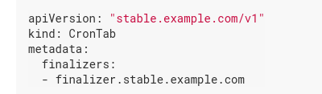

- A delete request to the object with finalizers get converted in to ‘update’ request and it adds ‘metadata.DeleteTimeStamp’ value to the
- Finalizers hold the object in terminating state
- On first resource delete request on object with finalizers metadata.DeleteTimeStamp field is set, but the object is not deleted.
- Finalizers can only be removed if the metadata.DeletionTimeStamp is set ( jas a non zero value). This is called executing a finalizer.
- When all the finalizers are executed, that is , the list of finalizers are empty, then only kubernetes finally deletes the object.
- Its the responsibility of the controller to remove the finalizers from its list.

PVC finalizing controller:
https://github.com/kubernetes/community/blob/master/contributors/design-proposals/storage/postpone-pvc-deletion-if-used-in-a-pod.md

