SERVICES in K8s.

- Services are used when we want to do any kind of networking on a K8s resource/object.
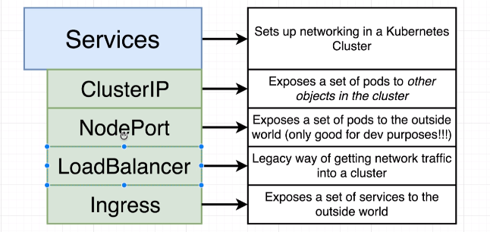

- Types:
a) Cluster IP:
- Provides access to objects( mostly a set of pods) to everything else inside our cluster.
- Sample Cluster IP manifest
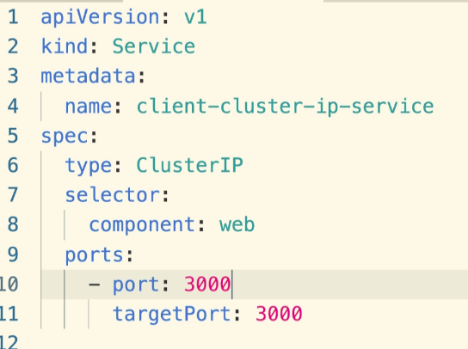
- The ‘Selector’ connects this service to appropriate object (pod) using the selector-label process.
- ‘port’ refers to the port that other services need to use in order to access the service.
- ‘targetport’ is the port on the POD ( that user is trying to access)
- Both ‘port’ and ‘targetPort’ could be same or different. Better keep them same.

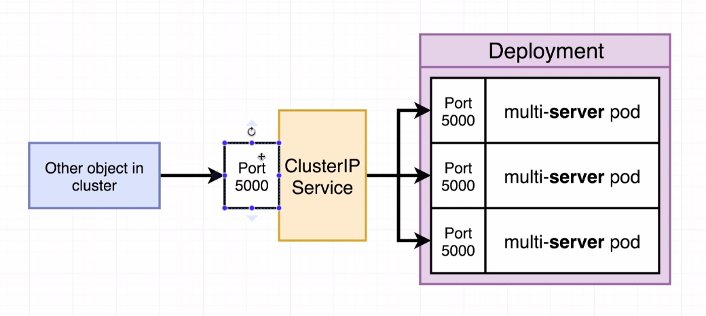

b) NodePort:
- Provides access to objects to outside the cluster.
- For example, people can access the service running on a POD from outside the cluster, like from a browser.
- Only good for development environment. We should use ingress in production.

c) Load balancer :
- A Legacy way to get network traffic inside our cluster.
- Load balancer only gives access to one set of pods like shown in the diagram below.
- So we need to create one load balancer for each service that we want to expose. This is not cost effective.
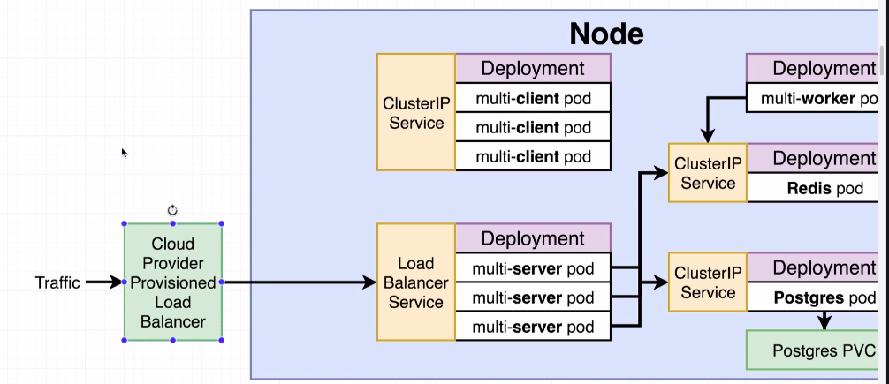
- K8s uses our load balancer config and reaches out to the cloud provider and creates a load balancer based on cloud provider’s configuration or definition of a loadbalancer.
- This Cloud provider specific load balancer then allows traffic to enter our cluster and reach our load balancer and access the pod exposed by the load balancer.

d) Ingress:
- Gets traffic inside our cluster.
- Used in production instead of nodeport
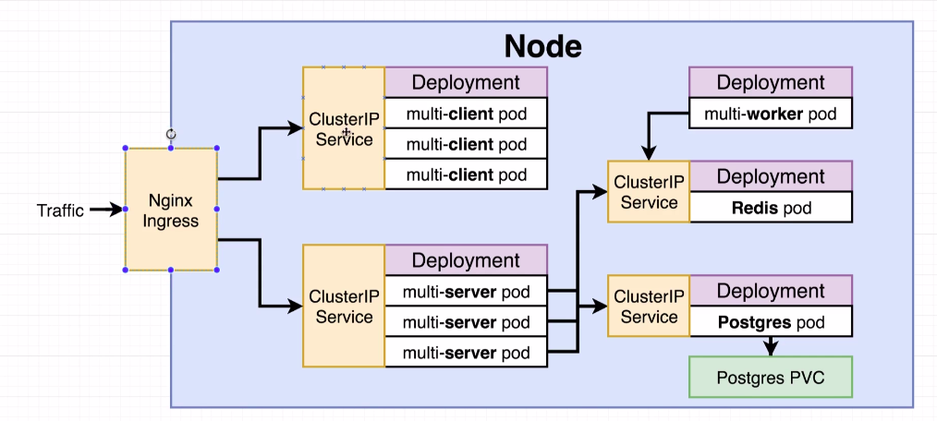
- We can use Kubernetes/nginx-ingress to setup nginx
- setup of nginx-ingress changes based on the cloud environment.
- Example of how ingress setup works in google cloud:
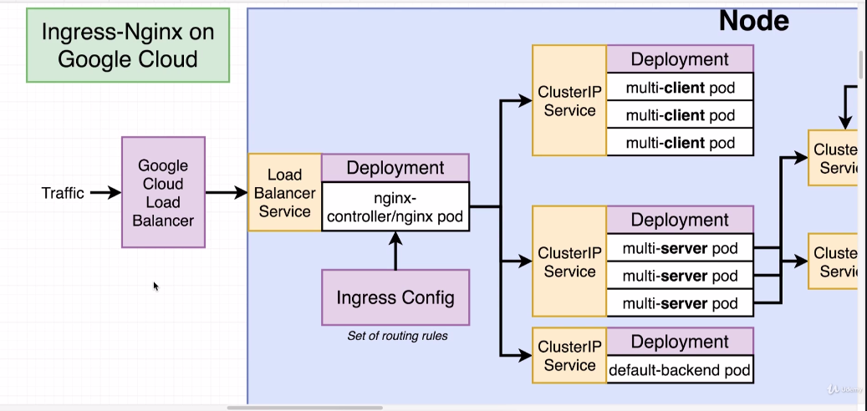
- The ingress-nginix controller works like any other controller inside in k8s by converting current state into desired state in a controlled loop.
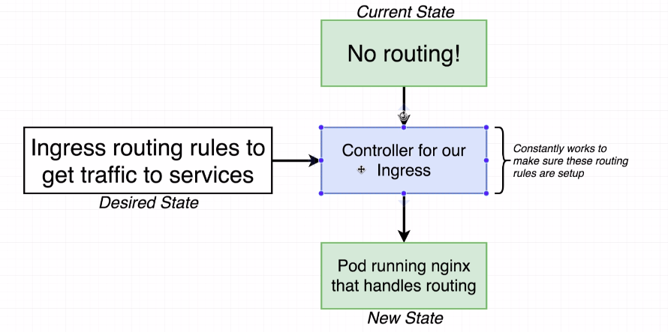
- We create a ingress config file with routes and feed it to the k8s using kubectl.
- this creates a ingress pod that handles all the routes rules.

- Note: nginx-controller bypasses the ‘ClusteterIP’ service and directly load balances the requests to one of the pods in the deployment and help achieving a Sticky session (multiple quick requests by the same user should go the same pod).

