ROOK

1. OPERATORS: An operator is a domain/application specific controller.
All Operators use the controller pattern, but not all controllers are Operators. It's only an Operator if it's got: controller pattern + API extension + single-app focus.

- We have both Stateless and Stateful applications that we want to deploy using K8s

Stateless Applications:
- Apps that can be destroyed, moved and upgraded easily anytime.

How K8s helps in case of Stateless Apps:
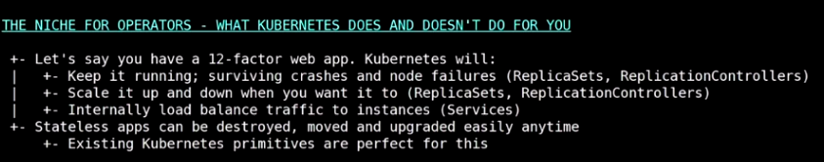

Stateful Applications:

- Say for example cassandra.
- These applications have some state (example data) associated with them. So its not very easy for K8s to replicate or bring them back when a POD is down.
- So we need to do other application domain specific things as well when moving such apps using containers or K8s.
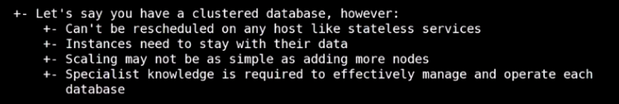

So operators help fill the gap of the application specific things that k8s can’t do on their own.
An operator represents the human operational knowledge in software to reliably manage a software
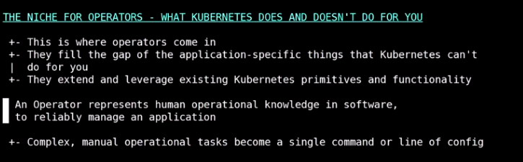

An operator is an application specific controller that extends the k8s API to create, configure and manage the instances of complex stateful application on behalf of the k8s user.
It builds up the basic kubernetes resources and controllers concepts but includes domain or application-specific knowledge to automate the common tasks.
Operator is just a standard design pattern that we can follow to automate things on K8s.
Operators extend the capabilities of the K8

- Basic design model behind operators:
OBSERVE ANALYSE AND ACT
- Observe the current state of the cluster.
- Analyse it with the desired state.
- Act to achieve the desired results.
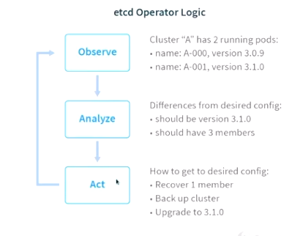

Guidelines to Create an Operator:
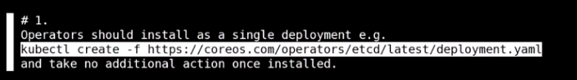

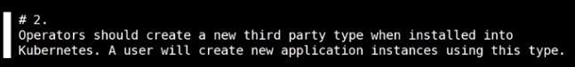

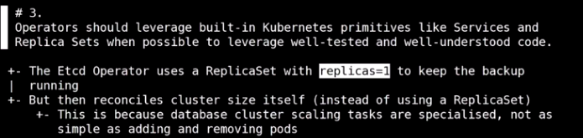
don’t implement something that K8 already provides.

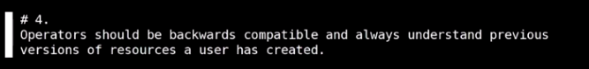

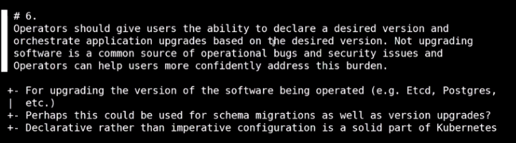

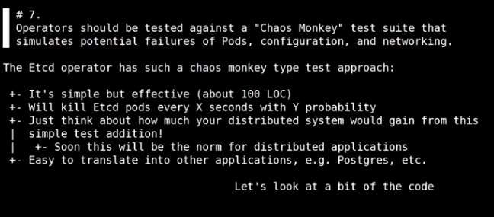

- Future of Operators:
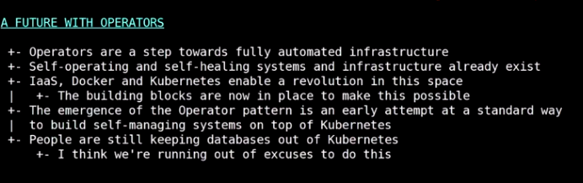

ROOK: A Software that extends kubernetes to enable users to use different 3rd part y storage solutions (like ceph, cassandra etc) with Kubernetes. Its file, block and object storage service for the cloud native Environments.

- Rook is a cloud native storage orchestrator.
- Rook uses Custom Resources and Controllers to extend the K8s by providing automated solutions for providing storage to the cluster.
- Rook automates storage related tasks like deployment, bootstraping, configuration, provisioning, scaling, upgrading, migration, disaster recovery, monitoring and resource management.
- All these points above are domain expertise around storage cluster that has been put into code and added to K8 to extend it.
- Its a framework for integrating storage solution into k8s

- The volume plugins helps to bring external storage solutions inside of kubernetes.
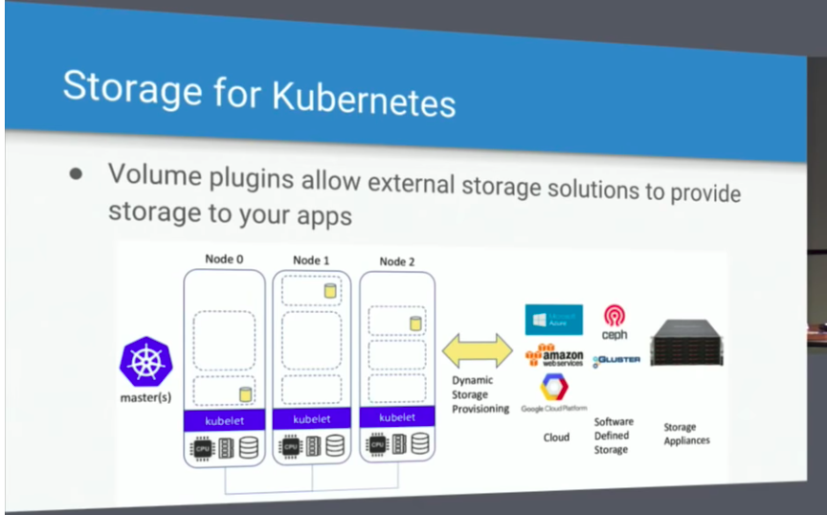

Limitations:

- Rook brings the storage inside k8.
- It runs storage as containers inside K8s
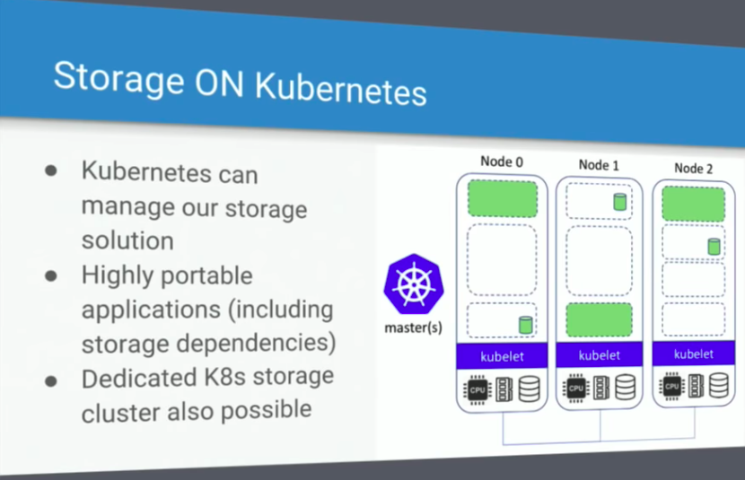

Operator Pattern:
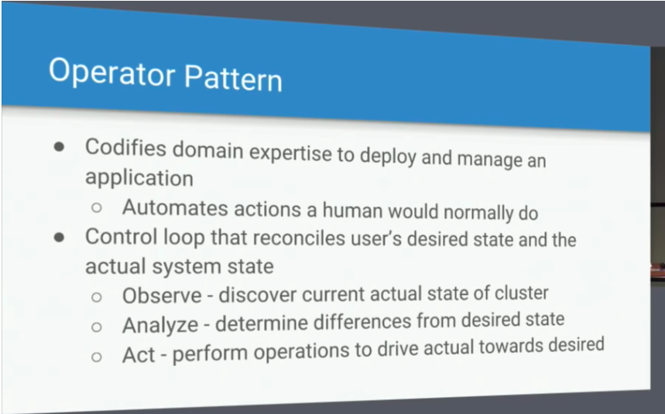
- Operator takes domain knowledge around the software (like adminstrative work) and puts that into the software to further automate the software and reduce any manual intervention.
- Operator sits in a controlled loop where it does three things:
a) observe the current state of the system.
b) Compare the current state with the desired state the user wants.
c) Act to bring the current state towards the desired state.

Custom Resource Definition:
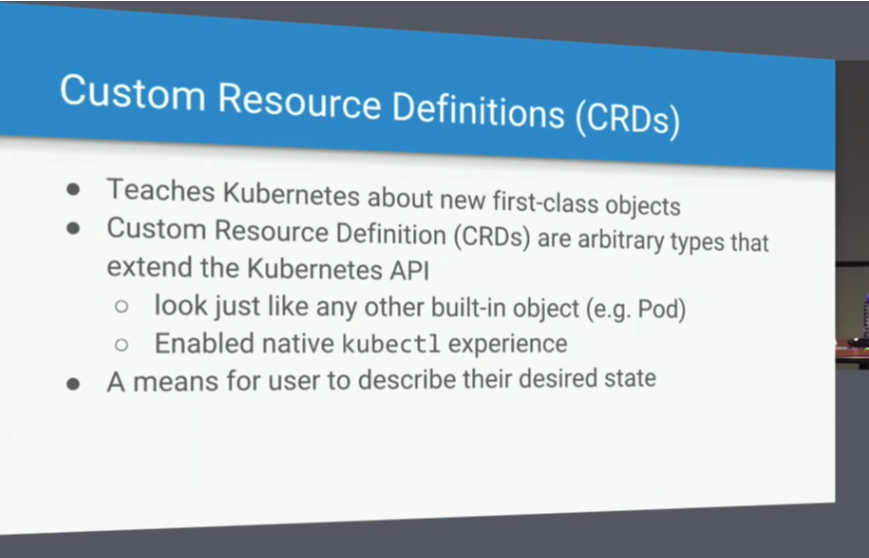

Rook Operators:

- Rook is collection of operators.
- Rook implements that operator pattern for a number of different storage solutions.
- Rook has CRDS for Storage Cluster, Pool, Object Store etc to allow the user to have define the desired state for these CRDs.
- Then rook will run the operators as controlled state to follow the Observe Analyse and Act model on these CRDs
- Apart from the built in logic that we add using the opeartor, they can also leverage the existing K8s APIs like services, replica sets

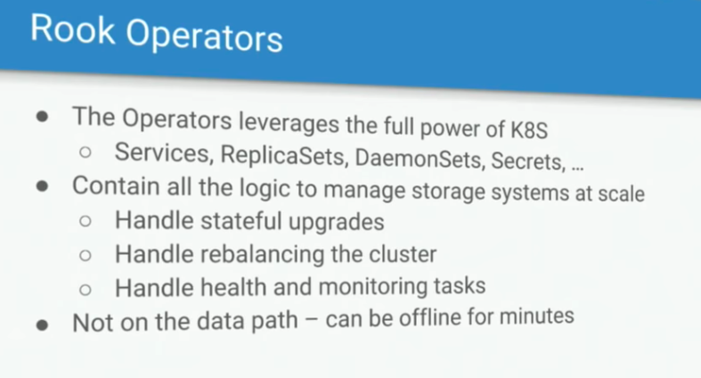

Not on the data path ???

- Deploying ceph on K8s using Ceph:
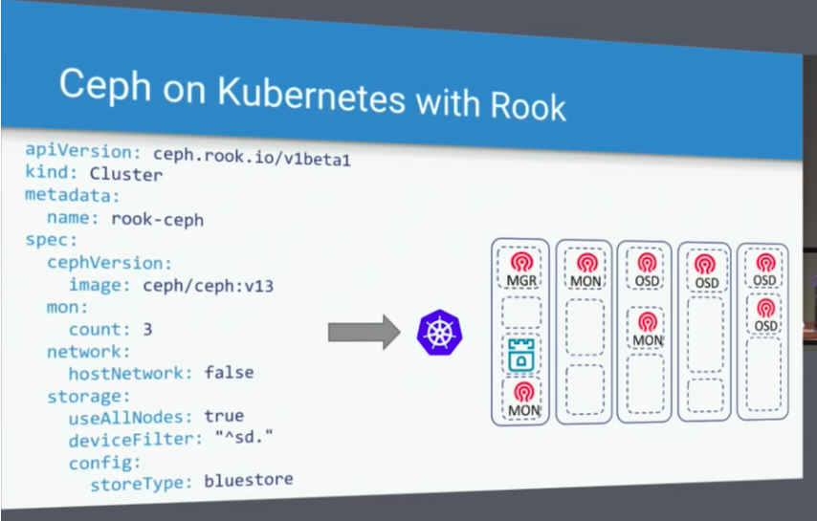

Rook Agent:
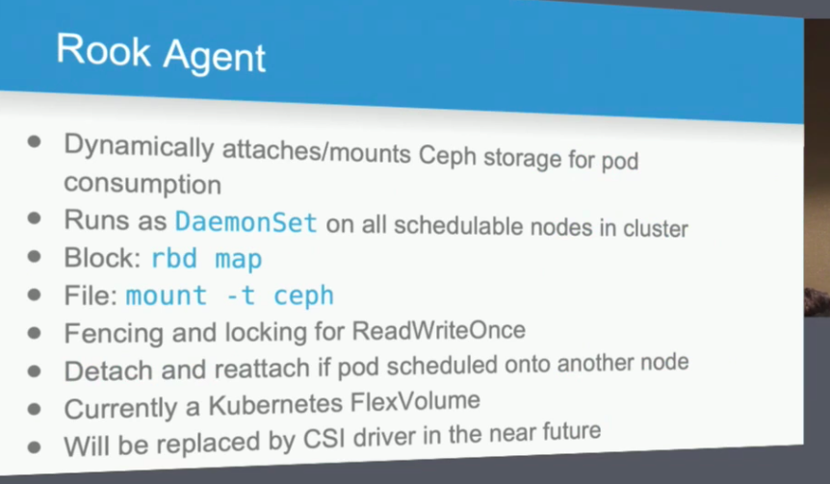

Installation:

1. Start the minikube cluster using:
minikube start --memory=3000 -b kubeadm --kubernetes-version v1.13.1

2. Run following commands inside minikube cluster :

minikube ssh "sudo mkdir -p /mnt/sda1/${PWD}; sudo mkdir -p $(dirname $PWD); sudo ln -s /mnt/sda1/${PWD} $(dirname $PWD)/"

minikube ssh "sudo mkdir /mnt/sda1/var/lib/rook;sudo ln -s /mnt/sda1/var/lib/rook /var/lib/rook"

2. Clone the Rook project and navigate to “cluster/examples/kubernetes/ceph”

3. Deploy the rook system components like Rook Agent Running on each node of the cluster Rook Operator and Rook discover using :
- kubectl create -f operator.yaml

4. Verify the results of the above command using:
- kubectl -n rook-ceph-system get pod
Ensure that three PODS ‘Rook Agent, Rook Operator and Rook Discover’ are running.

5. Create the Ceph cluster.
- kubectl create -f cluster.yaml

6. Create Storage class

7. Create Tool box

8. Create Mysql POD

9. Create WordPress POD

Test Setup:
1. From main directory run following command:
- make IMAGES=”ceph” build.
This will download all the dependencies and will create the ceph images.

2. Pull ceph image using:
- docker image pull ceph/ceph:v13

3. From tests/scripts directory run following command.
- sh minikube.sh up ceph
This will create the minikube VM and copy rook/ceph and ceph/ceph images to the cluster.

4. From cluster/examples/kubernetes/ceph run following command:
- Kubectl create -f operator.yaml

This will start the Operator Deployment. Operator performs the following operations:
a) Gets the rook image from the ‘rook-ceph-operator’ container.
b) Starts the rook operator.
c) Rook operator will then create a new Agent (using the rook image) and then start it as a daemon set.
d) Rook operator will then create a new Discover (using the rook image) and then start it as a daemon set.
d) Start the Volume provisioner
e) Starts the Cluster Controller to watch for changes in the rook cluster.

5. To test your local changes:
- Make changes
- Run following command from main folder:
make IMAGES=”ceph” build
- Delete the Operator POD or file
- Create the operator again.

6) Adding Rook Cluster:
From cluster/examples/kubernetes/ceph run following command:
- kubectl create -f cluster.yaml:
This command will: (ceph/cluster/cluster.go)
a) Create an instance of the cluster.
b) create and start the mons
c) Creates Crush Map
d) Creates and starts the manager.
e) Creates and starts the OSDs
f) Create and start the Rdb mirroring daemons.

Steps to start Mon:

Steps to start a Mgr

Steps to Start OSD

Steps to start

Code Understanding:

1. Operator.yaml:
This creates
- Namespace: rook-ceph-system
- CRD
a) CephCluster
b) CephFileSystem
c) CephNFS
d) CephObjectStore
e) CephObjectStoreUser
f) CephBlockPool
g) Volume

- ClusterRole:
a) rook-ceph-cluster-mgmt
b) rook-ceph-global
c) rook-ceph-mgr-cluster

- Role:
a) rook-ceph-system

- ServiceAccount:
a) rook-ceph-system

- RoleBinding:
a) rook-ceph-system

- ClusterRoleBinding:
a) rook-ceph-global

- Deployment:
a) rook-ceph-operator

MULTI-NODE LOCAL SETUP:

1. on ‘/tests/scripts’ run ‘k8s-vagrant-multi-node.sh’ file as
- sh k8s-vagrant-multi-node.sh up ceph
This will create a multiple node cluster (2 nodes by default).

(update the make command to start more than on nodes. - NODE_COUNT=3 make up -j4 )

2. Update the vagrant file for master and node (in /.cache/k8-vagreant-multi-node’ directory that got create on step 1) to add following line to create a bridge network
config.vm.network "public_network”, bridge: "enp0s31f6"

3. Reload the vagrant using ‘make vagrant-reload’.

4. download cni plugin (amd64) from https://github.com/containernetworking/plugins/releases

5. Make opt/cni/bin directory in each node.

6. Make the ‘vagrant’ user own this directory.

5. Copy and extract these files to node 1 and node 2
- scp cni-plugins-amd64-v0.7.5.tgz vagrant@192.168.1.16:/opt/cni/bin/
Get IP address of the each node using ifconfig

6. From cluster/examples/kubernetes/ceph run following command:
- Kubectl create -f operator.yaml

This will start the Operator Deployment. Operator performs the following operations:
a) Gets the rook image from the ‘rook-ceph-operator’ container.
b) Starts the rook operator.
c) Rook operator will then create a new Agent (using the rook image) and then start it as a daemon set on each node.
d) Rook operator will then create a new Discover (using the rook image) and then start it as a daemon set.
d) Start the Volume provisioner
e) Starts the Cluster Controller to watch for changes in the rook cluster.

7. To test your local changes:
- Make changes
- Run following command from main folder:
make IMAGES=”ceph” build
- Delete the Operator POD or file
- Create the operator again.

8) Adding Rook Cluster:
From cluster/examples/kubernetes/ceph run following command:
- kubectl create -f cluster.yaml:
This command will: (ceph/cluster/cluster.go)
a) Create an instance of the cluster.
b) create and start the mons
c) Creates Crush Map
d) Creates and starts the manager.
e) Creates and starts the OSDs
f) Create and start the Rdb mirroring daemons.

- Mons and OSDs are stored in the ‘var/lib/rook folder.
- Ceph-config is stored in the ‘var/lib/rook’ folder

