- What is kubernetes ?

- 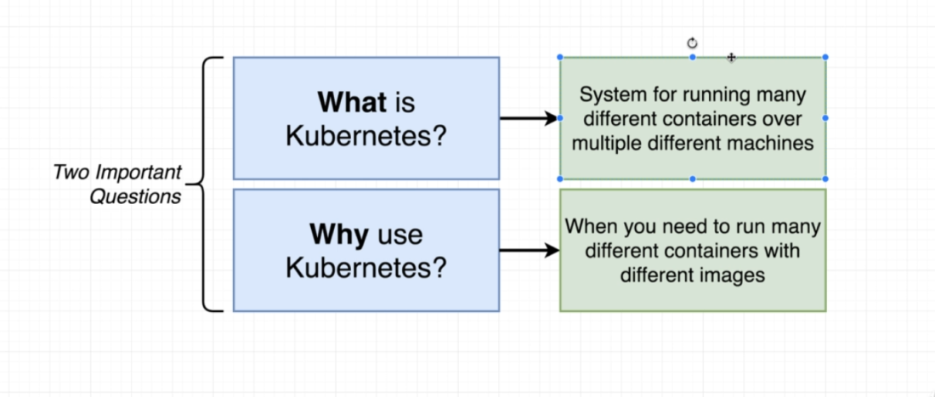
- Kubernetes is tool that provides container orchestration. It helps to run multiple containers, in different numbers, across multiple machines.
- It keeps the applications running, surviving crashes and node failures( replicaset and replicationcontrollers)
- Scale the application up and down when needed.
- Internally load balancing traffic to instances.
- Kubernetes is best solution when we have multiple different types of containers.
- If we need to scale only a single type of container(one single app), then kubernetes is not the best solution available.
- Kubernetes is a platform for managing containers. It runs and manages multiple containers across the virtual machines.

- Working with Kubernetes?

- Architecture:
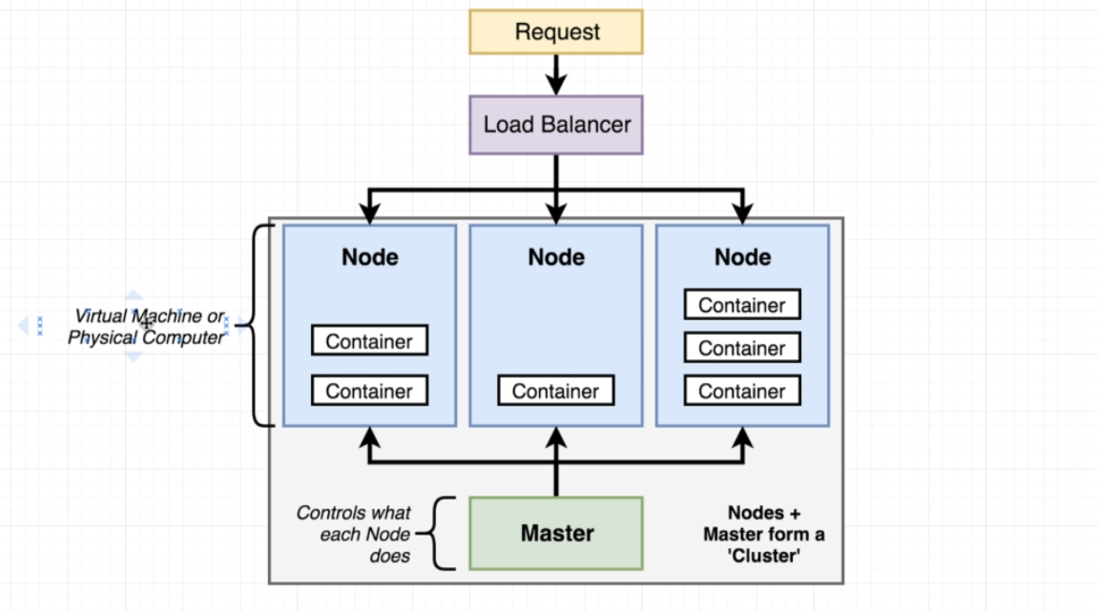

- Kubernetes architecture has a cluster having one master node and multiple worker nodes.
- A node can be a virtual machine or a physical computer to run some number of different containers
- Master nodes controls the worker nodes and the containers running on them.
- As developers, we send our commands to the master and master will perform them on the worker nodes.
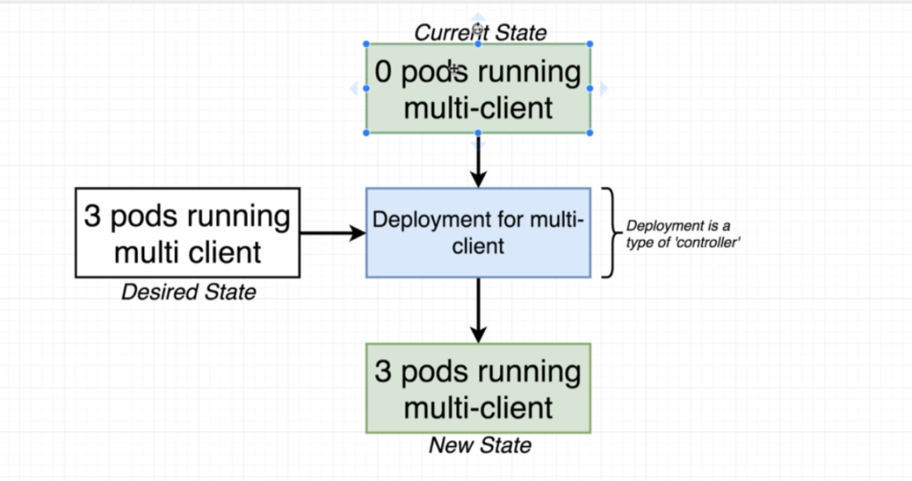

In short, we use kubernetes when we want to run different types of containers, running in different quantities on multiple different machines.

- Using Kubernetes in Dev vs Production:

- There is a huge difference between using kubernetes in development environment vs using it in local environment.
- 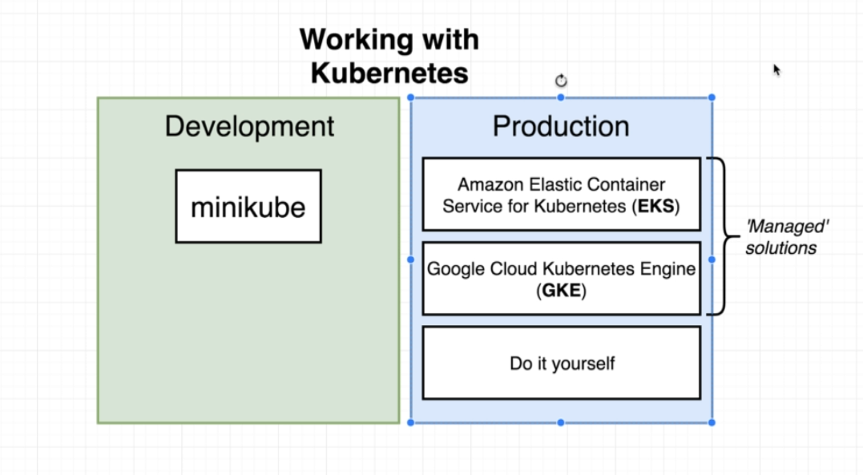
- Minikube:
- Command line tool.
- Sets up kubernetes cluster (nodes + master) on the local computer.
- That is, It creates a virtual machine having containers on our local computer.
- Minikube is a virtual machine running on an embedded Linux Distribution (Buildroot) and comes with the Docker daemon pre-installed.

- Managed Solutions:
- These are used in production.
- These are outside cloud providers.
- They set up kubernetes for us and take care of low level tasks.

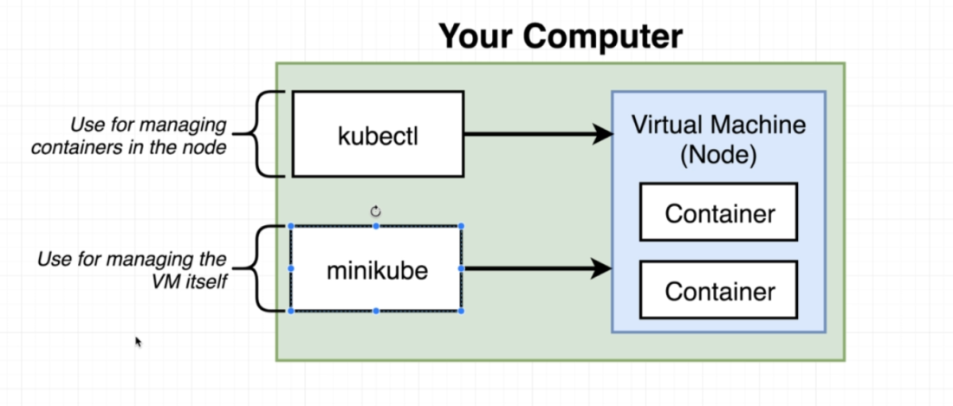
- Kubectl:

- Program to interact with the kubernetes virtual machine created by minikube
- So minikube creates the kubernetes cluster and kubectl helps to interact with it.
- Kubectl is used both locally and in production. Unlike minikube that is used only on local/dev

- Installation:
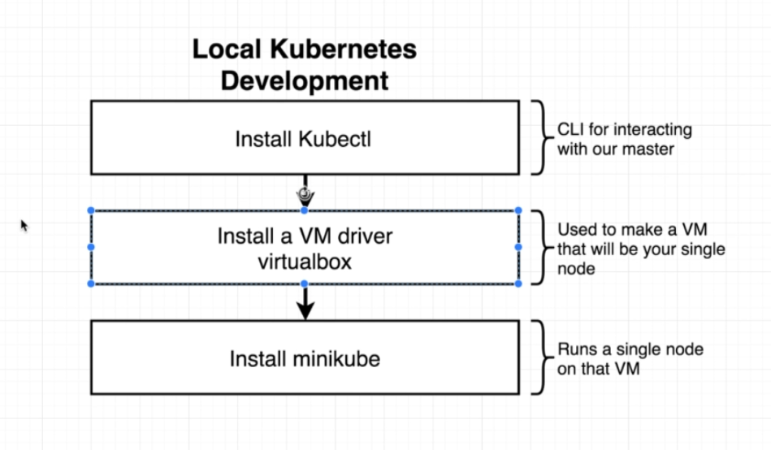

- Kubernetes in detail:
- Moving from Docker-compose to Kubernetes:
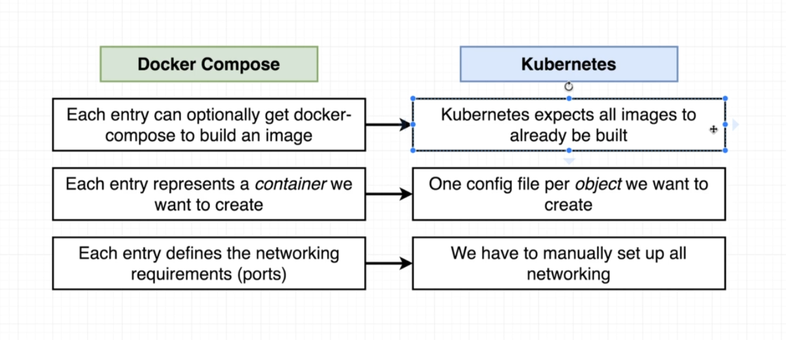

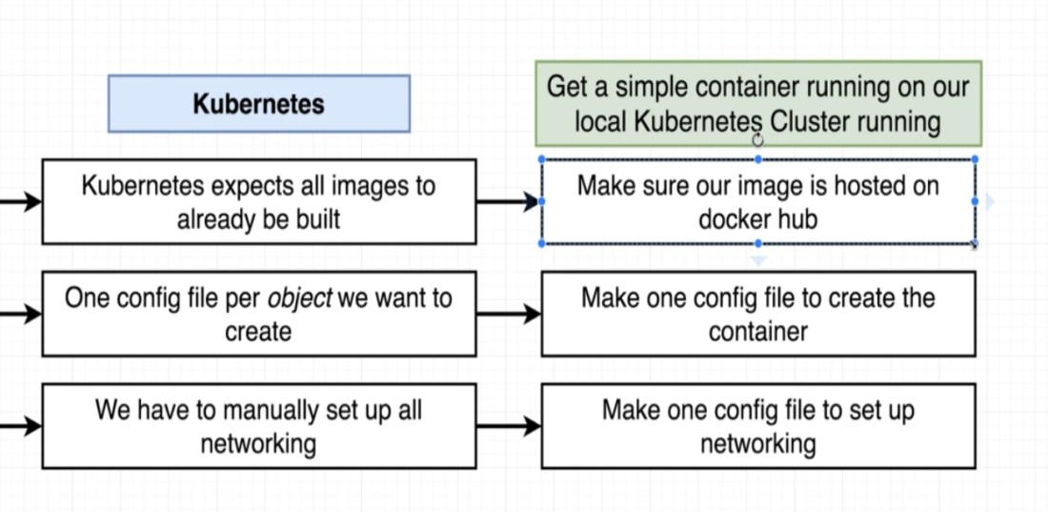

- Steps:
- Ensure that image is up and running on the docker hub.
- Create config file.
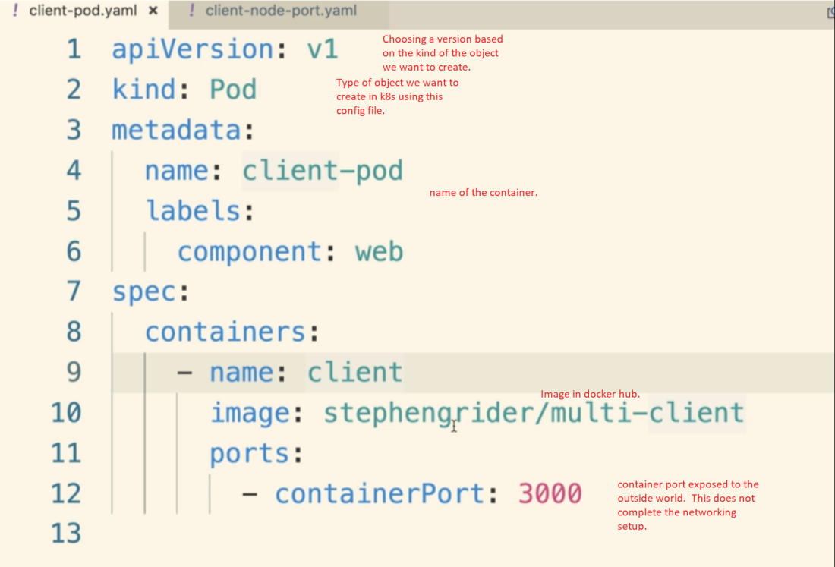

- A config file is not a container but an object. Some object types are below.
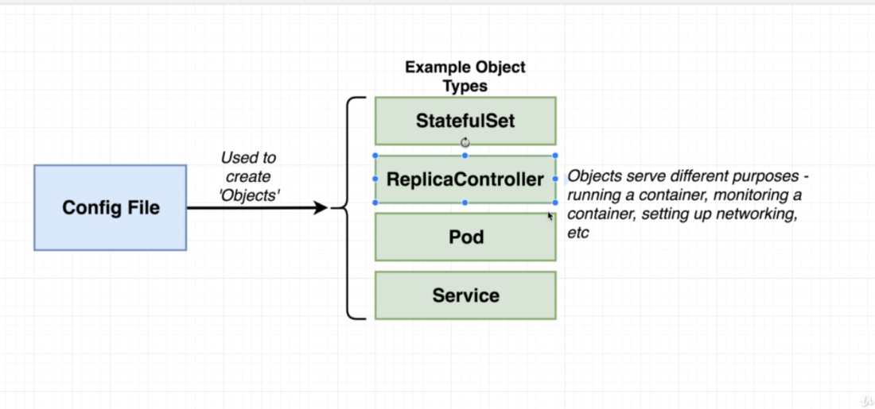
- The 'Kind' field in the config file tells us what kind of 'object' in the diagram above we want to make.

POD
- Pod object is used to run one or more containers that are closely related to each other.
- 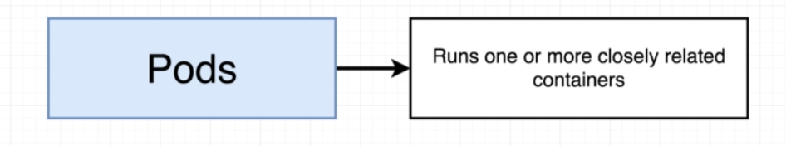
- Service object sets up some kind of networking.
- apiVersion:
based on the apiVersion we can use different types of objects.
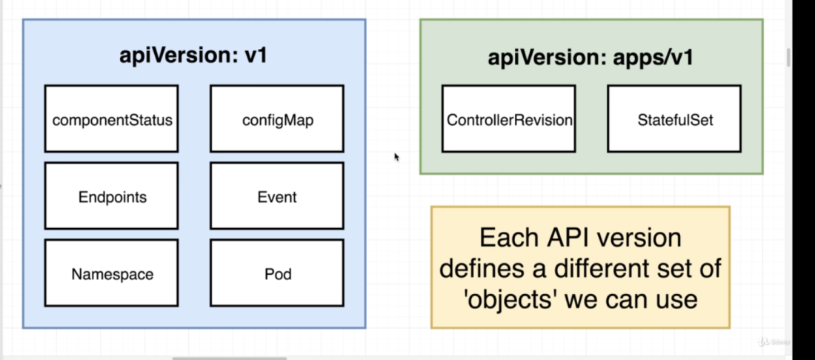

POD Object:
- POD is the smallest unit of deployment inside the kubernetes.
- Its an object running inside a Node that has a one or more containers running inside it.
- POD runs inside a Node
- 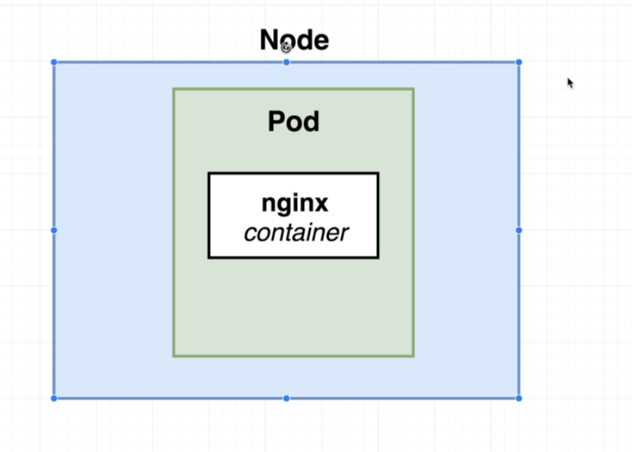
- A POD is a grouping of containers with a very common purpose that must be running together for our application to be working correctly.
- In the world of kubernetes we can't create a single container and use it. The smallest thing that we can deploy is a POD (which has containers running inside it).
- 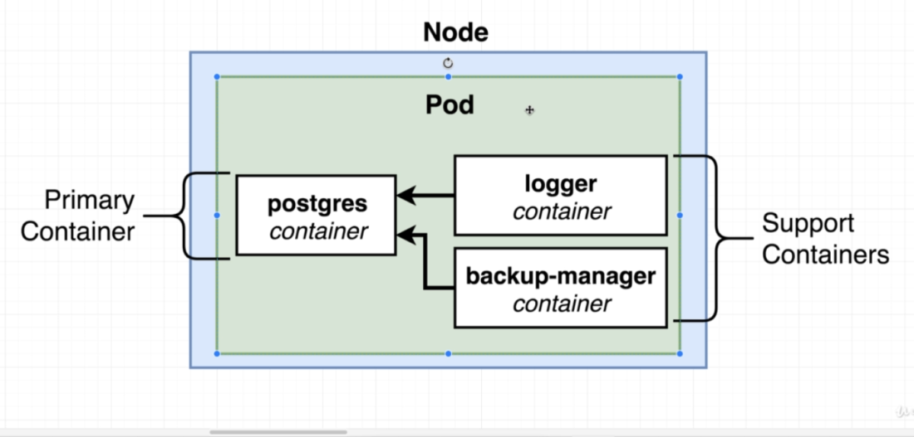
- Here, Logger and Backup manager container as closely integrated to 'postgress' pod. If postgress is down, then logger and backup manager are useless.

- When we delete a container running inside a POD, kubernetes will restart the container it self.

Services:
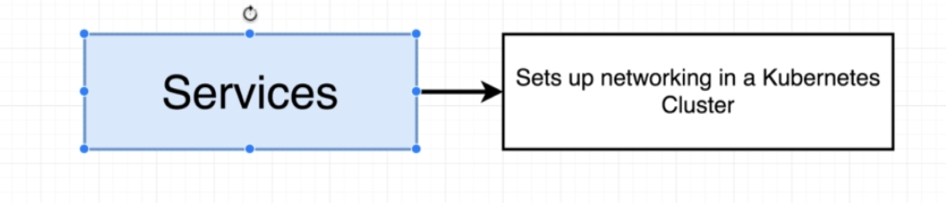

- Used for networking inside the kubernetes.
- Helps to identify which POD we have to access in case of multiple PODs in deployement object.
- Services tries to find every POD which matches its selector
- Each POD has an IP address associated to it. And when a POD is recreated, a new IP address is associated with that new POD. So service also helps to identify the POD with varying IP addresses.
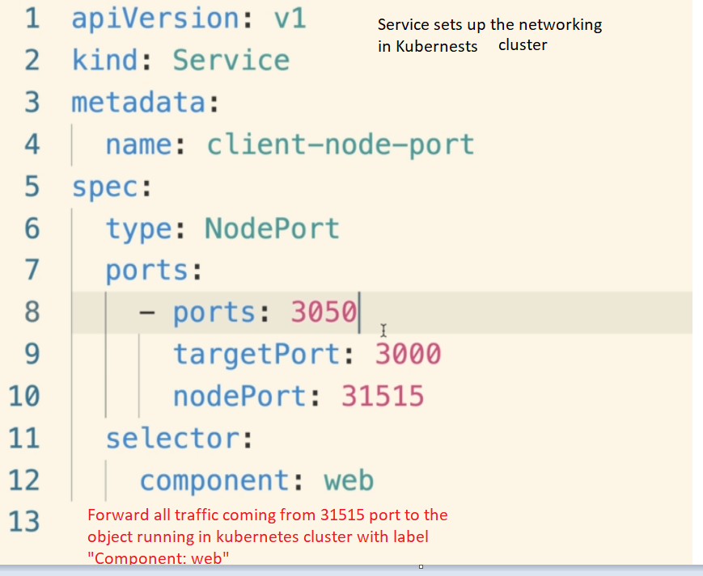
- We need to create a service in order to access any of the container exposed in a POD.

- POD does not have any subtypes.
- Service has 4 subtypes.
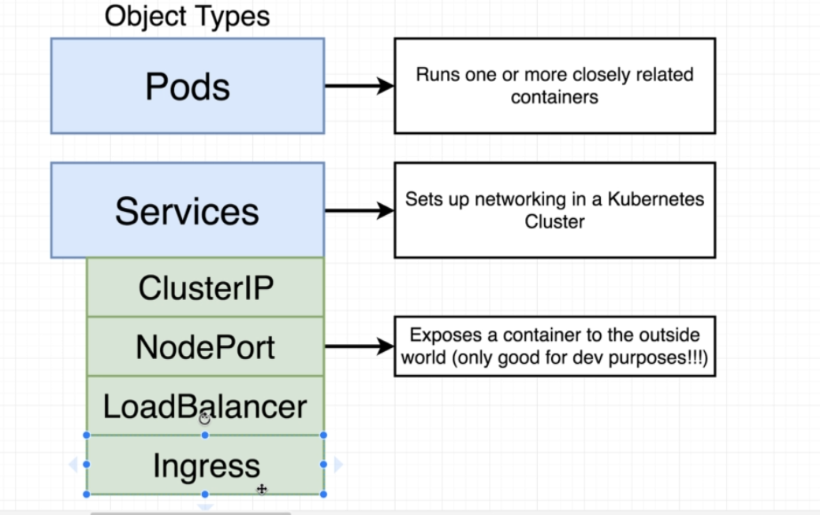

- Nodeport: To expose a container port to the outside world. Only good for development services.
- It creates a communication layer between outside world and the container running inside the POD
- Kubeproxy is a one single window to the outside world.
- Request coming in will pass through the 'kube proxy' which will decide which service should be called.
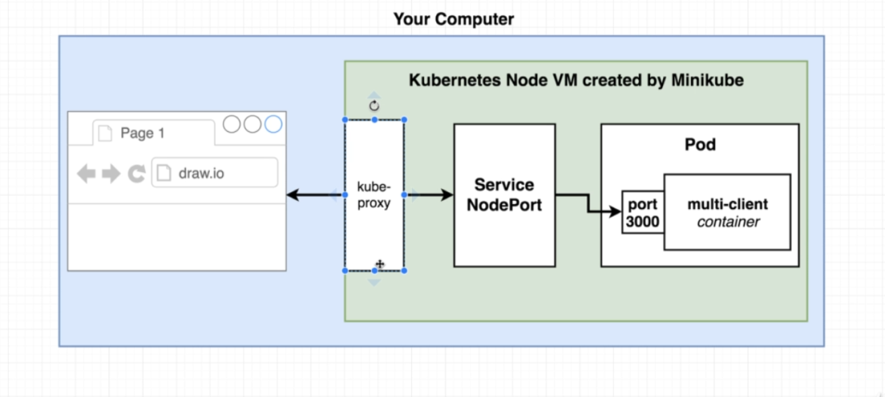
- Label- selector model is used to communicate between POD and service files.
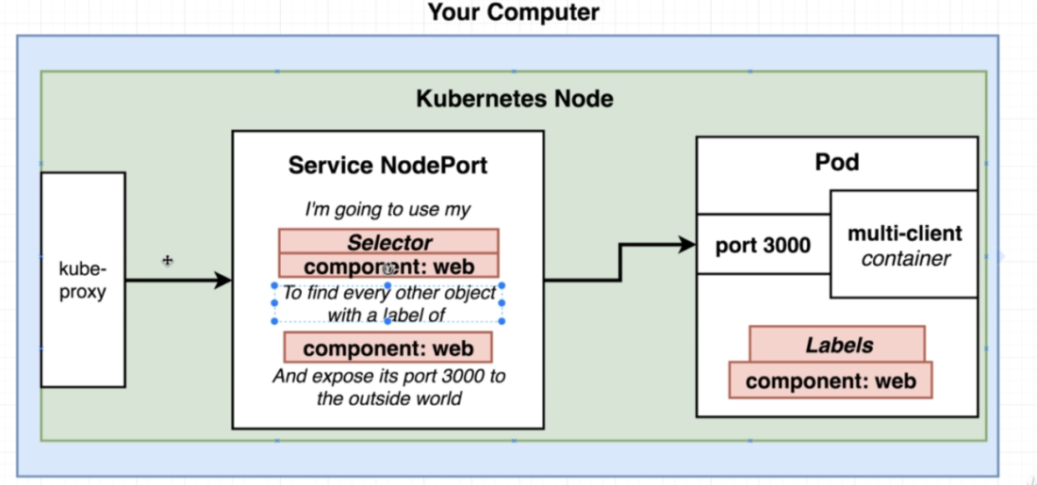
- How the 'ports' field work in the 'Service' config object.
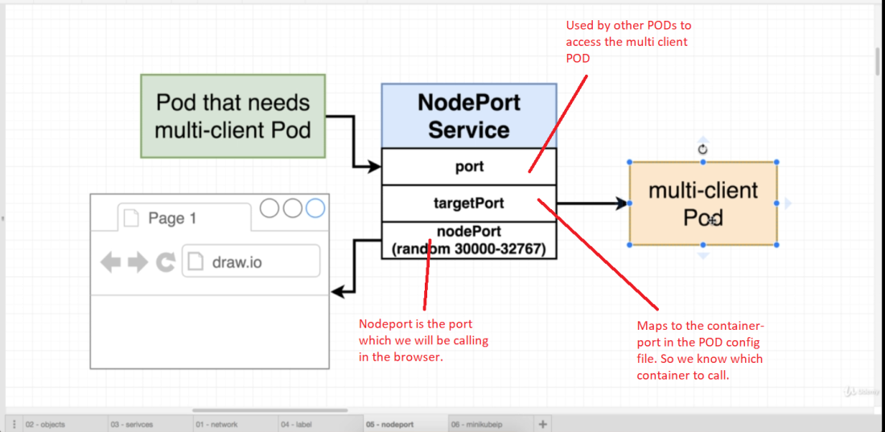

- Running containers in Kubernetes:
- Once we have our config files ready, we can push them to the kubernetes using the kubectl command.
- 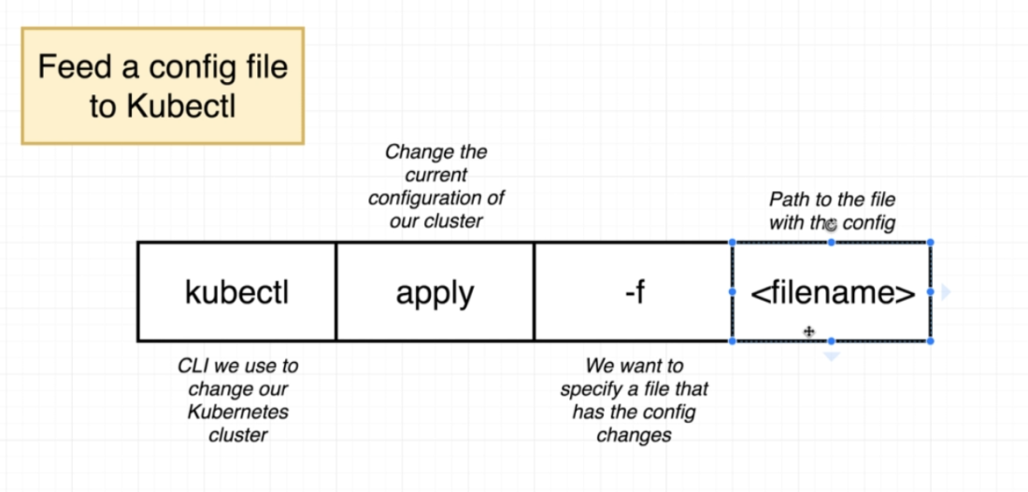
- Output of above program:
For POD
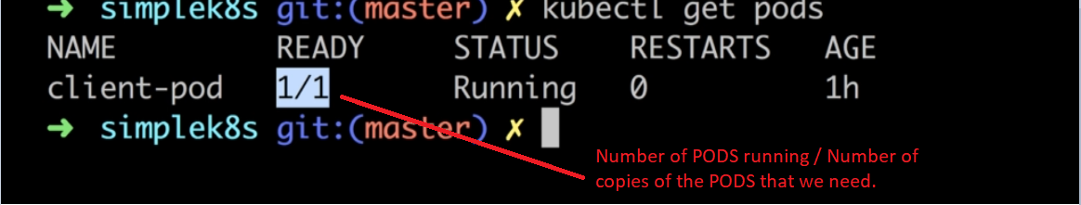

- For Service:
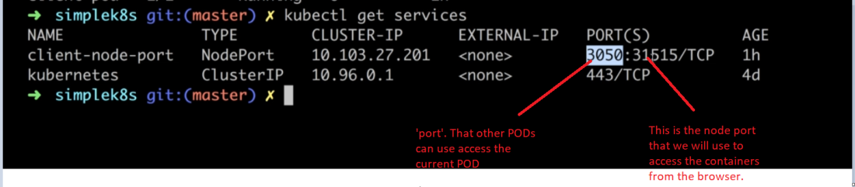

- To get the status of an object in the kubernetes:
- 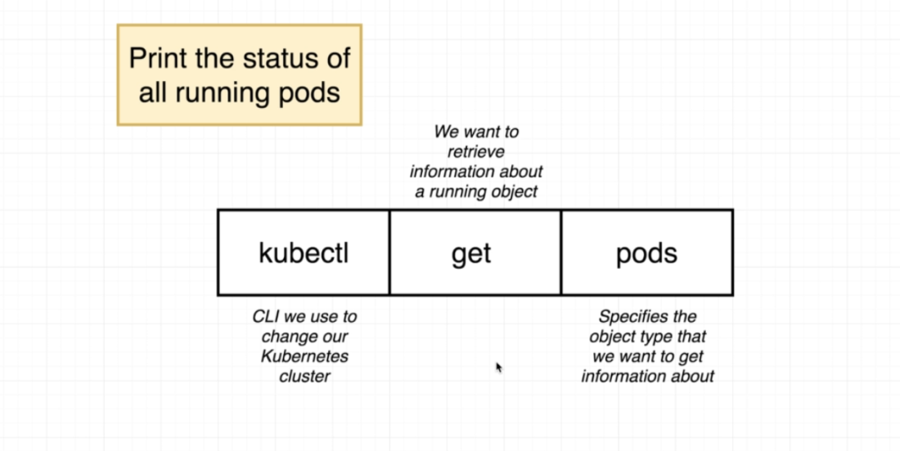
- To access the application running inside the minikube:
<minikube IP>::<nodeport>
Get ip using 'minikube ip' command.

- What happens when we send some command to Kubernetes?
- We send commands to kubernetes only using kubectl command.
- And our interaction is only with the master, which communicates with the Node
Scenario:
- Suppose the application has three containers- 'service', 'client' and 'worker'.
- We need to have 4 containers of 'worker' running.
- So we will feed the config files to master using 'kubectl apply -f <file_name>'
- The master has some applications running on it.
- One of the responsibilities of the master is to continuously poll the nodes and see what is happening.
- 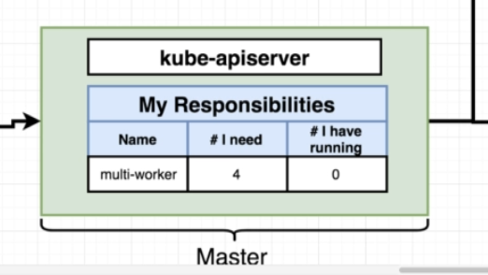
- So when we ask for 4 containers, master will see that we need 4 but the nodes are not running any containers.
- So it will tell the nodes to run 4 copies.
- 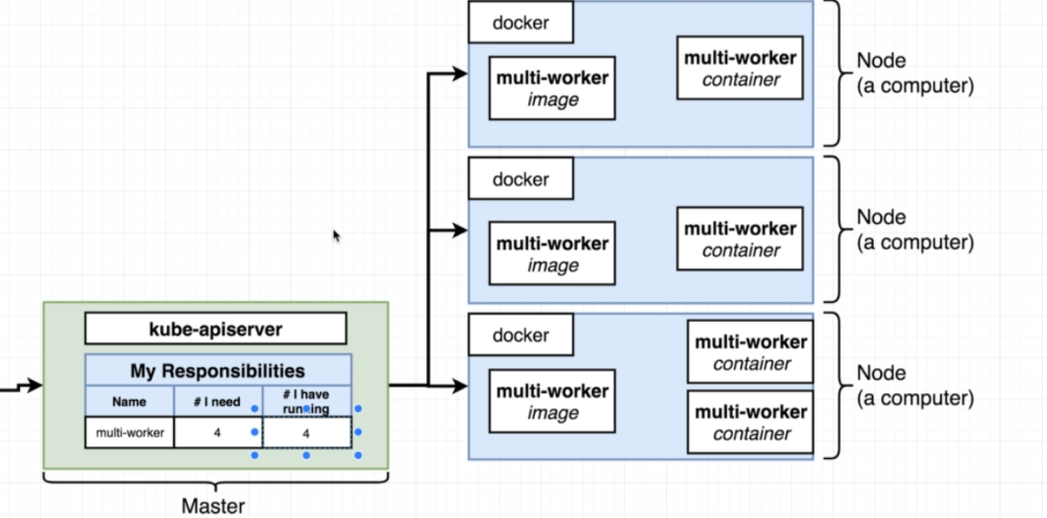
- If any one of the container is down, then master, which is continuously polling the nodes, will see that there is a difference between the desired and actual state.
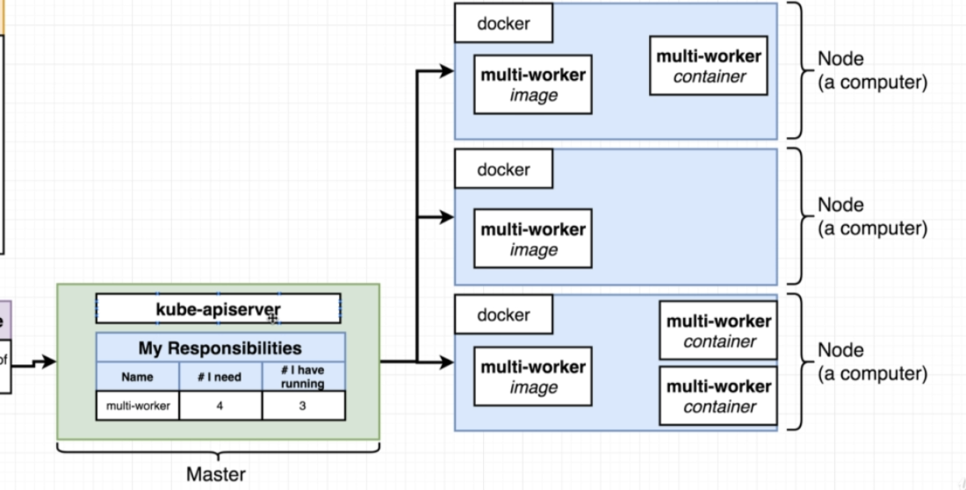
- So master will again create another container to match the desired and actual state.

- 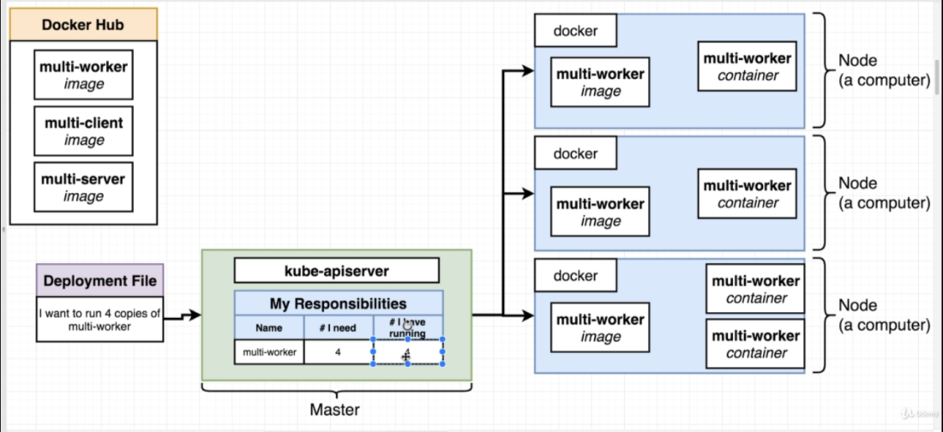

Notes:
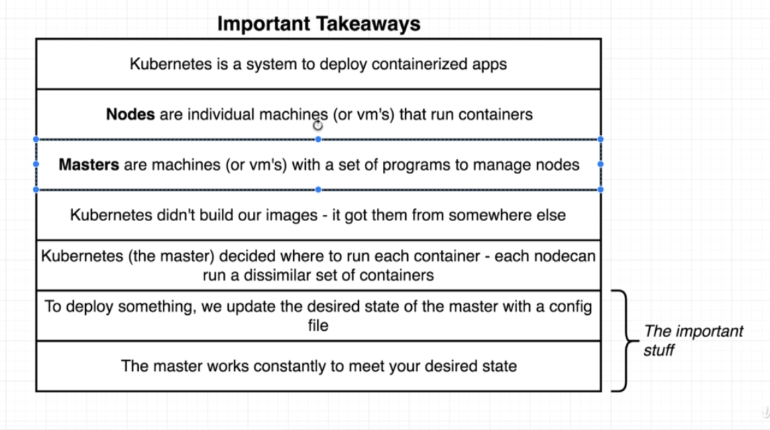

- Declarative vs Imperative Deployment in Kubernetes. ??
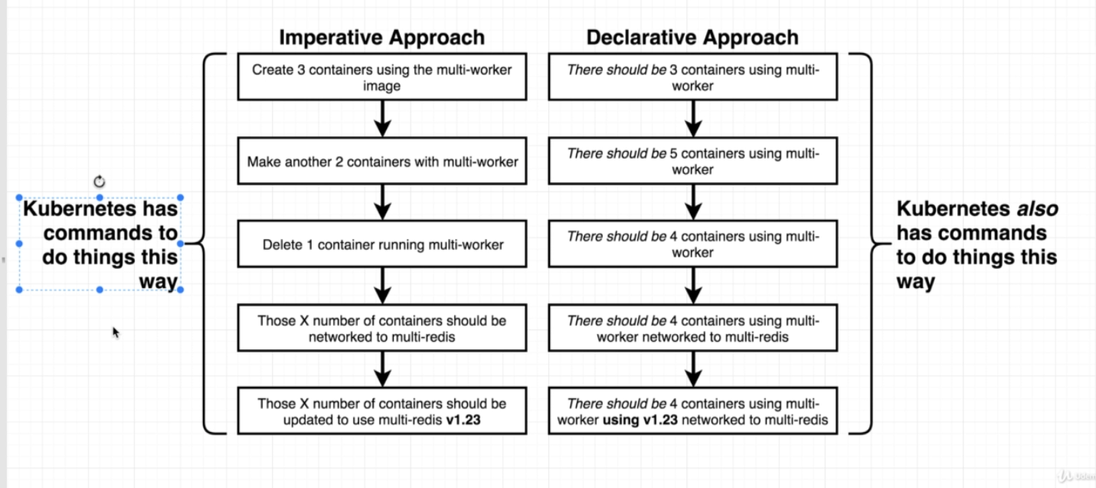

For example, below is the difference in imperative and declarative steps we can use in order to change the image type for a container:
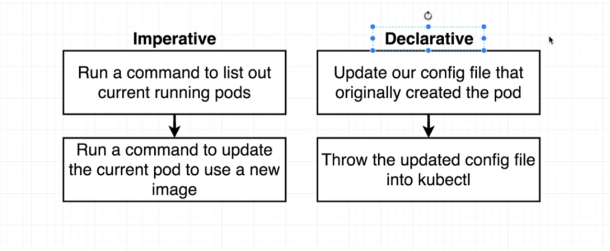

In declarative deployment, we usually update the config file and feed it to kubernetes and let kubernetes do the changes for us.

- Usually when we feed the config file, kubernetes will check the 'Name' and 'kind' fields in the file, if object with same name and kind exists, then kubernetes will not create a new one, but will use the existing one. If there are changes in the config file, k8 will try to apply those changes to the existing object to reach the new desired state.

- Limitations of Declarative deployments:
We can't update every k8 object.
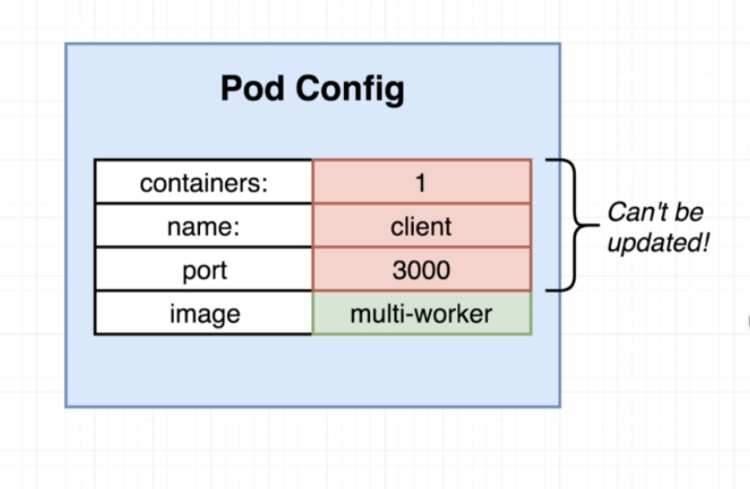
- In order to tackle this problem, we can use a different type of object called 'Deployment'

DEPLOYMENT:
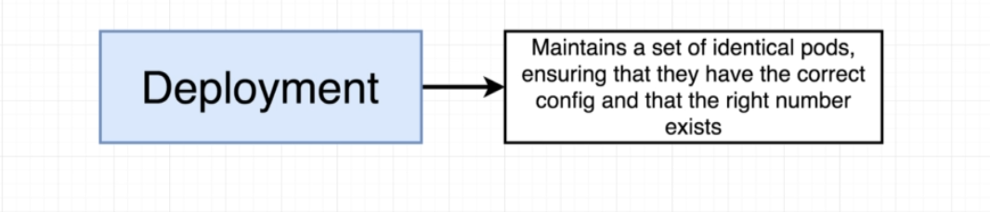

- Object with a set of similar PODs
- Ensures that every single POD in it has correct configuration and its running (not crashing etc).
- POD Vs deployment
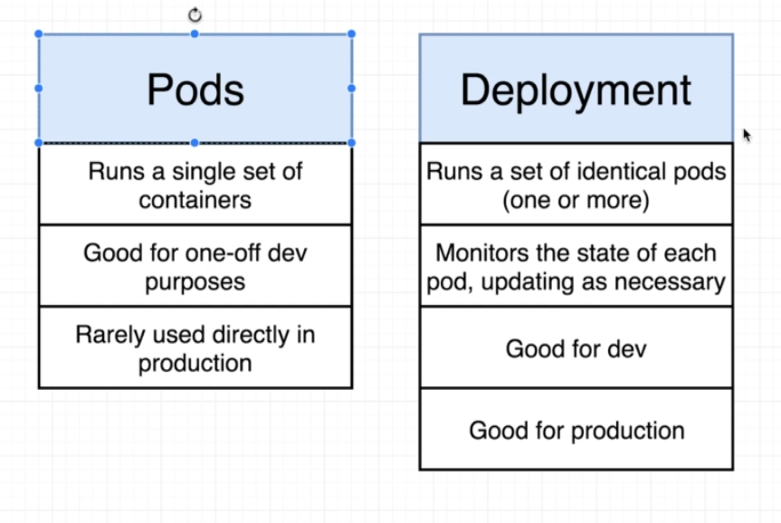
Important: Unlike POD, with deployment we can change any piece of configuration associated with the object.

- Deployment Configuration.
Overview:
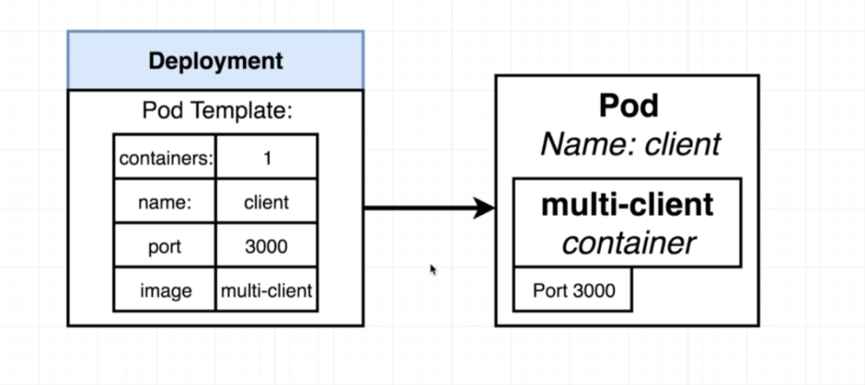

-Config file:
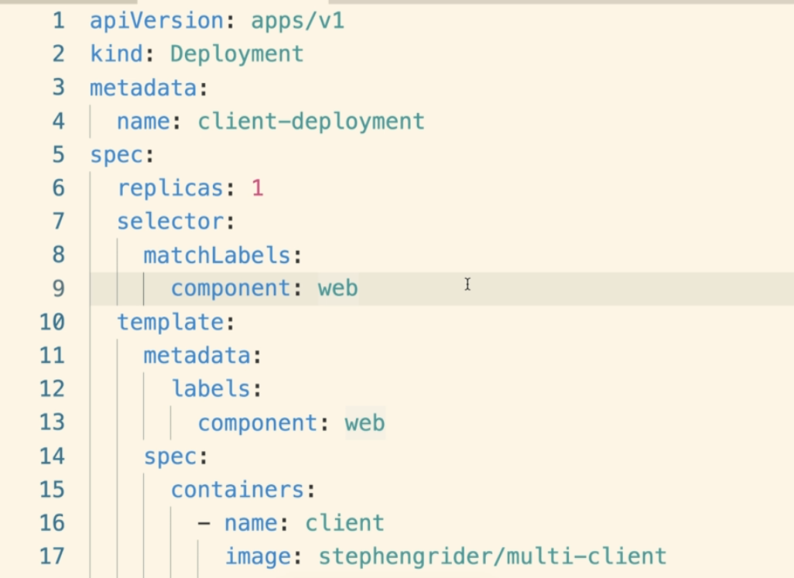

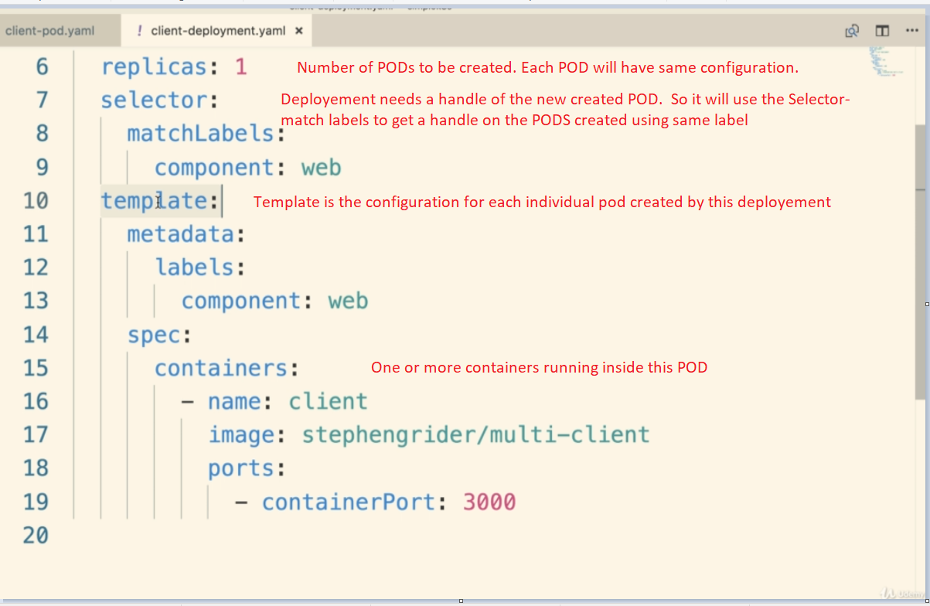

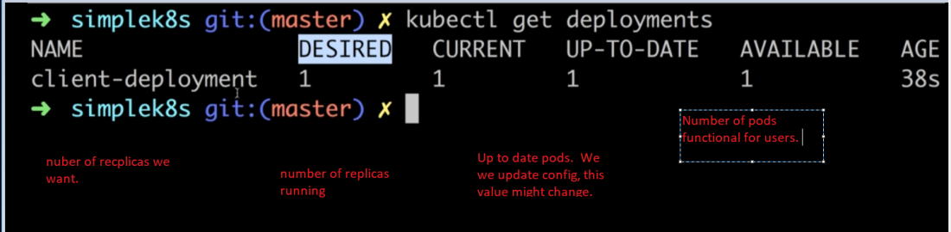

NAMESPACES:

- Used for managing kubernetes resource easier.
- Think of a namespace as a virtual cluster inside the K8 cluster.
- We can have multiple namespaces inside a k8 cluster.
- All the namespaces are isolated from each other.
- Helps in oraganization, security and even performance.
- k8 has some built in namespaces that the K8 clusters comes shipped with:
a) default
b) kube-system
c) kube-public

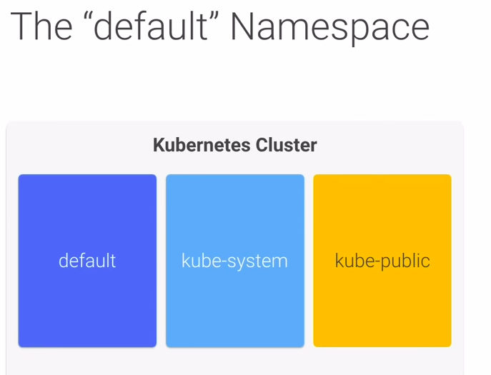
- kube-public is not used much.
- Its preferred to leave kube-system alone

Creating a namepace:
- we can either use a command or create a yaml file.
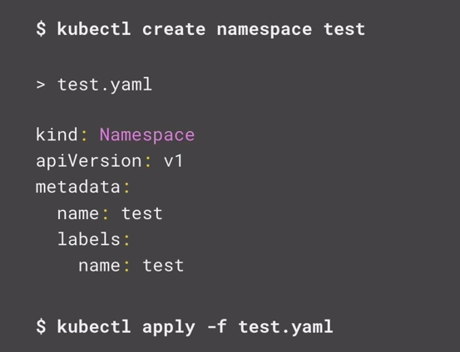

- To get all the namespaces we can use:
kubectl get namespace

Creating resources inside a namespace:
- There are two ways to tell kubernetes which namespace we want to have our resources created in.
a) Use a namespace flag when applying the config file:
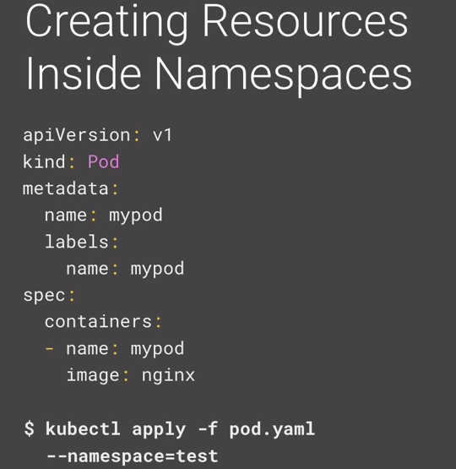
b) Specify the namespace in the Yaml config file:

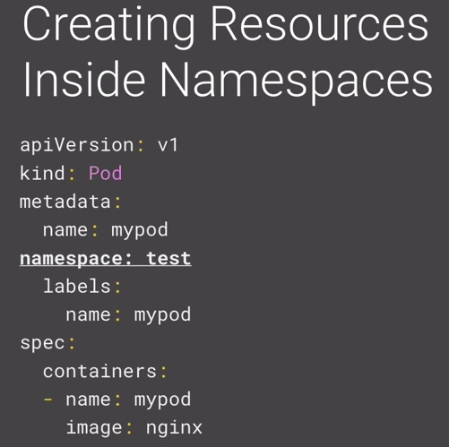

- All kubectl command are run against the current active name space.
- So to find a POD that belongs to a particular namesapce, we need to provide the namespace flag
as well.

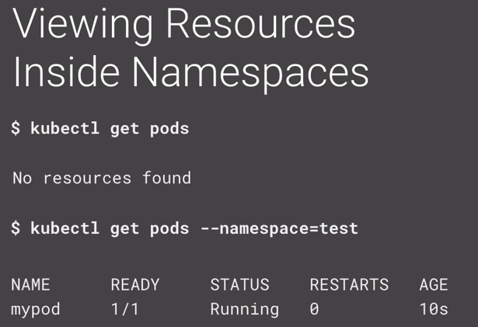

- The ‘default’ namespace is always activated by default.
- We can use ‘kubens’ command to activate a different name space.

- Namespaces are hidden to each other but are not isolated.
- A service in one namespace can talk to a service in another namespace.

- Ways to have PODs use the updated image from docker.
- Delete the POD manually. When the POD is deleted, Kubernetes will start it again .
And we can use the latest build.
Deleting PODs is a stupid idea
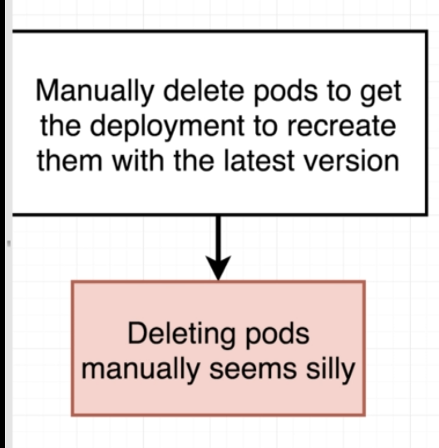

Always create images with build numbers. And also use the same build numbers inside the config files.
So whenever the config is applied again, the change in build number is detected and latest image from docker hub will be used.

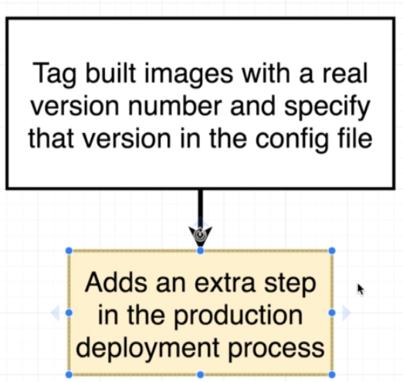

- Keep creating the image builds with version.
Use imperative commands to tell kubernetes to update to the latest version.
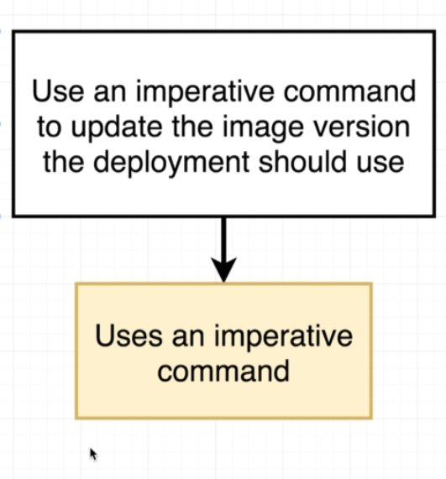

- Imperative image update:
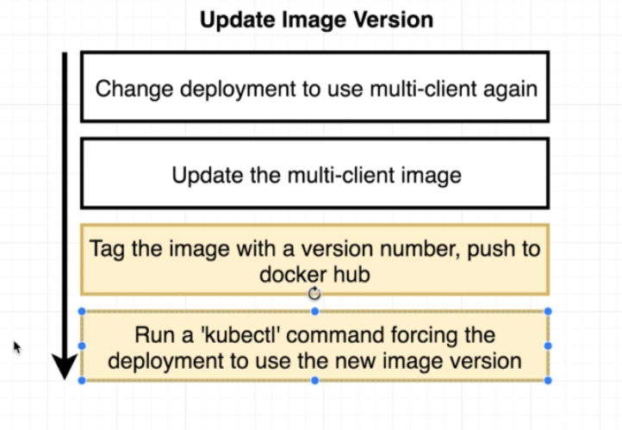

CLUSTERIP SERVICE
- It’s a restrictive form of Networking.
- 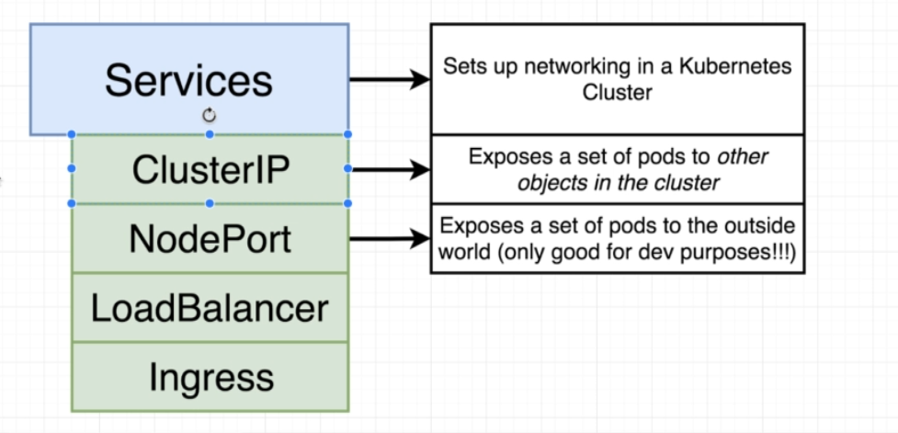
- ClusterIP allows object running inside the cluster to access the object that the cluster IP is pointing it.
- We, form outside, can't access the object.
- 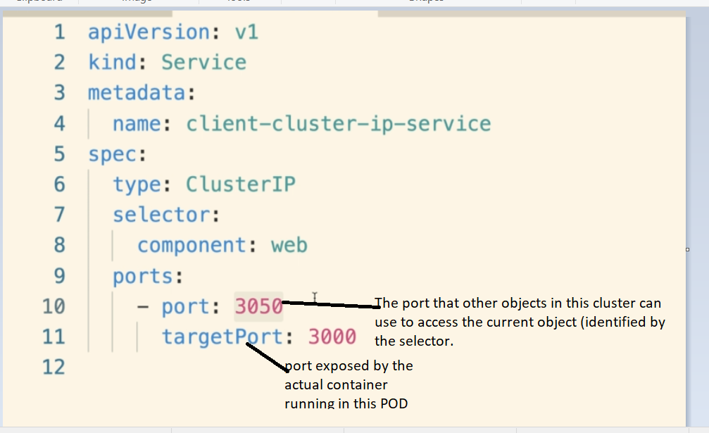

- We can combine multiple config files into one single file but separating them with three underscores between different configs
- A good thing would be to use config file for a deployment and its service in a single file

VOLUMES:
- Why we need volumes:-
- Suppose we have a postgress container that creates some data.
- When the container is deleted, all the data created by the container is also gone.

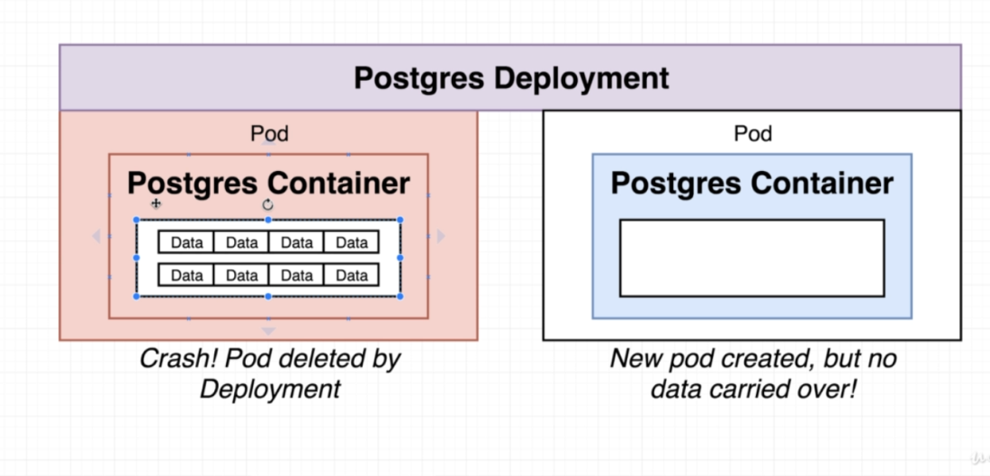
- We can solve this using Volumes
- Using volumes we can have persistent file system that can be accessed by the database container.
- So a file system in the host machine will be shared with a file system of the container.
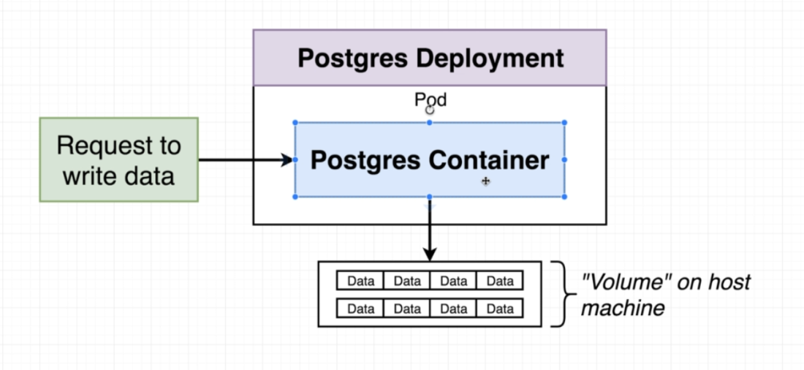
- So the data base won't be writing any data inside the container, but to the file system outside the container.
- And when a Pod is deleted and new one is created then the new Pod gets associated to the same file system to ensure data persistence .
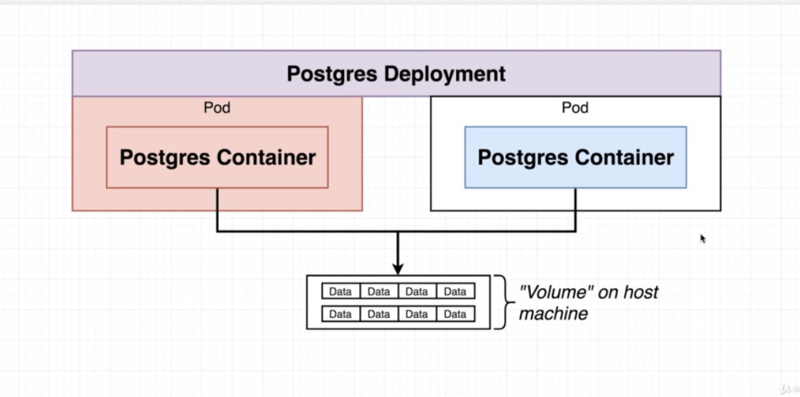

- At its core, a volume is just a directory, possible with some data, that is accessible to containers running inside a POD.

Some problems with containers are:
- Kubelet starts the containers with a clean state after a crash so the files will be lost.
- It is often necessary to share the files between containers running inside a POD.

- VOLUMES in Kubernetes:
- Volumes in Kubernetes vs in Docker:
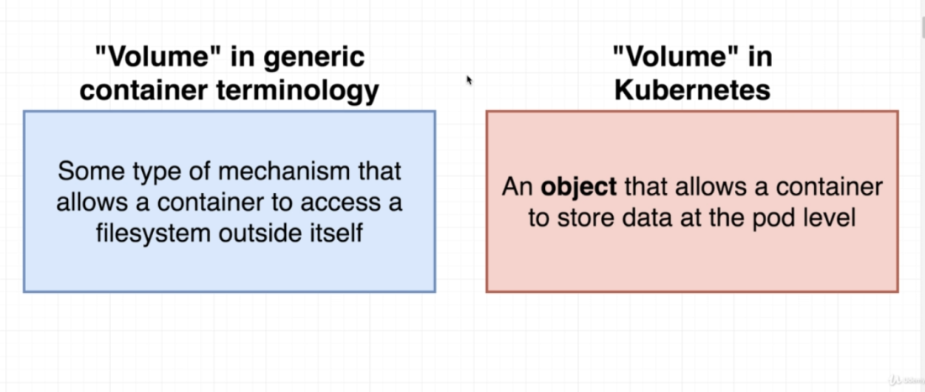

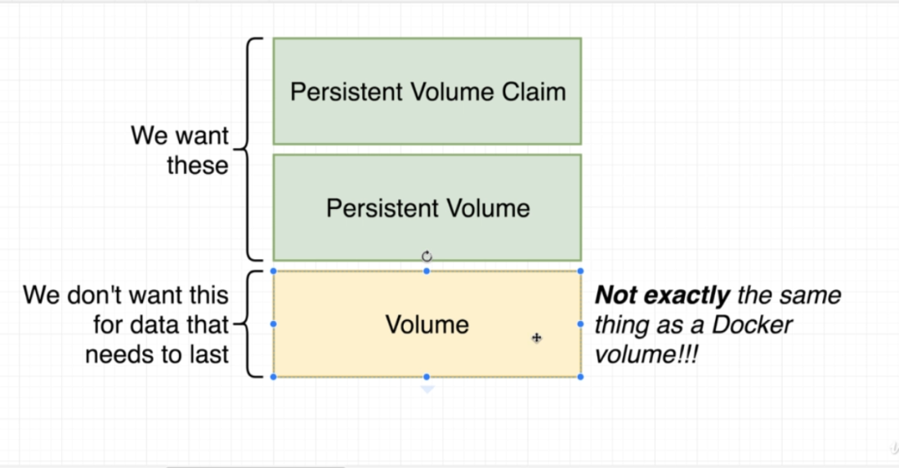
- We can create a config file in Kubernetes to create a volume.
- In Kubernetes, the Volume is data store that belongs to a particular Pod.
- Any container running on that Pod, has access to that data store.
- So if the container is destroyed and recreated, then it will have the access to the same data store.
- But this volume gets deleted if the entire Pod is deleted.
- To use a volume, the POD specifies what volumes to provide for the POD in .spec.volumes field and where to mount those onto the containers (spec.containers.volumeMounts).
- 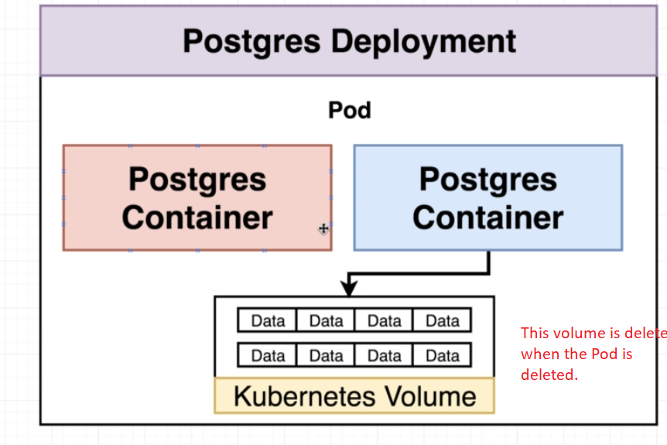
- So we need to use something called as a Persistent Volume

- Volumes Vs Persistence Volume:
- Persistence volume is not associated with any container or Pod.
- Where as volumes in Kubernetes are associated with a POD.
- So Persistence volumes remains persisted even if the Pod gets deleted.
- Where as ‘Volumes” in K8 gets deleted when the POD is deleted.
- 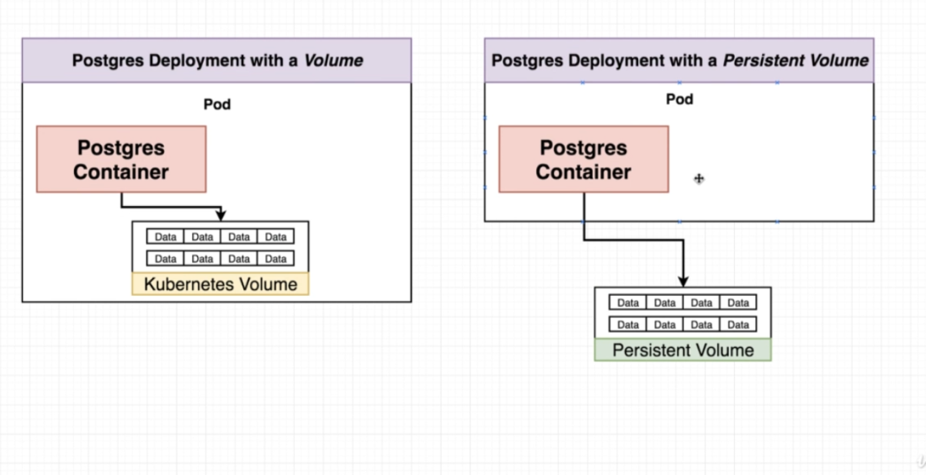
- Persistence Volume Vs Persistence Volume Claim
- Persistence Volume claim is like an advertisement that allows the Pods to choose form some pre advertised set of volume space.
- 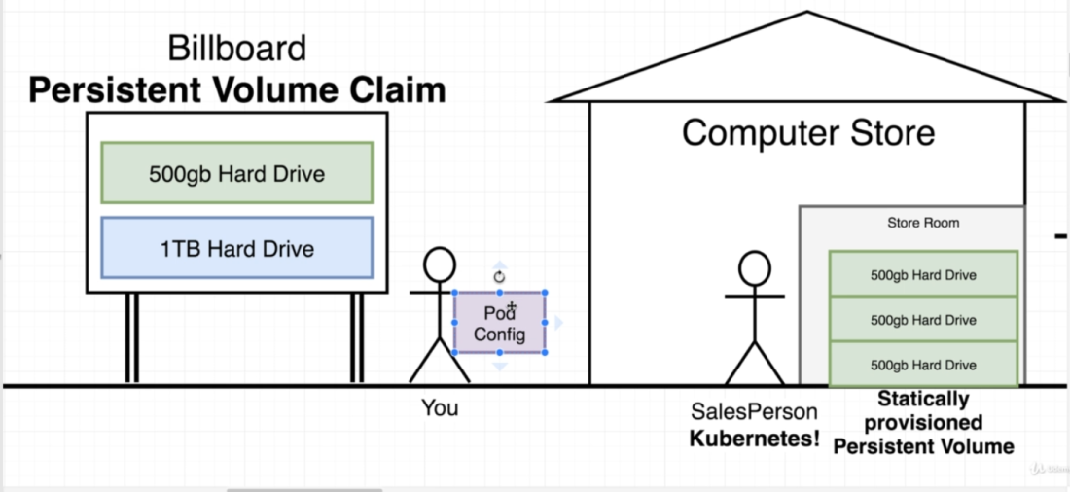

- If K8s does not have the volume that the user asked for, then I will create that Volume on the fly and provide it to the pod.
- Volume claim is not an actual instance of storage.
- We attach this volume claim to a Pod config.
- This Pod config is then applied to the K8.
- K8 will check the claim and try to find a statically provisioned (already created/ahead of time) or a dynamically provisioned volume. (created dynamically)
- So k8 needs to find an instance of storage from the host machine to meet this volume claim requirements.

- Config file for Persistence Volume.
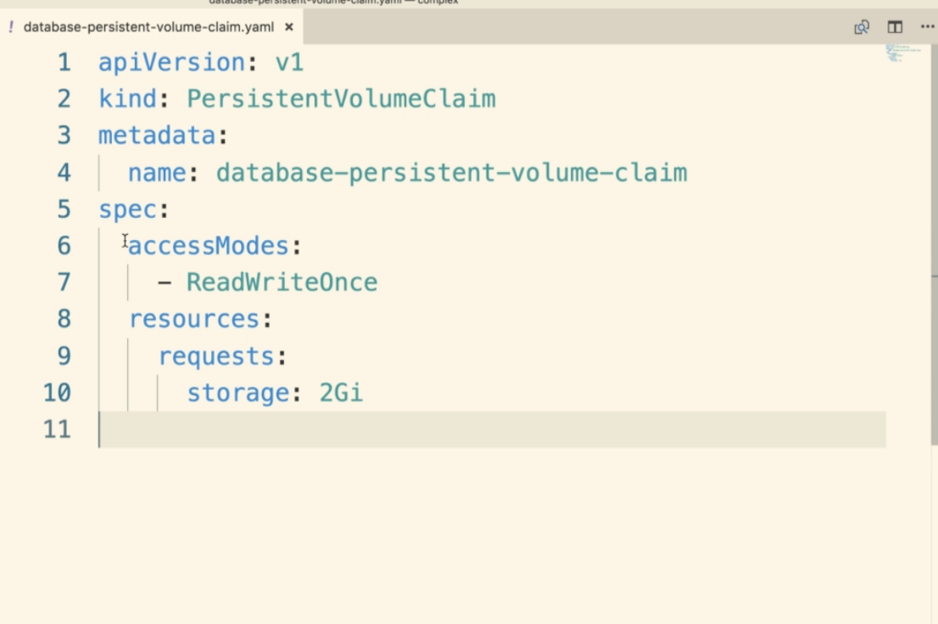

- Access Modes:
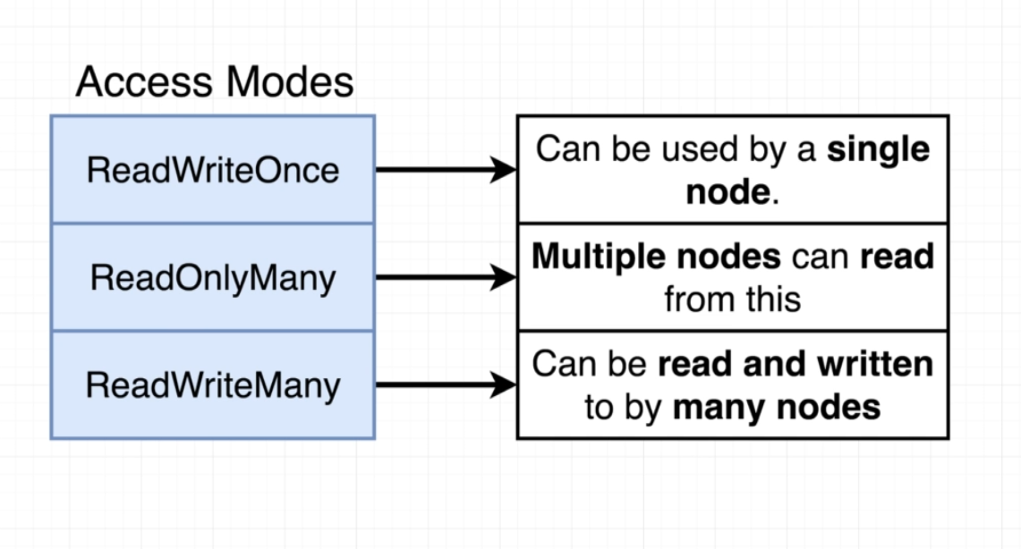
ReadWriteOnce: Only a single node can use this volume (both Read and Write) at a given time
ReadOnlyMany: Many nodes can (only) read the volume at a given time.
ReadWriteMany: Many nodes can both read and write the persistence volume at a given time.

Where does K8 allocate Persistence volumes ?

- StorageClassName
- Storageclass refers to all the possible options on our host machine that kubernetes can use in order to create a Persistence Storage from.
Kubectl get storageClass : gets all the storage classes available.
kubectl describe storageclass: Gives some extra information about the storage classes.
- Minikube/hostpath storageclass means that K8 will use the hard disk slice on the host machine where the minikube is running on.
- When we request k8s for some amount of storage in our local environment it will take a slice of the storage from the host machine.
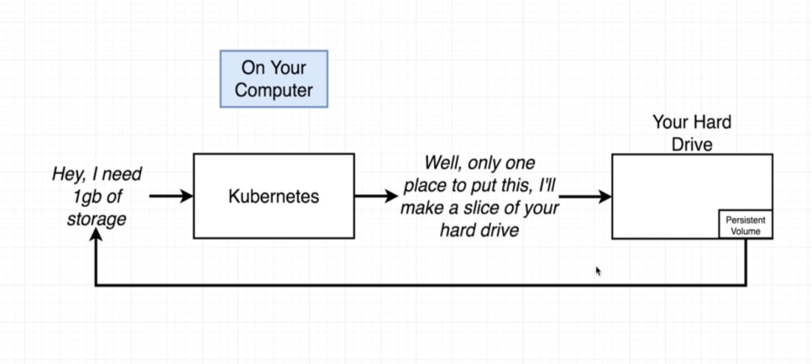

- So in local, it will be using the default minikube host path provisioner
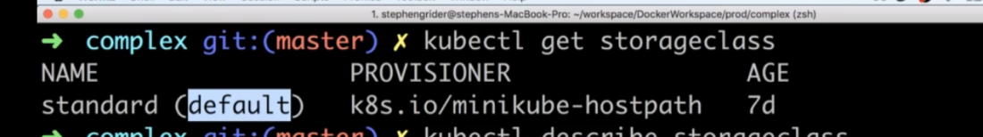
- In case of Production environment where its using some cloud platform, then it will automatically provided for us.
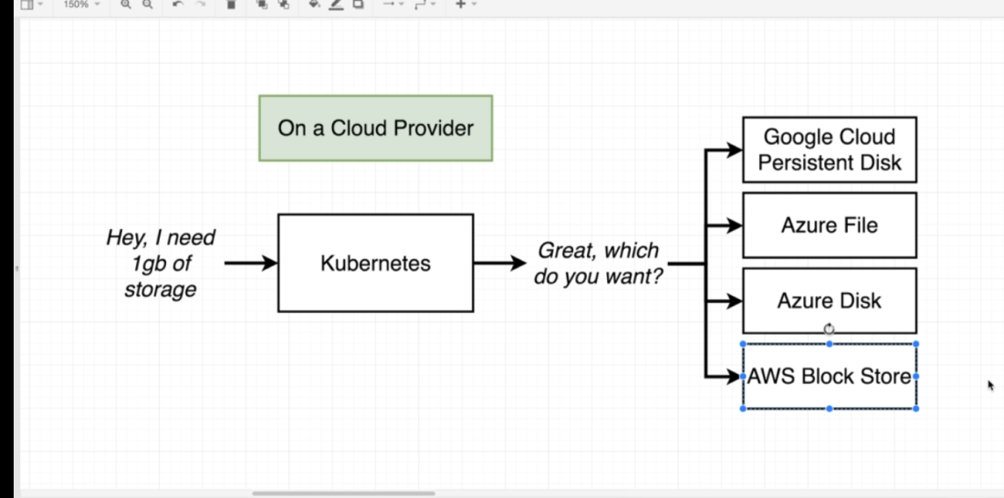

g) Associating Pod to the PVC
- We can do this inside the 'Spec' section of the pod config.
- 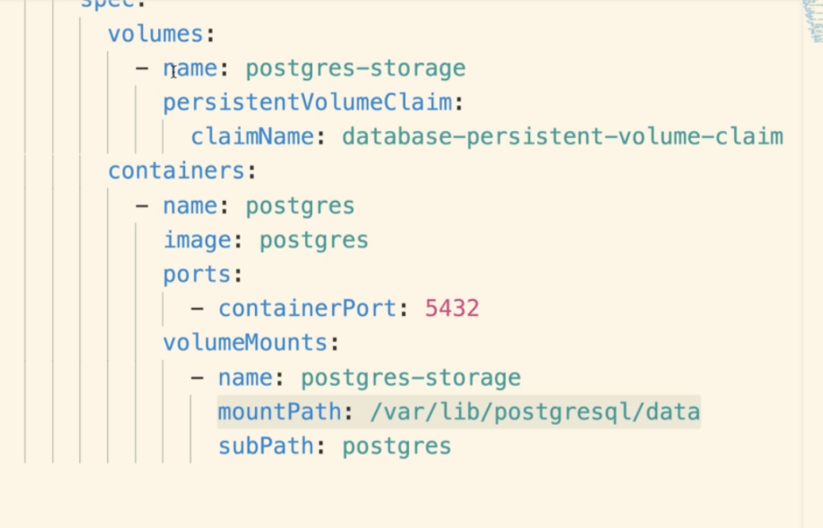

Quick steps to create a PVC:
1. Create a PVC object config file where we provide a name, access and the storage requirement claims
2. Inside the POD config, in spec, we need to add volumes field and tell which PVC this POD will use. K8 will use this info to use a statically created storage and dynamically created storage
3. Then we need to mount that storage created in step2 to some place inside our POD using ‘volumeMounts’

ENVIRONMENT VARIABLES:

- We can add environment variables using the 'evn' field inside the 'containers' of the 'deployement' 'template'.
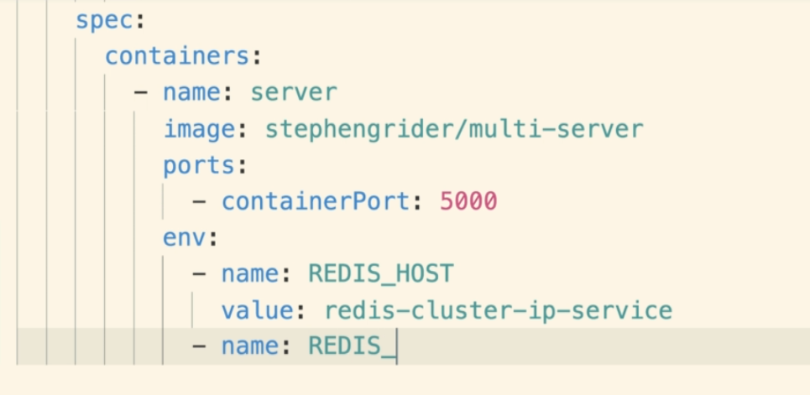

Important: For connection between two different services, we need to provide the host name that will be same as the ClusterIP name.

- Adding Password env (Confidential data)
- We should not be adding password as plain text.
- We can use the Secret Object for this
- 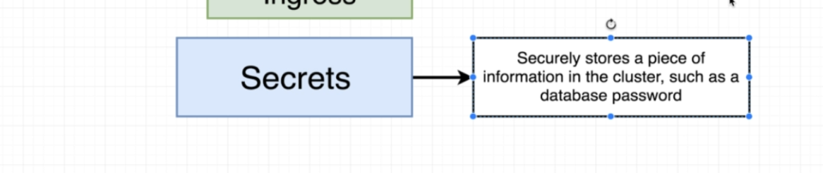
- We can create a config file for a secret or run an imperative command for create one.
- Command:
- 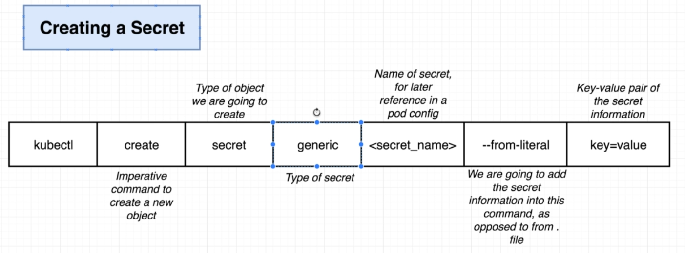

- Generic Type: To save arbitrary number of key value pairs together.
- Secret Name: Will be used to refer the secret in future inside of some pod config.
- --from-literal: We are not reading the secret data from a file, but we will use that in the command line it self.

- Using secrets in the config as env variable:
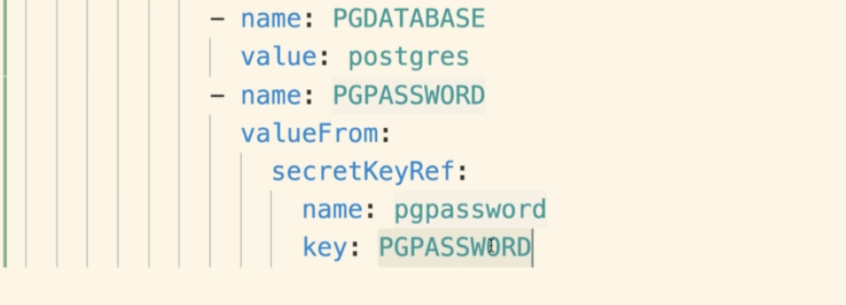

LOAD BALANACER SERVICE:

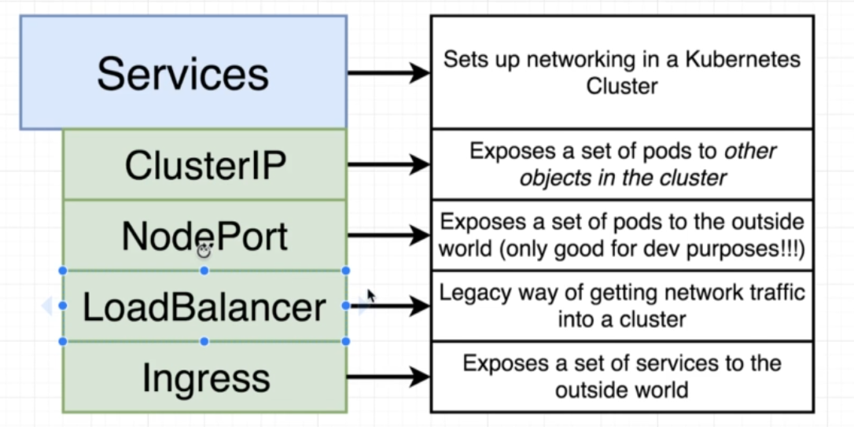

- A legacy way to get traffic from outside into our application (Ingress is a new and better way to do this).

- We create a config file for create a load balancer with the type of LoadBalancer.
- LoadBalancer only gives access to one set of POD inside the cluster. So it can’t be used when we have more than one PODS in our application.
- We don't use it anymore.

INGRESS SERVICE:
- To get the traffic inside our cluster. Allows outside users to access all the different containers/PODs running inside the cluster to access our application.

- How ingress works?
- In kubernetes a controller is any object that tries to migrate from current state to desired state.
- For example, Deployment object is a controller.
- Similarly we can have Ingress config working as controller.
- 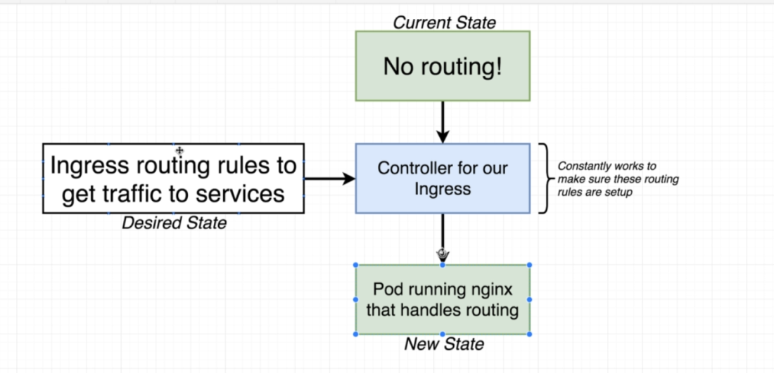

High level diagram of how ingress works.
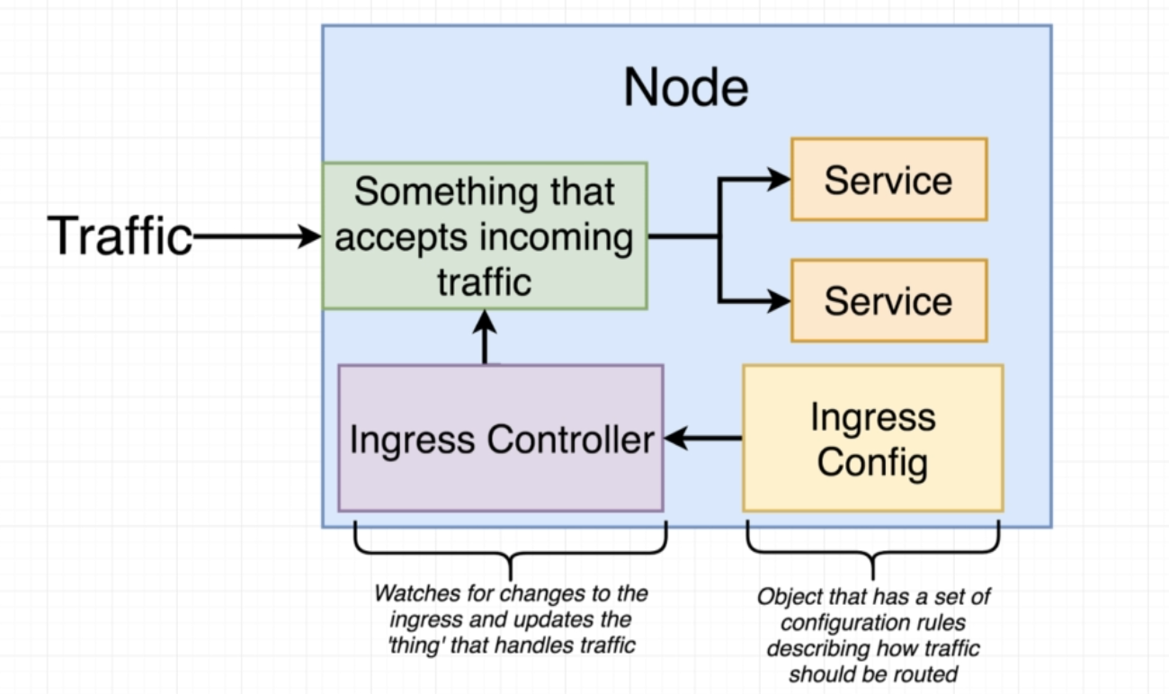

- 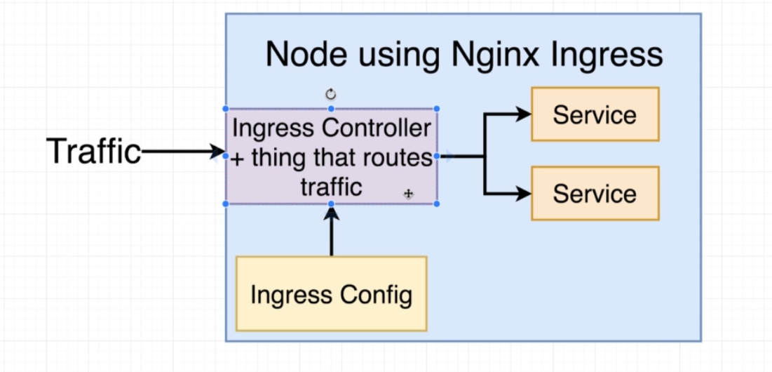

Steps:
1. Create an ingress config file.
2. Apply that file to the Kubernetes.
3. The Ingress controller running inside the Kubernetes create some rules based on the config file to decide how incoming traffic will reach the application .
4. Default backend POD will be created by default that will have some health checks.
5. Ingress nginx controller directly sends the traffic to the POD by passing the ClusterIP

RBAC: Role Based Access Control:
- In K8, a user must be authenticated (logged in) before his request can be authorized (grant permission for access)
RBAC is a method of regulating access of computer or network resources based on the roles of individual users within an enterprise.
- RBAC defines if a user can perform a specific operation on a specific resource in a certain context.
Analogy: Suppose I want to visit a country then following things wiill be required.
a) Authenticaiton: For others to know that I am whom I say I am. Passport.
b) Authoraization: To be able to do certain things or not do certain things in the foreign country. Visa is an example for this. Like I can go there on a student visa or a tourist visa.
c) Admission Control: Customs at the air port. They might allow us to enter but they may add further restriction like not allowing me to take certain things.

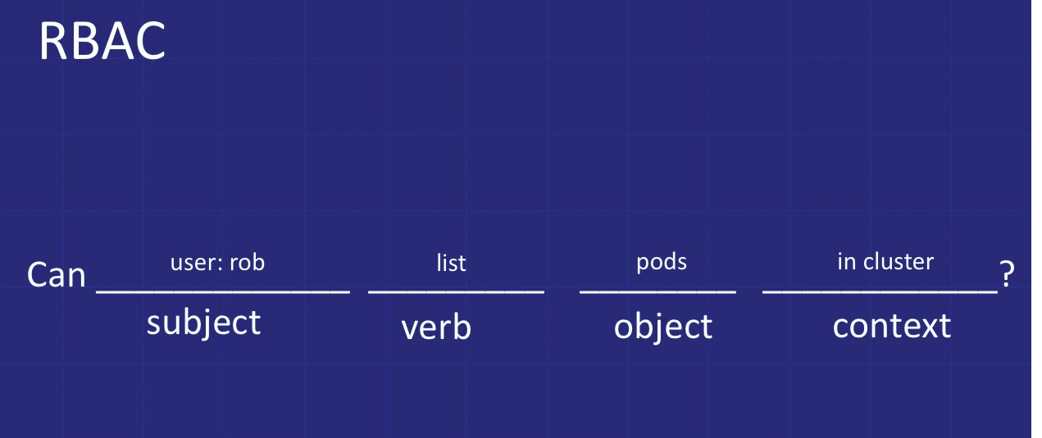
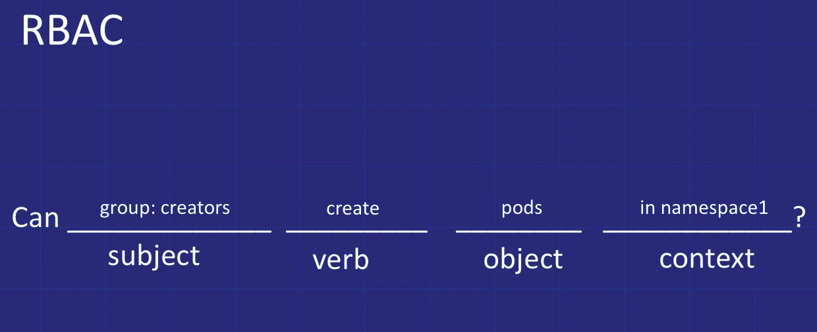

How it works ?
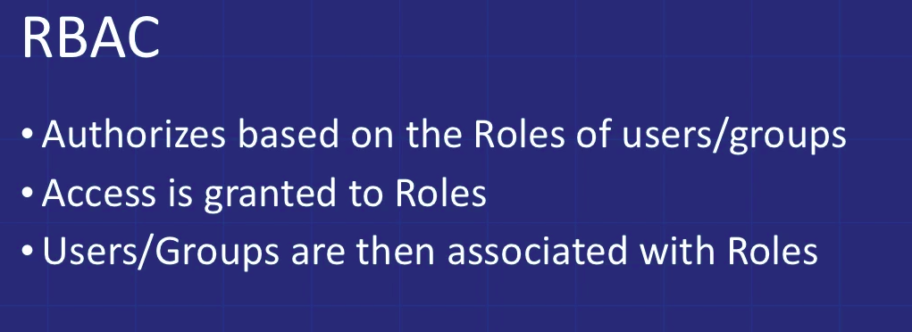
Type of RBAC objects that we work with :
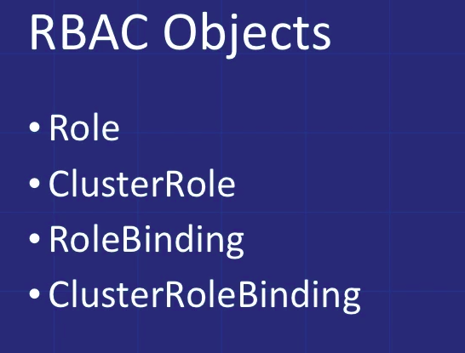

Roles and ClusterRole:
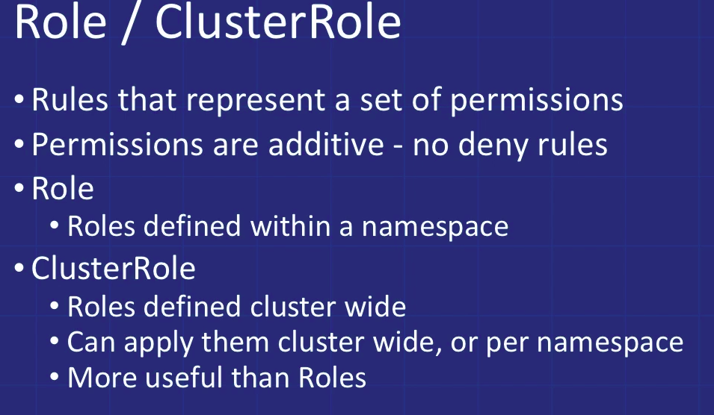

Example:
Role:
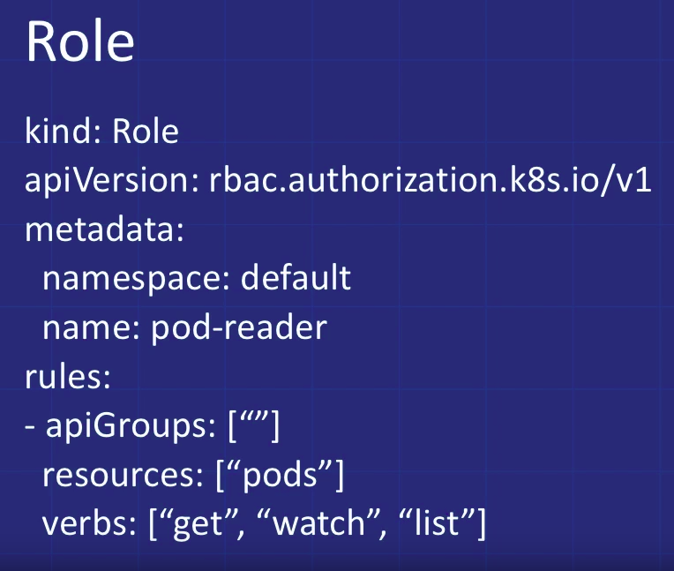

ClusterRoles:
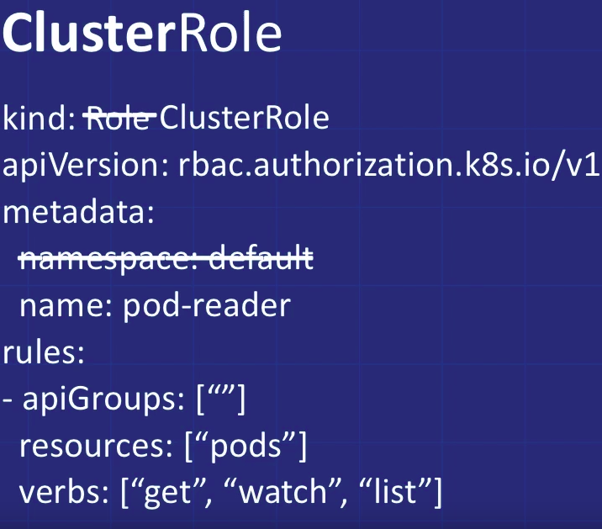

RoleBinding and ClusterRoleBinding:
- To associate a particular Role or Cluster Role to a particular User or Group.
- It grants permission defined in a Role to a user or a list of users.
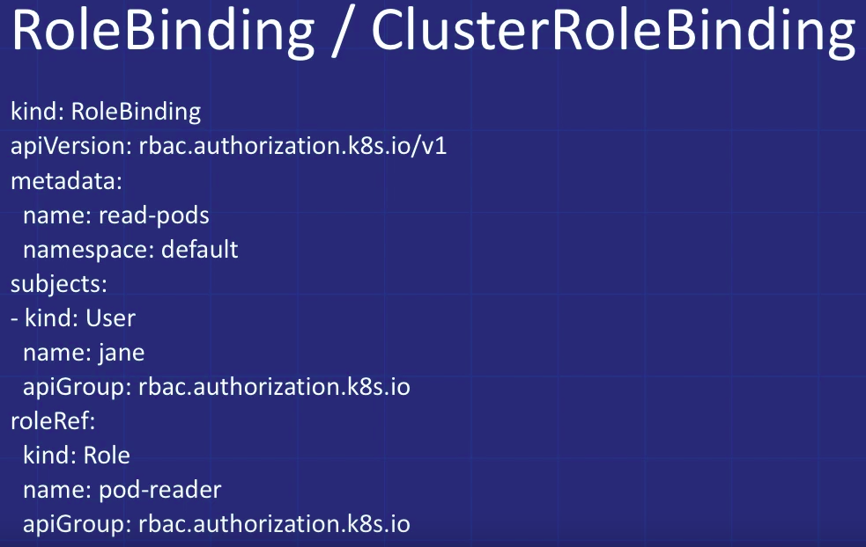
Two important fields in Role binding or Cluster Role Binding are:
a) Subjects: its a list of subjects like users, groups or service account.
b) RoleRef: A referrence to the role being granted to the subjects mentoned in the subjects field.
Role binding helps the grant the permission within a namespace so namespace field must be used in the metadata.
Cluster Role binding helps the grant the access across the cluster.

Daemon Sets:
- ensures that an instance of a specific POD is running on all (or a selection of ) nodes in a cluster.
- It creates the pod on each added node and garbage collects the POD when the Node is removed from the cluster.
- daemon sets are used for running daemons (and other tools) that need to run on all nodes of a cluster

Disruptions:
- POD disruption means that the POD gets destroyed due to some voluntary or involuntary actions.
- Involuntary actions:
a hardware failure of the physical machine backing the node
- cluster administrator deletes VM (instance) by mistake
- cloud provider or hypervisor failure makes VM disappear
- a kernel panic
- the node disappears from the cluster due to cluster network partition
- eviction of a pod due to the node being out-of-resources.

Kubernetes Drain:
https://kubernetes.io/docs/tasks/administer-cluster/safely-drain-node/
- Kubectl drain is used to safely evict all the pods on the Node before we can perform any maintenance on the node ( like kernel upgrade and hardware maintenance)
- Safe evictions allows the PODs containers to gracefully terminate
- They also respect the PodDisruptionsBudgets that have been specified on the POD.

Command:
- kubectl drain <node name>
- kubectl uncordon <node name>: if we want to leave the node on the cluster during the maintenance operation, we need to run this program to tell kubernetes that it can resume scheduling new pods onto the node.

Eviction API can be used to programatically cause evictions.

POD Terminations:
- A POD is a running process on a Node in a cluster.
- So its important to allow these process to terminate gracefully when they are not needed anymore.
- When a pod is requested to be deleted, the system records the intended grace period before the POD is allowed to be force fully killed.
- A TERM signal is send to the main process of each container in the POD.
- When the grace period is over then a KILL signal is sent to them and the POD is deleted from the API server.

FLOW:
a) User sends the POD deletion request.
b) POD in the API server is updated with a time beyond which the POD is considered to be dead along with the grace period.
c) State of the POD will now show up as terminating.
d) On seeing the POD state to be terminating, the kubelet will start performing the shutdown process where:
- each container in the POD is sent a TERM signal .
e) POD is then removed from the endpoint list of service and no longer considered the part of set of running pods for the replication controller.
f) When the grace period expires, any process still running in the POD are killed with SIGKILL
g) Kubectl will then delete the POD from the API Server by settings its grace period to 0 which means immediate deletion
h) POD disappears from the API and is then no longer visible to the user.

Kubernetes Controllers

Shared Informer

Assigning PODs to Nodes
- Generally K8 schedular automatically places a pod on a particular node.
- But sometimes we want to constraint a pod to only able to run on particular node or nodes
- For example, to ensure that the POD ends on a machine where the SSD is attached.
Ways to do this:
1) NodeSelector:
a) attach label to the node:
- kubectl label nodes <node_name> <label-key>: <label-value>
b) Add ‘nodeSelector’ field to the POD spec.
nodeSelector:
<label-key>: <label-value>
2) Affinity :
- Node affinitiy is similar to nodeSelector.
- It allows the users to contraint which nodes the POD is elligible to be scheduled on, based on the Node label
- Benefits of Affinity:
1. the language is more expressive (not just “AND of exact match”)
2. you can indicate that the rule is “soft”/“preference” rather than a hard requirement, so if the scheduler can’t satisfy it, the pod will still be scheduled
3. you can constrain against labels on other pods running on the node (or other topological domain), rather than against labels on the node itself, which allows rules about which pods can and cannot be co-located

Types:
a) requiredDuringSchedulingIgnoreDuringExecution (hard)
- Specifies rules that must be met for a POD to be scheduled on a Node
b) preferredDuringSchedulingIgnoreDuringExecution (soft)
- Specifies preferences the schedular will try to enforce but will not guarantee.

IgnoredDuringException:
- If the labels of the node change during the run time such that the affinity rules of the Nodes are no longer met, the pod will still continue to run on the Node.

Taints and Tolerations:
- Taints are opposite to Affinity
- The allow a node to repel a set of Pods
- Taints and tolerations work together to ensure that Pods are not scheduled onto appropriate nodes
- We apply one or more taints to Nodes.
- We apply tolerations to the Pods.
- Nodes donot accept the pods that tolerate the taints.

Adding a taint:
- command: kubectl taint nodes node1 key=value:Noschedule
- This adds a taint to the ‘node1’
- Taint has key as ‘key’, value as ‘value’ and taint affect NoSchedule.
- This means that no POD will be scheduled on Node1 unless it has matching toleration.

cannot delete Pods with local storage (use --delete-local-data to override): rook-ceph/rook-ceph-osd-1-7cdc944c7c-9ssns

