- Kubectl apply -f <file_name>
Kubectl apply -f <directory name> : to apply all the config files present in the directory.
- Kubectl describe:
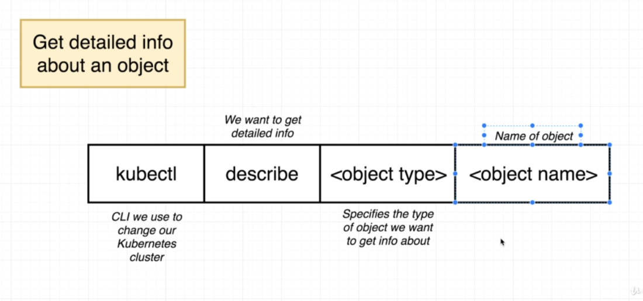

- Delete existing object
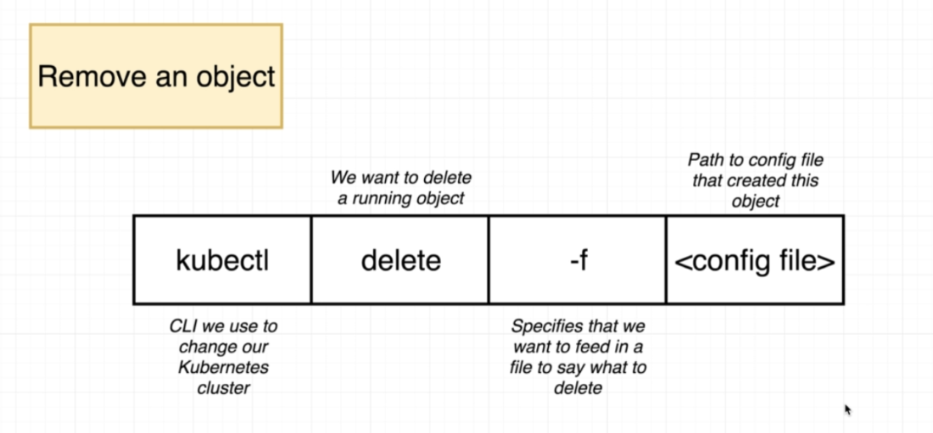
This is an imperative command.

Or

Kubectl delete <object type> <object-name>

- Kubectl get <object>
- To get the status of the objects like Services, POD, deployment, etc.
- Kubectl get <object> -o wide
- Kubectl set: to update a property of an object.
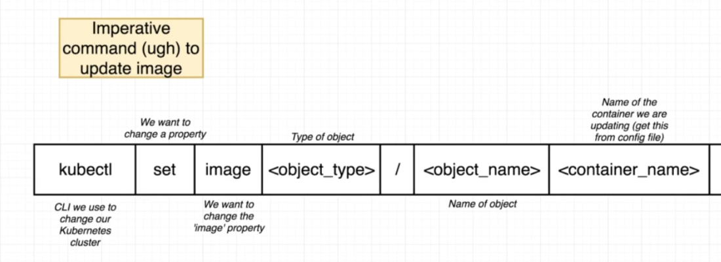

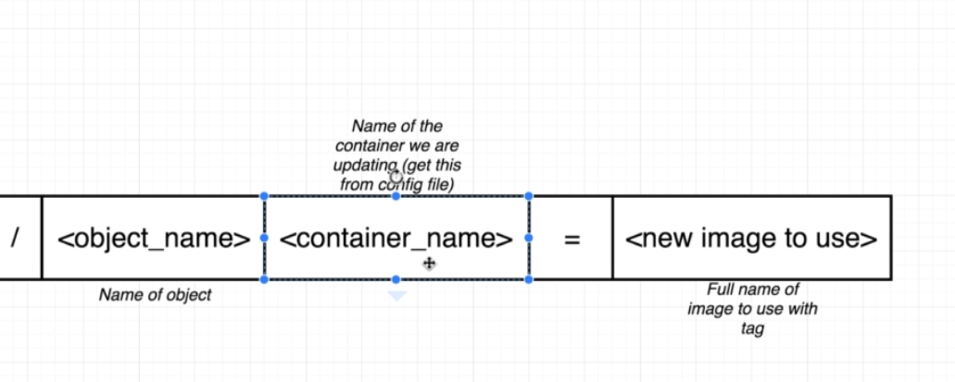

- Kubectl create:
- To create some object that we usually create using config file.
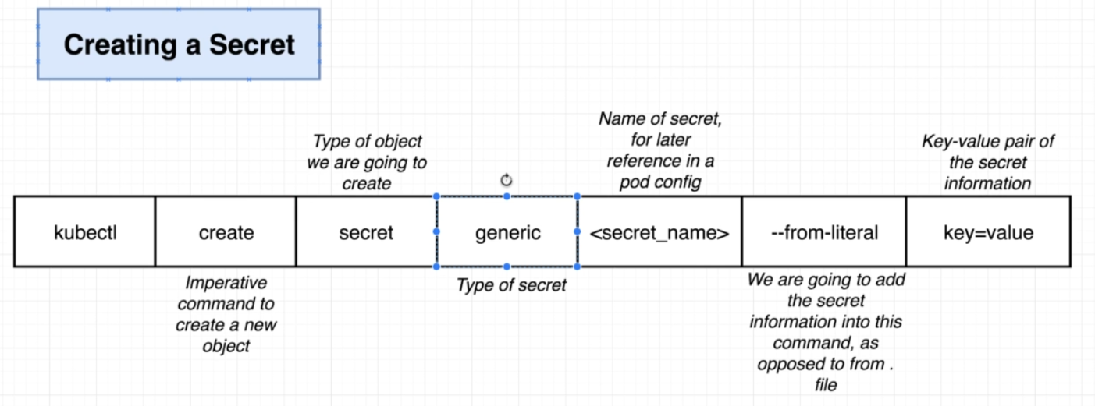

7. Kubectl get -all -n <namespace>
- get all the things running inside a namespace.

