Share Market: Udemy

Current Lec: 015

1. Technical Analysis:
- Technical analysis and fundamental analysis are the two to way to know where the chart/price is moving.
- Fundamental analysis: When a analyse a stock based on the factors that what is the revenue of the company, how many employees they have, how is the political environment for them, profit, how is the industry doing in that sector. etc.
- Technical Analysis: Here we only care about price and volume.

- We use fundamental analysis if we are long term investor and technical analysis if we are short term/intraday trader.

2. Charts and candlesticks:
- A chart is the graphical representation of historical prices.
- Candlestick is charting format that represents fluctuations in the price of a stock for a particular time period.
- Basic candlestick pattern for price :
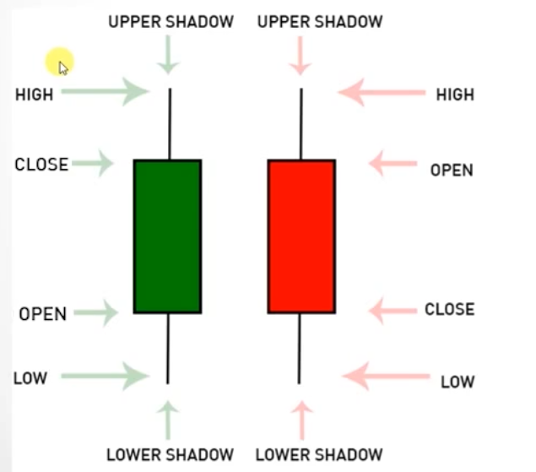

- Types of Candlesticks:

a) Big Candles:
- The size of these candles is comparitively higher than other candles.
- The represent a great increase or decrease in Supply and demand.
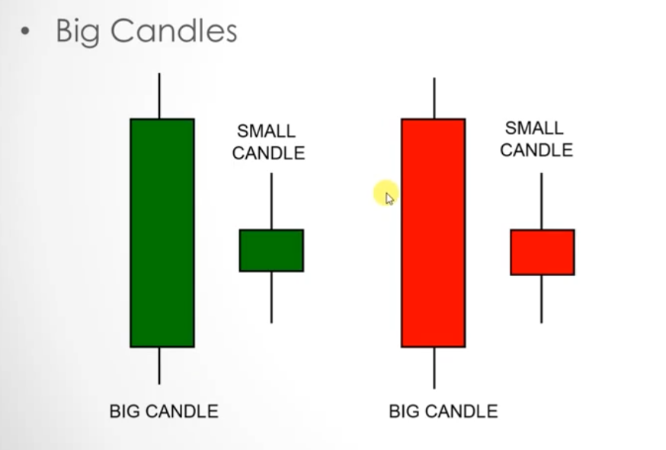

b) Doji:
- The open and close price are same in the candle stick for a particular time period.
- This pattern presents indecision as open and close price are same. Neither the buyers nor the sellers won.

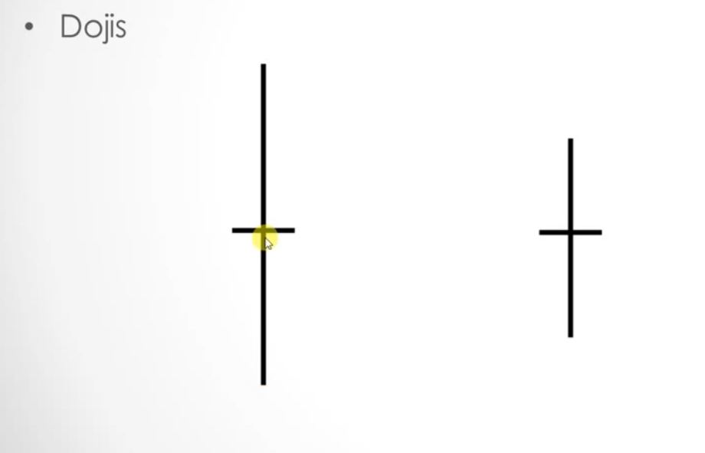

Trend Reversal:
- Downtrend or uptrend followed by doji could mean a trend reversal if the next candle stick after the doji breaks the trend:
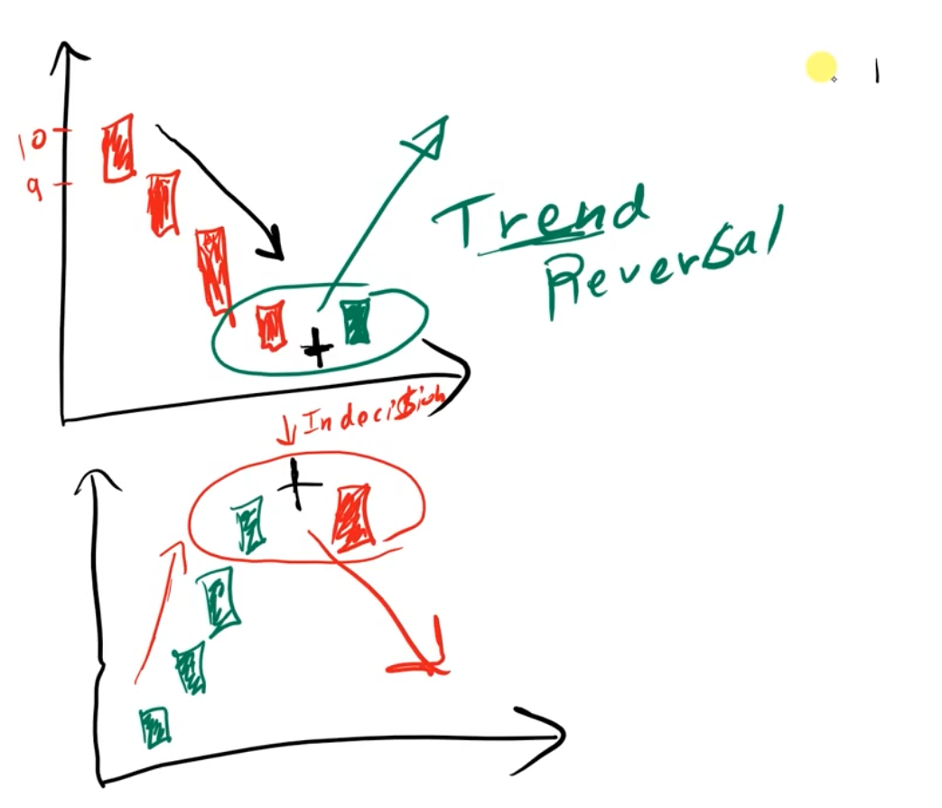

c) Gravestone:
- Price went up but then came down such that open,close and low price are same.

d) Dragonfly:
- Price went down but at the end, open, close and high prices are the same.
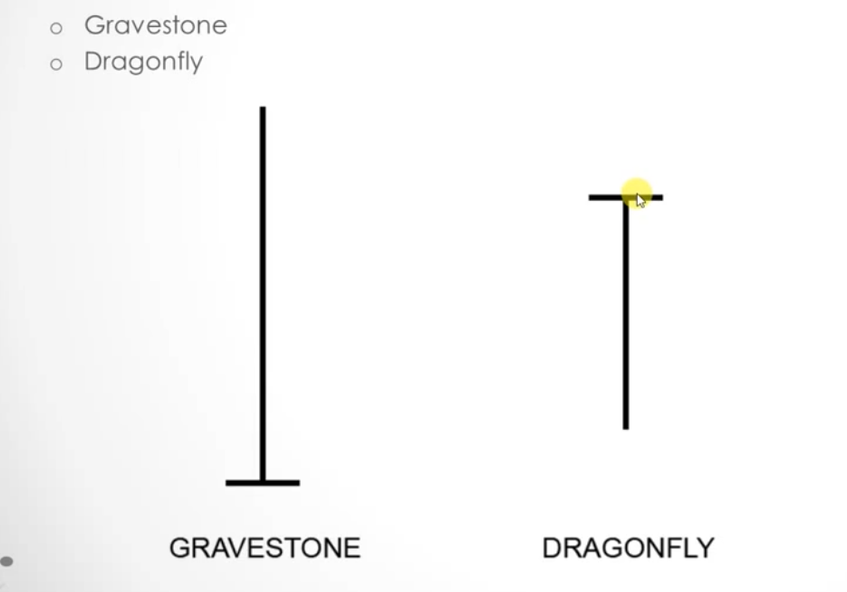

e) Hammer :
- Sellers were winning at the beginning, but buyers came back strongly at the end, such that open and close price are relatively closer, such that shadow is long in downward direction.

f) Shooting start:
- Buyers were winning at the beginning, but sellers came back and the price dropped at the end, such that open and close price are relatively closer and the shadow is long upwards.
- This is similar to gravestone

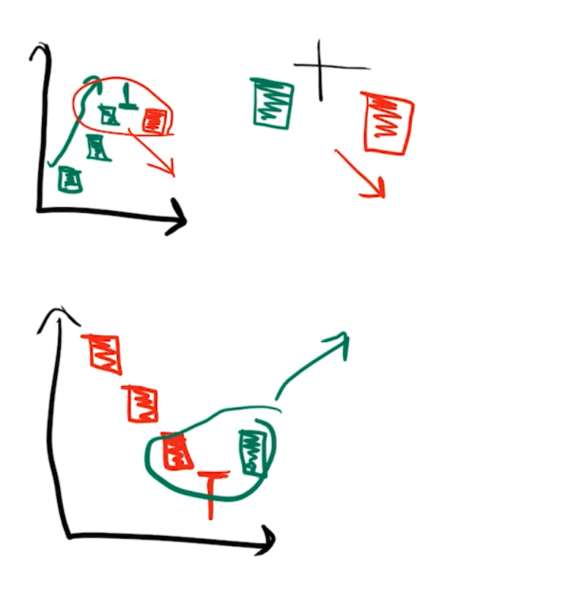

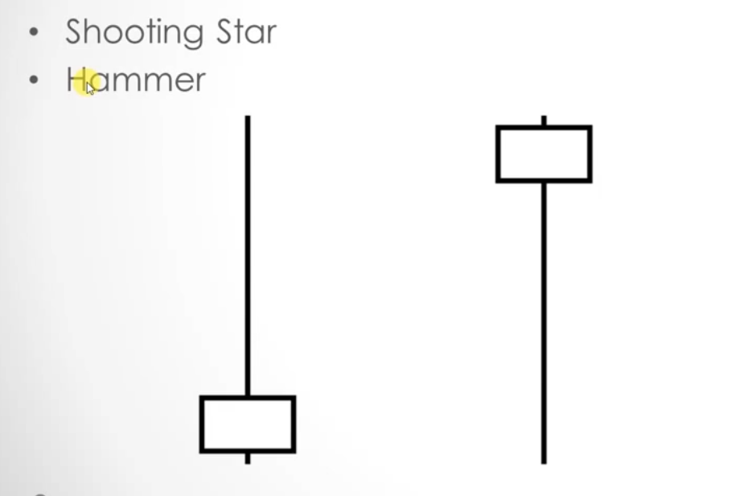

f) Bearish Harami
- Big green candle followed by a small red candle where green candle engulfs the red candle.
- Represents trend reversal.

g) Bullish Harami
- Big red candle followed by a small green candle where red candle engulfs the green candle.
- Represents trend reversal.

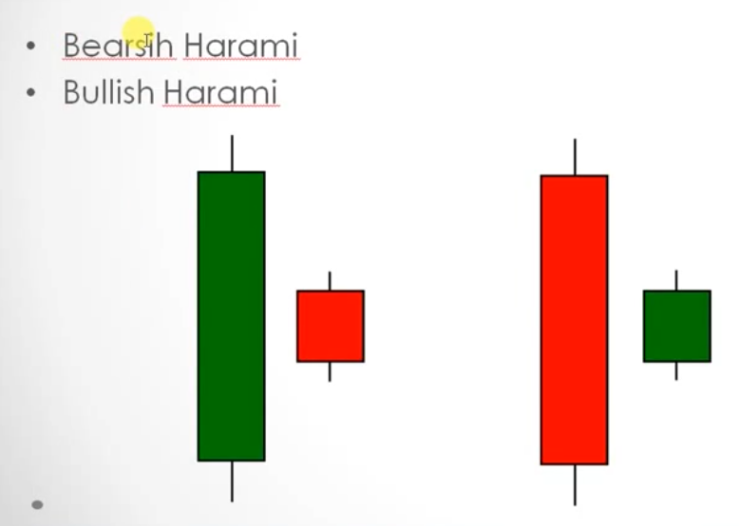

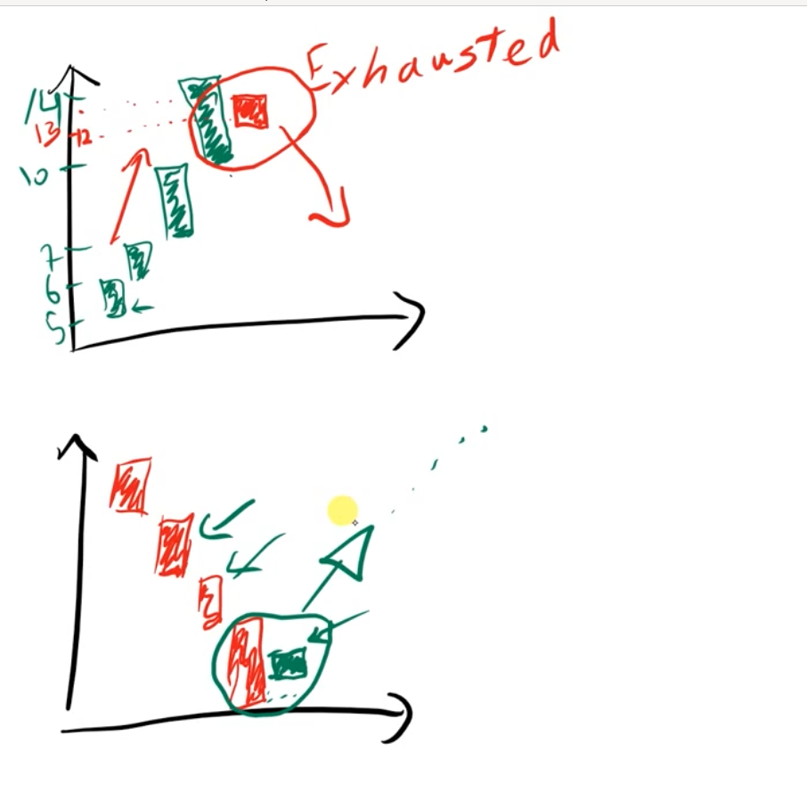

h) Engulfing bullish:
- A big green candle that engulfs the previous small red candle is engulfing bullish.
- Represents trend reversal.

j) Engulfing bearish
- A big red candle that engulfs the previous small green candle is engulfing bullish.
- Represents trend reversal.

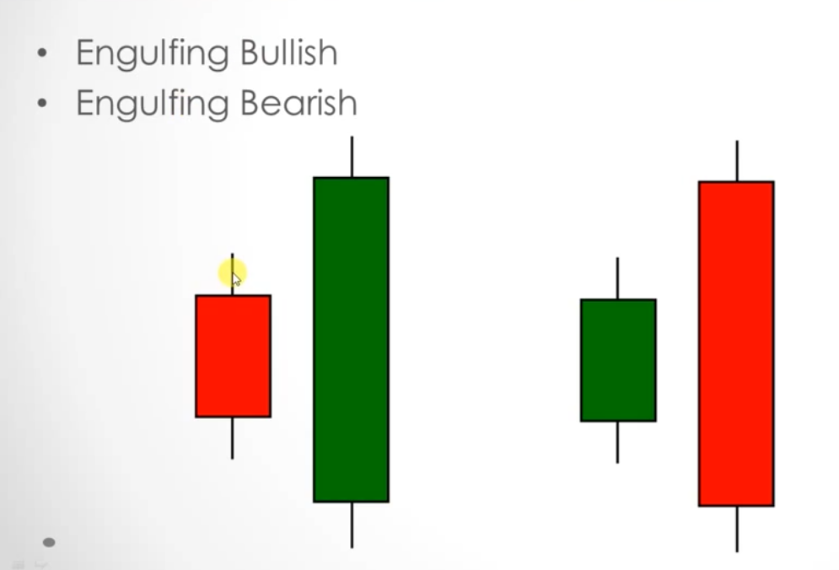

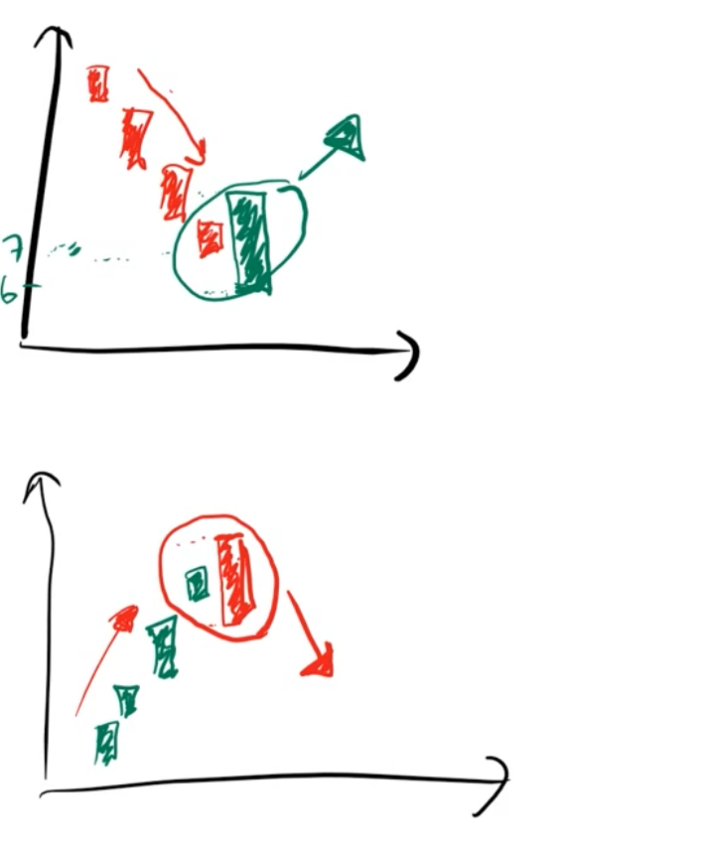

Trends:

- The direction of stock price movement. Trends can be uptrend, downtrend or sideways trend.
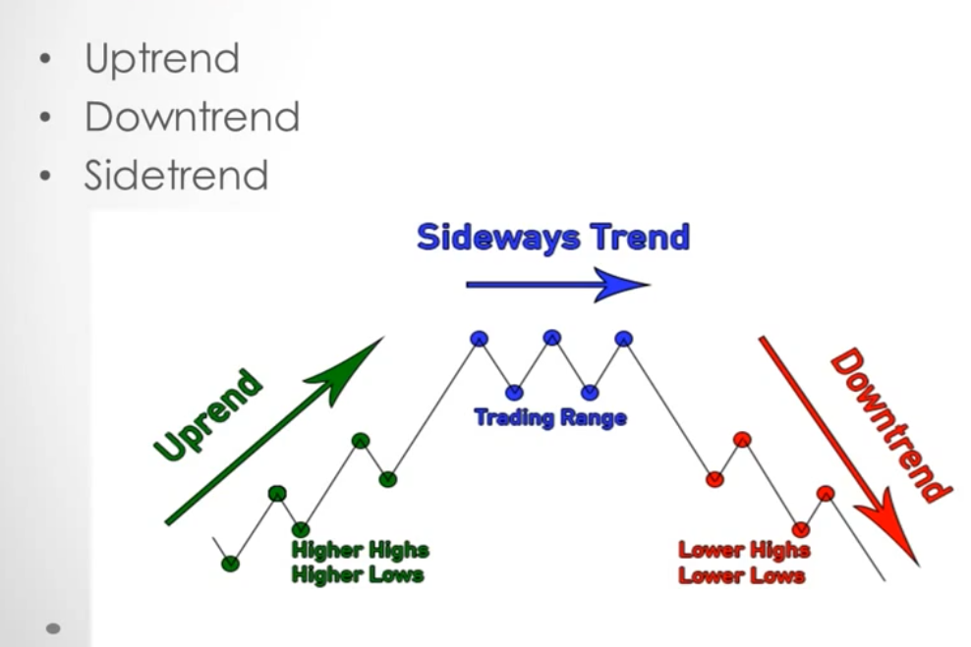

a) Uptrend:
- Higher lows and higher highs means uptrend.

b) Downtrend:
- Lower lows and lower highs means downtrends

Trend is your friend. If its going up, then it most likely will go up. Don’t go against the trend.

Trendline:
- A line drawn on the chart the shows the direction of the trend is called a trendline.
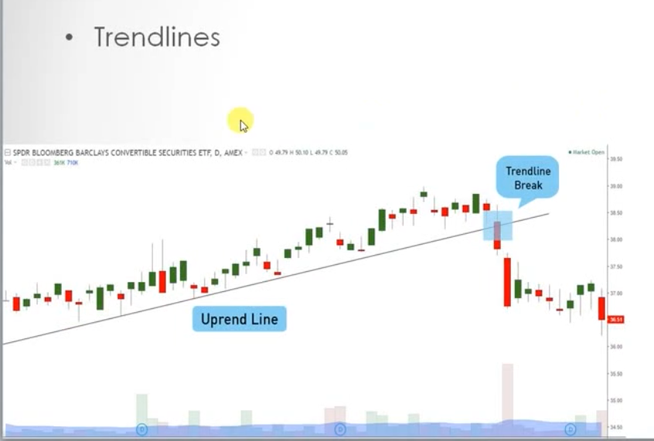

Channel:
- If we draw a trendline both on top and bottom of a trend, then we will get a channel. A channel represents the max and min range in which a stock is trending.
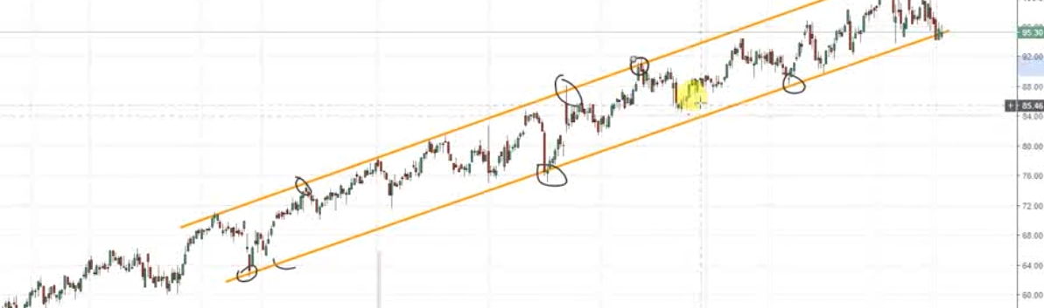

- Trend lines are used to create support and resistance:

- Support and Resistance:
a) Support: A price that acts as a support and tries to prevent the stock price form moving below that is called support.
b) Resistance: A price that acts as a resistance and tries to prevent the stock price from moving above that is called a resistance.

The idea should be to buy at support and sell at the resistance.

- Round numbers: Mostly people place their order at a round number like 100, 50, 15, 25, 10 etc. So its highly advisable to place orders near the round number and not at the round numbers.

Role Reversal:
- Support becomes resistance and resistance becomes support when they break.

- Trend Length:
a) short term trend
b) Medium term trend.
c) Long term trend: When you are buying for a few months.

