- For communication between go routines.
- Properties of goroutines:
- 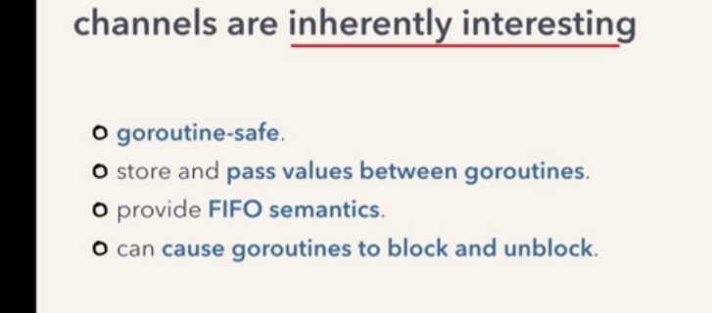

- Making channels:
-using built in make function.
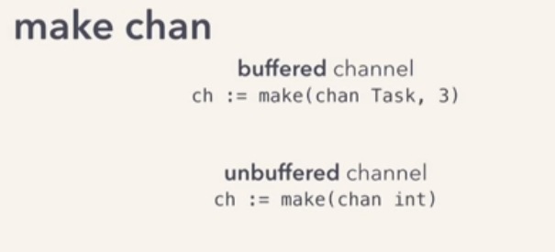

- Channel Internal working:
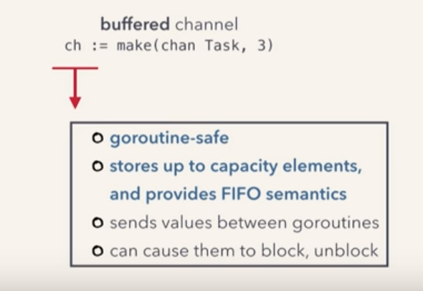

- Goroutine Safe:
- Channels internally use a queue with a lock.
-Making a channel allocates a 'hchan' struct
- hchan struct has some fields that implement a queue
- hchan struct:

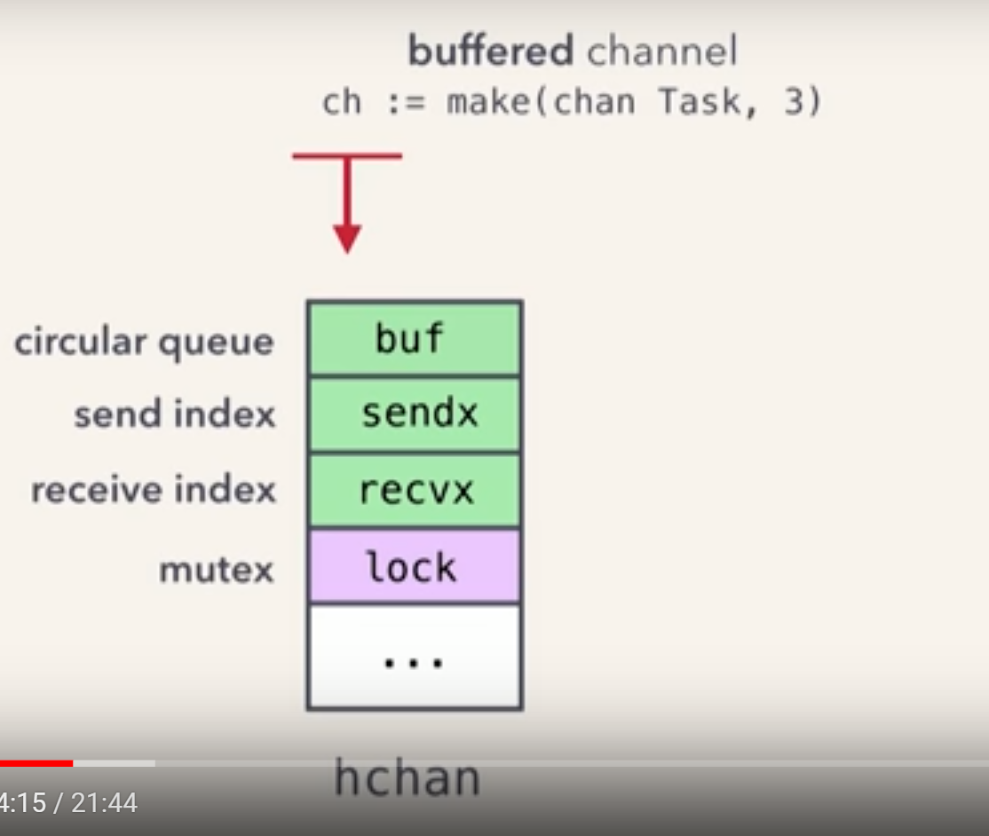

- Here, buf is a circular buffer that wraps around it self.
- Send index and receive index are for tracking the send and receive positions in that buffer.

- Hchan struct is allocated on the heap:
- The make function returns a pointer to it.
- Since make function already returns a pointer, we don't need to send pointers for channels across the goroutines.
- 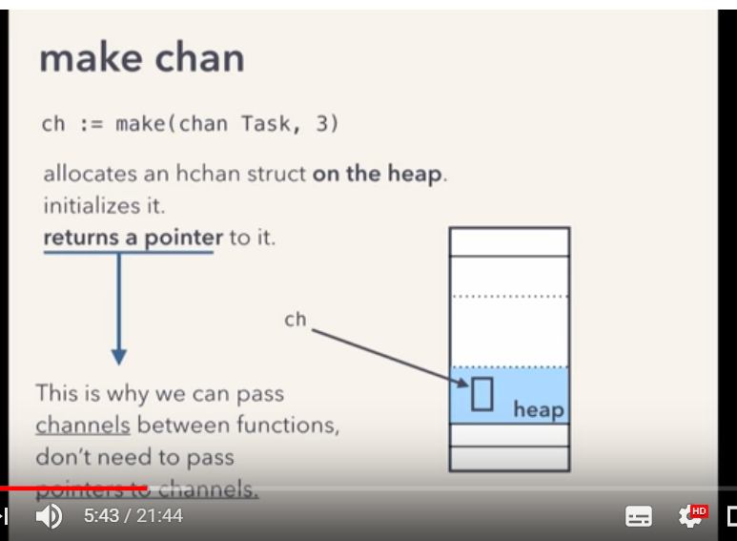

- Goroutines are user space threads.
- They are started and managed by go runtime schedular and not by os.
- They are lightweight and less expensive compared to os threads as they require less resources.
- The schedular uses an MN scheduling modules to run these user space threads on the os thread.
- The schedular takes our many goroutines and multiplexes them onto a few os threads.
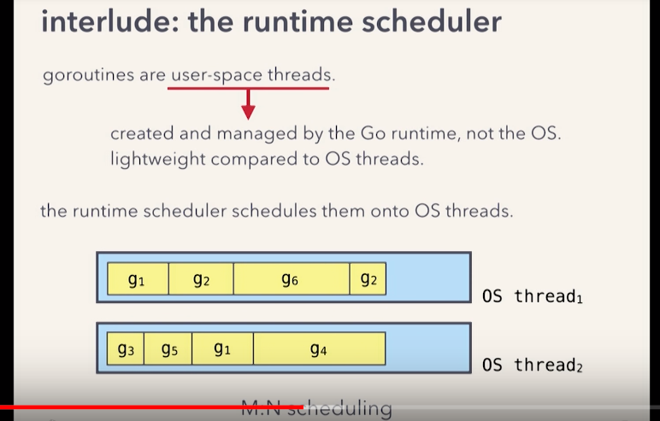

- M:N scheduling:
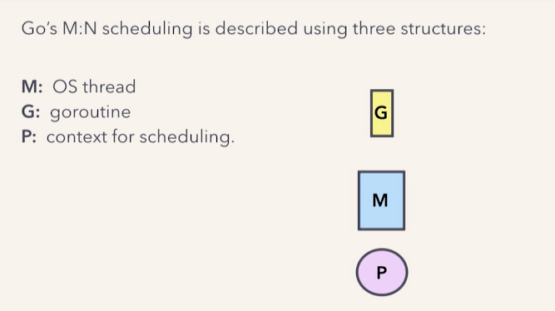

- 'P' holds the goroutines that are ready to run that is the run queues.
- The os threads get their workload from the goroutine in the 'P'
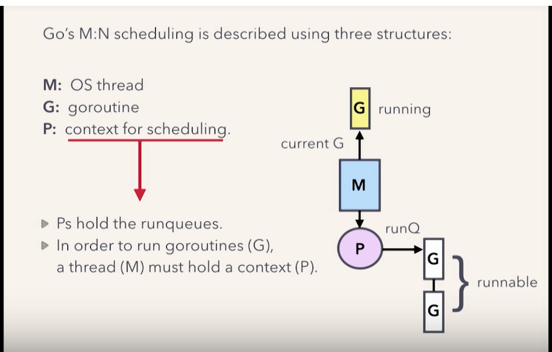

- So our goroutine is blocked but not the underlying os thread.

