Type script:

udemy:
On Lecture: 61
Check again:
055: export

1. What is Typescript?
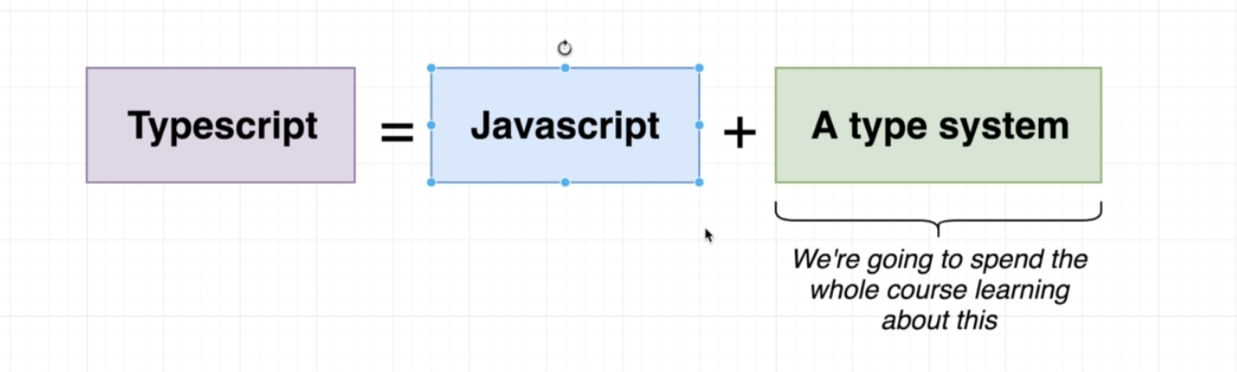

- In JS, we usually write code and then to test it we execute it on the Browser. That’s not very efficient to debug the code.
- Typescript helps use to find type errors while we are writing the code.
- Typescript is actually converted into js.

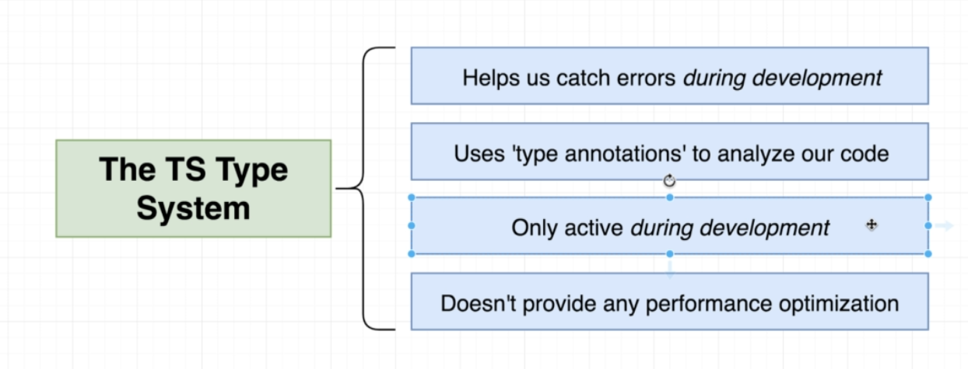

- How we write code in type script?
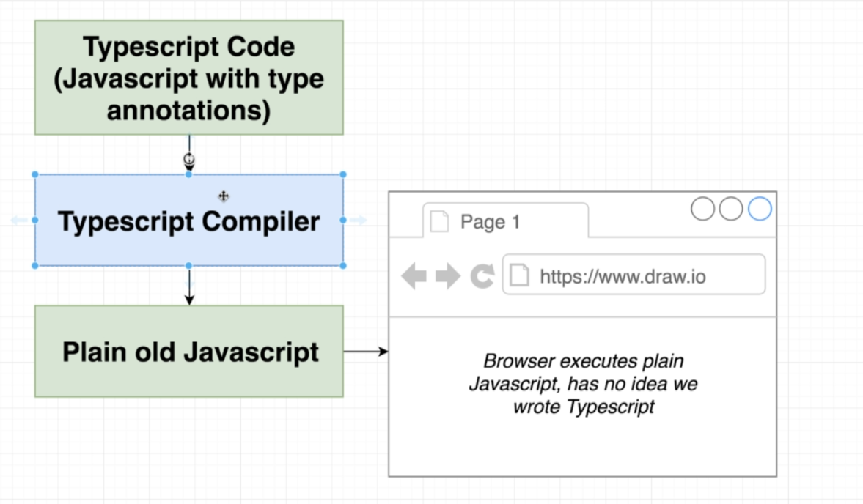

Summary:
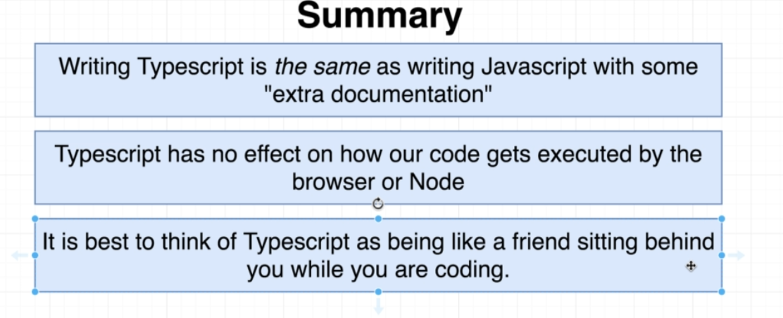

2. Local Setup:

- We need npm and nodejs to use and install typescript.

Commands to be use:
- sudo dnf install nodejs
- sudo npm install -g typescript ts-node
- Run tsc --help to verify that typescript is installed.
- tsc is the typescript complier.

- npm install -g parcel-bundler: To run ts in browser

3. Creating first typescript project:

- Go to a directory.
- Run ‘npm init -y ‘: this will create package
- Install any dependencies.

4. Types (in typescript)
- Type is an easy way to refer to the different properties and functions that a value has.
- For example, “red” is a value
- we can say that its a string.
- we can also say that its a value that has many different properties and functions like ‘concact()’, ‘charAt()’ etc.

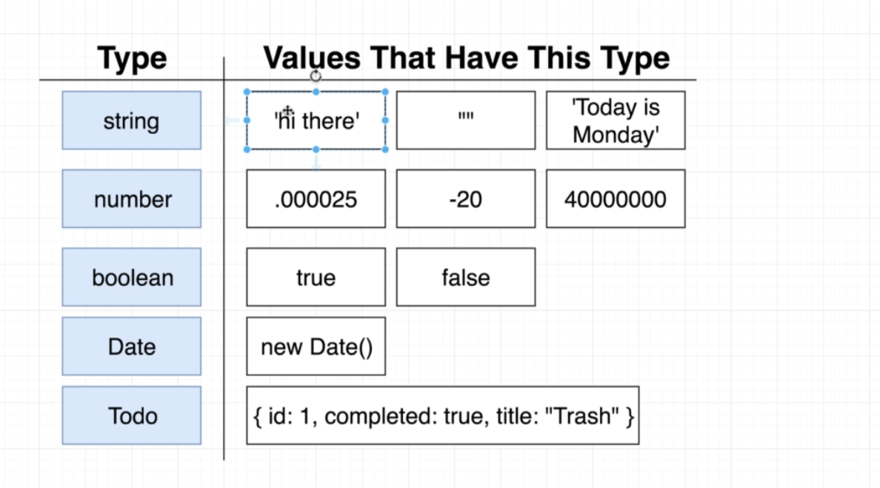

- Interface in TS also defines a new type.

- Classification of Types:
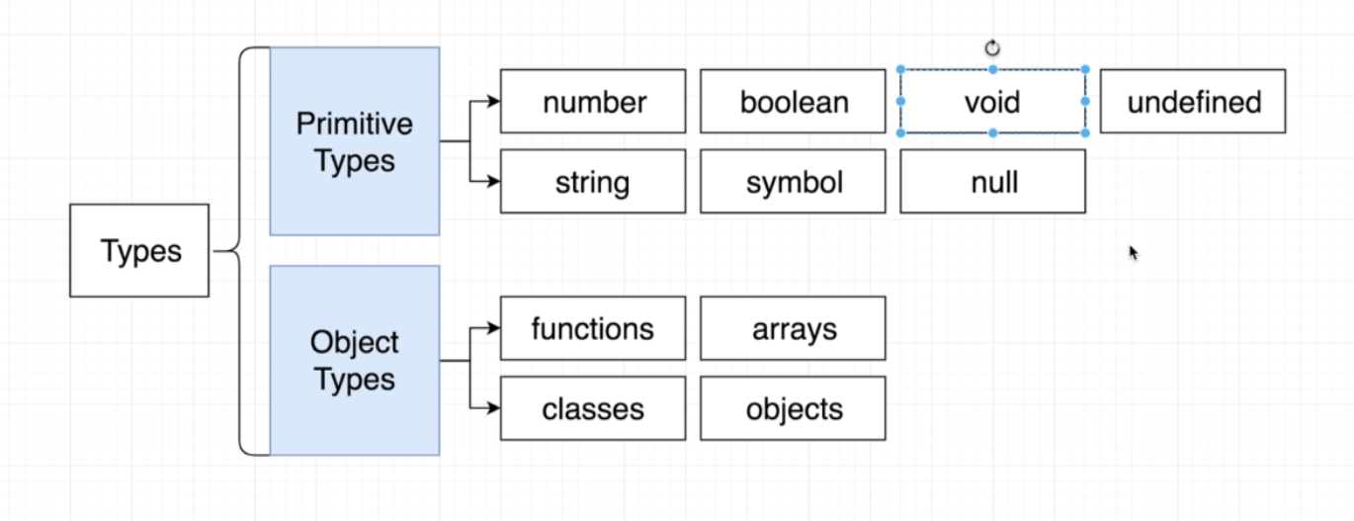
- Why do we need types:
- finding errors while writing the code.
- easy to know what type of value is floating around the project, like the arguments passed to a function.
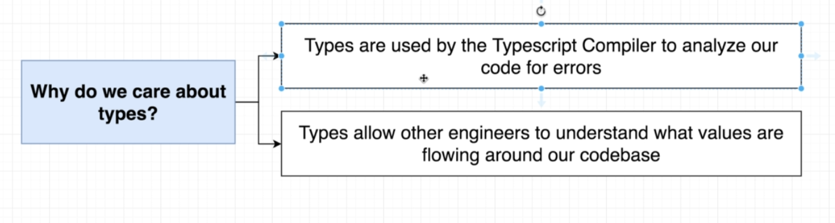

5. Type annotations and inference.
-
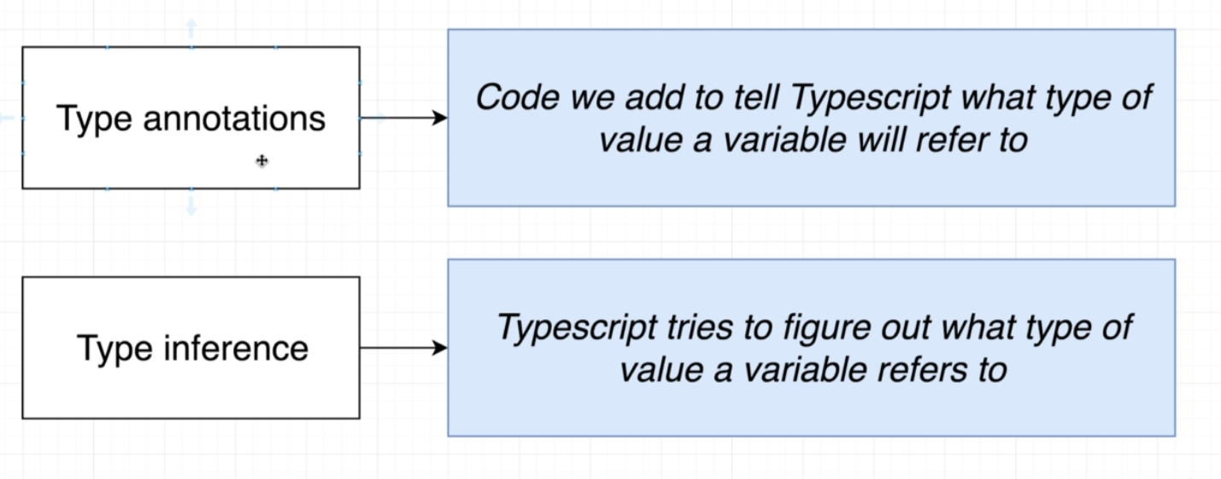

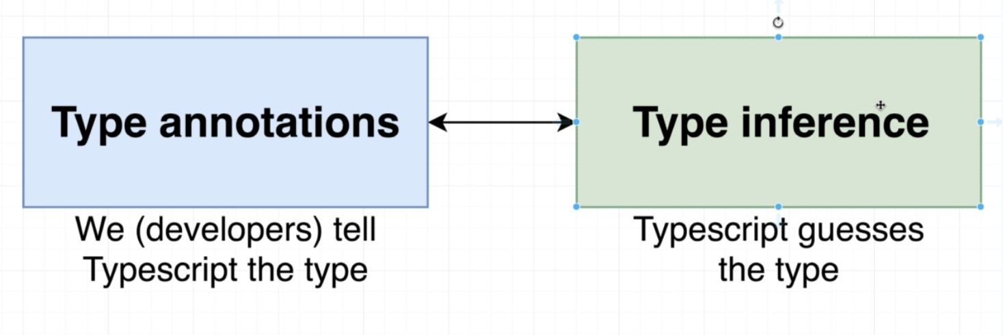
Annotations:
let apples: number = 5
This is annotation where a variable apple is having a type of number. Which also means that we can’t assign any other type to this variable now.

apples = true // this will result in an error

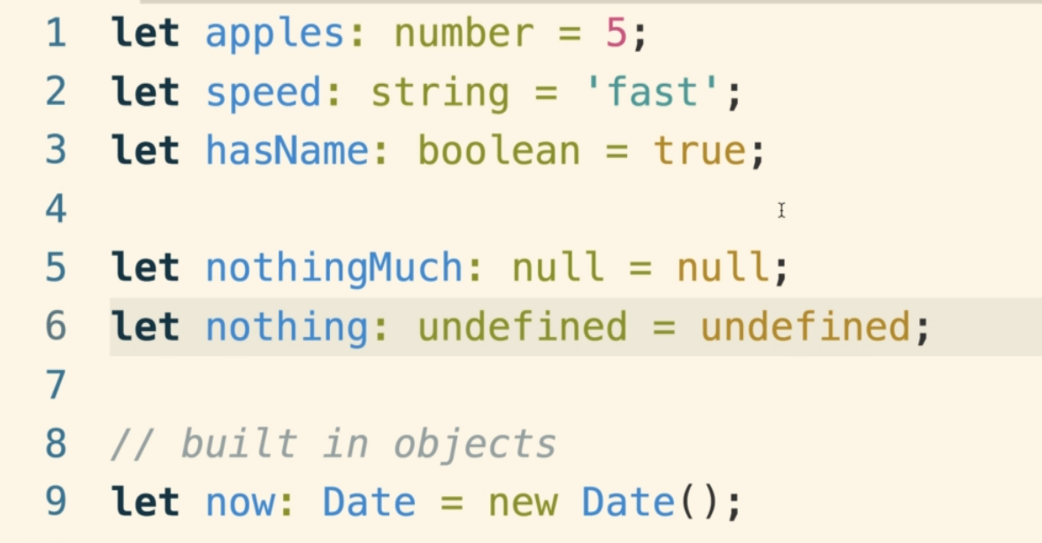

- Object literal Annotations:
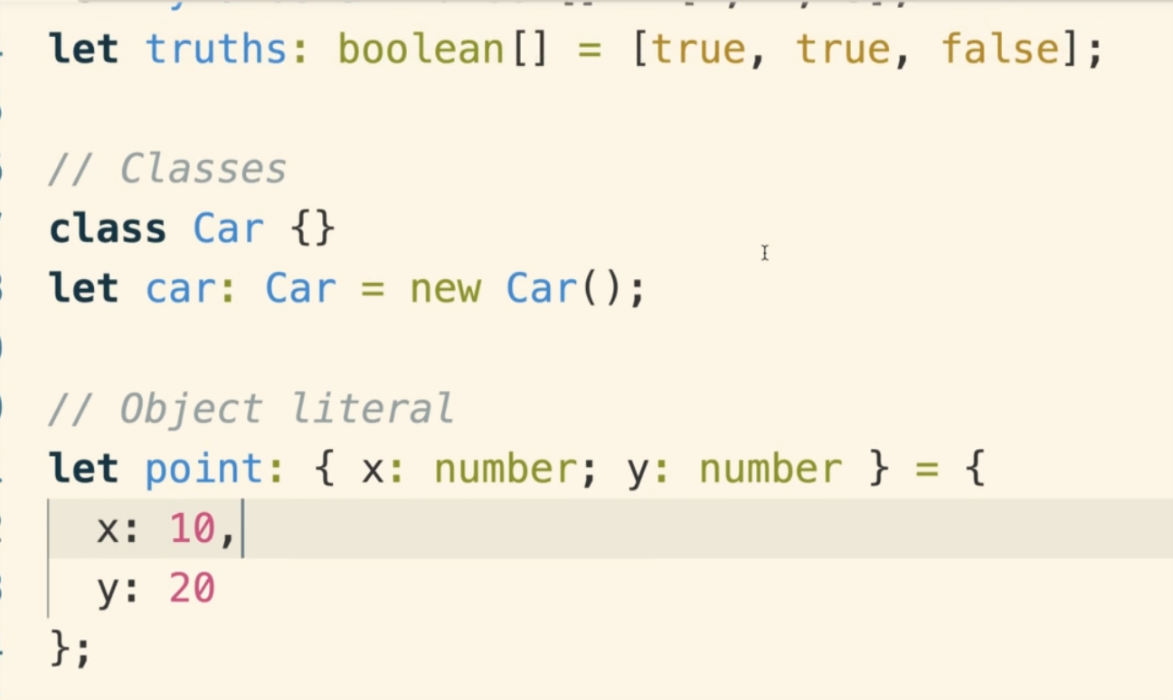

Function Annotations:
- function annotations deal with what arguments we are passing to the function and different type of values the function should return
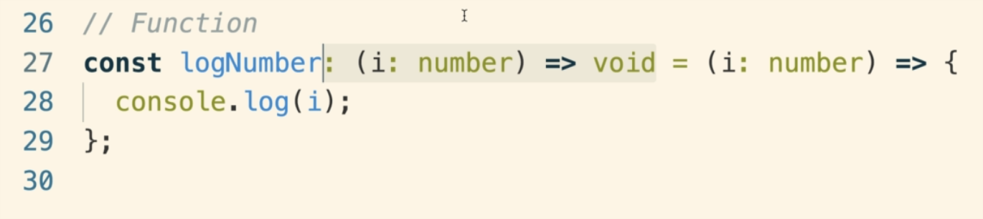

Type Inference:

1. Example:

- let age : number = 5.
- In the above type annotation, we can remove the ‘number’ and it will still work. Typescript will know that we want the ‘age’ to be of type number.
- So ‘let age = 5’ will also work. This is called type inference where TS will correctly apply a type to a variable
- This only works if we have variable declaration and initialization on the same line.

let age;
age = 5
- Inference won’t work in above example.
- The idea is the rely on type inference as much as possible.

2. When to use type annotations over inference.

a) When a function returns any type:

- Any type:
- Sometimes a function can return different types based on the input value. For example, consider the json.parse() function and its return type on different inputs:
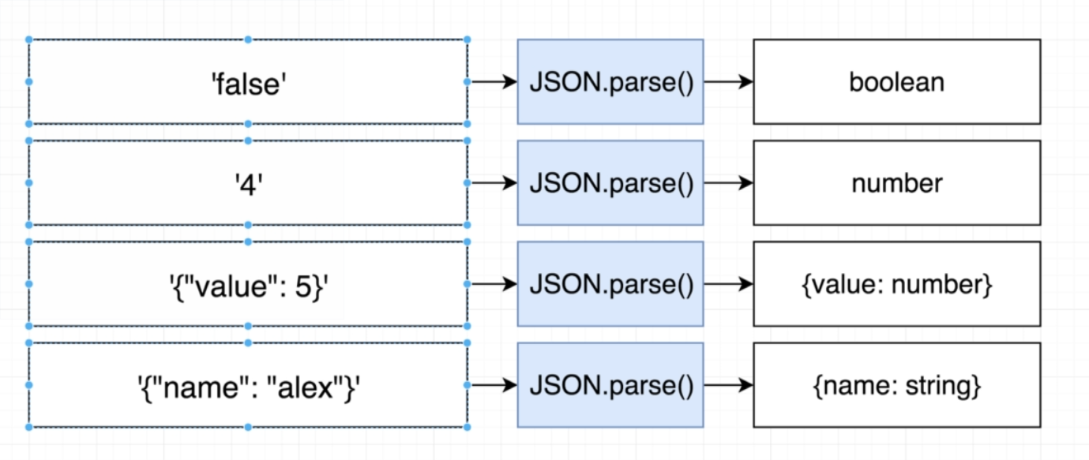

- So in this case the function can never be sure of the return type.
- So it returns ‘any’ type.

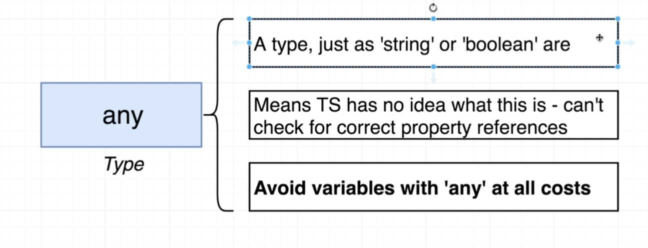

- Any type is not a good thing. Because it fails the purpose of TS. Ts can’t do any error checking on the variable of any type.
let a : any = 5
console.log(a.ereasdfasdf) won’t show any error because its type is any.
- So void ‘any’ type at all costs.

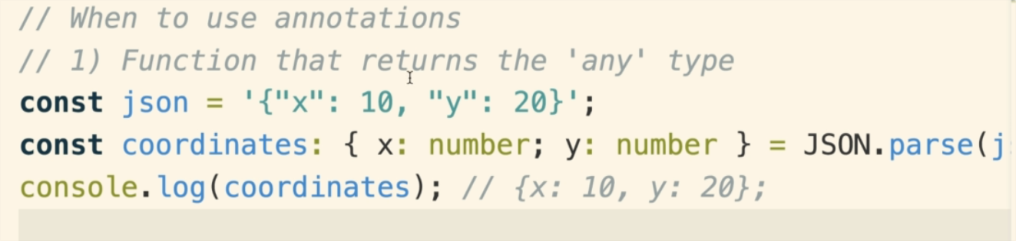

b) When we declare a variable in one line and initialize in another.
let a:number;
a = 5

c) Variable who’s type can’t be inferred correctly
- These scenarios can come up now and then where a variable can have different types based on the situation. For example, if we trying to get the favorite media for a user and store in a variable it can have different types.

For example.
- Suppose we want to loop through an array, if there is a number greater than 0 then assign that number to variable ‘numbergreaterthanzero), else assign false to this variable. So different types can be there based on the situation.

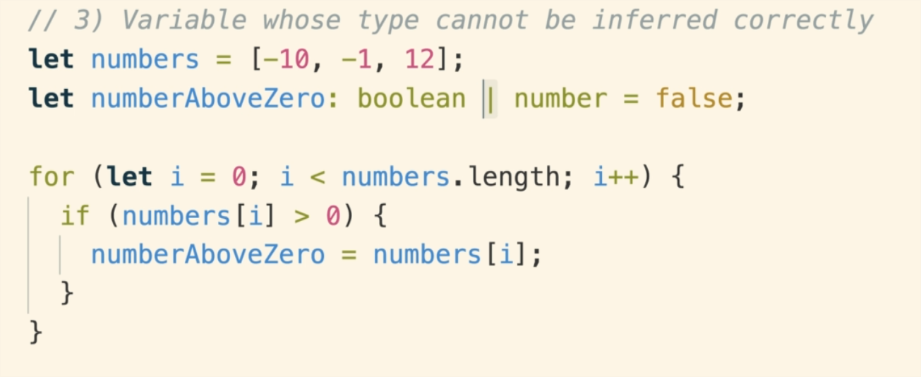

Annotations and functions:
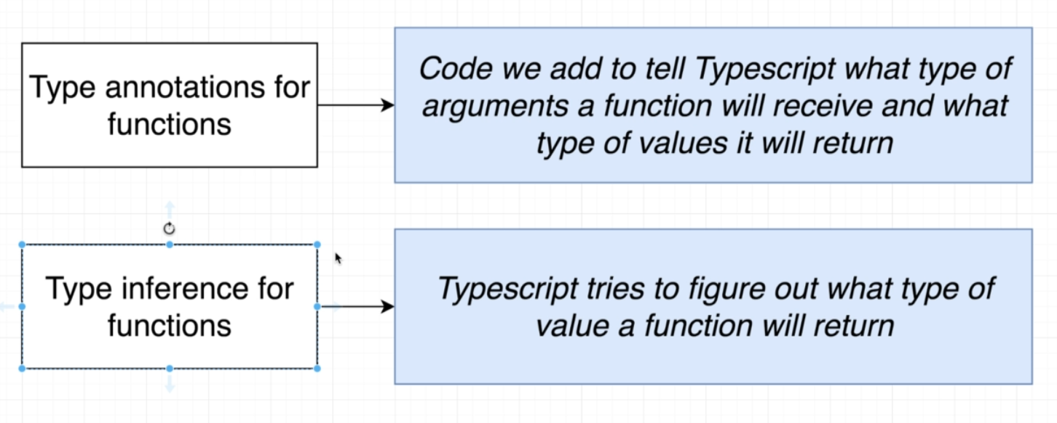
- Type annotations with functions deal with the arguments passed on to the function and the return type of the function
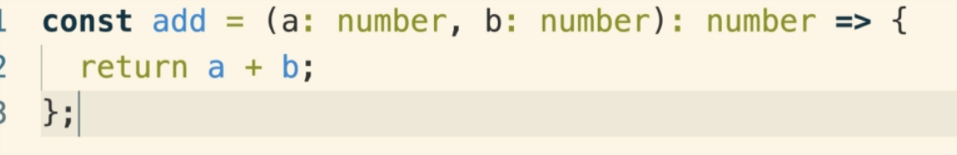
- Also note the the type system does not validate the code inside the function. It only ensure that the function returns the correct type that is annotated.

- Type inference does not work on the function argument type. So we need to annotate the argument type.
- Type inference does work on the function return type, but we won’t use it. Because if don’t provide any return type (assuming that inference will take care of it), then type inference will use the return type as ‘void’, which means no errors even if missed to return something.

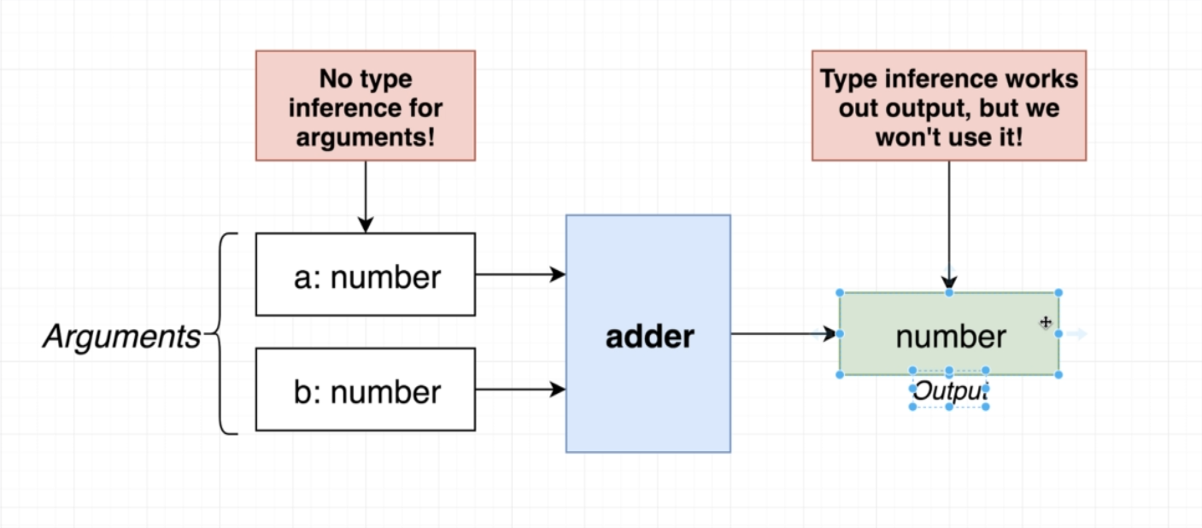

- Some other Function annotation syntax:
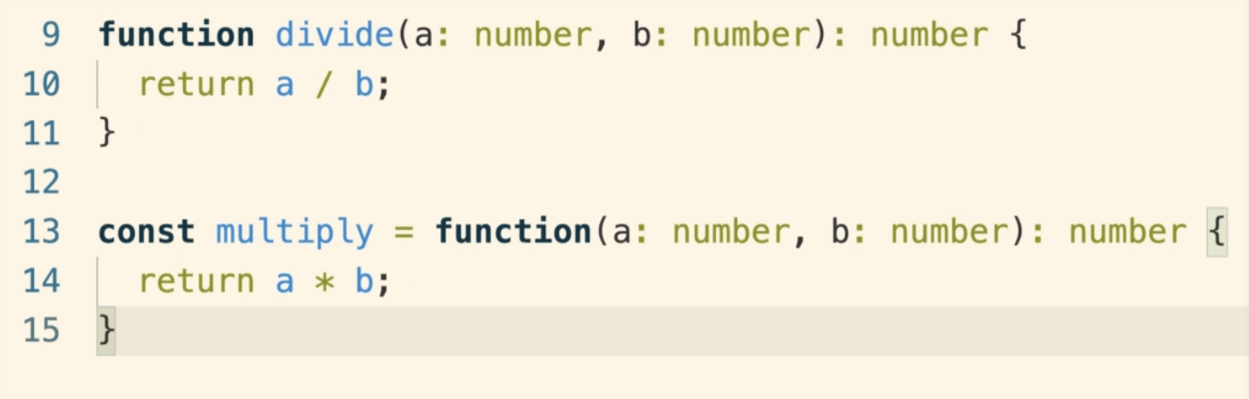

Void and Never:

- Void return type means the function can’t return anything (we can still return ‘null’ or ‘undefined’ from the function).

- Never means we are never (never ever!!) going to reach the end of the function. At some point we will exit the function without returning any value.

- SS: destructing the object in the function argument:

let todaysWeather = {
date: new Date(),
weather: “sunny”,
};

const logWeather = (forecast: { date: Date, weather: string }) => {
console.log(forecast.date)
console.log(forecast.weather)
}

- We can replace the ‘forecast’ variable with the actual destructing statement.

const logWeather = ({date, weather}: {date: Date, weather: string }) => {
console.log(date)
console.log(weather)

}

- the destructing statement and the annotations are two separate statements above.

Annotations and destructing with Objects:

- consider the following nested object:
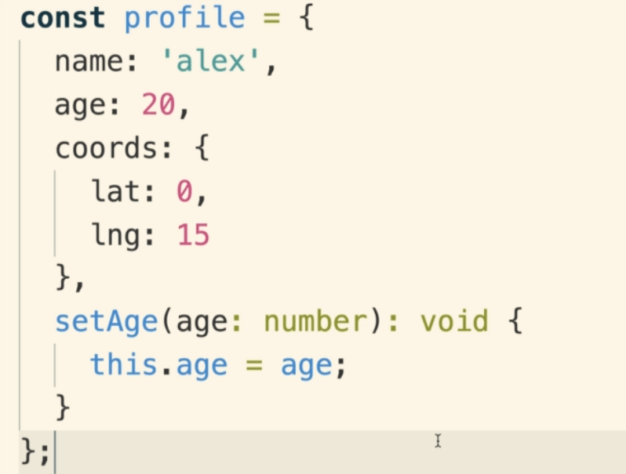

- We can get the age property out of it as:

const age = profile.age
const {age } = profile // using inference.
const {age}:{age: number} = profile //using annotation

const {age}: number = profile //this won’t work with destructing because profile has other attributes as well and with only number we can’t destructure multiple properties.

const {coords: { lat, long}} = profile //using reference.

//destructure //
Const {coords: {lat, long}}: {coords: {lat: number, long: number}} = profile.

Arrays in typescript:
- Array in TS is just an array in JS where each element is some consistent type of value.
- In TS, we only use consistent type of arrays. For example, we can’t put numbers in arrays of type strings unless being explicitly obvious about it.
- Again, we use inference if we are doing declaration and initialization on the same line, else we have to use annotations.
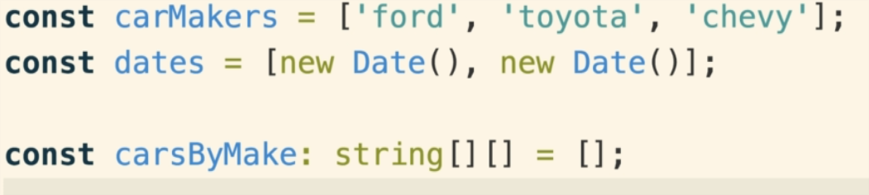

- Advantages of Typed Array:
1. helps in inference when extracting values:

const carMakers = [“ford”, “toyata”, “honda”]

const myCar = carMakers[0]
const myCar = carMakers.pop()
// ts will know in both the above cases tat myCar is of type string using inference.

2. Help prevent added incompatible values in the array

carMakers.push(0) //will give error as carMarkers should only have strings.

3. Easy iterations using ‘map’ , ‘for each’.
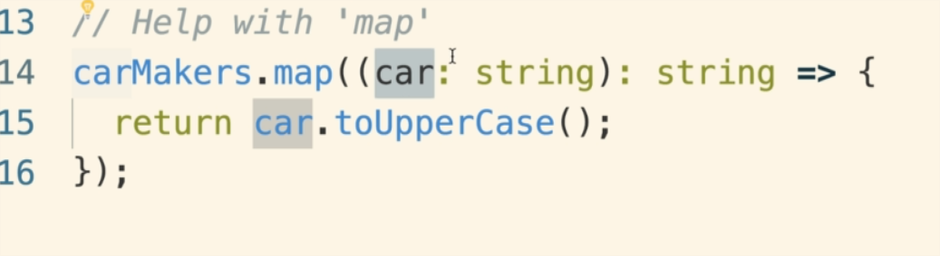
Since TS knows that ‘car’ (line 15) is a string, we can easily see all the properties or functions associated with the string. This is a nice little benefit.

4. Adding different types in an array
- We can use the pip symbol to suggest that multiple types can be used with an array:
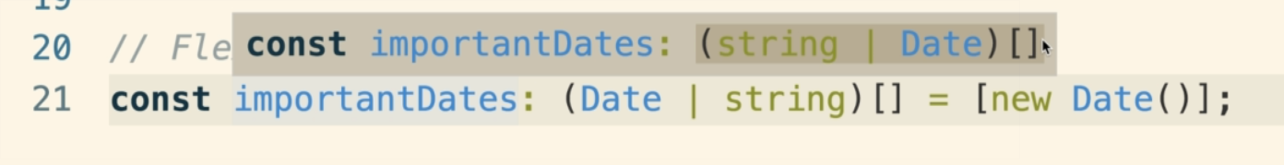
- Above suggests that ‘importantDates’ can have both ‘Date’ and ‘string’ type values.
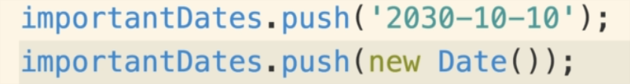

Tuples:
- Array like structure where each element represents some property of the same record.
- Array has different things, but tuple has different info about the same thing.
- We mix and match many different types inside a tuple.
- The order of elements inside a tuple is fixed to know what property that element presents.

- We annotate the variable with the types in specific order (which can’t be changed or altered) to create a tuple.

For example: Below is a tuple
const mydrink: [string, boolean, number] = [“brown”, true, 40]
myDrink[0] = 40 // this will give error because element at 0 index needs to be a string

- We can also use type alias like this:
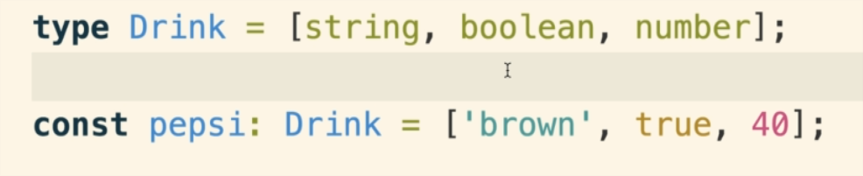
- Tuples ae not used very often. Its very hard to understand what the value represents looking at the code. So Objects are more user friendly:
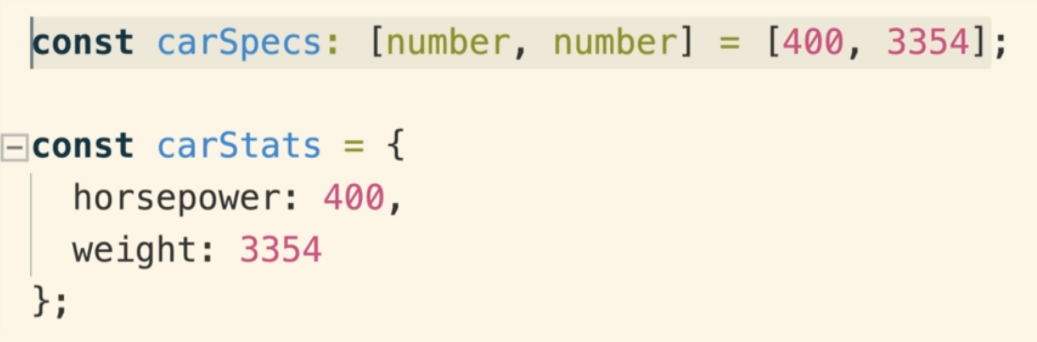
- Example usecase of tuples will be working with CSV files.

INTERFACES:

- Creates a new custom type (strings, number are built-in types)
- This custom type describes the different properties and value types that that object has.
- Interface help fix long annotation names.
- An object should have all the properties (and corresponding types) in order to satisfy an interface
- We can use both primitive and object types inside an interface.

interface Vehicle {
name: string,
year: number,
broken: boolean
summary(): string //function type
}

//in order to be a vehicle, you have must the same properties and types and mentioned above

const oldCivic {
name: ‘civic’,
year: 2000,
broken: true
summary(): string {
return `Name: ${this.name}`;
}
}

//oldCivic is a Vehicle as it has all the properties and corresponding types.

const printVehicle = (vehicle: Vehicle): void => {
console.log(`Name: ${vehicle.name}`};
console.log(`Year: ${vehicle.year}`};
console.log(`Broken: ${vehicle.broken}`};
};

printVehicle(oldCivic) // The argument/ object passed should meet the specifications provided by the Vehicle interface.

- Its all right for an object to have additional properties that the interface is not having. As long as object has all the properties that the interface has, it satisfies that interface.

interface Reportable {
summary(): string //function type
}

const oldCivic {
name: ‘civic’,
year: 2000,
broken: true
summary(): string {
return `Name: ${this.name}`;
}
};

//here oldCivic (despite of having additional properties), it still satisfies the Reportable interface.

const drink {
color: brown,
carbonated: true,
sugar: 40,
summary():string{
return `My drink has {this.sugar} mg of sugar`
}
};

- Here both OldCivic and drink (despite being completed different objects), satisfy the Reportable interface.
- this helps use to make generic /reusable functions.
- These function can be used with any object (passed in as argument) as long as they satisfy the interface.

VERY IMPORTANT:

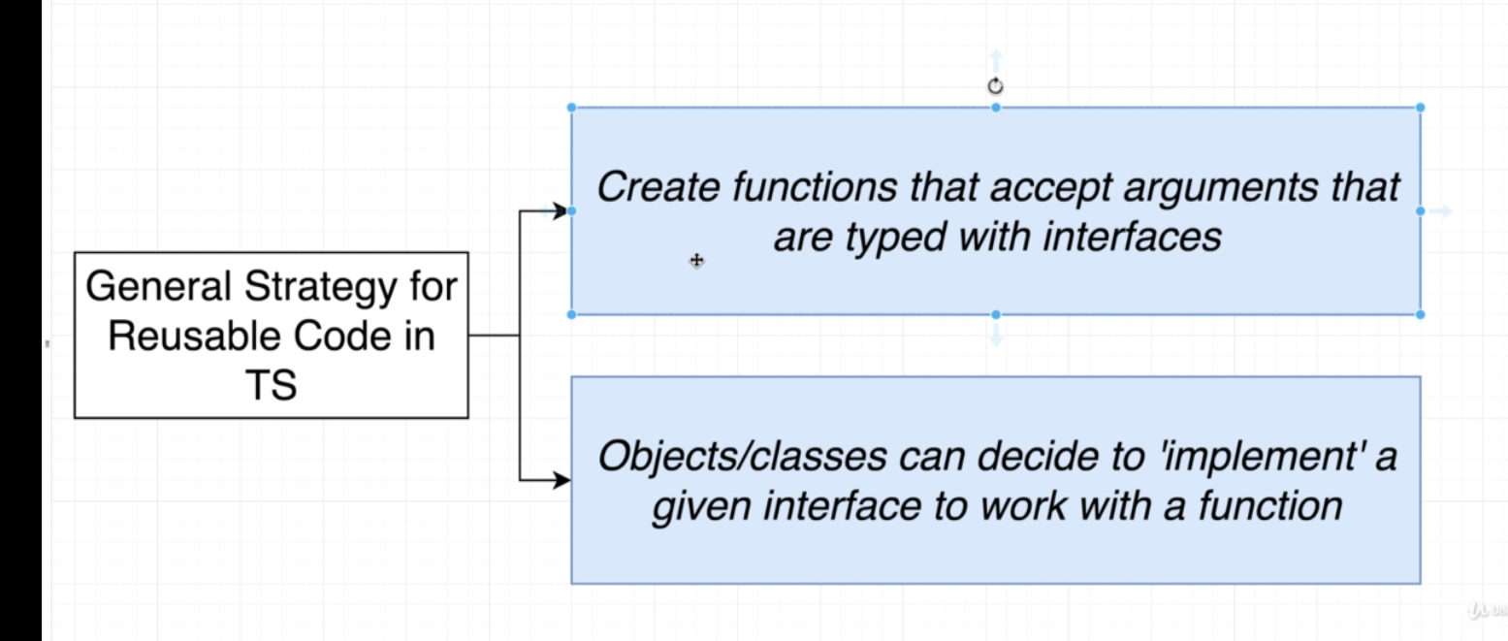

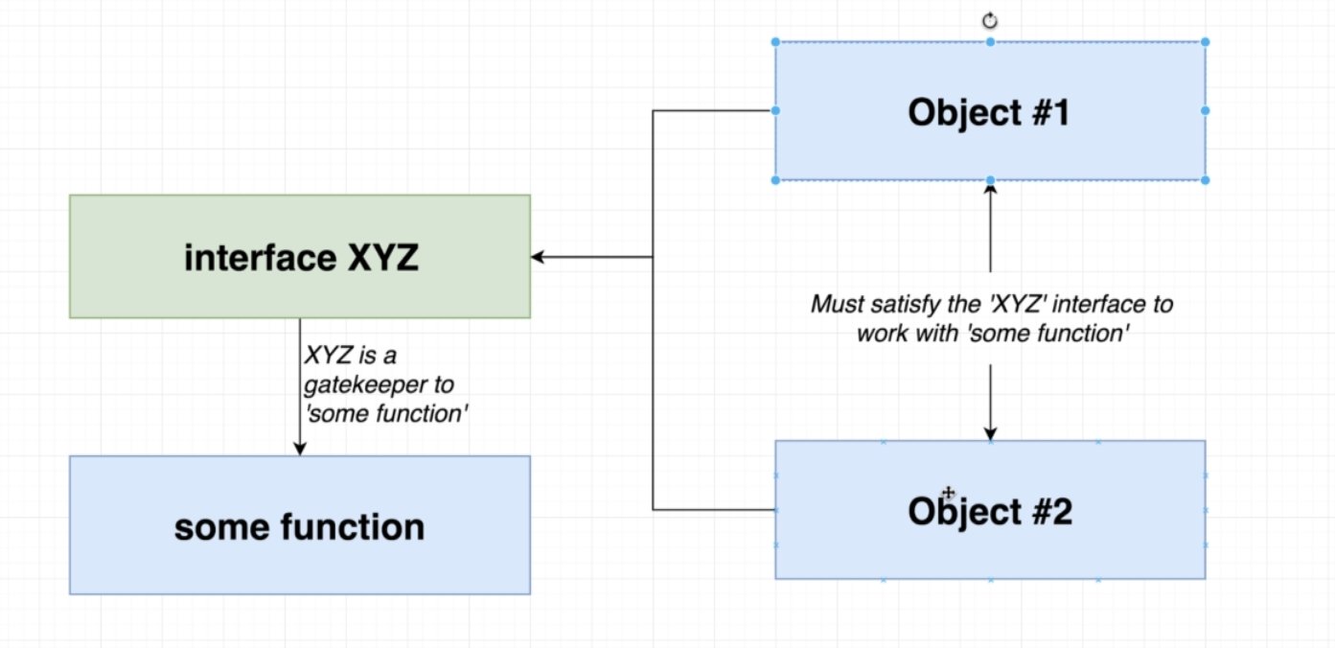

CLASSES:

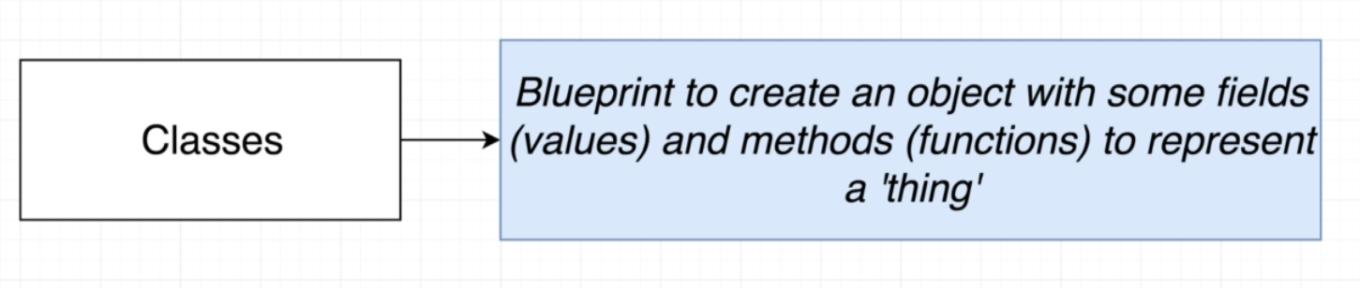

Inheritance:

Modifiers:
- keywords used before any class method or properties.
- Helps to restrict access.
- by default, all methods and properties use public modifier.
- Different access modifiers:
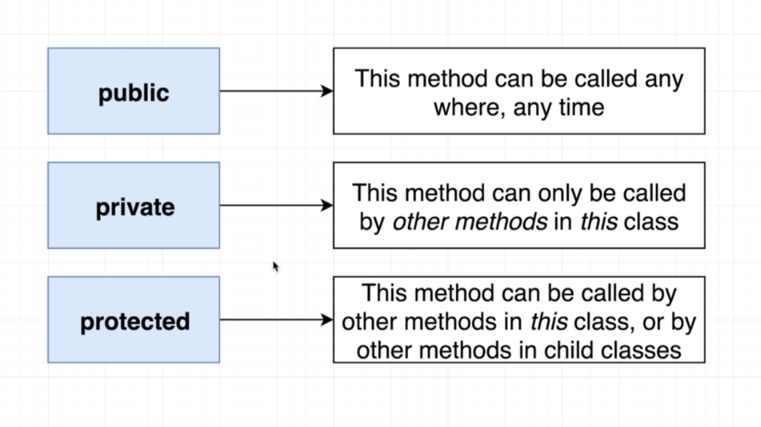

Together with interface, we can use classes to achieve code reuse.

By convention, if we are creating a file with a purpose to create and export a class, we create the file name with capital letters.

Type definition file:
- We can import JS libraries into our TS project.
- But these JS libraries don’t have TS annotations in them and typescript can automatically figure out what type of values are floating around in the JS library code.
- So when we import them, we might get some warnings about the type.
- Some JS files comes with a Type Definition file which is just an adapter between the typescript code and the JS library.
- Type Definition file tells Typescript code what all functions, type of argument they take and type of return they have in the JS file.
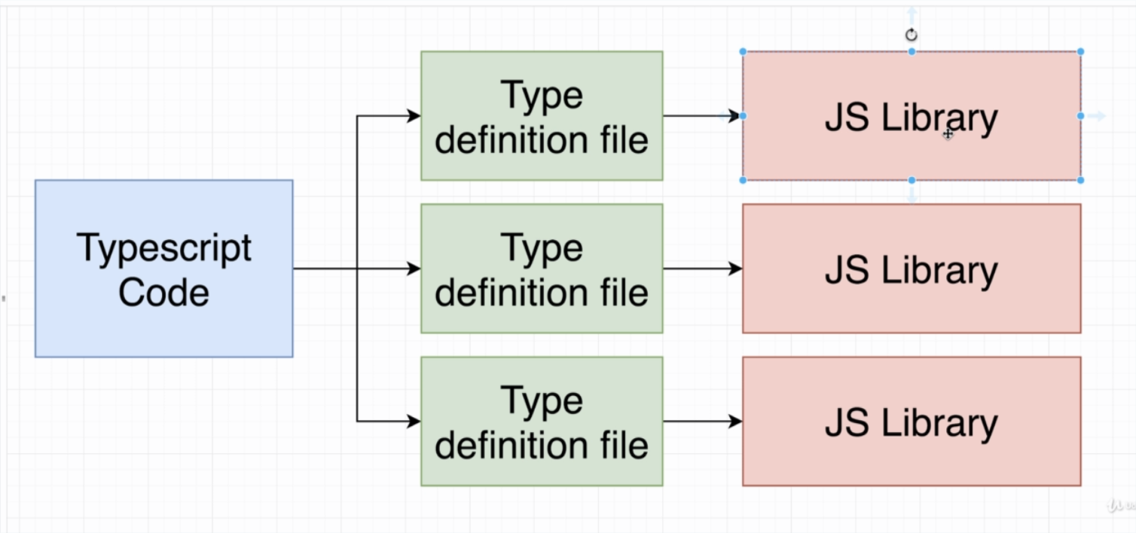
- Some JS libraries have this Type definition file built in and for some (in case we see warning while importing) we have to add them manually.

Installing Type Definition files:

- Helps Typescript understand how a third party library works.
- Definitely Typed project has all the type definition files for JS libraries
- They are available publically.
- We need to install @types/<library name>
- Type definition files are names as <name>.d.ts
- Type definition file can be used as documentation for using the library as its more frequently updated and has more recent information.

Aside:
- We usually create different files for different classes that we want to create.
- Then we export the class and import in some centralized file were we want to use them.
- To export a class, we have to start it with the keyword ‘export’.

