JS under the hood by Anthony Alacia:
Important videos: 09, 16, 37, 45, 46, 51, 52, 63

- Some important concepts:

1. Syntax parser: a piece of code written by someone that checks our code (character by charactoer) for any errors. Our javascript code is converted into the code that the computer can understand. We have compliers (or interpreter) for this.
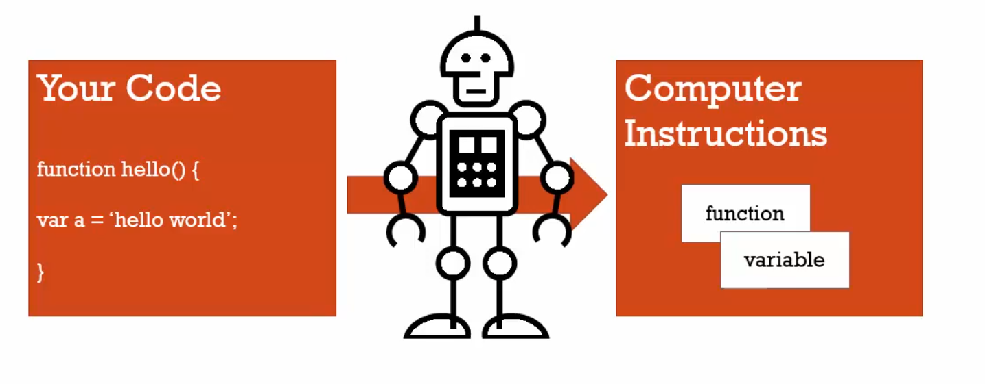

2. Lexical environment: Where something sits physically in the code we write is important.
Where the code is written and what surrounds it.
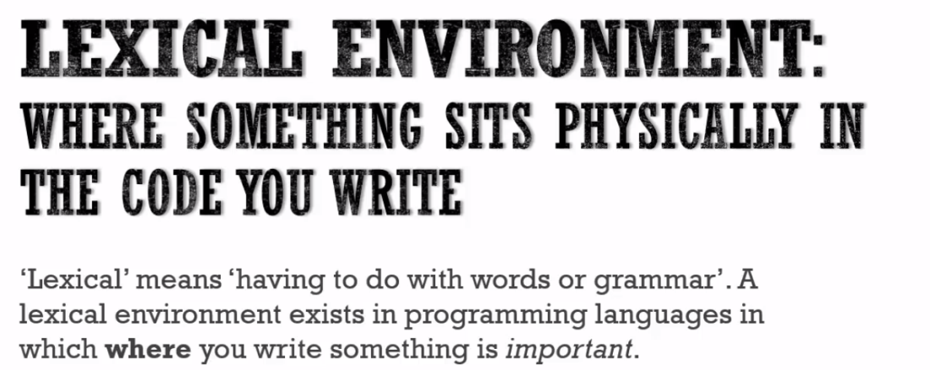

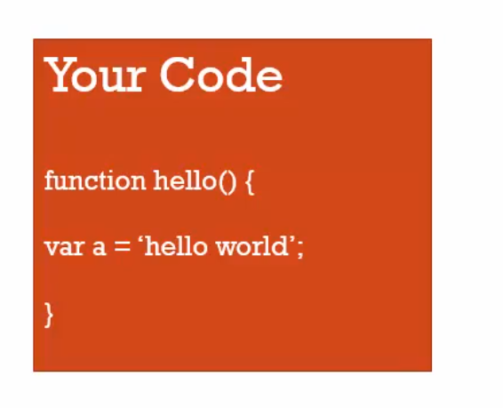

- Here to variable a sits lexically inside the function hello.
- In lexical environment we give importance to where the code is sitting and what surrounds. This is information is also important as compiler uses it to decide with that code entity will sit inside the computer’s memory.

3. Execution context: Part of the code that is running.
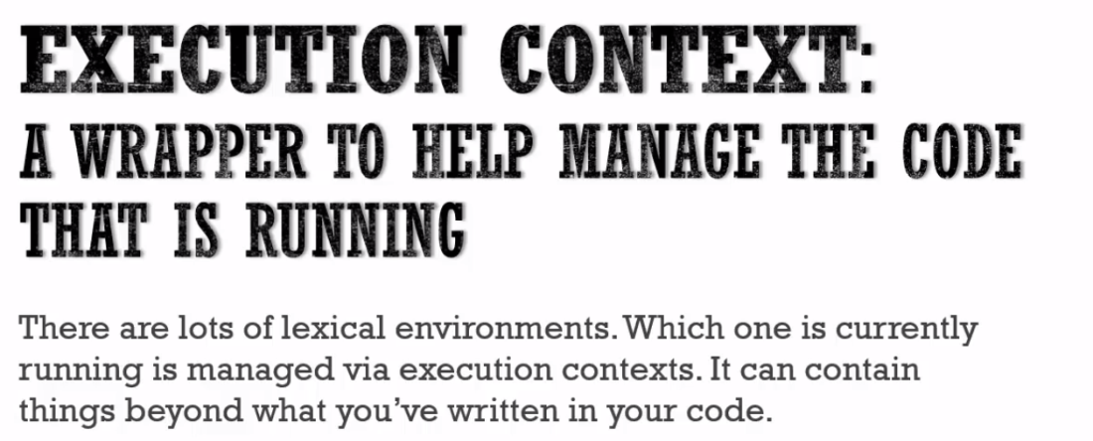

Object in Javascripts:

- Collection of name value pairs.
- The value can be collection of further key value pairs.
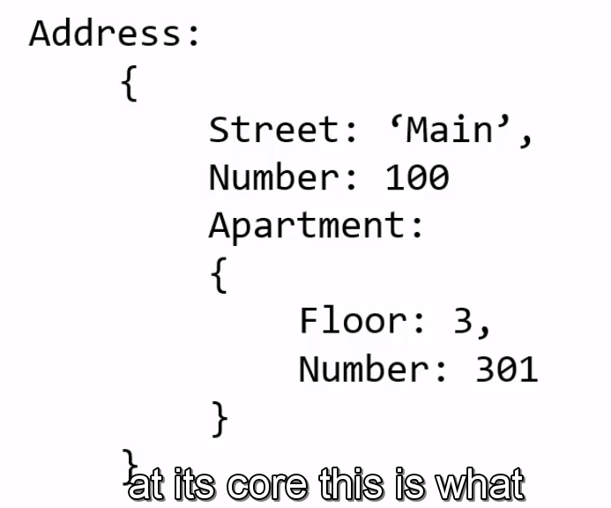

1. Global Environment and Global Object:
- Code in javascript is run inside in a execution context.
- Global execution context creates two things for use by default -
a) Global Object (window object if we are running inside a browser)
b) and a special variable called this.
c) At the global level the global object and this are equal
- The JS engine is creating these two things for us whenever the code is run as our code is wrapped inside an execution context.
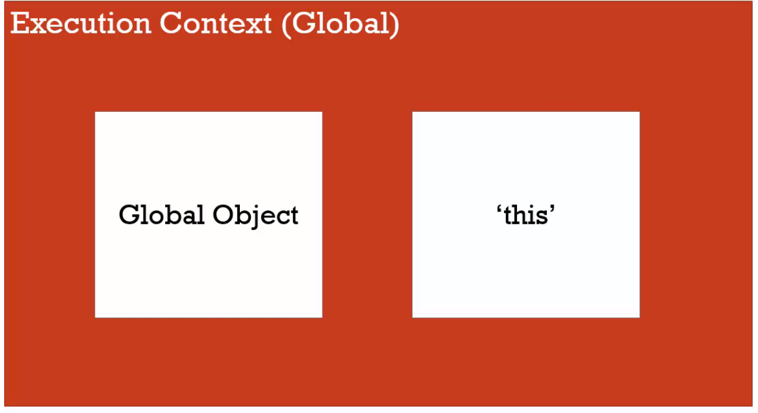

- There will always be one global object when we are running the javascript.
- And in case of browsers this global object is 'window'. ( in case of node.js or running js in server, the global object would be different. )
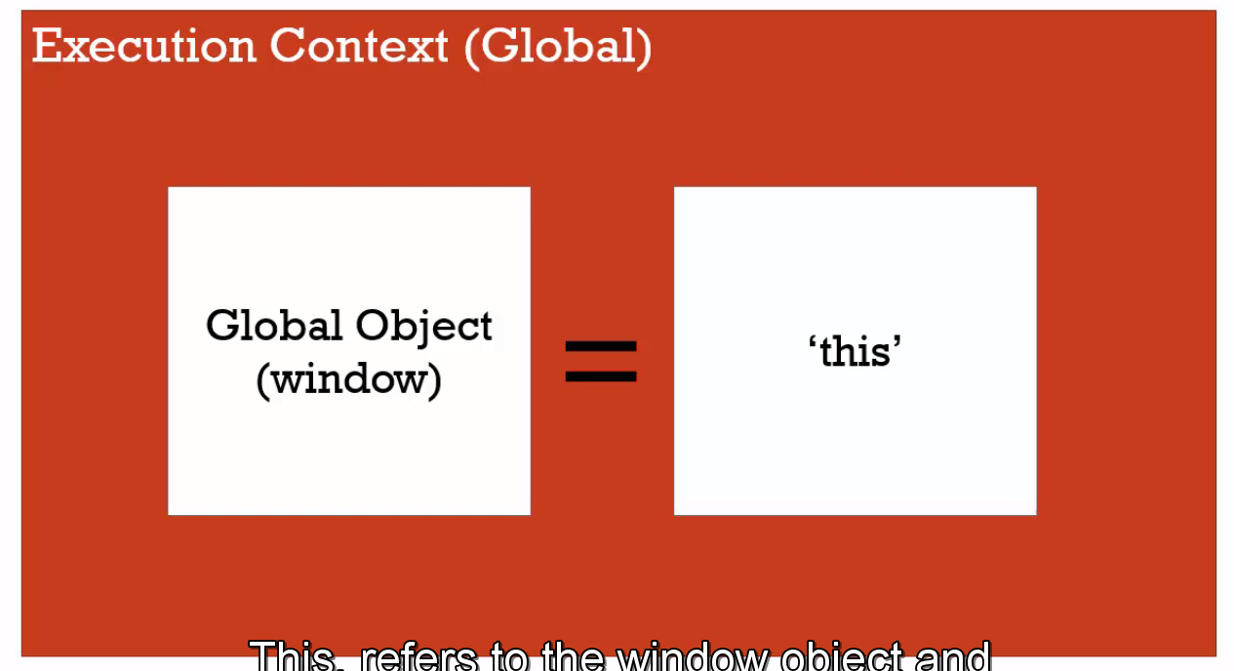

- In JS, global means code or variable that are not inside a function.
- In JS, if we create variables and functions and if we are not inside a function, then those variables and functions get attached to the global object. For example, if I create following js file:

var a = 'Hello World';
function b() {
}

Then this variable 'a' and function 'b' get attached to the global 'window' object.
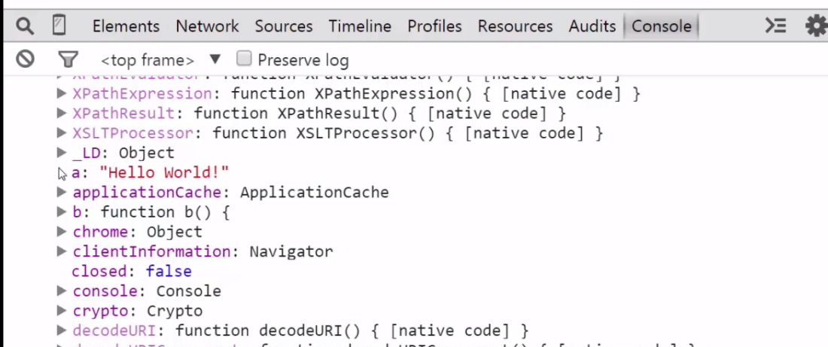

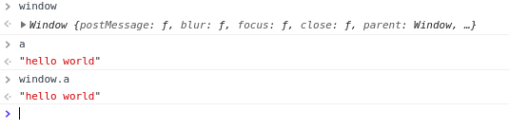
Important:
- When code is executed, an execution context is created.
- At the base level, when we are not inside a function, we have a global object that the js engine creates for us as part of that execution context.
- If we are running inside the browser then the global object is called the window object.
- We also get a special variable called 'this'.
- In case of the browser, 'this' is equal to the 'window' object at the global level.
- Apart from 'global object 'and 'this'. Js engine also creates a link to the 'outer environment'. This is null at the global level and only matters when we are in the execution context of some method.
- so we are only writing our code, but JS engine is giving as ‘Global Object’, ‘this’ and `outer environment’ wrapped with the code inside an execution context.

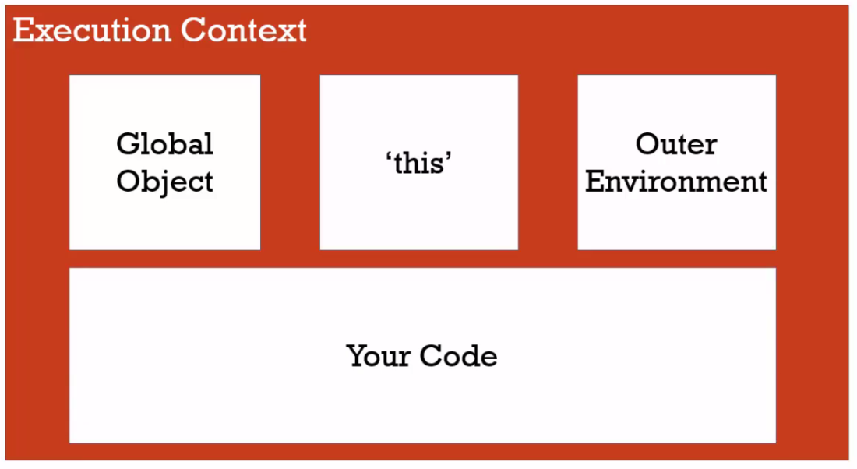

Execution Context: Creation and hoisting:
- execution context is created in two phases.
a) Creation Phase
b) Execution Phase
- Before the code is executed line by line, the js engine sets aside memory for the functions and variables that we have created.
- This happens during the execution context ‘creation phase’
- This feature is called hoisting and enables us to call the function even before it is declared in the javascript file.
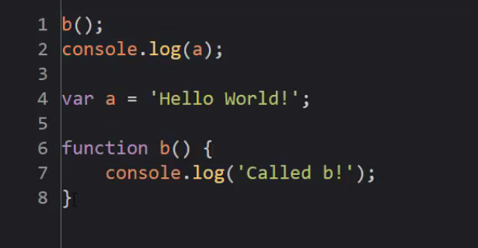
- Here we are using 'b' and 'a' before they are declared or defined in the code.
- In this, the function is entirely placed in the memory with all its code. This is not the case with variables. For variables only memory is assigned to the variables (with a placeholder value of undefined) and its actual assignment actually happens when the code is run.
- So all variables are initially set to undefined but all functions are placed in the memory in their entirety.

Undefined in Javascript:
- Undefined in javascript means that the value of the variable has not been set.
var a;
console.log(a)
- It would result in undefined. Undefined a special keyword that tells that variable has not been set to a value. It's like a placeholder.

- Never set a variable to 'undefined'. Always let the execution context of the js engine do it during the creation phase.

Execution Context:
- The execution context of the js engine has two phases:
a) Creation phase: sets up variables and functions in memory.

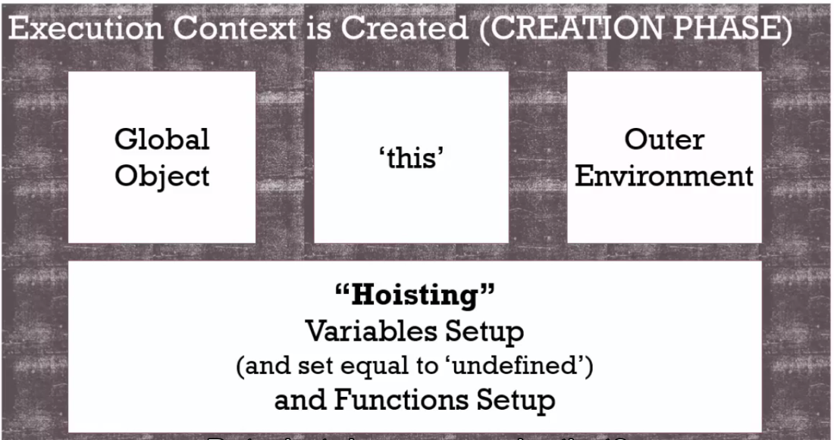

b) Execution Phase
- Runs the code line by line.

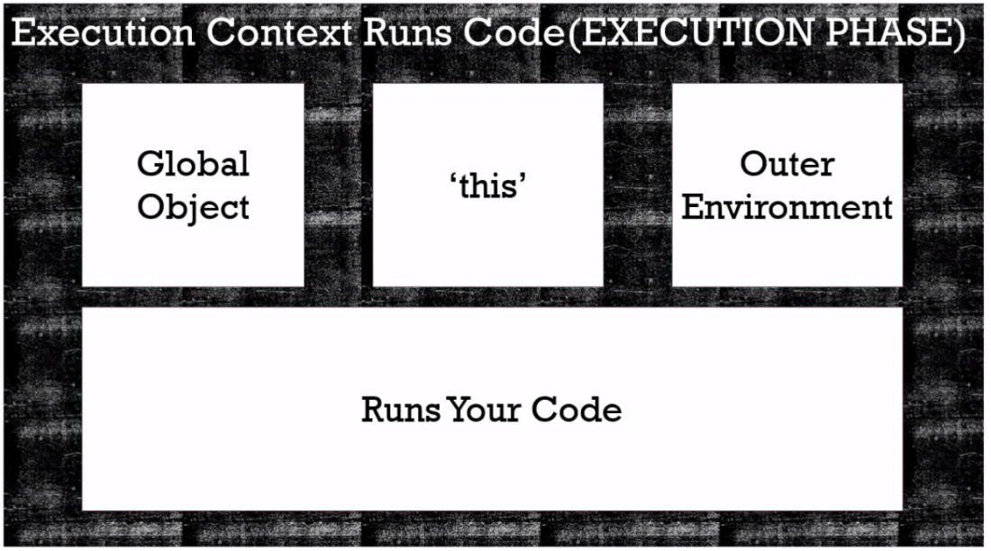

---------------------------------------------------------------------------------------------------------------------------

Single Threaded Synchronous execution:
- Javascript is a single threaded with synchronous execution language
- Single threaded: One command is being executed at time.
- Synchronous - One at a time and in order.
- In Javascript only one thing is happening at a time.

Function invocation and execution stack:
- Invocation: running/calling the function by putting () after the name of the function.
- Every time we invoke/call a function in javascript, a new execution context is created and put on the execution stack.
- So for every function call, we have a execution context with 'create' and 'execution' phase.
- Every time a function is invoked, even if its invoking itself, then new execution context is created.

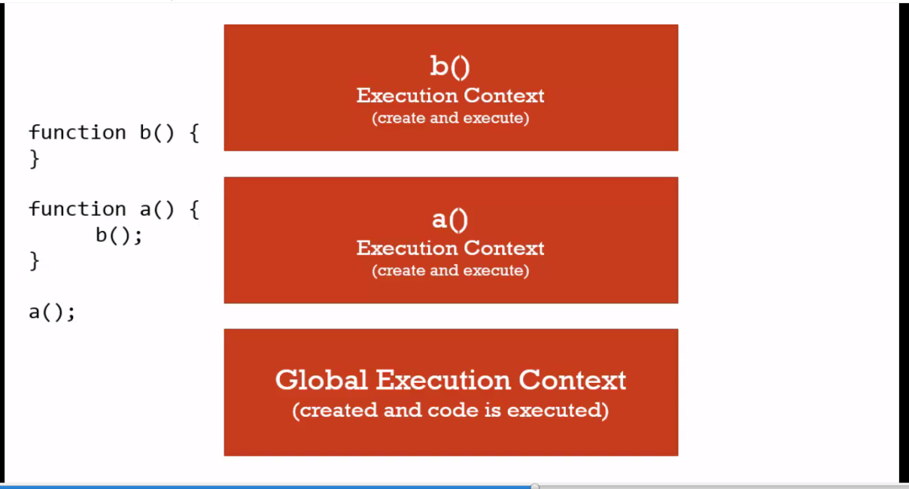

Functions, context and variable environment:
- Variable Environment: Where the variables, that we have created, live. And how they related to each other in the memory.
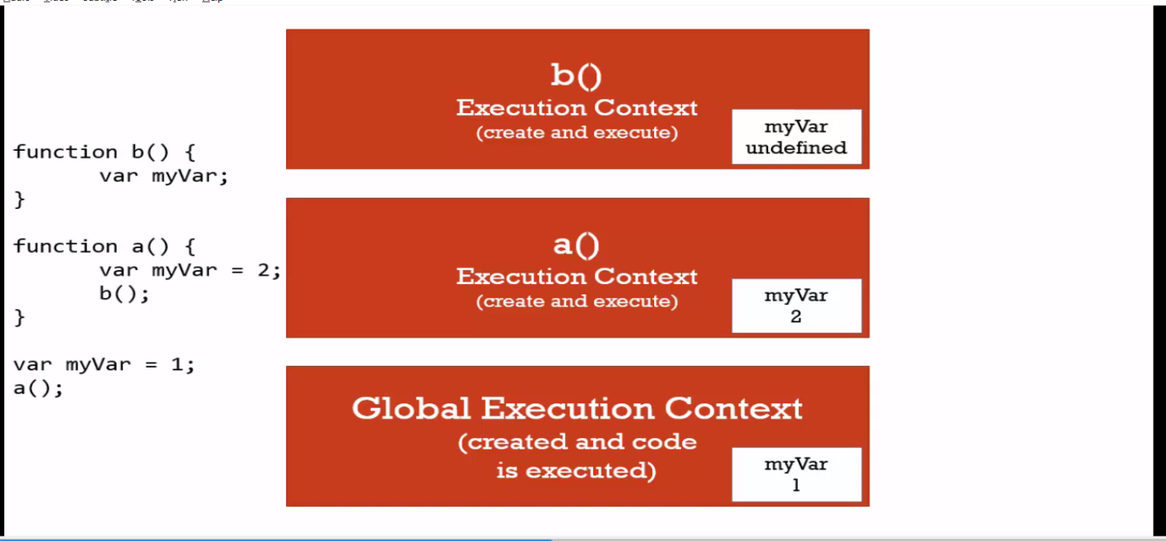

Here variable 'myVar' is declared three time in three different execution context, so they are distinct and they don't touch each other.

Scope Chain:
- The execution context also creates a reference to the outer environment. So if a variable is not found in the execution context, its then checked in the outer environment.
- Scope is where the variable is available in the code.
- This feature of understanding the layer of outer environments is called Scope Chain
- Helps to find a variable if it's not defined inside a function.
- The idea is to check in the current execution context, if the variable is not there, then look into the lexical environment of the outer execution context.
- Where a function sits determines its outer environment reference. If a functions sits inside a function, then that outer function is its outer environment.
- Scope means where a variable is available in the code. And if its truly the same variable or a copy of it.
- The outer reference of a variable depends on where the function is sitting lexically.
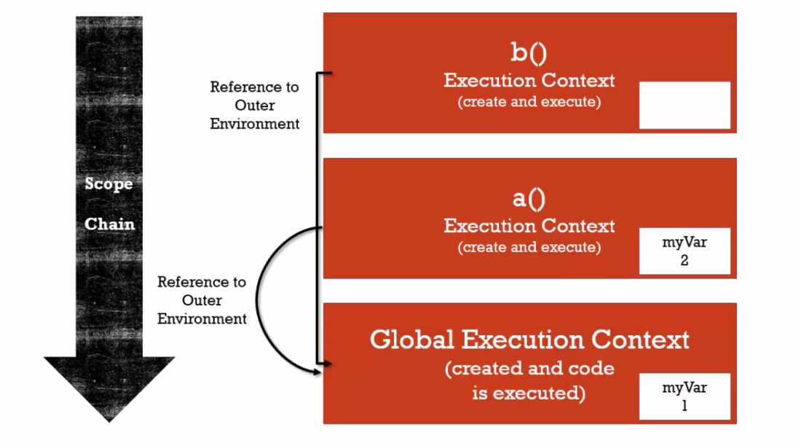
- Good way to check the outer lexical environment is to check where thing is actually created.

Let vs Var:
- Both can be used to declare a variable interchangeably.
- Let is used in ES6 and not in vanila js
- Let does not support hoisting. That is, we can used a variable before declaring it when using ‘let’.
- Let also creates block scoping, that is, a variable can only used in the scope (or function) in which
it is created.

Asynchronous Call backs:
- Asynchronous - More than one at a time.
- JS engine is synchronous and executes code one at a time.
- In a browser, apart form JS engine, there are other things as well, like the rendering engine (to display the screen), http request, etc.
- JS engine has hooks that it uses to talk to rendering engine or http request.
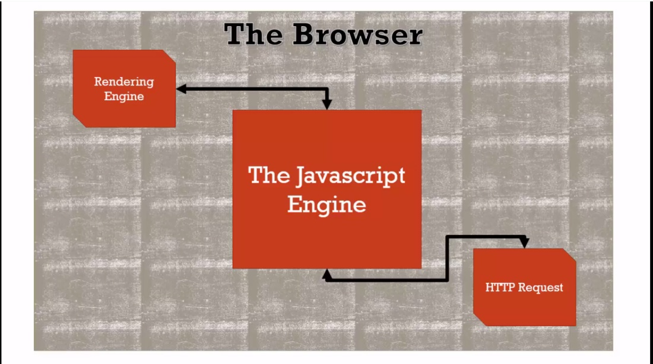

- JS engine, apart from execution stacks, has something called event queue.
- This event queue has notification of events that might be happening.
- So some action performed outside the js engine, is placed on the queue.
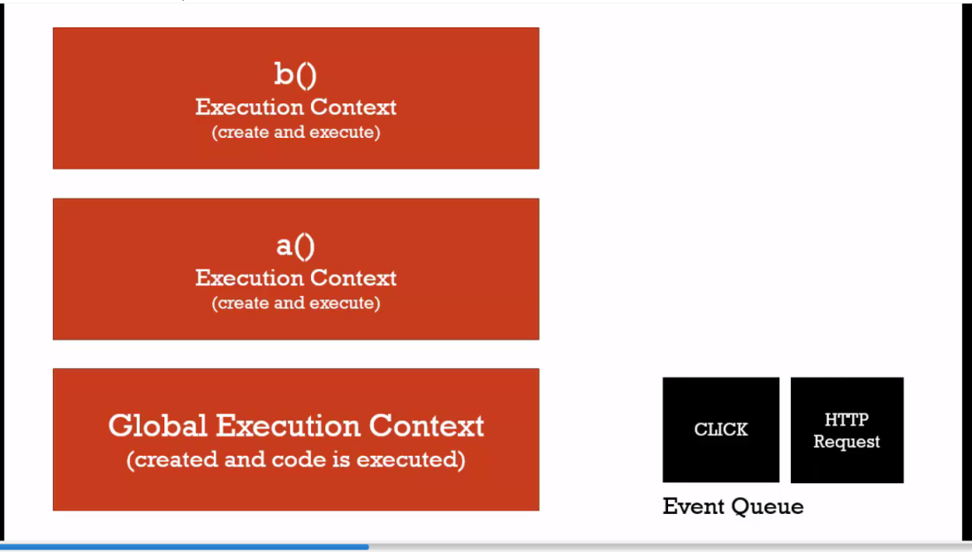

- The JS looks into the Event Queue only when the execution stack is empty.
- JS looks into the event queue to see if some other execution needs to be created for any event inside the event queue.
- So js in not asynchronous, it’s the browser that puts things asynchronously into the JS engine's event queue.

For example, look at the below example.

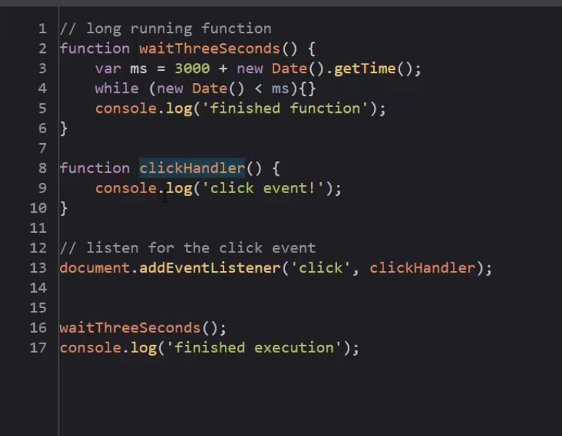

The order of execution will be:
- Finished function
- Finished execution
- Click event!
Because the clickhandler added the event into the event queue and it runs at the last when the js engine execution context is complete.

Types in javacript
- Dynamic typing is used in javascript.
- We don't tell js what kind of value a variable can hold. Js identifies that itself during execution.
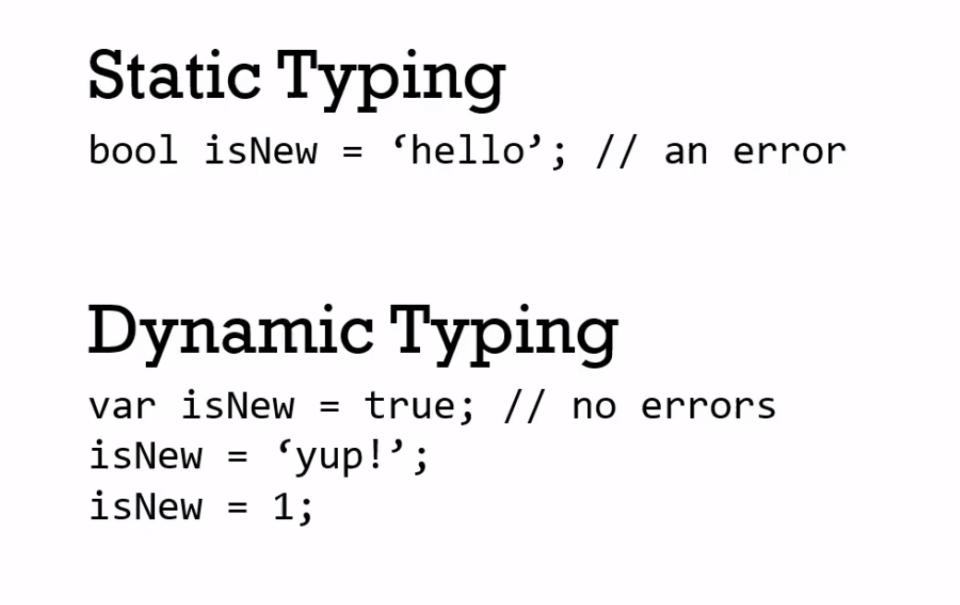

Primitive Type:
- Type of data the represents a single value, that is, something that isn't an object.
JS has 6 primitive types
- Undefined (set by js engine during execution context creation phase).
- NULL: means that the variable is set to nothing. Use this instead of 'undefined'.
- Boolean
- Number.
- String: both ‘’ and “” can be used to represent a string
- Symbol : used in escript.

Coercion:
- JS engine can change type of a variable during operators action.
- This is called coercion.
var a = 1 +’2’
this returns 12 as js engine converts number 1 to string ‘1’

console.log(3<2<1) // true
console.log(false<1) // here js engine coerces `false` to 0. So output is true.

We can use the `Number()` function in the JS console to verify the coercion.

Associativity and Precedence and coercion are important to know when working with Operators as they may return different output than what we may except

if we use types other than bool in || operator, then it will return the first value that can be coerced to ‘True’.
For example:
0 || 1 should return 1

Comparison Operators: == vs ===
- == uses coercion to help convert the operands to same type to some extent.
- Because of this we may see strange results when using == operator. For example.
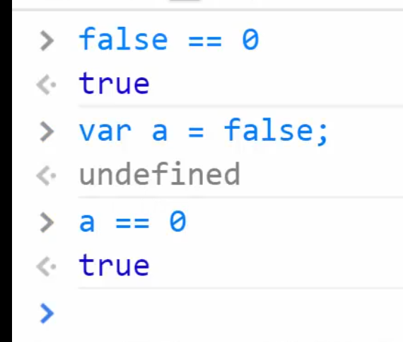
- === is strict equality which does not use coercion when comparing two things.
- So always try to compare two types which are of same types.
- use ‘==’ only if we want coercion.
- 99% of time use === by default.

Objects and functions
- Objects are collections of name-value pairs.
- These values can be either a property or a method:
- Property - a primitive
- Property – An Object.
- Method - Object can have functions associated to it. These functions are called methods.

Object is sitting in memory and has references to the addresses of these different values (primitives, other objects, methods) which also live in the memory.

- How objects live in memory:
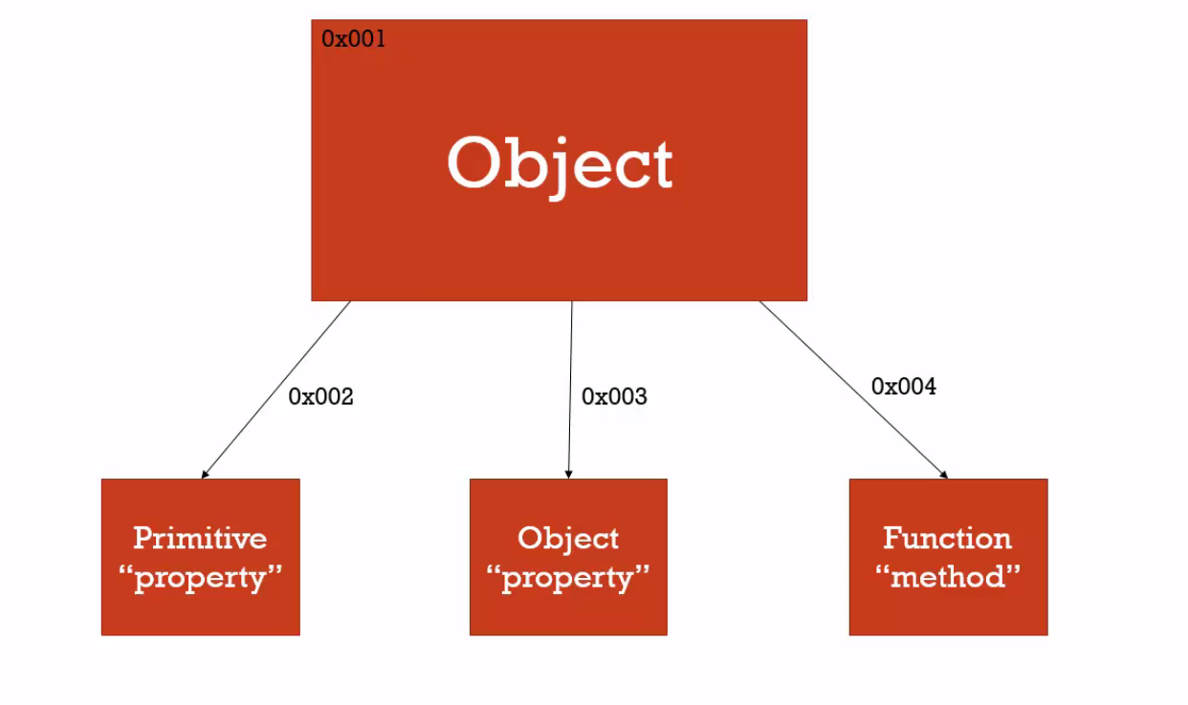

- So object is sitting in memory and has references to other things (properties and methods) associated to it.
- Both Brackets and dot operator can be used to create and access object properties.
- Creating a new object:
var person = new Object();
person['firstName'] = 'Santosh';
Person['lastName'] = ' Pillai';
Person.address.street = '2C/46';
Person.address.city='Faridabad';

console.log(person['firstName'])
console.log(person.firstName)
Console.log(person.address.street)

- To access the members of the object, we can use [] or dot operator.
- Dot operator is the preferred way.

Objects and Object Literals:
- We can create object using the object literal syntax as well.
- var person = new Object() is not the preferred way to create a new object in JS.
- bar person = {} // object literal. This is a shorthand and preferred way to create the object.

- Var person = {firstname: 'Santosh', lastName: 'pillai' }

- Two ways of creating objects in JS :
  - 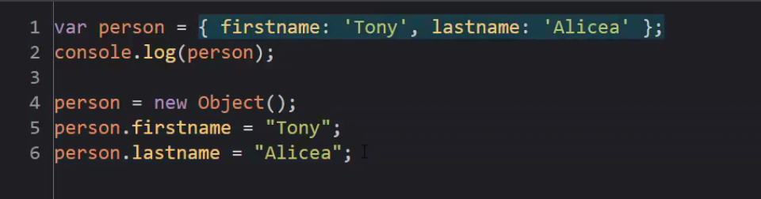

- Second one is more preferred where we use the object literal syntax.
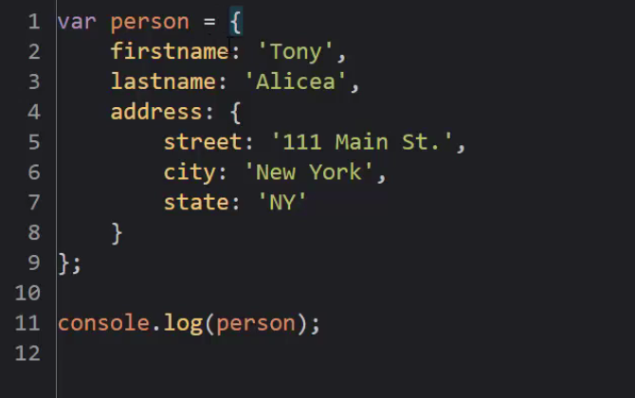

----------------------------------------------------------------------------------------------------------------------------

Faking Namespace:

- Namespace is container for variables or functions.
- Used the keep the variables and functions with the same name separate
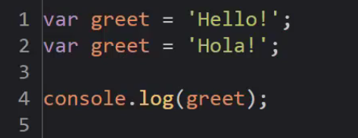

- Here ‘greet’ and ‘greet’ if coming from different frameworks will cause collision.
- In js we don't have name space, so we can fake it by wrapping them around object literals.
- The ‘english’ and ‘spanish’ object will act as a container or fake namespace

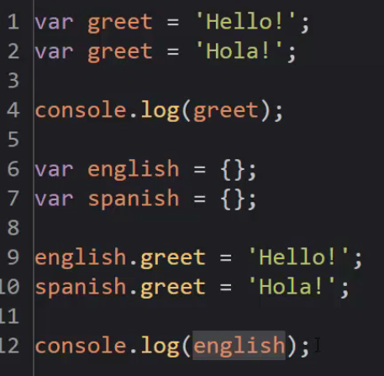

Json and Object Literals:
- Object literals is a way of creating objects using {} braces.
- Json and object literal (though have similar syntax) are not the same.
- In json, the properties have to wrapped in double quotes. In Object literal syntax, double quotes around the properties is not mandatory
- Anything that is json valid, is also a valid js object literal syntax, but object literal is only a json if properties are in double quotes.

JSON in built in method in js.
- JSON.stringify(jsobject) - will convert the object to a json string.
- JSON.parse(string) will take a json string and covert it into an object.
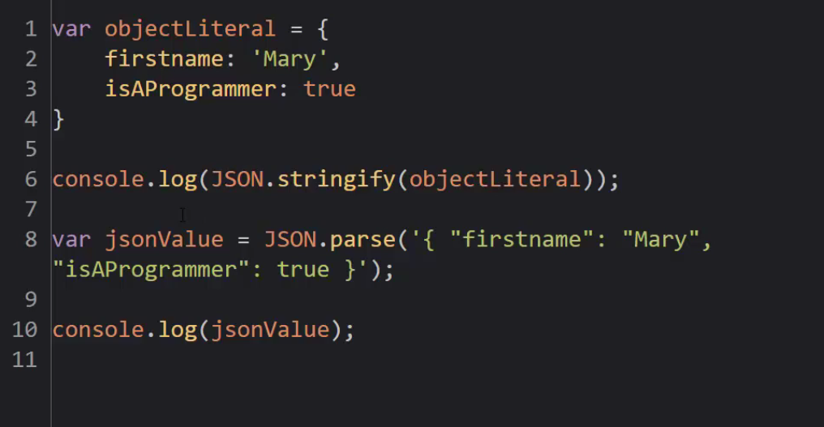

Functions are objects:
- IMPORTANT: in JS functions are objects.
- First class functions: Any thing that we can do with other types (object, string, booleans, etc) can be done with functions. Like assign them to variables, pass them around, create them on the fly.
- Function object like any other object resides in the memory.
- Function object have some hidden special properties like name (optional) and Code (the actual code inside the function.
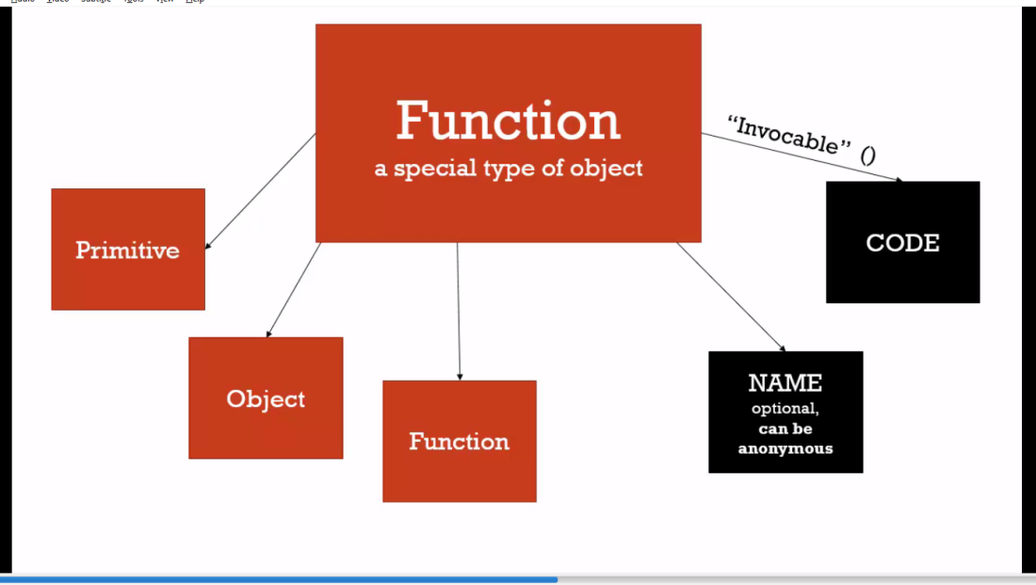

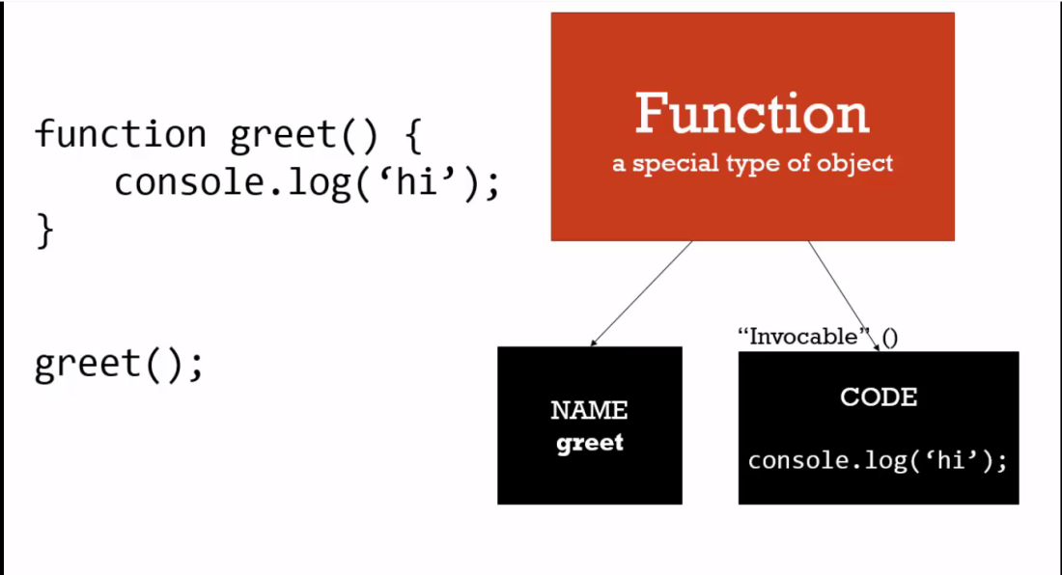

- Above, we can go ahead add a property to this function.
greet.language = “english”
console.log(greet.language)
This will work without any error.

Functional Expression and Functional Statement:
- A functional expression is something that results in a value.
  - 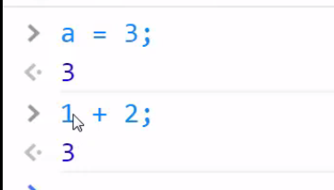

- A functional statement is something that does not result in a value.
- In JS, we have both functional statements and expressions.

- Function Statement:
  - 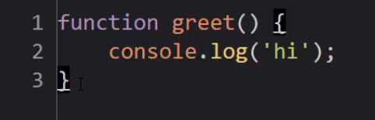
- It does not return a value hence a function statement.
- The function is put into the memory, but it doesn’t return a value.

Function Expression:
  - 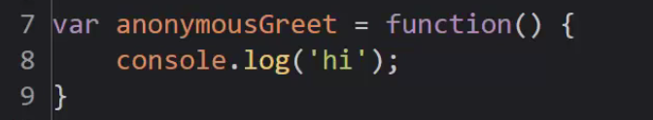
- Here, an anonymous function is created. Its stored in the memory at some address, and anonymosuGreet variable is referring to that memory address.

- And we can invoke this function using the reference variable
  - 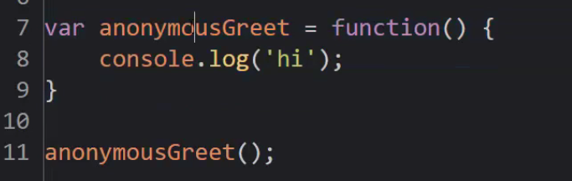

  - Passing function as argument to another function
  - 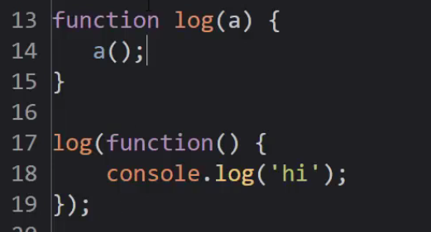

By Value and By Reference:

BY VALUE:
a = 3 // stores 3 in memory and 'a' points to the address in the memory.
b = a // b points to another location in memory that has a copy of 3.

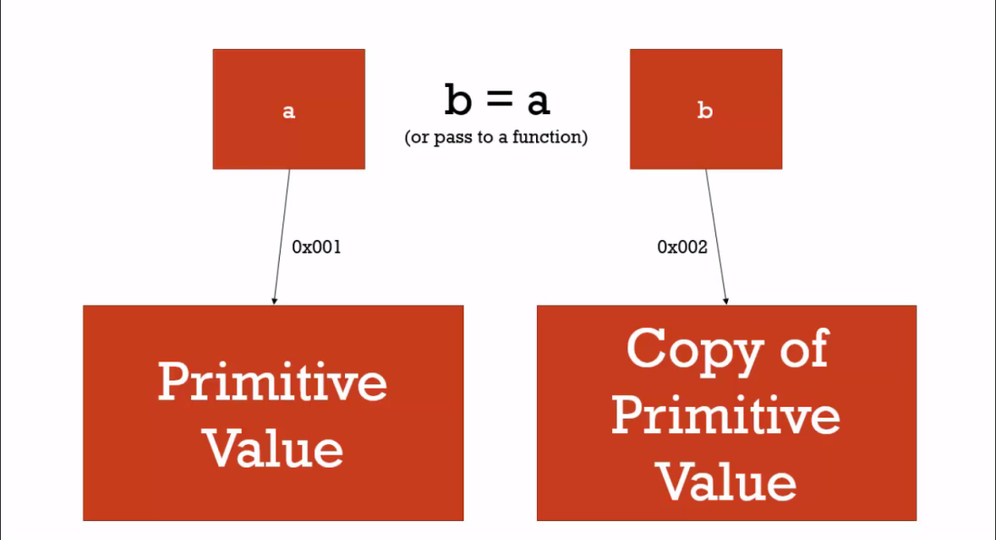

  - This approach is called 'by value'. This works in case of primitives only.
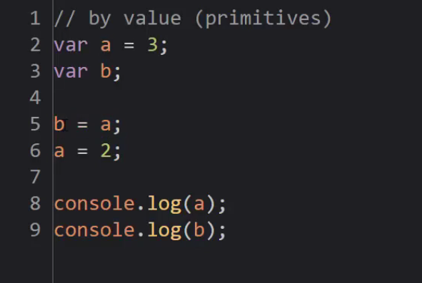

BY REFRENCE:
a = someobject // a points to the memory address where object is present.
b = a // b points to the same memory address and no copy is created.

This is called by reference.

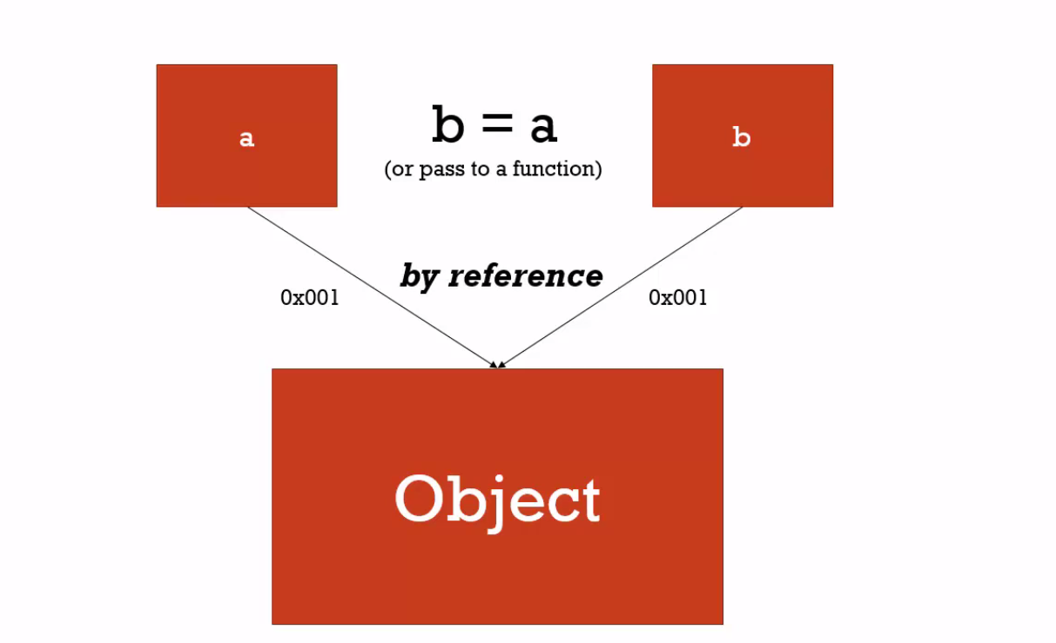

Important: All objects are 'by reference'. (even if they are passed to a function).

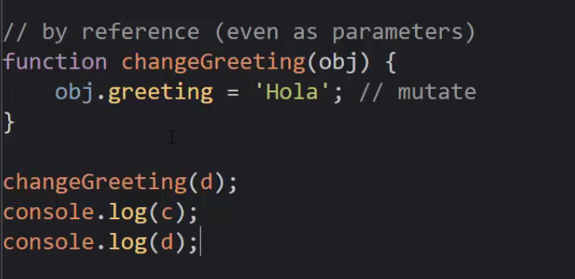

Important: The equals operator always creates a new memory and assigns the variable to that memory if the object of the right does not exist. The following will create a new object and point 'c' to that. So now, 'c' and 'd' are pointing to different objects (memory locations).

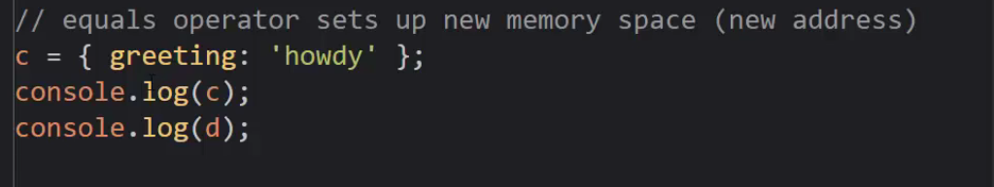

18: Objects, function and this :
- when a function is invoked a new execution context is created.
-A function is an object created in memory having 'properties', 'Name' and Code 'property'.
-JS engine creates a 'this' variable when execution context is created or a function is run.
-'this' will be pointing to a different object depending on how a function is invoked.
  - In the global execution context, 'this' refers to the 'window' object.
  - On simply invoking a function, 'this' will still refer to the global 'Window' object.
This is true in case of both function statement and function expression.
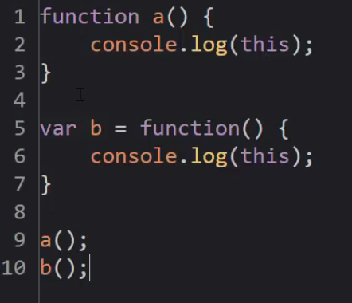
  - Above example, both console logs will give global window object.
  - Note: Any variables assigned to the global object, can be referenced directly.
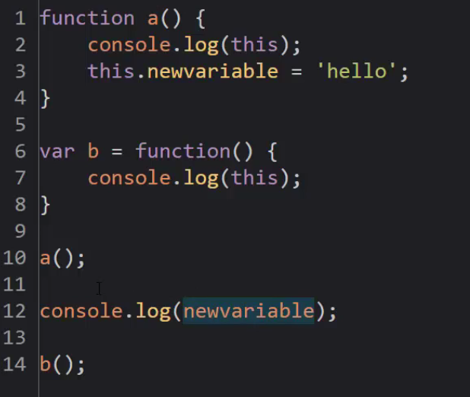

  - In above example, since 'this' keyword in the function 'a' is attached to the global namespace,
'newvariable' created using 'this' gets attached to the global execution context as well, and hence we are able
To call it directly without any dot operator.

  - If a function is attached to an object, then the 'this' keyword created (on invoking the method) gets attached to the object, where the method is sitting inside.
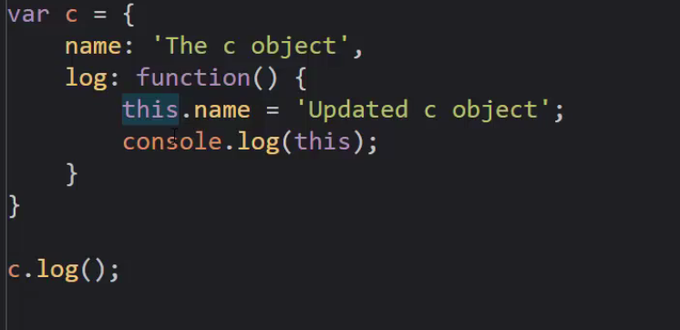

  - Here function 'log' is created as a method for 'c' object.
  - So the 'this' keyword is referencing the 'c' object present in the memory and not the global window object.
Important: In JS, when we create another method inside an object method, then that inner method's 'this' will
Always refer to the global window object.
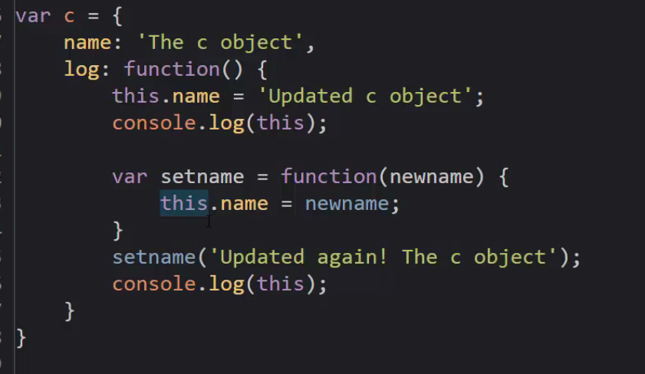

  - Here, the 'setname' function will create a new variable 'name' in the global 'window' object as the 'this'
Used inside 'setname' refers to the global object.
  - This is very strange behavior in js engine.
  - To avoid any problem due to this behavior, we can create a new variable pointing to the 'this' variable of the outer 'log' function and use the variable in the inner method.
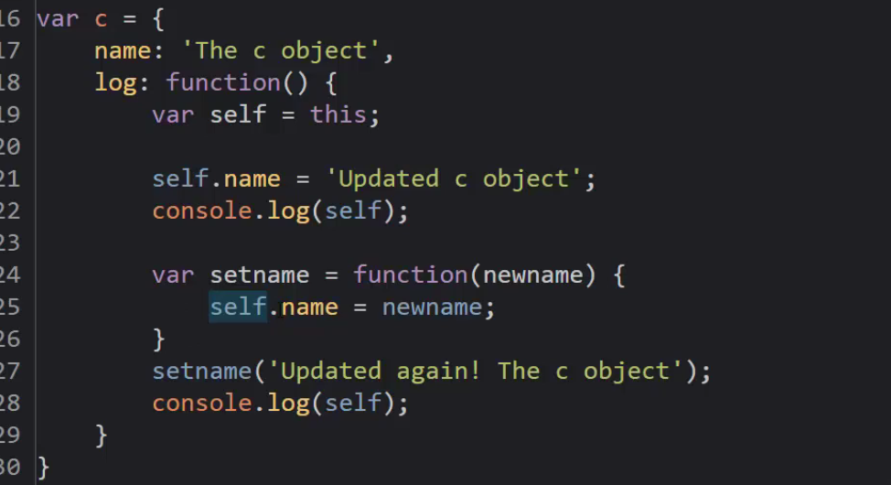

  - Since 'setname' does not have any 'self' variable, the js engine will look into its lexical environment (down the scope chain), that is, outer environment and get the 'self' keyword from the 'log' method.

19 - Arrays:
  - It’s a collection.
  - Holds many things inside it.
  - Creating arrays in JS:
var arr = new Array()
or
var arr = [ 1, 2, 3,] // array
syntax.
  - JS arrays (since js is dynamically type) can contain any data type (number, string, objects or functions).
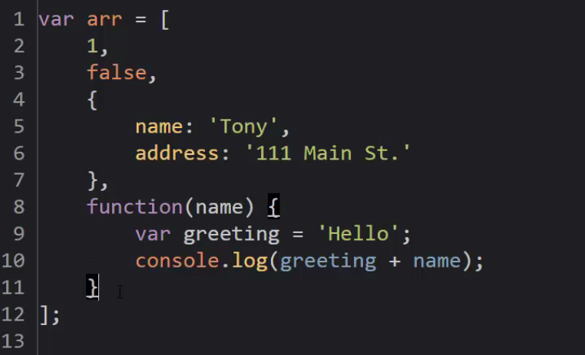

  - Arguments and spread:
  - Arguments is a special keyword, created during Execution Context creation phase, and it’s a list of all the values that we pass to the functions.
  - In general, arguments and parameters are the same things used interchangeably, and are passed to a function.
  - But JS, creates a keyword with the 'arguments' that contains the list of arguments passed.

  - Its ok not to pass the parameters when calling a function in js.
  - As these parameters were assigned undefined values during execution context creation phase.
  - Below example works without any error
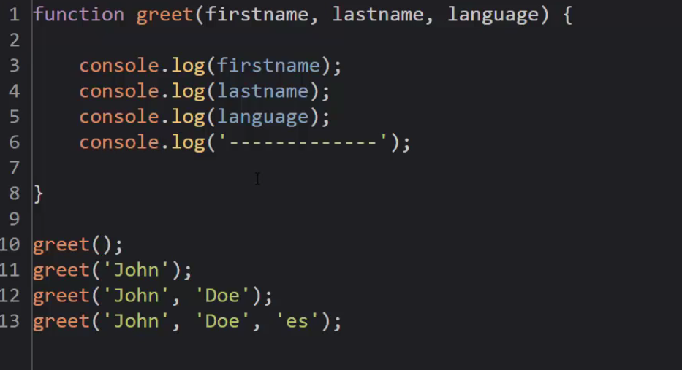

  - Console.log(arguments) - will give an array like object containing all the parameters passed on to the function.

SPREAD parameter:
  - To add … notation in the method to pass arbitrary number of arguments to a function.

21 - Function Overloading:
  - Its not supported in javascript, but there are other patterns we can use to achieve this.
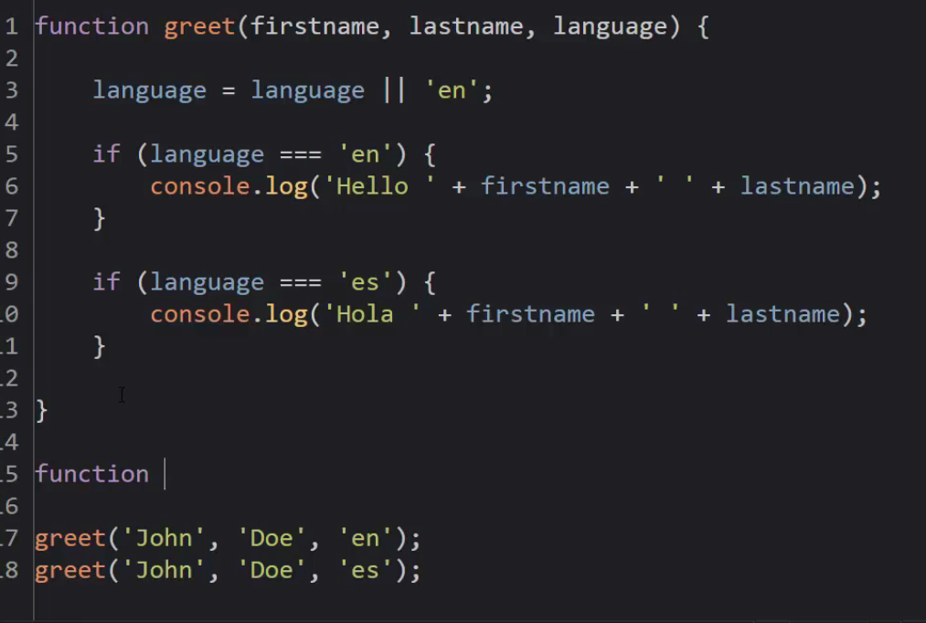

  - Syntax Parsers:
  - Validates our syntax character by character to check for syntax.
  - Syntax parsers try to insert a semicolon in our code.
  - Even though semi colons are optional, its always important to put your own semi colon.
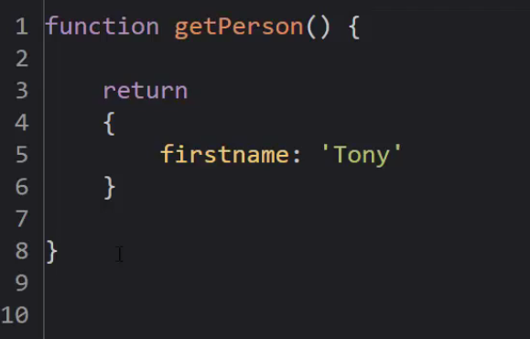

  - In the code above, the syntax parser will see the 'return' statement, inserts a semicolon and returns undefined.
  - So its always advised to use semi colon, whenever its needed.

  - Whitespace:
  - Invisible characters that create space in our code, like carriage return.
  - We can use white space liberally in our js code
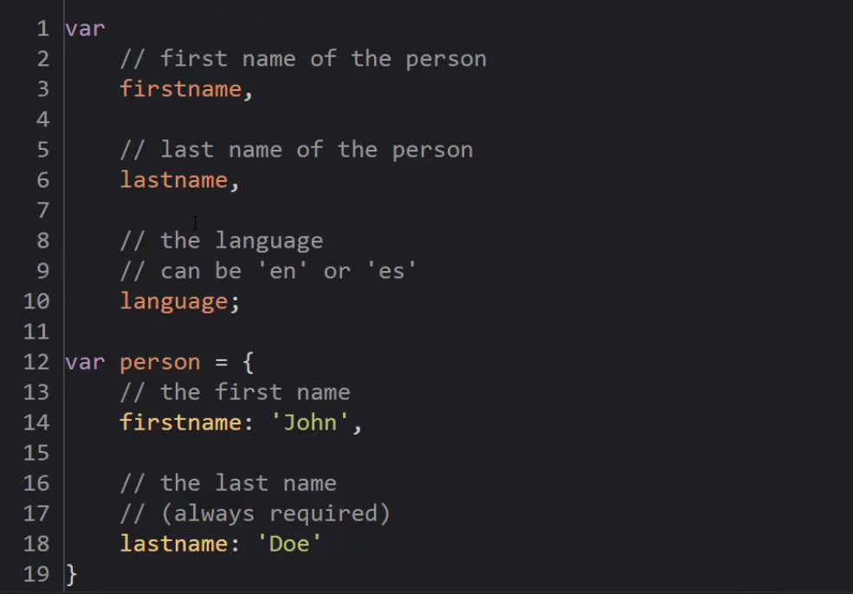

  - Immediately invoked function expressions:.
  - Like discussed, a function be used as a function statement and function expression.
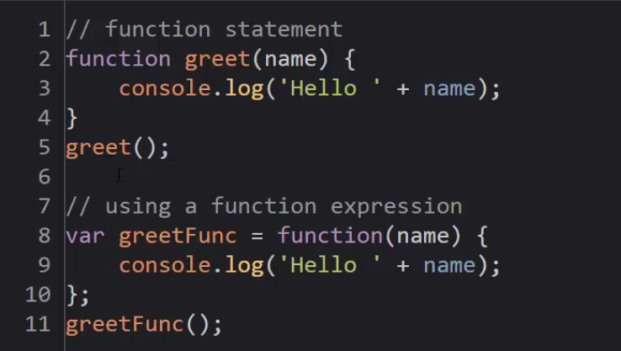

  - Function has a special 'Code' property that we can invoke using ().
  - Function expression can also be invoked immediately after its object gets created by adding () after it.
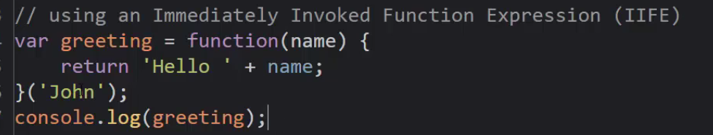
  - Here the greeting variable will not have the function object, but instead will have the string return value.
  - So using 'greeting()' over here will cause error.

  - The following code will give error.
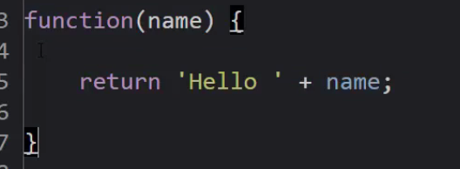
  - The syntax parser reads 'function' and expects it to be having a name but sees () instead so gives an error.
  - To solve this we can put this function in inside braces ( we can have expressions inside braces like (3 >4)).
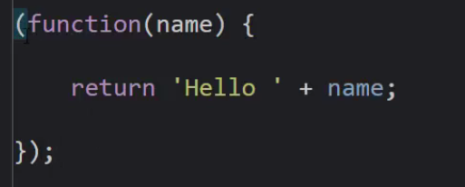
  - So once placed inside braces, the syntax parser will think this function as an expression.
  - We can also call this function at the same time we are creating it using () at the end of the function.
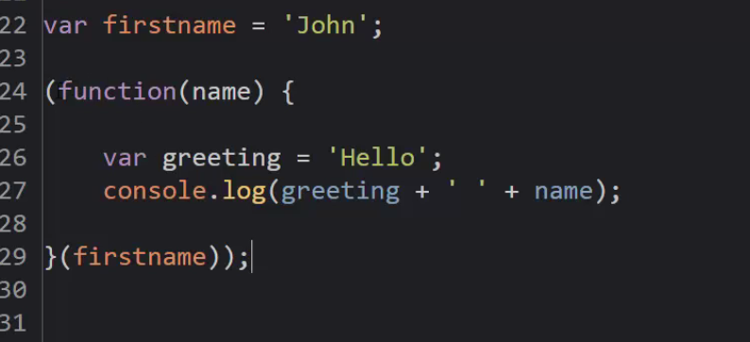
  - This is a very good example of IIFE
  - Here we are just executing a function on the fly.
  - We can invoke this method from both inside the parentheses and from outside is as well. Both are same.

IIFE and Safe code:
  - Some javascript frameworks wrap all their code in an immediately invoked function.
  - This is because when their code is inside braces, the execution context creates a separate execution stack to run this function and because of this variables , methods and other things insides this function don't collide with some other variables from other library being used in the same project.
  - For example:
  - 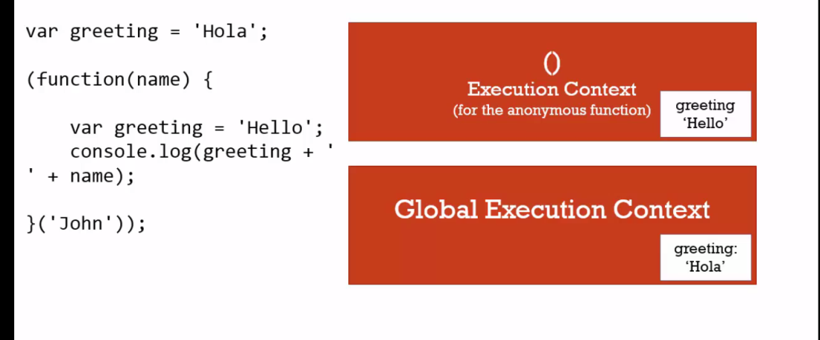
  - In the above code, suppose greeting (hola) was a variable in some other js library.
  - Our library also has a 'greeting' variable but everything is wrapped inside ().
  - So both the greeting variables will be treated differently resulting in a safe code.
  - So by keeping our code inside braces we are :
  - Eliminating any name collision.
  - Not putting anything accidently inside the global context.
  - Making our code safe as we can't unintentionally modifying any global object.
  - 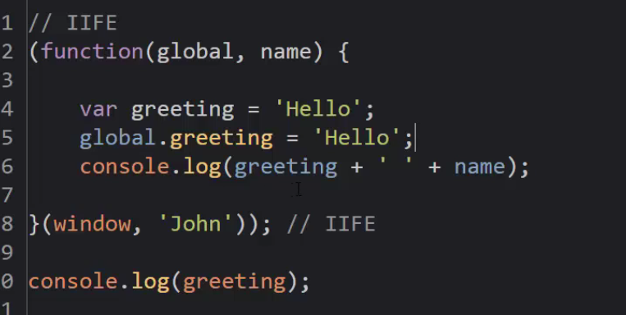

  - Closures in JS:
  - A phenomena by which an execution context has access to all the variables from its outer execution context (even though its completed) is known as closures.
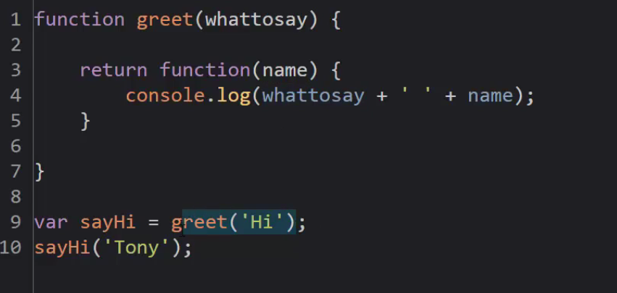

  - Here the output is 'Hi Tony'.
  - The sayhi is function when greet is called.
  - Greet's execution context is popped off when its completed. But its variable 'whattosay' is still there in the memory.
  - When Sayhi does the console output, it could not find 'whattosay' in its execution context, so js engine's scope chain looks into the lexical environment (outer environment).
  - Though the lexical environment for sayhi ( that is greet) is popped off from the stack, but its variables are still in the memory and sayhi can access it.
  - So sayhi prints 'hi Tony'.

  - So even though an execution context is completed, any function created inside of it, will have the access to its memory.
  - Execution context has closed in on its outer variables even though the outer execution context is gone.
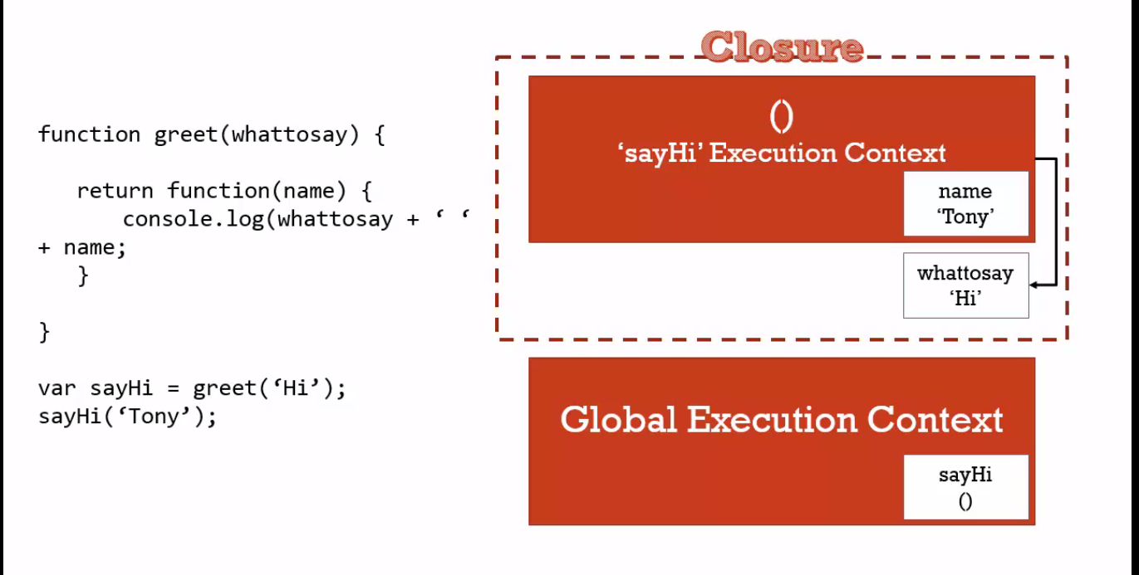

Important:
  - When an execution context completes and is popped off from the stack, its memory space (having its variables, etc) is still there.

Example on the internet about closures:
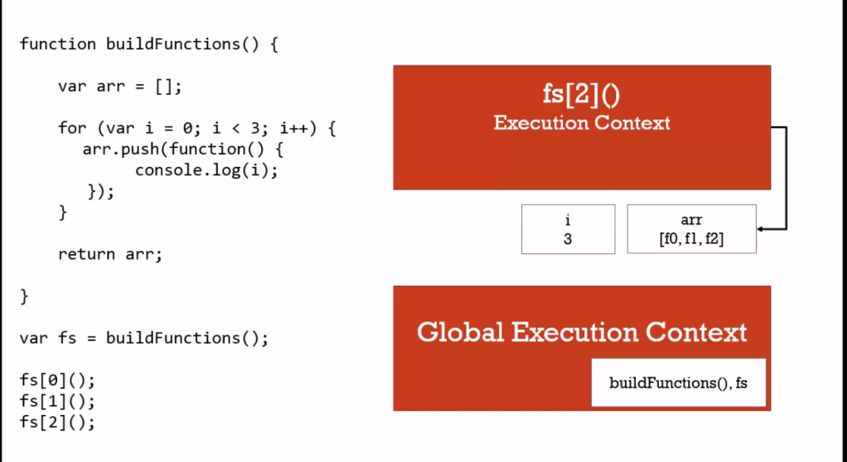

  - Using Closures - Function Factories:
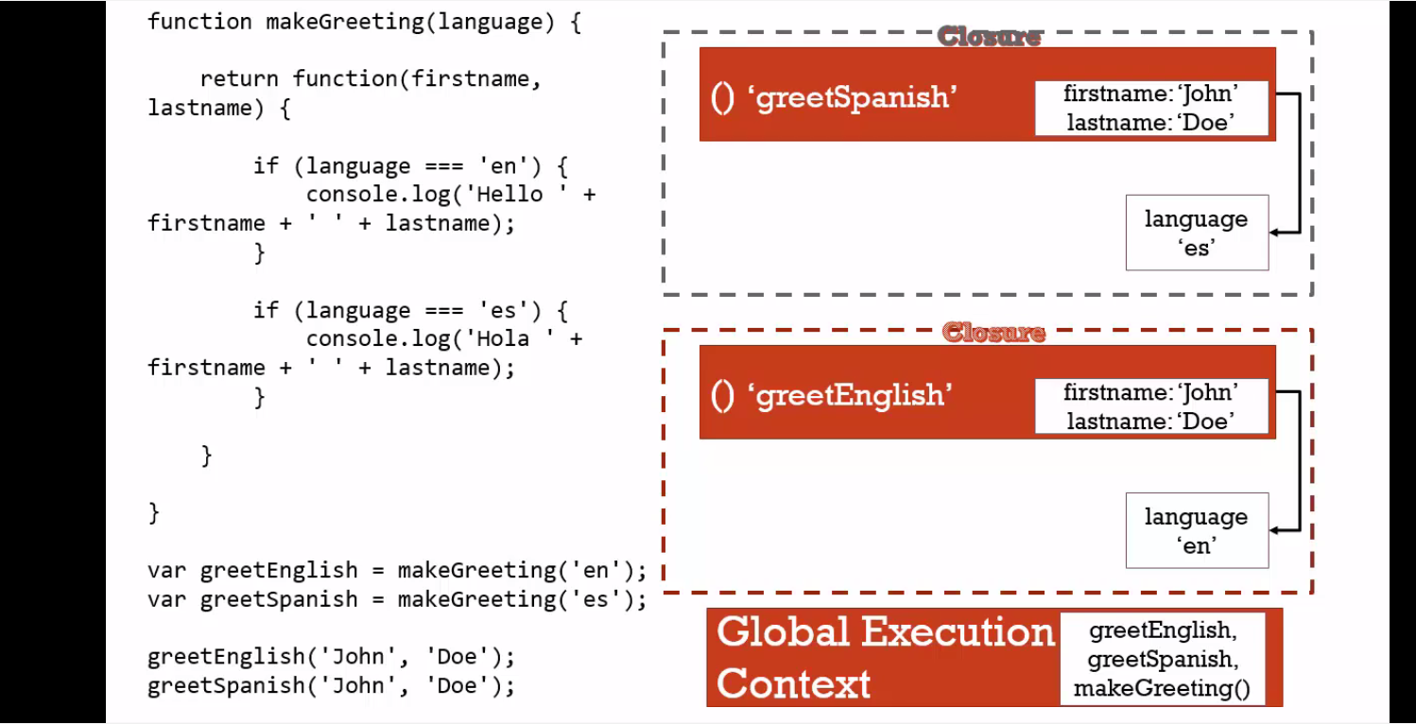

27 - Closures and Callbacks:
  - Callback function : A function given to another function to be run when the other function is finished.

28 - Call() , apply() and bind():
  - We can control what the 'this' variable ends up being when the execution context is created.
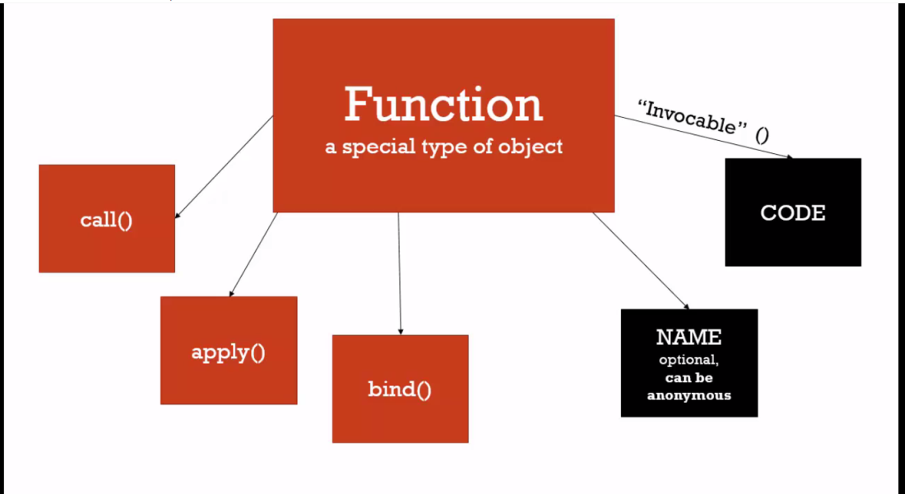
  - In the execution context, the function has following things:
  - Code (invocable).
  - Name (optional, can be anonymous)
  - Call()
  - Apply()
  - Bind()
  - The last three methods have to do with the 'this' object.

Bind method:
  - Can be invoked with a method name (object).
  - Takes an object as a parameter.
  - Returns copy of the method that invokes bind.
  - And converts the 'this' reference of method into the object that was passed as an argument.
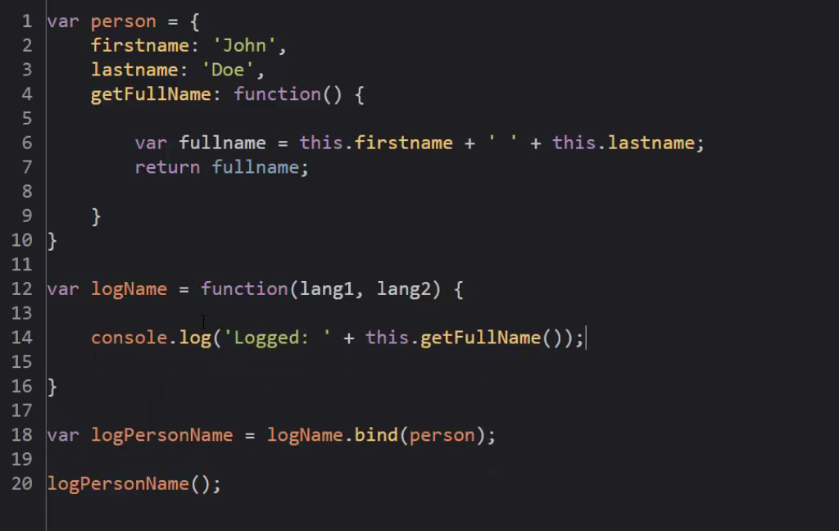

Call Method:
  - Works similar to invoking a function.
  - But it helps us to decide what the 'this' keyword of the method should point to.
  - methodname.call(object)
  - Unlike bind, call only executes the function. Does not create a copy of the function.
  - Call method executes the function.

Apply Method:
  - Exactly similar to 'call' method.
  - But takes the additional arguments as arrays.
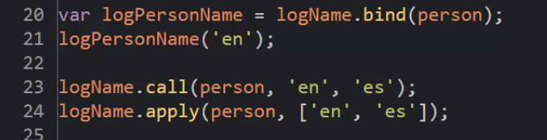

Use case:
  - Function borrowing: we can grab methods from other objects and use them as long we have the same property names.
  - Function currying: Creating copy of a method with a preset parameter. When bind is called with a parameter, it will ensure that the parameter becomes permanent in the copy of the method it created.
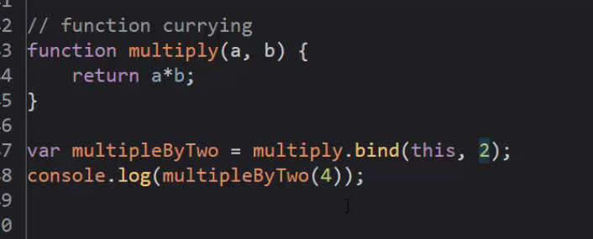

  - Here multiply.bind creates a copy of multiply and permanently assigns 'a' to 2

29 - Functional Programing: (IMPORTANT)
  - 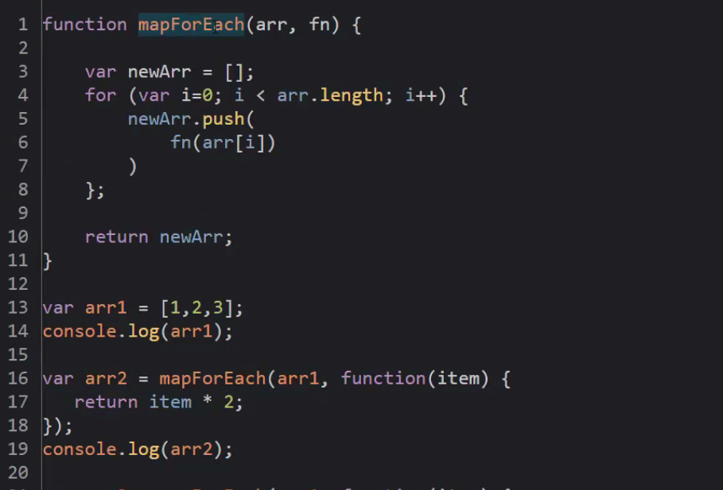

30 Object Oriented Programing in JS:
  - Inheritance : One object gets access to properties and methods of another object.
  - Js uses prototypal inheritance.
  - All objects in javascript have a prototype property.
  - Prototype chain : to check where we have access to properties and methods of an object.
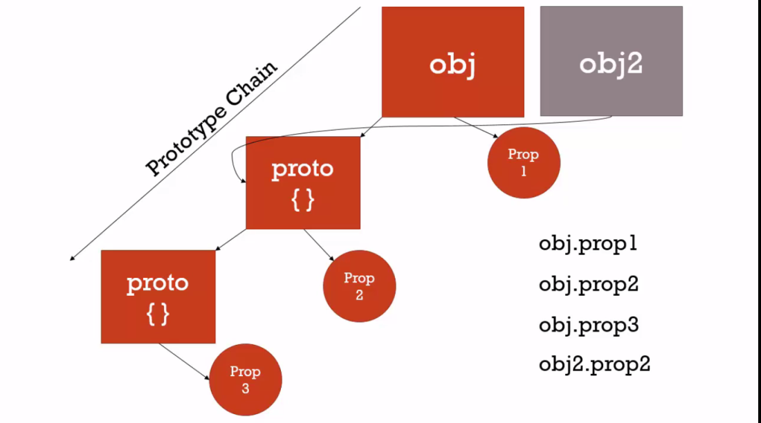

  - We can assign prototype of one object to another using following ways:
  - 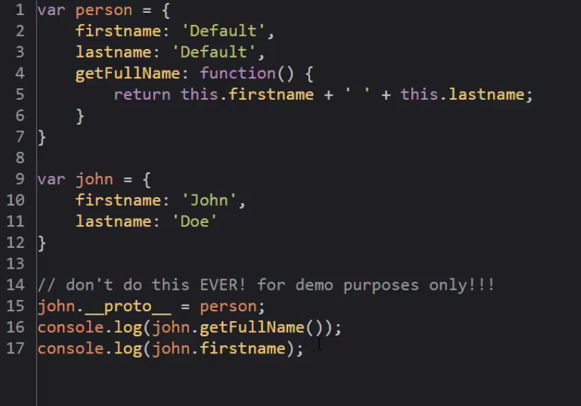

  - Using __proto__ is not a recommended way.
  - JS engine will start at the top of the prototype chain and search for the properties or methods untill they are not found down the chain.
  - All objects in JS have prototype, except the base object in javascript.
  - All arrays have prototype pointing to the object having the methods(push, length ) that we are using with the arrays. Similarity for funtions.

  - Reflection and Extend:
  - Extend is possible because of Reflection.
  - Reflection: An object can look at itself, listing and changing its properties and methods.
  - Extend: combines properties/methods of more than one object together.

  - Function constructors , new and the history of javascript.
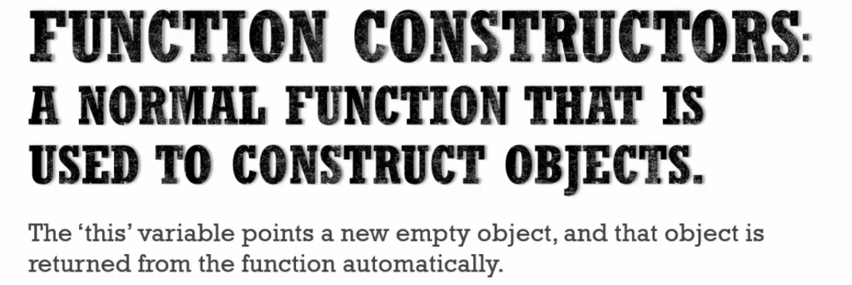
  - New is an operator in javascript
  - An empty object is created when we call 'new'.
  - Then the function after new is invoked.
  - On function invoke, execution context creates 'this'.
  - The 'this' variable points to the empty object created by the new.
  - As long as the function invoked after 'this' does not return anything explicitly, js engine will return the object set as the 'this' variable.
  - When we construct an object using a function. This function is called a function constructor.

  - 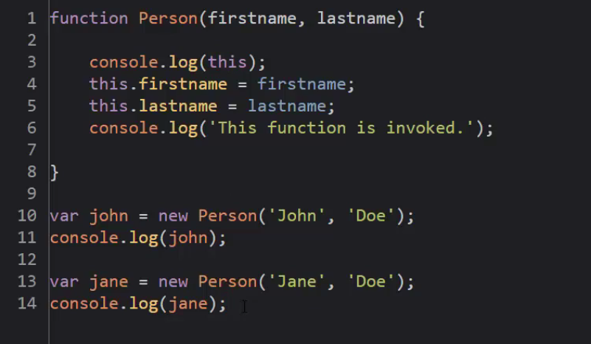

  - Function Constructor and prototype:
  - Function constructor already creates the prototype for us.
  - Every function (js object) has a prototype property, which comes into play we use the 'new' keyword before the function. ( that is we are using function prototype).
  - This prototype property is not the prototype of the function, but prototype of the object created if we are using function as a function constructor.
  - The prototype property starts its life as an empty object and we can add on to it.
  - var obj = new Person();
  - In the above function constructor , new keyword will create an empty object and assigns 'this' of the Person object to it.
  - Also, the prototype of Person object gets attached to 'obj'.
  - If I try to access any property or method with 'obj', if not found directly in obj, then it will search down the prototype chain, Person in this case..
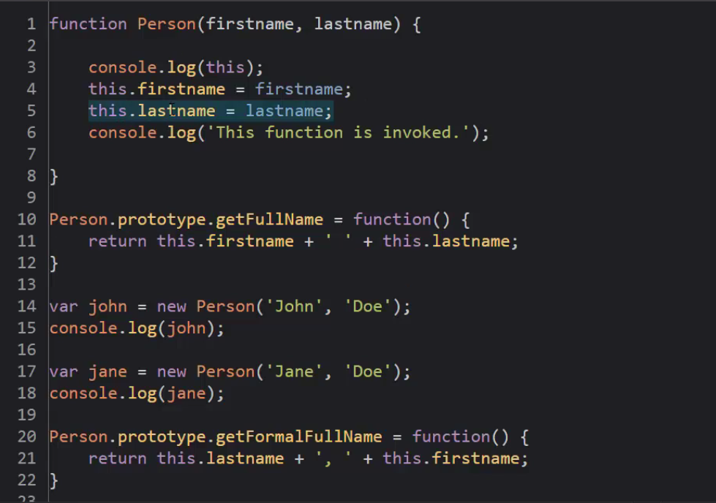

  - So any method added to the function constructor using the 'prototype' property, become available to all the objects ever created for the function constructor
  - It’s a good practice to add the methods as prototype to a function, rather than inside the function it self, because if added to a function, it will take more memory space as it will get passed on all the objects created for that function. If added using prototype, it will be created on once and can be used up by all the other objects.
  - By convention we create the function constructor name starting with a capital letter.

  - Built in function constructors:
-
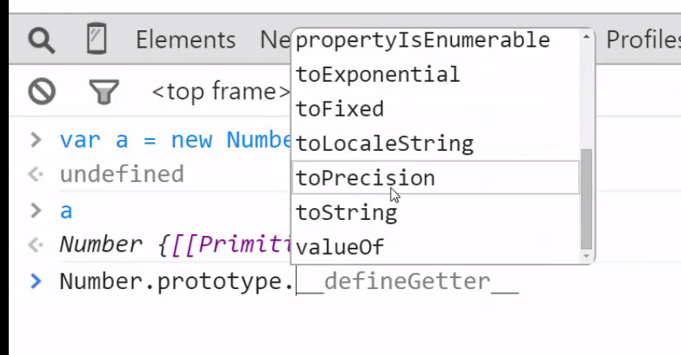

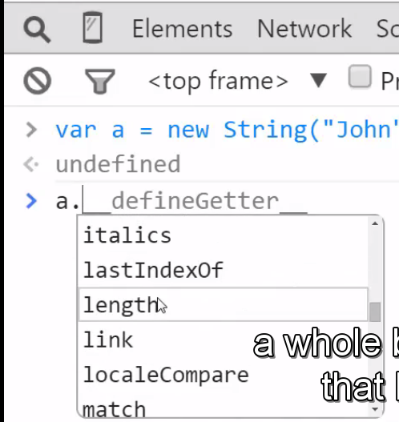

  - "john".length - The js engine boxed the primitive 'john' inside of the 'String' object and that helped us use the 'length' property available on the String Object with 'John.
  - We can also enhance the existing built in functional constructor and make all the objects to use that enhancement
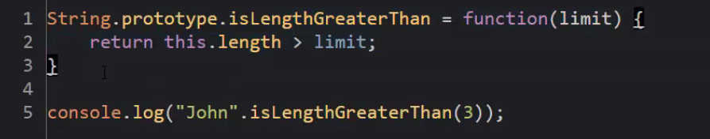

  - Note: Javascript only converts a 'string' to an object automatically. It does not convert a number. So any string literal will be converted to a string object and can access all the methods in String prototype chain. But an number does not have access to all the methods in the 'Number' function constructor prototype chain.
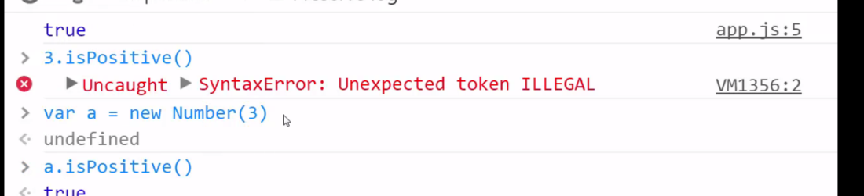

  - Why we should not use built in constructors for primitives.
  - == checks if two things are equal after coercing their types. That is coverts them into same type and check for equality.
=== also checks if both are of same type.
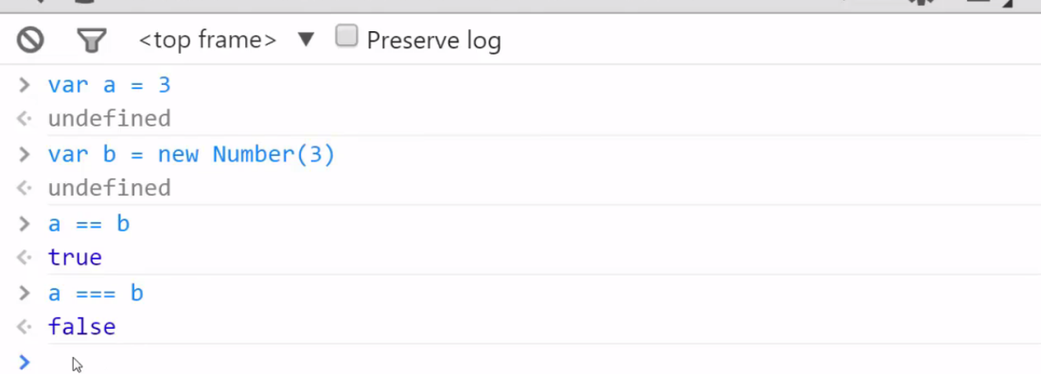

So it better not to use built in constructors for primitives as we can get error around using the equality operators.

Though we can use built in for conversions.
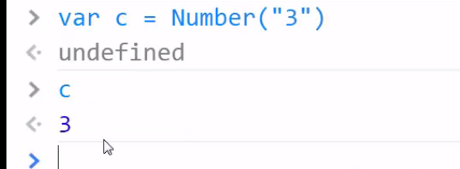

  - Avoid using for-in loops with arrays because they go down the prototype chain of arrays as well and returns strange results. This happens because arrays are objects and their items are added properties.
For example:
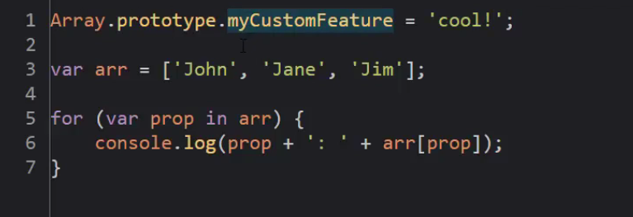

Output:
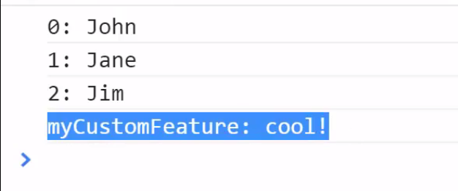

  - Object.create and pure prototypal inheritance:
  - New keyword to create objects in Js are copied from other languages. There are other ways to create object as well.
  - Another way to create an object in JS is 'Object.create'.
  - Object.create creates an empty object with its prototype pointing to whatever we have passed into the create method as parameter.
  - Object.create is available in the new browsers.
  - Pure prototypal inheritance:
We simply create an object. This will act like our base object and then we create other objects using that base object. The other objects created out of the base object can override or hide its properties. This is pure prototypal inheritance.
  - 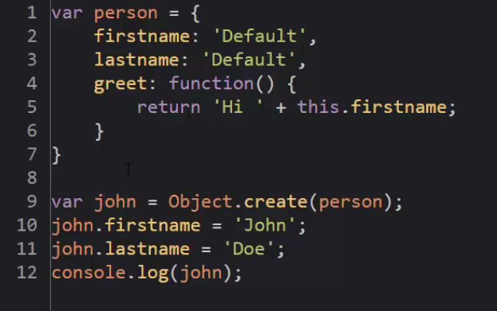

  - Polyfill: Code that Adds the feature that some version of JS engine may lack.
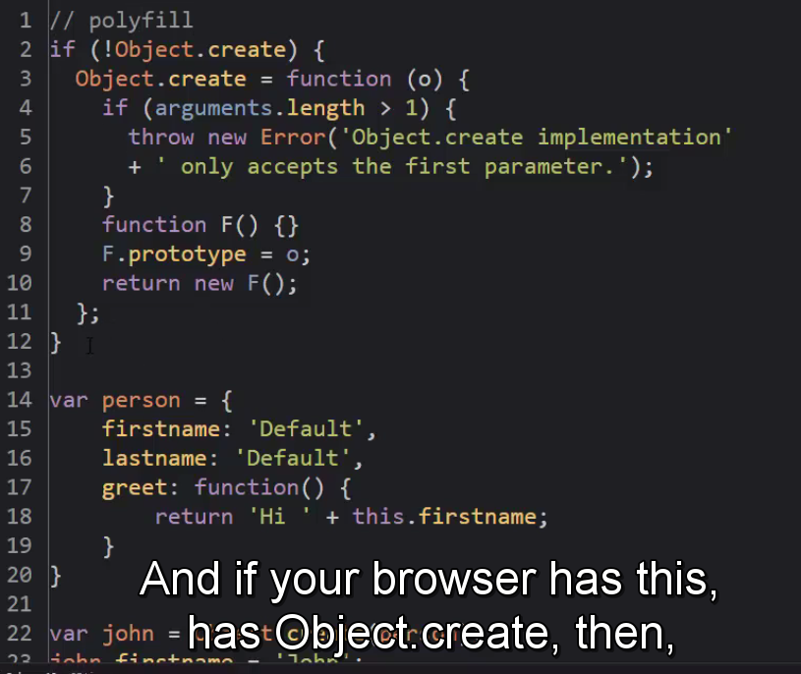

  - Type of and instance of.
  - Typeof - what is the type of it. Whether it’s a number, a string, etc. Tells us what something is.
  - Instanceof- if anywhere down the prototype chain I can find that object. Returns true or false. Tells if something has something in its prototype chain.

  - Use strict:
  - Used as a string in javascript - "use strict".
  - It’s a way to ask javascript not to be very liberal.
  - It should be used at top of the file or on top of the function (we can restrict use strict for an executional context)
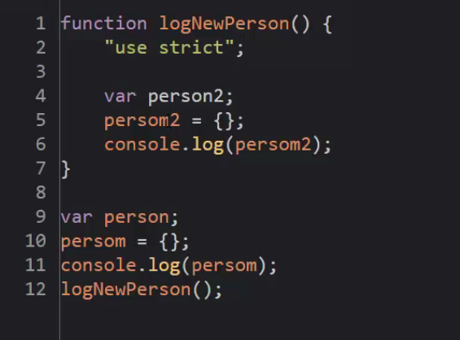

  - We can't rely on use strict 100 %.

