POD DISRUPTION BUDGET:

- How disruption may happen? Voluntary vs Involuntary disruption.
- Different types of voluntary vs involuntary disruptions.
- Disruption budgets.

Disruptions:
- A disruption may happen in the k8 cluster when a Pod disappears.
- This may be because of :
a) Voluntary disruption: A person or controller destroys the pod:
- Draining a node for repair or upgrade.
- Draining a node form the cluster to scale the cluster down.
- Removing a pod to make space for something else.
- Directly deleting a pod by accident
- Updating deployment’s pod template to cause a restart.
b) Involuntary disruptions:
- a hardware failure on the physical machine where node is running.
- Cluster admin deletes vm by mistake.
- kernel panic.

Handling Disruptions:
a) PodDisruptionBudget:
- User can create a PDB for each application.
- PDB specifies the number of pods an application can tolerate having, relative to how many its intended to have.
- PDB limits the number of the pods of a replicated application that can be down simultaneously.
- for example, if an application deployment runs 5 replica pods, and PDB for that application is 4, then only 1 of the pods can be brought down successfully at a given time.

- Cluster managers and hosting providers should use tool that respect PDB by calling the ‘Eviction API’ instead of directly deleting the pods.
- For example, kubectl drain commands follows the eviction API.

PDB Example scenario:

- Consider a 3 node cluster. Node1, Node2 and Node3.
- Cluster is running App1 with 3 pods – poda , podb and podc
- PDB for this application is 2. That’s is maximum of one pod can be down.
- cluster also has another application with single pod running – podx.

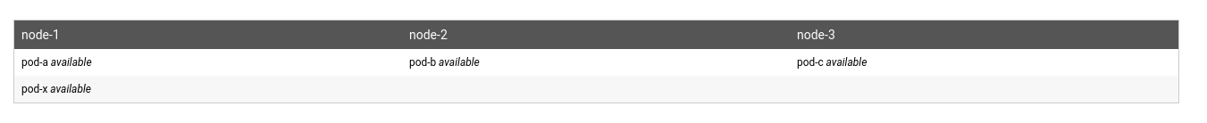

- Now the admin wants to upgrade kernel on Node1 so if stops it using – kubectl drain.

- poda and podx on Node1 goes into terminating state.
- podd and pody are started by their corresponding state to reach the desired state.

- At this stage, App1 has podb (Node2) and podc (Node 3).
- podd (node2) still hasn’t started running. Its not available yet.

- So if the admin, tries to mark the second node down. (kubectl drain), then he’s be blocked by the PDB.

Advantages of using disruptions tolerant application and use PDBs:
- No downtime.
- Minimal Resource duplication.
- Allows more automation for cluster admin.

USING PodDisruptionBudget

- Following things should be kept in mind while using pod disruption budget:
a) Identify the application to be protected:
- deployment
- Replication controller.
- ReplicaSet
- StatefulSet

- To connect a PDB to an application , make sure that the controller’s spec.selector should be same as the PDB’s spec.selector.

b) Think how the application reacts to disruptions.

