HTTP: HYPER TEXT TRANSFER PROTOCOLE:

* + It’s a language to communicate over the internet.
  + A Set of rules that govern how two devices should communicate with each other over the internet.

HTTP REQUEST: A request made to a server to get/post/update/delete some data on it.

Making an HTTP Request involves:

1. Request- line: The type of request and the URI

2. Headers: Information related to the type of request.

3. Blank Line

4. Request Body or payload: The data being sent along with the request. This is optional and only used with POST Request.

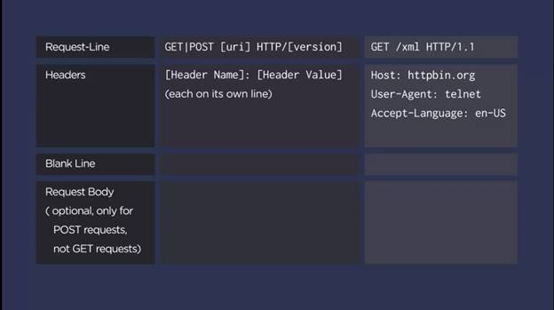

HTTP RESPONSE: The response sent back by the server for our response

The http response involves:

* + Status-line: This is similar to the request status line and shows
  + http version
  + Status code
  + Status message

* + Headers: information about the response like the type of server, date when the response was sent, content type, etc.
  + Blank Line:
  + Payload or data returned by the response.

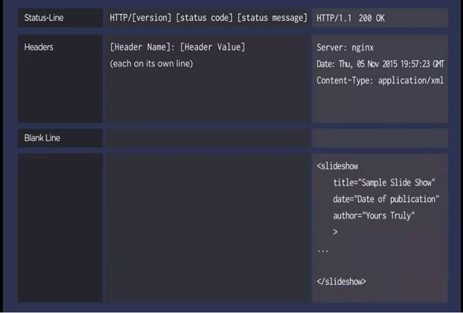

HTTP protocol is Stateless. This means that there is no record for previous interactions and each interaction is processed only with the information that comes with the particular interaction.

**That is, http does not remember any previous request to use its information.**

SENDING DATA ALONG WITH THE GET REQUEST:

* + In Get Request, we can send the data along with the URI using query parameters
  + Query parameters are name-value pairs starting with ‘?’ and each pair is separated by a ‘&’
  + In a browser, GET requests are usually made with the hyperlink represent in a <a href=”” > </a>

Text.

* + We can also send GET request using FORM submit.

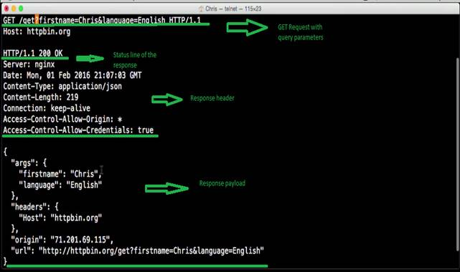

Sending Data along with a POST Request:

* + A post request is generally used to add/update some data in the server.
  + With post request, we can send the data along with the request body (payload)
  + In POST request, the data in the form of query parameter and added to the request body (payload).
  + Content Length and Content-type are also added to the POST request, unlike the POST method:

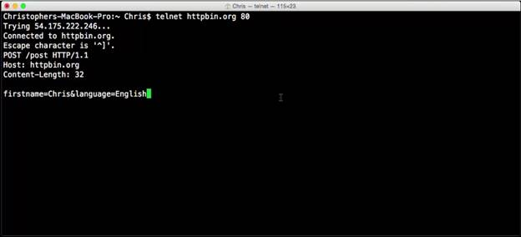

DIFFERENCE

|  |  |
| --- | --- |
| GET | POST |
| To fetch data from server without changing anything | To update some data in the server |
| Payload is send across to the server as query parameter along with the URI in request line above the header | Payload send across to the server as query parameter in the request body below the headers and Blank Line |
|  |  |

API : Application Programming Interface:

* + It’s a code that makes it easier for things outside our application to easily interact with our application.
  + API is like a piece of software the helps two different software to communicate.
  + When an API is created over the Web, its called a Webservice.