POT 198 Tasks Management - 4 June 2020

Please note that every report needs to have the below image functionalities.



1. **Task Settings**
   1. **Need a new tab page for “Tasks Settings” as below image**
   2. **Create Task Groups with Colours and prefix for the Group Task IDs. User to select the colour from colour picker**
   3. **New Tab page to show as “Priority”**
   4. **Need to have a button “Add Priority”**
      1. **Add multiple priorities**
      2. **Auto load the date**
   5. **Need to show the added “Priorities” in the same page**
      1. **Show the below details in the page**
         1. **Date**
         2. **Priority name**
         3. **User added**
   6. **System to auto show the Priority names as below;**
      1. **Low**
      2. **Medium**
      3. **High**
      4. **Urgent**
      5. **Critical**
   7. User to edit / delete the above system given priorities names or any name created by the users
   8. But, if any of the names already usd in the tasks, should NOT be able to delete.
   9. Any changes in the name, should effect only from the next future task and not for the tasks already in used or completed.

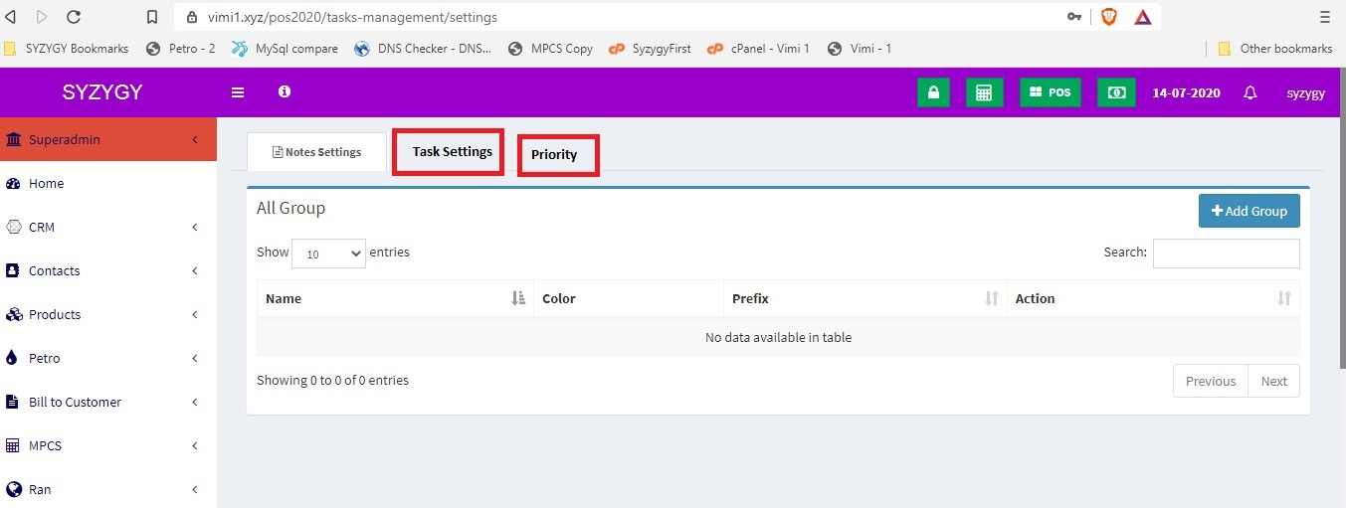

1. **“List Tasks” new page to be under the “Tasks Management” Module with below details**
2. **“List Tasks” page to show the below details (Columns) in the details sections** 
   1. **Action**
   2. **Date**
   3. **Task ID**
   4. **Task**
   5. **User Created**
   6. **Assigned Members**
   7. **Start Date**
   8. **End Date**
   9. **Estimated Hours**
   10. **Priority**
   11. **Task Status**
   12. **Action view, edit & delete buttons. If the note or task is assigned to another user, then should NOT be able to delete.**
3. **In the “List Tasks” page, need to have “Add Task” button.**
4. When the “Add Tasks” button is clicked, pop up to come which should have the below functionalities.
   1. **Date & Time – system to auto show. Should NOT be able to edit**
   2. **Task Group to select from drop down**
   3. **Task ID**
      1. **Auto increment with the prefix (set in the Task settings).**
      2. **If the prefix changes, increment Task ID number to change auto accordingly.**
      3. **Numbering is unique for each Group.**
      4. **If no prefix is created, then numbering to continue irrespective of the Groups.**
   4. **Task – User to enter. This is the task heading**
   5. Task Details
      1. Note editor to show for the user to enter. In this section, if any changes done after saving, edited date to show just below edited details. Edited details to auto highlighted.
   6. **Assigned or shared with users – multiple selection possible**
   7. Task status – any assigned users to make notes
   8. **Priority**
      1. **Select from the drop down. This is set in the “Task Settings” page.**
   9. **Status**
      1. **System to auto show the below status in the drop down;**
         1. **New**
         2. **In Progress**
         3. **On hold**
         4. **Completed**
      2. **Only the original user who created the Task could select the Status.**
   10. **Start date**
       1. **User to select from the date picker**
   11. **End date**
       1. **User to select from the date picker**
   12. **Estimated Hours**
       1. **User to enter**
   13. Reminders
       1. Multiple reminders
          1. On time
          2. Daily
          3. Weekly
          4. Monthly
          5. Annually
       2. With a sound and the pop up.
       3. Pop up to have a button “View’ button and when click, should show with all details, including the task colour.
       4. Any assigned user could customized this Reminder as per their selection. Any changes done by an assigned user in the reminders, should NOT have any effect on other users. Means, should not give any reminders for other user. Once changed, the reminders of the same task will function on an individual basis.
   14. Remarks
       1. Any assigned user to make any remarks.
          1. All the remarks added by should be shown one below the other, with the added date, time, and the user name
   15. Task Footer – only the user who opened this task to add the any footer notes
   16. **Task colour – user to select from the colour picker**
5. This page needs to be added to the company permission and role permission pages under “Task Management” section