1. Install Terraform using below link (select x86/x64 based on your machine CPU)

<https://www.terraform.io/downloads>

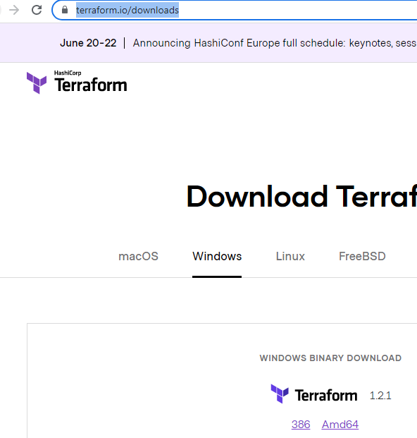

1. Place the downloaded terraform cli in C drive as below:

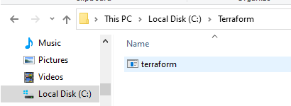

1. Open Environment variables in your local machine as shown below:

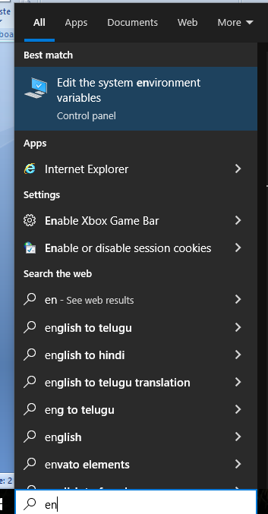

1. Click on Environment variables:

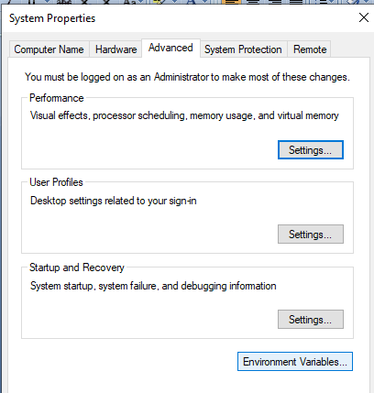

1. Select path and click on edit:

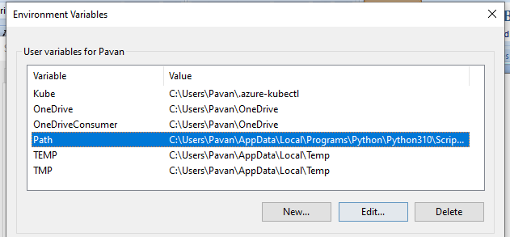

1. Add **new** path as highlighted below:

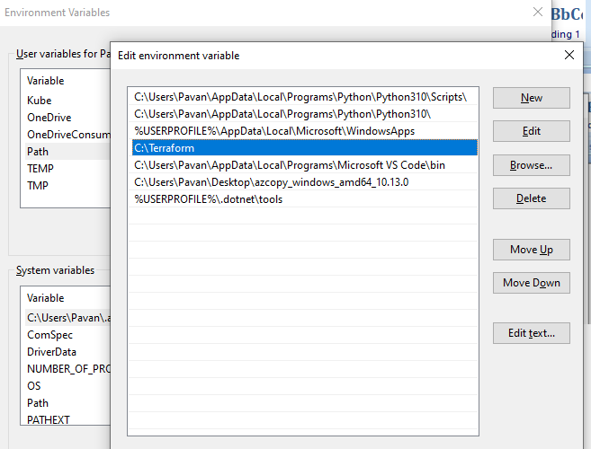

1. Click on OK.
2. Run the terraform application which is shown in above picture.
3. To check if the terraform is installed in your local machine, open cmd prompt and type “terraform --version”.

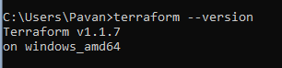

1. Install Azure CLI

https://docs.microsoft.com/en-us/cli/azure/install-azure-cli-windows?tabs=azure-cli