We will be making use of Visual Studio code to write all our Terraform, Bicep and dotnet Code:

1. Install Visual Studio using below link:

<https://code.visualstudio.com/download>

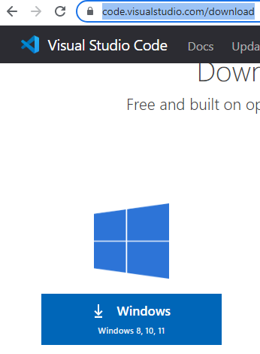

1. Once installed you should be able to open the VS Code and will look as below:

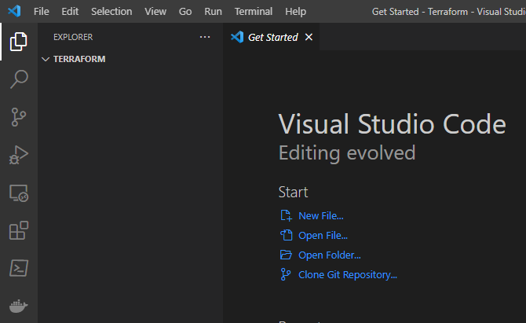

1. We have to open the VSCode in our working directory and do to that, follow below steps:

* Type CMD in the path as shown below:

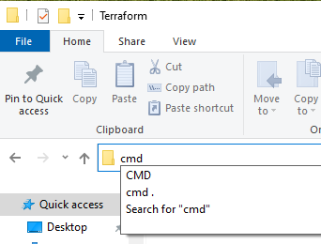

* It should open a command prompt in that particular folder. And once opened type “code .”

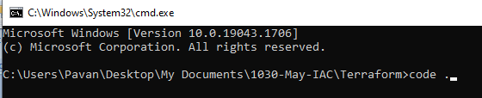

* Now this should open VSCode in this particular folder:

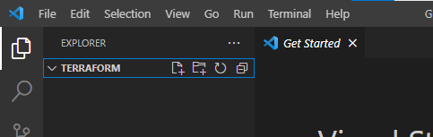

1. Installing the terraform extension in VSCode.

* View>Extensions

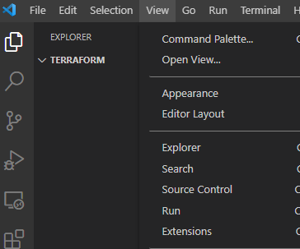

* Install Hashicorp Terrraform extension:

