Game Design Document

Fill up the following document

1. Write the title of your project.

Surviving the Apocolypse

1. What is the goal of the game?

To collect as many people as possible, and keep them alive in the car for as long as possible while avoiding the monster

1. Write a brief story of your game.

You have to drive a car away from a monster that is going to eat you, and pick up people on the way to avoid them getting eaten by the monster. You also have to pick up food and water so the people don’t starve, but as more people come on board, you’ll need more food to feed all of them, or else they start to die in the car. You also need to pick up fuel for the car to keep running. You need to keep all the people alive for as long as possible.

1. Which are the playing characters of this game?

* Playing characters are the ones who respond to the user based on the input from the user.
* Cars, monkeys, dinos, wizards, etc., are the playing characters in the game.

|  |  |  |
| --- | --- | --- |
| Number | Character Name | What can this character do? |
| 1 | You (the player) | Move the car left to right, and pick up people/food/water |
| 2 |  |  |
| 3 |  |  |
| 4 |  |  |
| 5 |  |  |
| 6 |  |  |
| 7 |  |  |
| 8 |  |  |

1. Which are the Non-Playing Characters of this game?

* Non-Playing characters are the ones that don't have an action or behavior when the user interacts with the game.
* Hurdles, stones, bananas, coins, etc., are non-playing characters in the game.

|  |  |  |
| --- | --- | --- |
| Number | Character Name | What can this character do? |
| 1 | Food | Fill up the food bar |
| 2 | Water | Fill up the water bar |
| 3 | Fuel | Fill up the fuel bar |
| 4 | People | Lower the food/water supply (not the fuel) |
| 5 | Monster | Eat the people (which is bad) |
| 6 | Food | Fill up the food bar |
| 7 |  |  |
| 8 |  |  |

Draw your imagination of this game. What does this game look like?

* Draw the game either on your computer or on paper.
* Add images of the game scenes to show each of the playing and non-playing characters at least once.

The background:

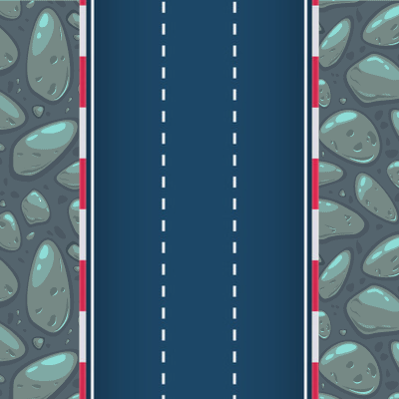

The player car:



The people:

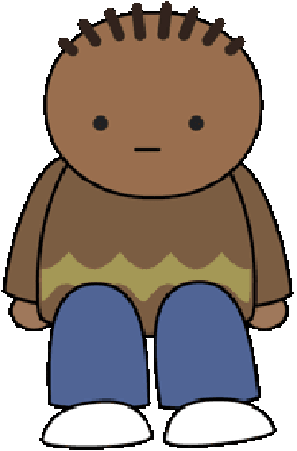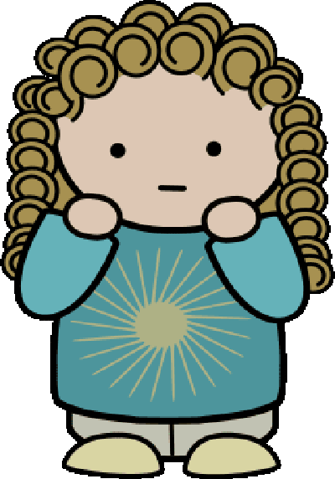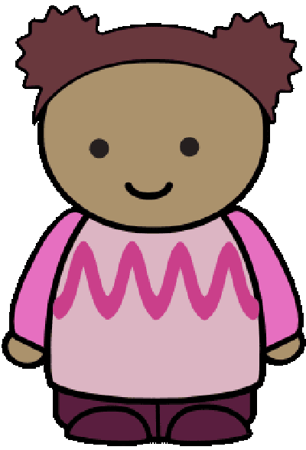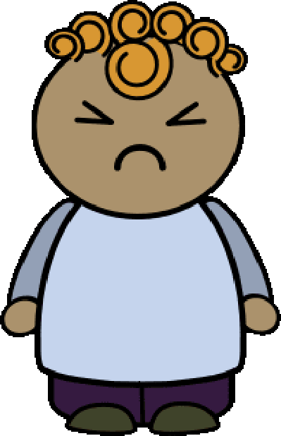

The monster:

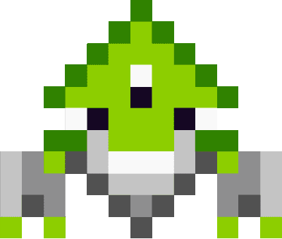

Food:



Water:



Fuel:



How do you plan to make your game engaging?

I plan to make the game engaging by lowering the food and water bars faster as more people are in the car. They decrease slower when there is less people in the car.