July 31, 2018

To
The Editor-in-Chief
Modern Physics Letters A

Dear Editor,

I have the pleasure of sending you the manuscript entitled “Connecting Loop Quantum Gravity and String Theory via Quantum Geometry”, to be considered for publication as an article in the your prestigious journal “International Journal of Theoretical Physics”. This paper contains original research and has not been submitted to or published in any other journal and is not being considered for publication elsewhere.

String theory and loop quantum gravity are the strongest candidates for a consistent, complete theory of quantum gravity which can explain how to combine quantum mechanics with general relativity in regions of very high energy density such as near black hole singularities and at the Big Bang. There has been a long running debate as to which, if either, of these two approaches can be successful in this regard and it is often assumed that only one or the other approach can provide us with a correct description of nature.

In this paper, I use some very simple and straightforward arguments to claim that LQG and string theory are in fact closely related. LQG describes the atomic structure of spacetime at the Planck scale, whereas String Theory describes the effective dynamics of spacetime in energies much lower than the Planck scale but much higher than, say, the weak unification scale (~ 150 GeV). Rather than being viewed as competing ideas, they are in fact descriptions of nature at two different scales and are, as such, both indispensable for helping us to understand the behaviour of matter and fields at all scales of interest.

This is a preliminary and essentially qualitative approach to tackling a difficult question. However, I feel that my work opens the door for a broader discussion of constructing a quantum gravity theory built upon essential ingredients taken from both LQG and String Theory.

Following are the names and email addresses of three possible reviewers and the justification for each:

Name | Email | Position | Justification
Mark Van Raamsdonk | mav@phas.ubc.ca | Professor of Physics,  University of British Columbia,  Canada | Mark has done fundamental work on quantum gravity and has clarified the relation between entanglement and spacetime geometry
Lee Smolin | lsmolin@perimeterinstitute.ca | Adjust Prof, Physics Dept,  University of Waterloo;  &  Faculty, Perimeter Institute for Theoretical Physics | Lee is one of the founders of the field of Loop Quantum Gravity and has made various attempts to unify LQG and String Theory in a coherent framework
Giorgio Immirzi | giorgio.immirzi@gmail.com | INFN - Istituto Nazionale di Fisica Nucleare,  Frascati, Italy | Prof Immirzi is an important figure in the LQG community known for his eponymous contribution of the "Barbero-Immirzi parameter". This parameter plays an important role in this article.

For any other questions/queries please don't hesitate to email me or call me at the numbers mentioned below.

Yours Sincerely,
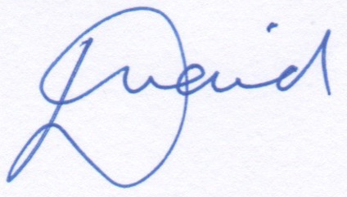

(Deepak Vaid)
June 23, 2018

