Local Directory

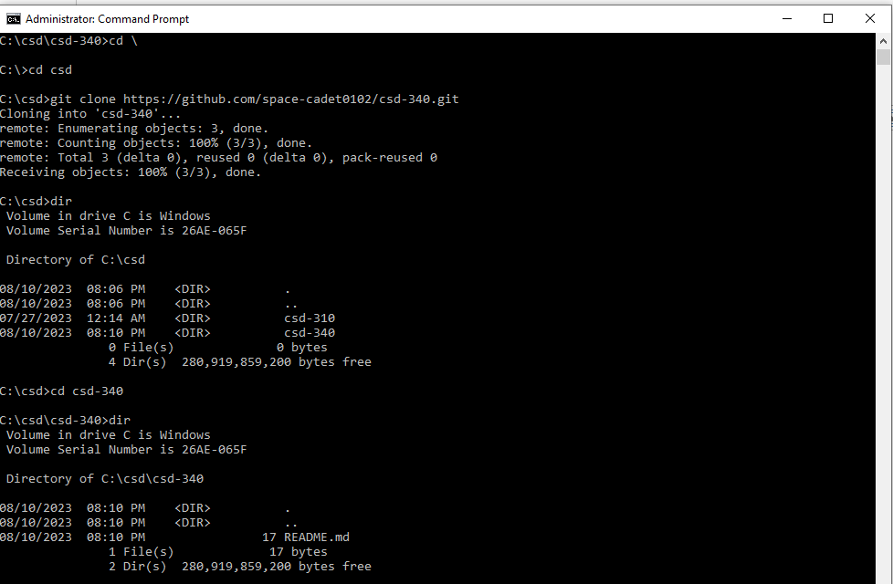

GitHub Repository

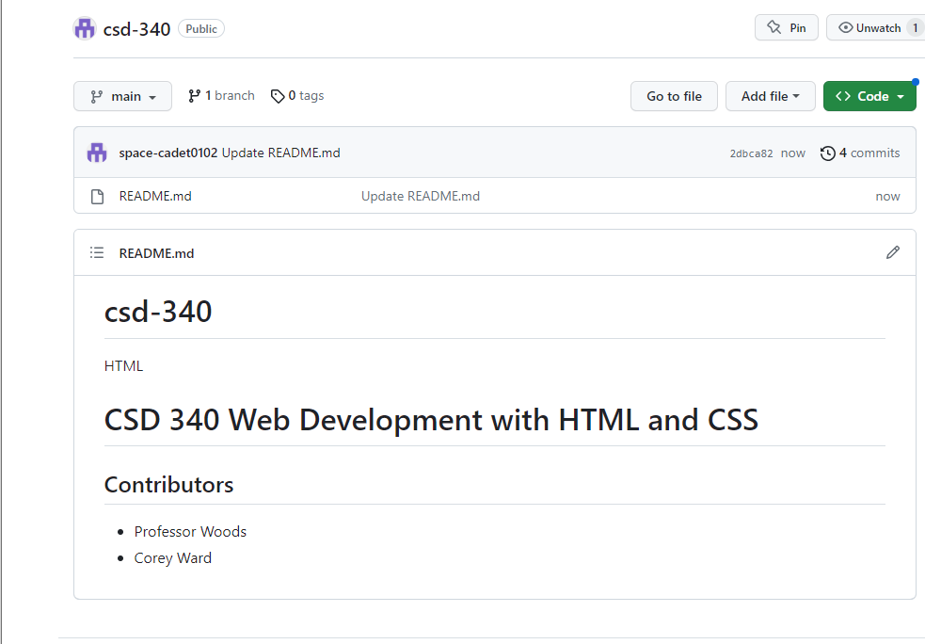

Link to GitHub repository

https://github.com/space-cadet0102/csd-340.git