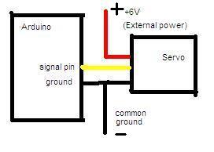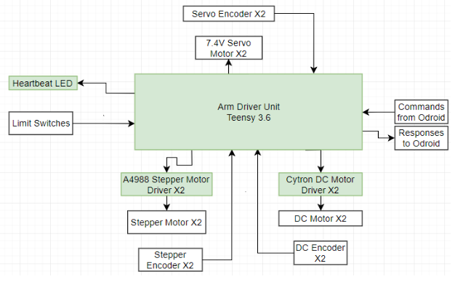

6 encoder A (yellow)

6 encoder B (orange)

6 encoder V+ (red)

6 encoder Ground (black)

4 PWM (blue)

4 Direction (green)

2 Step (purple)

2 Enable (white)

NOTE: THE COMMON GROUND IS ONLY FOR PROTOTYPING PURPOSES. THE SERVO’S POWER AND LOGIC CONNECTIONS WILL BE ISOLATED IN THE FINAL DESIGN

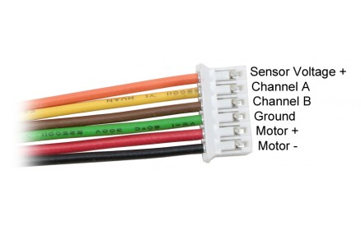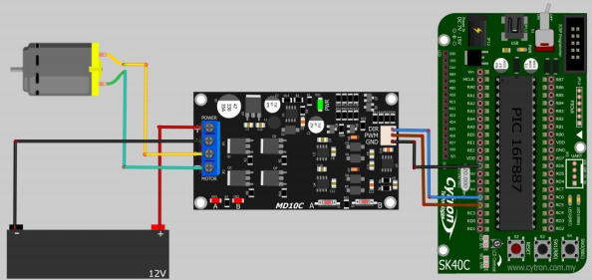

|  |  |  |  |  |  |  |  |  |  |
| --- | --- | --- | --- | --- | --- | --- | --- | --- | --- |
|  |  |  | GND |  | VIN |  |  |  |  |
| RX_ODROID | RX1 |  | 0 |  | AGND |  |  |  |  |
| TX_ODROID | TX1 |  | 1 |  | 3.3v |  |  |  |  |
|  |  | PWM | 2 |  | 23 | A9 | PWM |  | M3_LIMIT_SW_EXTEND |
| RESERVED FOR I2C | SCL2 | PWM | 3 |  | 22 | A8 | PWM |  | M3_LIMIT_SW_FLEX |
| RESERVED FOR I2C | SDA2 | PWM | 4 |  | 21 | A7 | PWM |  | M3_STEP |
| M1_DIR |  | PWM | 5 |  | 20 | A6 | PWM | SDA0 | M3_DIR |
| M1_PWM |  | PWM | 6 |  | 19 | A5 |  | SCL0 | M3_ENCODER_A |
| M1_ENCODER_A | RX3 | PWM | 7 |  | 18 | A4 |  |  | M3_ENCODER_B |
| M1_ENCODER_B | TX3 | PWM | 8 |  | 17 | A3 | PWM |  | M3_ENABLE |
| M1_LIMIT_SW_CW | RX2 | PWM | 9 |  | 16 | A2 | PWM |  | M4_ENABLE |
| M1_LIMIT_SW_CCW | TX2 | PWM | 10 | TEENSY 3.6 | 15 | A1 |  |  | M4_DIR |
| M4_ENCODER_A |  |  | 11 |  | 14 | A0 | PWM |  | M4_STEP |
| M4_ENCODER_B |  |  | 12 |  | 13 |  |  |  | HEARTBEAT |
|  |  |  | 3.3v |  | GND |  |  |  |  |
| M4_LIMIT_SW_EXTEND |  |  | 24 |  |  | DAC1 |  |  |  |
| M4_LIMIT_SW_FLEX |  |  | 25 |  |  | DAC0 |  |  |  |
| M2_ENCODER_A |  |  | 26 |  | 39 | A20 |  |  |  |
| M2_ENCODER_B |  |  | 27 |  | 38 | A19 | PWM | SDA1 | M6_ENCODER_B |
| M2_LIMIT_SW_FLEX |  |  | 28 |  | 37 | A18 | PWM | SCL1 | M6_ENCODER_A |
| M2_LIMIT_SW_EXTEND |  | PWM | 29 |  | 36 | A17 | PWM |  | M6_PWM |
| M2_PWM |  | PWM | 30 |  | 35 | A16 | PWM |  | M5_PWM |
| M2_DIR_PIN | RX4 | A12 | 31 |  | 34 | A15 |  | RX5 | M5_ENCODER_B |
|  | TX4 | A13 | 32 |  | 33 | A14 |  | TX5 | M5_ENCODER_A |

NOTE: the encoders for M5 and M6 won’t be implemented yet because it would require modifying the servos which is risky.

|  |  |  |  |  |  |
| --- | --- | --- | --- | --- | --- |
|  | DC Motors |  | Steppers |  | Servos |
|  | M1 |  | M3 |  | M5 |
| Encoder A | 7 | Encoder A | 19 | Encoder A | 33 |
| Encoder B | 8 | Encoder B | 18 | Encoder B | 34 |
| Direction | 5 | Enable | 17 | PWM | 35 |
| PWM | 6 | Step | 21 |  |  |
|  |  | Direction | 20 |  |  |
|  | M2 |  | M4 |  | M6 |
| Encoder A | 26 | Encoder A | 11 | Encoder A | 38 |
| Encoder B | 27 | Encoder B | 12 | Encoder B | 39 |
| Direction | 31 | Enable | 16 | PWM | 36 |
| PWM | 30 | Step | 14 |  |  |
|  |  | Direction | 15 |  |  |

NOTE: Orange and red means the encoders are unused right now. Red because it’s likely we won’t have encoders in the servos and orange because we may use the encoders in the steppers in the future.

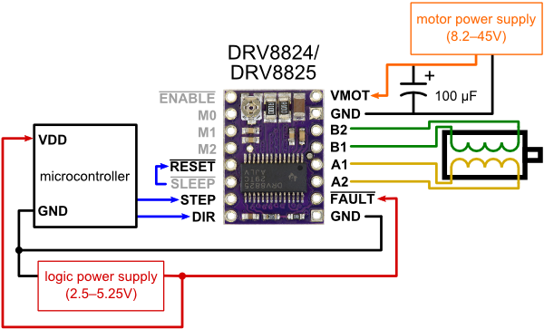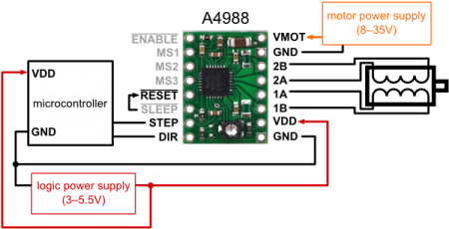 

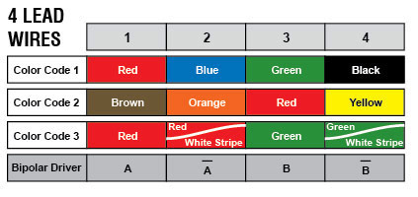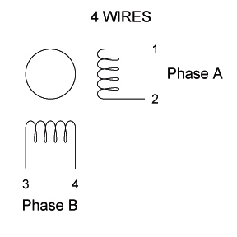

NOTE: Ignore this and just use colour code 1 from the 4 wire stepper diagram. Reasoning is that in our case, we’re connecting 8 wires into 4 using the series connection (see 8-wire diagram above). I wired it up so both motors have the same colour code which makes things easier for prototyping.

