**Integrated Space Station OS**

**Mission Statement**

SSOS-2025001

Space Station OS Project

Revision

NC draft 20250112

REVISION AND HISTORY PAGE

|  |  |  |  |
| --- | --- | --- | --- |
| 1. **Revision**  **No.** | 1. **Change**  **No.** | 1. **Description** | 1. **Release**  **Date** |
| 1. NC |  | 1. Initial Release 2. Documented by Hiroki Kato | 1. 2025/1/X |
|  |  |  |  |
|  |  |  |  |
|  |  |  |  |

TABLE OF CONTENTS

1.0 INTRODUCTION 4

1.1 Purpose 4

1.2 Applicable Documents 4

1.3 Relavant Documents 4

2.0 Project Mission Statement 5

3.0 Premise 6

3.1 TErm definition 6

3.2 Actors definition 6

3.3 Use caseS 7

3.3.1 Manufacturing space stations 7

3.3.2 Operating space stations 7

3.3.3 Business utilization of space stations 8

3.3.4 Rule making 8

3.3.5 Education 8

3.3.6 SSOS Project involvement 9

# INTRODUCTION

## Purpose

1. This document describes a mission statement for the "Integrated Space Station OS" (Integrated SSOS, thereafter). Integrated SSOS has already been made open source on github (<https://github.com/space-station-os>), and this document is intended to publicly communicate its mission design intention and requirements.

## Applicable Documents

N/A

## Relavant Documents

1. GitHub <https://github.com/space-station-os>
2. Documentations <https://space-station-os.github.io/index.html>
3. Program <https://spacestationos.com/>

# Project Mission Statement

**Integrated SSOS** is an open-source platform for space stations, designed to control various subsystems such as thermal control, attitude control, power, heat, communication, and life support systems. The platform facilitates operational research, simulation, and real-time control for space habitats, leveraging ROS 2 to provide tools like Fault Detection, Isolation, and Recovery (FDIR) to enhance the safety and autonomy of space environments. It integrates these functions to optimize the entire system, exploring emergent behaviors and cross-system interactions to ease communications among stakeholders including manufactures,

# Premise

1. In this section, we refer to the strategic use cases of Integrated SSOS. We first define the actors and then describe the use cases for each target user.

## TErm definition

1. The following table defines terms describing Integrated SSOS.
2. Table 3.1-1. Teams describing Integrated SSOS

|  |  |
| --- | --- |
| 1. SS | 1. Space station(s) |
| 1. OS | 1. Operating system |
| 1. SSOS | 1. Space Station OS, the target product to develop. It includes SSOS vehicle software, SSOS simulator, and SSOS ground station |
| 1. SSOS vehicle software (SSOS software) | 1. Space Station OS software that simulates the dynamic behavior of hardware and the physics of the environment. It may be referred as SSOS software, and it may include SSOS ground station software by context. |
| 1. SSOS simulator | 1. Space Station OS software |
| 1. SSOS ground station | 1. Space Station ground station including software |
| 1. OSS | 1. Open Source Software (we use GitHub as of Jan. 2025) |

## Actors definition

1. The following table defines actors for use cases describing Integrated SSOS.
2. Table 3.2-1. Actors describing Integrated SSOS

|  |  |
| --- | --- |
| 1. SS business operator | 1. The business company that utilizes space station(s) |
| 1. SS owner | 1. A space station owner, which could be a business operator, but not necessarily. |
| 1. SS manufacturer | 1. Engineering manufacturer of SS, which could be a business operator, but not necessarily. It could include a SS component or hardware manufacturer. |
| 1. SS component manufacturer | 1. Engineering manufacturer of SS component, including hardware or sensor manufacturer |
| 1. SS operator | 1. Flight operator of SS, which could be a business operator, but not necessarily. |
| 1. SS passenger | 1. Visitor to SS, like ISS crew or traveler |
| 1. Government official | 1. Government officials |
| 1. The SSOS project | 1. Us |
| 1. SSOS contributor | 1. Contributor of SSOS through OSS development, including OS developer, subsystem/component engineer, and model designer. It could even include hardware engineer. |
| 1. OS developer | 1. The ones create and improve SSOS vehicle software, SSOS simulator and SSOS ground station. |
| 1. Subsystem/component engineer | 1. The ones create and improve SSOS subsystem/component |
| 1. Model designer | 1. The ones create and improve SSOS simulator |
| 1. Hardware engineer | 1. The ones create subsystem/component that is defined in SSOS vehicle software, or they may give insights to define SSOS vehicle software. |
| 1. Prospective SSOS contributor | 1. Prospective contributor of SSOS through OSS development |
| 1. People | 1. People in the world |

## strategic Use caseS

1. In this section, we describe the strategic use cases of Integrated SSOS.

## Manufacturing space stations

1. SS manufacturers utilize SSOS in their SS to ease their development.
2. SS component manufactures test their product with SSOS simulator. Their products may or may not install SSOS vehicle software, although they are encouraged to be implemented in SSOS vehicle software
3. SS component manufactures sell products that are defined in SSOS vehicle software and complainant with it.
4. SS component manufacturers provide input into the SSOS project regarding their own products and request that the parts be incorporated into SSOS vehicle software.

### Operating space stations

1. SS passengers understand feature of SS by going through SSOS vehicle software with running SSOS simulation.
2. SS passengers interact with SSOS vehicle software as needed for safety operation and comforting the stay.
3. SS operators utilize SSOS ground station to run their SS.
4. SS operators utilize SSOS ground station to train their SS operation.
5. SS operators understand feature of SS by going through SSOS vehicle software by running SSOS simulation with various configurations.

### Business utilization of space stations

1. SS business operators communicate and understand feature and safety of SS by going through SSOS vehicle software and run on SSOS simulator.
2. SS business operators buy SS utilizing SSOS vehicle software. (SS business operators could be a SS manufacturer.)

### Rule making

1. Government officials communicate and understand feature and safety of SS by going through SSOS vehicle software and run on SSOS simulator.

### Education

1. People learn how SS works by going through SSOS.
2. Prospective SSOS contributors run and look through SSOS and see if they can involve the project.
3. SSOS contributors run and look through SSOS so that they \can learn its design, implementation, and philosophy.
4. People feel space environment emotionally attached by going through SSOS.

### SSOS Project involvement

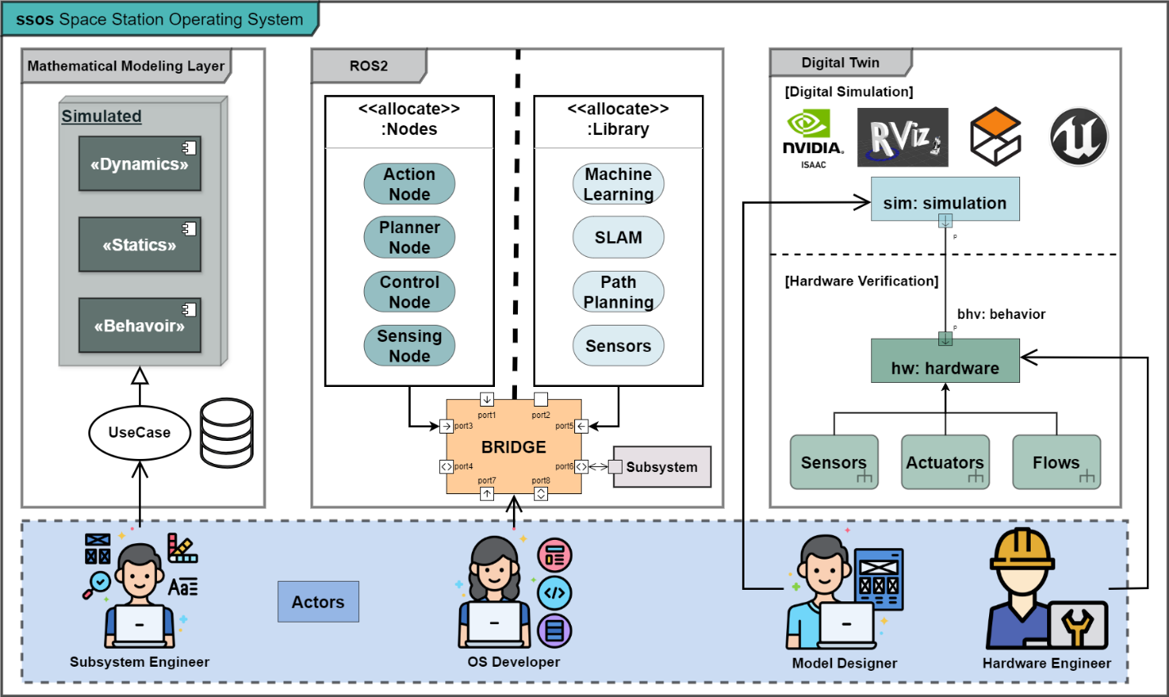

1. SSOS contributors contribute to make SS happen.
2. Subsystem/component engineers create and improve SSOS subsystem and/or component.
3. Model designers create and improve SSOS simulator.
4. Hardware engineers create subsystem/component that is defined in SSOS vehicle software, or they may give insights to define SSOS vehicle software.