Documentation for Timetable Software in Flask  
  
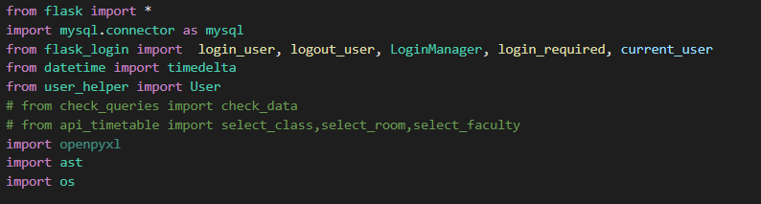

This code contains importing other python modules.  
The most important ones are flask module and mysql.connector module  
mysql module helps us to connect to database.  
  
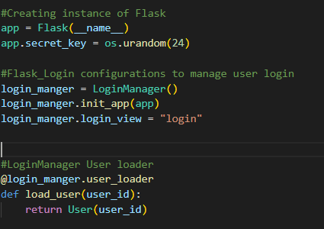

In this code we are creating Flask instance which in turn provides us all the methods and attributes of Flask class. So, it is an important step before we move ahead!

The app.secret_key is a flask attribute which is needed to make the connection secure. We are using random 24 characters which are generated by the os module.

After this we have our LoginManager which helps us in providing login functionality with sessions.

The load_user() is to load user into User object such that we can track it later on.

(Note: Even I don’t know much about this but with this we can load information into website and make it consistent)

Creating MySQL connection and giving Global variables some values!

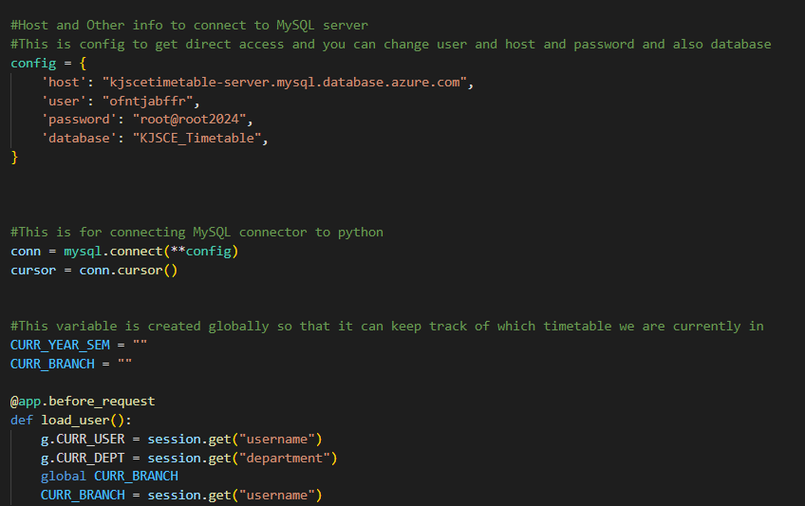

The config object contains all the information which we need to make sql connection.  
(Note: I would suggest to use environment variables for the purpose of creating connection as it is much secure than providing it directly in program! I didn’t used it as it was not much needed)

Now CURR_YEAR_SEM and CURR_BRANCH are global variables which I am using to make sure that once someone is logged in the information should be stored in them. CURR_YEAR_SEM is for timetable and CURR_BRANCH is for department which has logged in!

Another load_user function with which we can load information in global variables while users are registering or logging in.

(Note: g. is a flask way of storing global variables.But kindly note that once I get out of the load_user function the value g stores is deleted so I need to store it somewhere.So, I am using CURR_YEAR_SEM and CURR_BRANCH)

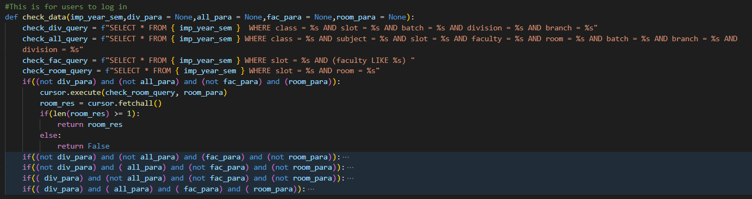

This function is used to check clashing of slots. Mostly they are sql queries.

Please check them so you can understand it properly!

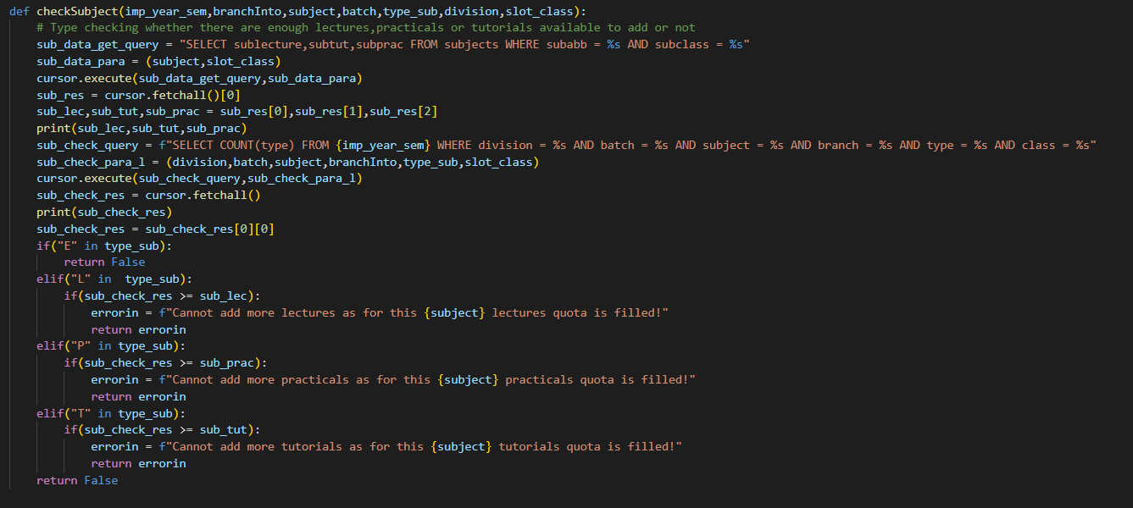

checkSubject() function is to check the if the amount of lectures,tutorials and practicals which are provided in subject are fulfilled or not!

Also, Electives don’t have limit for this so I skip whenever an subject is an elective!

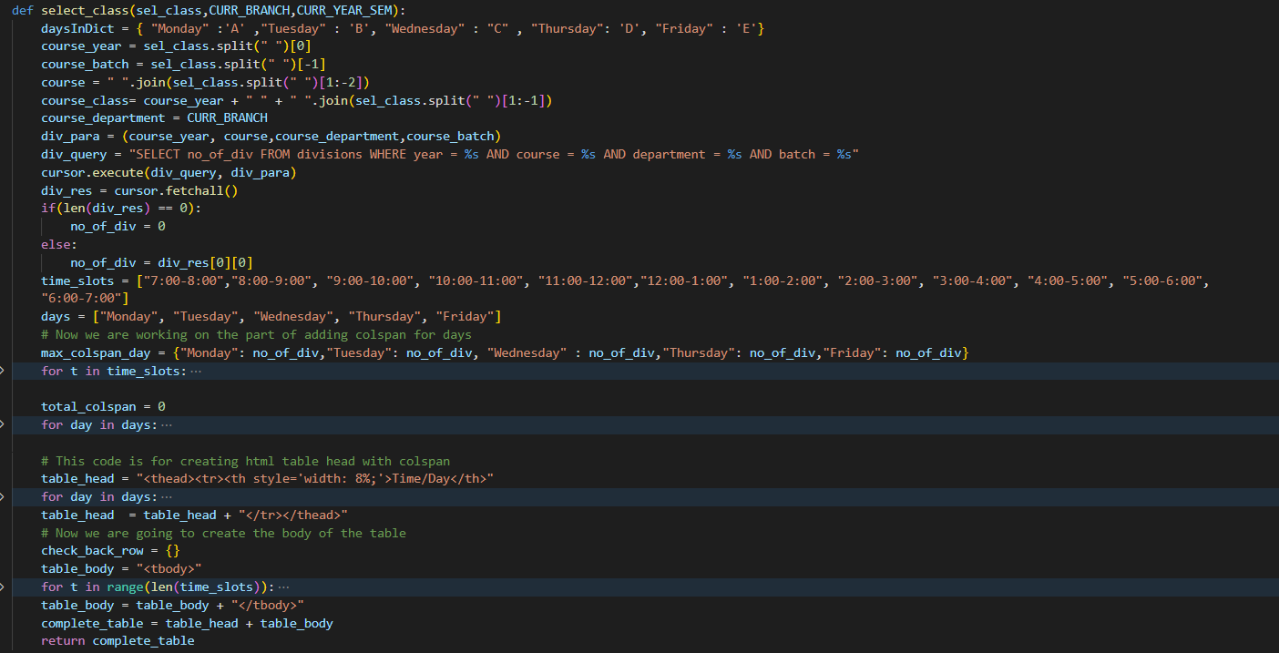

select_class() is the main function which makes timetable. Read this part properly to understand it!

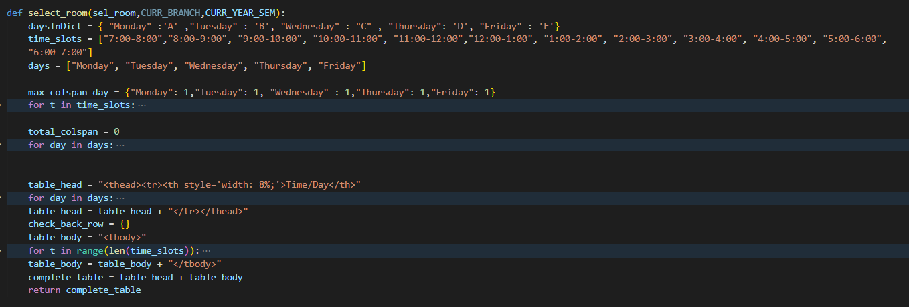

select_room() is for showing room timetable.

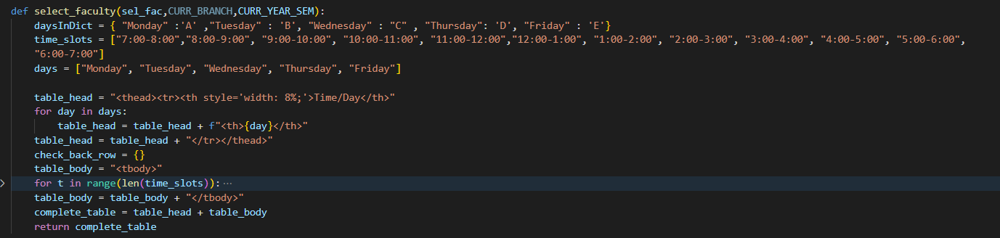

select_faculty() is for showing faculty timetable with proper load!

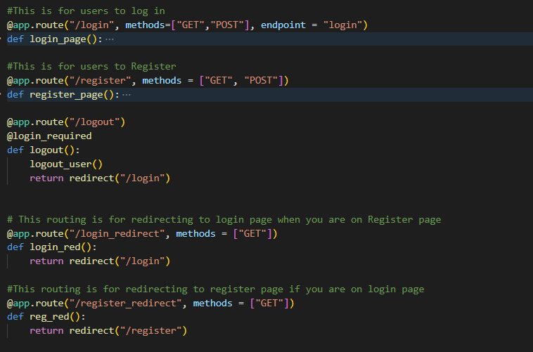

Now we have login and register routes which are used to pull user information or insert user information from or in users table of our database.