1. Background: Over the course of the 2019 Fall semester, the students of Nancy Emery’s Evolutionary Ecology class (EBIO 4450) conducted and experiment where they subjected a plethora of l. fremontii plants to varying forms for environmental stress. This study was conducted at the CU Greenhouse on 30th Street. Three different experiments were run for this class, all of them looking at how the manipulation of environmental parameters affected plant biomass, the ratio of dispersive to non-dispersive seeds produced by the maternal plant, and the height of the inflorescence, measured from the base of the plant. One experiment, called the “shade” experiment, subjected groups of plants to different levels of light. Another experiment, the “density” experiment, planted 1, 2, or three plants per cone as a measure of competition. The final experiment, the “resource” experiment, subjected plants to varying degrees of available nutrients, another measure of environmental stress. Data was collected near the end of the semester, and each experimental team analyzed their data, with help from Dr. Emery and those that worked in her lab. After the semester ended, as a member of Dr. Emery’s lab, was tasked with performing a meta analysis of all the data collected from each experiment, and performing more rigorous testing than we had time for during the class itself. The following is my work!

Experimental Assumptions: Really, the only assumptions made for these experiments, and that is that plant biomass is a measure of stress. This assumption, however, is supported by cited literature. The use of inflorescence height was statistically tested for as a dispersal trait by the class, and the seed type proportion as a measure of dispersal propensity is widely supported by cited literature.

1. Hypotheses

a: Nutrient concentration will have an effect on the plant biomass, the proportion or dispersive to non-dispersive seeds, and inflorescence height.

b: The number of plants in a cone will have an effect on plant biomass, the proportion or dispersive to non-dispersive seeds, and inflorescence height.

1. Access to light will have an effect on the plant biomass, the proportion or dispersive to non-dispersive seeds, and inflorescence height.
2. Predictions
3. Plant biomass will decrease with increasing nutrient concentration; the ratio of dispersive to non-dispersive seeds will increase with nutrient concentration; focal flower height will increase with nutrient concentration
4. With increasing competition, plant mass will decrease; dispersal propensity (seed ratio) will increase with competition; focal flower height will increase with competition
5. Plant biomass will decrease with less access to light; dispersal propensity will be inversely associated with light level; focal flower height will be inversely associated with light level.

4a) Package loading

#### Packages ####  
#+ message = FALSE, warning = FALSE  
library(tidyverse)

## ── Attaching packages ───────────────────────── tidyverse 1.3.0 ──

## ✓ ggplot2 3.3.2 ✓ purrr 0.3.4  
## ✓ tibble 3.0.3 ✓ dplyr 1.0.1  
## ✓ tidyr 1.1.1 ✓ stringr 1.4.0  
## ✓ readr 1.3.1 ✓ forcats 0.5.0

## ── Conflicts ──────────────────────────── tidyverse_conflicts() ──  
## x dplyr::filter() masks stats::filter()  
## x dplyr::lag() masks stats::lag()

library(nlme)

##   
## Attaching package: 'nlme'

## The following object is masked from 'package:dplyr':  
##   
## collapse

library(lattice) # contains function 'qqmath' for making qqplot for lmer model  
library(lmtest)

## Loading required package: zoo

##   
## Attaching package: 'zoo'

## The following objects are masked from 'package:base':  
##   
## as.Date, as.Date.numeric

# library(glmmTMB)  
# library(sjPlot)  
# library(sjmisc)  
library(knitr)  
library("grid")  
library("gridExtra")

##   
## Attaching package: 'gridExtra'

## The following object is masked from 'package:dplyr':  
##   
## combine

library(wesanderson)

4b) Data processing

#'Loading the Data  
dat <- read_csv("~/Repos/EmeryLab/DispersalMasterData.csv")

## Parsed with column specification:  
## cols(  
## gitNum = col_double(),  
## experiment = col_character(),  
## plantNum = col_character(),  
## survivorship = col_double(),  
## bin = col_double(),  
## treatmentActual = col_double(),  
## treatmentCat = col_character(),  
## phyllaryCount = col_double(),  
## raySeedCount = col_double(),  
## diskSeedCount1 = col_double(),  
## diskSeedCount2 = col_double(),  
## focalFlowerHeight_cm = col_double(),  
## focalPlantMass_g = col_double(),  
## comments = col_character()  
## )

#'Writing conditional to check for NA's in either disk seed count column and filtering accordingly  
d2NA <- which(is.na(dat$diskSeedCount2) & !is.na(dat$diskSeedCount1))  
d1NA <- which(!is.na(dat$diskSeedCount2) & is.na(dat$diskSeedCount1))  
view(dat[d2NA,]) #no cases where d1 is NA and d2 is not, so subset the master data where disk seed count 2 is an NA and disk seed count 1 is not  
  
  
  
#'#### Data Cleaning  
#'   
#'Getting Mean disk seed count  
dat$meanDiskCount <-((dat$diskSeedCount1) + (dat$diskSeedCount2))/2  
  
#replacing observations where disk count 2 was an NA with the value of disk count 1 for meanDiskCount  
dat[d2NA,"meanDiskCount"] <- dat$diskSeedCount1[d2NA]  
#'Ratio of ray seeds to disk seeds  
dat$phyllToTotal <- round(dat$phyllaryCount / (dat$phyllaryCount + dat$meanDiskCount), 3)  
  
#Setting plotting label order for all experiments  
labelOrders <- c("Control", "Structure", "Low", "Medium", "High")

4c) Subsetting by experiment

#### Data Cleaning: Shade Experiment ####  
#'  
  
#' #### Data  
shadeDat <- dat %>%   
 filter( experiment == "shade")  
  
#' Conditional filtering  
shadeDat <- shadeDat %>%   
 filter(!is.na(phyllToTotal)) %>%  
 mutate_at(vars(treatmentCat), factor) %>%  
 filter(!is.na(treatmentCat))  
   
  
#' Replicates per treatment  
shade_reps <- summarize(group_by(shadeDat, treatmentCat), n())

## `summarise()` ungrouping output (override with `.groups` argument)

shade_reps

## # A tibble: 5 x 2  
## treatmentCat `n()`  
## <fct> <int>  
## 1 Control 11  
## 2 High 6  
## 3 Low 11  
## 4 Medium 10  
## 5 Structure 10

#' Boxplot of the phyllary proportion by treatment  
ggplot(shadeDat, aes(treatmentCat, phyllToTotal)) +  
 geom_boxplot()

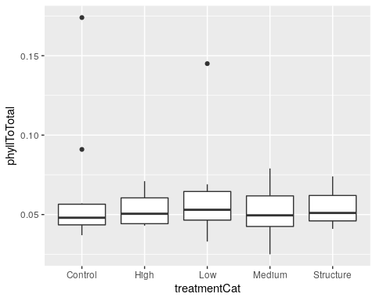

#' Boxplot of the floral height by treatment  
ggplot(shadeDat, aes(treatmentCat, focalFlowerHeight_cm)) +  
 geom_boxplot()

## Warning: Removed 4 rows containing non-finite values (stat_boxplot).

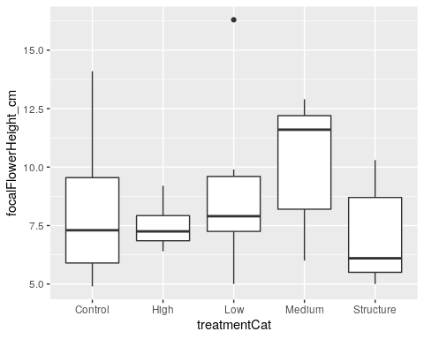

#' Boxplot of the plant mass by treatment  
ggplot(shadeDat, aes(treatmentCat, focalPlantMass_g)) +  
 geom_boxplot()

## Warning: Removed 1 rows containing non-finite values (stat_boxplot).

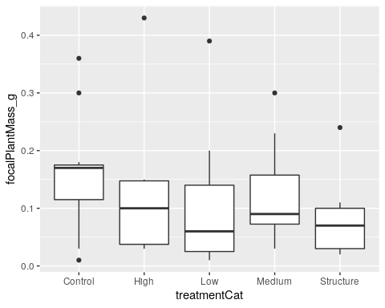

#### Data Cleaning: Density Experiment ####  
#'   
#' #### Data   
densityDat <- dat %>%   
 filter( experiment == "density")  
  
#' Conditional Filtering  
  
densityDat <- densityDat %>%   
 filter( !is.na(phyllToTotal)) %>%  
 mutate_at(vars(treatmentCat), factor) %>%  
 filter(!is.na(treatmentCat)) %>%  
 filter(survivorship == 1)  
  
#' Replicates per treatment  
density_reps <- summarize(group_by(densityDat, treatmentCat), n())

## `summarise()` ungrouping output (override with `.groups` argument)

density_reps

## # A tibble: 3 x 2  
## treatmentCat `n()`  
## <fct> <int>  
## 1 Control 30  
## 2 High 27  
## 3 Low 22

#' Boxplot of the phyllary proportion by treatment  
ggplot(densityDat, aes(treatmentCat, phyllToTotal)) +  
 geom_boxplot()

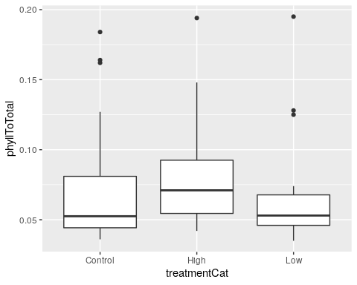

#' Boxplot of the floral height by treatment  
ggplot(densityDat, aes(treatmentCat, focalFlowerHeight_cm)) +  
 geom_boxplot()

## Warning: Removed 15 rows containing non-finite values (stat_boxplot).

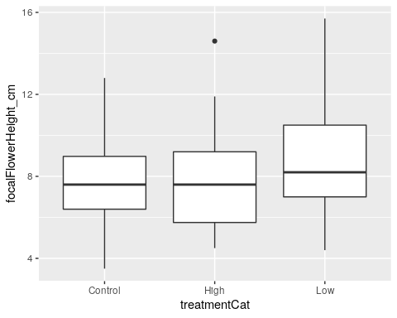

#' Boxplot of the plant mass by treatment  
ggplot(densityDat, aes(treatmentCat, focalPlantMass_g)) +  
 geom_boxplot()

## Warning: Removed 1 rows containing non-finite values (stat_boxplot).

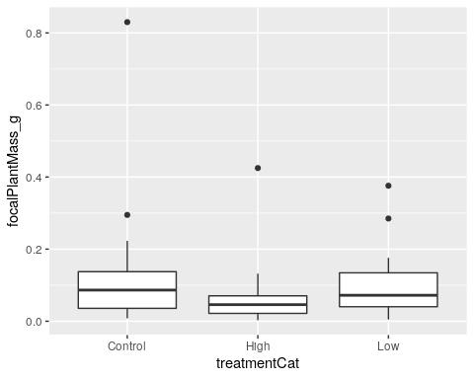

#### Data Cleaning: Resource Experiment ####  
  
#' #### Data  
#'   
#' Subsetting the data  
resourceDat <- dat %>%   
 filter(experiment == "resources")  
  
#' Conditional Filtering  
resourceDat <- resourceDat %>%   
 filter(!is.na(phyllToTotal)) %>%  
 filter(!is.na(treatmentCat)) %>%  
 filter(survivorship == 1) %>%  
 mutate_at(vars(treatmentCat), factor)  
  
#' Replicates per treatment  
resource_reps <- summarize(group_by(resourceDat, treatmentCat), n())

## `summarise()` ungrouping output (override with `.groups` argument)

resource_reps

## # A tibble: 4 x 2  
## treatmentCat `n()`  
## <fct> <int>  
## 1 Control 16  
## 2 High 3  
## 3 Low 13  
## 4 Medium 7

#' The "high" treatment was removed due to low replication (3 data points)  
resourceDat <- resourceDat %>%   
 filter( treatmentCat != "High" ) %>%  
 droplevels()  
  
  
#' Boxplot of the phyllary proportion by treatment  
ggplot(resourceDat, aes(treatmentCat, phyllToTotal)) +  
 geom_boxplot()

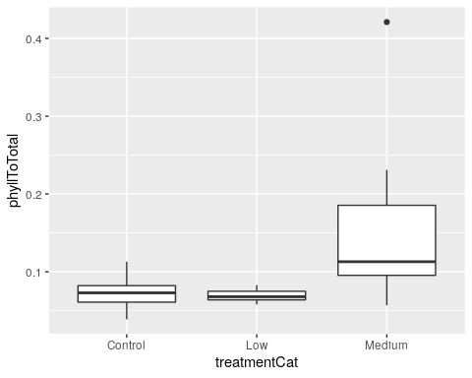

#' Boxplot of the floral height by treatment  
ggplot(resourceDat, aes(treatmentCat, focalFlowerHeight_cm)) +  
 geom_boxplot()

## Warning: Removed 4 rows containing non-finite values (stat_boxplot).

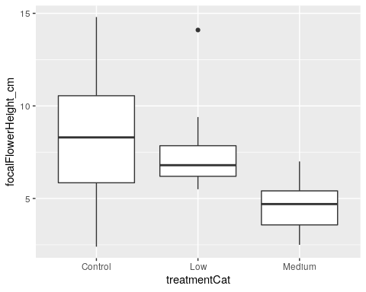

#' Boxplot of the plant mass by treatment  
ggplot(resourceDat, aes(treatmentCat, focalPlantMass_g)) +  
 geom_boxplot()

## Warning: Removed 1 rows containing non-finite values (stat_boxplot).

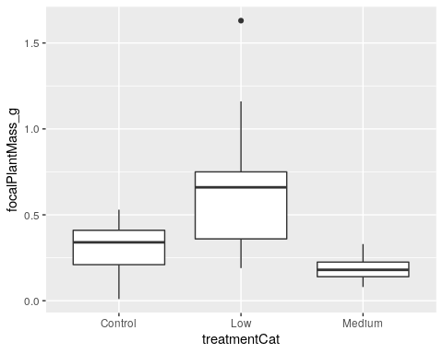

1. Shade Experiment: Plant Mass

#### Plant Mass: Shade to Control####  
#'   
#' Get rid of NA's  
shadeDat_mass <- shadeDat %>% filter( !is.na(focalPlantMass_g))  
  
#' __Linear mixed model__  
lme_mass_shade <- lme(focalPlantMass_g~treatmentCat,   
 random = ~1|bin,   
 data = shadeDat_mass)  
summary(lme_mass_shade)

## Linear mixed-effects model fit by REML  
## Data: shadeDat_mass   
## AIC BIC logLik  
## -45.83939 -33.6757 29.91969  
##   
## Random effects:  
## Formula: ~1 | bin  
## (Intercept) Residual  
## StdDev: 1.63485e-06 0.1040062  
##   
## Fixed effects: focalPlantMass_g ~ treatmentCat   
## Value Std.Error DF t-value p-value  
## (Intercept) 0.16181818 0.03135906 35 5.160174 0.0000  
## treatmentCatHigh -0.02181818 0.05278516 35 -0.413339 0.6819  
## treatmentCatLow -0.05636364 0.04434840 35 -1.270928 0.2121  
## treatmentCatMedium -0.04081818 0.04544359 35 -0.898216 0.3752  
## treatmentCatStructure -0.08181818 0.04674732 35 -1.750222 0.0888  
## Correlation:   
## (Intr) trtmCH trtmCL trtmCM  
## treatmentCatHigh -0.594   
## treatmentCatLow -0.707 0.420   
## treatmentCatMedium -0.690 0.410 0.488   
## treatmentCatStructure -0.671 0.399 0.474 0.463  
##   
## Standardized Within-Group Residuals:  
## Min Q1 Med Q3 Max   
## -1.45970287 -0.65992555 -0.09614809 0.24037023 2.78829470   
##   
## Number of Observations: 47  
## Number of Groups: 8

*According to this model, which incorporates bin as a potential random experimental design variable, there is no significant difference in plant mass among our different treatment categories*

#' _Diagnostic plots: Shade mass_  
#'   
#' qqplot to test for normality  
qqnorm(lme_mass_shade, ~ resid(., type = "p"), abline = c(0, 1))

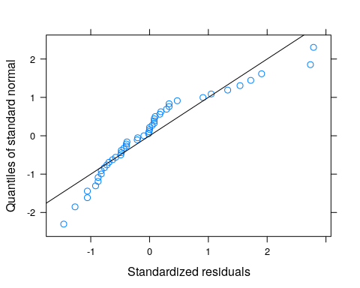

#' Residuals vs fitted plot  
plot.lme(lme_mass_shade)

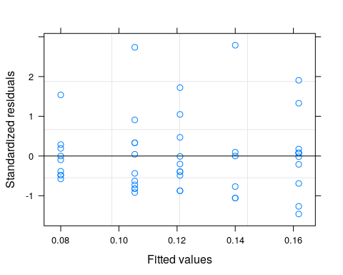 *Though the residual variances are somewhat different per fitted value, they aren’t all that concerning Even so, I fit an unequal variances model and then compared it to the equal variances model.*

#' __Linear mixed model with unequal variances__  
lme_mass_shade_uv <- lme(focalPlantMass_g~treatmentCat,  
 data = shadeDat_mass,  
 random = ~1|bin,  
 weights = varIdent(form = ~1|treatmentCat))  
  
summary(lme_mass_shade_uv)

## Linear mixed-effects model fit by REML  
## Data: shadeDat_mass   
## AIC BIC logLik  
## -42.50371 -23.38935 32.25186  
##   
## Random effects:  
## Formula: ~1 | bin  
## (Intercept) Residual  
## StdDev: 9.81347e-07 0.08774331  
##   
## Variance function:  
## Structure: Different standard deviations per stratum  
## Formula: ~1 | treatmentCat   
## Parameter estimates:  
## Medium Control Structure High Low   
## 1.0000000 1.1676304 0.7771636 1.7269188 1.2897760   
## Fixed effects: focalPlantMass_g ~ treatmentCat   
## Value Std.Error DF t-value p-value  
## (Intercept) 0.16181818 0.03089037 35 5.238467 0.0000  
## treatmentCatHigh -0.02181818 0.06914392 35 -0.315547 0.7542  
## treatmentCatLow -0.05636364 0.04602730 35 -1.224570 0.2289  
## treatmentCatMedium -0.04081818 0.04152233 35 -0.983042 0.3323  
## treatmentCatStructure -0.08181818 0.03835207 35 -2.133344 0.0400  
## Correlation:   
## (Intr) trtmCH trtmCL trtmCM  
## treatmentCatHigh -0.447   
## treatmentCatLow -0.671 0.300   
## treatmentCatMedium -0.744 0.332 0.499   
## treatmentCatStructure -0.805 0.360 0.541 0.599  
##   
## Standardized Within-Group Residuals:  
## Min Q1 Med Q3 Max   
## -1.4818504 -0.7134726 -0.1466471 0.2992745 2.5143361   
##   
## Number of Observations: 47  
## Number of Groups: 8

#' _Diagnostic plots_  
#'   
#' qqplot to test for normality  
qqnorm(lme_mass_shade_uv, ~ resid(., type = "p"), abline = c(0, 1))

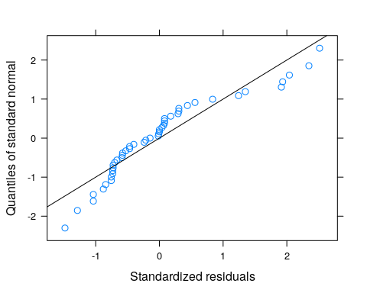

#' Residuals vs fitted plot  
plot.lme(lme_mass_shade_uv)

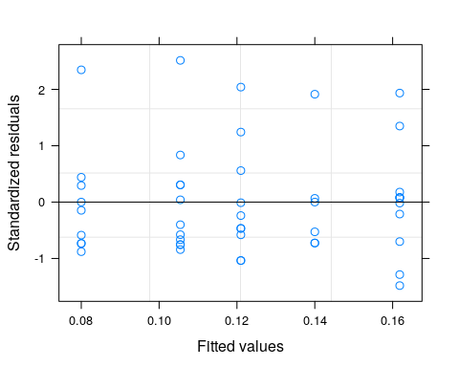 *The uneuqual variances model to seem to homogenize residual variances, but is it worth it to use this model over the equal variances model at the cost of less degrees of freedom?*

anova(lme_mass_shade, lme_mass_shade_uv) # No

## Model df AIC BIC logLik Test L.Ratio p-value  
## lme_mass_shade 1 7 -45.83939 -33.67570 29.91969   
## lme_mass_shade_uv 2 11 -42.50371 -23.38935 32.25186 1 vs 2 4.664329 0.3235

#' Fit the same model without at intercept to get the standard errors of the means for each group (for plotting)  
lme_mass_shade_noint <- lme(focalPlantMass_g~ 0 +treatmentCat,  
 data = shadeDat_mass,  
 random = ~1|bin)

#' _Final answer_  
summary_lme_mass_shade <- summary(lme_mass_shade)  
summary_lme_mass_shade_noint <- summary(lme_mass_shade_noint)  
anova(summary_lme_mass_shade)

## numDF denDF F-value p-value  
## (Intercept) 1 35 64.12918 <.0001  
## treatmentCat 4 35 0.88445 0.4833

*As we can see for this model, there is no significant treatment effect*

summary_lme_mass_shade

## Linear mixed-effects model fit by REML  
## Data: shadeDat_mass   
## AIC BIC logLik  
## -45.83939 -33.6757 29.91969  
##   
## Random effects:  
## Formula: ~1 | bin  
## (Intercept) Residual  
## StdDev: 1.63485e-06 0.1040062  
##   
## Fixed effects: focalPlantMass_g ~ treatmentCat   
## Value Std.Error DF t-value p-value  
## (Intercept) 0.16181818 0.03135906 35 5.160174 0.0000  
## treatmentCatHigh -0.02181818 0.05278516 35 -0.413339 0.6819  
## treatmentCatLow -0.05636364 0.04434840 35 -1.270928 0.2121  
## treatmentCatMedium -0.04081818 0.04544359 35 -0.898216 0.3752  
## treatmentCatStructure -0.08181818 0.04674732 35 -1.750222 0.0888  
## Correlation:   
## (Intr) trtmCH trtmCL trtmCM  
## treatmentCatHigh -0.594   
## treatmentCatLow -0.707 0.420   
## treatmentCatMedium -0.690 0.410 0.488   
## treatmentCatStructure -0.671 0.399 0.474 0.463  
##   
## Standardized Within-Group Residuals:  
## Min Q1 Med Q3 Max   
## -1.45970287 -0.65992555 -0.09614809 0.24037023 2.78829470   
##   
## Number of Observations: 47  
## Number of Groups: 8

#' Plot the model outcome (work in progress)  
shade_mass_output_df <- data.frame(cat_mean_noint = summary_lme_mass_shade_noint$tTable[,"Value"],  
 cat_se_noint = summary_lme_mass_shade_noint$tTable[,"Std.Error"],  
 trt_cat = levels(shadeDat$treatmentCat))  
  
shade_mass_output_df

## cat_mean_noint cat_se_noint trt_cat  
## treatmentCatControl 0.1618182 0.03135906 Control  
## treatmentCatHigh 0.1400000 0.04246036 High  
## treatmentCatLow 0.1054545 0.03135906 Low  
## treatmentCatMedium 0.1210000 0.03288966 Medium  
## treatmentCatStructure 0.0800000 0.03466874 Structure

p_shade_mass_output <- ggplot(shade_mass_output_df, aes(x=factor(trt_cat, levels = labelOrders), y=cat_mean_noint)) +   
 geom_errorbar(aes(ymin=cat_mean_noint-cat_se_noint, ymax=cat_mean_noint+cat_se_noint), color = "brown4", width = 0.5) +  
 geom_point() +  
 geom_jitter(data = shadeDat, aes(x = treatmentCat, y = focalPlantMass_g), color = "brown4", width = 0.1, alpha = 0.4) +  
 theme_light() +  
 ylab("Focal Plant Mass (g)") +  
 xlab("Shade Treatment (µmol of photons/m^2s)") +  
 ggtitle("Shade Experiment") +  
 theme(plot.title = element_text(hjust = 0.5, vjust = 0.3)) +  
 scale_x_discrete(labels = c("Control\n122.0", "Structure\n107.0", "Low\n87.2", "Medium\n71.6", "High\n69.0")) +  
 ylim(0,.5) +  
 labs(caption = "No Significant Treatment Effect")  
p_shade_mass_output

## Warning: Removed 1 rows containing missing values (geom_point).

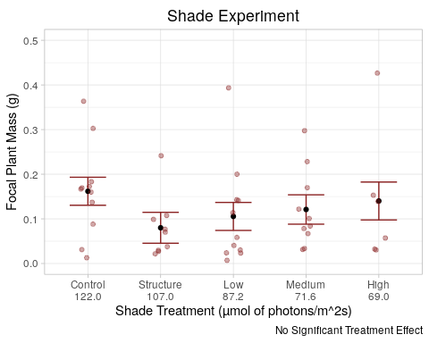 *No need for subsequent pairwise comparisons given that the treatment effect was insignificant*

1. Density Experiment: Plant Mass

#' Get rid of NA's  
densityDat_mass <- densityDat %>% filter( !is.na(focalPlantMass_g))  
  
#' __Linear mixed model__  
lme_mass_density <- lme(focalPlantMass_g~treatmentCat,   
 random = ~1|bin,   
 data = densityDat_mass)  
summary(lme_mass_density)

## Linear mixed-effects model fit by REML  
## Data: densityDat_mass   
## AIC BIC logLik  
## -90.33167 -78.74422 50.16583  
##   
## Random effects:  
## Formula: ~1 | bin  
## (Intercept) Residual  
## StdDev: 0.0160183 0.1154322  
##   
## Fixed effects: focalPlantMass_g ~ treatmentCat   
## Value Std.Error DF t-value p-value  
## (Intercept) 0.11859196 0.02259739 72 5.248037 0.0000  
## treatmentCatHigh -0.05699832 0.03097986 72 -1.839851 0.0699  
## treatmentCatLow -0.02131420 0.03266820 72 -0.652445 0.5162  
## Correlation:   
## (Intr) trtmCH  
## treatmentCatHigh -0.638   
## treatmentCatLow -0.610 0.446  
##   
## Standardized Within-Group Residuals:  
## Min Q1 Med Q3 Max   
## -0.9292079 -0.5029795 -0.1599247 0.1605080 6.1130415   
##   
## Number of Observations: 78  
## Number of Groups: 4

#' _Diagnostic plots_  
#'   
#' qqplot to test for normality  
qqnorm(lme_mass_density, ~ resid(., type = "p"), abline = c(0, 1))

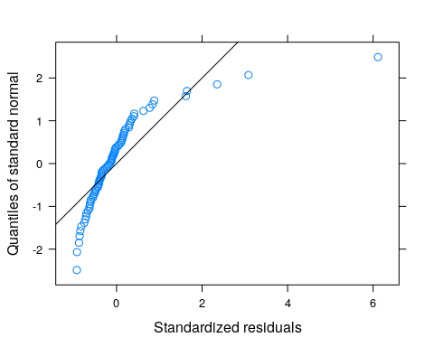

#' Residuals vs fitted plot  
plot.lme(lme_mass_density)

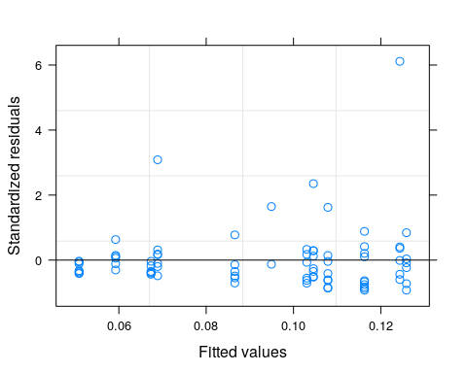 *Though the residual variances are somewhat different per fitted value, but they aren’t all that concerning. Even so, I fit an unequal variances model and then compared it to the equal variances model.*

#' __Linear mixed model with unequal variances__  
lme_mass_density_uv <- lme(focalPlantMass_g~treatmentCat,  
 data = densityDat_mass,  
 random = ~1|bin,  
 weights = varIdent(form = ~1|treatmentCat))  
  
summary(lme_mass_density_uv)

## Linear mixed-effects model fit by REML  
## Data: densityDat_mass   
## AIC BIC logLik  
## -100.6756 -84.45317 57.3378  
##   
## Random effects:  
## Formula: ~1 | bin  
## (Intercept) Residual  
## StdDev: 0.02528964 0.1550227  
##   
## Variance function:  
## Structure: Different standard deviations per stratum  
## Formula: ~1 | treatmentCat   
## Parameter estimates:  
## Control Low High   
## 1.0000000 0.5566794 0.4906089   
## Fixed effects: focalPlantMass_g ~ treatmentCat   
## Value Std.Error DF t-value p-value  
## (Intercept) 0.11847014 0.03105700 72 3.814604 0.0003  
## treatmentCatHigh -0.05701510 0.03206754 72 -1.777969 0.0796  
## treatmentCatLow -0.02135387 0.03415102 72 -0.625278 0.5338  
## Correlation:   
## (Intr) trtmCH  
## treatmentCatHigh -0.808   
## treatmentCatLow -0.764 0.742  
##   
## Standardized Within-Group Residuals:  
## Min Q1 Med Q3 Max   
## -0.9403186 -0.5315420 -0.2540512 0.1103916 4.6210594   
##   
## Number of Observations: 78  
## Number of Groups: 4

#' _Diagnostic plots_  
#'   
#' qqplot to test for normality  
qqnorm(lme_mass_density_uv, ~ resid(., type = "p"), abline = c(0, 1))

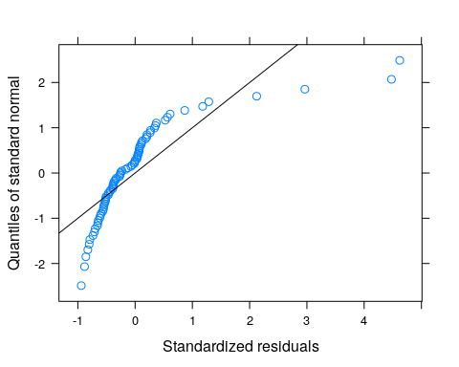

#' Residuals vs fitted plot  
plot.lme(lme_mass_density_uv)

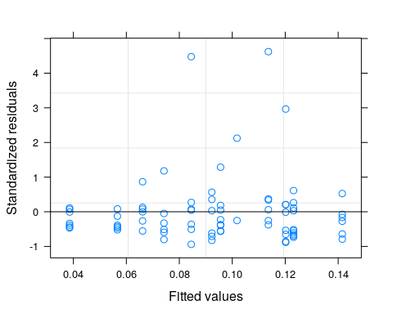

*The variance structure by fitted value seems to be somewhat more normal using the unequal variances model, though it looks like the gains are marginal, at best. Is it worth it to use the unequal variances model at the cost of degrees of freedom?*

anova(lme_mass_density, lme_mass_density_uv)

## Model df AIC BIC logLik Test L.Ratio  
## lme_mass_density 1 5 -90.33167 -78.74422 50.16583   
## lme_mass_density_uv 2 7 -100.67559 -84.45317 57.33780 1 vs 2 14.34393  
## p-value  
## lme_mass_density   
## lme_mass_density_uv 8e-04

*Yes, it is!*

#' Fit the same model without at intercept to get the standard errors of the means for each group (for plotting)  
lme_mass_density_noint <- lme(focalPlantMass_g~ 0 +treatmentCat,  
 data = densityDat_mass,  
 random = ~1|bin,  
 weights = varIdent(form = ~1|treatmentCat))  
  
summary(lme_mass_density_noint)

## Linear mixed-effects model fit by REML  
## Data: densityDat_mass   
## AIC BIC logLik  
## -100.6756 -84.45317 57.3378  
##   
## Random effects:  
## Formula: ~1 | bin  
## (Intercept) Residual  
## StdDev: 0.02528964 0.1550227  
##   
## Variance function:  
## Structure: Different standard deviations per stratum  
## Formula: ~1 | treatmentCat   
## Parameter estimates:  
## Control Low High   
## 1.0000000 0.5566794 0.4906089   
## Fixed effects: focalPlantMass_g ~ 0 + treatmentCat   
## Value Std.Error DF t-value p-value  
## treatmentCatControl 0.11847014 0.03105700 72 3.814604 0.0003  
## treatmentCatHigh 0.06145504 0.01956460 72 3.141134 0.0024  
## treatmentCatLow 0.09711627 0.02258076 72 4.300841 0.0001  
## Correlation:   
## trtmCC trtmCH  
## treatmentCatHigh 0.262   
## treatmentCatLow 0.220 0.365   
##   
## Standardized Within-Group Residuals:  
## Min Q1 Med Q3 Max   
## -0.9403186 -0.5315420 -0.2540512 0.1103916 4.6210594   
##   
## Number of Observations: 78  
## Number of Groups: 4

#' _Final answer_  
summary_lme_mass_density_uv <- summary(lme_mass_density_uv)  
summary_lme_mass_density_noint <- summary(lme_mass_density_noint)  
anova(summary_lme_mass_density_uv)

## numDF denDF F-value p-value  
## (Intercept) 1 72 24.171627 <.0001  
## treatmentCat 2 72 2.115444 0.128

*Given that there was no significant treatment effect, pairwise comparisons are not needed*

#Final model output  
summary_lme_mass_density_uv

## Linear mixed-effects model fit by REML  
## Data: densityDat_mass   
## AIC BIC logLik  
## -100.6756 -84.45317 57.3378  
##   
## Random effects:  
## Formula: ~1 | bin  
## (Intercept) Residual  
## StdDev: 0.02528964 0.1550227  
##   
## Variance function:  
## Structure: Different standard deviations per stratum  
## Formula: ~1 | treatmentCat   
## Parameter estimates:  
## Control Low High   
## 1.0000000 0.5566794 0.4906089   
## Fixed effects: focalPlantMass_g ~ treatmentCat   
## Value Std.Error DF t-value p-value  
## (Intercept) 0.11847014 0.03105700 72 3.814604 0.0003  
## treatmentCatHigh -0.05701510 0.03206754 72 -1.777969 0.0796  
## treatmentCatLow -0.02135387 0.03415102 72 -0.625278 0.5338  
## Correlation:   
## (Intr) trtmCH  
## treatmentCatHigh -0.808   
## treatmentCatLow -0.764 0.742  
##   
## Standardized Within-Group Residuals:  
## Min Q1 Med Q3 Max   
## -0.9403186 -0.5315420 -0.2540512 0.1103916 4.6210594   
##   
## Number of Observations: 78  
## Number of Groups: 4

#' Plot the model outcome  
density_mass_output_df <- data.frame(cat_mean_noint = summary_lme_mass_density_noint$tTable[,"Value"],  
 cat_se_noint = summary_lme_mass_density_noint$tTable[,"Std.Error"],  
 trt_cat = levels(densityDat$treatmentCat))  
  
density_mass_output_df

## cat_mean_noint cat_se_noint trt_cat  
## treatmentCatControl 0.11847014 0.03105700 Control  
## treatmentCatHigh 0.06145504 0.01956460 High  
## treatmentCatLow 0.09711627 0.02258076 Low

p_density_mass_output <- ggplot(density_mass_output_df, aes(x=factor(trt_cat, levels = labelOrders), y=cat_mean_noint)) +   
 geom_point() +  
 geom_errorbar(aes(ymin=cat_mean_noint-cat_se_noint, ymax=cat_mean_noint+cat_se_noint), color = "cyan4",width = .5, show.legend = F) +  
 geom_jitter(data = densityDat, aes(x = treatmentCat, y = focalPlantMass_g), color = "cyan4", width = 0.1, alpha = 0.4) +  
 theme_light() +   
 ylab("Focal Plant Mass (g)") +  
 xlab("Density Treatment (plants per cone)") +  
 ggtitle("Density Experiment") +  
 theme(plot.title = element_text(hjust = 0.5, vjust = 0.3)) +  
 scale_x_discrete(labels = c("Control\n0", "Low\n1", "High\n2")) +  
 ylim(0,.6) +  
 labs(caption = "No Significant Treatment Effect")  
  
p_density_mass_output

## Warning: Removed 2 rows containing missing values (geom_point).

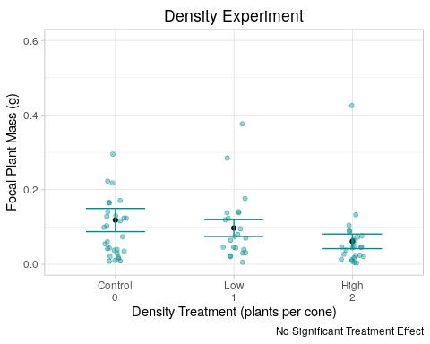 7) Resource Experiment: Plant Mass

#' Get rid of NAs in the data  
resourceDat_mass <- resourceDat %>% filter( focalPlantMass_g > 0)  
  
#' __Linear mixed model__  
lme_mass_resource <- lme(focalPlantMass_g~treatmentCat,   
 random = ~1|bin,  
 data = resourceDat_mass)  
summary(lme_mass_resource)

## Linear mixed-effects model fit by REML  
## Data: resourceDat_mass   
## AIC BIC logLik  
## 22.79992 30.1286 -6.399958  
##   
## Random effects:  
## Formula: ~1 | bin  
## (Intercept) Residual  
## StdDev: 0.1151415 0.2456891  
##   
## Fixed effects: focalPlantMass_g ~ treatmentCat   
## Value Std.Error DF t-value p-value  
## (Intercept) 0.3040863 0.07557856 25 4.023446 0.0005  
## treatmentCatLow 0.3627966 0.09343689 25 3.882798 0.0007  
## treatmentCatMedium -0.1282349 0.11452369 25 -1.119724 0.2735  
## Correlation:   
## (Intr) trtmCL  
## treatmentCatLow -0.571   
## treatmentCatMedium -0.470 0.382  
##   
## Standardized Within-Group Residuals:  
## Min Q1 Med Q3 Max   
## -1.74967073 -0.51912965 -0.01061838 0.38764019 3.24594989   
##   
## Number of Observations: 35  
## Number of Groups: 8

#' _Diagnostic plots_  
#'   
#' qqplot to test for normality  
qqnorm(lme_mass_resource, ~ resid(., type = "p"), abline = c(0, 1))

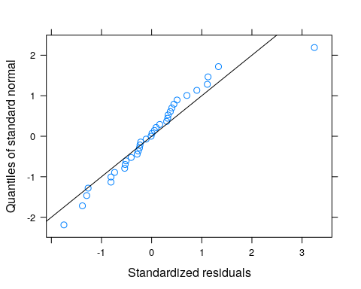

#' Residuals vs fitted plot  
plot.lme(lme_mass_resource)

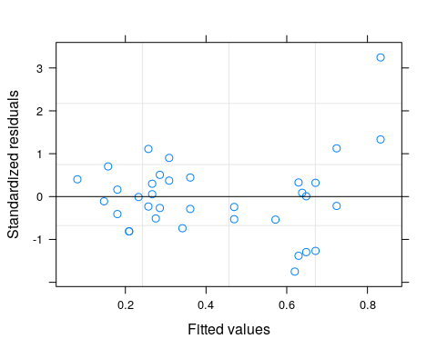

#’ There aren’t super clear differences in the variance of the residuals among by fitted value, but I decided to fit the unequal variances model anyway to see what it looked like/if it was worth using.

#' __Linear mixed model with unequal variances__  
lme_mass_resource_uv <- lme(focalPlantMass_g~treatmentCat,  
 data = resourceDat_mass,  
 random = ~1|bin,  
 weights = varIdent(form = ~1|treatmentCat))  
  
summary(lme_mass_resource_uv)

## Linear mixed-effects model fit by REML  
## Data: resourceDat_mass   
## AIC BIC logLik  
## 9.41227 19.67242 2.293865  
##   
## Random effects:  
## Formula: ~1 | bin  
## (Intercept) Residual  
## StdDev: 0.02401474 0.1614684  
##   
## Variance function:  
## Structure: Different standard deviations per stratum  
## Formula: ~1 | treatmentCat   
## Parameter estimates:  
## Control Low Medium   
## 1.0000000 2.4680769 0.4970882   
## Fixed effects: focalPlantMass_g ~ treatmentCat   
## Value Std.Error DF t-value p-value  
## (Intercept) 0.3054233 0.04257037 25 7.174550 0.0000  
## treatmentCatLow 0.3729799 0.11814907 25 3.156858 0.0041  
## treatmentCatMedium -0.1167955 0.05189481 25 -2.250619 0.0335  
## Correlation:   
## (Intr) trtmCL  
## treatmentCatLow -0.346   
## treatmentCatMedium -0.788 0.284  
##   
## Standardized Within-Group Residuals:  
## Min Q1 Med Q3 Max   
## -1.74952128 -0.70262104 -0.02447105 0.58680677 2.37527016   
##   
## Number of Observations: 35  
## Number of Groups: 8

#' _Diagnostic plots_  
#'   
#' qqplot to test for normality  
qqnorm(lme_mass_resource_uv, ~ resid(., type = "p"), abline = c(0, 1))

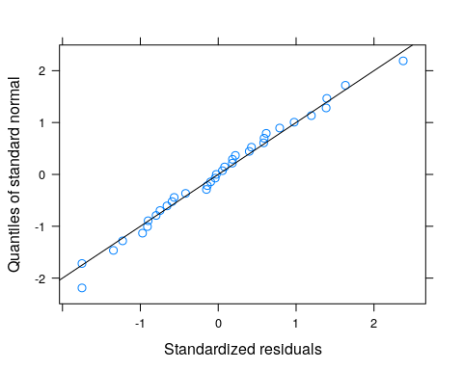

#' Residuals vs fitted plot  
plot.lme(lme_mass_resource_uv)

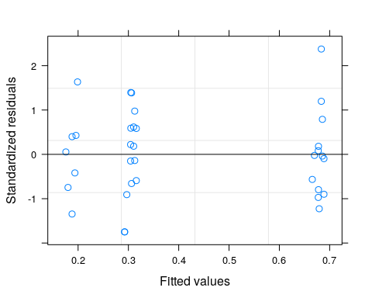

*Looks like the unequal variances model fixes the issues. But is it worth the extra spending of degrees of freedom?*

anova(lme_mass_resource, lme_mass_resource_uv)

## Model df AIC BIC logLik Test L.Ratio  
## lme_mass_resource 1 5 22.79992 30.12860 -6.399958   
## lme_mass_resource_uv 2 7 9.41227 19.67242 2.293865 1 vs 2 17.38765  
## p-value  
## lme_mass_resource   
## lme_mass_resource_uv 2e-04

*Yes*

#' _Final answer_  
summary_lme_mass_resource_uv <- summary(lme_mass_resource_uv)  
anova(summary_lme_mass_resource_uv)

## numDF denDF F-value p-value  
## (Intercept) 1 25 96.03677 <.0001  
## treatmentCat 2 25 10.37316 5e-04

*There was a significant treatment effect; subsequent pairwise comparisons will be necessary*

summary_lme_mass_resource_uv

## Linear mixed-effects model fit by REML  
## Data: resourceDat_mass   
## AIC BIC logLik  
## 9.41227 19.67242 2.293865  
##   
## Random effects:  
## Formula: ~1 | bin  
## (Intercept) Residual  
## StdDev: 0.02401474 0.1614684  
##   
## Variance function:  
## Structure: Different standard deviations per stratum  
## Formula: ~1 | treatmentCat   
## Parameter estimates:  
## Control Low Medium   
## 1.0000000 2.4680769 0.4970882   
## Fixed effects: focalPlantMass_g ~ treatmentCat   
## Value Std.Error DF t-value p-value  
## (Intercept) 0.3054233 0.04257037 25 7.174550 0.0000  
## treatmentCatLow 0.3729799 0.11814907 25 3.156858 0.0041  
## treatmentCatMedium -0.1167955 0.05189481 25 -2.250619 0.0335  
## Correlation:   
## (Intr) trtmCL  
## treatmentCatLow -0.346   
## treatmentCatMedium -0.788 0.284  
##   
## Standardized Within-Group Residuals:  
## Min Q1 Med Q3 Max   
## -1.74952128 -0.70262104 -0.02447105 0.58680677 2.37527016   
##   
## Number of Observations: 35  
## Number of Groups: 8

*Relative to the control, we can see that both the low and medium treatment categories differed significant. We can see that the low treatment category is associated with a 0.40 gram (27%) increase relative to the control (t(25) = 3.16, se = 0.12, p < 0.01). This suggests that the added nutrients within the low treatment category were in fact beneficial to the plant. The medium treatment category is associated with a 0.12 gram (62%) decrease relative to the control (t(25) = -2.25, se = 0.05, p < 0.05). Plants in this category, when using biomass as a proxy of stress, did no fare as well when compared to the control. Pairwise testing below will illustrate how the plant mass in the two treatments differed when compared to one another*

#Plant Mass: Resource Pairwise Comparisons  
resDat_mass <- resourceDat_mass %>% filter( !is.na(focalPlantMass_g))  
# Medium To All:  
res_mass_medbase <- resDat_mass %>% mutate(treatmentCat = relevel(treatmentCat, "Medium"))  
  
lme_mass_res_medbase <- lme(focalPlantMass_g~treatmentCat,  
 data = res_mass_medbase,  
 random = ~1|bin,  
 weights = varIdent(form = ~1|treatmentCat))  
  
summary(lme_mass_res_medbase)

## Linear mixed-effects model fit by REML  
## Data: res_mass_medbase   
## AIC BIC logLik  
## 9.41227 19.67242 2.293865  
##   
## Random effects:  
## Formula: ~1 | bin  
## (Intercept) Residual  
## StdDev: 0.02401474 0.1614684  
##   
## Variance function:  
## Structure: Different standard deviations per stratum  
## Formula: ~1 | treatmentCat   
## Parameter estimates:  
## Control Low Medium   
## 1.0000000 2.4680769 0.4970882   
## Fixed effects: focalPlantMass_g ~ treatmentCat   
## Value Std.Error DF t-value p-value  
## (Intercept) 0.1886278 0.03199139 25 5.896205 0.0000  
## treatmentCatControl 0.1167955 0.05189481 25 2.250619 0.0335  
## treatmentCatLow 0.4897753 0.11474610 25 4.268340 0.0002  
## Correlation:   
## (Intr) trtmCC  
## treatmentCatControl -0.574   
## treatmentCatLow -0.258 0.160  
##   
## Standardized Within-Group Residuals:  
## Min Q1 Med Q3 Max   
## -1.74952128 -0.70262104 -0.02447105 0.58680677 2.37527016   
##   
## Number of Observations: 35  
## Number of Groups: 8

*Here, we can see that the low treatment category is associated with a 0.48 gram (150%) increase relative to the medium treatment category (t(25) = 4.26, se = 0.11, p < 0.001). The results suggest that plants in the low treatment category faired the best when compared to both the control and the medium treatment*

#' Fit the same model without at intercept to get the standard errors of the means for each group (for plotting)  
lme_mass_resource_uv_noint <- lme(focalPlantMass_g~ 0 +treatmentCat,  
 data = resourceDat_mass,  
 random = ~1|bin,  
 weights = varIdent(form = ~1|treatmentCat))  
  
summary(lme_mass_resource_uv_noint)

## Linear mixed-effects model fit by REML  
## Data: resourceDat_mass   
## AIC BIC logLik  
## 9.41227 19.67242 2.293865  
##   
## Random effects:  
## Formula: ~1 | bin  
## (Intercept) Residual  
## StdDev: 0.02401474 0.1614684  
##   
## Variance function:  
## Structure: Different standard deviations per stratum  
## Formula: ~1 | treatmentCat   
## Parameter estimates:  
## Control Low Medium   
## 1.0000000 2.4680769 0.4970882   
## Fixed effects: focalPlantMass_g ~ 0 + treatmentCat   
## Value Std.Error DF t-value p-value  
## treatmentCatControl 0.3054233 0.04257037 25 7.174550 0  
## treatmentCatLow 0.6784031 0.11088018 25 6.118345 0  
## treatmentCatMedium 0.1886278 0.03199139 25 5.896205 0  
## Correlation:   
## trtmCC trtmCL  
## treatmentCatLow 0.016   
## treatmentCatMedium 0.052 0.021   
##   
## Standardized Within-Group Residuals:  
## Min Q1 Med Q3 Max   
## -1.74952128 -0.70262104 -0.02447105 0.58680677 2.37527016   
##   
## Number of Observations: 35  
## Number of Groups: 8

#' _Final answer_  
summary_lme_mass_resource_uv <- summary(lme_mass_resource_uv)  
summary_lme_mass_resource_uv_noint <- summary(lme_mass_resource_uv_noint)  
summary_lme_mass_resource_uv

## Linear mixed-effects model fit by REML  
## Data: resourceDat_mass   
## AIC BIC logLik  
## 9.41227 19.67242 2.293865  
##   
## Random effects:  
## Formula: ~1 | bin  
## (Intercept) Residual  
## StdDev: 0.02401474 0.1614684  
##   
## Variance function:  
## Structure: Different standard deviations per stratum  
## Formula: ~1 | treatmentCat   
## Parameter estimates:  
## Control Low Medium   
## 1.0000000 2.4680769 0.4970882   
## Fixed effects: focalPlantMass_g ~ treatmentCat   
## Value Std.Error DF t-value p-value  
## (Intercept) 0.3054233 0.04257037 25 7.174550 0.0000  
## treatmentCatLow 0.3729799 0.11814907 25 3.156858 0.0041  
## treatmentCatMedium -0.1167955 0.05189481 25 -2.250619 0.0335  
## Correlation:   
## (Intr) trtmCL  
## treatmentCatLow -0.346   
## treatmentCatMedium -0.788 0.284  
##   
## Standardized Within-Group Residuals:  
## Min Q1 Med Q3 Max   
## -1.74952128 -0.70262104 -0.02447105 0.58680677 2.37527016   
##   
## Number of Observations: 35  
## Number of Groups: 8

#' Plot the model outcome  
mass_resource_output_df <- data.frame(cat_mean_noint = summary_lme_mass_resource_uv_noint$tTable[,"Value"],  
 cat_se_noint = summary_lme_mass_resource_uv_noint$tTable[,"Std.Error"],  
 trt_cat = levels(resourceDat$treatmentCat))  
levels(resourceDat$treatmentCat)

## [1] "Control" "Low" "Medium"

mass_resource_output_df

## cat_mean_noint cat_se_noint trt_cat  
## treatmentCatControl 0.3054233 0.04257037 Control  
## treatmentCatLow 0.6784031 0.11088018 Low  
## treatmentCatMedium 0.1886278 0.03199139 Medium

p_res_mass_output <- ggplot(mass_resource_output_df, aes(x=factor(trt_cat, levels = labelOrders), y=cat_mean_noint)) +   
 geom_point() +  
 geom_errorbar(aes(ymin=cat_mean_noint-cat_se_noint, ymax=cat_mean_noint+cat_se_noint),color = "goldenrod3", width = .5, show.legend = F) +  
 geom_jitter(data = resourceDat, aes(x = treatmentCat, y = focalPlantMass_g),color = "goldenrod3", width = 0.1, alpha = 0.4, show.legend = F) +  
 theme_light() +   
 ylab("Focal Plant mass (g)") +  
 xlab("Nutrient Addition Treatment (tbsp nutrients/gal. water)") +  
 ggtitle("Eutrophication Experiment") +  
 theme(plot.title = element_text(hjust = 0.5, vjust = 0.3)) +  
 scale_x_discrete(labels = c("Control\n0", "Low\n0.5x", "High\n1x")) +  
 ylim(-0.5, 2) +  
 annotate("text", 1, 1, label = "a") +  
 annotate("text", 2, 1.75, label = "b") +  
 annotate("text", 3, .5, label = "c") +  
 labs(caption = "Significant Overall Treatment Effect; letters indicated within-group differences")  
   
  
p_res_mass_output

## Warning: Removed 1 rows containing missing values (geom_point).

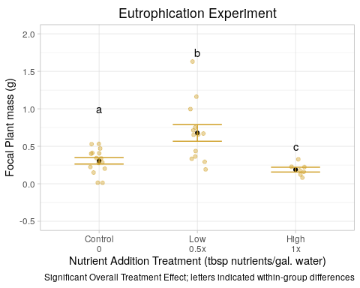 8) Shade Experiment: Ray Seed Proportion

#### Ray Seed Proportion: Shade to Control ####  
#' __Linear mixed model__  
lme_propn_shade <- lme(phyllToTotal~treatmentCat,   
 random = ~1|bin,   
 data = shadeDat)  
  
  
#' _Diagnostic plots_  
#'   
#' qqplot to test for normality  
qqnorm(lme_propn_shade, ~ resid(., type = "p"), abline = c(0, 1))

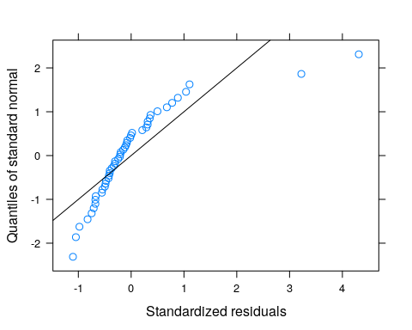

#' Residuals vs fitted plot  
plot.lme(lme_propn_shade)

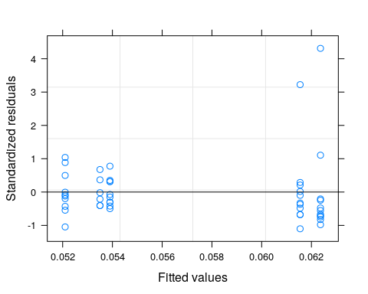 *There are again clear differences in the variance of the residuals among the treatments, so I fit an unequal variances model*

#' __Linear mixed model with unequal variances__  
lme_propn_shade_uv <- lme(phyllToTotal~treatmentCat,  
 data = shadeDat,  
 random = ~1|bin,  
 weights = varIdent(form = ~1|treatmentCat))  
  
  
#' _Diagnostic plots_  
#'   
#' qqplot to test for normality  
qqnorm(lme_propn_shade_uv, ~ resid(., type = "p"), abline = c(0, 1))

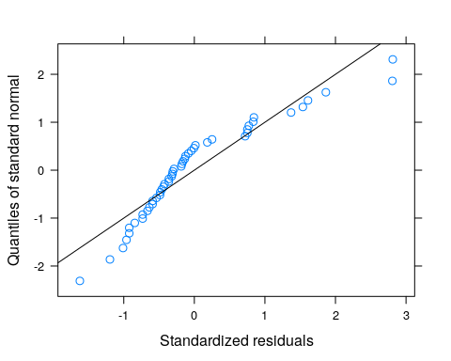 *This looks better*

#' Residuals vs fitted plot  
plot.lme(lme_propn_shade_uv)

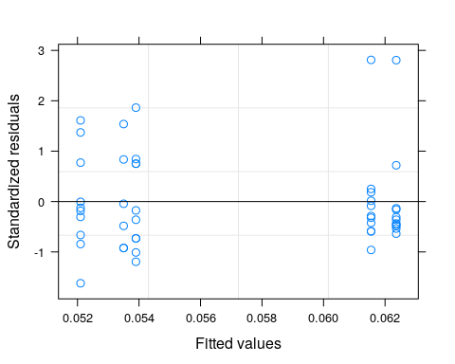 *This looks better, too. Looks like the unequal variances model fixes the issues. But is it worth the extra spending of degrees of freedom?*

anova(lme_propn_shade, lme_propn_shade_uv)

## Model df AIC BIC logLik Test L.Ratio  
## lme_propn_shade 1 7 -166.9899 -154.6616 90.49498   
## lme_propn_shade_uv 2 11 -179.5628 -160.1896 100.78142 1 vs 2 20.57288  
## p-value  
## lme_propn_shade   
## lme_propn_shade_uv 4e-04

*yes!*

#Checking for overall treatment effect  
anova(lme_propn_shade_uv)

## numDF denDF F-value p-value  
## (Intercept) 1 36 552.6755 <.0001  
## treatmentCat 4 36 0.3311 0.8552

*No significant treatment effect; subsequent pairwise comparisons are not necessary*

#' _Final answer_  
summary_lme_propn_shade_uv <- summary(lme_propn_shade_uv)  
summary_lme_propn_shade_uv

## Linear mixed-effects model fit by REML  
## Data: shadeDat   
## AIC BIC logLik  
## -179.5628 -160.1896 100.7814  
##   
## Random effects:  
## Formula: ~1 | bin  
## (Intercept) Residual  
## StdDev: 1.077449e-06 0.01670296  
##   
## Variance function:  
## Structure: Different standard deviations per stratum  
## Formula: ~1 | treatmentCat   
## Parameter estimates:  
## Medium Control Structure High Low   
## 1.0000000 2.3816184 0.6457106 0.6813048 1.7769006   
## Fixed effects: phyllToTotal ~ treatmentCat   
## Value Std.Error DF t-value p-value  
## (Intercept) 0.06236364 0.01199414 36 5.199507 0.0000  
## treatmentCatHigh -0.00886364 0.01286246 36 -0.689109 0.4952  
## treatmentCatLow -0.00081818 0.01496459 36 -0.054675 0.9567  
## treatmentCatMedium -0.01026364 0.01310566 36 -0.783145 0.4387  
## treatmentCatStructure -0.00846364 0.01246963 36 -0.678740 0.5016  
## Correlation:   
## (Intr) trtmCH trtmCL trtmCM  
## treatmentCatHigh -0.932   
## treatmentCatLow -0.802 0.747   
## treatmentCatMedium -0.915 0.853 0.734   
## treatmentCatStructure -0.962 0.897 0.771 0.880  
##   
## Standardized Within-Group Residuals:  
## Min Q1 Med Q3 Max   
## -1.6224669 -0.5911641 -0.2966298 0.3683429 2.8118582   
##   
## Number of Observations: 48  
## Number of Groups: 8

#' Fit the same model without at intercept to get the standard errors of the means for each group (for plotting)  
lme_propn_shade_uv_noint <- lme(phyllToTotal~ 0 +treatmentCat,  
 data = shadeDat,  
 random = ~1|bin,  
 weights = varIdent(form = ~1|treatmentCat))  
  
summary(lme_propn_shade_uv_noint)

## Linear mixed-effects model fit by REML  
## Data: shadeDat   
## AIC BIC logLik  
## -179.5628 -160.1896 100.7814  
##   
## Random effects:  
## Formula: ~1 | bin  
## (Intercept) Residual  
## StdDev: 1.077442e-06 0.01670296  
##   
## Variance function:  
## Structure: Different standard deviations per stratum  
## Formula: ~1 | treatmentCat   
## Parameter estimates:  
## Medium Control Structure High Low   
## 1.0000000 2.3816184 0.6457106 0.6813048 1.7769006   
## Fixed effects: phyllToTotal ~ 0 + treatmentCat   
## Value Std.Error DF t-value p-value  
## treatmentCatControl 0.06236364 0.011994145 36 5.199507 0  
## treatmentCatHigh 0.05350000 0.004645787 36 11.515811 0  
## treatmentCatLow 0.06154545 0.008948706 36 6.877582 0  
## treatmentCatMedium 0.05210000 0.005281940 36 9.863800 0  
## treatmentCatStructure 0.05390000 0.003410604 36 15.803651 0  
## Correlation:   
## trtmCC trtmCH trtmCL trtmCM  
## treatmentCatHigh 0   
## treatmentCatLow 0 0   
## treatmentCatMedium 0 0 0   
## treatmentCatStructure 0 0 0 0   
##   
## Standardized Within-Group Residuals:  
## Min Q1 Med Q3 Max   
## -1.6224669 -0.5911641 -0.2966298 0.3683429 2.8118582   
##   
## Number of Observations: 48  
## Number of Groups: 8

summary_lme_propn_shade_uv_noint <- summary(lme_propn_shade_uv_noint)  
  
  
#' Plot the model outcome  
shade_propn_output_df <- data.frame(cat_mean_noint = summary_lme_propn_shade_uv_noint$tTable[,"Value"],  
 cat_se_noint = summary_lme_propn_shade_uv_noint$tTable[,"Std.Error"],  
 trt_cat = levels(shadeDat$treatmentCat))  
  
shade_propn_output_df

## cat_mean_noint cat_se_noint trt_cat  
## treatmentCatControl 0.06236364 0.011994145 Control  
## treatmentCatHigh 0.05350000 0.004645787 High  
## treatmentCatLow 0.06154545 0.008948706 Low  
## treatmentCatMedium 0.05210000 0.005281940 Medium  
## treatmentCatStructure 0.05390000 0.003410604 Structure

p_shade_propn_output <- ggplot(shade_propn_output_df, aes(x=factor(trt_cat, levels = labelOrders), y=cat_mean_noint)) +   
 geom_point() +  
 geom_errorbar(aes(ymin=cat_mean_noint-cat_se_noint, ymax=cat_mean_noint+cat_se_noint), color = "brown4", width = .5, show.legend = F) +  
 geom_jitter(data = shadeDat, aes(x = treatmentCat, y = phyllToTotal), color = "brown4", width = 0.1, alpha = 0.4, show.legend = F) +  
 theme_light() +   
 ylab("# Phyllaries / Phyllaries + Disk Seeds") +  
 xlab("Shade Treatment (µmol of photons/m^2s)") +  
 ggtitle("Shade Experiment") +  
 theme(plot.title = element_text(hjust = 0.5, vjust = 0.3)) +  
 scale_x_discrete(labels = c("Control\n122.0", "Structure\n107.0", "Low\n87.2", "Medium\n71.6", "High\n69.0")) +  
 ylim(-.005, .2) +  
 labs(caption = "No Significant Treatmne Effect")  
  
p_shade_propn_output

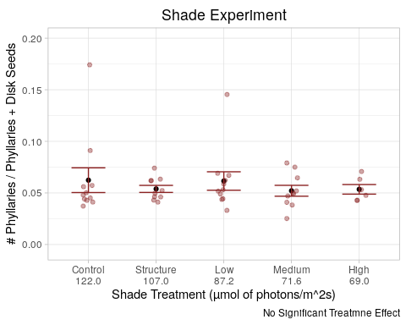 8) Density Experiment: Ray seed proportion

#### Ray Seed Proportion: Density to Control ####  
#' __Linear mixed model__  
lme_propn_dens <- lme(phyllToTotal~treatmentCat,   
 random = ~1|bin,   
 data = densityDat)  
#' _Diagnostic plots_  
#'   
#' qqplot to test for normality  
qqnorm(lme_propn_dens, ~ resid(., type = "p"), abline = c(0, 1))

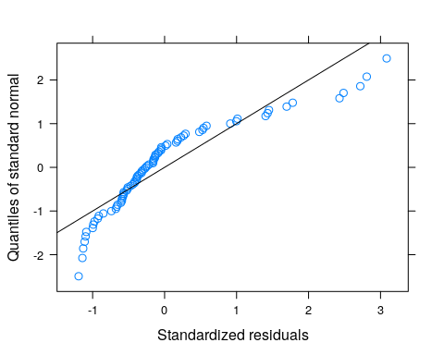

#' Residuals vs fitted plot  
plot.lme(lme_propn_dens)

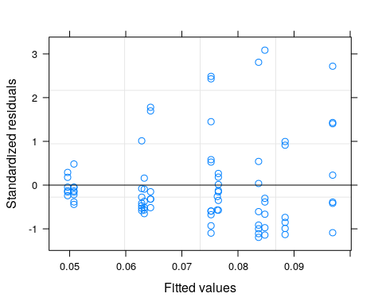

*Residual variances look somewhat heteroskedastic, so I fit an unequal variances model*

#'   
#' __Linear mixed model with unequal variances__  
lme_propn_dens_uv <- lme(phyllToTotal~treatmentCat,  
 data = densityDat,  
 random = ~1|bin,  
 weights = varIdent(form = ~1|treatmentCat))  
  
summary(lme_propn_dens_uv)

## Linear mixed-effects model fit by REML  
## Data: densityDat   
## AIC BIC logLik  
## -262.8589 -246.5437 138.4294  
##   
## Random effects:  
## Formula: ~1 | bin  
## (Intercept) Residual  
## StdDev: 0.01702673 0.03860758  
##   
## Variance function:  
## Structure: Different standard deviations per stratum  
## Formula: ~1 | treatmentCat   
## Parameter estimates:  
## Control Low High   
## 1.0000000 0.9167799 0.8389596   
## Fixed effects: phyllToTotal ~ treatmentCat   
## Value Std.Error DF t-value p-value  
## (Intercept) 0.06802558 0.011084100 73 6.137222 0.0000  
## treatmentCatHigh 0.01308071 0.009468734 73 1.381463 0.1714  
## treatmentCatLow 0.00084584 0.010574615 73 0.079988 0.9365  
## Correlation:   
## (Intr) trtmCH  
## treatmentCatHigh -0.482   
## treatmentCatLow -0.439 0.520  
##   
## Standardized Within-Group Residuals:  
## Min Q1 Med Q3 Max   
## -1.2498522 -0.5489920 -0.2187119 0.1977648 3.0725522   
##   
## Number of Observations: 79  
## Number of Groups: 4

#' _Diagnostic plots_  
#'   
#' qqplot to test for normality  
qqnorm(lme_propn_dens_uv, ~ residuals(., type = "p"), abline = c(0, 1))

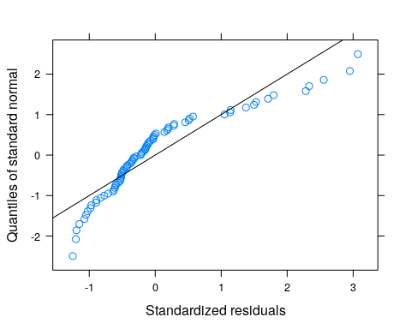

#' Residuals vs fitted plot  
plot.lme(lme_propn_dens_uv)

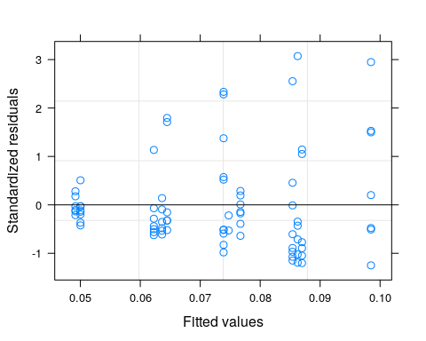 *The unequal variances model doesn’t seem to change much, but if it is worth using than I will use it*

anova(lme_propn_dens, lme_propn_dens_uv)

## Model df AIC BIC logLik Test L.Ratio  
## lme_propn_dens 1 5 -266.1081 -254.4544 138.0540   
## lme_propn_dens_uv 2 7 -262.8589 -246.5437 138.4294 1 vs 2 0.7507784  
## p-value  
## lme_propn_dens   
## lme_propn_dens_uv 0.687

*The model is not worth using. However, given that neither of these models successfully address the underlying heteroskedasticity, I will use the simpler model, or the equal variances model*

anova(lme_propn_dens)

## numDF denDF F-value p-value  
## (Intercept) 1 73 62.85675 <.0001  
## treatmentCat 2 73 1.13348 0.3275

*no significant treatment effect; no pairwise comparisons necessary*

#Final Answer  
summary_lme_propn_dens <- summary(lme_propn_dens)  
summary_lme_propn_dens

## Linear mixed-effects model fit by REML  
## Data: densityDat   
## AIC BIC logLik  
## -266.1081 -254.4544 138.054  
##   
## Random effects:  
## Formula: ~1 | bin  
## (Intercept) Residual  
## StdDev: 0.01649895 0.03571989  
##   
## Fixed effects: phyllToTotal ~ treatmentCat   
## Value Std.Error DF t-value p-value  
## (Intercept) 0.06795246 0.01054889 73 6.441668 0.0000  
## treatmentCatHigh 0.01320479 0.00953411 73 1.385005 0.1703  
## treatmentCatLow 0.00112065 0.01028124 73 0.108999 0.9135  
## Correlation:   
## (Intr) trtmCH  
## treatmentCatHigh -0.432   
## treatmentCatLow -0.409 0.458  
##   
## Standardized Within-Group Residuals:  
## Min Q1 Med Q3 Max   
## -1.1946842 -0.5787702 -0.2608876 0.2046280 3.0852664   
##   
## Number of Observations: 79  
## Number of Groups: 4

#' Plotting  
  
lme_propn_density_uv_noint <- lme(phyllToTotal~ 0 +treatmentCat,  
 data = densityDat,  
 random = ~1|bin,  
 weights = varIdent(form = ~1|treatmentCat))  
  
summary_lme_propn_density_noint <- summary(lme_propn_density_uv_noint)  
  
propn_density_output_df <- data.frame(cat_mean_noint = summary_lme_propn_density_noint$tTable[,"Value"],  
 cat_se_noint = summary_lme_propn_density_noint$tTable[,"Std.Error"],  
 trt_cat = levels(densityDat$treatmentCat))  
  
p_dens_propn_output <- ggplot(propn_density_output_df, aes(x=factor(trt_cat, levels = labelOrders), y=cat_mean_noint)) +   
 geom_point() +  
 geom_errorbar(aes(ymin = cat_mean_noint - cat_se_noint, ymax = cat_mean_noint + cat_se_noint), color = "cyan4", width = .5, show.legend = F) +  
 geom_jitter(data = densityDat, aes(x = treatmentCat, y = phyllToTotal), color = "cyan4", width = 0.1, alpha = 0.4, show.legend = F) +  
 theme_light() +   
 ylab("# Phyllaries / Phyllaries + Disk Seeds") +  
 xlab("Density Treatment (plants per cone)") +  
 ggtitle("Density Experiment") +  
 theme(plot.title = element_text(hjust = 0.5, vjust = 0.3)) +  
 scale_x_discrete(labels = c("Control\n0", "Low\n1", "High\n2"))   
  
  
p_dens_propn_output

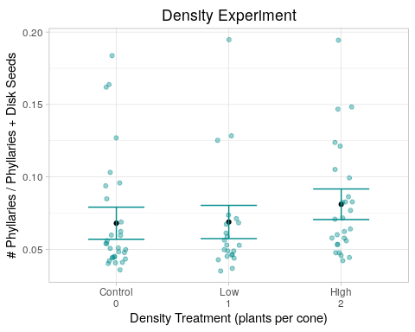 9) Resource Experiment: Dispersal Propensity

#### Ray Seed Proportion: Resource to Control ####  
#' Get rid of NAs in the data  
resourceDat_propn <- resourceDat %>% filter(!is.na(phyllToTotal))  
  
#' __Linear mixed model__  
lme_propn_resource <- lme(phyllToTotal~treatmentCat,   
 random = ~1|bin,  
 data = resourceDat_propn)  
  
#' _Diagnostic plots_  
#'   
#' qqplot to test for normality  
qqnorm(lme_propn_resource, ~ resid(., type = "p"), abline = c(0, 1))

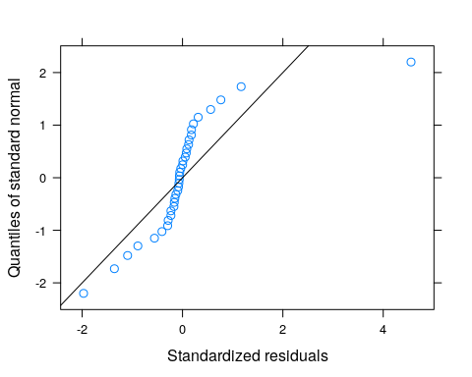

#' Residuals vs fitted plot  
plot.lme(lme_propn_resource)

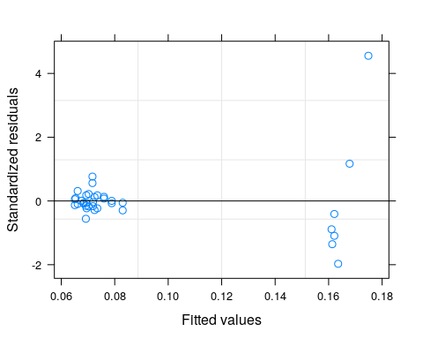 *These dont look great; will see if an unequal variances model addresses the issue*

#'   
#' __Linear mixed model with unequal variances__  
lme_propn_resource_uv <- lme(phyllToTotal~treatmentCat,  
 data = resourceDat_propn,  
 random = ~1|bin,  
 weights = varIdent(form = ~1|treatmentCat))  
#' _Diagnostic plots_  
#'   
#' qqplot to test for normality  
qqnorm(lme_propn_resource_uv, ~ resid(., type = "p"), abline = c(0, 1))

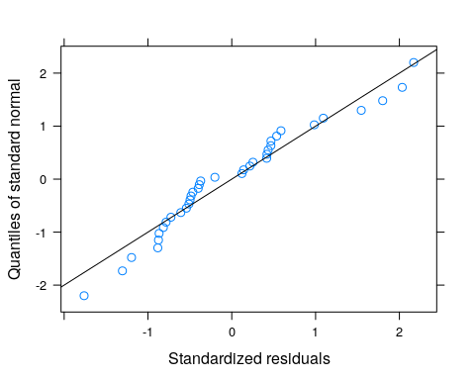

#' Residuals vs fitted plot  
plot.lme(lme_propn_resource_uv)

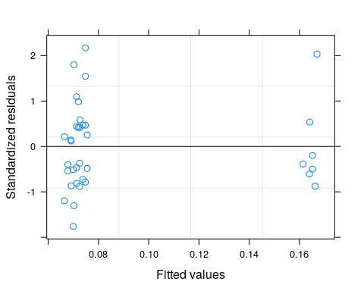

*Looks like the unequal variances model fixes the issues. But is it worth the extra spending of degrees of freedom?*

anova(lme_propn_resource, lme_propn_resource_uv)

## Model df AIC BIC logLik Test L.Ratio  
## lme_propn_resource 1 5 -80.41774 -72.9352 45.20887   
## lme_propn_resource_uv 2 7 -147.44011 -136.9646 80.72005 1 vs 2 71.02237  
## p-value  
## lme_propn_resource   
## lme_propn_resource_uv <.0001

*yes!*

#' Fit the same model without at intercept to get the standard errors of the means for each group (for plotting)  
lme_propn_resource_uv_noint <- lme(phyllToTotal ~ 0 + treatmentCat,  
 data = resourceDat_propn,  
 random = ~1|bin,  
 weights = varIdent(form = ~1|treatmentCat))  
  
summary(lme_propn_resource_uv_noint)

## Linear mixed-effects model fit by REML  
## Data: resourceDat_propn   
## AIC BIC logLik  
## -147.4401 -136.9646 80.72005  
##   
## Random effects:  
## Formula: ~1 | bin  
## (Intercept) Residual  
## StdDev: 0.003430446 0.01759339  
##   
## Variance function:  
## Structure: Different standard deviations per stratum  
## Formula: ~1 | treatmentCat   
## Parameter estimates:  
## Control Low Medium   
## 1.0000000 0.4026409 7.0992377   
## Fixed effects: phyllToTotal ~ 0 + treatmentCat   
## Value Std.Error DF t-value p-value  
## treatmentCatControl 0.07318750 0.00456251 26 16.041078 0.0000  
## treatmentCatLow 0.06965943 0.00232952 26 29.902912 0.0000  
## treatmentCatMedium 0.16459946 0.04722818 26 3.485196 0.0018  
## Correlation:   
## trtmCC trtmCL  
## treatmentCatLow 0.138   
## treatmentCatMedium 0.007 0.014   
##   
## Standardized Within-Group Residuals:  
## Min Q1 Med Q3 Max   
## -1.7620913 -0.6374905 -0.2863031 0.4669031 2.1702188   
##   
## Number of Observations: 36  
## Number of Groups: 8

#' _Final answer_  
summary_lme_propn_resource_uv <- summary(lme_propn_resource_uv)  
summary_lme_propn_resource_uv_noint <- summary(lme_propn_resource_uv_noint)  
summary_lme_propn_resource_uv

## Linear mixed-effects model fit by REML  
## Data: resourceDat_propn   
## AIC BIC logLik  
## -147.4401 -136.9646 80.72005  
##   
## Random effects:  
## Formula: ~1 | bin  
## (Intercept) Residual  
## StdDev: 0.003430446 0.01759339  
##   
## Variance function:  
## Structure: Different standard deviations per stratum  
## Formula: ~1 | treatmentCat   
## Parameter estimates:  
## Control Low Medium   
## 1.0000000 0.4026409 7.0992377   
## Fixed effects: phyllToTotal ~ treatmentCat   
## Value Std.Error DF t-value p-value  
## (Intercept) 0.07318750 0.00456251 26 16.041078 0.0000  
## treatmentCatLow -0.00352807 0.00482712 26 -0.730884 0.4714  
## treatmentCatMedium 0.09141196 0.04741704 26 1.927829 0.0649  
## Correlation:   
## (Intr) trtmCL  
## treatmentCatLow -0.878   
## treatmentCatMedium -0.089 0.085  
##   
## Standardized Within-Group Residuals:  
## Min Q1 Med Q3 Max   
## -1.7620913 -0.6374905 -0.2863031 0.4669031 2.1702188   
##   
## Number of Observations: 36  
## Number of Groups: 8

#Checking for overall treatment effect  
anova(lme_propn_resource_uv)

## numDF denDF F-value p-value  
## (Intercept) 1 26 1043.1583 <.0001  
## treatmentCat 2 26 2.2611 0.1244

*There was no significant treatment effect; pairwise comparisons not necessary*

#' Plot the model outcome  
propn_resource_output_df <- data.frame(cat_mean_noint = summary_lme_propn_resource_uv_noint$tTable[,"Value"],  
 cat_se_noint = summary_lme_propn_resource_uv_noint$tTable[,"Std.Error"],  
 trt_cat = levels(resourceDat$treatmentCat))  
propn_resource_output_df

## cat_mean_noint cat_se_noint trt_cat  
## treatmentCatControl 0.07318750 0.004562505 Control  
## treatmentCatLow 0.06965943 0.002329520 Low  
## treatmentCatMedium 0.16459946 0.047228179 Medium

p_res_propn_output <- ggplot(propn_resource_output_df, aes(x=factor(trt_cat, levels = labelOrders), y=cat_mean_noint)) +   
 geom_point() +  
 geom_errorbar(aes(ymin = cat_mean_noint - cat_se_noint, ymax = cat_mean_noint + cat_se_noint), color = "goldenrod4", width = .5, show.legend = F) +  
 geom_jitter(data = resourceDat_propn, aes(x = treatmentCat, y = phyllToTotal), color = "goldenrod4", width = 0.1, alpha = 0.4, show.legend = F) +  
 theme_light() +  
 ylab("# Phyllaries / Phyllaries + Disk Seeds") +  
 xlab("Nutrient Addition Treatment (tbsp nutrients/gal. water)") +  
 ggtitle("Eutrophication Experiment") +  
 theme(plot.title = element_text(hjust = 0.5, vjust = 0.3)) +  
 scale_x_discrete(labels = c("Control\n0", "Low\n0.5x", "Medium\n1x")) +  
 ylim(-.01, .5) +  
 labs(caption= "No Significant treatment effect")  
  
p_res_propn_output

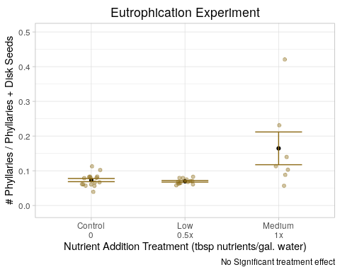 10) Shade Experiment: Inflorescence Height

#' Get rid of NA's  
shadeDat_height <- shadeDat %>% filter( !is.na(focalFlowerHeight_cm))  
  
#' __Linear mixed model__  
lme_height_shade <- lme(focalFlowerHeight_cm~treatmentCat,   
 random = ~1|bin,   
 data = shadeDat_height)  
#' _Diagnostic plots_  
#'   
#' qqplot to test for normality  
qqnorm(lme_height_shade, ~ resid(., type = "p"), abline = c(0, 1))

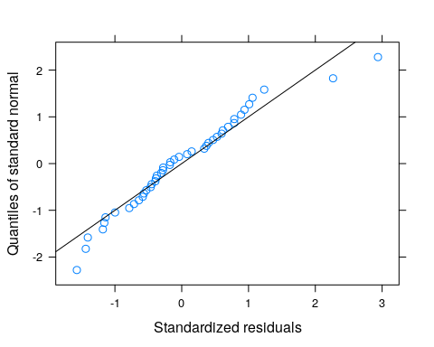

#' Residuals vs fitted plot  
plot.lme(lme_height_shade)

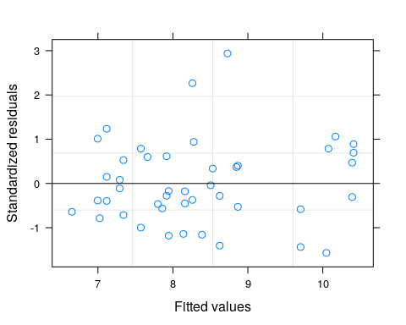 *These both look pretty good, but we’ll see if an unequal variances model makes it any better*

#' __Linear mixed model with unequal variances__  
lme_height_shade_uv <- lme(focalFlowerHeight_cm~treatmentCat,  
 data = shadeDat_height,  
 random = ~1|bin,  
 weights = varIdent(form = ~1|treatmentCat))  
#' _Diagnostic plots_  
#'   
#' qqplot to test for normality  
qqnorm(lme_height_shade_uv, ~ resid(., type = "p"), abline = c(0, 1))

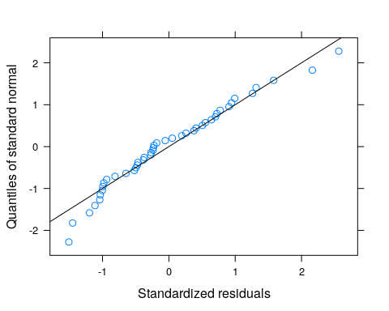

#' Residuals vs fitted plot  
plot.lme(lme_height_shade_uv)

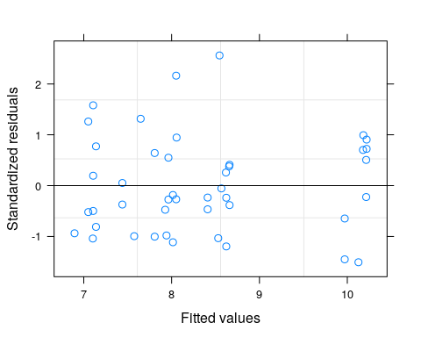 *Looks like the uv model makes the residuals look better, but is it worth using?*

anova(lme_height_shade, lme_height_shade_uv)

## Model df AIC BIC logLik Test L.Ratio  
## lme_height_shade 1 7 210.5659 222.2108 -98.28295   
## lme_height_shade_uv 2 11 214.9035 233.2027 -96.45175 1 vs 2 3.662394  
## p-value  
## lme_height_shade   
## lme_height_shade_uv 0.4536

*No*

#' Fit the same model without at intercept to get the standard errors of the means for each group (for plotting)  
lme_height_shade_noint <- lme(focalFlowerHeight_cm~ 0 +treatmentCat,  
 data = shadeDat_height,  
 random = ~1|bin)  
  
summary(lme_height_shade_noint)

## Linear mixed-effects model fit by REML  
## Data: shadeDat_height   
## AIC BIC logLik  
## 210.5659 222.2108 -98.28295  
##   
## Random effects:  
## Formula: ~1 | bin  
## (Intercept) Residual  
## StdDev: 0.55443 2.57765  
##   
## Fixed effects: focalFlowerHeight_cm ~ 0 + treatmentCat   
## Value Std.Error DF t-value p-value  
## treatmentCatControl 7.993167 0.8064139 32 9.911991 0  
## treatmentCatHigh 7.711347 1.3265504 32 5.813083 0  
## treatmentCatLow 8.581149 0.8039043 32 10.674341 0  
## treatmentCatMedium 10.124676 0.8901813 32 11.373724 0  
## treatmentCatStructure 7.073644 0.8974007 32 7.882369 0  
## Correlation:   
## trtmCC trtmCH trtmCL trtmCM  
## treatmentCatHigh 0.044   
## treatmentCatLow 0.056 0.038   
## treatmentCatMedium 0.059 0.035 0.060   
## treatmentCatStructure 0.052 0.024 0.056 0.057   
##   
## Standardized Within-Group Residuals:  
## Min Q1 Med Q3 Max   
## -1.5701130 -0.5700973 -0.1752117 0.6013107 2.9375655   
##   
## Number of Observations: 44  
## Number of Groups: 8

#' _Final answer_  
summary_lme_height_shade <- summary(lme_height_shade)  
summary_lme_height_shade_noint <- summary(lme_height_shade_noint)  
summary_lme_height_shade

## Linear mixed-effects model fit by REML  
## Data: shadeDat_height   
## AIC BIC logLik  
## 210.5659 222.2108 -98.28295  
##   
## Random effects:  
## Formula: ~1 | bin  
## (Intercept) Residual  
## StdDev: 0.55443 2.57765  
##   
## Fixed effects: focalFlowerHeight_cm ~ treatmentCat   
## Value Std.Error DF t-value p-value  
## (Intercept) 7.993167 0.8064139 32 9.911991 0.0000  
## treatmentCatHigh -0.281820 1.5220832 32 -0.185154 0.8543  
## treatmentCatLow 0.587981 1.1064437 32 0.531416 0.5988  
## treatmentCatMedium 2.131509 1.1651552 32 1.829378 0.0767  
## treatmentCatStructure -0.919524 1.1747923 32 -0.782712 0.4396  
## Correlation:   
## (Intr) trtmCH trtmCL trtmCM  
## treatmentCatHigh -0.492   
## treatmentCatLow -0.688 0.361   
## treatmentCatMedium -0.647 0.340 0.476   
## treatmentCatStructure -0.647 0.332 0.474 0.449  
##   
## Standardized Within-Group Residuals:  
## Min Q1 Med Q3 Max   
## -1.5701130 -0.5700973 -0.1752117 0.6013107 2.9375655   
##   
## Number of Observations: 44  
## Number of Groups: 8

#Checking for treatment effect  
anova(lme_height_shade)

## numDF denDF F-value p-value  
## (Intercept) 1 32 360.4197 <.0001  
## treatmentCat 4 32 1.7273 0.1683

*There was no significant treatment effect; no pairwise comparisons needed*

#' Plot the model outcome  
shade_height_output_df <- data.frame(cat_mean_noint = summary_lme_height_shade_noint$tTable[,"Value"],  
 cat_se_noint = summary_lme_height_shade_noint$tTable[,"Std.Error"],  
 trt_cat = levels(shadeDat$treatmentCat))  
  
shade_height_output_df

## cat_mean_noint cat_se_noint trt_cat  
## treatmentCatControl 7.993167 0.8064139 Control  
## treatmentCatHigh 7.711347 1.3265504 High  
## treatmentCatLow 8.581149 0.8039043 Low  
## treatmentCatMedium 10.124676 0.8901813 Medium  
## treatmentCatStructure 7.073644 0.8974007 Structure

p_shade_height_output <- ggplot(shade_height_output_df, aes(x=factor(trt_cat, levels = labelOrders), y=cat_mean_noint)) +  
 geom_point() +  
 geom_errorbar(aes(ymin=cat_mean_noint-cat_se_noint, ymax=cat_mean_noint+cat_se_noint),color = "brown4", width = .5, show.legend = F) +  
 geom_jitter(data = shadeDat, aes(x = treatmentCat, y = focalFlowerHeight_cm),color = "brown4", width = 0.1, alpha = 0.4, show.legend = F) +  
 theme_light() +  
 ylab("Focal Flower Height (cm)") +  
 xlab("Shade Treatment (µmol of photons/m^2s)") +  
 ggtitle("Shade Experiment") +  
 theme(plot.title = element_text(hjust = 0.5, vjust = 0.3)) +  
 scale_x_discrete(labels = c("Control\n122.0", "Structure\n107.0", "Low\n87.2", "Medium\n71.6", "High\n69.0")) +  
 ylim(-.5, 20) +  
 labs(caption = "No signficant treatment effect")  
  
p_shade_height_output

## Warning: Removed 4 rows containing missing values (geom_point).

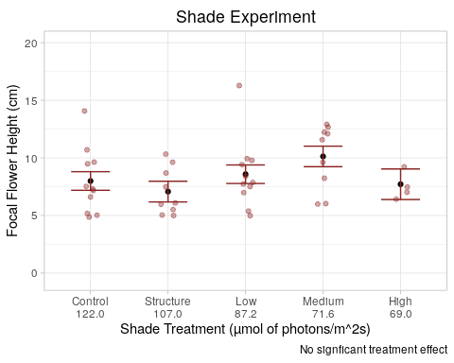

1. Density Experiment: Inflorescence Height

#' Get rid of NA's  
densityDat_height <- densityDat %>% filter( !is.na(focalFlowerHeight_cm))  
  
#' __Linear mixed model__  
lme_height_density <- lme(focalFlowerHeight_cm~treatmentCat,   
 random = ~1|bin,   
 data = densityDat_height)  
#' _Diagnostic plots_  
#'   
#' qqplot to test for normality  
qqnorm(lme_height_density, ~ resid(., type = "p"), abline = c(0, 1))

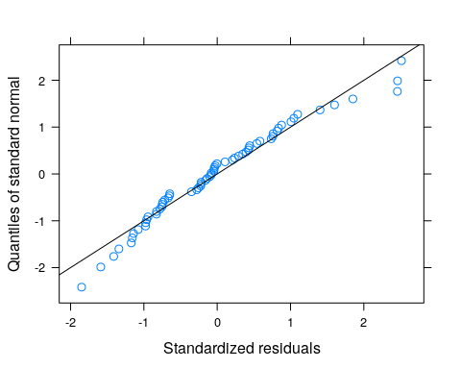

#' Residuals vs fitted plot  
plot.lme(lme_height_density)

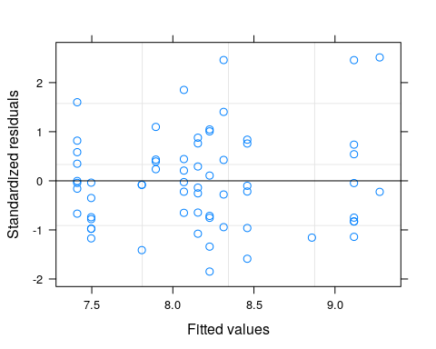 *These both look pretty good. Will a uv model make it better, and be worth using?*

#' __Linear mixed model with unequal variances__  
lme_height_density_uv <- lme(focalFlowerHeight_cm~treatmentCat,  
 data = densityDat_height,  
 random = ~1|bin,  
 weights = varIdent(form = ~1|treatmentCat))  
#' _Diagnostic plots_  
#'   
#' qqplot to test for normality  
qqnorm(lme_height_density_uv, ~ resid(., type = "p"), abline = c(0, 1))

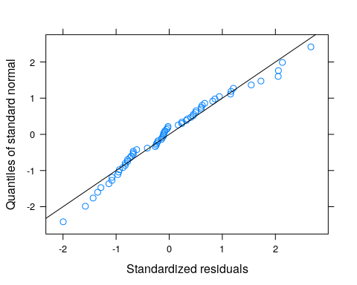

#' Residuals vs fitted plot  
plot.lme(lme_height_density_uv)

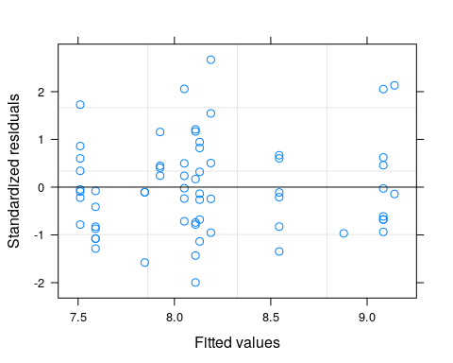 *The gains from using a uv model seem marginal, at best. My guess is model comparison will suggest not using the uv model*

anova(lme_height_density, lme_height_density_uv)

## Model df AIC BIC logLik Test L.Ratio  
## lme_height_density 1 5 308.3461 318.9005 -149.1730   
## lme_height_density_uv 2 7 310.5444 325.3206 -148.2722 1 vs 2 1.801659  
## p-value  
## lme_height_density   
## lme_height_density_uv 0.4062

*Not worth using the uv model, as suspected*

#' Fit the same model without at intercept to get the standard errors of the means for each group (for plotting)  
lme_height_density_noint <- lme(focalFlowerHeight_cm~ 0 +treatmentCat,  
 data = densityDat_height,  
 random = ~1|bin)  
  
#' _Final answer_  
summary_lme_height_density <- summary(lme_height_density)  
summary_lme_height_density_noint <- summary(lme_height_density_noint)  
summary_lme_height_density

## Linear mixed-effects model fit by REML  
## Data: densityDat_height   
## AIC BIC logLik  
## 308.3461 318.9005 -149.1731  
##   
## Random effects:  
## Formula: ~1 | bin  
## (Intercept) Residual  
## StdDev: 0.5585454 2.555996  
##   
## Fixed effects: focalFlowerHeight_cm ~ treatmentCat   
## Value Std.Error DF t-value p-value  
## (Intercept) 7.878283 0.5960402 58 13.217705 0.0000  
## treatmentCatHigh 0.086384 0.7472926 58 0.115596 0.9084  
## treatmentCatLow 1.049069 0.8193532 58 1.280363 0.2055  
## Correlation:   
## (Intr) trtmCH  
## treatmentCatHigh -0.616   
## treatmentCatLow -0.555 0.450  
##   
## Standardized Within-Group Residuals:  
## Min Q1 Med Q3 Max   
## -1.84925790 -0.75098278 -0.08155598 0.55151916 2.51339794   
##   
## Number of Observations: 64  
## Number of Groups: 4

#Checking for overall treatment effect  
anova(lme_height_density)

## numDF denDF F-value p-value  
## (Intercept) 1 58 359.6482 <.0001  
## treatmentCat 2 58 0.9529 0.3916

*No significant treatment effect; pairwise comparisons not neeeded*

#' Plot the model outcome  
density_height_output_df <- data.frame(cat_mean_noint = summary_lme_height_density_noint$tTable[,"Value"],  
 cat_se_noint = summary_lme_height_density_noint$tTable[,"Std.Error"],  
 trt_cat = levels(densityDat$treatmentCat))  
  
density_height_output_df

## cat_mean_noint cat_se_noint trt_cat  
## treatmentCatControl 7.878283 0.5960402 Control  
## treatmentCatHigh 7.964667 0.6038071 High  
## treatmentCatLow 8.927353 0.6957508 Low

p_density_height_output <- ggplot(density_height_output_df, aes(x=factor(trt_cat, levels = labelOrders), y=cat_mean_noint)) +   
 geom_point() +  
 geom_errorbar(aes(ymin=cat_mean_noint-cat_se_noint, ymax=cat_mean_noint+cat_se_noint),color = "cyan4", width = .5, show.legend = F) +  
 geom_jitter(data = densityDat, aes(x = treatmentCat, y = focalFlowerHeight_cm),color = "cyan4", width = 0.1, alpha = 0.4, show.legend = F) +  
 theme_light() +  
 ylab("Focal Flower Height (cm)") +  
 xlab("Density Treatment") +  
 xlab("Density Treatment (plants per cone)") +  
 ggtitle("Density Experiment") +  
 theme(plot.title = element_text(hjust = 0.5, vjust = 0.3)) +  
 scale_x_discrete(labels = c("Control\n0", "Low\n1", "High\n2")) +   
 labs(caption = "No significant treatment effect")  
  
  
p_density_height_output

## Warning: Removed 15 rows containing missing values (geom_point).

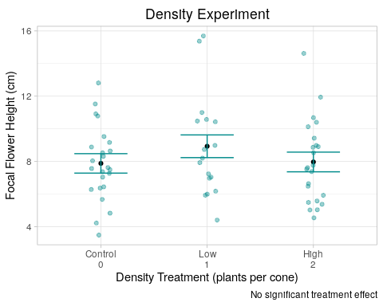 12) Resource Experiment: Inflorescence Height

#' Get rid of NAs in the data  
resourceDat_height <- resourceDat %>% filter( focalFlowerHeight_cm > 0)  
  
#' __Linear mixed model__  
lme_height_resource <- lme(focalFlowerHeight_cm~treatmentCat,   
 random = ~1|bin,  
 data = resourceDat_height)  
#' _Diagnostic plots_  
#'   
#' qqplot to test for normality  
qqnorm(lme_height_resource, ~ resid(., type = "p"), abline = c(0, 1))

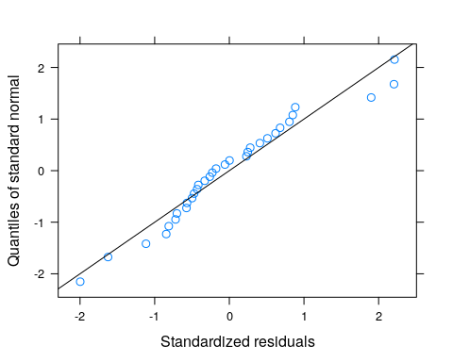

#' Residuals vs fitted plot  
plot.lme(lme_height_resource)

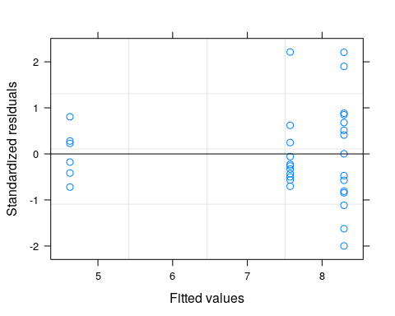 *These both look okay, but will a uv model be worth using?* #’

#' __Linear mixed model with unequal variances__  
lme_height_resource_uv <- lme(focalFlowerHeight_cm~treatmentCat,  
 data = resourceDat_height,  
 random = ~1|bin,  
 weights = varIdent(form = ~1|treatmentCat))  
  
#' _Diagnostic plots_  
#'   
#' qqplot to test for normality  
qqnorm(lme_height_resource_uv, ~ resid(., type = "p"), abline = c(0, 1))

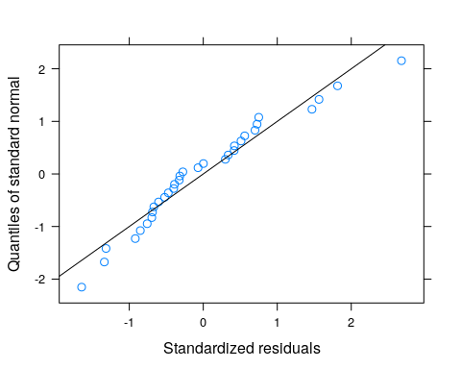

#' Residuals vs fitted plot  
plot.lme(lme_height_resource_uv)

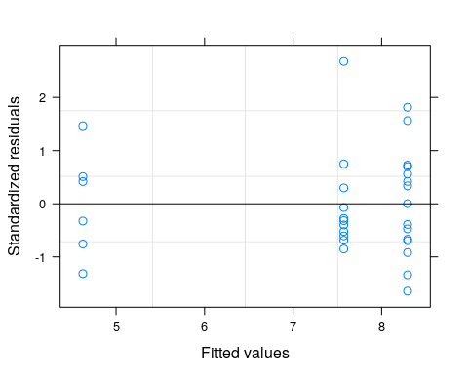 *Again, gains are marginal*

#Comparing model fit  
anova(lme_height_resource, lme_height_resource_uv)

## Model df AIC BIC logLik Test L.Ratio  
## lme_height_resource 1 5 161.9394 168.7759 -75.96970   
## lme_height_resource_uv 2 7 161.5616 171.1327 -73.78082 1 vs 2 4.377753  
## p-value  
## lme_height_resource   
## lme_height_resource_uv 0.112

*The uv model is not worth using*

#' Fit the same model without at intercept to get the standard errors of the means for each group (for plotting)  
lme_height_resource_noint <- lme(focalFlowerHeight_cm ~ 0 + treatmentCat,  
 data = resourceDat_height,  
 random = ~1|bin)  
  
#' _Final answer_  
summary_lme_height_resource <- summary(lme_height_resource)  
summary_lme_height_resource_noint <- summary(lme_height_resource_noint)

#Testing for treatment effect  
anova(lme_height_resource)

## numDF denDF F-value p-value  
## (Intercept) 1 22 199.07882 <.0001  
## treatmentCat 2 22 3.35815 0.0534

*There was a marginally significant treatment effect. Will conduct pairwise comparisons*

summary_lme_height_resource

## Linear mixed-effects model fit by REML  
## Data: resourceDat_height   
## AIC BIC logLik  
## 161.9394 168.7759 -75.9697  
##   
## Random effects:  
## Formula: ~1 | bin  
## (Intercept) Residual  
## StdDev: 0.0001345786 2.949926  
##   
## Fixed effects: focalFlowerHeight_cm ~ treatmentCat   
## Value Std.Error DF t-value p-value  
## (Intercept) 8.293333 0.7616677 22 10.888388 0.0000  
## treatmentCatLow -0.720606 1.1709973 22 -0.615378 0.5446  
## treatmentCatMedium -3.668333 1.4249498 22 -2.574360 0.0173  
## Correlation:   
## (Intr) trtmCL  
## treatmentCatLow -0.650   
## treatmentCatMedium -0.535 0.348  
##   
## Standardized Within-Group Residuals:  
## Min Q1 Med Q3 Max   
## -1.9977900 -0.5687867 -0.2030097 0.5379179 2.2126901   
##   
## Number of Observations: 32  
## Number of Groups: 8

*It would appear that the medium treatment category differed signifcantly from the control, with a 3.8cm decrease (56%) (t(22) = -2.57, se = 1.42, p < 0.05). The low treatment category did not differ significantly from the control. However, given that the overall treatment effect was marginal, I cannot make any strong inferences based on this information*

#Pairwise comparisons  
resDat_h <- resourceDat_height %>% filter( !is.na(focalFlowerHeight_cm))  
# High To All:  
res_h_medbase <- resDat_h %>% mutate(treatmentCat = relevel(treatmentCat, "Medium"))  
  
lme_h_res_medbase <- lme(focalFlowerHeight_cm~treatmentCat,   
 random = ~1|bin,   
 data = res_h_medbase)  
  
summary(lme_h_res_medbase)

## Linear mixed-effects model fit by REML  
## Data: res_h_medbase   
## AIC BIC logLik  
## 161.9394 168.7759 -75.9697  
##   
## Random effects:  
## Formula: ~1 | bin  
## (Intercept) Residual  
## StdDev: 0.0001345849 2.949926  
##   
## Fixed effects: focalFlowerHeight_cm ~ treatmentCat   
## Value Std.Error DF t-value p-value  
## (Intercept) 4.625000 1.204302 22 3.840398 0.0009  
## treatmentCatControl 3.668333 1.424950 22 2.574360 0.0173  
## treatmentCatLow 2.947727 1.497144 22 1.968900 0.0617  
## Correlation:   
## (Intr) trtmCC  
## treatmentCatControl -0.845   
## treatmentCatLow -0.804 0.680  
##   
## Standardized Within-Group Residuals:  
## Min Q1 Med Q3 Max   
## -1.9977900 -0.5687867 -0.2030097 0.5379179 2.2126901   
##   
## Number of Observations: 32  
## Number of Groups: 8

*The low treatment category did not differ significantly from the medium treatment category*

#' Plot the model outcome  
height_resource_output_df <- data.frame(cat_mean_noint = summary_lme_height_resource_noint$tTable[,"Value"],  
 cat_se_noint = summary_lme_height_resource_noint$tTable[,"Std.Error"],  
 trt_cat = levels(resourceDat$treatmentCat))  
  
height_resource_output_df

## cat_mean_noint cat_se_noint trt_cat  
## treatmentCatControl 8.293333 0.7616677 Control  
## treatmentCatLow 7.572727 0.8894363 Low  
## treatmentCatMedium 4.625000 1.2043024 Medium

p_res_height_output <- ggplot(height_resource_output_df, aes(x=factor(trt_cat, levels = labelOrders), y=cat_mean_noint)) +   
 geom_point() +  
 geom_errorbar(aes(ymin = cat_mean_noint - cat_se_noint, ymax = cat_mean_noint + cat_se_noint), color = "goldenrod4", width = .5, show.legend = F) +  
 geom_jitter(data = resourceDat_height, aes(x = treatmentCat, y = focalFlowerHeight_cm), color = "goldenrod4", width = 0.1, alpha = 0.4, show.legend = F) +  
 theme_light() +  
 ylab("Focal Flower Height (cm)") +  
 xlab("Nutrient Addition Treatment (tbsp nutrients/gal. water)") +  
 ggtitle("Eutrophication Experiment") +  
 theme(plot.title = element_text(hjust = 0.5, vjust = 0.3)) +  
 scale_x_discrete(labels = c("Control\n0", "Low\n0.5x", "Medium\n1x")) +  
 labs(caption = "Marginally Significant Treatment Effect (p = 0.53)")  
  
p_res_height_output

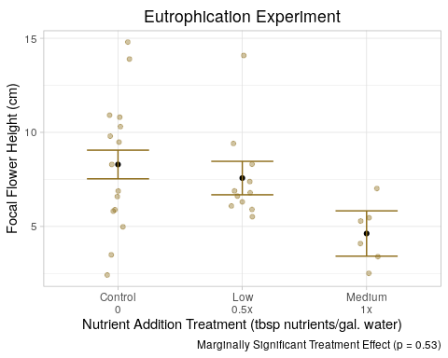 *Final Remarks and Discussion: It would appear that, among experiments, only the nutrient experiment responded significantly to treatment effects. While measures of stress did not differ significantly within treatments for the shade and density experiment, they did within the resouces experiment, with the highest form of stress being that of the medium treatment category (or 1x fertilizer addition relative to the contrl). As well, we may have stumbled upon an optimal range for nutrient concentration for l. fremontii in the “low” treatment category, as it’s mean plant biomass was signficantly larger than that of the control’s. Dispersal traits within the shade and density experiment did not differ significantly among treatmen categories, suggesting that, in such circumstances, competition and varying access to light have no effect on traits associated with dispersal, and thus we cannot make any inferences on how these environmental conditions might affect plant fitness. Within the nutrient experiment, we did see a marginal treatment effect on inflorescence height, suggesting a potential negative relationship between increasing eutrophication and inflorescence height. Lower inflorescence heights are often associated with dispersal close to the maternal plant, however it seems unlikely that an increase in availlble nutrients was associated with selection for these traits; rather, if we look at how tall a plant grows as a measure of perceived stress, more eutrophic environments might be associated with more stress, and thus a lower inflorescence height might be an indication of higher stress levels, not a response to a favorable immediate environment. This idea also makes sense given that biomass, a proven measure of stress, was lowest in the more eutrophic environments.*

Final Plots

#### Final Plots ####  
  
#' Biomass Plot  
  
biomassGrid <- grid.arrange(p_shade_mass_output, p_density_mass_output, p_res_mass_output, nrow = 1, top = "Biomass Response to Treatment Effect by Experiment")

## Warning: Removed 1 rows containing missing values (geom_point).

## Warning: Removed 2 rows containing missing values (geom_point).

## Warning: Removed 1 rows containing missing values (geom_point).

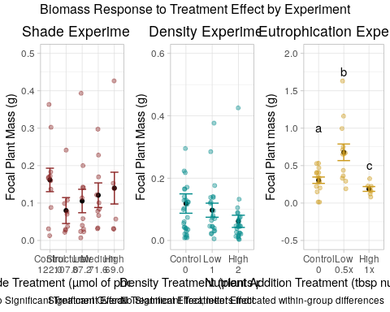

propnHeightGrid <- grid.arrange(p_shade_propn_output, p_dens_propn_output, p_res_propn_output, p_shade_height_output, p_density_height_output, p_res_height_output, nrow = 2, ncol = 3, top = "Dispersal Propensity and Inflorescence Height Response to Treatment Effect by Experiment")

## Warning: Removed 4 rows containing missing values (geom_point).

## Warning: Removed 15 rows containing missing values (geom_point).

