ArduSat Pi:

A redundant satellite computer based on Arduino and Raspberry Pi

Abstract
This document describes a possible architecture for an extended ArduSat payload, produced during SpaceApps Challenge 2013. The proposed system includes an applications processor (Broadcomm BCM2835) and a microcontroller (Atmel SAM3X). This means the system is roughly compatible with the Raspberry Pi and Arduino Due platforms, connected with an I2C bus.
To address the problem of Single Event Effects produced by radiation, and to improve the system's reliability, a redundancy mechanism is introduced. This mechanism is implemented using a FPGA.

Introduction
The ArduSat is a cubesat-compatible satellite based on GOMspace's platform and the Arduino development board. Its purpose is to open satellite technology to hobbyists and developers around the globe, allowing people to “hack” into space. The potential this presents is huge: opening satellite data to the masses might be the space industry's equivalent to the PC (which triggered fundamental advances in the computer industry). Moreover, such a simple and light satellite opens a wide range of research opportunities, like creating an orbiting sensor mesh or planning missions beyond LEO with reduced propulsion mass requirements.
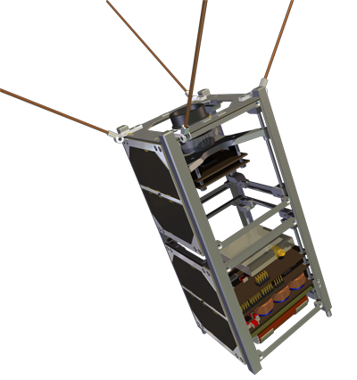Fig. 1: GOMspace's GOMX platform
The purpose of this project is to extend this platform by adding processing power, provided by a Raspberry Pi computer. This would improve the satellite's capabilities by introducing a complete Linux system that can be hacked from Earth and gathers data in Low Earth Orbit.
Given the limited time frame for the development of this solution, a general architectural description is presented, trying to cover as many details as possible but not providing CAD files of any sort. This is pending for further development (and requires obtaining access to Broadcomm's design files for BCM2835, not publicly available). It should be noted that the BCM2835 could easily be replaced by a similar applications processor, like Freescale's i.MX or TI's AM335x, and most of the proposed solution would remain the same.

The problems
There are several difficulties in designing flight hardware; this solution focuses on two of them:
On the one hand, a cubesat is a small and constrained system: there are power, mass and volume limitations. The solution must be as least power-hungry as possible (less than 4W approximately, assuming a worst-case 3U cubesat) and should not cause mechanical complications.
On the other hand, space hardware suffers from radiation. Among other things, this can cause logic gate latchups and bit flips which can ruin a digital circuit's functionality. The solution should try to involve commercial-grade components (to reduce costs and simplify manufacturing) but should be as radiation-resistant as possible.

Proposed solution
A block diagram for the proposed system is shown in Fig. 2. As we mentioned earlier, the main components are the BCM2835 and SAM3X ICs. Program memory for the applications processor resides in SD-compatible NAND flash (like SanDisk's iNand). The processor and microcontroller are interfaced using the I2C protocol, which minimizes the amount of connections required. This protocol also connects the BCM2835 (which acts as master) to the rest of the platform (radio, attitude control, etc) and another I2C bus connects the Arduino to the sensors.
Redundancy is introduced on several subsystems:
- BCM2835 is duplicated (dual redundancy). The primary processor works while the other one sleeps; if it fails (the mechanism for failure detection will be explained in the section “FPGA Circuitry”), the backup processor is activated.
- NAND flash has triple redundancy.

Bibliography
Angilly, ryan, TREMOR: a triple modular redundant flight computer and fault- tolerance testbed for the WPI Pansat nanosatellite

