Table of Contents

# Simulation Execution

## Simulation Configuration

### Historical Weather Data for Green River, Utah

|  |  |  |  |  |  |
| --- | --- | --- | --- | --- | --- |
| Date | Elevation | Ground Pressure | Ground Temperature | Wind Speed | Humidity |
| 2015/06/15 | 4,078 ft (1,243 m) | 101300 Pa | 298.15 K (25 ${}^{∘}$ C) | 6 km/h (1.6 m/s) | 33 % |
| 2014/06/15 | 4,078 ft (1,243 m) | 100700 Pa | 296.15 K (23 ${}^{∘}$ C) | 20 km/h (5.56 m/s) | 8 % |
| 2013/06/15 | 4,078 ft (1,243 m) | 101000 Pa | 299.15 K (26 ${}^{∘}$ C) | 10 km/h (2.78 m/s) | 19 % |

### General Conditions

For all tests, the following conditions were used, based on historical data for June 25th, 2015 at 12:00PM (noon) near Green River, Utah [1].

|  |  |  |
| --- | --- | --- |
| Elevation | Humidity | Launch Guide Length |
| 4,078 ft (1,243 m) **???** | 33 % | 5.4864 (18 ft) |

### Best Case

The best case scenario is with no wind, and a 0 ${}^{∘}$ launch angle, and the lowest air pressure.

|  |  |  |  |
| --- | --- | --- | --- |
| Wind Speed | Ground Pressure | Ground Temperature | Launch Guide Angle |
| 0 m/s | 101000 Pa | 298.15 K (25 ${}^{∘}$ C) | 0 ${}^{∘}$ |

### Worst Case

The worst case scenario, is the maximum wind condition permitted for launch by the competition, and a launch guide angle, and the highest pressure.

|  |  |  |  |
| --- | --- | --- | --- |
| Wind Speed | Ground Pressure | Ground Temperature | Launch Guide Angle |
| 8.33 m/s | 101325 kPa | 288.15 K (15 ${}^{∘}$ C) | 10 ${}^{∘}$ |

## Simulation Execution

Identical rocket designs were implemented in OpenRocket, RockSim, RASAero, and our Engineering Simulator. The 3rd party simulator results were parsed with Matlab to determine essential performance criteria and to compare with our model.

### Matlab

#### Matlab Models

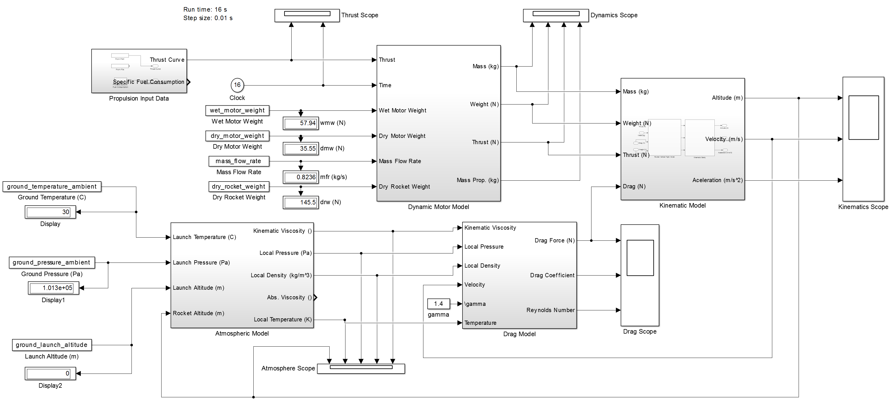

Vertical Model in Simulink, angle of attack less than 5 degrees

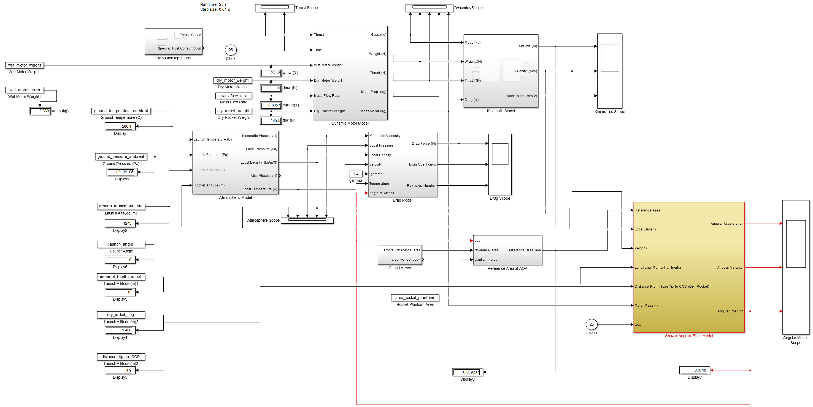

Full Model in Simulink, angle-of- attack less than 15 degrees

## Observations

## Primary Plots

Figure shows the predicted Altitude of the rocket compared against OpenRocket, RASAero, and Rocksim. It would appear that RASAero and Rocksim predict a higher altitude, perhaps considering their underestimation of the drag forces, shown in Figure .

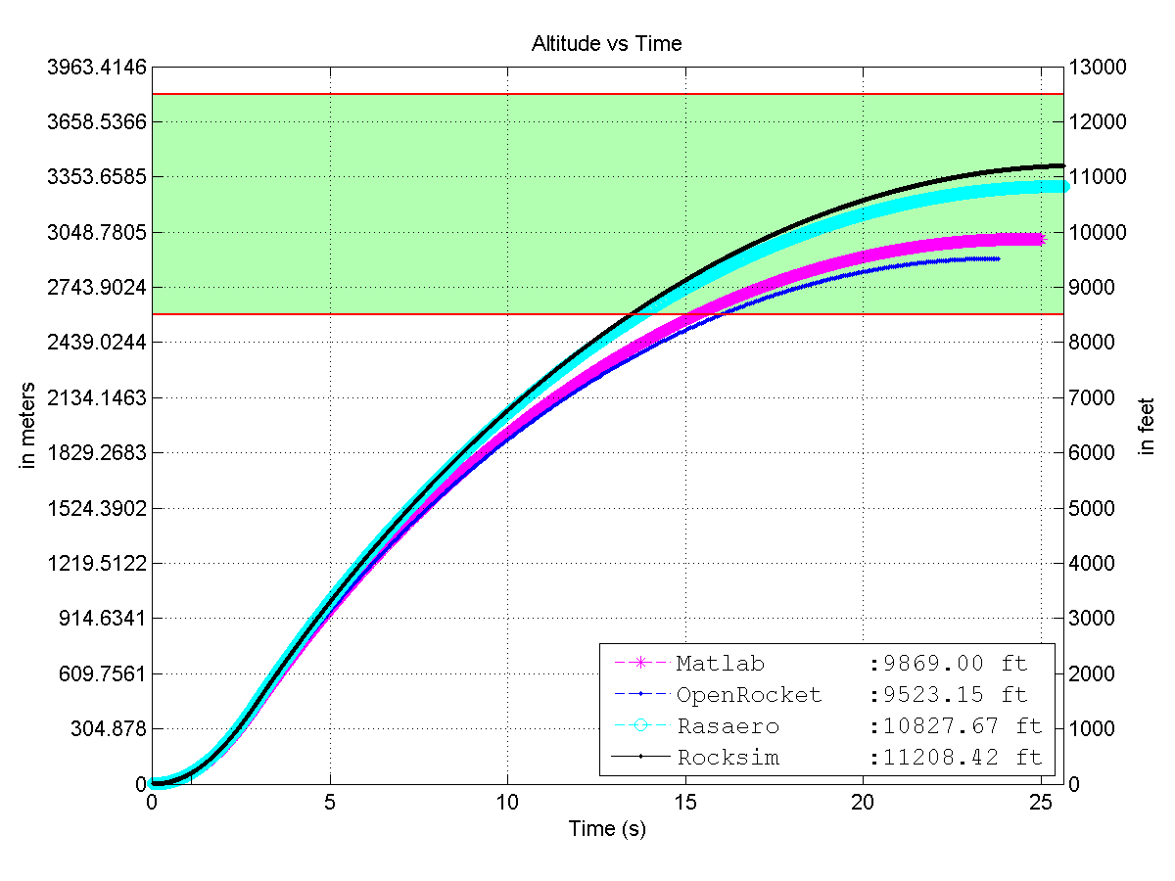

Altitude as a Function of Time

2e Vehicle reaches 10,000 ft altitude (+1000 feet / - 0 feet)

Figure shows that the Mach number predicted by each software is quite close.

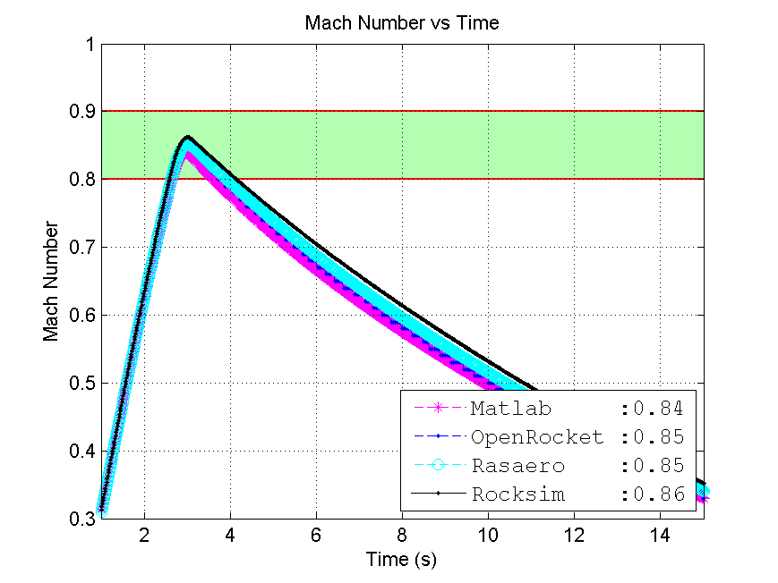

Mach Number as a Function of Time

2d Vehicle max speed mach 0.9

Figure shows that the dynamic stability is quite similarly predicted by all tested simulators. OpenRocket shows a continuous oscillation, which according to my current analysis of their methodology, perhaps does not correctly consider the oscillation damping encountered during flight. In any case, if the OpenRocket model were to be 100% correct, the dynamic stability criteria would still be satisfied by a wide margin.

2a Static stability above 2 calibers

2b Dynamic stability above 0

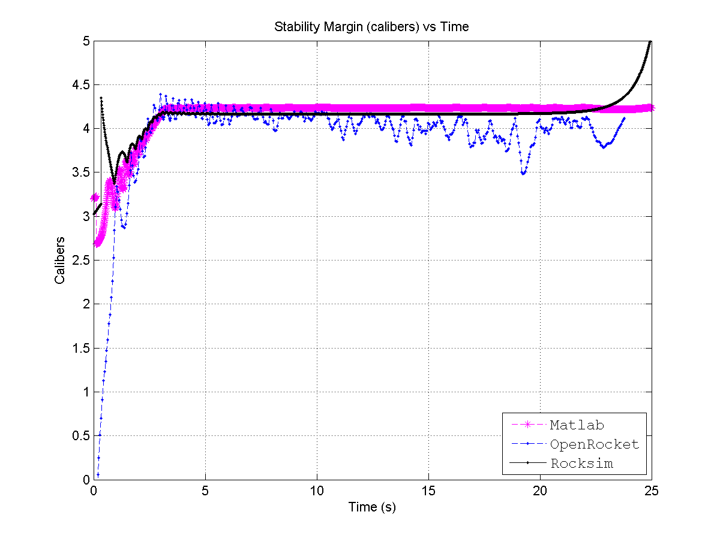

Stability (Calibers) as a Function of Time

As seen in Figure , once the rocket leaves the launch pad, the angular frequency of the rigid-body oscillation does not approach the natural frequency of the rocket, confirming requirement:

2f - The vehicle does not experience resonant pitching/yawing motion in flight

In any case, we know that resonant oscillation at the natural frequency does not occur, since the rocket stabilizes. Figure shows the stabilization of the angle-of-attack with time.

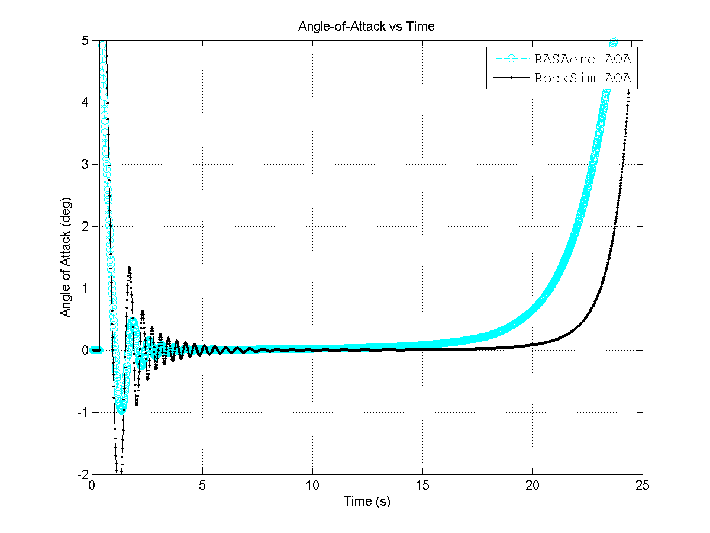

Angle of Attack Stabilization

RockSim and RASAero are chosen for this plot since they have a more mature stability methodology.

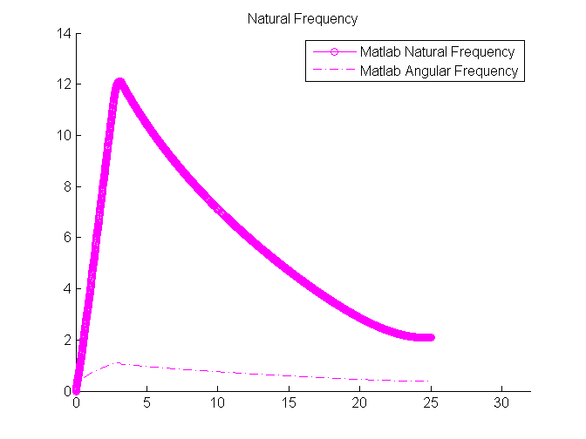

Natural Frequency

## Simulation Summary

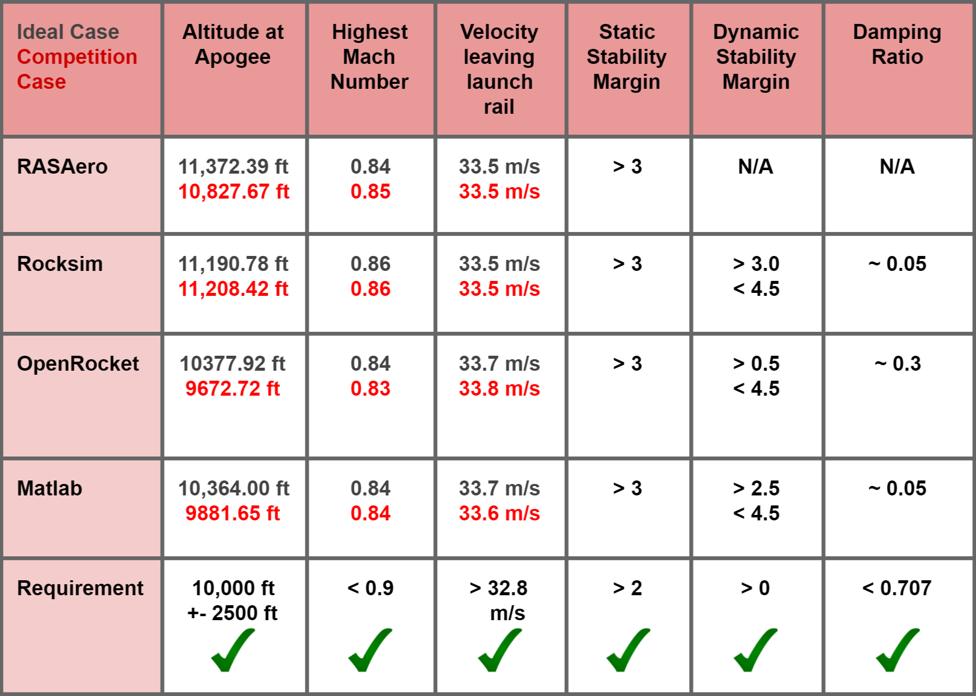

Simulation Summary

[1] F. IO, “Forcaset iO time machine.” Online [Online]. Available: <http://forecast.io/>