Home Page 1
Navigation Basics 3
Searching 5
Name Search 5
Name Search Results – OLs and Organizations 5
Advanced Search – OL and Organizations 7
Adding a Guest OL 8
OL Summary 10
Audit Trial 11
Editing Profile Details 11
BMS Info 13
OL Selection Criteria 13
Organization Profile 14
Affiliated OLs 14
Interactions (Organization Profile) 16
Organization Affiliations 17
Adding a missing Organization 18
Recording an Interaction 18
Recording an Interaction from the OL profile. 19
Entering an Interaction 20
Expanding or Collapsing Sections 21
Entering an Unsolicited Off-label Interaction 21
Accessing a Survey 22
Link to Medical Meeting 23
Saving an Interaction 23
Searching for an Interaction 23
Medical Meetings 24
Viewing a Medical Meeting 24
Reports 25
Reports 25
Report Parameters 26
Exporting a Report 26

Home Page
The Home Page is the default screen when you open synergy. When you login to the system you are automatically connected to your personal home page view.
D

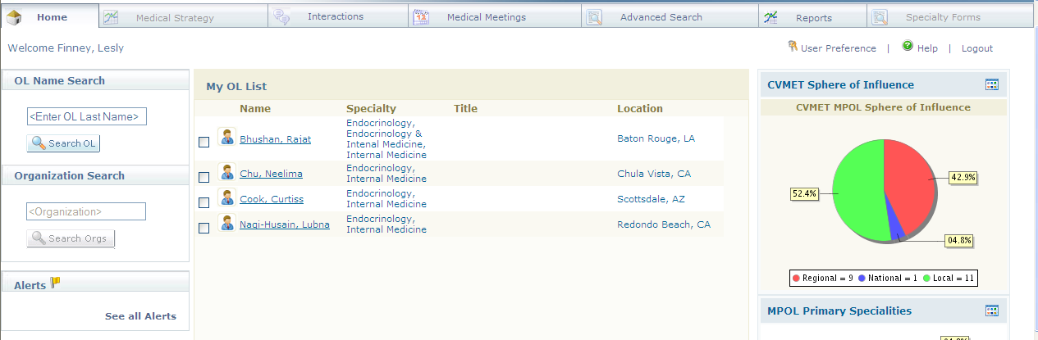
A
B
C
E

Important features of the Home Page include:
A | User Identification: Users name will appear in the upper left corner of the screen
B | OL Name Search: Search for OLs, organizations and HCP contacts in this and other databases linked to this system.
C | My OL List: Displays the list of OLs that have added to for your convenience.
D | Top-Level Tabs: Allows users to navigate to key modules in the tool
E | Dashlets: Mini real-time reports delivered right to the home page
F | Logout: Exit the system

Navigation Basics

Home Page
The Top-Level Tabs allow users to navigate to the primary application modules:
  - The Interactions tab lets you track your 1 to 1 live interactions with OLs in person via the phone and any email communications. It will also allow you to document group meetings with multiple OLs.

  - Medical Meetings is an enterprise calendar that will be populated with meetings specific to the therapeutic area which may include medical conferences, speaker training events, advisory boards and other events

  - Advanced Search lets you search for OLs, Organizations, and other information

  - Reports contain a variety of OL, Interaction, and other consolidated data options

  - The Medical Strategy tab will be defined further in a future release

Clicking on any OL Name or Organization Name displayed as a hyperlink in the system will take you
immediately to that OL or Organization’s profile.

 | Users should always directly select the tab they would like to view.


 | Users should not use the back buttons in the synergy tool

Searching

The search functions are the best method for quickly identifying specific experts, lists of experts or organizations.

There are many types of searches available in the system:
- Home Page Quick Search
- Home Page Organization Search
- Advanced Keyword Search
- OL Search Builder Searches

Name Search

The Home Page Keyword Search and the Organization Name Search are located on the Home Page.

These searches enable you to look up a specific or organization by name or search for an expert by name or other attribute.
A
For the quickest and most accurate results use as must of the last name as you know. | 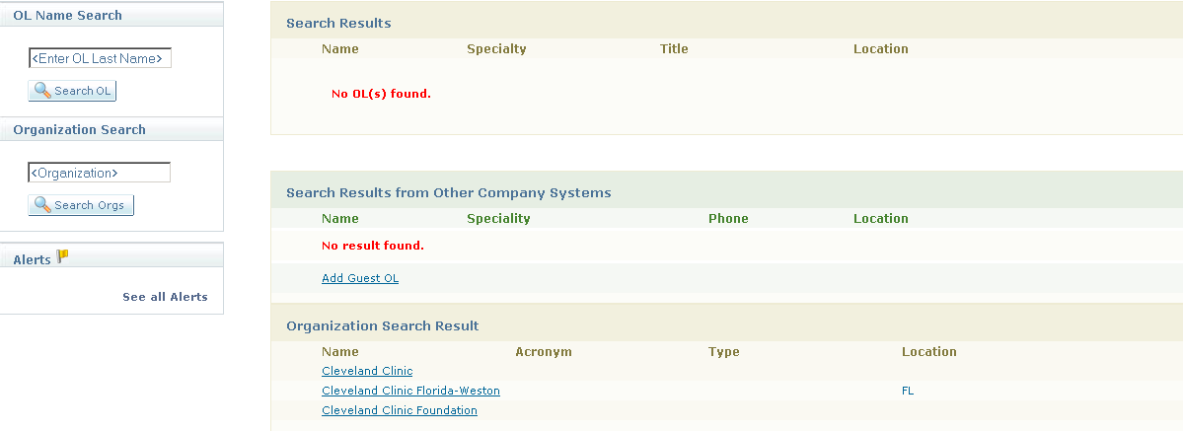
A | - Quick Search: Enter in the as many letters of the last name of the OL or Organization for your search.  - Another tip is that the home page OL keyword search treats all the text you enter as a single term meaning that it does not do AND and OR type of searches. For example if you entered “Chicago Oncology”, it would look for that entire word, not oncologists in Chicago.

Name Search Results – OLs and Organizations
Name Search results that appear as hyperlinks can be clicked on to view more detailed profile information about the selected individual.

Search Results:
Search results appear to the right of the search panel, replacing the default “My OL List”. Double-clicking on a hyperlinked name takes you to a full OL Profile.

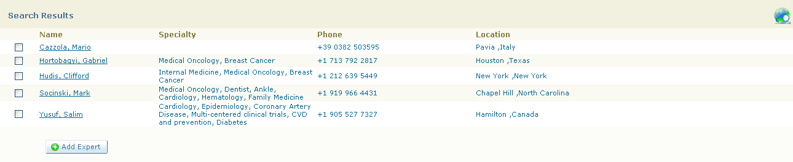

Tips for Getting the Best Results from Keyword Searches

Use the last name and take advantage of autocomplete
Do not include Abbreviations, Middle Names, Suffix, Prefix, or Titles in your search.
Do not use Boolean symbols in your search, such as <, >, *, AND, OR .
Placing a check beside the Expert name(s) and selecting the 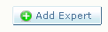 button will save this individual to the My Expert List on your homepage.

Advanced Search – OL and Organizations

The Advanced Search is accessible as a Main Navigation Tab.

The Advanced Search enables you to look up any OL or organization by using a keyword or by constructing a boolean search.

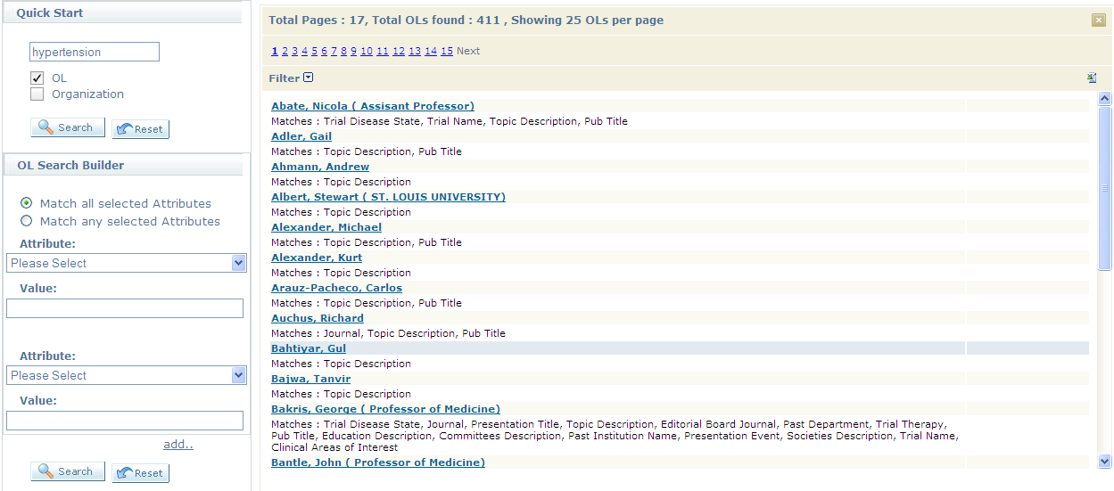
A
B
C
D
E
F
Important features of the Advanced Search include:
A | Quick Search: Type in OL Name or area you would like to search synergy, users can also type in the name of an Organization.
B | OL Search Builder: With the expert search builder function you can build more complex, targeted searches. The attribute list contains all the fields on the profile and list of values that are searchable.
C | Results Field: Displays returned results from search. 25 OLs or Organizations are displayed in the results set. Users can click on the next button are number to advanced to the next 25 results.
D | Add Attributes: Add will allow up to eight additional attributes boxes to be displayed.
E | Search/Reset: The Search button needs to be clicked for the search to be executed. (Note: The Quick Start Search and OL Search Builder Search are independent of each other.)  Reset: Will reset the search fields to blank
F | Excel Export Button: Search results can be exported to Excel by clicking on this button

Adding a Guest OL
This section describes the process for adding a newly identified OL or HCP to the system.

1. From the Home Page, perform an OL Name Search for the person you would like to add to the tool.
2a. If no OL matches are found in the Search Results (top results window) and the individual is found in the Search Results from Other System (bottom results window), select the Add Guest OL link to the right of the desired individual’s name.
2b. If no matches were found in any of the search results, select the Add Guest OL link at the bottom of the screen below the search results windows.
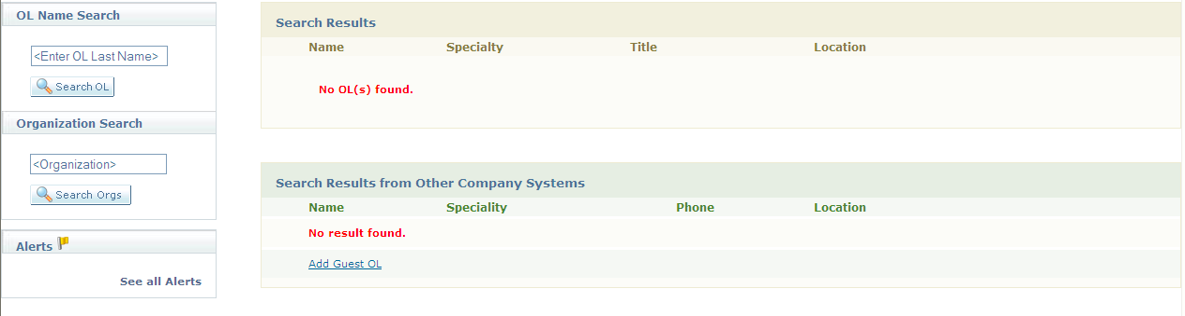
3. Verify and complete all of the contact information in the Add Guest OL window and select the Save button.
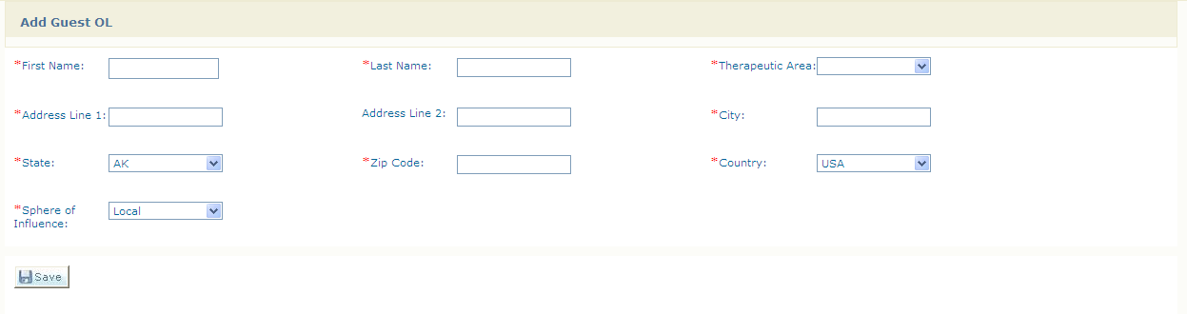
4. The new OL will automatically be added to your My OL List.

Profile Navigation

When viewing a profile, mouse over any of the Profile Main Tabs to view sub categories of information. Profile information can be printed by tab or for the full profile. Notifications can be initiated to view each

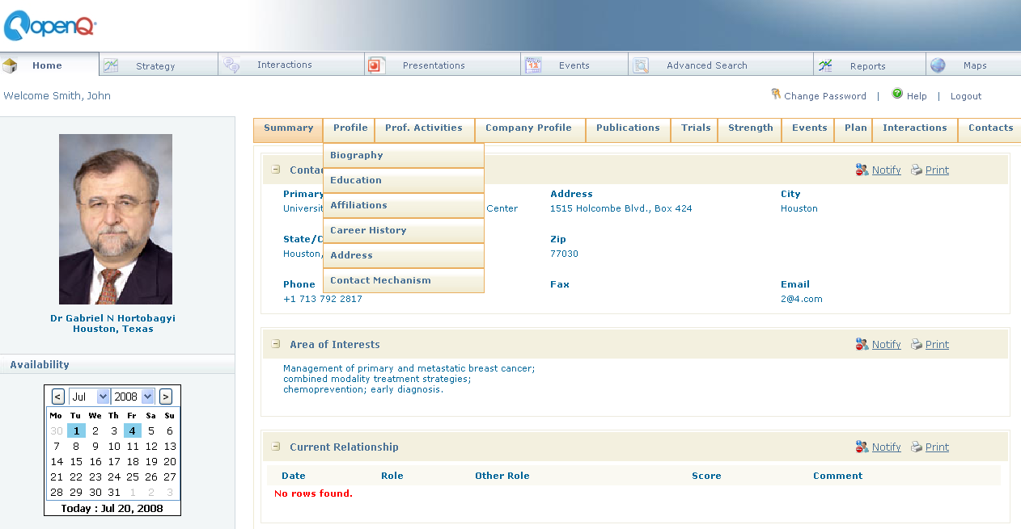
A
B
C
D
E
F

Important features of the Profile screen include:

 | Expert Summary – Export photo, name, contact info, areas of interest, current relationship, calendar
 | Profile Main Tabs – Profile information is organized into these 8 main sections
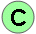 | Profile Sub Tabs – Some Main Tabs contain sub-tabs that enable you to  navigate to more detailed profile information
 | Profile Content – Displays the detailed content of the selected profile tab; Scroll up  and down to view all available information
 | Updating Profiles – Some profile tabs enable users to add, edit or delete profile content
 | Quick Action Icons – Download Vcard, download profile, print profile, turn on notifications

OL Summary
The profile summary has been designed to show the most commonly accessed OL profile information. The top section contains key information such as contact information, BMS assigned contacts, OL Type, Sphere of Influence, Selection Criteria, and affiliations. The information in the profile summary is printable with the link at the top of the page. The summary is read only and you would have to go to one of the sub-tabs to add or update any information.

Additional information may be below your screen view, remember to scroll down to see entire profile summary.

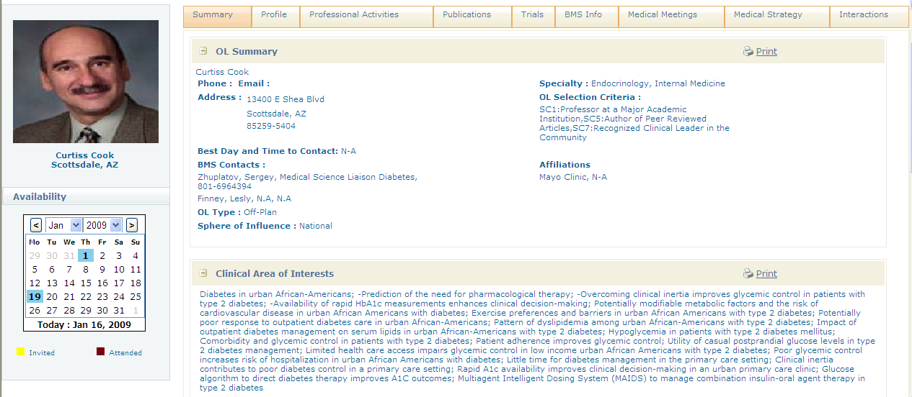

Audit Trial
At any point you can mouse over a particular field and get a history of the record showing when the last update was, the user who made the update, and the previous value (in the case of an edit). The user field may be the logon ID of a synergy user or the name of another BMS system (e.g. TrecNet or TIMS) or a 3rd party data provider

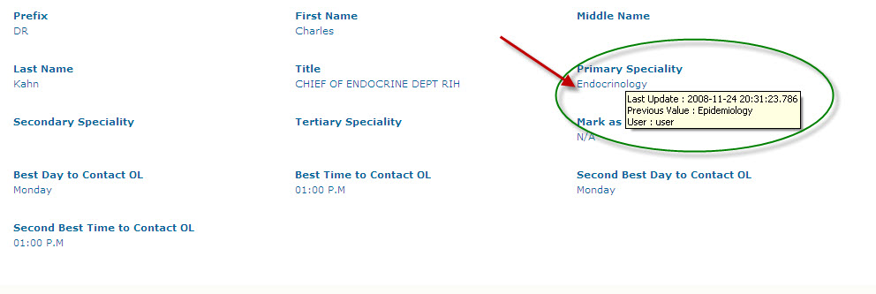

Editing Profile Details
If the users have permission there will be Add/Edit/ Delete buttons at the button of the TAB. Some fields are free text but most are dropdown where the user must select from a pre-defined list. The dropdown fields all have arrows indicating that you must select from the list and these fields do not allow any free text entry. After making edits, the changes can be saved and they will be committed to the database in real time.
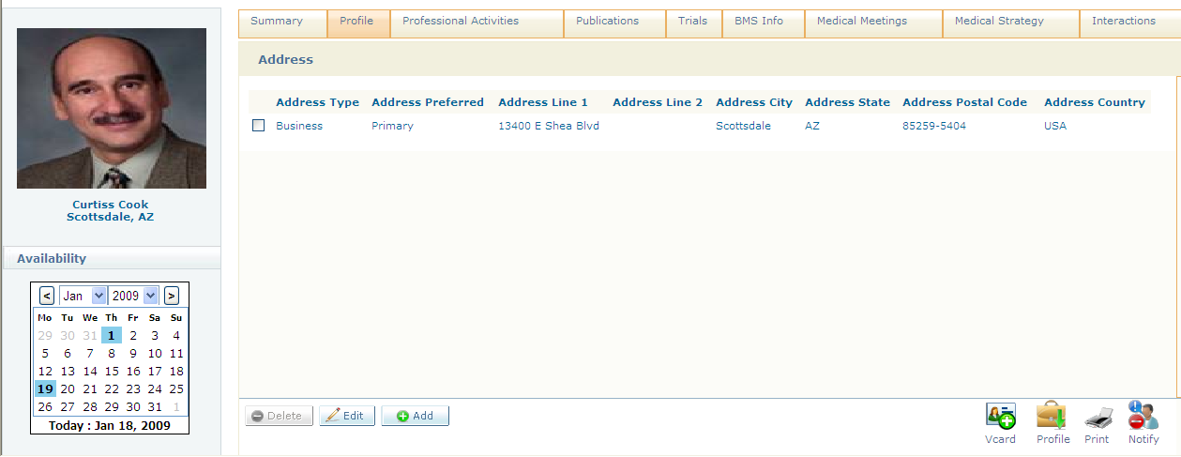

To edit an OL Profile:
1. Place a check mark in the box next to the data you would like to change, and click on the edit button. | 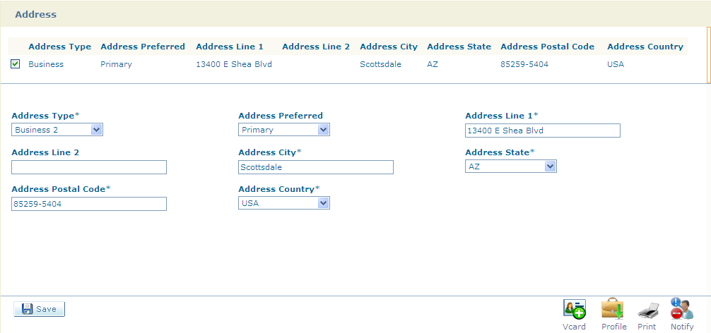
- Change the data by selecting the dropdown box or typing in free-text.  - Click on the Save Button | 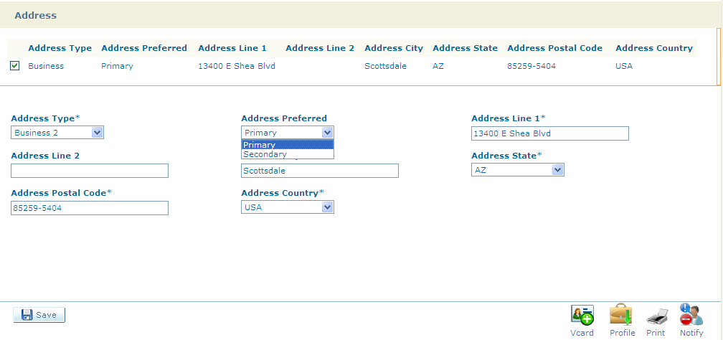

BMS Info
Each Therapeutic Area will have its own sub-tab under the BMS profile. Users will generally see only the profile that pertains to their Therapeutic Area. This is where information such as a TA specific Sphere of Influence or other involvement related tags and attributes will be stored.

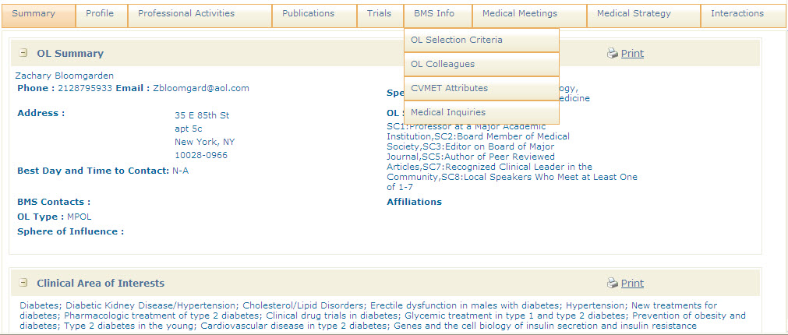

OL Selection Criteria
The OL Selection Criteria sub-tab under BMS Info has a special feature. An OL cannot be made an MPOL without any selection criteria identified, the system will ensure that at least 1 Selection Criteria is entered before an MSL OL Type is set to MPOL.

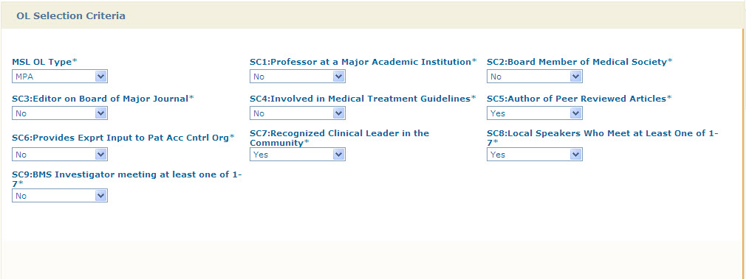

Organization Profile
The system organizes organization profile information into the following categories for managed market engagement.

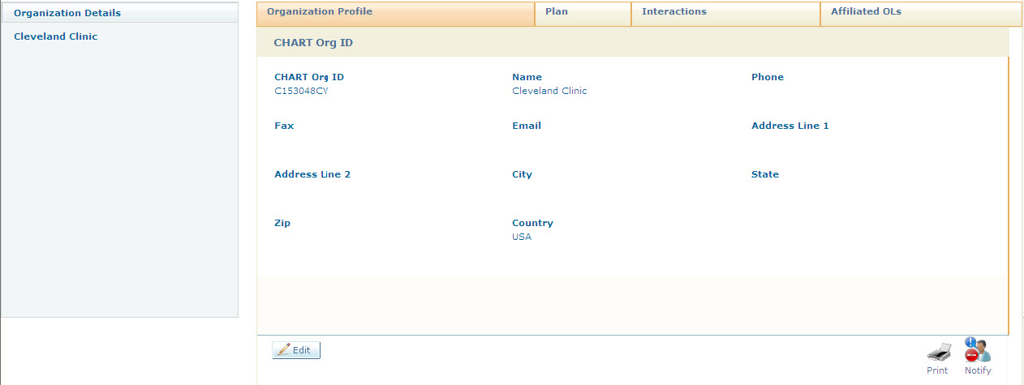

Affiliated OLs
The second tab of the Org Profile shows the OL’s that have been affiliated with the Org. You can click on the OL Name to navigate to the Org profile.

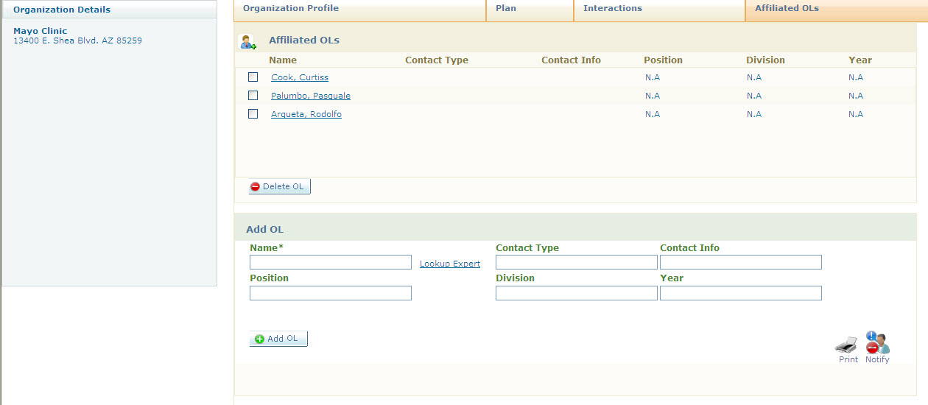

To add an additional Affiliated OL:
1. Select the Lookup OL link, enter the Last Name of the desired Expert in the search window, and select the search button:
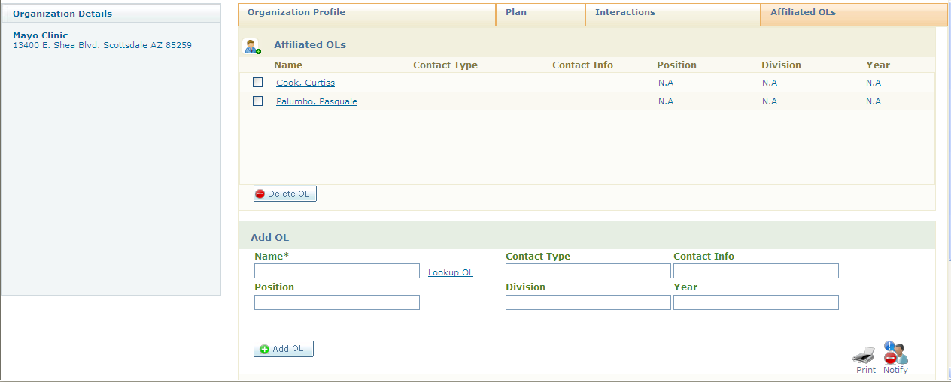

2. Place a check beside the name of the desired OL in the Search OL Results and close the search window.
3. The selected name is now displayed in the Add OL section of the Affiliated OL tab and can be added by selecting the Add OL button.

Interactions (Organization Profile)
The Interactions tab within the organization profile lists all of the documented interactions with the organization. The default view for the organization profile Interactions tab is Interaction window.

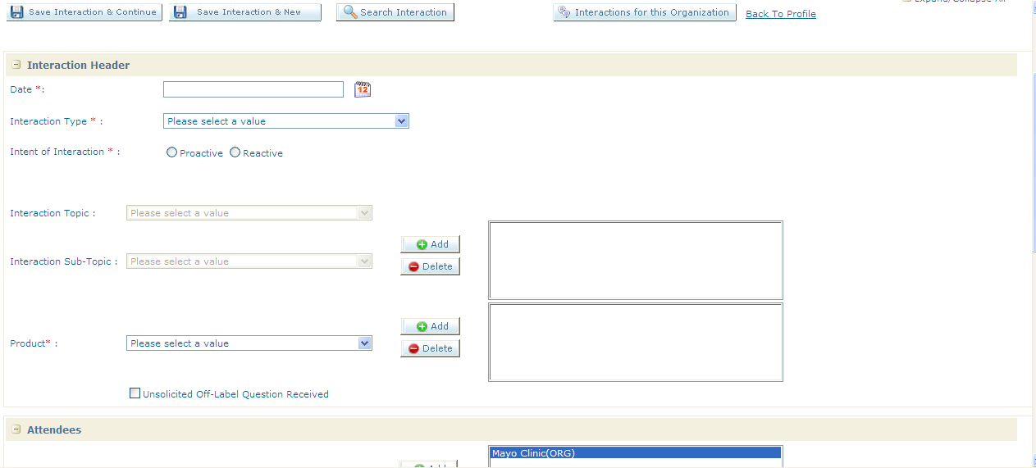

1. Selecting the Interactions for this Organization button displays a list of all documented interactions between the organization and users
2. Select the View hyperlink beside each interaction allows users to view the entire interaction
3. Selecting the 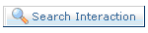button enables you to search for lists of interactions by date range, organization name and assigned user. | 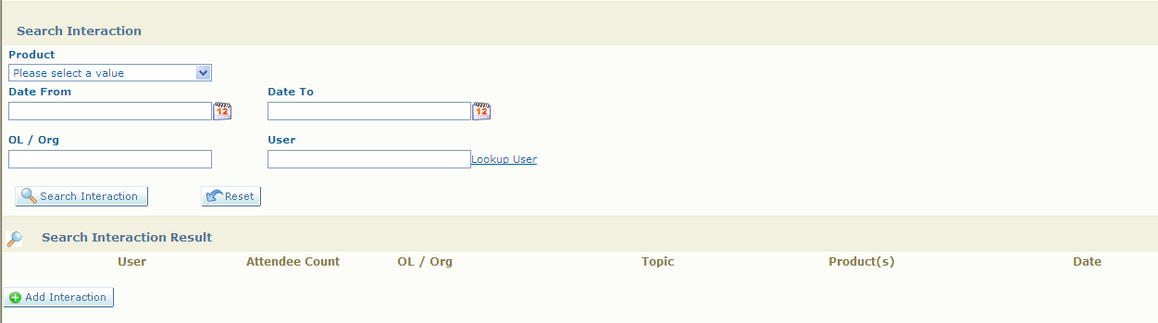

Organization Affiliations
Users may want to affiliate an OL to an Organization.

- Select the sub-tab Org. Affiliation | 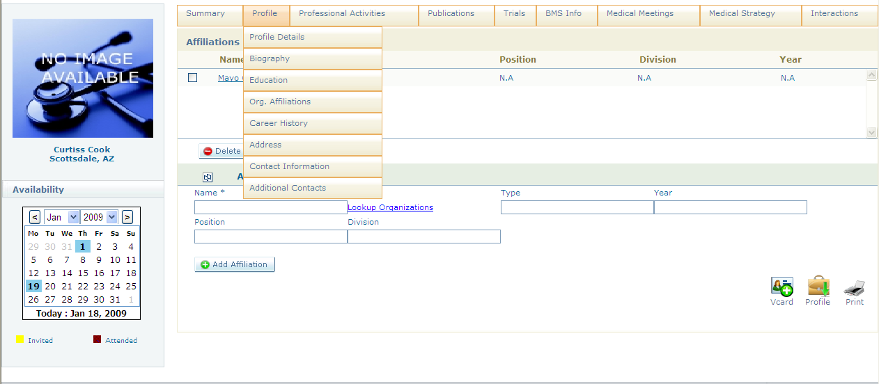
- Select the Lookup Organizations hyperlink. | 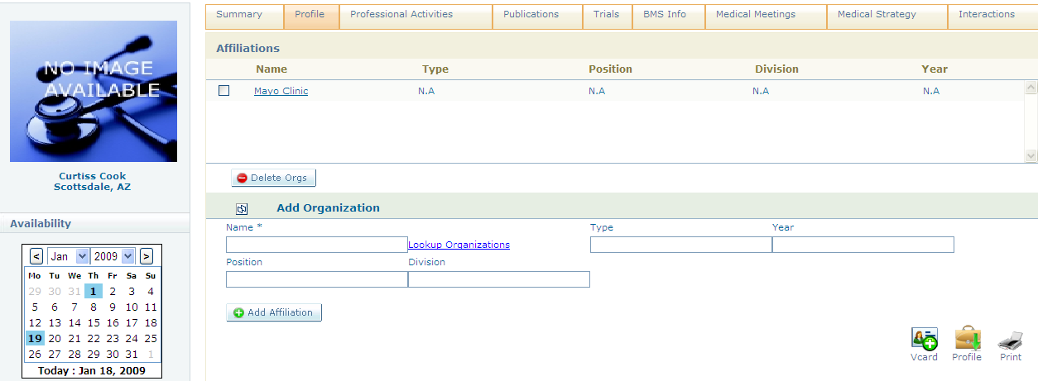
- Type in the name of the Organization and select Search Orgs button. Click in the link next to the organization you would like to select. Click Close Window. | 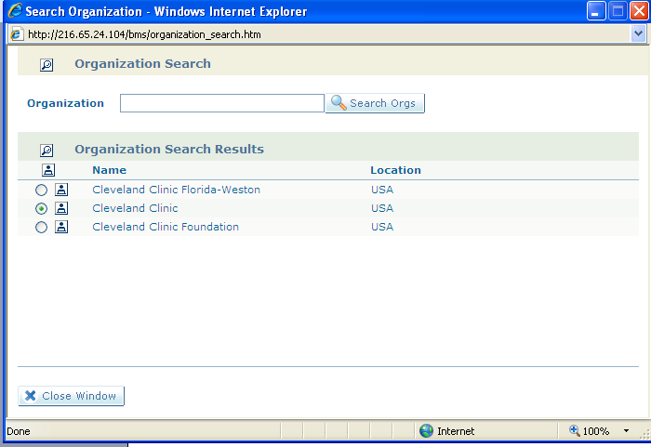

Adding a missing Organization
If you search for an organization and no results are found, it is very easy to add an Organization.

- Select the Advanced Search Tab from the Top-Level Tabs buttons.  - Place a check in the organization checkbox.  - Type in the name of the Organization, and click on the Search Button. | 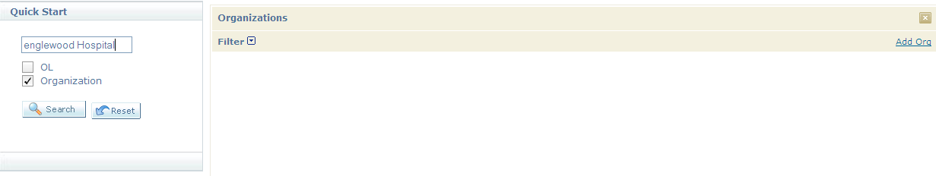
- If no results are returned click on the Add Org link | 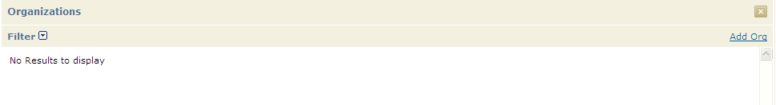
- In the Add Organization window complete all information where there is an asterisk next to the window, and click Save. The Organization has been entered into synergy. | 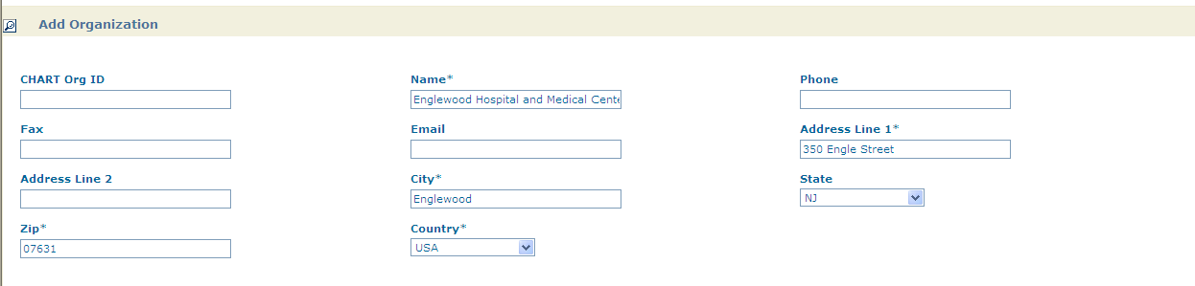

Recording an Interaction
Recording interactions is the primary area where users will be entering information into the database. Users entering data must make every effort to ensure accuracy and timeliness of the entries they are responsible for populating.

The Interactions Tab can be accessed from the Top-Level Tab. When accessed from the top-level tab, a blank interaction form will open.

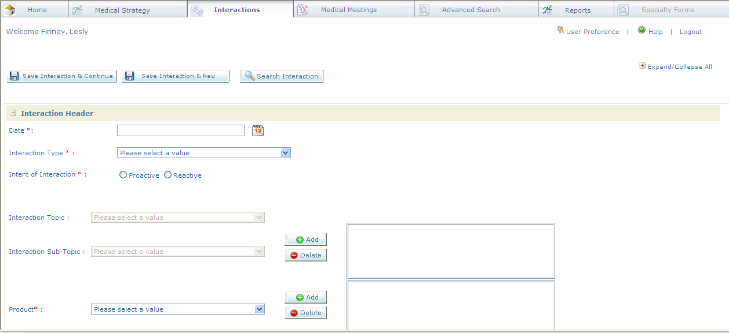

Recording an Interaction from the OL profile.
Users can also launch the interactions Tab within any OL Profile.

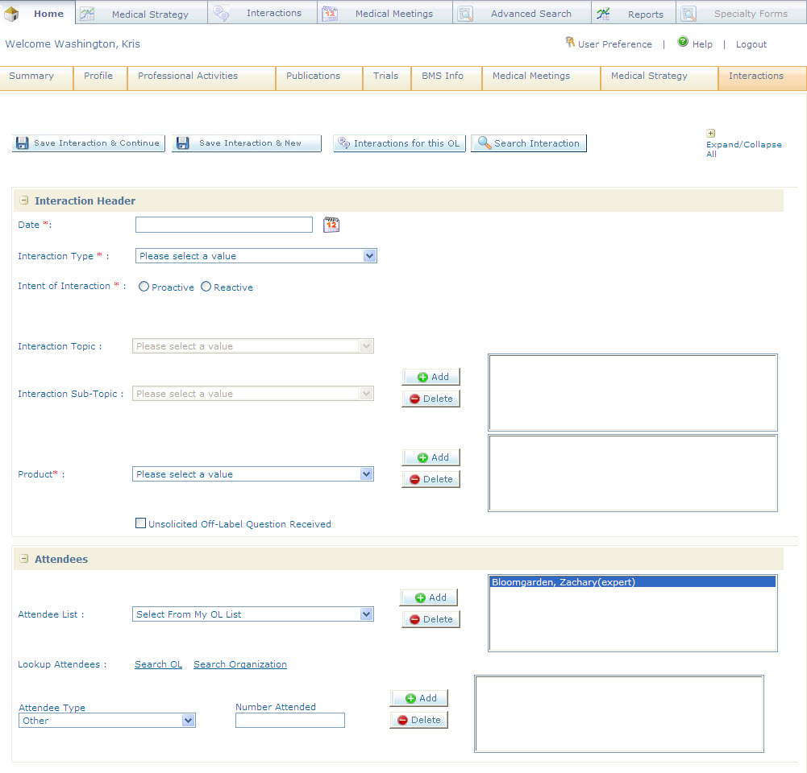
Note: When you launch an interaction from the OL Profile the OL name will appear in the Attendee List.

Entering an Interaction
Users can enter in a single interaction or if multiple interactions.

To Record an Interaction:
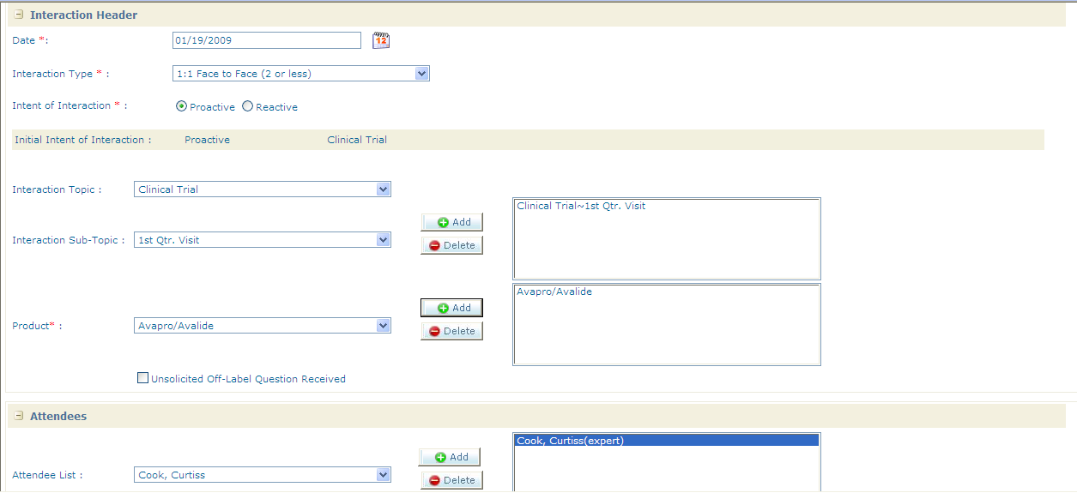

Required Data: | Example
- Date | Calendar will display
- Interaction Type | Example: 1:1 Face to Face (2 or less)
- Interaction Sub-Topic | 1st Qtr. Visit
- Intent of Visit | Proactive or Reactive
- Click on the Add Button
- Select Product | Avapro/Avalide
- Select Attendee | Search OL or Organization
- Other Attendee | Include only the number of attendees who were not individually added, not the total number of presentation attendees.

- Complete any additional sections that are added to Interaction Form:  i.e. Example: Clinical Trial Visit/Speaker Training | 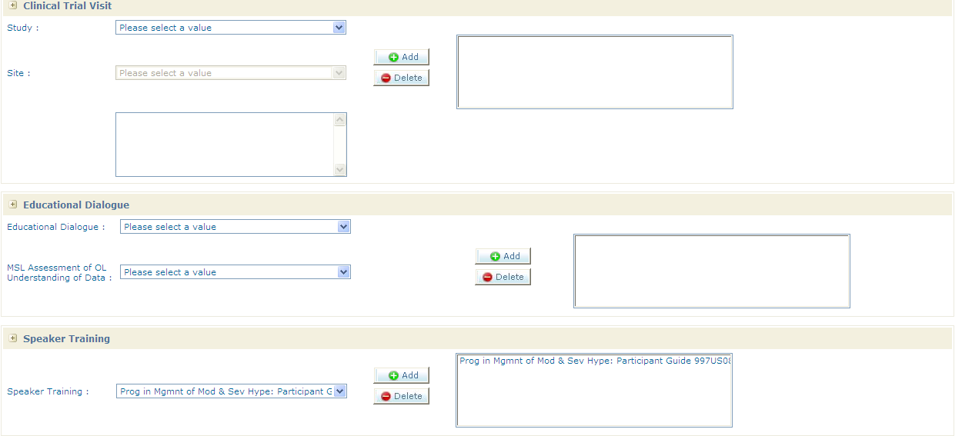

13. Select the Save button to save the Interaction.

Verify that your interaction was saved by confirming that the “Interaction Details Saved Successfully” prompt appears at the top of the Interactions TAB screen.

Expanding or Collapsing Sections

Some of the interaction topics require that further details be entered.

Depending on which interaction topic(s) you select, additional sections may open at the bottom of the interaction form (or screen) to capture more details.

In general, data must be filled out for these additional sections, all fields should be completed. An example of this would be recording a speaker training interaction.

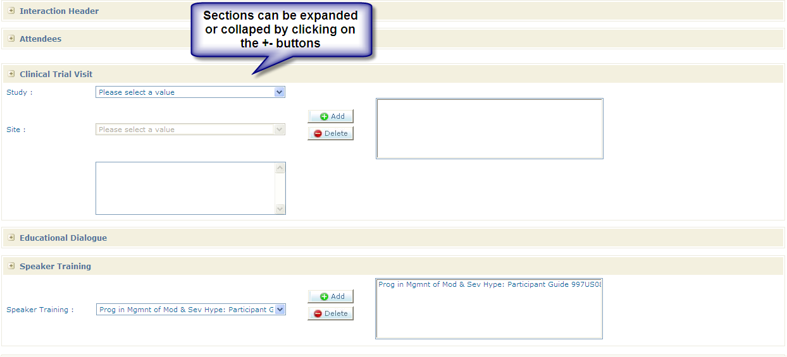

Entering an Unsolicited Off-label Interaction
To record an Unsolicited Off label Question Received check the box titled Unsolicited Off-Label Question Received.

- Check the box Unsolicited Off-Label Question Received. | 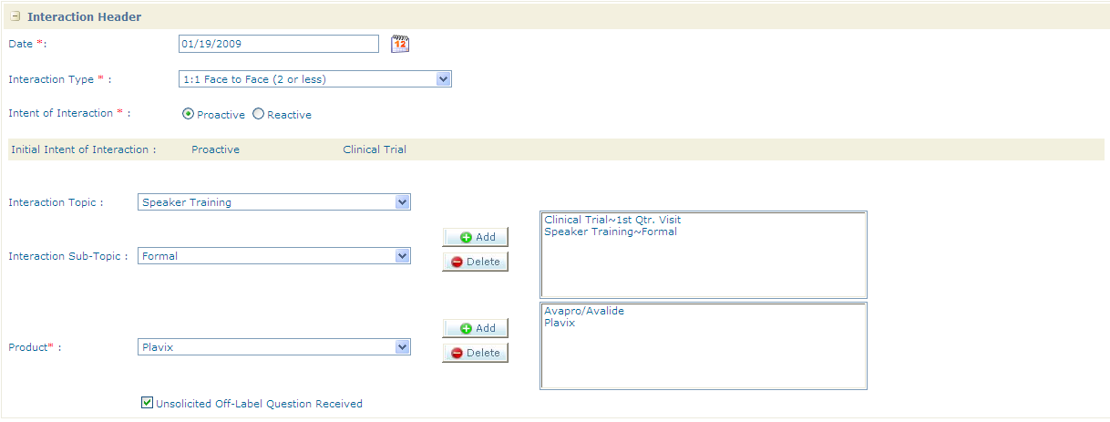
- After checking this box a section will open titled Unsolicited Off-Label Question Received to provide further details on the inquiry.  - Select the Product  - Topic & Sub-Topic  - Click on the Add Button | 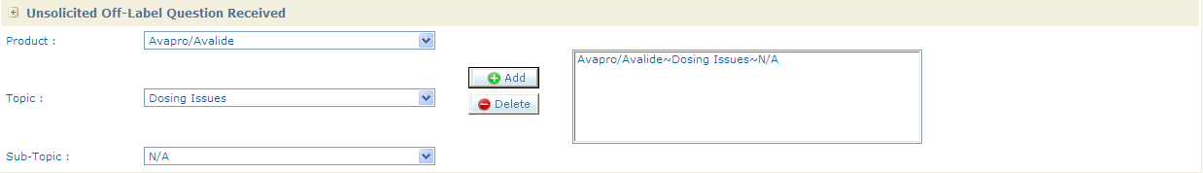

Accessing a Survey
The Filled Surveys section will allow you to edit any survey entered by the user, through selection of the survey name and the name of the OL specified when the survey was created.

- Select the survey you would like to complete and click on the survey button | 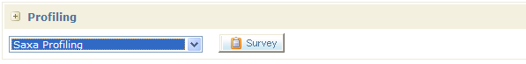
- Complete the survey and click the 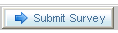  button | 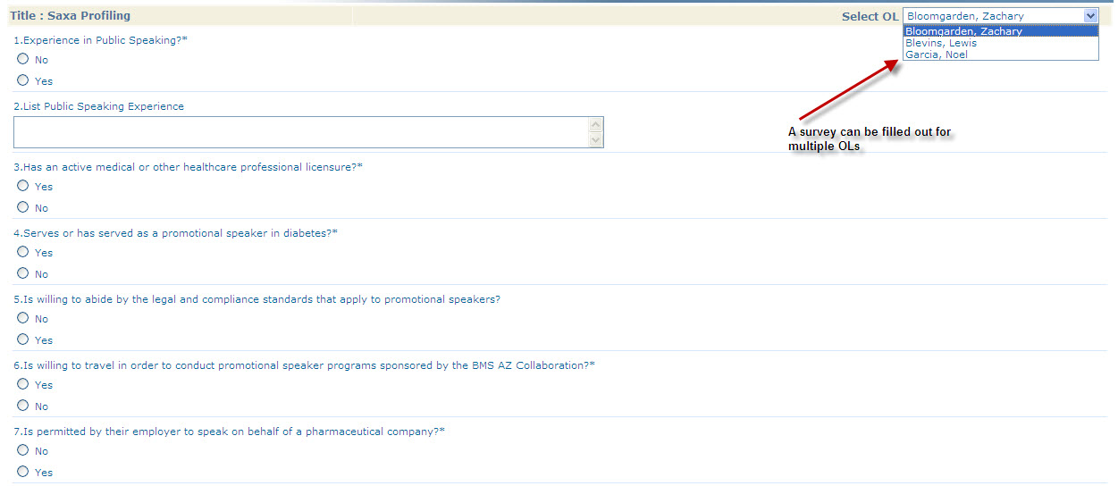

Link to Medical Meeting

- Click on the “Get Meeting” button, a list of meetings that took place within a week of the interaction date will be displayed in a pop-up for you to choose from. | 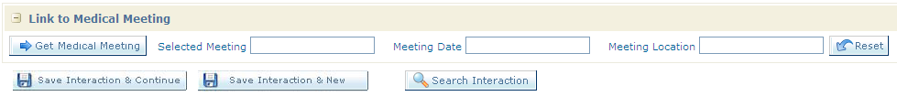

Saving an Interaction
The interactions form has a few different saving options:

- Save Interaction & Continue will allow you to save the interaction and complete the interaction later.

- Saves the interaction you are working on and allows you to start with a new blank interaction form

Searching for an Interaction
Search Interactions allows you to Search for a specific types of interactions in the system.

- Click on the Search Interaction Button on the Interaction TAB
- To search by user you will need to first search for the user by last name. This search form is a pop-up that is invoked with the lookup company owner link. | 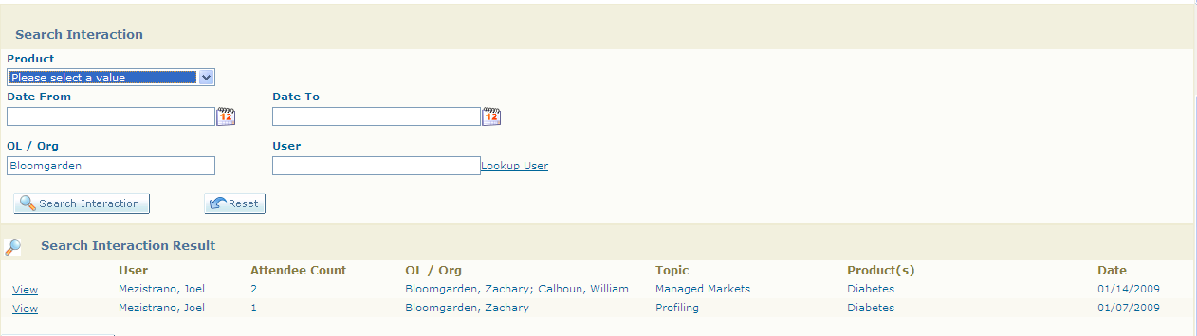
- You can search by product, date range, OL or Organization attendee, or user. | 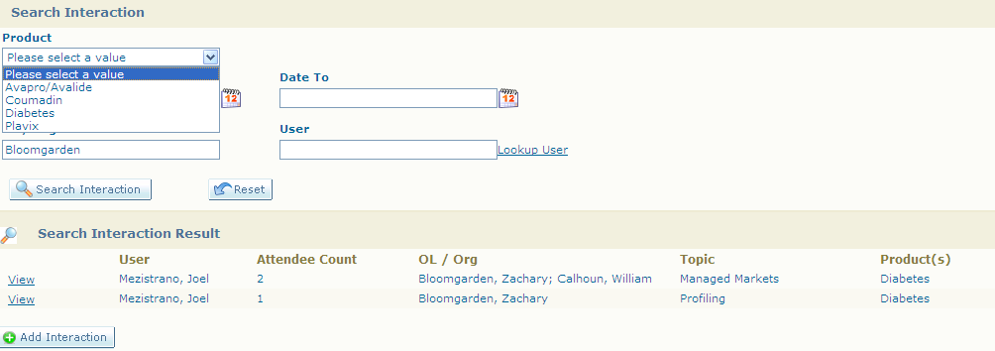

Medical Meetings
The Medical Meetings modules can be accessed via a top-level tab. It is designed to be an enterprise calendar that is populated with a variety of meeting types (e.g. speaker training events, ad-boards, medical conferences, congresses).

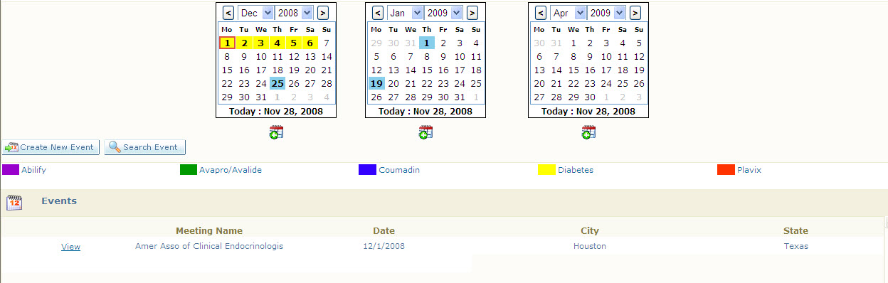

Viewing a Medical Meeting
Click on a meeting from either the calendar or search results will bring up the meeting details page.

- Click on Search Medical Meeting
- Type in criteria for the medical meeting you are looking for:  Type  Company Owner  Therapeutic Area  Therapy | 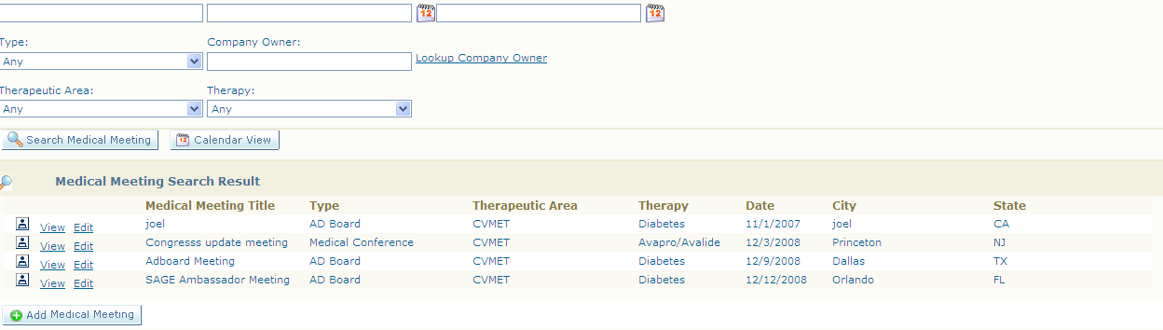
- Click on the View Button to access the Medical Meeting | 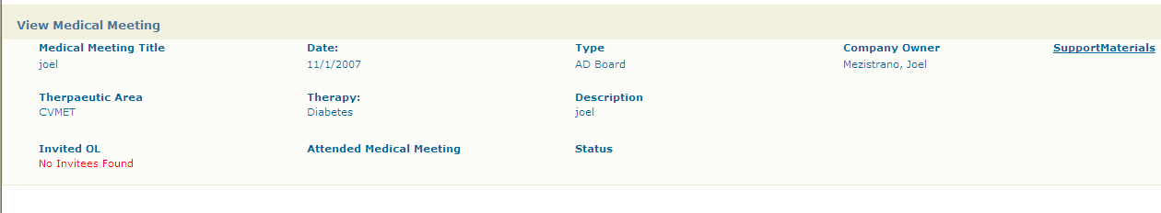

Reports

Dashlets

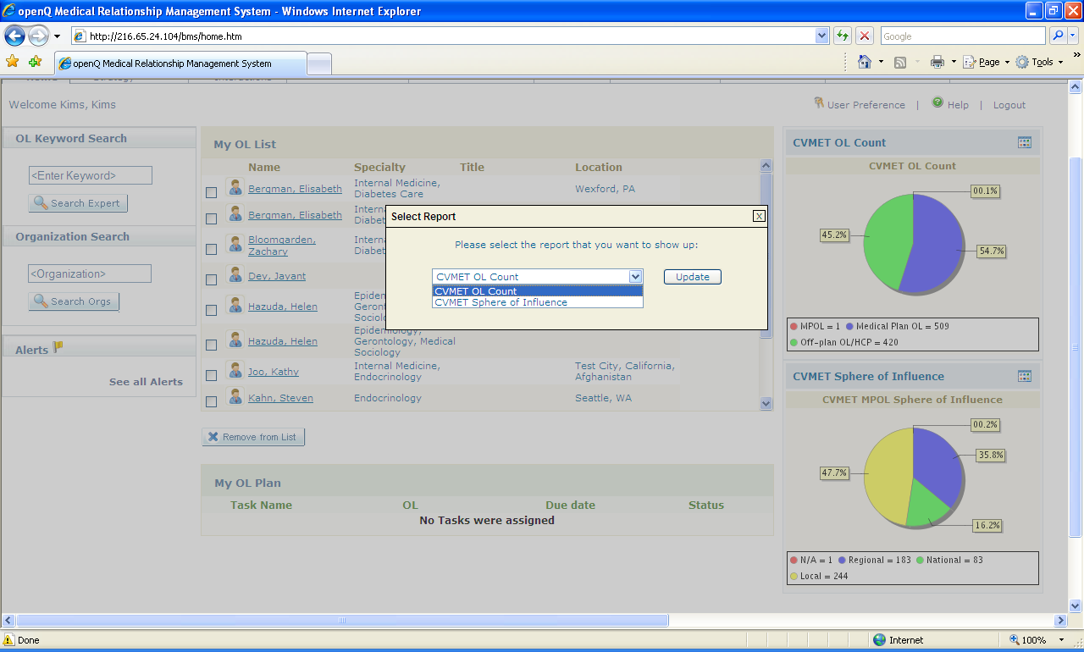
A
B

A | Select the configuration icon to add or remove a dashlet report
B | Select the dashlet report to add or remove

Reports
Reports are real time, live data is presented every time a report is run; no data synchronization or data transmission is required in the synergy system.

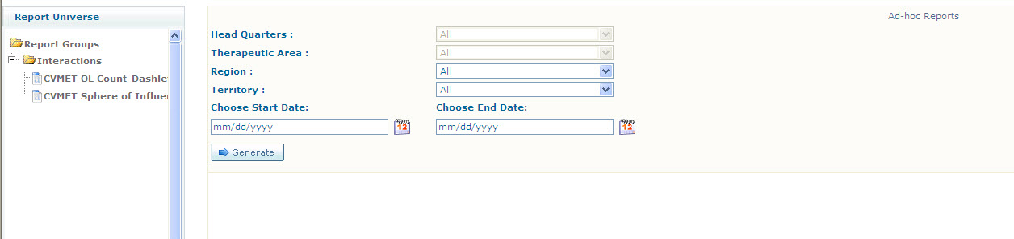

Report Parameters
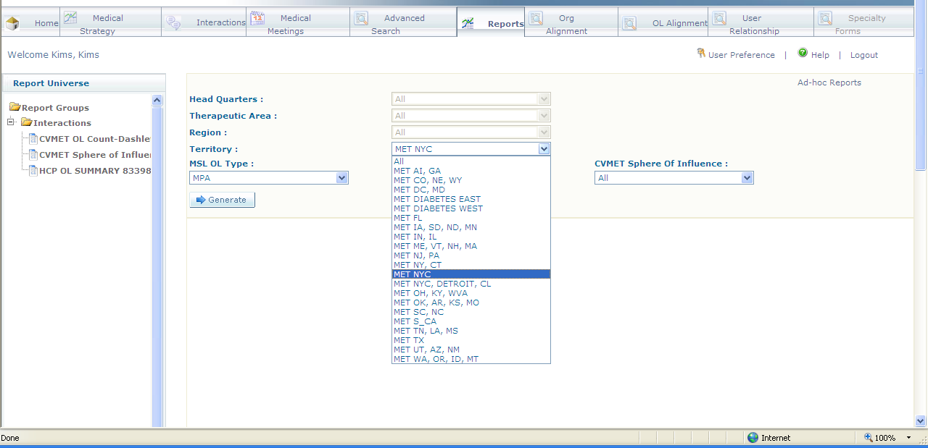

Some reports will have additional parameters in addition to Territory & Region information. For example in this field medical report, you can select an OL type for a subset of the entire universe.

Exporting a Report
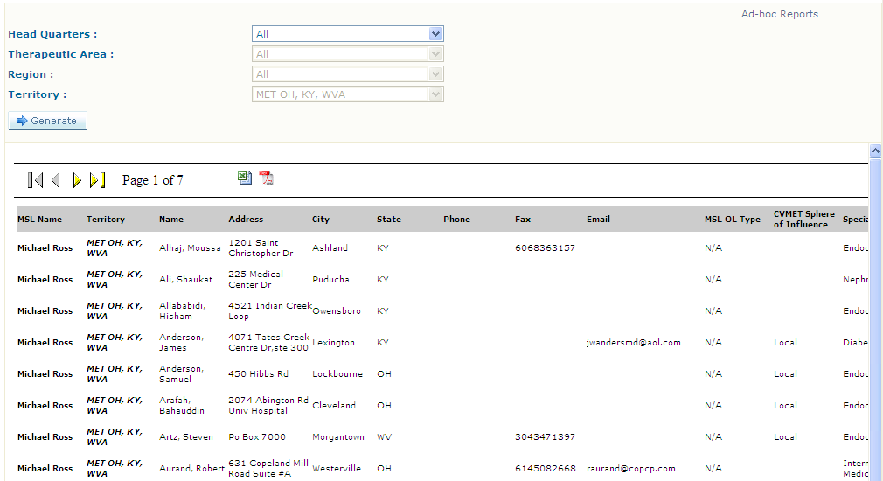

To export a report for easier viewing or to print it, locate the excel and PDF export icons in the upper right hand corner of the report. Exporting is the most effective way to print a report.

