Project ConSat: Control of Small Satellites

† Pedro Tavares, ∗Paulo Tabuada, ‡ Pedro Lima

Instituto de Sistemas e Robótica, pólo do Instituto Superior Técnico
Torre Norte, Av. Rovisco Pais, 1 - 1096 Lisboa Codex
Fax: (+351 1) 8418291 E-mail: † pts, ∗tabuada, ‡ pal @isr.ist.utl.pt

Abstract: This article describes ConSat, a research project aimed at the study of stabilisation and control of small satellites’ attitude. The work presented here includes a simulator of a micro-satellite’s attitude determination and control system (ADCS) and a new attitude stabilisation and spin control algorithm.

Keywords: simulators, satellite control, attitude, dynamics, sensors, magnetic field computation.

- Introduction

Due to their relative low cost and fast turn-around time (from contract to launch), micro and mini-satellites have steadily gained in popularity since the early eighties. In the past, they have provided an affordable access to space for many small countries such as Portugal, Chile and Korea, and new applications for their use emerge every year.

A core system for most satellites, whether large or small, is the Attitude Determination and Control System (ADCS), which carries out such tasks as the pointing of the satellite, and the stabilisation of its rotation. In micro-satellites the ADCS is affected by the same trade-offs as the other systems, resulting in less powerful sensors and actuators due to cost and size/weight criteria. Hence, there is the need for adequate control strategies which consider this trade-off.

On September 26 1993, an Ariane-4 rocket launched PoSat-1, a 50-Kg micro-satellite built by the University of Surrey's Spacecraft Engineering Research Group and Surrey Satellites Technology Limited. This technology demonstration satellite was built for a Portuguese consortium of industry and academia of which IST of Lisbon Technical University and UBI were part. At the time, neither of these two universities played a major part in the definition of the satellite, and especially, in the design of the ADCS.

In 1997, Instituto Superior Técnico (IST) and Universidade da Beira Interior (UBI) obtained funding for a three-year research project in stabilisation and control of small satellites so as to develop a national group with expertise in ADCS.

- Project ConSat

ConSat aims at the study of the dynamics of bodies under the influence of gravitational, aerodynamic and control moments in the particular case of small satellites. The work carried out includes the development of new approaches to the attitude control of small satellites.

The project team includes of eleven researchers and graduate students from the two Portuguese universities involved and has promoted multiple contacts with European universities working on small satellites, such as the University of Surrey (United Kingdom) and Aalborg University (Denmark, with the help of the ESF COSY programme).

The first year of the project (second half of 1997 and first half of 1998) was dedicated to the study of the satellite’s dynamics and the development of an attitude sensor environment simulator, described in the following chapter. The second year of the project is being dedicated to the development, implementation and test of multiple attitude control algorithms and of a attitude determination strategy.

- ConSat Simulator

The ConSat simulator reproduces the environment as perceived by the ADCS by modelling all quantities which the satellite senses and with which it interacts. Since small-satellites are typically in Low Earth Orbit (LEO), the preferred attitude actuators are those which generate a magnetic momentum that interacts with Earth's geomagnetic field, thus generating a momentum that rotates the satellite. Small gas jets are also becoming an option for this class of satellites.

PoSAT-1 was used as a case study for the ConSat simulator. This satellite’s ADCS is composed of two single-axis sun-sensors, two earth horizon sensors, one Earth underneath detector, two sun detectors, one (non functional) star sensor, two three-axis magnetometers, one mass tipped boom and three one axis magnetorquers. PoSAT-1’s on-board computer is based on an INTEL 80C186 processor running at 8 MHz with 512 Kbytes of RAM, interfacing with a 16 Mbytes RAMDISK. Its secondary computer is based on an INTEL 80C188 processor running at 8 MHz with 512 Kbytes RAM.

Future versions of the simulator will be able to simulate different micro-satellites (such as the Danish micro-satellite, Ørsted), depending on the satellite configuration file used that describes the satellite’s ADCS, based on the set of sensors and actuators available in the simulator.

Using Simulink, the sensors' and actuators' model blocks are combined with a user-defined attitude determination and control algorithm block and the output of the simulation is simultaneously saved to file and presented to the user using the simulator's graphical interface (see Fig. 1).

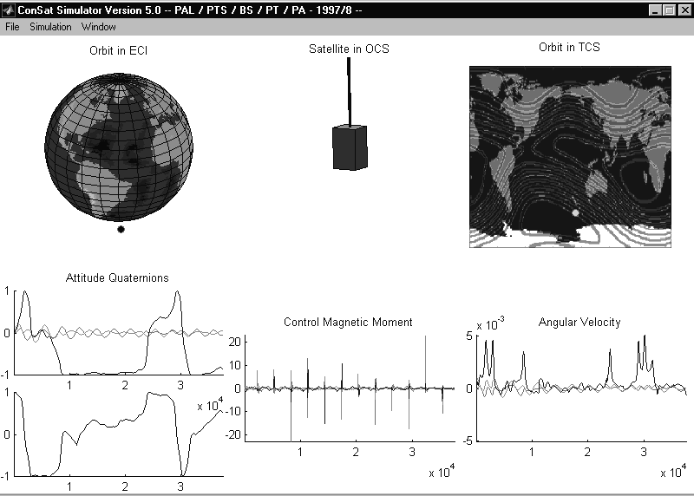

Fig. 1- ConSat Simulator Graphical Interface

  - Models Used

To simulate the evolution of the satellite attitude motion and the time-varying behaviour of all the sensors, several models had to be implemented, as depicted in Fig. 2.

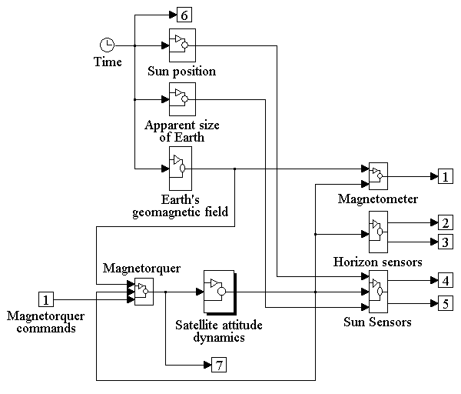

Fig. 2 - ConSat Simulator Block Diagram

The attitude motion of the satellite is modelled by the Euler equations for the motion of a rigid body under the influence of external moments, such as the control moment generated by the actuator. The simulation of the actuator (a magnetorquer) requires the use of a geomagnetic field model and the calculation of the satellite position using an orbit model.

The simulation of sensors modelled requires the knowledge of the magnetic field vector (for the magnetometer) and the position of the Sun and Earth as seen from the satellite (for the Sun and Earth horizon sensor). One of the main control problems faced here is the fact that, besides being noisy, the information provided by the Sun and Earth sensors is not always available, depending on the relative positions of the satellite, Sun and Earth.

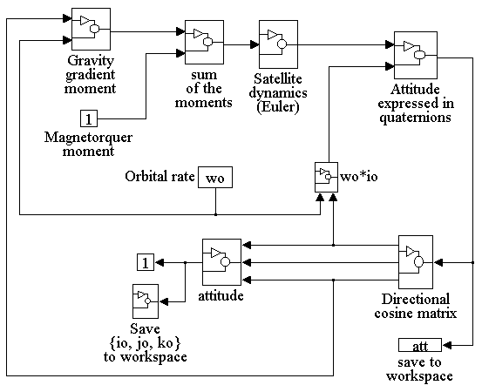

Fig. 3 - Satellite Attitude Dynamics Block Diagram (expanded from Fig. 2)

In this simulator the kinematics (see Fig. 3) is expressed in quaternions (also known as Euler symmetric parameters), through the integration of the angular velocities provided by Euler’s equation (Wertz, 1995).

Five different reference co-ordinate systems (CS) are employed in this work:

Inertial (ICS): 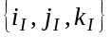 is a right orthogonal CS centred on Earth's CM that is fixed (doesn't rotate with Earth). is along the vernal equinox (1st point of Aries ϒ, or the vector along the line passing Earth's and the Sun's CM on the last day of autumn, pointing away from the Sun). 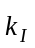 is along the spin axis of the Earth and points from south to north and 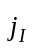 complements this right orthogonal CS.

Terrestrial (TCS): 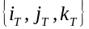 is a right orthogonal CS centred on Earth's CM. It coincides with ICS on the vernal equinox and rotates with Earth.

Local Horizontal (LHCS): 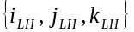 is a right orthogonal CS centred in the CM of the satellite. 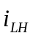 is pointing along the Zenith, 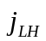 along East longitude and 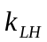 along South positive coelevation.

Orbital (OCS): 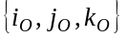 is a right orthogonal CS centred in the CM of the satellite. is orthogonal to the plane of the orbit (right-hand rule), 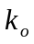 is pointing to the Zenith and 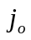 forms a right orthogonal system.

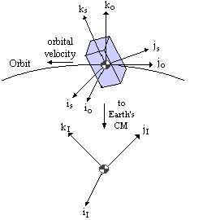

Fig. 4 - Inertial, Orbital and Satellite Co-ordinate Systems

Satellite (SCS): 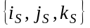 is a right orthogonal CS centred in the centre of mass of the satellite, parallel to principal moment of inertia axle of satellite. is parallel to the smallest moment of inertia axis (along gravity gradient boom, if present) and and are parallel to the two remaining principal moment of inertia of the satellite.

The orbit generation in the ConSat simulator was done with the USSPACECOM SGP4 mathematical model for prediction of satellite position and velocity. Earth’s geomagnetic field was simulated using a 15th order spherical harmonic IGRF model (parameters available at various sources world-wide).

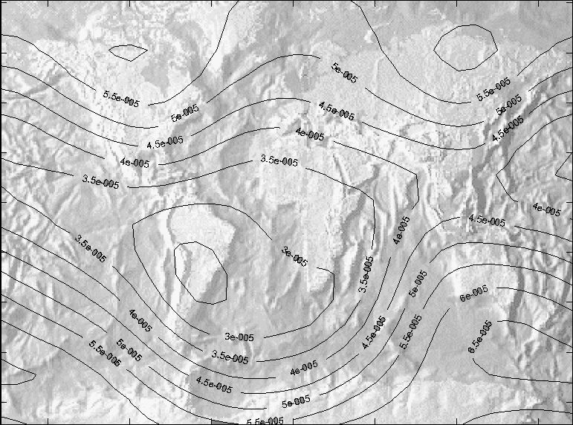

Fig. 5 - Earth's Geomagnetic Field - Simulation

The results performance of the simulator was described in (Tavares, 1998).

- Control Algorithms

Several researchers from various countries have already begun to explore and solve the control problems imposed by a LEO small satellite. (Ong, 1992) proposes some intuitive control laws to tackle this problem, but the actuation is very restricted and does not take advantage of the time-varying nature of this problem. (Steyn, 1994) approaches the control problem by using a Fuzzy Logic Controller that achieves better results than a Linear Quadratic Regulator (LQR), despite considering the constraint of actuating on a single coil at each actuation time. This approach suggests that non-linear and time-varying control methodologies should be further explored so that a better problem understanding and possible solutions may be found. (Wisniewski, 1996) compares two non-linear solutions: sliding mode control and energy based control, achieving better results than LQRs based on linear periodic theory.

Using the ConSat simulator as a workbench, several attitude control algorithms were implemented and preliminary tests carried out, without the use of the attitude determination block in the loop. Two different control objectives were studied: attitude stabilisation and attitude stabilisation with spin control. In the first group, the present PoSAT-1 controller, a sliding mode controller, an energy-based controller and a predictive regulator were studied. In the second group the existing spin controller for PoSAT-1, an energy-based controller, a fuzzy logic controller and, finally, a predictive controller were studied.

The above-mentioned algorithms, with the exception of the predictive controller, are described in detail in (Ong, 1992), (Steyn, 1994) and (Wisniewski, 1996).

The predictive algorithm developed is a new algorithm for attitude stabilisation and spin control of small satellites using only electromagnetic actuation. This approach takes advantage of the time varying nature of the problem (the geomagnetic field changes through the orbit) by using the most appropriate control effort (according to an energy-based criterion) given the geomagnetic field and the satellite angular velocity at each actuation instant.

  - Problem formulation

The dynamics of a small satellite are well known and may be expressed in the Control CS as (Wertz, 1995):

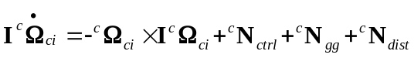 (1)

where I is the inertia tensor, 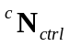 the control torque, 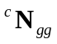 the gravity gradient torque and 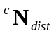 a disturbance torque cause by aerodynamic drag and other effects. 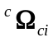 is the angular velocity of the Control CS w.r.t. the Inertial CS written in the Control CS.

The control torque is obtained by electromagnetic interaction with the geomagnetic field (Wertz, 1995),

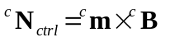 (2)

where 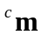 is the control magnetic moment generated by the satellite coils and will be referred to as the control variable throughout the paper. 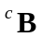 is the geomagnetic field.

Equation (2) shows that the control torque is always perpendicular to the geomagnetic field, pointing out the non-controllability of electromagnetic actuation. The direction parallel to the geomagnetic field is not controllable, but the geomagnetic field changes along the orbit. This implies that, e.g., yaw is not controllable over the poles but only a quarter of orbit later, i.e. approximately over the equator. Those characteristics must be adequately explored to regulate appropriately the satellite’s attitude. A time-varying predictive algorithm to determine the control moment, which takes advantage of the geomagnetic field changes, is proposed as a solution to this control problem.

  - The Predictive algorithm

Motivation

Using the satellite total energy as a Lyapunov candidate function (Wisniewski, 1997) shows that its time derivative is given by:

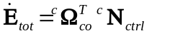 (3)

The equation 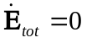represents all the control torques that lie on a plane that is perpendicular to 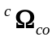. Therefore, imposing 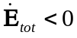 is the same as constraining the control torque to lie “behind” the plane perpendicular to . Furthermore, the control torque is obtained from (2), therefore it must always be perpendicular to the geomagnetic field. As such, the solution of this control problem must satisfy two requirements:

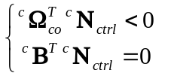 (4)

It can be seen from (4) that although the solution to these constraints is not a linear space, it is nevertheless an unlimited subset of a plan embedded in a three-dimensional space, in the general case, or it doesn’t exist if is parallel to 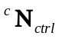. This is equivalent to state that the solutions to this control problem are infinite in the general case, suggesting a control algorithm that should choose the optimum magnetic moment (or at least the best one, given all the constraints) at each actuation instant to take advantage of the particular angular velocity and geomagnetic field. This approach differs from most other solutions available in the literature, which use a constant control law, independently of the current angular velocity and geomagnetic field.

Formulation

As in (Steyn, 1994), the measurements of the current geomagnetic field and satellite angular velocity are used to determine the control magnetic moment. We start by defining a cost function based on the kinetic energy:

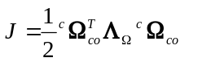 (5)

where 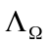 is a positive definite gain matrix. More insight will be given regarding the choice of the cost function, when studying the algorithm stability in Stability Study sub-section.

The dynamic model of the satellite is well known and understood so it can be used to see the influence of the magnetic moment on the angular velocity. The angular velocity of the Control CS w.r.t. the Inertial CS can be written as:

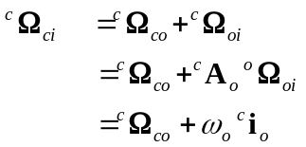 (6)

where 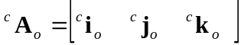 is the direct cosine matrix which transforms vectors expressed in the Orbit CS to the Control CS. Small satellites are usually launched into polar orbits with small eccentricities. Therefore, the angular velocity of the Orbital CS w.r.t. the Inertial CS is approximately given by:

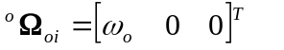 (7)

The derivative of eq. (6) now becomes:

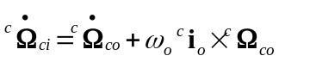 (8)

substituting in the dynamics equation (1) and neglecting the disturbance torque we get:

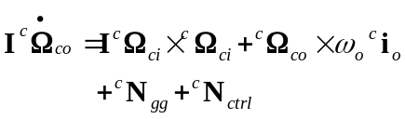 (9)

Equation (9) is used to predict the evolution of the angular velocity produced by a given control torque by discretising it, considering a small time step Δt:

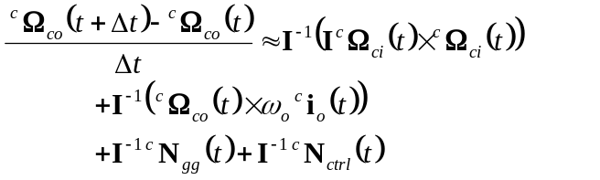 (10)

which may be written as:

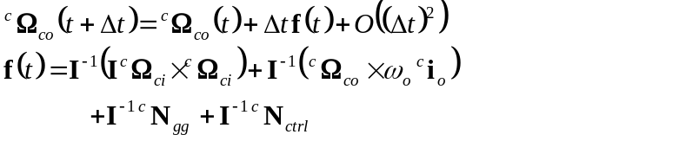 (11)

and the prediction equation is obtained by discarding the higher order terms:

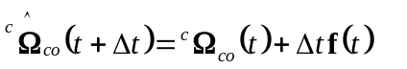 (12)

where the ^ stands for prediction. It can be seen from (12) that it is possible to predict the effect that a given control torque will produce on the angular velocity. For this prediction there is only need to know the current angular velocities and attitude, readily available from the attitude determination system. Using the prediction equation (12) and (2) it is possible to choose from the available magnetic moments the one that minimizes the cost function (5), once the geomagnetic field value is available from the magnetometers.

Stability study

The total energy of satellite is composed of a kinetic term and a potential term,

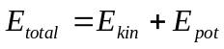 (13)

Their sum, the total energy, is constant, since the dissipative forces and torques actuating on a satellite are very weak. By dissipating the kinetic energy, the total energy is also decreased. Since the system is not fully controllable it is not possible to place the satellite in a zero kinetic energy configuration and keep it there because gravity-gradient torques will impose a libration movement converting potencial energy to kinetic energy. All potencial energy is converted to kinetic energy during the libration movement and all kinetic energy is dissipated by the predictive algorithm, therefore the only stable configuration for the satellite is a minimum total energy one (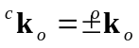).

There is, however, a situation when the predictive algorithm is not capable of dissipating energy, when using on-off actuation and the actuation instants coincide with zero kinetic energy configurations. This situation can be avoided by guaranteeing that the libration movement period, which is a function of the inertia moments and the satellite angular velocity around earth (Chobotov), is different from the actuation period.

Having established that a kinetic energy like cost function is enough for stability it is still necessary to show that this minimization method based on a predictive model will work. Consider a Lyapunov candidate function 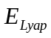 as defined in (3), the kinetic energy based on (10) may be expressed as:

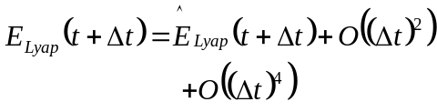 (14)
where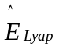 is the Lyapunov candidate function computed using the predicted angular velocity. Assuming that the minimization algorithm is working correctly, we will have:

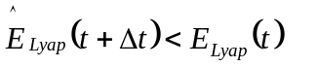 (15)

substituting (14) in (15) we get:

(16)

dividing by Δt and assuming Δt as small as wanted, we can write:

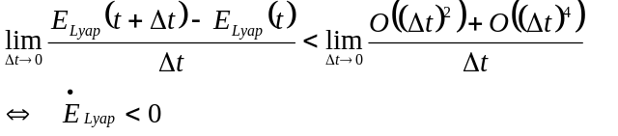 (17)

Therefore global uniform asymptotical stability is ensured towards the reference 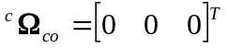, and as previously shown also towards .

Implementation
Unrestricted actuators

For ideal actuators the minimization of the cost function is done on a continuous unlimited subset of a plan. An iterative method for the cost function minimization was required, so a Genetic Algorithm (GA) (Goldberg, 1989) was implemented. Any other iterative algorithm could be used but the GA was chosen because of its fast convergence characteristics, since in this problem the geomagnetic field is constantly changing. The implemented GA uses the standard techniques and two special operators: elitism, under which the best solution is always preserved and transmitted to the next generation and cloning, by which we insert into the population the solution 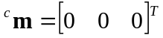. Cloning is justified because it has been found through simulation that sometimes the algorithm would converge to magnetic moments parallel to the geomagnetic field after the stabilization had been completed. The solution 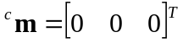 performs same action (do nothing), but preserves power, as it does not use the magnetorquers for that purpose.

Restricted actuators

PoSAT-1 as other satellites of the UoSAT class has reduced control capabilities due to the restricted nature of its actuators. Satellite design factors have restricted the values of the control magnetic moment to only three different values of positive/negative polarity. Combining this restriction with the single-coil-actuation the available set of magnetic moments is reduced to only 18 different values (6 for the i coils, 6 for the j coils and 6 for the k coils).

Power consumption is another serious restriction, which reflects on PoSAT actuation capabilities. For each actuation on a coil there must be at least a back-off time of 100 sec. to recharge the power supplies. This means that the actuators have at most a duty cycle of 3%, since the maximum actuation time is only 3 seconds. Considering these restraints, there are only 19 available magnetic moments: the 18 already referred and the do nothing solution . With such a restricted search space it is not necessary to use an iterative minimization algorithm, because all solutions may be evaluated and the best one (the one that minimizes (5)) is chosen.

  - Simulation Results

Several simulations were performed using the ConSat simulator, where perfect attitude determination is assumed and no disturbance torques (ex: aerodynamic drag or other effects) are considered. Simulations were performed for attitude stabilisation only and attitude stabilisation with spin control, where the cost function used was a variation of (5).

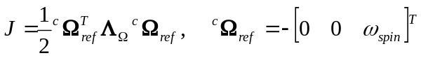 (18)

Figure 6 shows that the performance attained with the predictive algorithm, for attitude stabilisation only, is similar to energy based control proposed by (Wisniewski, 1997). γ, the angle between the local vertical and the boom axis, is reduced from 60º to less then 5º in only 3 orbits. It is interesting to note that the results attained with restricted actuators are similar to unrestricted actuators, and since the computational effort involved is considerably small this algorithm is valid solution for the on board computer resources.

For attitude stabilisation and spin control the algorithm’s libration damping performance is slightly reduced since it is now necessary 4 orbits to reduce γ to 5º and a steady state error of 2º is attained, while maintaining the spin velocity at a reference of 0.02 rad/s.

Figure 7 shows that spin velocity oscillates around the reference while libration is being dampened but the set point is attained again as soon as the perturbation is rejected and the oscillation amplitudes reduced, being smaller than 0.0006 rad/s.

To test the spin control algorithm performance the satellite was spinned-up from 0 to 0.02 rad/s with an initial γ value of 5º. Simulation results show that the predictive algorithm takes less than 19.2 minutes or 12 actuations to set the spin velocity within a neighbourhood of 0.001 rad/s and achieves a final accuracy of less than 0.0005 rad/s.

These are encouraging results since the actuators’ restrictions are quite severe. However, the dissipated energy is superior to energy based control since it is impossible to generate a magnetic moment perpendicular to the geomagnetic field at all actuation instants.

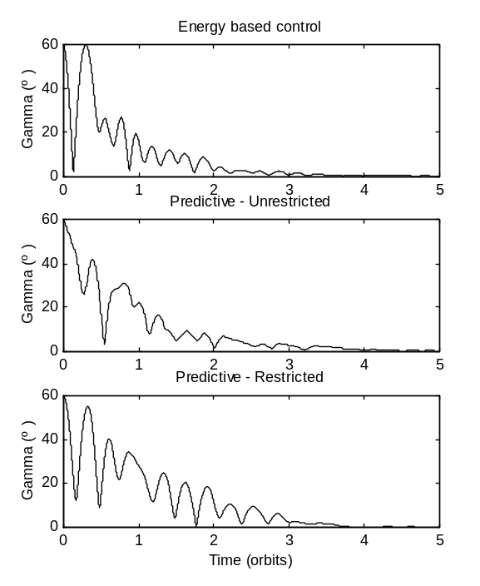
Fig. 6 - γ evolution for energy based control and predictive algorithm. Initial condition γ=60º, 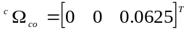.
Desired reference γ=0º, 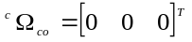.

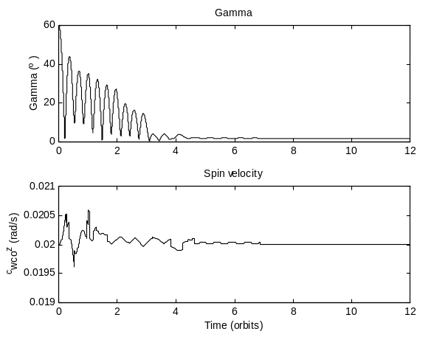
Fig. 7 - γ and spin velocity evolution for the predictive algorithm. Initial condition γ=60º, 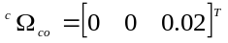.
Desired reference γ=0º .

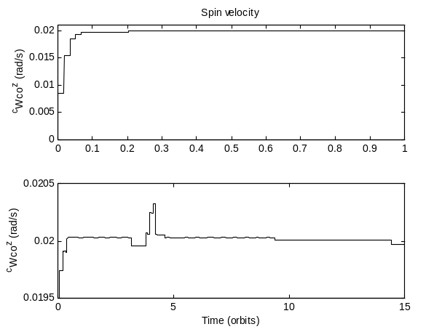
Fig. 8 - Spin velocity evolution for the predictive algorithm. Initial condition γ=5º, .
Desired reference γ=0º, .

- Conclusions and Future Work

This article presented the work carried out to date under the ConSat project, in particular the implementation of an ADCS simulator and the development of an innovative attitude stabilisation and spin control algorithm.

It was shown that this algorithm is asymptotically stable. Simulation results revealed good performance, when compared with the algorithms proposed in the literature. For restricted actuators the low computational demands suggest a possible implementation for the on board available computer resources. The reduced computational needs of the algorithm when used with restricted actuators suggest its use also with unrestricted actuators. Guaranteeing that the available set of control magnetic moments is perpendicular to the geomagnetic field can reduce the power needs, which is a critical factor for small satellites.

At present the attitude determination block of the ADCS loop is being implemented, enabling the further testing of the control algorithms mentioned in section 4 as well as of different or new algorithms. This testing may lead to an improved ADC algorithm for PoSAT-1 and to further attitude control results for micro satellites. The same path used to attain an improved controller for PoSAT-1 can then be followed in the future with other micro and mini satellites.

Preliminary contacts have been made for upgrading the ADC software of PoSAT-1.

Acknowledgements

The ESF COSY Programme supported some of the work presented in this article. The authors would also like to acknowledge the support of INETI and Marconi.

Bibliography

Chobotov, Vladimir A. Spacecraft Attitude Dynamics and Control, ORBIT – A foundation Series.
Goldberg, D. (1989). Genetic Algorithms in search, Optimisation and Machine Learning, Addison-Wesley.
Ong, Wah Thye. (1992). Attitude Determination and Control of Low Earth Orbit Satellites. MSc. Thesis, Dept. of Electronic and Electrical Engineering, University of Surrey.
Steyn, Willem H. (1994). Comparison of Low-Earth-Orbit Satellite Attitude Controllers Submitted to Controllability Constraints. Journal of Guidance, Control, and Dynamics, Vol. 17, No. 4, July-August.
Tabuada, Paulo; Alves, Pedro; Tavares, Pedro; Lima, Pedro. (1998). Attitude Control Strategies for Small Satellites. Institute for Systems and Robotics / IST internal report.
Tavares, Pedro; Sousa, Bruno; Lima, Pedro. (1998). A Simulator of Satellite Attitude Dynamics. Proc. of the 3rd Portuguese Conference on Automatic Control, Vol. II, pp. 459-464, Coimbra, Portugal.
Ward, Jeffrey W., Price, Harold E. (1996). PoSAT-1. In: Wertz, James R., Larson, Wiley J., Reducing Space Mission Cost, Space Technology Library.
Wertz, James R., (1995). Spacecraft Attitude Determination and Control, Kluwer Academic Publishers.
Wisniewski, Rafal (1997), Satellite Attitude Control Using Only Electromagnetic Actuation, Ph.D. Thesis, Dept. of Control Engineering, Aalborg University.

The use of 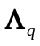instead of the inertia matrix was chosen due to the possibility of defining relative weights for the angular velocities.
Recall that eq. (11) corresponds to the Euler method for solving numerically first order differential equations.

