
SimSat
Small Satellite Attitude Simulator

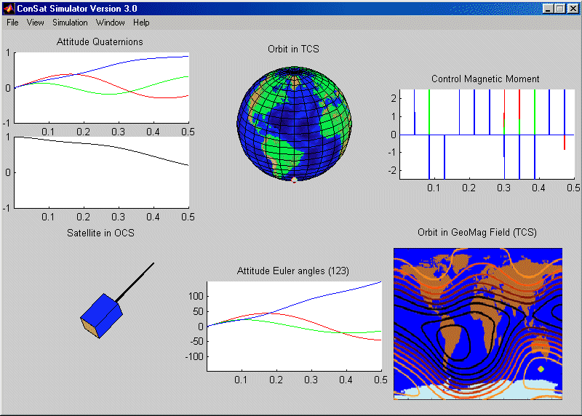

User’s Manual

Pedro Tavares Silva - 1999
Institute for Systems and Robotics

Index

1. Introduction 3
2. Installation 3
3. Interactive simulation 3
4. Simulating a batch of condition 12
5. Making large numbers of simulations 18
6. Result analysis 19
7. Acknowledgements 20

Introduction

The simulator SimSat was developed to help test small satellite attitude controllers and estimators. It may be used in one of three ways:
- As a tool to simulate and view graphically the results;
- to simulate and analyse a batch of simulations
- or to make simultaneous series of batches of simulations.

It was developed to enable the researcher to interact with the data in an intuitive fashion, using a simple graphical interface.

The SimSat simulator was developed to run using Math Works, Inc. Matlab 5.3 release 11 with Simulink 3.0.

Installation

To install the simulator simply copy the files on the disc(s) to a folder on the hard disk. This folder will be referred to in this manual as the “root” of the simulator’s tree.

Interactive simulation

To use the simulator simply run Matlab, change the working directory to the folder you installed SimSat in and type “simsat”.

If you installed SimSat in the folder “smallsat” of your “E” drive then you should type the following in the Matlab prompt:

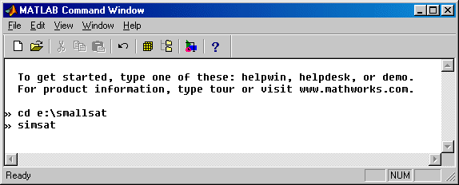

After starting SimSat it will try to determine how you want it to run. It will do so by asking if you want to run in batch mode:

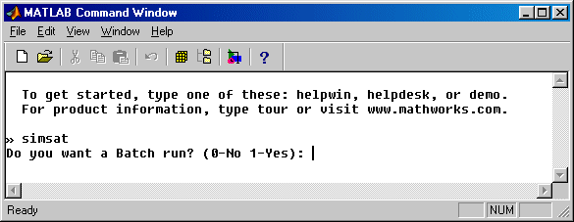

In this section we are going to use SimSat interactively so you should type “0” at the prompt (don’t forget to hit “return”). Now the simulator’s graphical interface will start and your screen will change to:

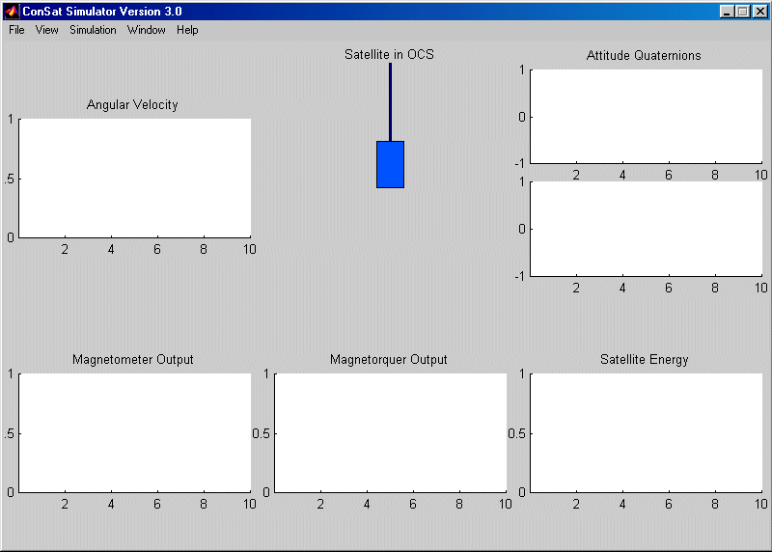

In this window a set of menus are available to let you define your course of action.
To simulate you need to enter the initial conditions and to do so you need to go to open the “Simulation” menu:

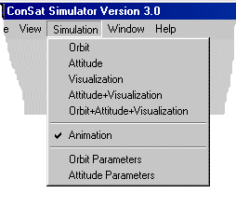
and then select “Orbit Parameters”. The following window will let you define the parameters of the starting point of the orbit for this simulation:

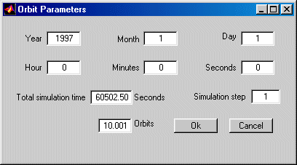

The date parameters are very straightforward. They indicate the first second of the simulation. The “Total simulation time” can either be indicated in seconds or in orbits. Notice that the simulator is calibrated to duplicate the behaviour of the PoSat-1 micro-satellite and, thus, one orbit equals 6050 seconds. The “Simulation step” determines the resolution of the simulation; i.e. the time step between simulator data output instants. After defining all the values necessary in the window you can click on the “OK” button to proceed.

To complete the initial parameters you will need to indicate the initial satellite attitude. To do so you need to open the “Simulation” menu once again and select the “Attitude Parameters” option. A new window will be shown:

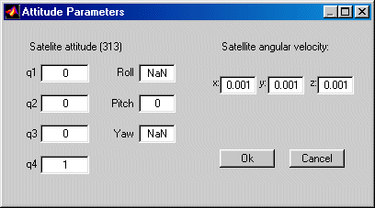

In this window you can either specify the initial attitude by entering a roll, pitch and yaw angle (0 to 360°) or the corresponding quaternion. After entering the desired values please click on “OK”.

You are now ready to start the simulation. To begin select “Simulation” yet again and choose “Orbit+Attitude+Visualisation”. A waitbar will be shown:

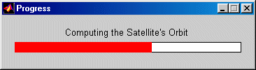

This will indicate the progress in the calculation of the orbit of the satellite. When complete, a new stage will start, corresponding to the calculation of the magnetic field vector along the orbit. This too is accompanied by a waitbar:

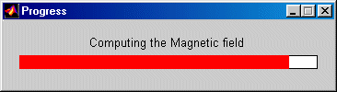

After completion, the determination of the satellite’s attitude will begin. This also generates a waitbar:

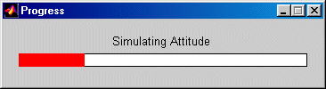

At this stage you need to change back to the Matlab window (using ALT + TAB) because the simulator will want to ask you some questions. First you will be asked to choose an attitude estimator:

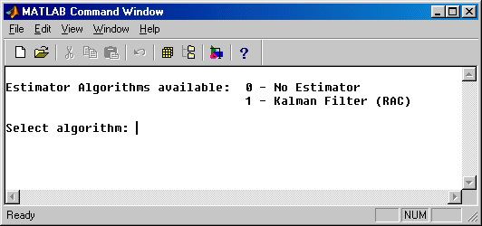

If you choose zero no estimator will be used and perfect attitude knowledge will be employed. Next you will be asked which controller should be used (or to enter “14” if you don’t want a controller) and then you will need to enter the parameters for the controller you chose. For example, if you chose the “Brute Force Controller” (also known as the “Predictive Controller”) your screen should look something like this:

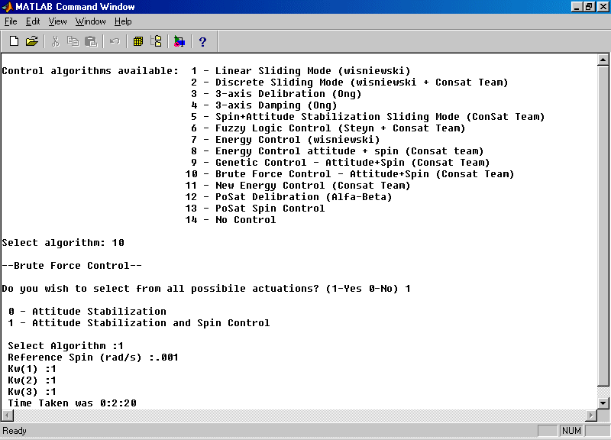

After answering the last question the waitbar will start to increase and when it reaches the end the graphical interface will start to animate the results (don’t forget to change back from the Matlab window to the Interface’s). At this stage the interface will look something like:

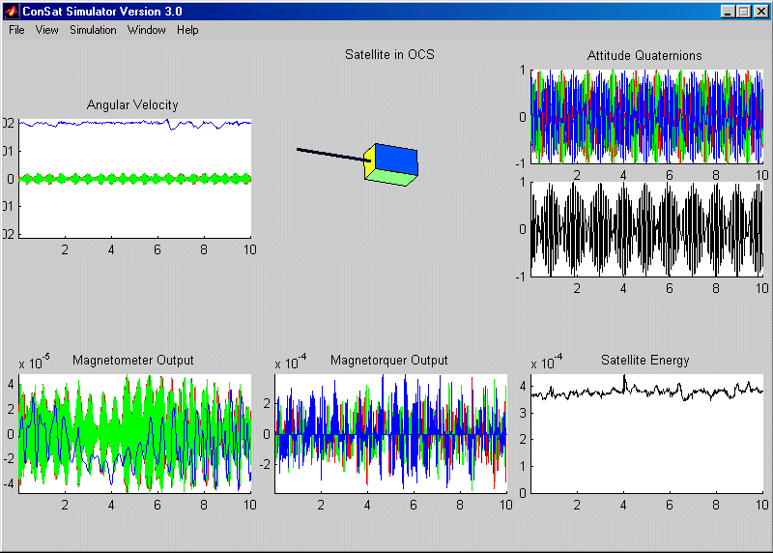

After the animation stops you can open the “Window” menu:

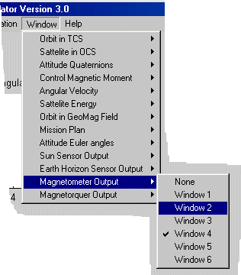

Here you can see all the variables that the interface can display for you and choose where you would like to place them in the window. This works as follows: Window number one is the top left-most graphic in the interface. The numbers then go clock-wise up to window number six, corresponding to the bottom left-most graphic. As the following picture shows, the layout of the interface can change quite dramatically! (Compare this view with the previous picture of the interface)

Each of the six “sub-windows” can be zoomed using the “view” menu:

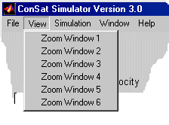

As we have seen, the three main stages of a simulation are:

- Orbit (and geomagnetic field) determination,
- Attitude determination,
- Visualisation.

After running step 1 you can run steps 2 and 3 as many times as you like as long as you don’t change the orbit parameters. The same applies to running step 3 without running again steps 1 and 2. This means that, for example, if you want to compare controllers in the same orbital conditions you run the simulator as described above for the first controller and then instead of choosing once again the option “Orbit+Attitude+Visualisation”, you simply select “Attitude+Visualisation” for the following controllers. After all, in this example you don’t need to repeat the calculations for the exact same orbit.

Along the same lines (speeding up the simulating process) you can disable the animations of the satellite and it’s orbital position. To do this open the “Simulation” menu:

and remove the tick mark on the “Animation” option by selecting it. You can turn it back on the same way.

The key concept at this stage is that every time you simulate something (orbit, geomagnetic field, attitude, etc) the data gets saved in the “simsat\data” folder. It stays there until overwritten so you can count on it until you repeat the calculations for the same type of data.

Simulating a batch of conditions

If you want to make tens, possibly hundreds or even thousands of simulations, the simulating method using the graphical interface described above just isn’t an option. If you need to do a series (or batch) of simulations then you need to be able to let the computer make the changes of parameters and save the resulting data all by itself.

To run a batch of simulations you first need to edit the file “generate_ops.m” on the SimSat folder. This is where you will store all the data needed.

The file “generate_ops.m” simply created an array called “opcoes_sim” that has one line for every simulation desired. The columns of this matrix are labelled in the file so you can identify the type of parameter stored. Notice that every line has the same number of parameters so you still need to enter a value even if you don’t need it (e.g. if you don’t do spin control you still have to enter a spin reference).

How do you start the batch run after inserting the data in “generate_ops.m”?

You just type “simsat” at the Matlab prompt as before, but now you should enter one at the question:

Once you do this you are now in “batch mode”. All the questions from now on will be made to determine which lines of the “opcoes_sim” matrix are to be simulated and where you want the data to be saved.

First you will be asked the duration (in orbits) of a single simulation, then the starting and ending simulation number of the run. This numbers correspond to the first and last lines of the “opcoes_sim” matrix that you want to simulate. After inserting these numbers, you will be asked the number of the folder of the data from the first simulation saved.

Suppose that you want to simulate lines 1 to 10 of “generate_ops”, for 10 orbits each, but you already have done and save (let’s say) 999 simulations. Then you would enter the values indicated in the following picture.

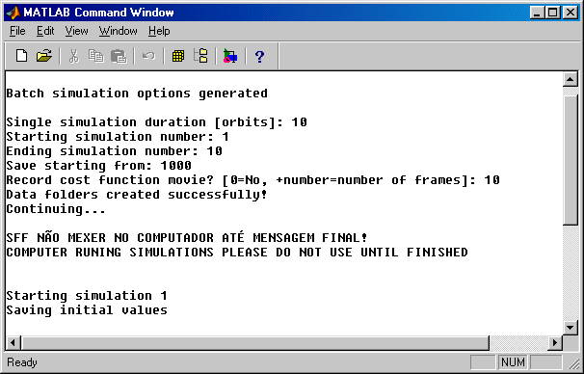

This will create ten folders (one for every simulation) in the “root\sim_results” folder. These folders will be named “sim_data?” where the question mark is the number of the folder.

Notice that the simulator also asks if you want to record a cost function movie. This will create a sequence of frames created by the graphical plot of the values of the cost function of the “Brute Force” controller. If you don’t need to see these plots simply answer zero (for no).

Sometimes you will want to overwrite some data that you simulated earlier. In this case simply enter a saving range (from “save starting from” to “save starting from” + “Ending simulation number” – “Starting simulation number”) that overlaps any previously created data and the simulator will check if you are not going to destroy the earlier data by mistake.

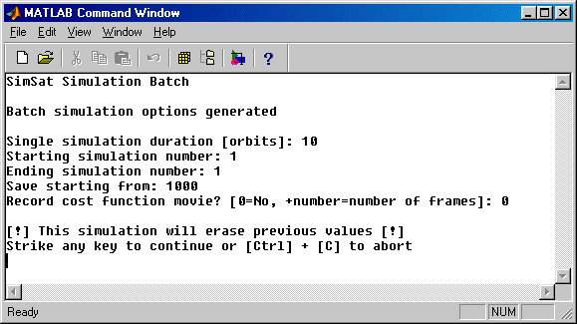

Until now, if you have been trying to make a batch simulation then have been presented the following error message:

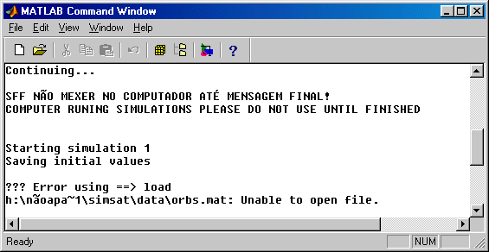

This is due to the orbit database being unavailable.

The orbit database works as follows: you can store orbits that are frequently used in a database folder called “root\simsat\data\orbits” that is indicated in line 248 of the “batch.m” file. This line describes the path “root\simsat” and can be any path reachable by your computer. When you run a batch, the simulator looks for the desired orbit description in the data file “orbs.mat”. If you want to simulate ten orbits starting (say) January the 1st 2000, 0h 0m 0s, the simulator looks for that description in the “orbs.mat” file variable “orbs”. If it finds this orbit in line X (that is, the values (2000 1 1 0 0 0 10) it will copy the data on folder “data\orbits\orbX” to the “data” folder instead of simulating the ten orbits. This saves a lot of time when you want to simulate the same orbits with different controllers/estimators.

After changing line 248 of the “batch.m” file to point to your “root\simsat” you can proceed with your batch simulations. The screen will then look like this:

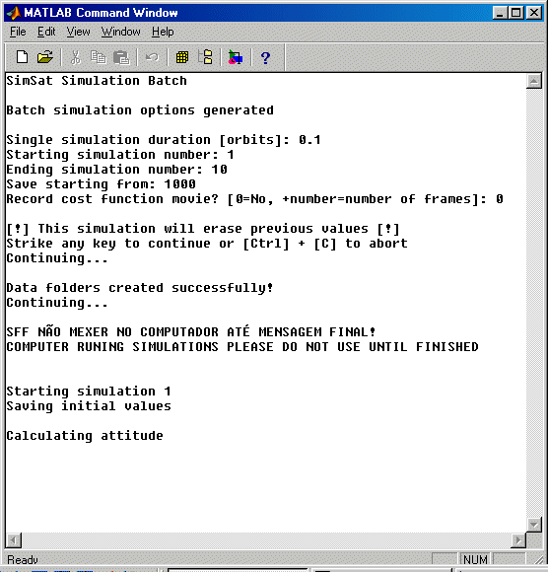

After a while (and a few waitbars) the first simulation will be completed the simulator will proceed with the next. Your attention will only be required after the batch is done. You may go home and come back tomorrow ;-)

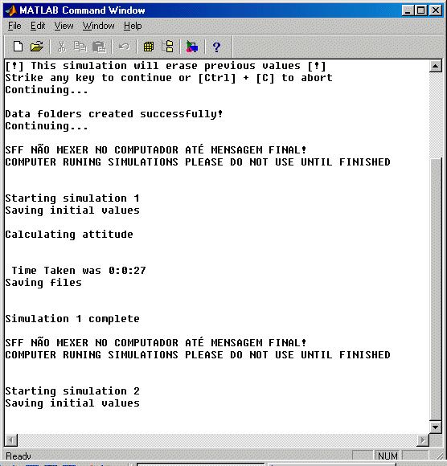

At the end of each simulation the time elapsed is shown to help you determine how long the batch will take and a new warning will be printed to prevent the message from being scrolled out of sight, leaving your computer apparently available to others. In the end the simulator will let you know it finished:

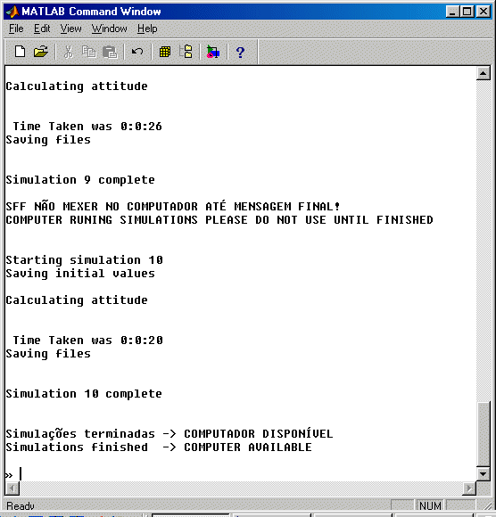

Making large numbers of simulations

When you need to make use of the computing power of various machines you can simply copy the folders to each new computer and start a batch run there by running a local copy of Matlab. Don’t use the folders on a single machine with Matlab of various machines. Make a copy of the simulator for every instance of Matlab. Also notice that the orbit database only needs to be present in one computer, as long as this machine is accessible by all others.

Results analysis

To analyse the results of a batch you must type “results” at the Matlab prompt. The result analysis program will then ask you some questions to determine the range of the batch of simulations and if you want plots of the data of every single simulation. It will also ask if you want it to create a table with statistical analysis for you.

During result analysis the screen will look like this:

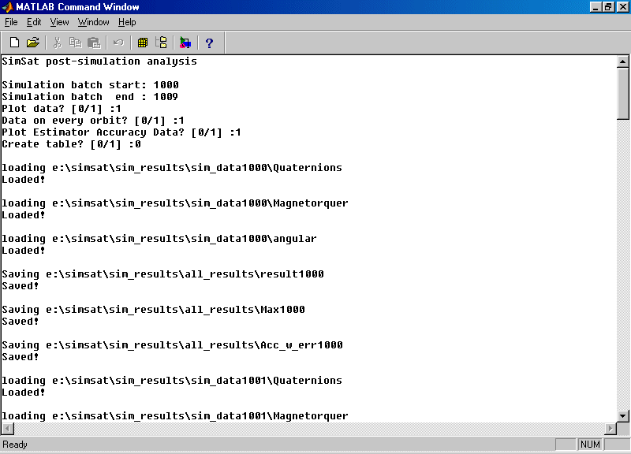

If you choose to plot the data you will see one of these plots for every simulation in the batch:

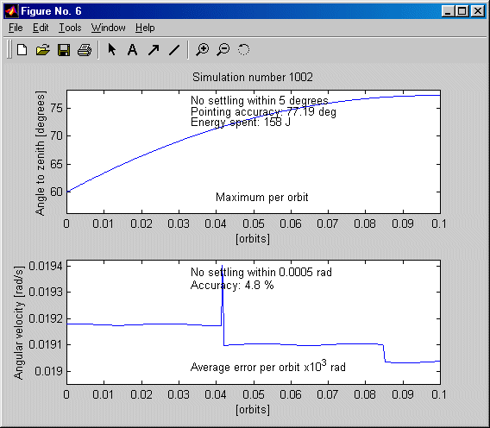

The results table, if required, will look as follows:

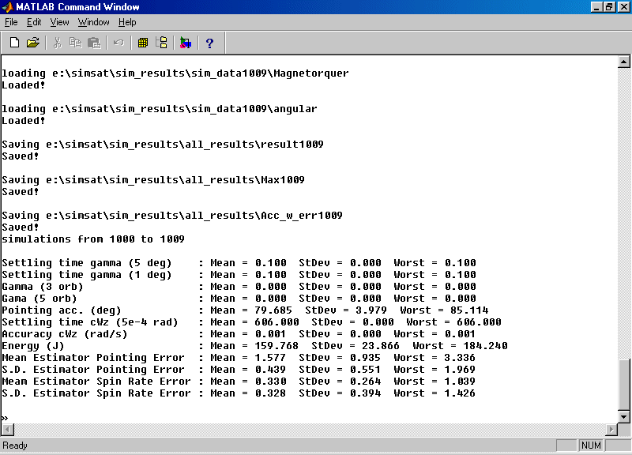

Acknowledgements

This simulator was developed with the support of PRAXIS XXI program project PRAXIS/3/3.1/CTAE/1942/95.

