The CATSAT Attitude Control System

Chris Whitford
Space Research Centre, Department of Physics and Astronomy, University of Leicester, University Road, Leicester LE1 7RH UK
Tel: +44 (116) 252 3496
email: chw@star.le.ac.uk

David Forrest
Laboratory for Advanced Small Satellites, Morse Hall, University of New Hampshire, Durham, NH 03824-03525
Tel: (603) 862 3705
email:dave.forrest@unh.edu

Abstract. CATSAT is a small 3-axis stabilised satellite in the STEDI program, to be launched in 1999. This paper describes the development of the attitude control system, with emphasis on the control laws. The 2 primary modes are the safe-hold and science modes. The safe-hold mode uses a momentum wheel, magnetometers and torque coils, with the “B-dot” algorithm. The science mode also uses momentum bias and torque coils, with Sun sensors and horizon sensors, to maintain 3-axis control. The use of reaction wheel control is also being studied. The expected performance is demonstrated by simulations.

.

Introduction
CATSAT (Co-operative Astrophysical and Technology Satellite) is the third satellite in the STEDI (Student Explorer Demonstration Initiative) programme¹. It is a 140 kg, 3-axis stabilised spacecraft which will be launched into a Sun-synchronous orbit between 550 and 650 km. Its primary mission is to study the X- and gamma-ray spectra of gamma-ray bursts. This is at the forefront of astrophysical research, and places stringent demands on the spacecraft systems. Secondary objectives are to develop and test on-orbit novel low-cost subsystem designs. The majority of the design and construction is being done by students at the collaborating universities.
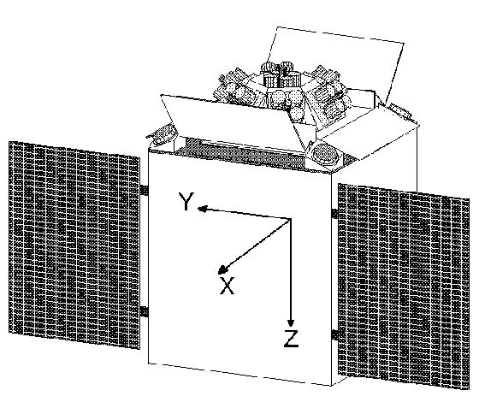
Figure 1. General view of CATSAT showing coordinate axes.
The main instrument on the satellite is a wide-field cooled X-ray detector, which must be shielded from both the Sun and the Earth at all times. The solar arrays are on the X face, which must therefore be aligned to the Sun (Figure 1). To achieve this the satellite is placed in a Sun-synchronous terminator orbit, with the X axis pointed towards the Sun and the -Z axis, which is the viewing direction of the X-ray detector, pointed away from the Earth.
These requirements are met with a momentum bias control system, having a momentum wheel aligned with the X axis, and the roll controlled by varying the speed of the wheel. The momentum is controlled with magtorquing coils. As the Solar panels must face the Sun to maintain power, the satellite is not unconditionally safe; it relies on an active attitude control system. A safe-hold mode is implemented with the B-dot algorithm^{2,3,4}, to maintain the solar panels towards the Sun. This mode is entered at separation and whenever an anomaly is detected during operations. A major emphasis in the design has been simplicity and robustness, to give a high confidence of success.
A three-axis control system in small, low-cost satellite such as this is ambitious, particularly as neither of the authors have developed an attitude control system before. Useful advice has been received from a number of people, who are acknowledged at the end of the paper. We are confident that, with the advantage of this support, and modern development tools, it will be a success.
This paper describes the AD&C hardware and analyses the spacecraft dynamics. The performance of the safe-hold mode and the science mode are demonstrated with simulations, using Simulink/Matlab⁵. Table 1 gives a summary of the main spacecraft characteristics.
Table 1. Catsat characteristics
Altitude: 550 km
Inclination: 97.5°
Ascending node: 6 pm local time
Dimensions: box: X, Y: 70 cm
Z: 100 cm
solar panels: 70 × 75 cm
Mass: 134 kg
Inertia matrix: 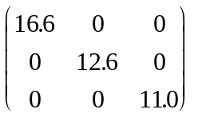kg.m²

Requirements

Science mode
In the operational phase of the mission, the two requirements on the attitude control system are to keep the X-axis in the direction of the Sun to within 5°, and to keep the Z axis in the Sun-Earth-satellite plane to within 5°. The primary scientific instrument is a soft X-ray spectrometer (SXR), which is passively cooled by radiation to -40° C. During launch and the initial period on orbit the SXR is protected by closed doors; once the satellite has been checked out, the operational attitude achieved, and sufficient time has elapsed for it to outgas, the doors will be opened. The door in the +X direction acts as a Sun-shield, which shadows the SXR for Sun angles of up to 5° from the X axis. If the Sun should shine directly on to the SXR it would not maintain its -40° C temperature and the light would also contaminate the data.
This defines two axes; the requirement in the roll axis is to keep the Earth out of the field-of-view of the SXR, and to minimise the view factor from the Earth to the SXR. The field-of-view of the SXR is almost a hemisphere; as the Earth’s limb is 20° below the local horizontal at an altitude of 600 km, an attitude error in roll of ±20° is acceptable without the Earth encroaching into the field-of-view. But as the view factor to the Earth increases, the additional heat input prevents the temperature being maintained. This is a “soft” requirement, and the thermal design has been done using a figure of ±5°, as this is easily achievable by the AD&C.
If the Sun vector were on the orbit normal, the spacecraft Z axis could always be directed towards the nadir; as the Sun can be up to 43° from the orbit normal (for a 20° drift of the orbit away from the terminator) the Earth will at times be visible to the SXR in either the +X or –X direction. This is unavoidable, and results in a loss in observing time.
The scientific attitude determination requirement is ±1° in each axis.

Safe-hold mode
When not operational the only requirement on the attitude is to keep the solar panels within about 45° of the Sun to maintain solar power. This is implemented in the safe-hold mode, which is entered at initial orbit injection, when the on-board computer is reset, or when any anomaly is detected in the science mode.

Attitude control concepts
The two most common methods for attitude control of small satellites are spin stabilisation and gravity gradient. Both of the other STEDI missions are spin stabilised (SNOE⁶ and TERRIERS⁷). This provides inertial pointing of one axis, and as the angular momentum of the whole satellite is large, the stability is good and manoeuvring the satellite by magtorquing open-loop from the ground control is possible. If Earth pointing is required, gravity gradient stabilisation is an option. This has been used on a number of microsats (for example, Oscar14/Uosat-3⁸). Gravity gradient by itself gives only very approximate attitude control and needs to be supplemented by momentum wheels or magtorquers. When other methods of control are used, the gravity gradient torque is considered an unwanted disturbance.
Neither of these passive techniques meet the requirements, as Catsat needs to be 3-axis stabilised, which eliminates a spinning satellite, and it is not nadir pointing, which prevents the use of gravity gradient. The initial design study chose a zero-momentum system with four reaction wheels for control. As a result of advice received from several external reviewers, it was decided that a biased momentum system would be safer. Although only one wheel is required, the original four reaction wheels have been retained in the design so that a zero-momentum control system can be implemented by a software upload later in the mission.
The momentum bias control uses angular momentum, like a spinning satellite, but the momentum is provide internally by a wheel, so the satellite body is stationary. The orientation about the wheel axis is controlled by torquing the wheel. Moving the angular momentum vector inertially requires external torques, which can be provided by magtorquing or by thrusters. Catsat uses magtorquing.

Attitude control hardware

Axis definitions
Figure 1 gives an outline of the satellite geometry. The solar arrays are on two panels which deploy in orbit, positioning the arrays in the +X direction. The Z axis is “down” in the figure, towards the Earth, and the Y axis is along the velocity vector. The SXR is at the top of the figure. Rotations about the X, Y and Z axes are referred to as roll, pitch and yaw respectively, and designated by φ, θ and ψ.

Sensors
Magnetometers: Two 3-axis magnetometers (TAM’s) are provided, a commercial flux-gate magnetometer, and an in-house design using magneto-resistive sensors. The flux-gate magnetometer is the default at power on.
Sun sensors: There are in-house coarse Sun sensors on the +X and –X faces, and two fine Sun sensors on the +X face—one commercial and one built in-house. The field-of-view of the coarse Sun sensors is nearly a hemisphere, with a 1° resolution but with limited accuracy. In the terminator orbit, the Sun is always close to the horizon and the Earth albedo has a significant effect on an analogue Sun sensor⁹, which limits its accuracy to about 10°. The fine sensors are digital, to avoid the bias from the albedo, with a resolution of 0.5° over a ±30° field-of-view. The wide field-of-view is needed to ensure that when the satellite is oriented with the coarse sensors, the Sun is in the field-of-view of the fine sensors.
Horizon sensors: There are two commercial, one-dimensional, infra-red horizon sensors which are aligned in the Y-Z plane. These are analogue sensors with an accuracy of 1° over a 22° field-of-view, and are positioned so that, when the satellite is in science mode, they view the opposite limbs of the Earth. They are only used in science mode.

Actuators
Reaction wheels: Four reactions wheels are arranged in a modified tetrahedron. As the intended normal operation is with a momentum bias along the X axis, the 4 wheels are symmetrically arranged at an angle of 30° to the X-axis (a true tetrahedron would be 55°); two forming a “vee” in the X-Y plane and the other two forming a “vee” in the X-Z plane. This provides more momentum along the X axis and less in the other axes, which still allows the wheels to be used for control, as well as providing the momentum bias. Each wheel can develop about 0.6 N.m.s. With momentum bias either one of the two “vee’s” is required. In a zero momentum mode any 3 wheels out of 4 are needed.
Torque coils: Magtorquing is provided by flat coils on the side panels of the satellite body on the X and Y faces, each capable of generating 20 A.m². Each coil is split into two windings to provide redundancy. The magnetic moment is proportionally controlled by duty-cycle modulation of the current. The structural design makes a Z-axis coil difficult to accommodate. The performance with two and three coils has been compared by simulation, with the conclusion that the Z coil is not needed.

Controller
The AD&C control is done in the spacecraft computer, which uses an 80C186 processor. The safe-hold mode is implemented in ROM, which is executed when the processor is reset or rebooted. Other modes are in RAM which is uplinked once the satellite is on orbit. The fundamental sample time for the control algorithms is 5 sec.

Disturbance torques
The disturbance torques in Table 2 have been estimated using the data from Larson and Wertz¹⁰ (page 353). An offset of 10 cm between the CG and centre of force was assumed.
Table 2. Estimated disturbance torques
Gravity gradient | 8.7.10⁻⁶ N.m
Solar pressure | 1.0.10⁻⁶ N.m
Magnetic moment | 1.3.10⁻⁶ N.m
Aerodynamic drag | 3.2.10⁻⁶ N.m
Some part of these disturbance torques will be cyclic, while part will be cumulative. The gravity gradient torque depends only on the satellite moments of inertia, which can be measured or calculated with some accuracy; the others cannot be predicted very accurately, particularly in a low Earth orbit, where both the atmospheric density and the magnetic field are high. A figure of 3.10⁻⁵ N.m has been used for sizing the control system.

Attitude determination
When the satellite is maintaining the correct attitude in science mode, the Sun sensors and horizon sensors, together with the time and orbital elements, provide the attitude to better than 1°, while in sunlight. During eclipse (up to 26 minutes at end of life) the horizon sensors still give the roll error but there is no sensing or control in pitch or yaw.

Attitude control laws

Safe-hold mode
The safe-hold mode uses the B-dot^{2,3,4} algorithm which has been used on many satellites. Two of the reaction wheels are used to generate angular momentum in the +X direction. The basic algorithm is to sense the magnetic field with a TAM, and generate a magnetic moment in the torque coils proportional to the negative of the rate of change of the field.
Mathematically, if B is the field, measured in spacecraft body coordinates,
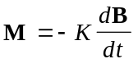 (1)
where K is a positive number. If the satellite is spinning, B has a constant amplitude but changing direction (in the body frame of reference), dB/dt is orthogonal to B, and the torque, M × B is opposed to the angular velocity vector, acting to decrease it. If instead, the direction of B is constant but the magnitude is varying, dB/dt is parallel to B, and there is no torque (M × B = 0).
In the absence of momentum bias, the spacecraft has no preferred axis or orientation, and the B-dot algorithm only stops it from spinning or tumbling. With momentum bias in the +X direction, the B-dot algorithm still despins the satellite, but as it orbits the Earth, its angular momentum prevents it from following the field, and the only stable state in which dB/dt is zero is when the momentum vector H is in the same direction as the orbital rotation vector ω₀. With an equatorial orbit this effect is relatively weak, but in the 98° terminator orbit, the field is predominantly in the plane of the orbit, and rotates twice per orbit. The satellite becomes oriented with the X axis along the orbit normal and rotating twice per orbit, following the field. The orbit normal is never more than 43° from the Sun, assuring a positive power orientation.
Simulations have been performed with a variety of initial orbit positions, orientations and spin rates. A typical scenario for a Pegasus launch is with the satellite –Z axis in the direction of the velocity vector, and a spin of 1 rpm about the Z axis. The results of one simulation run are shown in Figures 2, 3 and 4.
The gain, K, needs to be large enough to be effective, but if it is too large, the TAM noise will drive the torque coils into saturation. It has been found that the minimum acceptable value is 3×10⁷ A.m².s.T⁻¹ and 10⁸ provides a satisfactory margin. Initially, while the satellite body rates are high, the torque coils are saturated for most of the time. Several different strategies were tried for managing the saturation. The simplest is to limit the value independently in each axis. The second strategy was to limit the largest component, and scale the other two so that the direction of the resultant vector remains the same. The third was to scale the three components to limit the total power in the torque coils. The second method reoriented the satellite in the minimum time, and is now the baseline design. The end of the despin phase is defined as the time when the coils are no longer being saturated. As can be seen from the figures, this typically takes 3500 sec. with 20 A.m² coils.
At the end of the despin phase the X axis slowly moves on to the orbit normal and the satellite spins at 2 revolutions per orbit around the X-axis, typically reaching a positive power condition by 8000 sec. (less than 1.5 orbits). However, the orientation at the end of the despin phase varies, depending on the initial conditions, and the situation can arise where the X axis is along the negative orbit normal, which is a position of unstable equilibrium. Because the magnetic field is irregular, the satellite does eventually recover, but can take over 2.5 orbits to do so. The addition of a coarse Sun sensor on the –X face can detect this situation and provide an additional control signal to “push” the satellite away. Although in principle this sensor also has a null exactly on axis, the sensitivity is so much higher than the magnetometer that the small movements produced by the magnetic field soon disturb the attitude enough for the Sun sensor signal to take effect.
After initial acquisition, the satellite should never get into a negative power situation without the on-board safety measures switching it into safe-hold mode.

Science mode
The science mode uses the fine Sun sensor to control the Y and Z axes, and the horizon sensors to control the X axis. As presently implemented, the control uses traditional linear control theory, with a proportional-differential controller. For simplicity an integral term is not used, and the required performance can be achieved without it. For small deviations from the required attitude the dynamic equations can be linearised (see, for example, Sidi¹¹, chapter 8). The wheel momentum on the X axis couples the Y and Z axis dynamics, which form a fourth order system, while the X axis is a simple second-order system, independent of the other two.
Two control algorithms have been designed, one using the reaction wheels for control and the other using the wheel momentum on the X axis and magtorquing for the Y and Z axes. The reaction wheel design will be considered first.

Reaction wheel control
The momentum bias was fixed at 0.6 N.m.s. The closed-loop control system was analysed first with linear control theory using the Control System Toolbox³, and the control gains adjusted iteratively to get a satisfactory performance. The values chosen are
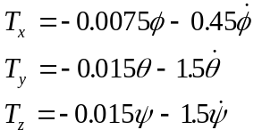 (2)
where the angles are in radians, and the torques in N.m. The frequency characteristics are:
X: ω = 0.021 rad/s, ζ = 0.64,
Y,Z: ω₁ = 0.01 rad/s, ζ₁ = 0.91,
ω₂ = 0.13rad/s, ζ₂ = 0.91.
Both poles in Y-Z are overdamped, but this gives better performance in the simulations—in terms of the time to reach the required error—than when they are critically damped. This is possibly because, even with small angles, neglecting the cross-product terms between the axes is not valid.
The reaction wheels are not physically aligned with the satellite axes. If only three wheels are in use there is a unique mapping from the control axes to the wheel axes. If all four wheels are used, an extra degree of freedom is available, and another constraint is required, such as minimising the sum of the squares of the wheel speeds. This is discussed in, for example, Sidi¹¹ section 7.3. As there is no integral term in the controller, the disturbance torques produce a static error. This is largest on the X axis, where the worst-case torque gives 0.25° error. More significant is that disturbance torques will build up momentum in the Y and Z axes. As the satellite rotates around the orbit this momentum has to be transferred between the wheels, which requires an attitude error to generate the torques. For an angular momentum vector 10° off the X axis, this produces a maximum error of 0.9°. This is a consequence of the fact that the reaction wheels do not change the total system momentum; they just move it between the satellite body and the wheels. An external torque can only be produced with the magtorquer coils, which leads into the issue of momentum management.

Magtorquing control
Here, the reaction wheels will only be used to provide the momentum bias on the X axis, and to control the error about X, using the same control law as for the previous case. The other two axes will be controlled by magtorquing. In this case the torque can only be generated normal to the magnetic vector B. Only the X coil is used for control, so no torques are generated about X, which avoids an interaction between the two control loops. Writing the component of B normal to X as B_{XY}, the control law was determined for a torque on the Y axis, with B_{XY} on the Z axis, then in the control algorithm, a coordinate transformation is made to convert the θ and ψ errors to a term parallel to B_{XY} and a term orthogonal to B_{XY}. It was found that the control law
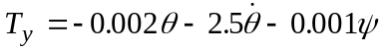 (3)
which uses the errors in both axes, gave a better performance than using the θ error alone. The closed loop response has real poles at
0.0009 and 0.019 rad/s
and a complex pair at
ω = 0.009 rad/s, ζ = 0.8.
The gains are much lower than for reaction wheel control because the torque available from the coils is more limited, but it still gives a static error of less than 1° for the worst case disturbance torque. As before, an overdamped system seems to perform better than one critically damped.

Momentum management
The buildup of momentum in the reaction wheels has to be removed by magtorquing. The torque produced by a field, B, is
T = M × B, (4)
where M is the magnetic moment. A torque cannot be produced in an arbitrary direction, as no torque can be produced in the direction of B. Using the reaction wheels for 3-axis control, this would be done continuously, whenever the direction of the magnetic field makes it possible to reduce the error between the actual wheel momentum and that required.. The control is more complicated when the wheels are only used to provide the momentum bias. Attempting to adjust the wheel momentum will generate an unwanted torque in the other axes which, in this case, cannot be balanced by a transverse wheel. The momentum control becomes coupled to the attitude control, and the two have to be analysed as a single control loop.
Allowing a momentum buildup of 0.1 N.m.s, and the worst-case disturbance torque of 3.10⁻⁵ N.m.s operating continuously in a constant direction, the limit will be reached in
0.1 / 3.10⁻⁵ ≈ 3000 sec.
which is half an orbit. It should never be necessary to wait for more than a quarter of an orbit (1500 sec.) for the field to be in a suitable direction, but this demonstrates that the momentum control must operate continuously and autonomously. This part of the control system has not been designed in detail yet.

Trade-off
In comparing the two methods of control, magtorquing appears to be simpler to implement, and places fewer requirements on the reaction wheels (only two are needed), but is more limited in the maximum disturbance torque which it can handle. Although final decisions have not been made, it is likely that the magtorquing code will be tried first, and reaction wheel control will only be used if the former is not satisfactory.

Eclipse operation
If the orbit is on the terminator there will be one eclipse season each year with a maximum eclipse period of 21 minutes; as the orbit normal drifts, the length of eclipses increases, to a maximum of 26 min at 20° from the terminator. The horizon sensors will continue to operate during the eclipse, but there will be no Sun sensor signals and there are no rate sensors, so the satellite will just “coast” through the eclipse. With a maximum disturbance torque of 3.10⁻⁵ N.m and a wheel momentum of 0.6 N.m.s, the drift in 26 minutes will be
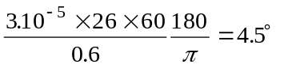
which is just inside the required specification. This is for a pessimistic estimate of the disturbance torques and end of life. If all four reaction wheels are still operational the angular momentum can be doubled, which halves the drift. The attitude determination requirement of 1° is more problematical, and may have to be done by modelling the torques and interpolating through the eclipse. It is anticipated that the magnetometer data will not achieve 1° accuracy, although correlating the data with the other sensors on orbit may make this possible.

Sun acquisition mode
In safe-hold mode, the orbit normal can be up to 43° from the Sun, which is outside of the field-of-view of the fine Sun sensors. Additionally the horizon sensors need to identify the horizon. The Sun acquisition mode is a transitional mode using the coarse Sun sensor to bring the X axis closer to the Sun. The control loop for the Y and Z axes is the same as for the science mode, but using the coarse Sun sensor signals instead of the fine Sun sensor and using the magtorquing algorithm. Once the Sun is in the field-of-view of the fine Sun sensors control is switched over to them.
As the satellite is rotating at twice the orbital rate in safe-hold mode, it is only necessary to wait for the Earth to come into the field-of-view of the horizon sensors. At this rate the control loop can lock on to the horizon first time, without losing it again.
The Sun acquisition and horizon acquisition will be sequential, and either order seems to work. Figures 5, 6 and 7 show the results of simulating this. The Sun control loop is enabled at 8,000 sec. and the X axis is aligned to the Sun by 10,000 sec. The initial oscillatory behaviour is because there is no damping while the torque coil is saturated. The transient at 10,000 sec. is where the Earth sensor control loop is enabled. In this simulation the roll control is linear; it doesn’t use the search strategy described in the previous paragraph, which will give a much smaller transient.

Mode switching
The general principle is that on-board safety checks can cause a transition down from science mode to safe-hold mode, but that transitions up are only done by ground command.

Simulations
The attitude control system is being modelled on a PC using Simulink⁵ and Matlab⁵.

Coordinate systems and representation
Two coordinate systems are used. The fundamental one is “Earth Centred Inertial” (ECI). This is centred on the Earth, with the X axis towards the vernal equinox and the Z axis towards the north pole. It is used for calculating the orbit, the rotation of the Earth (needed for the magnetic field) and the position of the Sun. The other coordinate system is that of the satellite, which moves with it. These will be referred to with the subscripts I and B respectively.
The most convenient representation of positions and directions for computation is in Cartesian coordinates, (X, Y, Z). If
R_{I} = (X_{I}, Y_{I}, Z_{I}) (5)
is the Cartesian representation of a vector in inertial coordinates, and
R_{B} = (X_{B}, Y_{B}, Z_{B}) (6)
is the representation of the same vector in body coordinates, the conversion between them is
R_{B} = A R_{I} (7)
where A is the 3×3 rotation matrix, which can be used to represent the satellite attitude. The translation of the origin is generally not significant for attitude control. It is more convenient to express the attitude with a quaternion, which is an alternative method of defining the rotation, but has only 4 components instead of 9. For a full discussion of the mathematics of coordinate transformations and quaternions, see Wertz¹², appendix E.
In the simulation model, directions are expressed as vectors, and orientations (such as the satellite attitude) as quaternions.

Structure of the model
Figure 8 shows the top-level block diagram of the model, which has four sub-systems.

World
This block models the orbit, the position of the Sun and the Earth’s magnetic field. The code for these was provided by APL¹³. They are all calculated in ECI coordinates and converted, using the attitude quaternion, to satellite body coordinates. It is this coordinate rotation which closes the feedback loop in the model.

Disturbance torques
This block is at present empty. It will, as the name suggests, model the external disturbance torques.

Spacecraft dynamics
The spacecraft dynamics block is shown in Figure 9. This block will be described in more detail, as an example, and because it is generally applicable to any satellite. It performs the integration of the Euler equations to compute the instantaneous angular velocity, and then integrates the attitude quaternion to give the attitude. In a moving coordinate system, Newton’s laws of motion take the form of Euler’s equations. For a rigid spacecraft these are, in vector notation (see Wertz¹² or Sidi¹¹ for a more complete exposition)
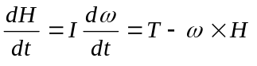 (8)
where H is the angular momentum, ω is the angular velocity, T is the torque and I is the moment of inertia tensor (or matrix). All the vectors are measured in the (moving) body coordinates. When the satellite contains reaction or momentum wheels, the momentum H is
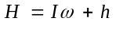 (9)
where h is the angular momentum of the wheels, relative to the satellite, and I is moment of inertia of the satellite, with the wheels stationary. Putting this into equation (8),
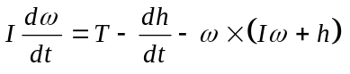 (10)
or
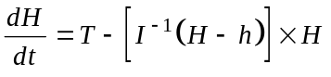. (11)
The latter equation is used in this model. Formulae for quaternion integration are also given in the references^{11,12}. The actual numerical integrations are built into Simulink. The fixed step ode4 solver is used with a 1 sec. step size.

ADC system
This block contains models of all of the attitude control hardware: the sensors, actuators and control laws. The reaction wheels, being a part of the dynamics, could have been in the dynamics block; either choice has merits.

Verification of the model
As the simulation model is developed, one increasingly relies on it being right, so it is very important to continually check it.
- The dynamics block was thoroughly tested by putting in test cases which can be solved analytically.
- As each new block was added it was tested by itself with synthetic inputs to verify its correctness.
- In inertial coordinates, with no external torques applied, the total angular momentum should stay constant. When torques are applied, the change of angular momentum is equal to the integral, over time, of the torques.
- The work done on the system is the integral of the external torque times the angle, or equivalently, the time integral of the dot-product of the torque and the angular velocity. This should equal the change of kinetic energy in the body plus wheels, as there is no change of potential energy in the system. This is true in either the body or inertial coordinates.
- When testing the actuators and control laws, the first few steps have been cross-checked “by hand” to make sure that applied torques are as expected.

Future work
- Improving the hardware model, including products of inertia and misalignments of the sensor and actuator axes.
- Modelling of the sensors and actuators, including noise and quantisation.
- Modelling disturbance torques.
- Modelling the momentum management control.
- Modelling the dynamics of the solar panel flexure.
- Monte Carlo simulations of the safe-hold mode, to confirm that there are no weaknesses in the design.

Conclusions
As is inevitable with a short programme, hardware choices had to be made before detailed design. Much of the emphasis in the design so far has been to verify that the right choices have been made and that the hardware system will meet the requirements. The control algorithms, in software, can still be changed. Indeed, only the safe-hold mode is in ROM; the rest is uplinked, and can be changed even after launch.
From a study of previous missions one learns that it is very easy to get the attitude control system wrong. As previously described, Catsat has solar panels on only one face, and if the safe-hold mode does not work correctly after separation from the launch vehicle, the satellite could be dead before the first ground pass. Because of the importance of the safe-hold mode, this is being simulated very thoroughly, to uncover any weaknesses.
It is evident that, as a result of changing to a momentum biased mode, the chosen reaction wheels are marginal for holding the attitude through eclipse. A single large wheel, with around 5 N.m.s, would also have given the satellite sufficient stability to be safe for at least 24 hours without any active control, without reliance on the safe-hold mode. The authors are confident, however, from the work done so far, that the AD&C system will meet its mission goals.

Acknowledgements
Larry Sholz (Lockheed Martin Missiles and Space), Gerry Murphy (Design_Net Engineering Group LLC), Wade Radford (APL/JHU), Henry Hoffman (GSFC, retired) and Shabbir Parvez (Space Products and Applications) have given valuable advice as external reviewers for the Catsat programme.
The authors particularly acknowledge the help given by Jack Hunt (Applied Physics Laboratory, John Hopkins University) in setting up the Simulink model and providing some of the code.

References
1. Forrest, D. J., et. al., The CATSAT Student Explorer Mission. Presented at the 10th Annual AIAA/USU Conference on Small Satellites, 1996.
2. Zimbelman, D., et. al., The Attitude Control System Design for the Transition Region and Coronal Explorer Mission, Proceedings of the 9th Annual AIAA/USU Conference on Small Satellites, 1995.
3. Konigsmann, H. J., et. al., The Magnetic Attitude Control of ABRIXAS, Proceedings of the 9th Annual AIAA/USU Conference on Small Satellites, 1995.
4. Jung, J., et. al., The Design of the OPAL Attitude Control System, Proceedings of the 10th Annual AIAA/USU Conference on Small Satellites, 1996.
5. The MathWorks Inc., 24 Prime Park Way, Natick, MA 01760-1500.
6. Solomon, S. C., et. al., The Student Nitric Oxide Explorer, Proceedings of the 9th Annual AIAA/USU Conference on Small Satellites, 1995.
7. Chakrabarti, S., Cotton, D., Cook, T., Vickers, J., “Space Weather and the TERRIERS Mission,'' EOS Trans. AGU, 76 (1995), 434.
8. Davidoff, M, The Satellite Experimenter’s Handbook, 2nd ed. The American Radio Relay League, 1990.
9. Benton, J., Pyramid Coarse Sun Sensing for NASA SSTI “Clark” Safe-Hold Mode, Proceedings of the 10th Annual AIAA/USU Conference on Small Satellites, 1996.
10. Larson, W. J. and Wertz, J. R., eds.,Space Mission Analysis and Design, 2nd ed., Kluwer Academic Publishers, Dordrecht, Holland, 1992.
11. Sidi, M. J., Spacecraft Dynamics and Control, Cambridge University Press, Cambridge, UK, 1997.
12. Wertz, J. R. ed., Spacecraft Attitude Determination and Control, Kluwer Academic Publishers, Dordrecht, Holland, 1978.
13. Jack Hunt, APL/JHU, private communication.

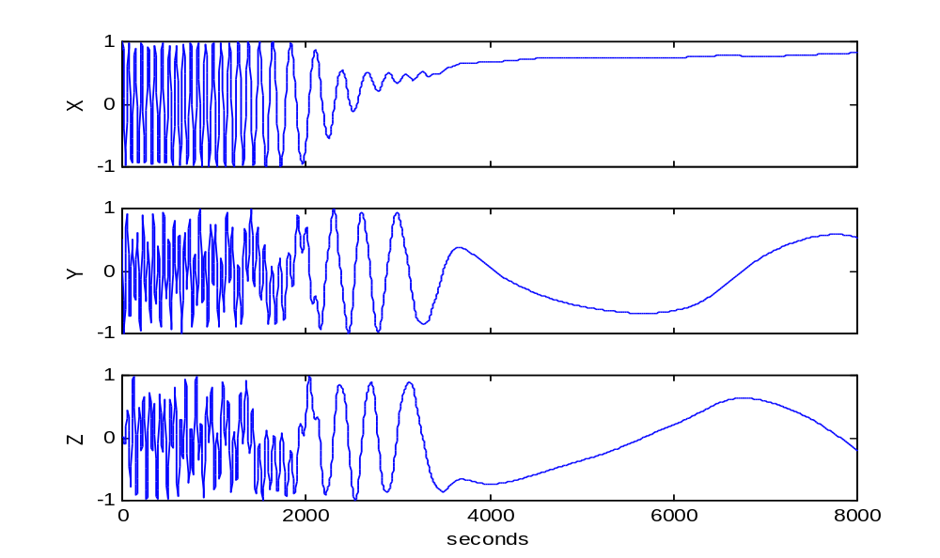
Figure 2. Sun vector direction cosines - acquisition and safe-hold

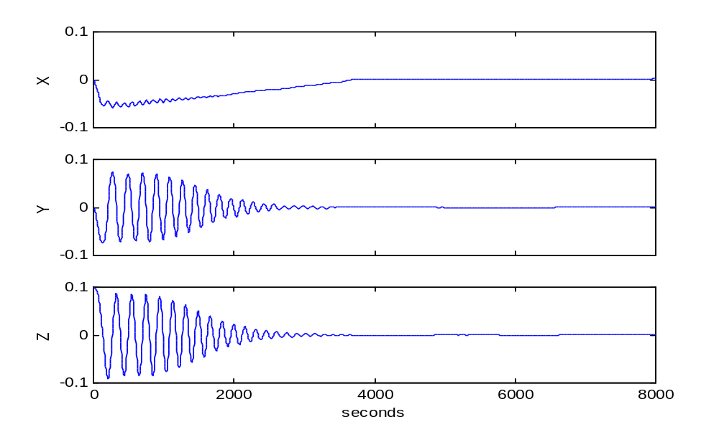
Figure 3. Body rates - acquisition and safe-hold

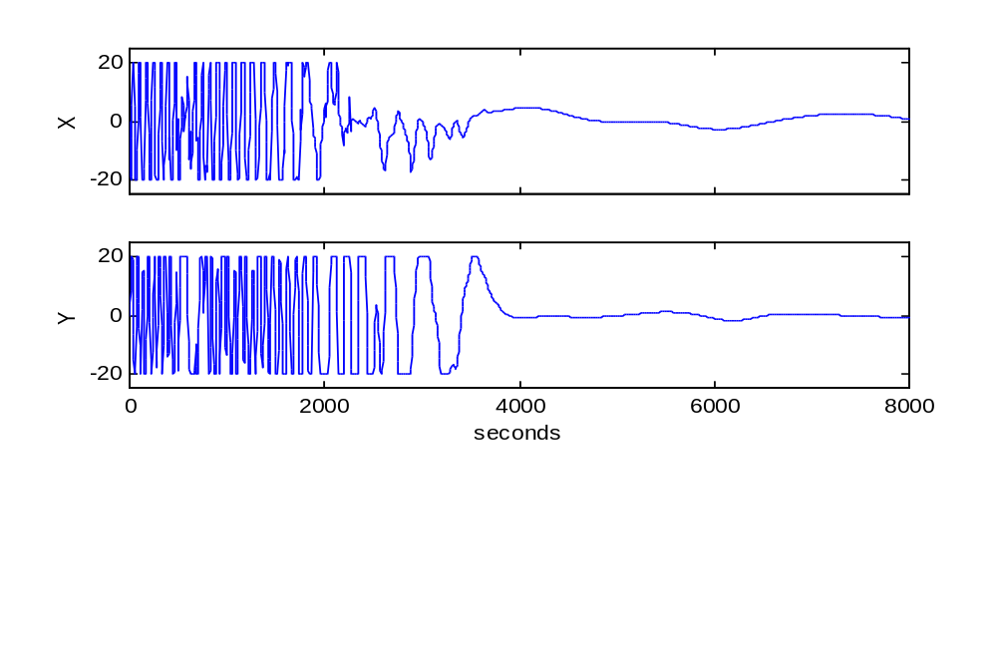
Figure 4. Magnetic moments (A/m²) - acquisition and safe-hold

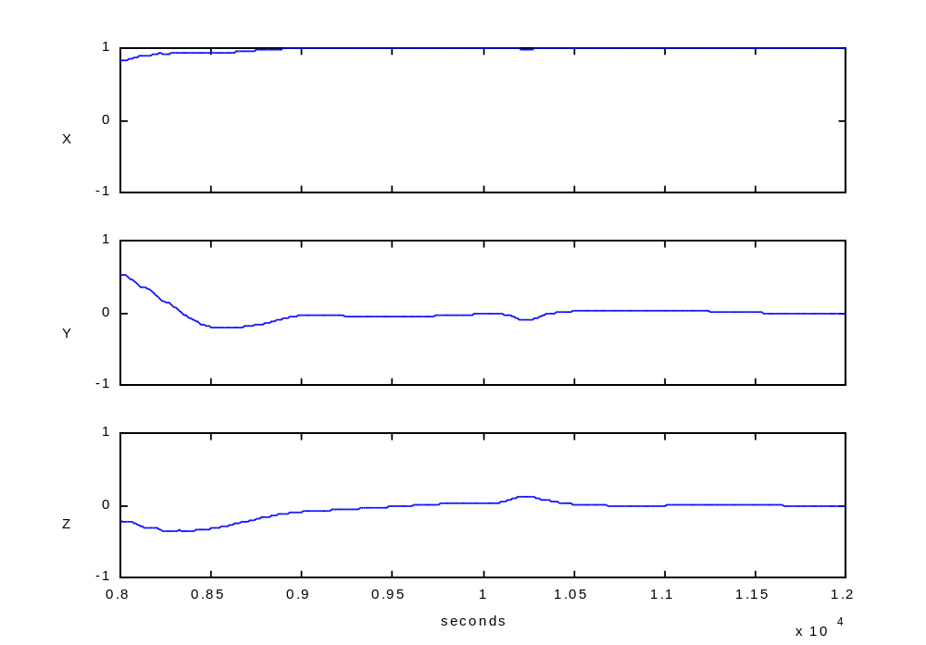
Figure 5. Sun vector direction cosines - Sun acquisition

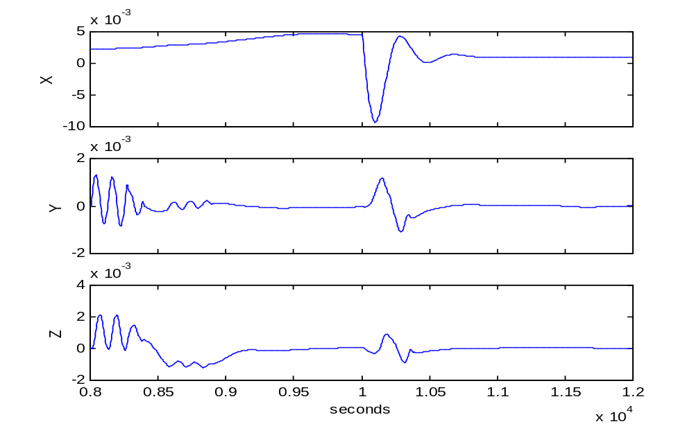
Figure 6. Body rates - Sun acquisition

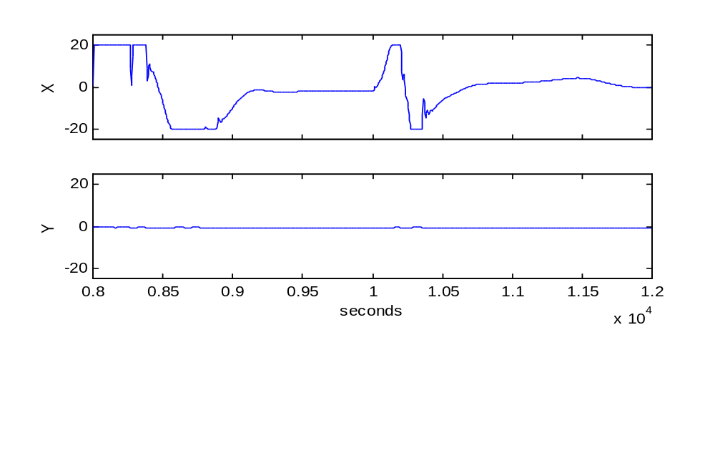
Figure 7. Magnetic moments (A/m²) - Sun acquisition

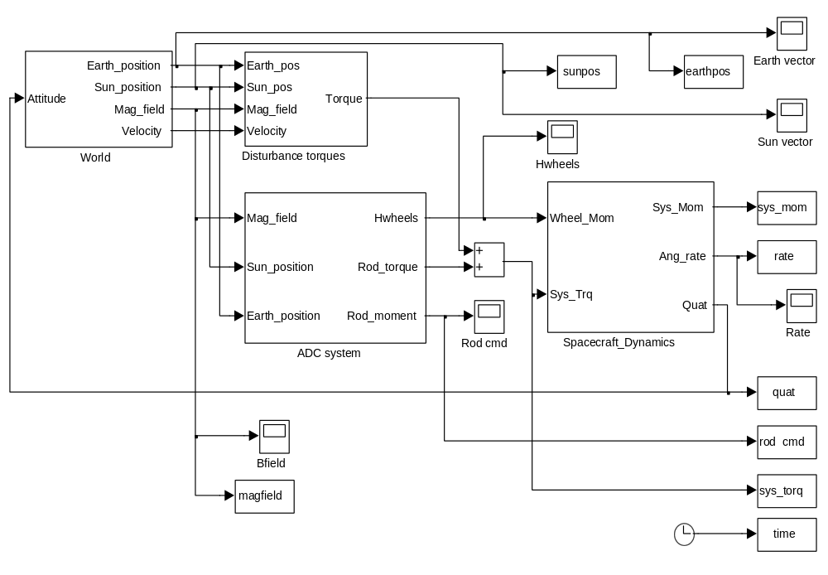
Figure 8. Block diagram of the CATSAT simulation

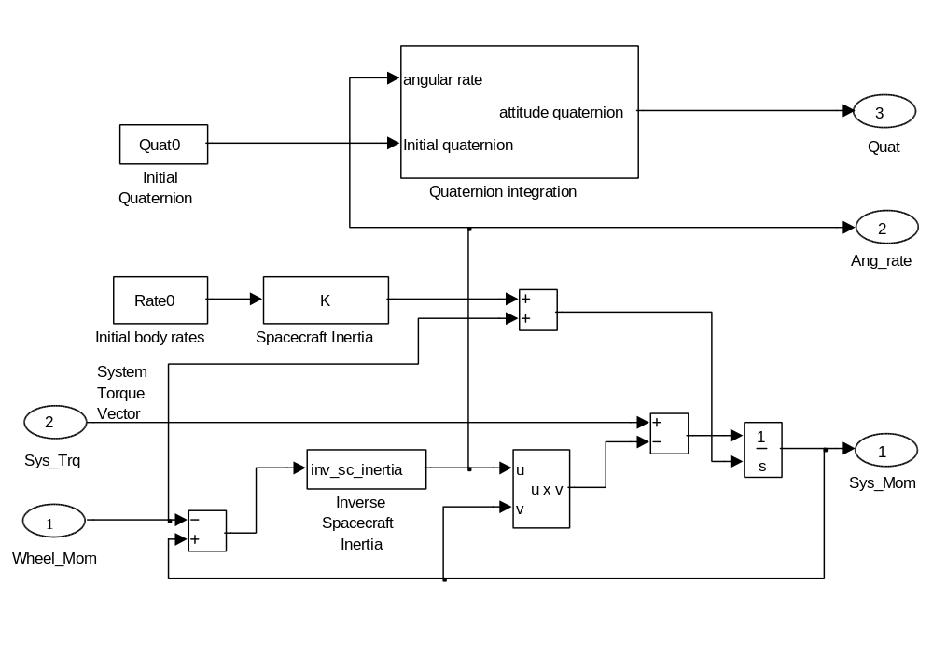
Figure 9. Block diagram of the Spacecraft Dynamics simulation block

