Tatkal Booking System
  - Containerization and Deployment of the Microservices
Scalable Services (SEZG583) - Assignment 2 - Deployment Report
Group member | BITS ID | Main work in Assignment 2
Dhruv Bhat | 2025TM93139 | docker-compose.yml, networks and secrets, restart check, report
Ratani Snehi Rajesh Darshana | 2025TM93530 | Dockerfiles and images, health endpoints
Atharva Kadam | 2025TM93221 | the deployment problem (Task 3), configuration and start-up logging
N Abhishek Reddy | 2023MT93400 | Kubernetes manifests, scaling and rollout, demo video
Source code: https://github.com/spaceman-dev/tatkal-booking-microservices (Assignment 1 ends at the tag assignment-1, everything after it is Assignment 2)
Demo video: [video link]

1. Application and deployment overview
The application is our Assignment 1 project, the back end for booking Indian Railways Tatkal tickets: a few seats open at a fixed time and thousands of people try to book them in the same minute. It has four business services and a mock bank, all in Python (FastAPI). booking-service runs each booking as a saga: hold seats in inventory-service, take the payment through payment-service (which talks to the bank), confirm the seats, and tell notification-service through an outbox. Each business service owns its own PostgreSQL database, and the services talk to each other only over REST.
For this assignment we built one image per service and run the whole system in two ways: with Docker Compose (docker compose up --build, nine containers) and on Minikube. The code does not know where it runs. Every address and password reaches it through environment variables. Figure 1 shows the Compose deployment.
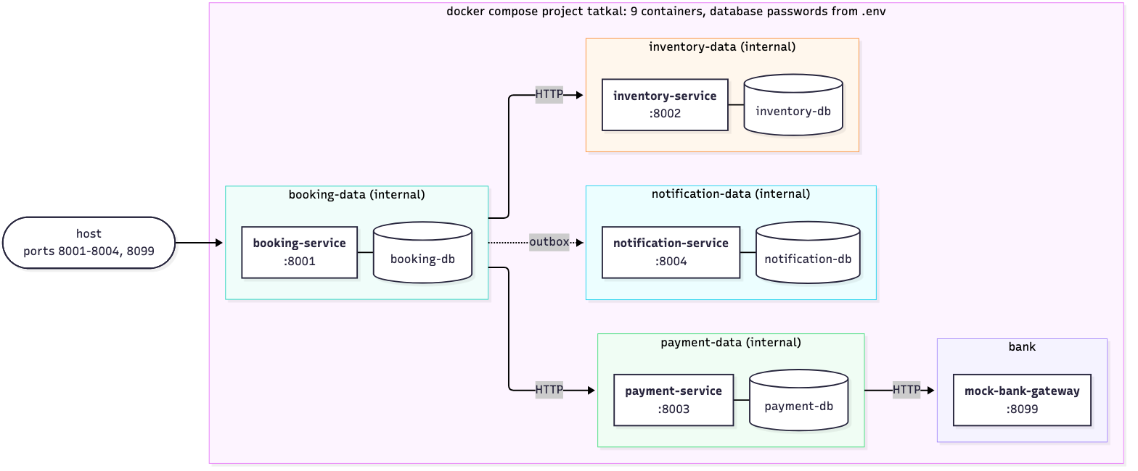
Figure 1 - Docker Compose deployment. Each database is on an internal network shared only with its own service, so booking-service cannot even resolve inventory-db. The services call each other by name on the network services (http://inventory-service:8002), and only payment-service is on the network bank. Ports 8001-8004 and 8099 are published for the tests, the databases are not. Each database keeps its data in a named volume.

2. Containerization and Docker Compose

2.1 Images
Each service has a Dockerfile in its own folder (services/<name>/Dockerfile), built as tatkal/<name>:1.0. All five follow the same pattern:
- Base and layers. python:3.12-slim. requirements.txt is copied and installed before the code, so a code change rebuilds only the last layers. The four services with a database come to 348 MB each, the mock bank to 274 MB. pytest moved to requirements-dev.txt so it no longer goes into the images.
- Non-root. The code is owned by root and the process runs as tatkal (uid 10001), so the service can read its code but not change it.
- Configuration from outside. Only HOST, PORT and APP_VERSION have defaults in the image. The database URL, the other services’ URLs and the log level are given when the container starts. .dockerignore keeps .env, .venv and the tests out of the build context, so a password cannot be copied in by mistake. We checked the built images with docker image inspect and by listing /app inside them.
- Health check. HEALTHCHECK calls the service’s own /health with Python (the slim image has no curl). --start-interval=2s makes a new container healthy a few seconds after start-up.
- Clean stop. CMD ["python", "-m", "app"] in exec form, so Python is PID 1 and receives SIGTERM from docker stop and from Kubernetes.
We also added to the code: /health reports the version and the container (instance), and a new /health/live only says the process is running, without touching the database. Compose and the Kubernetes readiness probe use /health, the liveness probe uses /health/live. That way a database outage takes a pod out of its Service instead of restarting it over and over.

2.2 docker-compose.yml
- Nine containers: four postgres:16-alpine databases, each with its own user, database and volume, and the five services.
- Passwords only in .env. The file uses ${BOOKING_DB_PASSWORD:?...}, so Compose stops with a clear message when .env is missing, and builds each DATABASE_URL from it. .env is ignored by git; the repository has .env.example with placeholders.
- Service names, never localhost: INVENTORY_SERVICE_URL=http://inventory-service:8002, and the database host is booking-db:5432.
- Six networks: services for the REST calls, bank for payment-service and the bank only, and one internal network per database, shared with its own service only.
- Start order: depends_on with condition: service_healthy. The databases come up first, then each service once its database is ready, and booking-service last because it calls the other three.
- restart: unless-stopped everywhere, and json-file logs capped at 3 x 10 MB per container.

2.3 Running it
What we did | Result (files in evidence/deployment/)
docker compose build --no-cache | five images built with BuildKit (1-images)
docker compose up --build -d --wait | all nine containers healthy about 11 s after the start (2-compose/up.txt)
/health of each service, docker inspect | all UP with the database UP, 0 restarts (health.txt)
main workflow: 7 end-to-end tests and the demo script | book, pay, confirm, notify; a failure at step 3 refunded and released; a declined payment; sold out. 7 passed (e2e.txt, demo_flow.txt)
one booking followed through the logs | its correlation id appears in all five containers, in order (trace.txt)
name lookups from inside booking-service | its own database and the three services resolve, the other databases and the bank do not (networks.txt)
docker compose down, then up -d --wait | the newest confirmed booking (PNR 8394445298) is still there, the 7 tests pass again (restart.txt)

3. Situated learning: the container that could not find its database
Problem. Once the first Dockerfile was ready we ran the inventory-service image on its own, with the .env file we had been using on the laptop since Assignment 1: docker run -d -p 8012:8002 --env-file services/inventory-service/.env tatkal/inventory-service:1.0. The development database was up and healthy on localhost:5442, and the service with that same file had worked fine outside Docker. The container started but stayed at health: starting, curl got an empty reply, and after 30 seconds it exited with code 3. The log said database not reachable yet (attempt n/30) thirty times and then Application startup failed.
Diagnosis. We worked from the outside in:
Command | What it told us
docker ps -a, docker inspect -f '{{.State.ExitCode}}' | exit code 3 and unhealthy: the service gave up on its own, nothing killed it
docker logs | 30 failed attempts one second apart, but no reason
docker inspect (environment, networks) | DATABASE_URL=...@localhost:5442/inventory_db; the container is on the default bridge network
docker compose -f docker-compose.db.yml ps, docker inspect tatkal-inventory-db | the database is healthy, published as 5442 on the host, and on the network tatkal-db_default with the DNS name inventory-db
docker exec ... grep localhost /etc/hosts | inside the container localhost is 127.0.0.1 / ::1 of the container itself
docker exec ... getent hosts inventory-db | the name does not resolve from the bridge network
a database connection from a container of the same image | connection to server at "127.0.0.1", port 5442 failed: Connection refused
The image was fine, the configuration was wrong. localhost:5442 means “this machine”, and inside a container this machine is the container. Port 5442 exists only on the host, where Docker publishes the database. To confirm it we changed only the host in the URL (inventory-db:5432) and attached the database’s network: the same image with the same file was healthy within 8 seconds, with no failed attempt.
Solution. (1) In docker-compose.yml every DATABASE_URL uses the database’s service name and port 5432, and each service shares a private network with its database. The other services’ URLs work the same way. (2) The per-service .env files are only for running on the host. They stay out of the images (.dockerignore) and are never passed to containers, which get their settings from Compose, and on Kubernetes from ConfigMaps. (3) The wait-for-database log line now shows the target, with the password hidden, and the reason, so the cause is in the first line: ...@localhost:5442/inventory_db ... Connection refused.
Validation. In the Compose deployment, docker compose exec inventory-service printenv DATABASE_URL shows inventory-db:5432, getent hosts inventory-db resolves, /health reports the database UP and the 7 end-to-end tests pass. evidence/deployment/3-troubleshooting has each step with screenshots, plus the raw output from the morning it first happened.
Learning.
- Inside a container, localhost is the container. Containers reach each other by name on a shared network. A published port is for the host, not for other containers.
- Configuration does not carry over from a laptop into containers. Each environment needs its own configuration (Compose environment, ConfigMaps), and the developer’s .env should never go in.
- A log line that only says “not reachable” made the diagnosis slow. Logging the target and the reason turns minutes into seconds.
- Run one container alone before wiring up the rest. When it fails, only the image or its configuration can be wrong.
In a real deployment we would apply this by making every service log its effective configuration (without secrets) at start-up and fail fast with a clear message when a dependency is missing, and by keeping each environment’s configuration in its deployment files rather than in files copied from someone’s machine.

4. Advanced: Kubernetes on Minikube

4.1 Deployment and main workflow
deploy/k8s/ has the manifests (Figure 2), and bash deploy/k8s/deploy.sh deploys everything to Minikube 1.39 (Kubernetes 1.37):
- It builds the images with Compose and copies them in with minikube image load (no registry, imagePullPolicy: IfNotPresent), creates the Secret db-passwords from the same .env, and runs kubectl apply -k.
- Each database is a StatefulSet with a headless Service and a 1 Gi PersistentVolumeClaim. Each service is a Deployment, a ClusterIP Service and a ConfigMap with the other services’ URLs. DATABASE_URL is put together from the Secret with $(DB_PASSWORD).
- An init container waits with pg_isready until the pod’s database answers, like depends_on in Compose. Startup and liveness probes use /health/live, the readiness probe /health. The service and database containers have CPU and memory requests and a memory limit.
- booking-service runs 2 replicas with maxSurge: 1, maxUnavailable: 0. inventory-service and the mock bank stay at one replica, because the fault switches used in the demo are kept in memory.
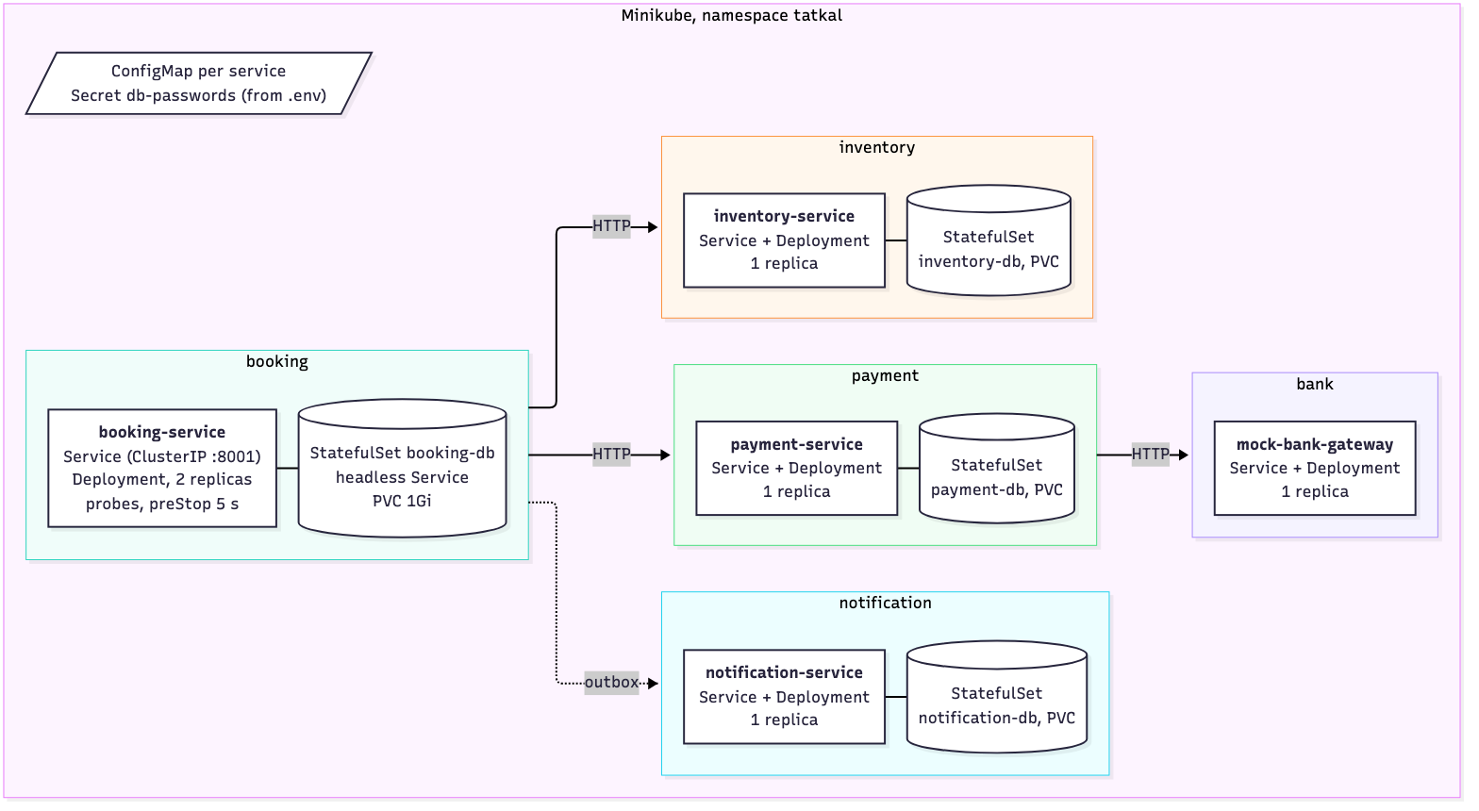
Figure 2 - The Minikube deployment (namespace tatkal). Every service follows the pattern shown for booking-service: a Service, a Deployment and a StatefulSet for its database. The tests reach the cluster through kubectl port-forward on the same local ports as with Compose.
A clean deploy takes 41 s once the images are in Minikube (3 min 36 s the first time, mostly copying the images). The main workflow runs through the Kubernetes Services: with port-forward.sh running, the same 7 end-to-end tests pass, reading the logs with kubectl logs, and one booking’s correlation id appears in the logs of all five Deployments.

4.2 Self-healing and scaling
demo-scaling.sh deletes one of the two booking-service pods and then scales the Deployment to 3, while a pod inside the cluster calls booking-service twice a second. A replacement pod was running 3 s after the delete, and the third replica was ready 3 s after kubectl scale. The client made 80 requests, all answered, by four different pods.

4.3 Rolling update and rollback
demo-rollout.sh rolls booking-service out to 1.1 (the same code with APP_VERSION=1.1.0), rolls back with kubectl rollout undo, then deploys a tag that does not exist (9.9). That pod never gets ready, maxUnavailable: 0 keeps the three 1.0 pods serving, and a second undo removes it. 159 requests during all of this, none failed.
It was not like that the first time. 3 of 141 requests failed during our first update and rollback, each just as an old pod was stopping: Kubernetes sends SIGTERM and removes the pod from the Service endpoints at the same time, so for a moment requests still reached a stopping pod. A preStop sleep of 5 s fixed it (0 of 139 afterwards). Running replicas also showed a race we had never seen with one copy of each service: replicas that create their tables at the same moment can crash with UniqueViolation (3 of 4 in our test). Table creation now runs under a PostgreSQL advisory lock. Both are described in Appendix C.

5. Contributions and AI use
Member | Assignment 2 work | Share
Dhruv Bhat | docker-compose.yml (networks, health-based start order, passwords from .env), restart_check.sh, the evidence runs, report sections 1, 2.2 and 5 | 25 %
Ratani Snehi Rajesh Darshana | the five Dockerfiles and .dockerignore, /health with version and instance, /health/live, checking the images, report section 2.1 | 25 %
Atharva Kadam | Task 3: reproducing and diagnosing the localhost problem, the better start-up log, .env.example files with placeholders, report section 3 | 25 %
N Abhishek Reddy | Kubernetes manifests and scripts, the preStop and advisory-lock fixes, report section 4, video editing | 25 %
AI-use declaration. We used GitHub Copilot in VS Code (agent mode) for this assignment too. It wrote the Dockerfiles, docker-compose.yml, the Kubernetes manifests, the deploy and demo scripts and the small code changes (health endpoints, start-up log, create_tables). It ran the builds and deployments and recorded the evidence. The problems in section 3 and Appendix C came up during those runs, and the files in evidence/ are not edited (passwords are masked when they are printed). It also drafted this report, the READMEs and a plan for the video. Our part: we decided what to show for Task 3 and which advanced tasks to attempt, went through every Dockerfile, the Compose file and the manifests until each of us could explain them, and each of us ran docker compose up --build from a fresh clone on our own laptop.

Appendix A - Commands
# Docker Compose
cp .env.example .env # put your own passwords in .env
docker compose up --build -d --wait
docker compose ps # 9 containers, all healthy
python3 -m venv .venv && .venv/bin/pip install -r scripts/requirements.txt # Python 3.11+, tests only
.venv/bin/python -m pytest tests/e2e -v
bash scripts/demo_flow.sh
bash scripts/restart_check.sh
# the Task 3 problem, on purpose (the .env.example has the same localhost URL as our old .env)
docker compose -f docker-compose.db.yml up -d --wait inventory-db
docker run -d --name inventory-host-env -p 8012:8002 \
--env-file services/inventory-service/.env.example tatkal/inventory-service:1.0
docker ps -a; docker logs inventory-host-env 2>&1 | tail -3
docker inspect -f '{{range .Config.Env}}{{println .}}{{end}}' inventory-host-env | grep DATABASE_URL
docker exec inventory-host-env getent hosts inventory-db; echo $?
docker rm -f inventory-host-env; docker compose -f docker-compose.db.yml down
# Kubernetes
docker compose down # frees the local ports for the port-forward
minikube start --cpus=2 --memory=3500mb
bash deploy/k8s/deploy.sh
bash deploy/k8s/port-forward.sh # second terminal
LOG_SOURCE=k8s .venv/bin/python -m pytest tests/e2e -v
bash deploy/k8s/demo-scaling.sh
bash deploy/k8s/demo-rollout.sh

Appendix B - Evidence index
Everything was recorded on 29 Oct 2026. Every file starts with the command, the time and the commit.
Folder in evidence/deployment/ | What it shows
1-images | the clean build of the five images; sizes, user, ports, command, environment and files of each image
2-compose | up, health, the 7 end-to-end tests, the demo script, a trace across services, network isolation, logs, down and up with the data kept, and our very first compose up
3-troubleshooting | the Task 3 problem: symptom, exit, diagnosis, the one-change confirmation, the fix and the tests; the raw output of the first time it happened
4-kubernetes | deploy, resources, the 7 tests through port-forward, demo, trace, self-healing and scaling (80 requests, 0 failed), rollout and rollback (159 requests, 0 failed), and the first deploy
5-other-problems | the rolling update that dropped requests, before and after the preStop fix; the table-creation race before and after the advisory lock
The service test suites were run again after the changes: 133 passed (evidence/tests).

Appendix C - Other problems we hit
Problem | How it showed up | What we changed
docker compose was not found on the Mac | docker: 'compose' is not a docker command, although the plugin was installed with Homebrew | pointed Docker at Homebrew’s plugin folder (cliPluginsExtraDirs in ~/.docker/config.json)
the first build used the old builder | Compose warned that it requires buildx plugin (2-compose/first-up.txt) | installed buildx; builds use BuildKit since
one end-to-end test failed against the containers | 6 of 7 passed: the log check read old files in logs/, while the containers log to stdout | the test and trace.py read docker compose logs or kubectl logs (LOG_SOURCE, detected automatically)
demo_flow.sh failed at step 1 | python3 on macOS is 3.9, the scripts need 3.11+ | the script uses the virtualenv’s Python; stack.py checks the version and says what to install
a rolling update dropped requests | 3 of 141 failed (connection refused, timeouts) while old pods stopped | preStop sleep 5 s and terminationGracePeriodSeconds: 30: 0 of 139, later 0 of 159 (commit c264040)
replicas starting together crashed | race_check.py with 4 replicas on an empty schema: 3 UniqueViolation on pg_type_typname_nsp_index | create_tables() takes pg_advisory_xact_lock first; 4 of 4 start; regression test added (commit 4511fed)

Appendix D - Screenshots
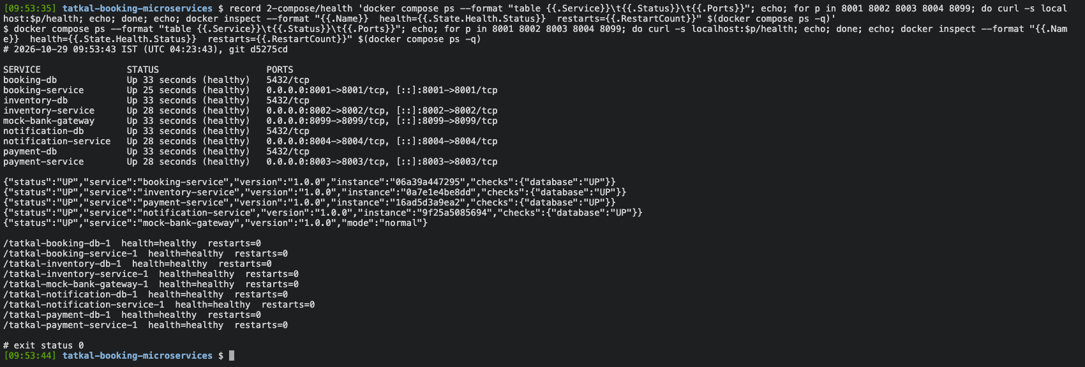
Compose: nine containers healthy, every service UP
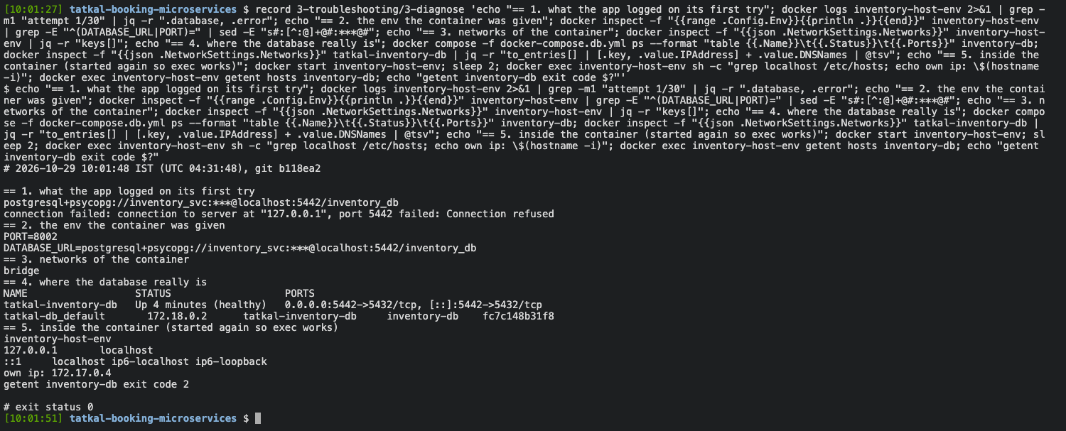
Task 3 diagnosis: the target and reason from the log, the environment, the networks, and localhost inside the container
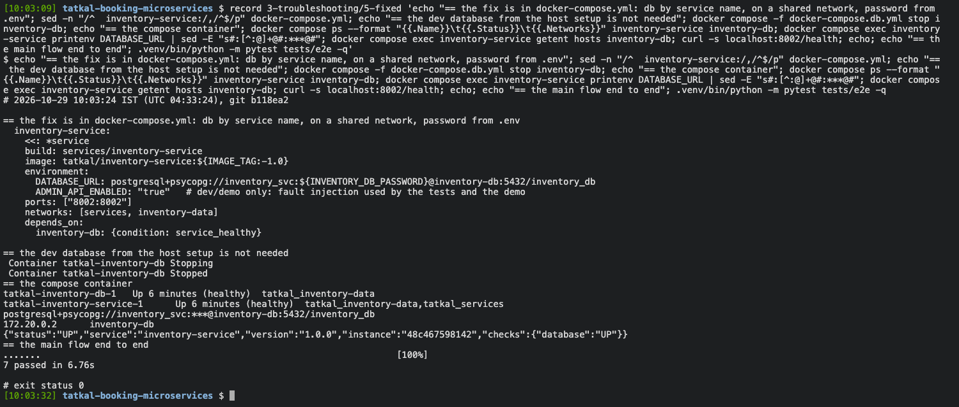
Task 3 after the fix: the service name, the shared network, health UP, 7 end-to-end tests passed
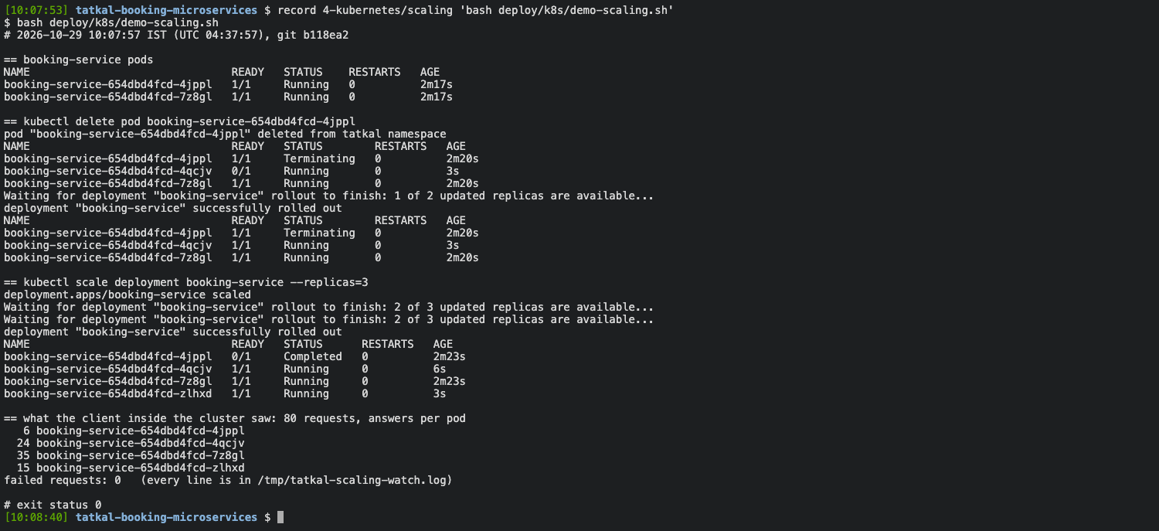
Kubernetes: one pod deleted and replaced, scaled to 3, 80 requests and none failed
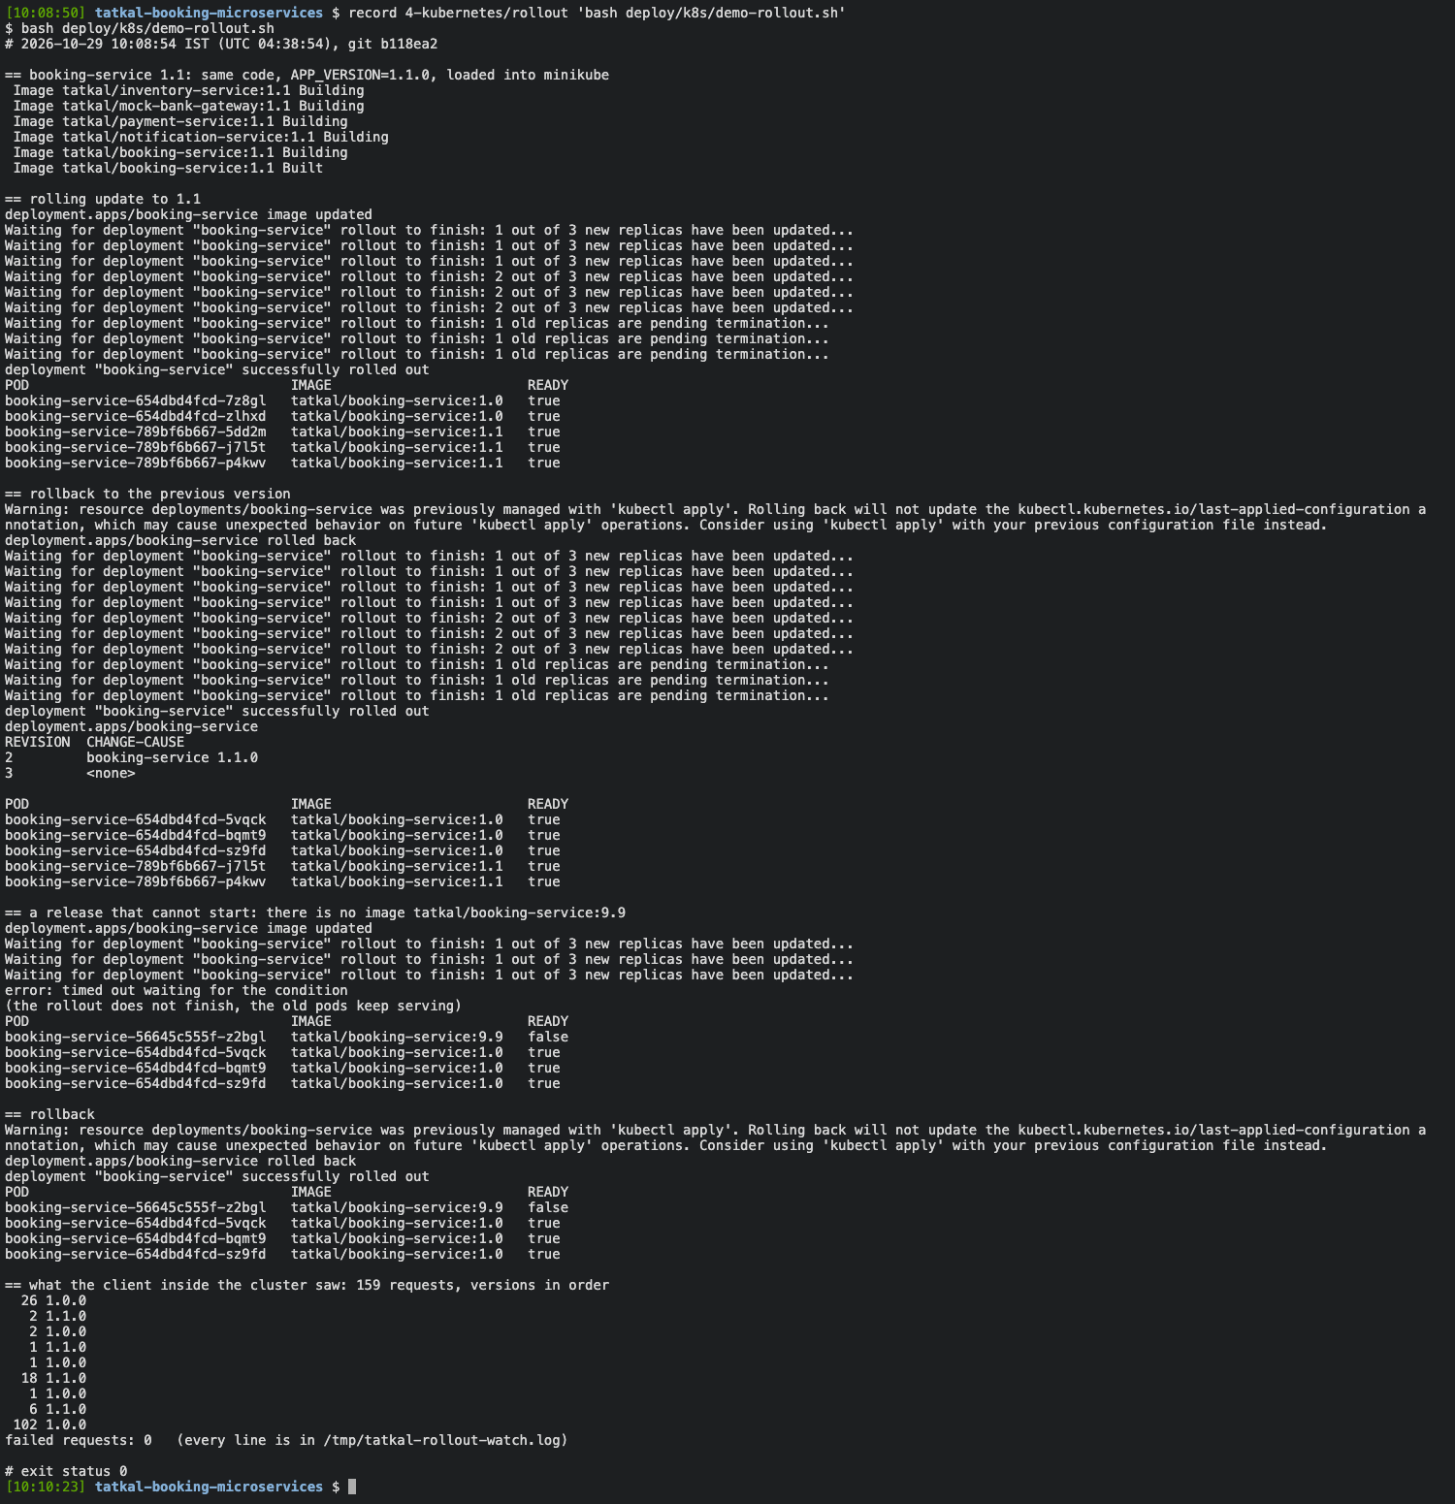
Kubernetes: rolling update, rollback, a broken release and a second rollback, 159 requests and none failed

