Dwight Naylor
Daniel Campos
NLP Project Proposal

My proposal is to create a program which will automatically generate formal grammars from a series of example inputs. The goal is to reduce time in simple NLP tasks, wherein the domain is simple enough that a defining grammar can be written, but doing so would require time and resources that would be better allocated to the core problems of a project. The intention is to allow a programmer or designer to feed a collection of example inputs into the program, which will learn a simple grammar capable of understanding all of these inputs, and nothing more. This will gain all of the benefits of an NLP interface, without the potentially expensive processing that a full-fledged NLP system would require.

This program hopes to address the existing need for NLP interaction in various situations which require advice or knowledge, by allowing a developer without a great deal of experience in NLP to easily generate a processor capable of understanding NLP queries related to the task at hand. The prime example for a project of this kind is in "attendant" or "helper" NLP programs, such as greeting programs, restaurant advice programs, store guidance programs, etc. Any task for which there is likely to be a limited grammar that can be learned easily enough from a few sample inputs would be the optimal target for this project.

My technical approach to addressing this problem is a two-part solution. The first part involves using a neural network to parse and understand the inputs, while the second part involves transforming the neural network's contents into a grammar in some standard form. The first part of this project will be completed no matter what, while the second part will be completed only if time is available.

Part one: Neural Network
The primary goal of this program is to generate something that can understand inputs similar to a collection of sample inputs. For this purpose, I've decided to use what I call an "iterative" neural network.

For those unfamiliar with the jargon, a neuron (or perceptron) can be viewed as a machine which takes a series of inputs, and calculates a weighted (often linear) sum to return as a result. A neural network is nothing more than a group of these neurons (dubbed "input neurons") which may repeatedly feed into another group of input neurons (dubbed a "hidden layer"), eventually feeding into a final group of neurons from which output is discerned (dubbed "output neurons"). To train such a network, a sample input is fed into the network, at which point the calculations made by each neuron propagate through the network, eventually reaching the output neurons and calculating a result. This result is then compared to the sample output, and errors are calculated. These errors can then be back-propagated through the network, adjusting the weights of individual neurons to closer-approximate the given solution to the problem. Repeated enough times with a proper network, this will eventually yield a configuration capable of yielding the correct answer to all example inputs and outputs. Note that this network described is known as a "feed forward neural network" or FFNN, which is only one of many types of neural networks used.

My "iterative" neural network is a special type of FFNN which operates by processing input one token at a time (for example, one word in a sentence at a time). Each token is fed into the network, and the network is tasked with correctly identifying important abstract structures as they appear within the sentence. This approach can be augmented by considering other data related to the token, such as neighboring tokens and position in the sentence, but the core concepts are most easily applied when limited to token appearance, and so this document will assume that is all the input being given (although the actual program will use these augmenting features).

Exactly which abstract structures will be deciphered from NLP input are still being decided. Currently, the most prominent option is to construct some form of semantic tree from the inputs, but this is an approach that doesn't lend itself easily to the output format of neural networks (a list of values). Another option is perform some sort of tagging for POS or name data, but frankly I don't find this very interesting.

One benefit of this approach is that it allows us to process a sentence of any size and structure, so long as we have a neuron associated with each possible input token in our input layer, and a neuron associated with each possible desired output in our output layer.
Another benefit is that I already have functioning neural network code with which to tackle this problem, with the biggest hurdle being the conversion of a standard FFNN into an iterative FFNN.

I plan to train the neural network using a corpus of hand-tagged sentences either generated by me or from some online source. The most important part of this program is that it can be re-adjusted for new datasets without too much difficulty, and still give useful results from any new dataset.

Part Two: Interpreting a neural network

The second part of the project is converting the neural network's internal representation into some form of formal grammar. This part of the process is entirely theoretical at this point, and would consist of recognizing what certain parts of grammars looked like when learned by a network, and teaching a secondary system to recognize these patterns and convert them into rules within the formal grammar. A few possible examples of this are shown below:

For a sequential rule, a possible neural interpretation is shown below. Note that grey arrows indicate 50% of a neurons required firing value (it would take two inputs to cause the neuron to fire), while black arrows indicate 100% of a neurons firing value (a single neuron input will cause the neuron to fire).
ILikePie:= "I" "Like" "Pie"
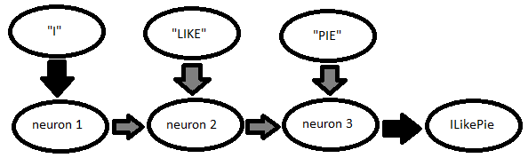
Note that the neurons labelled "neuron n" don't have any explicit meaning to the program, but can be abstractly given meaning by a developer. Neuron 1 is a recognition of the word "I", while neuron 2 is a recognition of the phrase "I like", and neuron three is a recognition of the phrase "I like pie". So in fact, the above diagram could be reduced by one neuron by replacing neuron 3 with the full "I like pie" recognition neuron.
For a choice rule, wherein any of a series of inputs will work, a possible interpretation is shown. Note that "is my favorite color" is shown as one token below, as it could be recognized with the recognitions strategy noted above.
ColorPreference:= ("red" | "green" | "blue" | "pink") "is my favorite color"
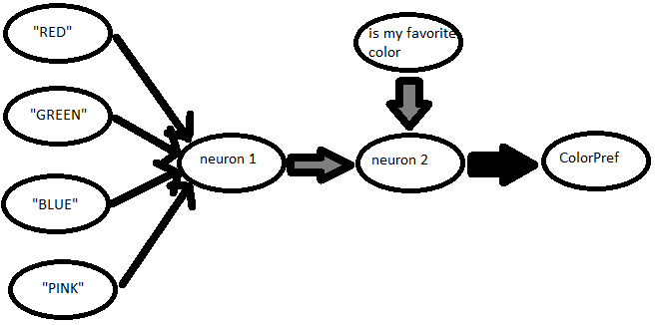
Note that any of the colors are enough to trigger neuron 1 (abstractly, a "color was said" neuron).

For both of these configurations, any sort of recognition would take into account that a real neural network will never perfectly approach the configurations shown, either in structure or in weight values. Any recognition program will have to be able to accept these differences during analysis.

Conclusions, deliverables and timetable

As mentioned, the entire process of part 2 will only be done if part 1 is sufficiently completed. For my purposes, "sufficient" will be when part 1 is able to construct a recognition network for most series of inputs with a good accuracy. I doubt that part 2 will be done, but it would be necessary for the product to ever be practically useful to somebody without any NLP background using the program.

The deliverable for Part 1 of this project is a neural network package that can be trained to recognize and parse a series of example inputs/outputs. The deliverable for Part 2 (should it be completed) would be a program capable of generating a formal grammar after completing the task in Part 1.

I plan to divide the timetable for the program into roughly three parts, consisting of a prototyping phase, a "fleshing out" phase, and a finalization phaze. Given the time constraints, each of these will last a couple weeks as needed.
- The prototype will consist of a tagger capable of some level of helpful tagging through the neural network. At this point, minimal functionality is all that I'm looking for. (3-4 weeks)
- Fleshing out the program will mean making it capable of tackling various input examples effectively and helpfully. By the end of this phase, the program will be good enough for simpler NLP tasks. (2-3 weeks)
- The finalization phase of the program will involve harder training and testing with a variety of examples. By the end of this phase, the neural network package is ready for full use. (all remaining time)

In addition to these, a fourth phase may or may not be allocated for completion of part 2 of this project.

