Project Brief

Project – Brooklyn Film Festival Website

Date – 10-04-2019

Executive Summary

The client (Jennifer Viala) requested a website for Brooklyn Outdoor Film Festival.

The purpose and goal of the website is to display information about the festivals held and act as a bulletin for the upcoming festivals with location details.

Additionally, the website will contain all social medial network links and updates related to Brooklyn Outdoor Film Festival.

Finally, the website will contain a feature to allow visitors to pre-register for festivals being held for the purpose of accounting and preparing the venues beforehand based on the visitors’ counts.

This document illustrates steps that will be taken to achieve the goals here.

|  |  |
| --- | --- |
| *Revisions* | *Date* |
| *1* | *10-04-2019* |
|  |  |

Stakeholders

Client Project Manager – Jennifer Viala (Brooklyn Outdoor Film Festival Founder)

Developer Project Manager – Shafiq al-Shaar

Deliverables

1. Interactive prototype:
   1. Uniquely designed landing page
   2. Updates/News Bulletin
   3. Films to be shown (directory)
2. Features to include:
   1. Content Management System
      1. Manage news being shown first thing on the page (top).
      2. Manage venues (opening/closing times, entry cost)
      3. Manage films being shown at the venues.
      4. Manage registration list of visitors.
      5. Export registration list of visitors via Excel.

Total Investment

|  |  |
| --- | --- |
| Task | Price |
| Discovery session | $550 |
| Prototype | $850 |
| Development | $1,500 |
| Initial maintenance costs  (domain registration / server management) | $500 (first year)  $250 (yearly) |
| **Total** | $3,400 |

Professional fees for the services are estimated to total between $2,899 to $3,499 for the project approach outlined in this proposal. Services will be billed on hourly basis on Upwork and those are based on objectives, scope of work, activities, deliverables, and timeline as described in this RFP response.

As the pricing for research and testing heavily depends on the market size and confidence level, a final scope of work document will be crafted and delivered based on the discussions we have.Any changes in the scope of Services or Deliverables agreed upon by the parties shall be set forth in a Change Order.

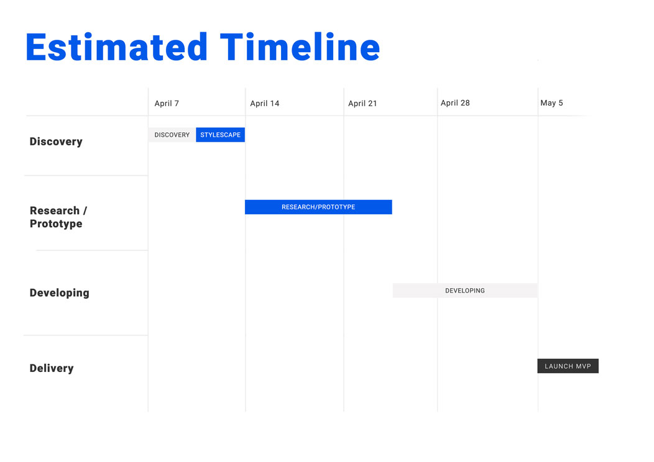

Technical Specifications

* Technologies used:
  + HTML/CSS/Photoshop/Illustrator – Prototype
  + Laravel/VueJS/Docker/Ansible - Development
  + DigitalOcean – Server hosting
* The source-code will be hosted on BitBucket repository.

Thank you**.**