WEEK 3-Collections

- Write a Python program to accept n integers into a list and perform the following operations. Convert the list into a tuple and display the results.
- Display the original list.
- Find the largest and smallest elements.
- Calculate the sum and average.
- Count the number of even and odd elements.
- Display the elements in ascending and descending order.
- Remove duplicate elements from the list.
- Convert the final list into a tuple.
- Display the tuple.
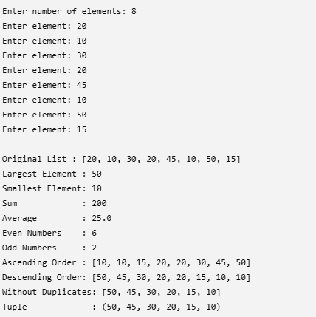

- A college maintains the USNs of students enrolled in two elective courses. Develop a Python program using sets to analyze the enrollment.

The program shall accept student USNs for Python Programming and Data Science and display:
- Students enrolled in both courses.
- Students enrolled only in Python Programming.
- Students enrolled only in Data Science.
- Students enrolled in at least one course.
- Students enrolled in exactly one course.
- Total number of unique students.

Concepts to be used: Sets, union, intersection, difference, symmetric difference, membership.
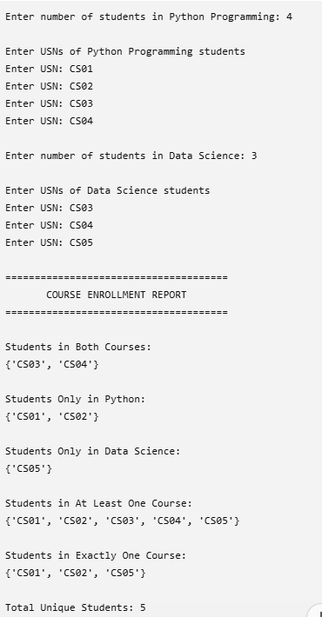

3. A college intends to automate student result management. Develop a Python program using lists, tuples, sets, and dictionaries to store and analyse student academic records.
Each student record shall contain: USN, Name, Branch, Marks in three subjects
The program shall provide the following menu:
1. Add Student
2. Search Student
3. Display All Students
4. Display Topper
5. Display Branches
6. Display Passed Students
7. Remove Student if he is failed in more than two subjects
8. Exit
Functional Requirements
Use a dictionary with USN as the key to maintain student records.
Store the three subject marks as a tuple.
Use a set to maintain unique branch names.
Use a list to prepare and display student results.
The system shall:
Prevent duplicate USNs.
Calculate total and average marks.
Consider a student passed only if the student scores at least 35 marks in every subject.
Display students who passed.
Identify the student with the highest total marks.
Display all unique branches.
Search for a student using USN.
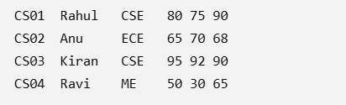

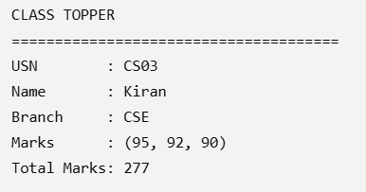
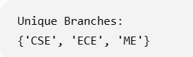
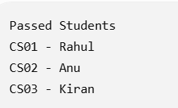

4. A supermarket intends to automate product inventory and sales analysis. Develop a Python program using lists, tuples, sets, and dictionaries to manage products and process customer purchases.
Each product shall contain:
- Product ID
- Product Name
- Category
- Price
- Available Quantity
The system shall provide:
1. Add Product
2. Search Product
3. Purchase Product
4. Display Products
5. Display Categories
6. Low Stock Report
7. Sales Summary
8. Exit
Functional Requirements
- Use a dictionary with Product ID as the key to maintain product information.
- Store fixed product details such as (Product Name, Category, Price) using a tuple.
- Use a set to maintain unique product categories.
- Use a list to maintain purchased products or sales records.
The application shall:
- Prevent duplicate Product IDs.
- Search for a product using Product ID.
- Verify quantity before completing a purchase.
- Reduce stock after a successful purchase.
- Display products with quantity below 5.
- Display all unique product categories.
- Calculate the total sales amount.
- Display the product with the highest sales amount.
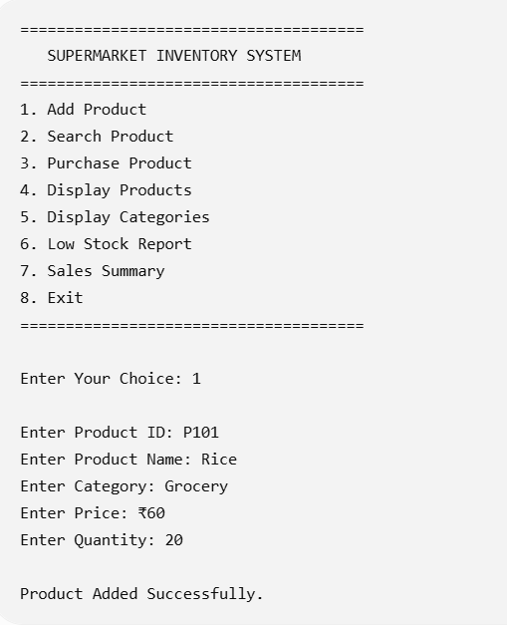
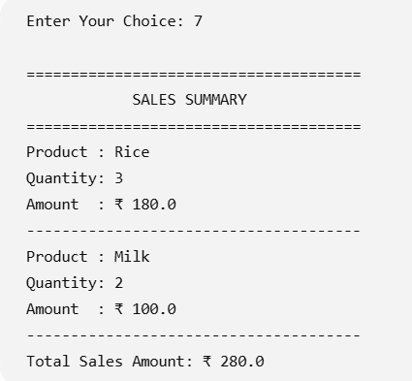

5. Develop a Python program to analyze the monthly electricity consumption of households using a dictionary. Store the consumer number as the key and the units consumed as the value.

The program shall:

Accept consumer numbers and their corresponding units consumed.
Display all consumer records.
Search for the consumption of a particular consumer.
Display consumers whose consumption is above 300 units.
Identify the consumer with the highest electricity consumption.
Calculate the average consumption of all consumers.
Update the units consumed for a given consumer.
Display the total number of consumers.
