Daniel Murphy  
CSCI 6454 – Fall 2020  
Homework 1 – report

Question 3

Serial and OpenMP computation of pi

# Serial

|  |  |
| --- | --- |
| No. Threads | Time to compute pi (seconds) |
| 1 | 0.000270 |

# OpenMP

|  |  |
| --- | --- |
| No. Threads | Time to compute pi (seconds) |
| 2 | 0.000626 |
| 3 | 0.000852 |
| 4 | 0.000926 |
| 5 | 0.001578 |

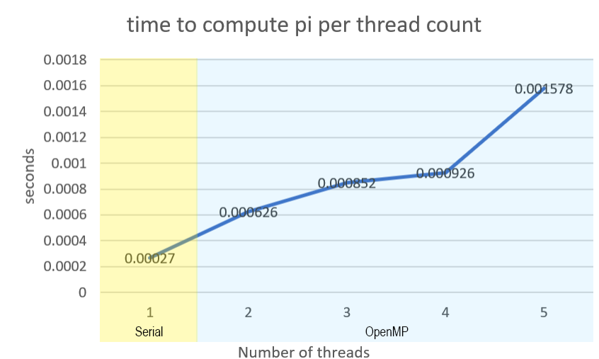

Question 4

OpenMP computation of PI using padding

|  |  |
| --- | --- |
| Padding size (4 bytes each) | Time to compute (seconds) |
| 2 | 0.004564 |
| 4 | 0.000635 |
| 6 | 0.000380 |
| 8 | 0.000340 |
|  |  |

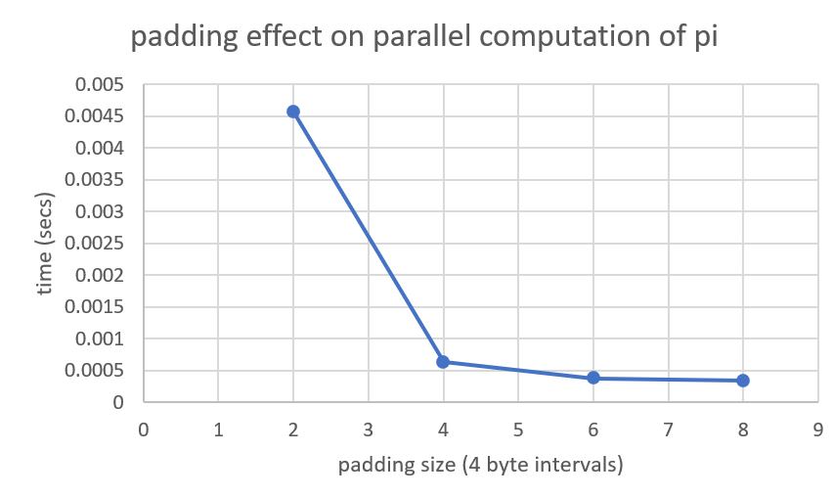

Question 5

OpenMP computation of PI using implicit and explicit barriers

|  |  |
| --- | --- |
| No. Threads | Time to compute pi (seconds) |
| 2 | 0.000181 |
| 3 | 0.000167 |
| 4 | 0.000160 |
| 6 | 0.000214 |

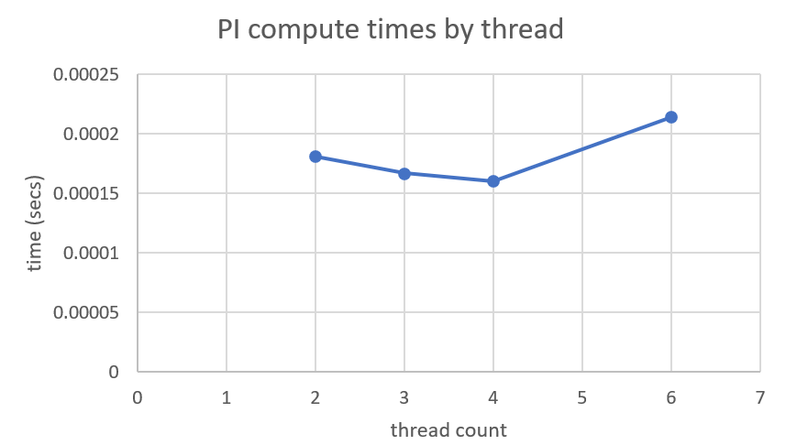

Question 6

computing sum and average of all cells in 2D array with OpenMP parallel-for and reduction

|  |  |
| --- | --- |
| Scheduling type | Time (secs) |
| Static | 0.001822145 |
| dynamic | 0.001646145 |
|  |  |

