Daniel Murphy  
CSCI 6454 – Fall 2020  
Homework 3 – report

Question 1

Please see code documentation in file /HW3_DANIEL_MURPHY_1/p1.c for comments related to this question. For info on how to run p1.c, see the README.md file.

Question 2

1.

Matrices MatA and MatB are initialized to a SIZExSIZE dimension and populated with randomly generated integers. To achieve parallel matrix multiplication, each processor calculates a subset of the final result.

MatA is transposed to optimize memory locality and each processor multiplies its corresponding sub-set of MatA against the entirety of MatB, saving the results to a local one-dimensional array MatFlat. Each process’ MatFlat is then gathered to the root processes MatC.

The one-dimensional matrix MatFlat was used to simplify the datatype used in the MPI_Gather operation.

As can be seen below, there is a performance benefit to multi-processing. One can note that the biggest improvement is seen between the single processor serial calculation, and the parallel calculation using 2 processors. The slightly diminishing returns in performance improvements might be explained by the overhead of sharing memory between the different processes.

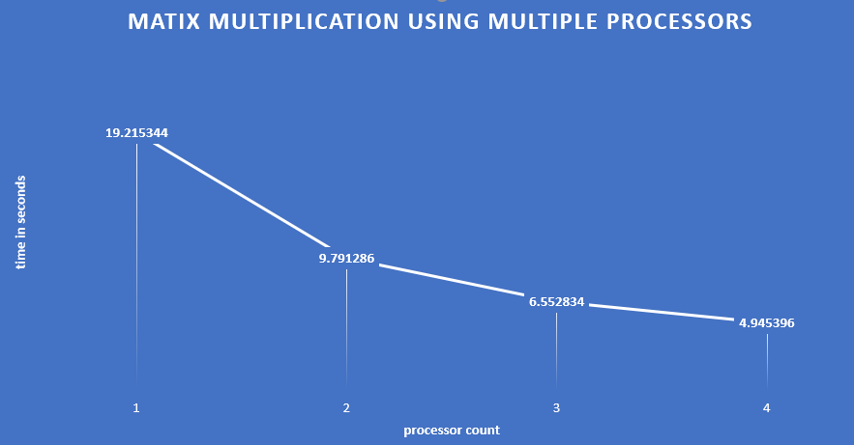2.

3.

An example of the input and output for a small matrix size. For the output of a large matrix, see the file MatC.txt

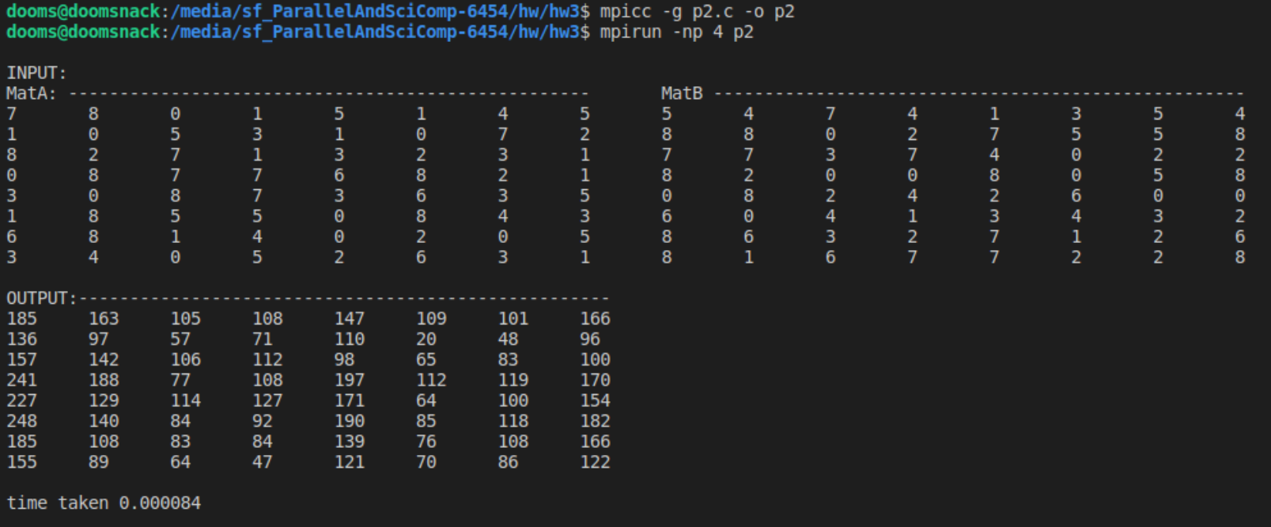

These results are printed to the console automatically for matrix sizes of 9x9 and less.