The NIRISS Magnitude/Count Rate Simulation Code

The code magnitudes.py and the associated data files allow one to calculate simulated NIRISS and other magnitudes for stellar sources. This program is intended to aid in estimates of NIRISS brightness values for imaging observations. The main utility of the code is to allow NIRISS magnitude estimates to be derived from non-NIRISS photometry such as the WISE or 2MASS catalogues. This process is necessarily approximate and depends on the knowledge of the spectrum of an object, but it provides a way to estimate brightness values for potential NIRISS targets that can then be used in the James Webb Space Telescope (JWST) Exposure Time Calculator, for example, to estimate exposure times.

The document describes the magnitudes.py code, how it can be used, and the basis of the simulations. This includes a description of the conversions from count rates to magnitudes and to flux density adopted for the NIRISS filters.

# The Magnitude.py Program

The program is a python code written in Python 2.7. It depends on a number of Python packages including sys, math, bisect, glob, matplotlib, astropy, numpy, and tkinter. All of these packages are widely available. The code depends on a set of data files that provide information about the throughputs of the NIRISS filters, the throughputs of the NIRCam and MIRI filters, the throughputs of a set of non-JWST filters. The program also requires sets of stellar model spectra for the calculations, although it can also be used with a spectrum read in from an ascii data file. The code allows a number of options for specifying the normalization of the spectrum. One can also apply interstellar extinction to the spectrum as part of the calculation.

The program is designed to be run interactively, although one can run the code from the command line and produce output values. The command line option is useful if one wishes to carry out a large grid of calculations.

# Defining Path Values for the Program

The magnitude.py code requires a number of standard input files to allow the calculations to be carried out. The minimum set of such files is provided with the code. The code requires a number of throughput files to allow count rates to be calculated for the NIRISS filters. The code also requires three standard A0V template spectra to provide the “standardization” of the magnitudes. The code is intended to use several well known grids of stellar atmosphere model spectra to allow calculations for a range of different types of stars. These include three sets of Altas9 stellar model spectra and of sets of Phoenix stellar models. Two sets of Altas9 models are provided with the code, as these are relatively small in total size. One can supplement the default Altas9 “Kurucz” model sets with more recent sets of Altas9 or Phoenix models that are available on the internet. These are described below.

The code needs path values to define where the different files are located. These values are set within the code using the os.environ function to obtain the values of three environment variables. These variables are:

1. NIRISS_MAGNITUDE_PATH: the path to the directory containing the program and the associated files for the filter profiles, the A0V spectral templates, and the ISM extinction function;
2. NIRISS_PHOENIX_PATH: the path to the directory holding the Phoenix grid models of Husser et al. (2013), if these are to be used in the program; and
3. NIRISS_THROUGHPUT_PATH: the path to the directory where the NIRIS and JWST standard throughput values are located.

If these environment variables are not defined they are given the value “./” to point to the current directory. When the program starts it will look for the NIRISS and other throughput files, the A0V template spectra, and the extinction function. These are required for the code to operate. The path to the Phoenix model grid files is optional, but it needs to be defined if one is using the grid files in the simulation.

As an example, in the BASH shell one would need to set the values with commands such as (using /home/auser as the base directory; change this as required for your system)

export NIRISS_MAGNITUDE_PATH=’/home/auser/magnitude_code/’

export NIRISS_PHOENIX_PATH=’/home/auser/husser2013grid/’

export NIRISS_THROUGHPUT_PATH=’/home/auser/nirissthroughputs/’

and in TSCH or CSH via commands such as

setenv NIRISS_MAGNITUDE_PATH /home/auser/magnitude_code/

setenv NIRISS_PHOENIX_PATH /home/auser/husser2013grid/

setenv NIRISS_THROUGHPUT_PATH /home/auser/nirissthroughts/

The three values do not need to be distinct; if one puts all the required files in one directory the three environment variables can be the same. If the / character at the end of the path is missing the code inserts it.

The NIRISS standard throughput files that are required to be in the directory pointed to by the NIRISS_THROUGHPUT_PATH variable are:

jwst_telescope_ote_throughput_nis.fits

jwst_niriss_internaloptics_throughput.fits

jwst_niriss_h2rg_qe.fits

jwst_niriss_internaloptics-clear_throughput.fits

jwst_niriss_internaloptics-clearp_throughput.fits

jwst_niriss_f090w_trans.fits

jwst_niriss_f115w_trans.fits

jwst_niriss_f140m_trans.fits

jwst_niriss_f150w_trans.fits

jwst_niriss_f158m_trans.fits

jwst_niriss_f200w_trans.fits

jwst_niriss_f277w_trans.fits

jwst_niriss_f356w_trans.fits

jwst_niriss_f380m_trans.fits

jwst_niriss_f430m_trans.fits

jwst_niriss_f444w_trans.fits

jwst_niriss_f480m_trans.fits

jwst_niriss_nrm_trans.fits

The files that need to be in the directory pointed at by the NIRISS_MAGNITUDE_PATH variable are:

alpha_lyr_mod_002.fits

alpha_lyr_stis_005.fits

extinction.data

miri_filter_throughputs.out

newkurucz.ascii

newkurucz.list

nircam_filter_throughputs.out

non_jwst_filters.data

oldkurucz.ascii

oldkurucz.list

sirius_mod_002.fits

The phoenix grid models of Husser et al. (2013) are stored in FITS table form. An example of the file names is lte12000-6.00-0.0.PHOENIX-ACES-AGSS-COND-2011-HiRes.fits. It is the higher resolution version that is best for the use with this code. The code looks for files with names matching lte*.fits to make a list of available files that can be used for the calculations. If no such files are found the selection list for these models will have no entries. The code also needs the wavelength file WAVE_PHOENIX-ACES-AGSS-COND-2011.fits. If this is missing the Phoenix models will not be used.

# Basic Use of the Program

If the code is started by issuing the command “magnitudes.py” the main window will appear. This is shown in Figure 1 below. The window has a message area at right and function buttons at left. Initially a number of the function buttons are greyed out. The first task is generally to define a spectral shape and normalization. Prior to this being done most of the functions of the program are not available.

The code depends upon an A0V spectral template of “known” magnitudes for the calculations. When a spectral shape is defined the calculations generate magnitudes by simulating the relative brightness of the standard A0V spectrum and the specified object spectrum to give magnitude values. This process is the general equivalent of carrying out a standardization using the mean brightnesses of a set of A0V stars to define the same magnitude value in different filters. That calculation is only as accurate as the set of magnitudes assigned to the standard A0V spectrum. The code provides a radio button to select between three possible A0V shapes: the default is the Sirius model spectrum from the HST Calspec site, located at <http://www.stsci.edu/hst/observatory/crds/calspec.html>, with alternatives of the current (2014) Vega model from the Calspec site and the previous (2012) Vega mode from the Calspec site.

The three standard spectral models are stored as FITS tables, the file names being alpha_lyr_mod_002.fits, alpha_lyr_stis_005.fits, and sirius_mod_002.fits. These are the 2014 Vega model, the 2012 Vega model, and the 2014 Sirius model respectively. See Bohlin (2014) and reference therein for a discussion of the stellar model spectra for Sirius and Vega that posted are in the calspec site.

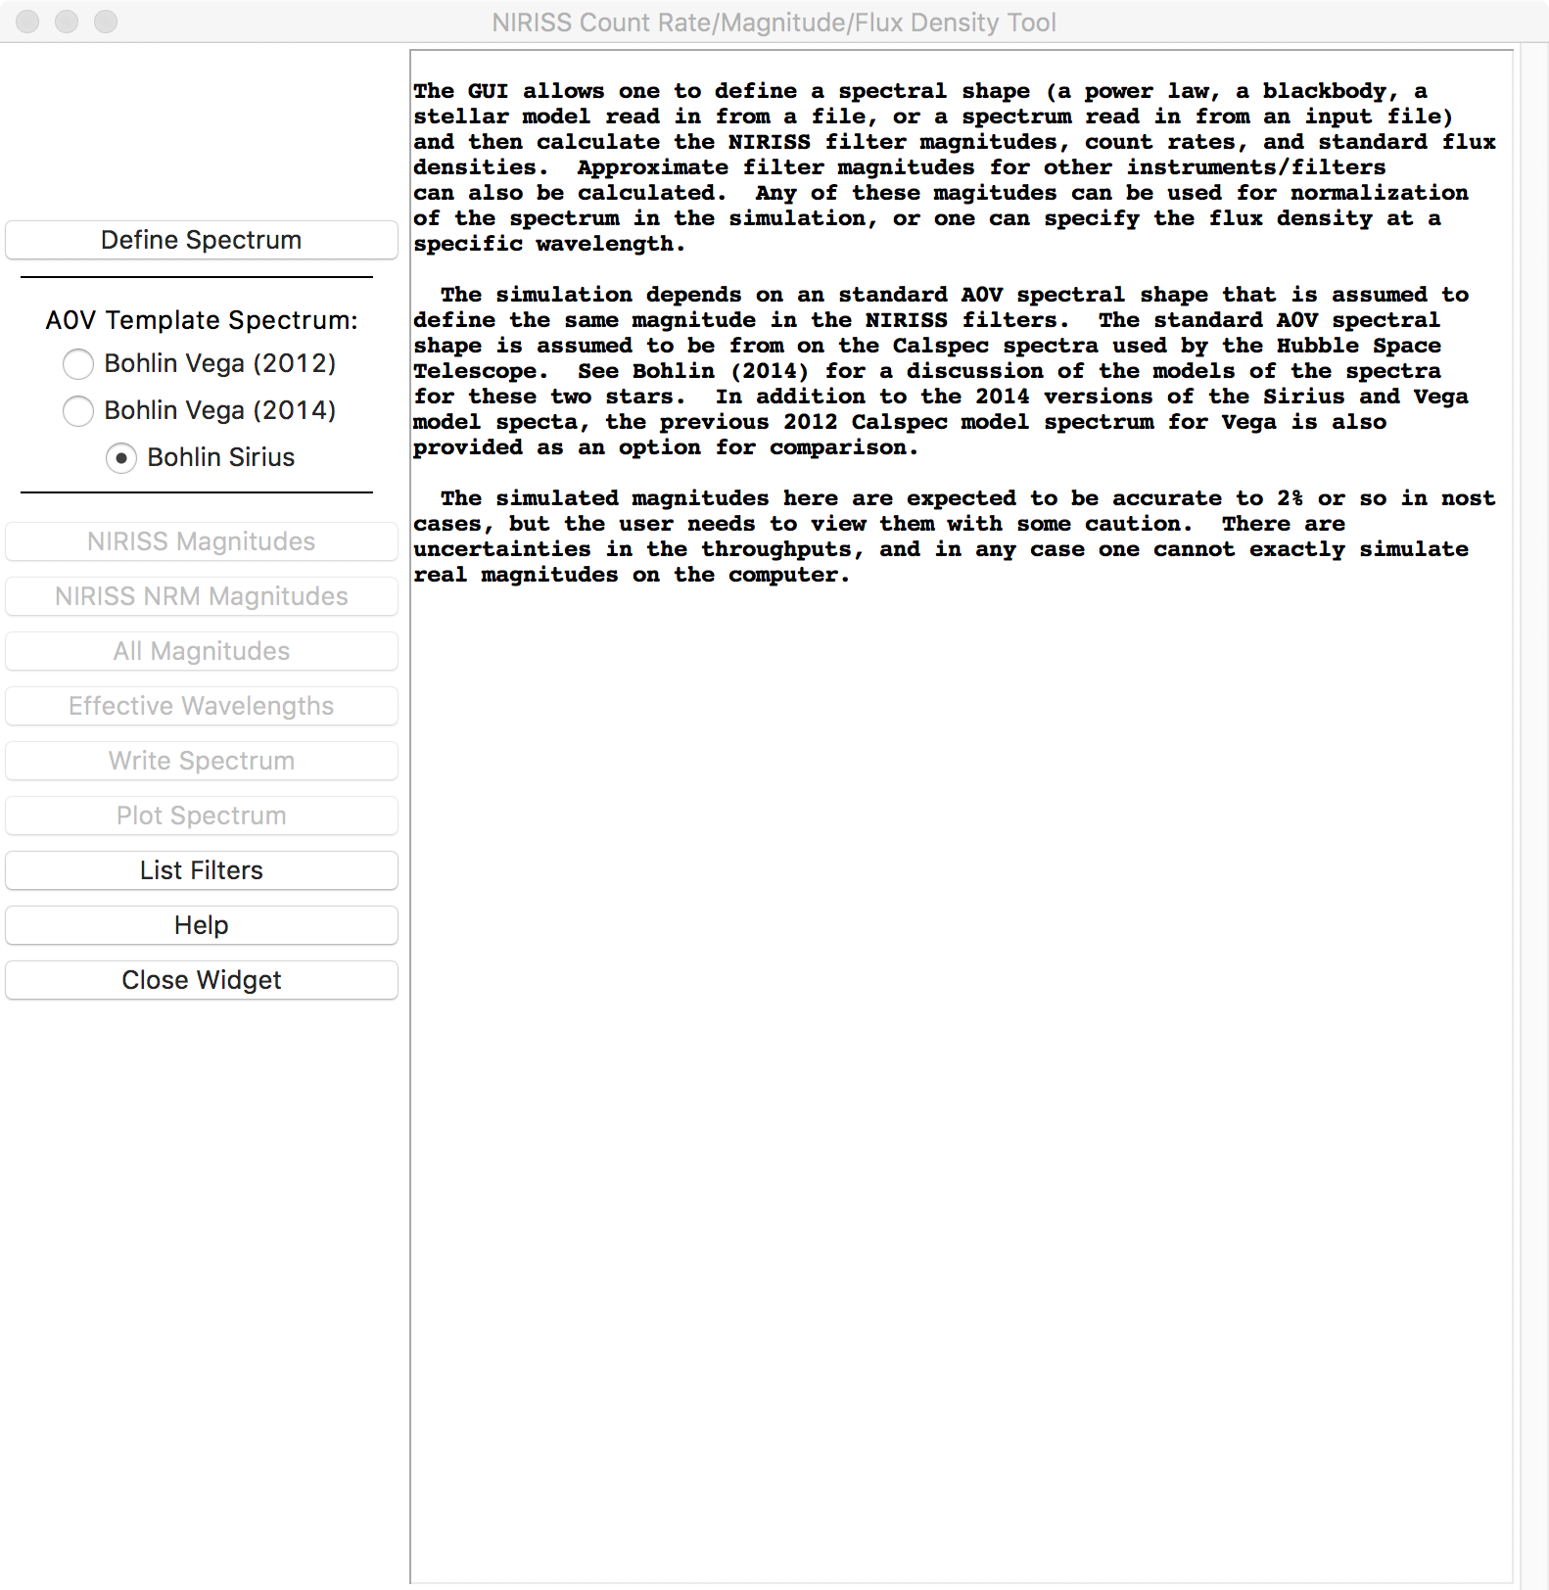

Figure 1: The magnitude.py main window, as it appears in the initial start-up.

Note that Sirius is of spectral type A0mA1Va in Gray et al. (2003). This indicates that the star is of spectral type A0V but appears to be of type A1V based on the metal lines. Sirius has a metallicity 4 times that of Vega. For the purpose here, Sirius is treated as an A0V star.

It is important to note that this is approach different than the “Vega magnitudes” used by the HST instruments, where Vega is assigned magnitude 0.0 in all filters. The HST method is different than the Johnson “Arizona” system and those other magnitude systems that use the same assumption, where the average colours of A0V standard stars between filters is set to 0.0, as was mandated by the IAU in 1917 for relating different magnitude systems. The “average A0V” systems do not assign a specific magnitude to Vega in any filter; it is just by chance that Vega as an A0V standard has UBV magnitudes that are close to 0.0 in the Johnson system. What is being done here is assuming that the A0V spectral template represents an average A0V spectrum and matching the NIRISS magnitudes to the V-band magnitude for either Vega or Sirius. The V magnitude values are taken to be +0.03 and ­­−1.415 for Vega and for Sirius respectively. The zero magnitude count rates and flux density values are taken from the A0V standard spectral shape with a scaling to adjust from the assumed magnitude to magnitude 0.0.

The proper way to simulate the A0V-based magnitude standardization would be to have detailed spectral models of a number of specific A0V stars that might be used as photometric standards for NIRISS and then simulate the observations of these stars as a group, from which zero magnitude count rates would need to be selected to make the average count rates in the different NIRISS filters correspond to the same magnitude. One could make this attempt just from the Sirius and Vega template spectra. The result of this would be intermediate between the results obtained using Sirius as the A0V template and the results obtained using Vega as the A0V template. Inasmuch as neither Vega or Sirius can be observed by NIRISS it was judged that that level of simulation was not needed. It is simpler to just take the magnitudes of either Vega or Sirius as fixed for the current simulation. The differences in the results that are obtained due to the selection of the three available A0V spectral templates are smaller than the uncertainties in the NIRISS response (mostly due to uncertainties in the detector quantum efficiency and photon yield).

The usual first step is to define a spectral shape for the calculations. This is done with the “Define Spectrum” button at the upper left. This brings up a selection window as shown in Figure *2* below. This window allows one to select from a variety of spectral shapes and then to define the overall normalization of the spectrum. Note that the internal calculations are carried out for spectra in Fλ form, with expected units of wavelength in μm and flux density in W/m2/μm, these being common units used in the infrared astronomy.

The window provides options for a number of spectral shapes. One can define a power law in wavelength, defined as

|  |  |
| --- | --- |
|  | (1) |

where the power law index α is selected by the entry field or the slider. When this option is used the wavelength array for the spectrum is a duplicate of the wavelength values for the standard A0V spectrum (which varies over the three choices). An α value of 0.0 produces a flat spectrum in Fλ. The α value can be selected in the range from –10 to +10.

The next option is a blackbody spectrum of the form

|  |  |
| --- | --- |
|  | (2) |

with T being the temperature, and h, c, and k being the Planck constant, the speed of light, and the Boltzmann constant respectively. In that case the temperature can be selected in the range from 1.0 K to 106 K either by the slider or by entering a value in the entry box. The slider has a logarithmic scaling to cover the large range. As with the power law case, the wavelength values used with this option are taken from the A0V standard spectrum.

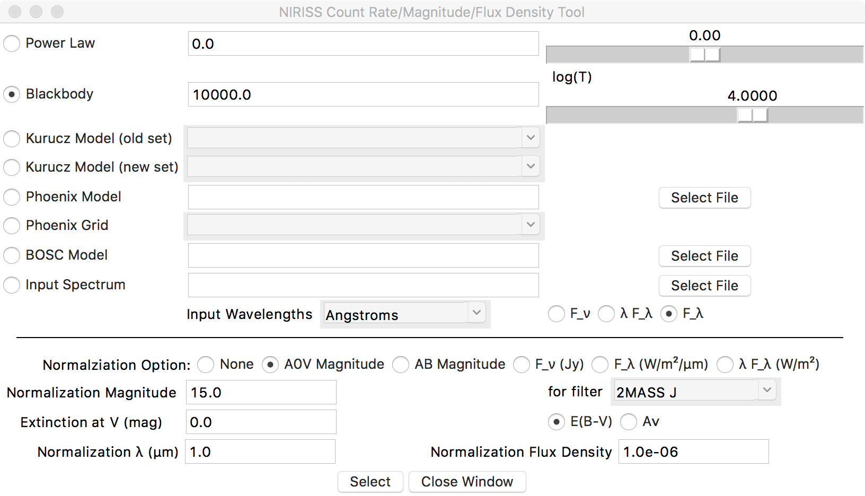

Figure 2: the spectrum selection window from magnitudes.py. One can select from the various options at the top of the window for the overall spectral shape. The lower region allows one to define the normalization and apply interstellar extinction to the spectrum if desired.

The first two options are, in general, poor approximations for the spectra of astronomical sources. The next four options allow one to use stellar atmosphere model spectra to define the spectral shape. There are two options for the Altas models of Kurucz (1992) or Castelli and Kurucz (2003), referred to as the “old” and “new” Kurucz model sets. The first set is from the Kurucz CD-Rom but only includes the solar metallicity models. There are 410 models that cover a range of temperature from 3500 K to 30000 K and log10(g) values from 0.0 to 6.0, and then a specialized solar spectrum and a specialized Vega spectrum for a total of 412 models in the set. The second set from Casteli and Kurucz (2003) has the full range of metallicities from +0.5 to –2.5 and the same range of T and log10(g) as in the older set of models. These models are stored in ascii form in files oldkurucz.list, oldkurucz.ascii, newkurucz.list, and newkurucz.ascii, which are included with the code. The more recent models of Bohlin et al. (2017) from the Atlas code are better in wavelength coverage than these older Atlas models, and are recommended for use with the code, but that set of models is far too large to package with the code. See below for how to use the Bohlin et al. (2017) files in the code.

The Kurucz models have sparse wavelength coverage beyond 10 μm. To allow the full set of magnitudes to be approximately calculated, the long wavelength spectrum is extrapolated with Fλ ∝ λ-4. The mid-infrared filter magnitudes from the Kurucz models are therefore only approximate. If any user needs to predict the NIRISS magnitudes based upon long wavelength photometry such as from Sptizer MIPS or the longer wavelength IRAF filters then the safest way to do this is to provide a good quality spectrum covering the JWST wavelengths and the longer wavelengths so as to get good relative magnitudes between the JWST filters and the mid-infrared filters. The A0V spectral templates all cover out to about 300 μm so this is not an issue for those models.

The next two options are for Phoenix stellar model files. A large set of Phoenix model files are available at France Allard’s web site <http://perso.ens-lyon.fr/france.allard/> and these individual files can be read by the code if one enters a file name in the “Phoenix Model” option. Those files can be either compressed with bzip2 or xz (the latter being equivalent to 7-zip) as is the case when any of the files are downloaded or be uncompressed. The code attempts to uncompress the file for the calculation and then recompress it later if the file name has .bz2 or .xz in it. This uncompressing requires that bunzip2 and xz are installed and can be called from the command line, since the os package is used to run the commands for uncompressing and compressing the files. Also the user must have write access in the directory where the compressed file is stored. These Phoenix models have a good wavelength coverage into the infrared. An example file, lte046.0-2.5-0.0a+0.0.BT-Settl.spec.7.xz, is included with the code for testing purposes. This file is for T=4600 K and log10(g)=2.5, approximately matching a K1III star.

There is also a separate grid of Phoenix models described by Husser et al. (2013). The Husser models can be downloaded from <http://phoenix.astro.physik.uni-goettingen.de/>; if this is done, and if the code is provided with the path to the directory where these files are stored, then they can be used via the “Phoenix Grid” option. The set of Phoenix grid files is not provided along with the code and needs to be downloaded separately if one wishes to use this option. Note that the Husser et al. (2013) set of Phoenix models only cover the wavelength range to 5 μm, and so while they are useful for simulating the NIRISS magnitudes they cannot be used to simulate the MIRI magnitudes or a number of the far-infrared magnitudes that the program can use. Even for NIRISS there will be a small error in the F444W filter count rates with these models because the filter has some response at wavelengths beyond 5 μm.

The final stellar atmosphere model option is to use one of the BOSC models. Those models can be obtained from <https://archive.stsci.edu/prepds/bosz/>. The models can be in either FITS table form or in a bzipped ascii file. The set of models is far too large to be provided with the code. If one downloads any of the BOSC model files they can be used with the code by selecting the file with the “BOSC Model” option. The code can read the FIST table versions and it is able to read either the .asc.bz2 files or the unzipped .asc versions. If the bzipped version is requested, the code will use the bunzip2 command (assuming that it is available on the system) to unzip the file to ascii form, then it will read the file, and then it will use the bzip2 command to re-zip the file. The process requires that the user of the code have write permission in the directory where the .asc.bz2 file is stored, otherwise it will fail. An example file from the BOSZ grid, amp00cp00op00t10000g40v20modrt0b300000rs.fits, is included with the code for testing purposes. This is approximately an A0V spectral model.

The last of the spectral shape options is to read in a spectrum from an ascii file. The file needs to have wavelengths in column 1 and flux density values in column 2. Other columns are ignored. Any lines or parts or lines after the “#”, “\”, or “|” characters are taken to be comments and are ignored. The file needs to have two columns consistently through the file, except for comment lines that are skipped. The units in the ascii file are set by the various option fields on the next line in the window. The spectrum is assumed to have wavelengths in either Å or μm units, as can be selected by the menu. The spectrum can be either Fλ, λFλ, or Fν as selected by the radio button adjacent to the wavelength unit menu. Note that the input spectrum will be converted to wavelengths in μm and to Fλ from whatever the type of spectrum is specified.

If the first two wavelengths in the file are in descending order rather than ascending order the arrays will be inverted in order when they are read in. It is important to note that the code does not check the input spectrum in any way besides inverting the order of the wavelengths if the first two values indicate that the wavelengths are in decreasing order, as happens with some codes that work in frequency or energy units and then write out wavelengths. There is no check that the input spectrum is “reasonable” nor that the wavelengths are in sorted order. These details are left to the user. If a user inputs a spectrum with negative or zero flux density values, or if the wavelength values are not sorted the code may crash or produce bad results. If the wavelength range is not sufficient to cover the set of filters the code will also produce bad results in some circumstances. The code does not attempt to make these type of checks of the input values.

An example asci spectrum file smp_lmc_58_model.txt is included. This file has wavelengths in μm and Fλ values in W/m2/μm. The object SMP LMC 58 is a planetary nebula in the Large Magellanic Cloud that will be used for NIRISS wavelength calibration in the wide-field slitless spectroscopy mode. The model is reasonably accurate in the 1 to 5 μm range but is known to be inaccurate at longer wavelengths where the dust emission is not properly modelled. If this file is used without normalization the simulated 2MASS J magnitude will be about 15.81.

## Selecting a Normalization for the Spectrum

Once the spectral shape has been specified, the next step is to define the normalization and whether any interstellar extinction factor is to be applied. These parameters are set in the lower part of the window. The first selection line in the bottom part specifies how the normalization is to be done with a radio button. One can select no renormalization of the spectrum, normalization to a Vega magnitude in a selected filter, normalization to an AB magnitude in a selected filter, or normalization to a flux density value at a specific wavelength. In the latter case, one has the option of specifying Fλ in units of W/m2/μm, λFλ in units of W/m2, or Fν in units of Jansky as selected the by individual radio buttons.

If one selects a magnitude, then the filter and the magnitude value need to be defined in the second line in this part of the window. Any of the 132 filters, from JWST, HST, and other telescopes or satellites, can be selected for the normalization if a filter magnitude is to be used. Note that some of the spectral models may not cover the full wavelength range of the set of filters, and in that case normalization in those filters is not possible. If the requested filter is not within the wavelength range of the specified spectrum then no renormalization is carried out.

If one selects normalization at a particular wavelength then the wavelength and the normalization value in the required units are specified in the fourth line in this part of the window, the “Normalization λ (μm)” and “Normalization Flux Density” fields. When this option is used the spectrum is linearly interpolated to the specified wavelength (if possible), and then the input flux density value is compared to the specified normalization flux density to determine the scaling. Once the scaling factor is calculated, it is applied to the whole spectrum. In the interactive usage of the code there is no check that the scaling is positive.

For either of these options there is the ability to apply interstellar extinction to the spectrum after it is defined and before the normalization takes place. The extinction is specified in magnitudes either as E(B – V) or AV as selected by the radio button options on line 3 of this part of the window. The infrared extinction curve used is based on Rieke and Lebofsky (1985) with some revisions to the extinction at wavelengths from 7 to 23 μm based upon IRAS low resolution spectral data. At shorter wavelengths a standard optical extinction cure and a UV extinction curve are used. The assumption is that AV = 3.52 E(B – V), so if an E(B – V) value is entered it is multiplied by 3.52 to convert to AV for the internal calculations of the extinction as a function of wavelength. The ratio between 0.44 μm and 0.55 μm is 3.0852, but integrated over the filter the ratio is about 3.52 depending a little on the spectral shape. The extinction is actually defined at 0.55 μm rather than in the V filter, but for hot star spectral shapes the overall V extinction is close to the value at 0.55 μm. For M-type stars the exact ratio varies a bit.

Once the “Select” button is activated the parameters from the window are set and the window is closed. The function buttons in the main window that start out as inactive are activated. If one closes the window with the “Close Window” button then the parameters are not set, and if the spectral shape has not been defined the various function buttons remain inactive. If a spectral shape has been previously defined it stays in place until a new shape is defined and the “Select” button is activated again.

## Filter Profile and Throughput Information

To carry out the normalization in terms of magnitudes the filter profiles of the JWST, HST, and other filters need to be defined. These values come from several files. For NIRISS the individual throughput values for the internal instrument optics and for the JWST main optics are stored in a set of FITS table files. These are the same files that were provided to the JWST Exposure Time Calculator. For NIRCam the total photon conversion function for side A taken from <https://jwst-docs.stsci.edu/display/JTI/NIRCam+Filters#NIRCamFilters-Filtertransmissions> and include the telescope throughput. The required values were extracted and repackaged in file nircam_filter_throughputs.out for use with the code. A similar process was carried out for the MIRI throughput values from <http://rcamera.as.arizona.edu/MIRI/pces.htm> to produce the file miri_filter_throughputs.out for use here.

For the other filters the profiles are read in from non_jwst_filters.data. The various response curves included here have been assembled by Kevin Volk from a wide range of sources over about 30 years. The sources of these curves are in general not documented as the file was originally intended for use only by Volk. The file lists wavelengths and response values for a filter and then gives a line marked by a # symbol that lists the filter name, wavelength, and zero magnitude flux density in Jansky. Then values for another filter are listed through to the end of the file. The values here in some cases can be traced back to the data source such as Cohen et al. (2003) for the 2MASS filter profiles, or data from the SVO Filter Profile Service page (<http://svo2.cab.inta-csic.es/svo/theory/fps>), or from the Spitzer Space Telescope instrument pages, while others come from Allen’s *Astrophysical Quantities* in one edition or another. Any experts in magnitude simulation may find grounds to dispute the throughput curves or the zero magnitude flux density values that are used here. Hence the user is warned against assuming that the simulated magnitudes must be accurate. Nonetheless they provide some basis for transformation of non-JWST magnitudes into approximate estimates of the NIRISS brightness.

The NIRISS throughput values are the best available estimates prior to the launch of JWST. However, there are uncertainties in some of the values that are likely to produce significant differences of order 10%, possibly more at the shortest wavelengths covered by NIRISS) between the real on-orbit performance and the simulations from this code or from the JWST ETC. The real performance of NIRISS will only be determined in JWST commissioning and in early calibration. The history of the calibration of the NIRISS filters and detector properties will not be described here; suffice to say that the NIRISS detector properties are not as accurately determined as we would have liked and so there are uncertainties in the predictions of the NIRISS response that cannot be resolved until we are able to observe standard stars on-orbit.

# Magnitude Simulations

For the normalization of a specified spectral shape by a filter magnitude the in-band flux

|  |  |
| --- | --- |
|  | (3) |

or the photon total flux

|  |  |
| --- | --- |
|  | (4) |

is calculated for the A0V standard spectral shape and for the specified spectral shape. The photon total flux is used for the JWST filters and the flux is used for all other filters. The ratio of the flux for the object to the flux for the A0V standard spectral shape is used to define a magnitude as in

|  |  |
| --- | --- |
|  | (5) |

where m0 is the assumed standard magnitude for either Vega or Sirius in the filter, depending on which star is selected to define the A0V standard shape, and F represents either the in-band flux or the photon total flux as appropriate. The Vega magnitude values are taken from the literature in some cases, but more generally are assumed to be either +0.03 to make the colour with respect to Johnson V equal to zero or taken to be +0.00 for those infrared magnitude systems that indicate that they use Vega as a definition of magnitude 0. The standard magnitude for Sirius is taken to be –1.415 for all filters; this is the best estimate of the V magnitude as is discussed below. The brightness of Vega and of Sirius pose problems for finding reliable magnitude measurements in the literature, and in general either near-infrared interferometic measurements or the old Johnson measurements are preferred for the relative brightness calibration. The relative normalization draws upon currently unpublished work by George Rieke on the comparison of the standard magnitudes for Vega and Sirius and the match between these values and the Bohlin stellar models.

Figure 3 below shows the simulated magnitude difference between the two stellar atmosphere models as calculated from the in-band flux or the photon total flux for the set of filters used in this code, except for the Sloan filters where the in-band flux is not used for the magnitude simulation. Also shown on the plot are the observed magnitude difference in V band from the old Johnson measurements (Johnson et al. 1966 and Cousins 1971, as stated by George Rieke in the unpublished document) and the 2.22 μm value from Rieke et al. (2008). The assumed V magnitude of Sirius from the Cousins paper is –1.415, and at 2MASS KS Sirius is taken to 1.37 magnitudes brighter than Vega. Combined with the colour V – Ks for Vega from Rieke et al. (2008) and the V magnitude of +0.03 for Vega this produces a Ks magnitude estimate of –1.419 for Sirius and hence a V – Ks value of +0.004 magnitudes, consistent with zero colour. These values are not the same as what is reported in SIMBAD for the UBV and 2MASS JHKs magnitudes for Sirius and Vega.

The results from the simulations agree with the assumed standard magnitude differences to within about 0.02 magnitudes. This is taken to be the uncertainty in the relative A0V magnitude calibrations with Vega and Sirius. There are possible additional zero point magnitude offsets of 0.03 magnitudes in the near-infrared if the magnitude system assumes that Vega defines zero magnitude, as is done for example by Cohen et al. (2003) for the 2MASS absolute calibration, or whether Vega or the average A0V star is assumed to have the same magnitude in the filters. For the NIRISS magnitudes we assume a standard Vega magnitude of +0.03 in all the filters to match the V magnitude or a standard Sirius magnitude of –1.415 in all filters. However, this assumption for Vega is inconsistent with the Ks magnitude value from Reike et al. (2008) which is –0.036. That offset may produce an overall zero point discrepancy between the magnitudes for the NIRISS filters and magnitudes in the literature, depending upon which “system” is being used and whether Sirius or Vega is taken to be the standard A0V spectral shape. The latter choice will also affect the colours simulated for stars of other spectral types to some degree.

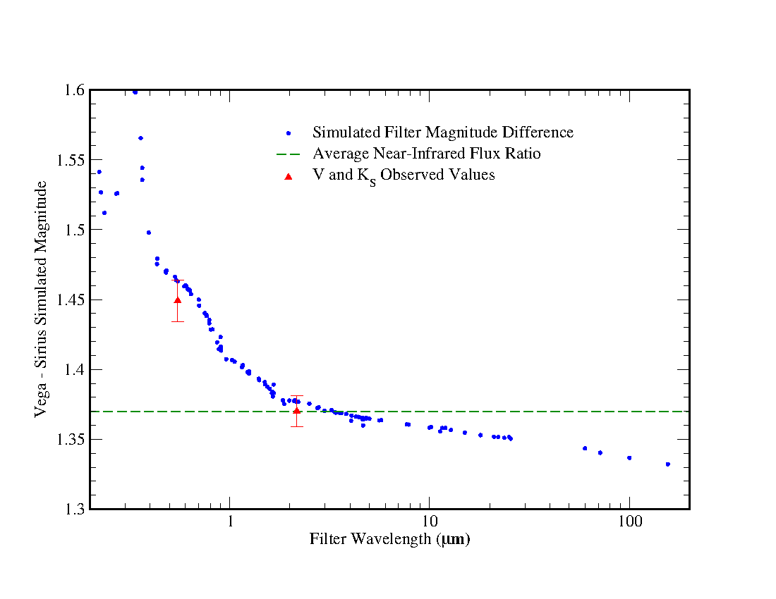

Figure 3: Simulated magnitude differences between the Bohlin 2014 Sirius stellar model and the Bohlin 2014 Vega stellar model (blue triangles) for a wide range of filters as simulated in the magnitudes.py program. Shown in red is the measured magnitude difference at V and at 2.22 μm (close to 2MASS Ks). The green dashed line shows the average near-infrared (1 to 5 μm) magnitude ratio derived by George Rieke from the MSX measurements and available ground-based comparisons.

Using the assumed standard magnitudes for Sirius or Vega and the stellar model spectra allows one to produce zero magnitude count rate estimates for the NIRISS filters. These require the assumed JWST primary mirror area as well as the through-put values. The mirror area is assumed to be 25.326 m2. These estimates are not the same because the relative in-band flux varies with wavelength as in Figure 3. Table 1 lists the derived zero magnitude count rate values from the three possible assumptions about the average A0V spectral shape available here. The Vega (2012) values are higher than the Vega (2014) values by a uniform value of 0.7% in all the NIRISS filters. The zero magnitude values from the Sirius spectrum range from 2.1% lower for the F090W filter to 6.5% lower for the F480M filter. The difference in zero point count rates is due to the discrepancy between the adopted Vega V – Ks value of 0.0 magnitudes and the actual estimated value of 0.066 from Rieke et al. (2008). Or another way to look at this is that the difference in the relative V and K flux densities for Vega as compared to Sirius due to the lower effective temperature (9400 K compared to 9850K) produces the zero point discrepancy because the magnitudes are tied to the V band photometry.

Table 1: The simulated zero magnitude count rates for the NIRISS imaging filters with the three possible assumptions about the standard A0V spectral shape and associated magnitudes. If the NRM is in place these values are scaled by a constant factor of 0.15/0.84. The zero magnitude count rates using Sirius as the A0V template differ from those from using Vega as the A0V template by between 2% and 7%.

|  |  |  |  |
| --- | --- | --- | --- |
| Filter | Simulated Zero Magnitude Count Rate (electrons/second) | | |
| Sirius | Vega 2014 | Vega 2012 |
| F090W | 1.225 1011 | 1.251 1011 | 1.258 1011 |
| F115W | 1.026 1011 | 1.061 1011 | 1.067 1011 |
| F140M | 3.207 1010 | 3.348 1010 | 3.367 1010 |
| F150W | 6.080 1010 | 6.363 1010 | 6.400 1010 |
| F158M | 2.835 1010 | 2.975 1010 | 2.993 1010 |
| F200W | 4.182 1010 | 4.424 1010 | 4.449 1010 |
| F277W | 2.435 1010 | 2.587 1010 | 2.603 1010 |
| F356W | 1.602 1010 | 1.709 1010 | 1.719 1010 |
| F380M | 2.887 109 | 3.081 109 | 3.099 109 |
| F430M | 1.874 109 | 2.004 109 | 2.016 109 |
| F444W | 9.800 109 | 1.048 1010 | 1.054 1010 |
| F480M | 1.678 109 | 1.795 109 | 1.806 109 |

## The Sloan Filters

The Sloan filter magnitudes are not on the normal logarithmic magnitude system that applies to all the other filters simulated here. Sloan magnitudes are calculated from the mean flux density in Jy using the nominal AB magnitude zero point of 3631 Jy along with the “softening” parameters (b) and filter offsets from the AB standard value. The individual zero-point offsets used here are from Convey et al. (2007). The b values are taken from the SDSS web page <http://www.sdss.org/dr12/algorithms/magnitudes/#asinh>. The mean flux density in Jy (see equation 7b below) is used for the flux density in the calculation of the Sloan magnitudes. The Sloan magnitude is assumed to be the same as the AB magnitude for the purposes of normalization.

If a Sloan magnitude is selected for the normalization there is no difference between the AB magnitude and A0V magnitude options. The mean flux density from the spectrum is compared to the mean flux density calculated from the Sloan magnitude and this defines the scaling of the spectral shape. Note that Sloan magnitudes can go to zero or negative flux density values. There is no check in the code to prevent this. The user needs to be aware of the upper bound on the Sloan filter magnitudes. Also note that for Sloan catalogue values that are very close to the limit the selection of the AB magnitude offsets and the sky background values used in the Sloan magnitudes may affect the results if these are slightly different than the values used in the code from the Covey et al. (2007) paper.

## Imaging with the NIRISS Non-Redundant Mask

The magnitude definition is for regular NIRISS imaging. If the NIRISS non-redundant mask (NRM) is used for science the overall throughput is changed by two constant factors: there is a wavelength dependent throughout factor of 0.84 that applies to the long wavelength NIRISS imaging filters (F277W through F480M) because of the presence of a metric alignment PAR element in the CLEARP slot within the NIRISS Pupil wheel that is used along with the filters in the Filter wheel (see <https://jwst-docs.stsci.edu/display/JTI/NIRISS+Pupil+and+Filter+Wheels> for a description of the elements in the NIRISS Pupil wheel and Filter wheel). When switching to the NIRISS Aperture Masking Interferometry mode the CLEARP element is removed from the beam and the NRM is put in the beam in its place. The CLEARP throughput is estimated to be 0.84 independent of wavelength. The NRM throughput is estimated to be 0.15 independent of wavelength. Thus in the NRM mode the count rates are expected to be scaled by a fixed factor of 0.15/0.84 = 0.17857. For the NRM mode the simulated count rates and the zero magnitude count rate values are both scaled by this constant factor and the magnitude of any given object is assumed to be the same as in regular imaging.

# Conversion of Count Rates to Flux Density

The magnitude values for NIRISS will be determined by the relative count rates observed on sky. A separate issue is how to convert from count rate to flux density in a meaningful way. There is no one-to-one conversion from the count rate to the flux density at any given wavelength. The NIRISS detector records the total number of photons per unit time received from any source in the field of view, but this does not provide information about the distribution of those photons with wavelength within the filter passband. There is no general conversion from the observed NIRISS signal values to physical units such as Fν in Jansky for NIRISS imaging that provides the correct measurement for objects of all possible spectral shapes. In the JWST data reduction pipeline the absolute calibration is to surface brightness in units of either MJy/steradian or Jy/square arc-second. This requires first a conversion of the count rate to Jy and then division by the pixel area in either steradian or square arc-seconds to produce the surface brightness measurement.

The absolute calibration to Jansky as carried out for NIRISS imaging in the JWST data reduction pipeline uses the (photon-weighted) mean flux density in Jansky. Following Bohlin, Gordon, and Tremblay (2014), the mean flux density is defined as

|  |  |
| --- | --- |
|  | (6) |

This value is proportional to the NIRISS count rate, as is seen in equation (4) above. For an input spectrum in W/m2/μm as is used in the code, the resulting value also has those units. To transform the value to Jansky the equation used is

|  |  |
| --- | --- |
|  | (7a) |
| with the mean frequency flux density defined by |  |
|  | (7b) |

where c is the speed of light and λp is the pivot wavelength, assumed to be in units of μm. The pivot wavelength is defined by

|  |  |
| --- | --- |
|  | (8) |

with λ measured in μm. The pivot wavelength ensures that and are correctly calculated whether one choses to calculate the mean flux density in wavelength units, as is done here, or in frequency units. Equations (6) and (8) correspond to equations (3) and (10) in Bohlin, Gordon, and Tremblay (2014). Table 2 lists the λp and values for the NIRISS filters as derived from the simulation code.

The pivot wavelength is independent of the source spectrum. The mean flux density value or is not the actual flux density in the source spectrum at the pivot wavelength. In the absence of detailed spectral shape information for a given source one cannot determine the actual flux density of the object at any particular wavelength within the NIRISS filter passband. If the actual flux density value is to be determined the spectral shape needs to be defined, after which one can find the relation between the real flux density Fν and the mean flux density at the pivot wavelength or at some other wavelength of interest. It is important to keep this distinction between the and Fν values in mind when interpreting results from NIRISS imaging. In general, if one normalizes a spectrum to the value at the λp wavelength and calculates the NIRISS magnitude and the associated mean flux density in Jansky the output value will not match the input value. If one uses the in Jansky value to determine a NIRISS magnitude value from the quoted zero magnitude flux density values and normalizes to that value, the code will produce a consistent result.

The analogous calculations are carried out for the other JWST instruments, and the conversion from count rate to flux density is done in the same way. Hence the magnitudes and flux densities for the four JWST instruments are on the same system.

For the non-JWST filters the mean flux density values are calculated from equations (6) and (7) above in the same way as is done for the JWST instruments. In these cases the f(λ) function may not include the detector response, and also likely does not include the telescope throughput function. Exactly what throughput is being used depends on the filter and the source of the throughput values. However, the mean flux density values should be fairly accurate in most cases. The only exception would be if a particular filter depended on the detector to provide a cut-off (usually at long wavelengths) and this was not included in the thoughput function.

Table 2: The calculated zero magnitude mean flux density values and pivot wavelength values for the NIRISS imaging filters. These are the same when the NRM is used. The pivot wavelength does not depend on the shape of the A0V template spectrum.

|  |  |  |  |  |
| --- | --- | --- | --- | --- |
| Filter | λp (μm) | Zero Magnitude Value (Jansky) | | |
| Sirius | Vega 2012 | Vega 2014 |
| F090W | 0.9025 | 2269.178 | 2316.677 | 2330.094 |
| F115W | 1.1495 | 1764.163 | 1825.206 | 1835.776 |
| F140M | 1.4040 | 1289.576 | 1345.961 | 1353.756 |
| F150W | 1.4935 | 1178.127 | 1232.900 | 1240.030 |
| F158M | 1.5820 | 1067.824 | 1120.755 | 1127.246 |
| F200W | 1.9930 | 746.977 | 790.204 | 794.780 |
| F277W | 2.7643 | 427.100 | 453.817 | 456.446 |
| F356W | 3.5930 | 265.409 | 283.037 | 284.677 |
| F380M | 3.8252 | 232.048 | 247.652 | 249.086 |
| F430M | 4.2828 | 187.666 | 200.625 | 201.787 |
| F444W | 4.4277 | 179.313 | 191.737 | 192,847 |
| F480M | 4.8152 | 151.310 | 161.908 | 162.846 |

# Outputs From the Program

Once the spectral shape has been defined the code allows one to calculate the NIRISS magnitudes. The previous section described the basis for the simulation of the NIRISS magnitudes. The magnitude values are calculated as in equation (5) above using the photon total flux values as in equation (4) above and the assumed JWST primary mirror area value of 25.326 m2. The calculation is carried out using the “NIRISS Magnitudes” button once this is active. The values are written to the text area of the main window as well as being appended to a file named niriss_magnitudes.out in the current directory. Several comment lines are presented giving the parameters for the calculation, followed by lines for the 12 NIRISS imaging filters giving the filter name, the magnitude value, the mean flux density values in wavelength and frequency form, and finally the pivot wavelength value. Carrying out the calculation for the Kurucz (1991) Vega and Solar models produces the following output with the default normalization to magnitude 15.0 at 2MASS J and the default Sirius A0V spectral template:

# A0V template spectrum: Bohlin Sirius (2014)

# Model Spectrum: Old Kurucz model T = 9400.0 log(g) = 3.95000 z = 0.00

# No ISM extinction

# Normalization: A0V magnitude 15.000000 for filter 2MASS J

# Filter Magnitude Count Rate Mean F_lambda Mean F_nu Pivot Wavelength

# electron/sec W/m^2/micron Jy Microns

NIRISS F090W 15.01609 1.207234e+05 8.229947e-15 2.235782e-03 0.902457

NIRISS F115W 15.00324 1.022478e+05 3.990365e-15 1.758902e-03 1.149542

NIRISS F140M 14.99059 3.235414e+04 1.978230e-15 1.300805e-03 1.404035

NIRISS F150W 14.99279 6.120600e+04 1.594084e-15 1.185976e-03 1.493457

NIRISS F158M 14.99563 2.846247e+04 1.284251e-15 1.072133e-03 1.582011

NIRISS F200W 14.98361 4.245329e+04 5.723816e-16 7.583375e-04 1.992961

NIRISS F277W 14.98227 2.475433e+04 1.703242e-16 4.341301e-04 2.764281

NIRISS F356W 14.97859 1.634392e+04 6.286159e-17 2.706949e-04 3.593004

NIRISS F380M 14.97966 2.941714e+03 4.844194e-17 2.364369e-04 3.825227

NIRISS F430M 14.97543 1.917360e+03 3.135962e-17 1.919614e-04 4.283827

NIRISS F444W 14.97433 1.003441e+04 2.807657e-17 1.836029e-04 4.427699

NIRISS F480M 14.97167 1.722172e+03 2.008103e-17 1.553108e-04 4.815243

# A0V template spectrum: Bohlin Sirius (2014)

# Model Spectrum: Old Kurucz model T = 5777.0 log(g) = 4.43770 z = 0.00

# No ISM extinction

# Normalization: A0V magnitude 15.000000 for filter 2MASS J

# Filter Magnitude Count Rate Mean F_lambda Mean F_nu Pivot Wavelength

# electron/sec W/m^2/micron Jy Microns

NIRISS F090W 15.34831 8.890043e+04 6.060513e-15 1.646425e-03 0.902457

NIRISS F115W 15.10446 9.314680e+04 3.635186e-15 1.602343e-03 1.149542

NIRISS F140M 14.81941 3.787916e+04 2.316046e-15 1.522939e-03 1.404035

NIRISS F150W 14.75294 7.633671e+04 1.988156e-15 1.479161e-03 1.493457

NIRISS F158M 14.68272 3.796962e+04 1.713222e-15 1.430251e-03 1.582011

NIRISS F200W 14.62236 5.921230e+04 7.983370e-16 1.057702e-03 1.992961

NIRISS F277W 14.59839 3.525371e+04 2.425660e-16 6.182634e-04 2.764281

NIRISS F356W 14.58380 2.351095e+04 9.042725e-17 3.893983e-04 3.593004

NIRISS F380M 14.58218 4.242187e+03 6.985715e-17 3.409610e-04 3.825227

NIRISS F430M 14.59335 2.726058e+03 4.458639e-17 2.729263e-04 4.283827

NIRISS F444W 14.60097 1.415258e+04 3.959934e-17 2.589545e-04 4.427699

NIRISS F480M 14.62242 2.375610e+03 2.770031e-17 2.142399e-04 4.815243

The pivot wavelength is the same for all spectral shapes and is given only to provide the λ value used in the conversion of the value from the value.

When the NIRISS magnitude values are calculated the zero magnitude flux count rate values are written out to a new file named niriss_zero_magnitude_countrates.txt. This file is provide for information purposes although the values are not directly used in the internal calculations. The file is overwritten each time the “NIRISS Magnitudes” button is activated.

To generate the full set of simulated magnitudes one can use the “All Magnitudes” button. This produces a list of 132 magnitudes in different filters. The values are appended to a file named all_mgnitudes.out in the current directory and are written to the text window. In this case the first six columns are the same as in the NIRISS magnitudes output, except that for the non-JWST filters the simulated in-band flux in W/m2 is given rather than a count rate in electrons/second. The mean flux density values and pivot wavelength values are calculated for all filters just as is the case for the NIRISS filters, and they are listed in the output file. A seventh column is added giving the AB magnitude value, and an eighth column is also added which has the symbol C or F depending on whether the third column lists the electron count rate or the in-band flux. All the count rates use the JWST primary mirror area in the calculation, while the in-band flux values are in W/m2. This option writes out the NIRISS magnitudes along with all the others.

## The “NIRISS NRM Magnitudes” Button

As noted previously, when the NRM is placed in the NIRISS beam for aperture masking interferometry observations the count rates are expected to be reduced by a constant factor due to the geometric blockage from the mask as compared to the PAR element in the CLEARP position. The “NIRISS NRM Magnitudes” button produces the expected count rates when the NRM is in the beam but scaling the count rates by the constant factor of 0.15/0.84. The format for the output that is produced is shown just below. The count rates are scaled but the other output values are the same as in regular imaging. Only the four long wavelength filters are listed as these are the only ones allowed to be used with the NRM.

# Assumed A0V spectral template: Bohlin Sirius (2014)

# Model Spectrum: Old Kurucz model T = 9400.0 log(g) = 3.95000 z = 0.00

# No ISM extinction

# Normalization: A0V magnitude 15.000000 for filter 2MASS J

# Imaging with the NRM

# Filter Magnitude Count Rate Mean F_lambda Mean F_nu Pivot Wavelength

# electron/sec W/m^2/micron Jy Microns

NIRISS F277W 14.98227 4.420416e+03 1.703242e-16 4.341301e-04 2.764281

NIRISS F380M 14.97966 5.253060e+02 4.844194e-17 2.364369e-04 3.825227

NIRISS F430M 14.97543 3.423857e+02 3.135962e-17 1.919614e-04 4.283827

NIRISS F480M 14.97167 3.075307e+02 2.008103e-17 1.553108e-04 4.815243

## Other Functions

The code has a few other function buttons besides the ones producing the magnitude estimates. The first of these is the “Effective Wavelengths” button. After a spectrum has been defined one can use this button to generate a number of filter effective wavelength values that have been used in the literature, and the flux density values of the standard A0V spectrum at these wavelengths, for the NIRISS filters. This is general information to show whether the flux density values at these various wavelengths differ from one another. Use of this button produces two output files: effective_wavelengths.out which simply lists a number of the effective wavelength values for the 12 filters, and effective_wavelengths_long.out which also gives the flux density values at the different effective wavelengths filter by filter.

The different definitions of the filter wavelength tabulated in the output file are listed in Table 3 below. The filter wavelength values are all given in μm, and the flux density values are given in units of Jansky, W/m2/μm, and W/m2. Except for the mean flux density values as defined in equation (6) above and the associated values calculated using the pivot wavelength, all the flux density values are determined by linear interpolation of the A0V template spectrum. For some of the wavelength values and some of the NIRISS filters there are strong spectral lines near the filter effective wavelength, and in this case the flux density values can change by up to 25% for small changes in the wavelength value. This is the case for the NIRISS F090W filter for example, as the Hydrogen Paschen 10 → 3 line at 0.9017 μm is close to the mean wavelength of the filter, and it is broad enough in A0V stars to affect the flux density at the different filter wavelengths.

Once a spectrum has been defined the normalized spectrum can be written out using the “Write Spectrum” button. This produces a file named scaled_spectrum.txt in the current directory. The file has the wavelength in μm in the first column, the Fλ value in W/m2/μm in the second column, and the Fν value in Jansky in the third column. There are some header lines that give the parameters of the normalization and the extinction values, if any. Each time the button is used the values overwrite any file already present in the current directory. The code also produces a file named scaled_spectrum_etc.txt, which gives the spectrum in a form that can be used as an input to the JWST Exposure Time Calculator: there are no comments, the first column has wavelengths in μm, and the second column has the Fν value in mJy. Such a file can be uploaded to the ETC and used directly. One can select the option to not renormalize the spectrum so as to make a direct comparison between the count rates predicted by this code and the count rates calculated in the ETC, if some care is taken to allow for possible aperture corrections in the ETC results. The values calculated here are the total count rates over the entire image of the source on the detector, whatever shape that might be.

Table 3: Some definitions of the filter wavelength used in the literature. These are not an exhaustive list of the possibilities. All of these values are listed in the output files produced by the “Effective Wavelengths” button in magnitudes.py.

|  |  |
| --- | --- |
| Quantity | Definition |
| Synphot pivot wavelength |  |
| Mean wavelength |  |
| Photon mean wavelength |  |
| Central wavelength, λc |  |
| SDSS effective wavelength |  |
| Flux weighted mean wavelength |  |
| Photon flux weighted mean wavelength |  |

One can also make a plot of the A0V template spectrum along with the specified object spectrum. This is the function of the “Plot Spectrum” button. It produces a log-log plot of the two spectra in λFλ form, to reduce the range on the y axis. In the plot the A0V template spectrum is scaled by the same normalization as is used for the object spectrum, to keep both spectra in roughly the same flux density range. Figure 4 shows the way the plot window appears. The plot is at left and there are some control buttons at right. One can put values into the range fields in the upper right to change the x or y axis range when the “Apply Range” button is clicked. Once the range is changed, it can be reset to the default using the “Autoscale Plot” button. One is also able to save the plot in postscript or PNG form. The plot shows the A0V template spectrum in red and the defined spectrum in blue. Both spectra have the same normalization applied. If the normalization is a magnitude the two spectra are scaled to the same count rate or in-band flux value. If the normalization is at a given wavelength then the two spectra are separately normalized to that value for the plot.

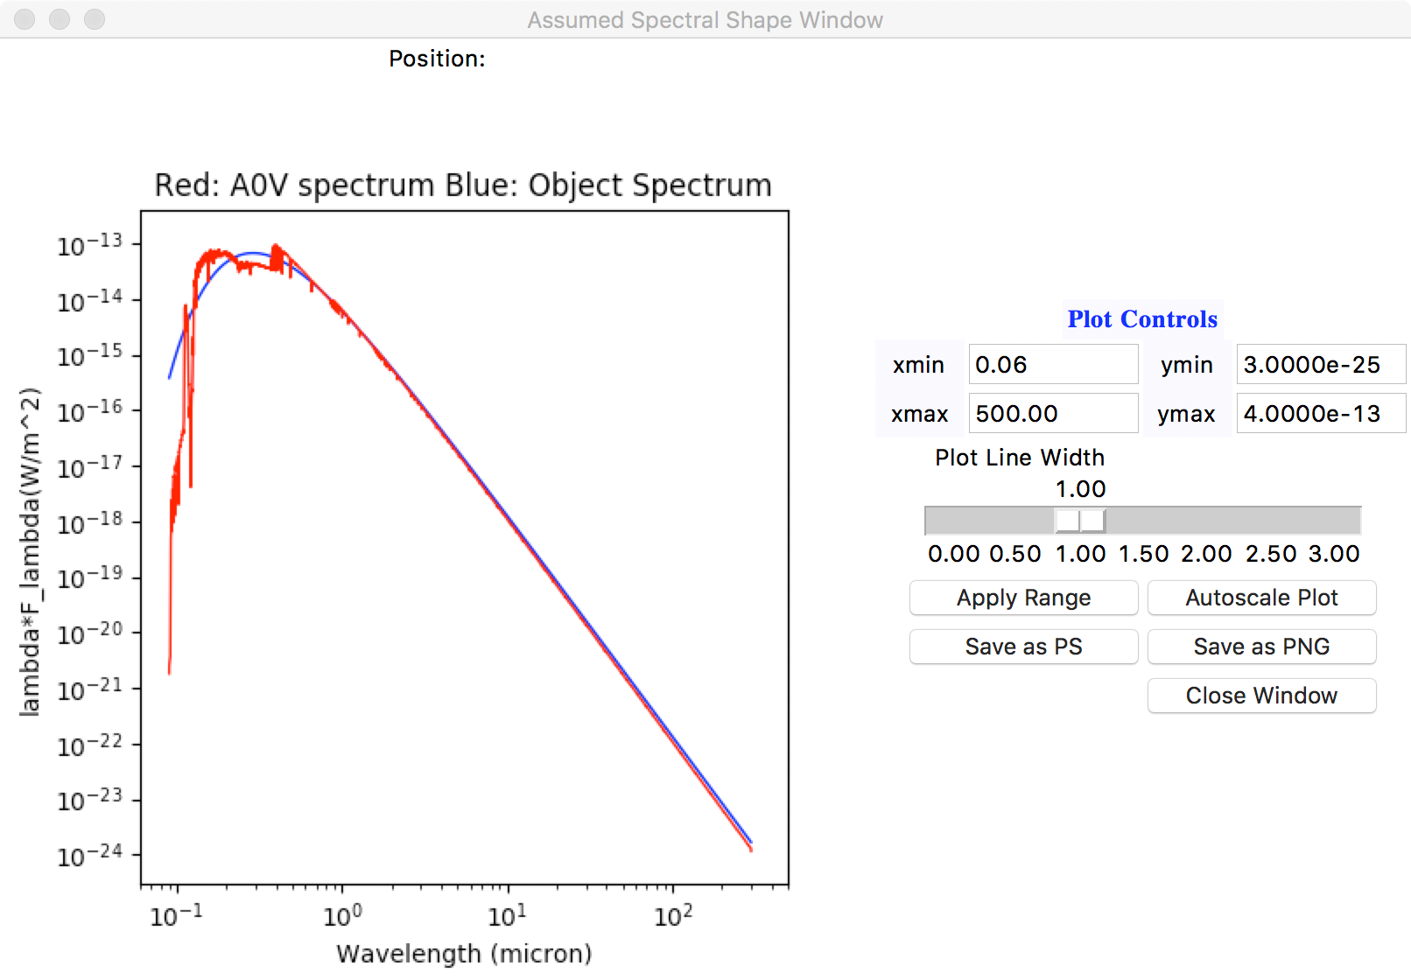

Figure 4: An example of the appearance of the spectrum plot window. In this case the object spectrum is a 10000 K blackbody spectrum.

The “List Filters” button produces a list of the filter names, wavelengths, and zero magnitude flux densities for those filters considered in the program. The NIRISS, NIRCam, and MIRI filters are listed first and then the other filters are given afterwards. The list is written to the text area and to a file named filter_list.out in the current directory. The wavelengths and zero point flux densities for the non-JWST filters are the values listed in the non_jwst_filters.data file. The values for the JWST instruments are calculated from the filter profiles and the selected A0V spectral shape.

There is a “Help” button that writes some additional help information into the text area. That information is mainly concerned with the details of the magnitude simulation rather than providing help in using the functions in the program. The information here is much more detailed than the help available within the program.

# Non-Interactive Usage

One is able to run the program without creating the user interface. In that case the parameters need to be defined on the command line. As there are a fair number of parameters the number of options is also fairly large as well. The non-interactive usage is flagged by having the option –nogui on the command line. If this option is absent, the command line parameters are ignored and the user interface is used.

The most basic command-line usage is of the form

magnitudes.py magnitude option parameter -nogui

where the three parameters are used to define the object spectrum. These are assumed to be first a normalization magnitude, then the option describing which type of spectrum is to be used, and then the parameter for selecting the spectrum. The use of a Vega magnitude value for the normalization is the default. One can override this option, but a numerical value still needs to be provided as the first parameter after the program name. The next parameter, option, selects which spectral shape is to be used. The allowed values are: powerlaw, blackbody, oldkurucz, newkurucz, phoenix, phmodel, BOSZ, and input. These correspond to the button options in the spectrum selection window. The first four are for a power law spectrum, a blackbody spectrum, one of the Kurucz (1991) models, or one of the Castelli and Kurucz (2003) models. The option “phoenix” is for the use of one of the Allard Phoenix stellar model files, “phmodel” is for use of one the Husser et al. (2013) Phoenix stellar models, and “BOSZ” is for use of one of the Bohlin et al. (2017) Atlas9 stellar models. The option “input” allows the user to specify an input asci file for the spectrum. So to use the Kurucz (1991) Vega model spectrum normalized to NIRISS F090W magnitude of 17.0 one would use the command

magnitudes.py 17.0 oldkurucz 412 -nogui

assuming that magnitudes.py is somewhere in one’s path.

The parameter is used to select the file or model or define the shape parameter. The type of parameter depends on the option:

* for powerlaw the parameter is a number, the power law index;
* for blabkbody the parameter is a number, the temperature in K;
* for oldkurucz the parameter is an integer number between 1 and 412, the model index;
* for newkurucz the parameter is an integer number between 1 and 3808, the model index;
* for phoenix the parameter is the Allard Phoenix model file name;
* for phmodel the parameter is the name of the Husser et al. (2013) Phoenix grid file;
* for BOSZ the parameter is the name of the Bohlin et al. (2017) stellar model file;
* for input the parameter is the asci file name.

There are only minimal checks on the parameter values in the code in the command line usage. For the file names, there is no check that the file exists or is of the right type.

For the “input” option there are a number of additional flags that allow the user to tell the program about the units and type of spectrum that is being read in. These flags are:

* “-angstroms’ to flag that the wavelengths are in Angstroms, rather than the default assumption of μm;
* “-fnu” to flag that the spectrum values are Fν values, rather than the default of Fλ;
* “-lfl” to flag the that spectrum values are λFλ values, rather than the default of Fλ;
* “-factor value” to cause the input spectrum to be scaled by the number specified following the “-factor” flag.

The default is to use a Vega magnitude normalization with the Sirius A0V model template spectrum and the NIRISS F090W filter. One can select a different filter for the normalization with an option such as

magnitudes.py magnitude option parameter –nogui –normmag 10

which selects filter 10 in the filter list, the NIRISS F430M filter, for the normalization. The filter number can be from 1 to 132. To obtain a list of the filters one can use the “List Filters” button in the GUI, and see the list in filter_list.out that this produces. The filter numbers in that file correspond to what is used in the command line option.

If one wishes to specify an AB magnitude the option “-abmag” can be specified. This produces the same result as using the “AB magnitude” button in the GUI.

To produce a normalization at a specific wavelength or to specify no rescaling of the input spectrum one uses one of four command line options:

-normflambda wavelength flux

-normfnu wavelength flux

-normlfl wavelength flux

-noscale

such as

magnitude.py 15.0 blackbody 10000.0 –nogui -normflambda 1.0 1.e-15

magnitude.py 15.0 blackbody 10000.0 -normfnu 2.056 0.001

magnitude.py 15.0 blackbody 10000.0 -normlfl 0.55 8.6e-20

magnitude.py 15.0 blackbody 10000.0 -noscale

which produce normalizations of Fλ = 10-15 W/m2/μm at 1.0 μm, Fν = 0.001 Jy at 2.056 μm, λFλ = 8.6 10-20 W/m2, and no rescaling of the spectrum respectively. These “-norm” flags must be followed by two real number values and the values must be positive, non-zero numbers.

One can specify extinction with the flag “-extinction 2.0” where the number after the flag is the extinction in magnitudes at V. The value is assumed to be E(B – V) unless a “-av” flag is present, in which case the value is assumed to be an AV value in magnitudes. Hence to get an AV value of 0.5 magnitudes the flags “-extinction 0.5 -av” would be used.

The default is to use Sirius as the A0V template spectrum. The optional flags “-oldvega” and “-newvega” can be used to select the 2012 Vega template or the 2014 Vega template respectively.

The normal command line usage calculates the NIRISS filter count rates and magnitudes. One can ask for the full set of magnitudes using the optional “-magnitudes” flag, which produces the same result as using the “All Magnitudes” button in the GUI. One can specify the NRM calculation using an optional “-nrm” flag, in which case the result is the same as using the “NIRISS NRM Magnitudes” button in the user interface.

Finally, one can direct the program to write out the scaled spectrum with the “-spectrum” flag. This produces the same result as using the “Write Spectrum” button in the user interface.

# References

Bohlin, R. C., 2014, AJ, 147, 127B.

Bohlin, R. C., Gordon, K. D., and Tremblay, P.-E., 2014, PASP, 126, 711B

Bohlin, R. C., Mészáros, S., Fleming, S. W., Gordon, K. D., Koekemoer, A. M., and Kovács, J., 2017, AJ, 153, 234B.

Castelli, F., and Kurucz, R. L. 2003, in IAU Symp. 210, Modelling of Stellar Atmospheres, ed. N. Piskunov, W. W. Weiss, and D. F. Gray (San Francisco, CA: ASP), A20.

Cohen, M., Wheaton, Wm. M., and Megeath, S. T., 2003, AJ, 126, 1090.

Cousins, A. W. J. 1971, Ann. Roy. Obs., 7, 1.

Covey, K. R., Ivezic, Z., Schlegel, D., Finkbeiner, D., Padmanabhan, N., Lupton, R. H., Agueros, M. A., Bochanski, J. J., Hawley, S. L., West, A. A., Seth, A., Kimball, A., and Go, S. M., 2007, AJ, 134, 2398.

Gray, R. O., Corbally, C. J., Garrison, R. F., McFadden, M. T., and Robinson, P. E., 2003, AJ, 126, 2048

Husser, T.-O., Wende-von Berg, S., Dreizler, S., Homeier, D., Reiners, A., Barman, T., and Hauschild, P. H., 2013, A&A, 553, 6H.

Johnson, H. L., Mitchell, R. I., Iriarte, B., & Wisniewski, W. Z. 1966, Comm. Lun. and Plan. Lab., 4, 193.

Kurucz, R. L., 1994, in IAU Symp. 149, Stellar Populations of Galaxiers, ed. Beatriz Barbuy and Alvio Renzini (Kluwer, Dordrecht), p. 225.

Rieke, G. H., and Lebofsky, M. J., 1985, ApJ, 288, 618.

Rieke, G. H., Blalock, M., Decin, L., Engelbracht, C., Ogle, P., Avertt, E., Carpenter, J., Cutri, R. M., Gordon, K., Gray, R. O., Hinz, J., Su, K., and Willmer, Christopher N. A., 2008, AJ, 135, 2245.