CRDS Affected Datasets

Tools and System

Todd Miller

Science Software Branch

2016-05-20

Scope

This document describes the CRDS system which is used to determine the IDs of datasets which are affected by the submission of new reference files. Affected datasets become candidates for reprocessing by the pipelines.

Overview
The effects of new references are nominally computed by running the crds.bestrefs program on multiple sets of dataset/observartion instrument configuration parameters using two different sets of reference assignment rules; the recommended references under context #1 are compared to the recommended references under context #2. Where best reference recommendations differ, those datasets become candidates for reprocessing. In the case of tables, there is a proposed optimization whereby the old and new tables are themselves compared, and a dataset should only be reprocessed if the table rows applicable to that dataset differ. The table optimizations are currently incomplete and not yet activated.

The CRDS reprocessing system consists of these components:

1. crds.bestrefs program
The crds.bestrefs program can be configured to evaluate two contexts with respect to a set of dataset parameters and compare the results, outputting the IDs of those datasets where reference files change. This program can be configured and run by anyone in this mode but but unlike the pipeline use case is typically dependent on the CRDS server to rapidly provide dataset matching parameters. Dataset parameters can be accessed from data files, but that method depends on dataset file availability and is also slow relative to dumping a database.

2. CRDS dataset parameter acquisition
The CRDS server has a system for acquiring data set IDs and best reference assignment parameters from the archive database. For HST, this system makes direct SQL queries to a replicated copy of the DADSOPS database. For JWST, this system acquires dataset IDs and parameters from an archive web service. The CRDS server in turn makes these parameter sets available to the crds.bestrefs program via a standard web service on the CRDS server.

3. CRDS server context change monitor
The CRDS server VM runs a cron job which monitors the CRDS server for changes in the operational context. When the operational context changes, the cron job computes affected datasets using crds.bestrefs and captures the results. This provides a central shared “official” repository of reprocessing information which can be downloaded over the web or obtained from several different e-mail lists.

4. CRDS Server Results Service
The CRDS server provides a raw web service which can be used to query the captured results from the affected datasets monitor described in (3) above. This service has intricate timing issues so direct use is not recommendend.

5. CRDS client reference script
The CRDS client library provides a reference client which shows how to use the web service defined in (4). This client is intended as a subclassable example which illustrates how to use the web service and takes a first stab at handling various nuances like the timing of results availability.

6. CRDS bestrefs optimizations
The crds.bestrefs tool has a number of optimizations which can limit the datasets which are considered for reprocessing.

6.1 Context Differencing
The crds.bestrefs program can difference two contexts to determine which instruments and types are affected by a context transition and only compute reprocessing results for those instruments and types.

6.2 USEAFTER date limiting
Based on the USEAFTER dates of new references, crds.bestrefs can limit the datasets evaluated to only those datasets with DATE-OBS and TIME-OBS >= USEAFTER.
The CRDS bestrefs program is equipped to difference to contexts to determine which instruments and types can be affected by the difference. This is an optimization which is used to avoid evaluating parameters for all instruments and dates.

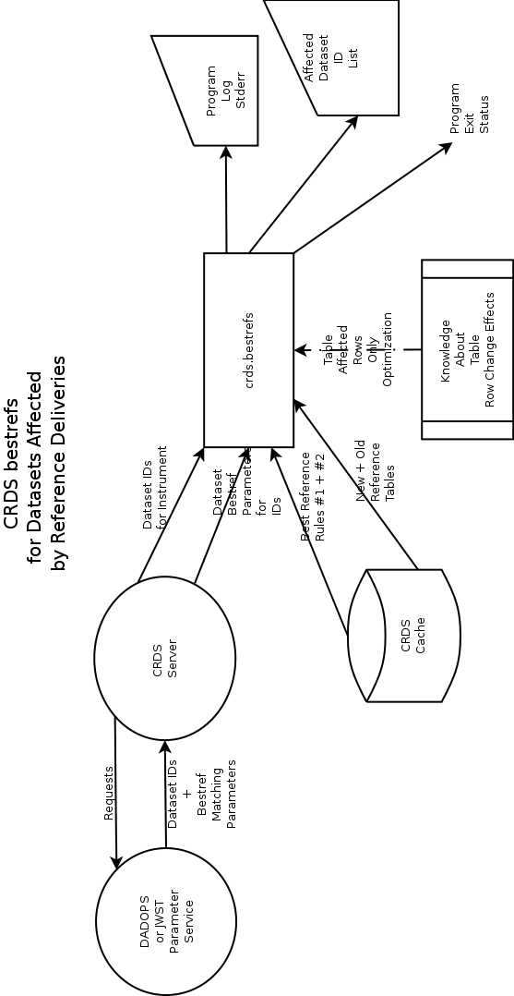
2. Server Side Reprocessing Monitor

The default context to be used in the the pipeline is defined on the CRDS server and then synchronized to the pipeline's cache. The CRDS server runs a cron job which monitors for changes in the pipeline context using a CRDS default context web service. The CRDS server also records the last context used for reprocessing and compares this to the current default from the web service. When the default context and last reprocessing context differ, a new reprocessing run is performed on the CRDS server by running the crds.bestrefs program using the two contexts as points of comparison. The results of crds.bestrefs are captured permanently in a directory on the CRDS server and made available for download via another CRDS web service. In addition to making the results available by web service, when the reprocessing job completes, it emits an e-mail which contains snipped log output and a compressed attachment specifying the dataset IDs which are candidates for reprocessing.

It's important to note that at present, the same crds.bestrefs program used by the HST pipeline to populate FITS files with best references is also used here in a different mode. It's also important to note that for JWST, crds.bestrefs is not used in the actual calibration pipeline, an equivalent function is built directly into the calibration code and executes automatically.

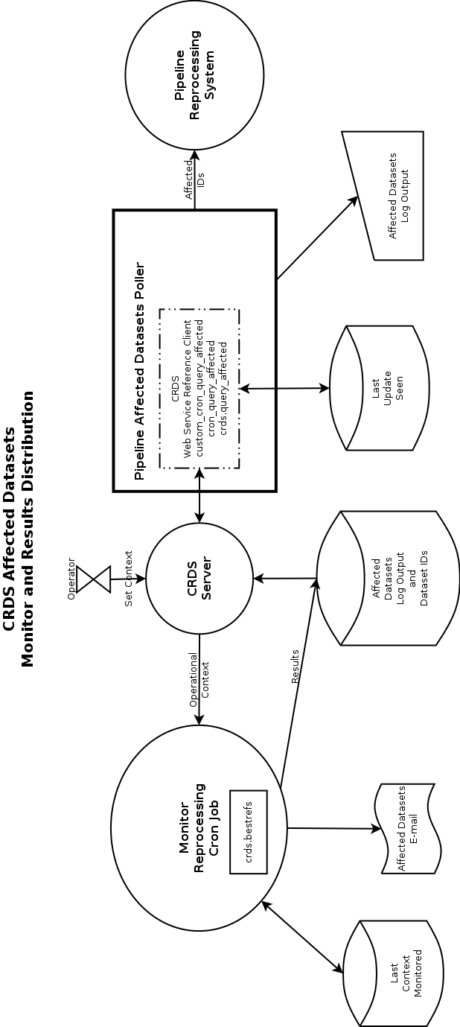

Obtaining Affected Datasets

Three different methods are available for obtaining affected datasets results:

1. Local crds.bestrefs run
End users have the option of running the crds.bestrefs program themselves to compute the affects of a context transition. Running the crds.bestrefs program themselves, end users have the option of choosing the crds.bestrefs configuration and behavior that best suits them, and have the option of processing arbitrary choices of old and new contexts. Some command line switch options of crds.bestrefs can be used to change the output produced by the context-to-context comparison.

2. Server Results E-mail
End users have the option of subscribing to several mailing lists to which the CRDS VM cronjob outputs centrally computed results. The CRDS e-mail of affected datasets includes a summary line in the subject which identifies the project and development level, the two contexts which defined this transition, the count of datasets affected by the transition, and the presence or absence of errors in the computation. The body of the e-mail consists of log output from crds.bestrefs which is snipped to limit the maximum number of lines in the event of large amounts of log output. The dataset ids which are affected by the transition are listed in a compressed plaintext e-mail provided as an attachement. The compression of the dataset id list prevents extremely long lists from overwhelming the capabilities of common mail programs.

3. CRDS Web Service Pull
End users have the option of polling a CRDS server web service which is used to distribute stored results. The CRDS library provides a module (crds.query_affected) and two example scripts (query_affected_datasets and custom_query_affected_datasets) to encapsulate the nuances of obtaining stored affected dataset results from the CRDS server. Crds.query_affected is intended to be used as-is (query_affected_datasets) or sub-classed (custom_query_affected_datasets). The scripts maintain state on a users file system which records the context transition last seen.

3.1 CRDS Context History
The CRDS server maintains a history of default contexts used in the archive pipeline which is updated when the operator sets the default context on the web site. Not all contexts are adopted by the pipeline as default, sometimes some are skipped. Further, it's possible for the CRDS default context to transition backwards as a temporary work around for some issue in the latest context. The net result is that the context history can have gaps or reversals in the progression of context history context serial numbers.

3.2 Available Context Transitions
While the crds.bestrefs program can compute the datasets affected of any potential context transition, since there are N^2 possibilities, CRDS only pre-computes the official pipeline transitions which are recorded in the the context history. Only historical transitions are available by download from this service, users with requirements for arbitrary transitions must run the crds.bestrefs tool directly.

3.3 Affected Datasets Client Scripts
The CRDS client package installed in the pipeline provides a reference package and scripts which encapsulate the nuances of the CRD server's affected datasets web service. The affected datasets query scripts can be used to interactively query the server and to replay logs and lists of dataset ids from the context history, either individually or as ranges of combined transitions. Run in a polling configuration, the scripts produce output from each transition as it occurs. Because results may not be available on the CRDS server for minutes or hours after a transition, it's possible for polled output to indicate that no results are ready yet.

3.3.1 Affected Datasets Script Output

Run in the default mode, the script provides the crds.bestrefs output captured on the CRDS server to stderr. Run in quiet mode, most bestrefs output is suppressed and the script only outputs a few lines indicating which transition is being considered, whether results were ready, and whether errors occurred. In either mode, the list of affected dataset ids output on stdout is the same. The script is limited to querying the available stored results from official transitions on the CRDS server. The script cannot query transitions between aribtrary old and new context numbers not already stored on the CRDS server. The script can list all available transitions and replay them.

Email Output
This section discusses the affected dataset results which are available by e-mail.

Mailing lists
CRDS server VMs output e-mail results to multiple addresses, each VM has it's own list and the HST OPS server also outputs to datamng@stsci.edu.
List | Description
datamng@stsci.edu | Archive list
crds_hst_ops_reprocessing@maillist.stsci.edu | CRDS dedicated lists
crds_hst_test_reprocessing@maillist.stsci.edu | “
crds_jwst_ops_reprocessing@maillist.stsci.edu | “
crds_jwst_test_reprocessing@maillist.stsci.edu | “
crds_jwst_b6it_reprocessing@maillist.stsci.edu | “
crds_jwst_b7it_reprocessing@maillist.stsci.edu | “
crds_jwst_b8it_reprocessing@maillist.stsci.edu | “

Subject Line
Each results e-mail currently has a subject line describing one context transition. For example:
OK: CRDS hst ops datasets affected hst_0376.pmap --> hst_0377.pmap : 404 affected

Status Token
The first token is either OK, ERRORS, or FAILED. OK indicates that CRDS is aware of no problems with the computation. ERRORS indicates that some aspect of the computation resulted in errors which call some results into question. FAILED means that some aspect of the computation failed so badly that there are no results.
An example ERRORS would be if CRDS discovers that a parameter value provided by the archive is invalid or cannot possibly select a reference file. For example an ACS SHUTRPOS with a value or MULTI could cause CRDS ERRORS.
An example FAILED would be if the CRDS Server, DADSOPS, or archive web service was unavailable making the computation impossible.

Project and Development Level
The next portion of the subject line identifies which CRDS project and server the e-mail was issued from and that it is for affected datasets: CRDS hst ops datasets affected

Context Transition
The next portion of the subject line indicates the context transition for which the results were computed: hst_0376.pmap --> hst_0377.pmap

Affected Datasets Count
The final piece of subject information is the number of datasets which have been identified as candidates for reprocessing: 404 affected

Crds.bestrefs Program Output
The body of the e-mail contains the snipped output from the crds.bestrefs program bracketed inside summary lines from the cron job:
--------------------------------------------------------------------------------------------------------------
CRDS hst ops datasets affected hst_0376.pmap --> hst_0377.pmap on 2015-11-24-11:25:09
--------------------------------------------------------------------------------------------------------------
CRDS : INFO [2015-11-24 11:25:13,925] Mapping differences from 'hst_0376.pmap' --> 'hst_0377.pmap' affect:
{'wfc3': ['darkfile']}
CRDS : INFO [2015-11-24 11:25:14,618] Possibly affected --datasets-since dates determined by 'hst_0376.pmap' --> 'hst_0377.pmap' are:
{'wfc3': '2015-10-11 00:04:38'}
CRDS : INFO [2015-11-24 11:25:14,619] Computing bestrefs for db datasets for ['wfc3']
CRDS : INFO [2015-11-24 11:25:14,619] Dumping dataset parameters for 'wfc3' from CRDS server at 'https://hst-crds.stsci.edu' since '2015-10-11 00:04:38'
CRDS : INFO [2015-11-24 11:26:03,785] Downloaded 2536 dataset ids for 'wfc3' since '2015-10-11 00:04:38'
CRDS : INFO [2015-11-24 11:26:20,315] Updated exposure counts:
{'WFC3': {'darkfile': 760}}
CRDS : INFO [2015-11-24 11:26:20,316] Affected products = 404
CRDS : INFO [2015-11-24 11:26:20,317] Unique error types: 0
CRDS : INFO [2015-11-24 11:26:20,317] STARTED 2015-11-24 11:25:10.89
CRDS : INFO [2015-11-24 11:26:20,317] STOPPED 2015-11-24 11:26:20.31
CRDS : INFO [2015-11-24 11:26:20,317] ELAPSED 0:01:09.41
CRDS : INFO [2015-11-24 11:26:20,317] 0 total-files at 0.0 total-files-per-second
CRDS : INFO [2015-11-24 11:26:20,317] 2.5 K datasets at 36.5 datasets-per-second
CRDS : INFO [2015-11-24 11:26:20,317] 0 total-bytes at 0.0 total-bytes-per-second
CRDS : INFO [2015-11-24 11:26:20,317] 0 errors
CRDS : INFO [2015-11-24 11:26:20,317] 0 warnings
CRDS : INFO [2015-11-24 11:26:20,317] 14 infos
--------------------------------------------------------------------------------------------------------------
OK: CRDS hst ops datasets affected hst_0376.pmap --> hst_0377.pmap : 404 affected
--------------------------------------------------------------------------------------------------------------
Logs containing large numbers of warnings or errors are snipped in the center, showing only lines from the start and end of the log.

Context Difference Logging
The first few lines of the log generally indicate that crds.bestrefs was run in a differencing mode which computes which instruments, types, and dataset dates can possibly be afffected by this context transition. The differencing mode is an optimization which enables crds.bestrefs to produce results faster. For example, the output:
CRDS : INFO [2015-11-24 11:25:13,925] Mapping differences from 'hst_0376.pmap' --> 'hst_0377.pmap' affect:
{'wfc3': ['darkfile']}
CRDS : INFO [2015-11-24 11:25:14,618] Possibly affected --datasets-since dates determined by 'hst_0376.pmap' --> 'hst_0377.pmap' are:
{'wfc3': '2015-10-11 00:04:38'}

indicates that only WFC3 DARKFILE references need to be checked, and only for datasets taken after 2015-10-11 00:04:38. WFC3 DARKFILE is determined by differencing the two contexts. The date is computed by taking the minimum USEAFTER date of references revealed by differencing contexts. It is possible to by-pass the differencing optimization and run crds.bestrefs on all available datasets, instruments, and types; it takes longer to compute, up to 4-8 hours for all HST datasets, instruments, and types.

Database Status
The next few lines of log output indicate the actions and status for interactions with the archive database service which provides dataset parameters for which to compute best references:
CRDS : INFO [2015-11-24 11:25:14,619] Computing bestrefs for db datasets for ['wfc3']
CRDS : INFO [2015-11-24 11:25:14,619] Dumping dataset parameters for 'wfc3' from CRDS server at 'https://hst-crds.stsci.edu' since '2015-10-11 00:04:38'
CRDS : INFO [2015-11-24 11:26:03,785] Downloaded 2536 dataset ids for 'wfc3' since '2015-10-11 00:04:38'
The output identifies which CRDS server is being consulted and gives the definitive indication of which dataset dates will be considered. The output also indicates how many dataset parameter sets were found for each instrument relative to that date. Initially crds.bestrefs only queries for dataset ids, not the corresponding parameter sets. Later, incrementally, crds.bestrefs asks for parameter sets corresponding large blocks of ids and computes bestrefs as each block is retrieved.

ERROR messages
Any errors which occur during the process of computing best references will occur inline in the next section of the log.

Product Status
The next section of the log contains summary status about affected exposures and products which is presented after all computations have taken place:
CRDS : INFO [2015-11-24 11:26:20,315] Updated exposure counts:
{'WFC3': {'darkfile': 760}}
CRDS : INFO [2015-11-24 11:26:20,316] Affected products = 404

CRDS computes bestrefs for every exposure ID identified by the database. Very often, multiple affected exposures are associated with the same product. For HST CRDS only reports product IDs so that count is shown and indicates the rough number of lines in the affected IDs output file.

Program Status
The final section of the log contains a summary of any errors that occurred, timing information, and total counts of warnings and errors:
CRDS : INFO [2015-11-24 11:26:20,317] Unique error types: 0
CRDS : INFO [2015-11-24 11:26:20,317] STARTED 2015-11-24 11:25:10.89
CRDS : INFO [2015-11-24 11:26:20,317] STOPPED 2015-11-24 11:26:20.31
CRDS : INFO [2015-11-24 11:26:20,317] ELAPSED 0:01:09.41
CRDS : INFO [2015-11-24 11:26:20,317] 0 total-files at 0.0 total-files-per-second
CRDS : INFO [2015-11-24 11:26:20,317] 2.5 K datasets at 36.5 datasets-per-second
CRDS : INFO [2015-11-24 11:26:20,317] 0 total-bytes at 0.0 total-bytes-per-second
CRDS : INFO [2015-11-24 11:26:20,317] 0 errors
CRDS : INFO [2015-11-24 11:26:20,317] 0 warnings
CRDS : INFO [2015-11-24 11:26:20,317] 14 infos

Compressed Dataset IDs Attachment
The useful portion of the affected datasets e-mail is a gzipped text file (affected_ids.txt.gz) which lists one dataset product ID per line. Each listed HST product ID is a candidate for reprocessing. The nature of the IDs listed in JWST output is TBD. Example HST IDs:
jchl04f1q
jchl04f5q
jchx01010
jchx02010
jchx03010
…

