
ST-ECF Instrument Science Report

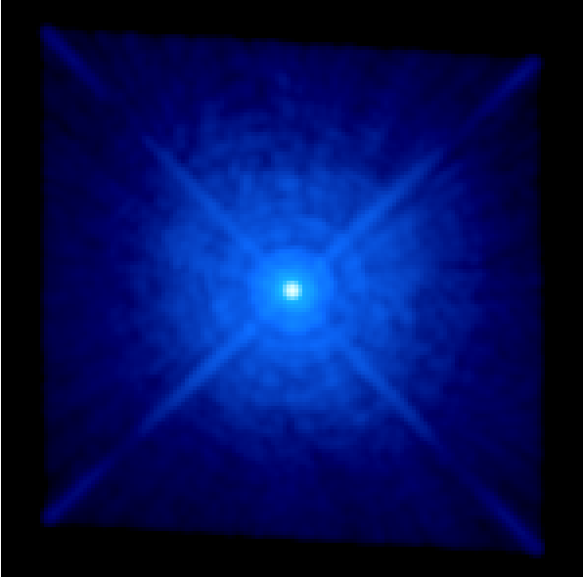

WFC3 Support in Tiny Tim

Richard Hook & Felix Stoehr, ST-ECF
June 2008

Introduction

Tiny Tim [1][3][4] was written by John Krist soon after Hubble was launched and has become the most widely used PSF simulator for all the cameras on the observatory. Over the years it has been extended to handle new instruments as they are installed and to incorporate many instrumental effects as they have been discovered. Simulated PSFs are useful for many applications including observation planning, modelling and image deconvolution. Tiny Tim is written in standard C and is very easy to install and run. With modern computers preparing a PSF typically only takes a few seconds.

In view of the forthcoming installation of a new camera, the Wide Field Camera 3 (WFC3), during the next Hubble servicing mission, later in 2008, it was clearly desirable to have WFC3 included in Tiny Tim before the phase II proposal period in the summer of 2008. After discussions with the WFC3 team at STScI it was agreed that the ST-ECF would take on this job and build on their experience with the initial NICMOS implementation back in 1997.

This document describes the WFC3 features that have been included in the initial release of Tiny Tim 7.0 and the comparisons that have been made between simulations and point-spread function data from the Thermal Vacuum tests made in Spring 2008. We also introduce a web interface to Tiny Tim.

Characteristics of WFC3 PSFs

Modifications to Tiny Tim for WFC3

Field-dependent Aberrations

Filters

Geometric Distortion
Preliminary estimations of the geometric distortion of the two WFC3 channels have been made from the optical model of the camera and converted into cubic two-dimensional polynomial coefficients in the standard IDCTAB format used for other Hubble cameras. These values, kindly made available by Colin Cox (STScI), are included in Tiny Tim 7.0 for use in tiny3 the last stage in the production of the PSF. They should be regarded as preliminary but are probably good enough for most purposes.

For the WFC3 UVIS channel the distortion is a strong skew, similar to that in the ACS. For the IR channel the main effect is a significant difference in the X and Y scales.

Charge Diffusion and Related Effects
CCD detectors suffer from charge-diffusion – photo-electrons created by incident photons are not confined precisely to a single pixel but leak into neighbouring ones. As a result a kernel (that can be well represented as a three-by-three matrix) effectively smoothes the PSF. This kernel is a strong function of wavelength, being a larger effect at shorter wavelengths. For the WFC3 UVIS channel we have included empirical charge diffusion kernels (Table 1) derived from thermal vacuum tests and kindly provided by George Hartig (STScI) [6]. These were derived at 250nm and 810nm and are linearly interpolated between these values. Although the code includes support of space-variant charge diffusion kernels (as implemented for ACS) no information is yet available for WFC3.

0.027 0.111 0.027 0.002 0.037 0.002
0.111 0.432 0.111 0.037 0.844 0.037
0.027 0.111 0.027 0.002 0.037 0.002

Table 1: Charge diffusion kernels for WFC3 UVIS CCD chips at 250nm (left) and 810nm (right).

For the infrared channel there is an Intra-Pixel Capacitance effect that smoothes the PSF and possibly other effects. For this channel we have used a single kernel with no wavelength or space-dependence, also provided by George Hartig. This is shown in Table 2.

0.002 0.038 0.002
0.038 0.840 0.038
0.002 0.038 0.002

Table 2: Diffusion kernel used for the WFC3 IR detector.

The knowledge of the diffusion effects will be refined at a later stage.

Cold-Mask Geometry
The WFC3 IR channel has a cold stop that introduces additional obscuration of the pupil. We have included this effect and modelled it as a circular obscuration of the outside of the pupil, a larger circular central obstruction and wider spiders, aligned with the OTA ones. The cold mask does not cover the pads holding the HST primary. The parameters we used were derived from [7]. The central obscuration radius was 0.354, the outer radius of the cold mask 0.9755 and the spider width 0.061, all expressed in units of the radius of the HST primary at the pupil.

Comparisons between Tiny Tim simulations and Test Data from TV3 Tests

UVIS Channel Comparisons

F275W
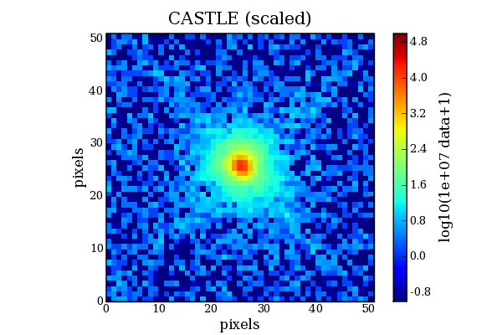
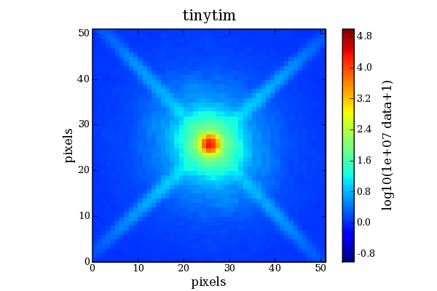

F336W
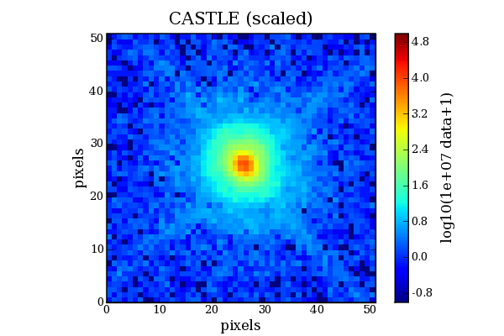
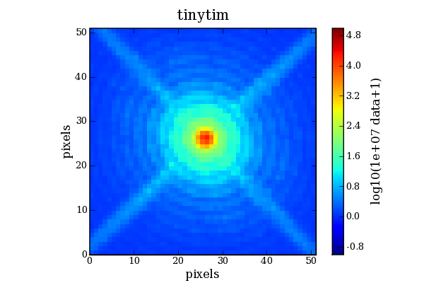

UVIS - F625W
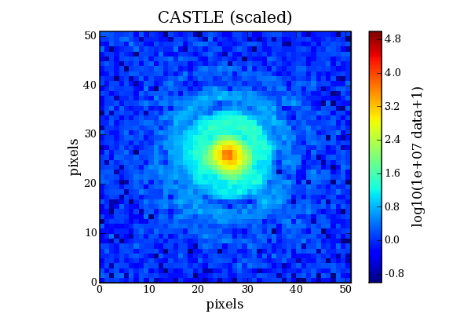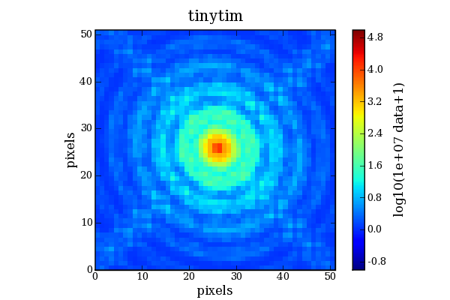

UVIS - F814W
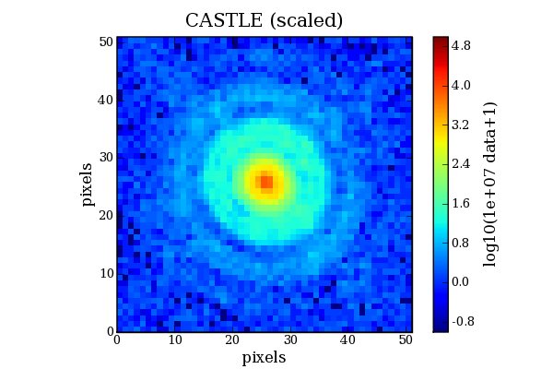
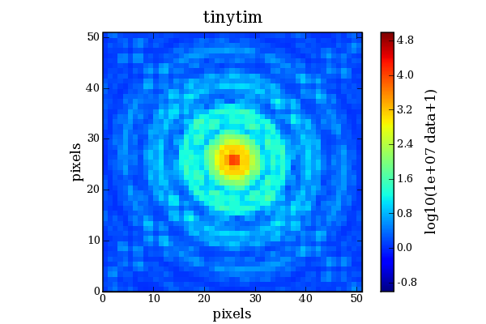

IR Channel Comparisons

IR - F105W
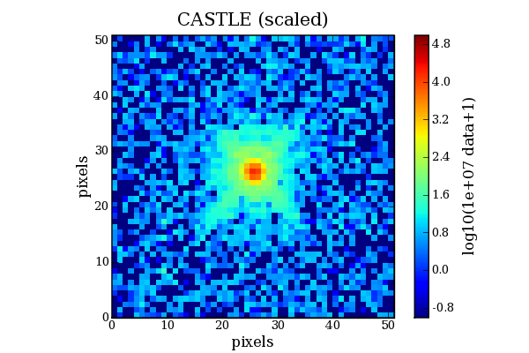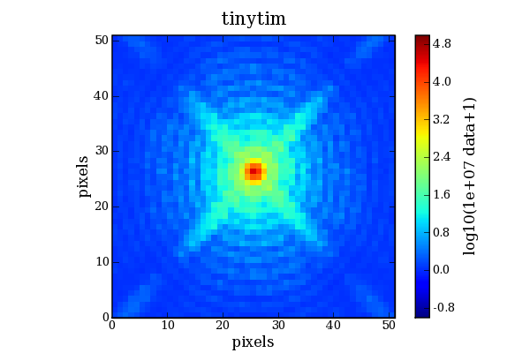

IR - F125W

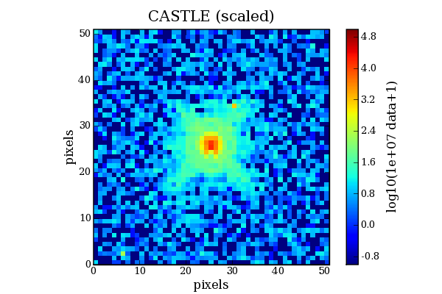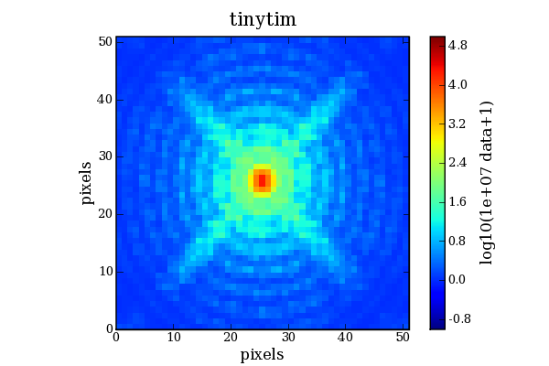

IR - F160W
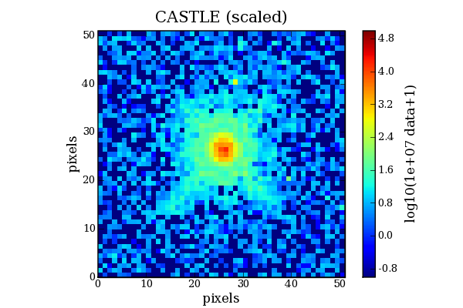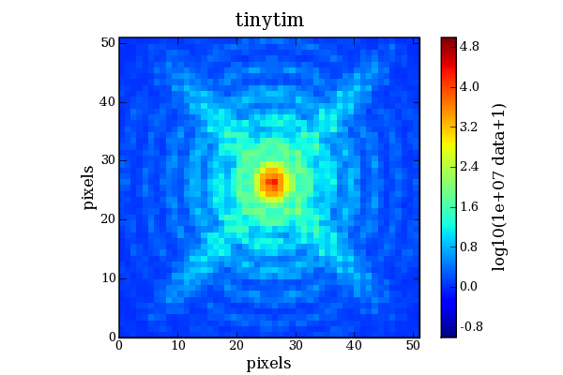

The Web Interface

Although it is easy to download and install Tiny Tim and run it locally we felt that many would prefer the convenience of a web interface for preparing PSFs. The aim was to have an interface through which the user specifies the PSF parameters using dynamic forms. The PSF is then prepared on the server, using the standard Tiny Tim software and then displays and many options for downloading the resultant image are made available.

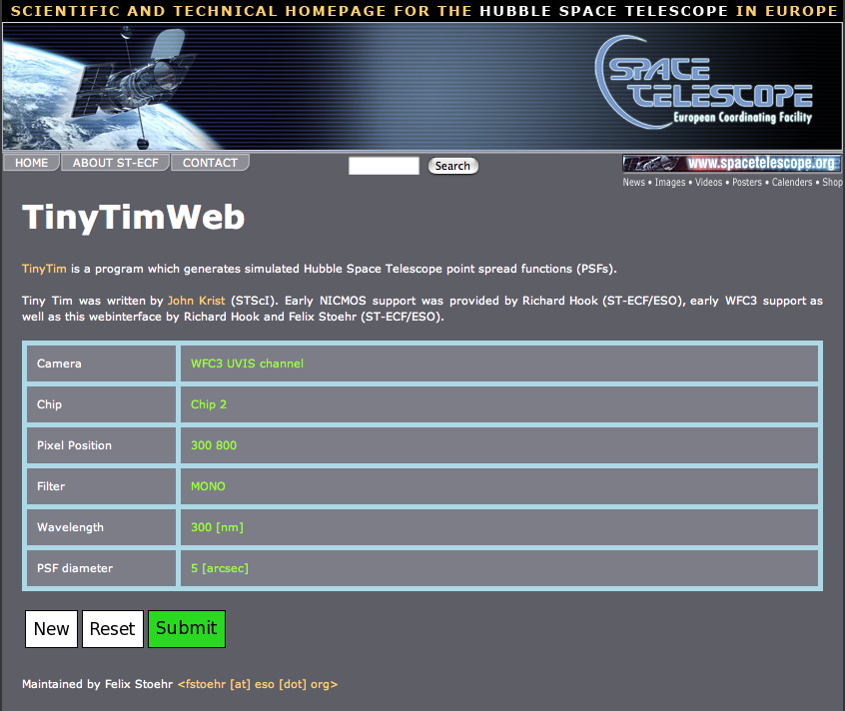
Figure 3 shows the web form itself, after it is complete and ready to run, and Figure 4 the resulting displays and download options available after the simulation has been completed. The web version can be accessed at [2].

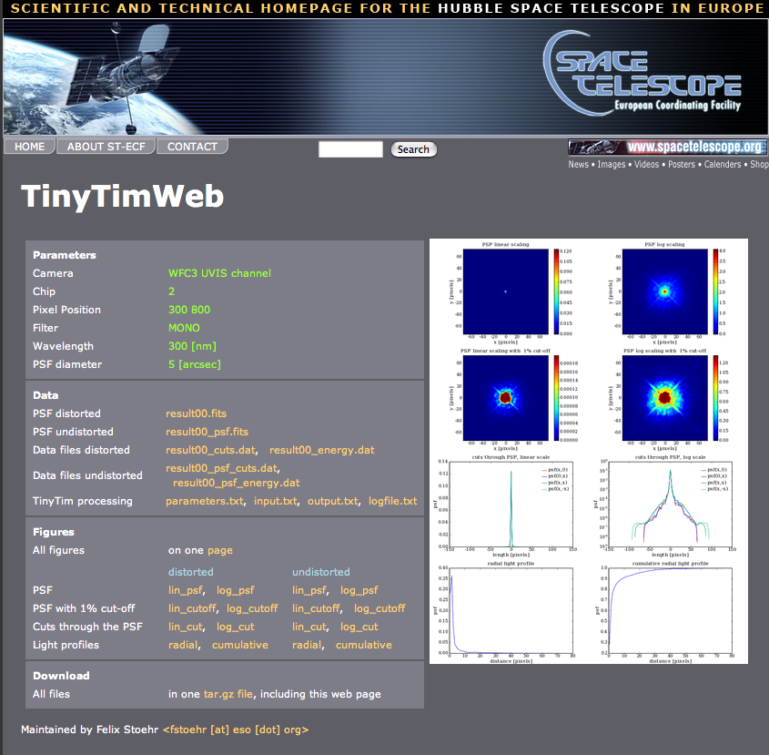

Figure 4: The final display of the Tiny Tim web interface after a PSF has been created on the server. The user can inspect several view of the point-spread function (right) or download the files created (left).

Users of the web interface are strongly advised to carefully read the relevant parts of the User Manual before preparing any PSFs.

Future plans
Tiny Tim 7.0, with the initial WFC3 support, was made available in early June 2008 from the usual STScI Tiny Tim web site [1] as well as through the ST-ECF web pages [2]. It must be stressed that this version is based on early estimates for aberrations, geometrical distortions and charge diffusion effects and similar effects in both channels and is certainly far from complete. As a result the PSFs created may differ significantly from those found once the camera is in orbit. We hope to include better estimates as they become available and also try to incorporate the “unknown unknowns” that surface as the camera is used for science.

References

[1] The Tiny Tim site at STScI: http://www.stsci.edu/software/tinytim/tinytim.html

[2] Web access at the ST-ECF: http://www.stecf.org/instruments/TinyTim/tinytimweb

[3] The Tiny Tim Users Guide: http://www.stsci.edu/software/tinytim/tinytim.pdf

[4] Krist, J. 1995, “Simulation of HST PSFs using Tiny Tim”, Astronomical Data Analysis Software and Systems IV, ASP Conference Series, R.A. Shaw, H.E. Payne, and J.J.E. Hayes, eds., 77, 349.

[5]
[6]

[7] Randal Telfer 2006, “A Nominal Geometrical Calculation of the Throughput of the WFC3 IR Channel Cold Mask”, unpublished internal memo, kindly supplied by George Hartig.

