# Algorithms

## FACE (Frontal Approach Cost Edition)

The Fast Marching Method does not ensure by itself the arrival of the path following a certain heading final condition. This is because rather than the direction the vehicle is heading, only 2-D position of the waypoints is considered when computing a path, being the heading of each of these waypoints just the tangent to the path they make up. Moreover, this method do not consider the shape and kinematic configuration of the vehicle, using a simplification in the form of a single point in space. Nevertheless, it is still possible to define a cost map that takes into account the distance between the rover center and the sample location, while at the same time ensuring the rover arrives facing to the sample. This is the premise of FACE. This technique follows a series of steps towards building a cost map starting from a DEM.

1. An obstacle map, consisting of a Boolean matrix indicating the existence of obstacles or not in each node, is generated.
2. A preliminar proximity map is created, consisting on a matrix containing values that indicate the distance to the respective closest obstacle. This is computed using the OpenCV library, in particular function cv::distanceTransform().
3. According to the proximity, each node is assigned a value of traversability in the so called Traversability map (see figure below). This traversability means, according to its value:
   1. Obstacle (red area).
   2. First obstacle dilation (green area). Together with the previous one they represent the area in which neither the rover or the sample can be placed.
   3. Second dilation (orange area). This is the area reachable by the arm but not by the rover center.
   4. Sampling area (grey area). The area extracted from the second dilation, consisting on a circle centered by the sample position with radius = reachable distance.
   5. Traversable area (brown area). The area in which the rover center can be placed without risks of colliding with obstacles.
4. By means of Shadowing FM, we create a ring around the sample location. The areas free from obstacles of this ring serve as locations from which the rover can go straight to the sample. In the figure below (see cost map), we distinguish three circumferences:
   1. The magenta circumference delimits the circle used for the Sampling area, i.e., its radius is the reachable distance rover center – sample.
   2. The yellow circumference. This is the internal limit of the ring. Its radius is the sum of the previous one and the distance chosen for holding the risk area (the area surrounding obstacles that serves as a repelling area).
   3. The blue circumference. This is the external limit of the ring, it is set at a radius a bit higher than the previous one, so as to contain a line of obstacles that avoid the rover making straight lines towards the sample that may endanger it.
5. Finally, the cost map is computed. A second proximity map is generated. It is worth mentioning the obstacles in the area enclosed by the yellow circumference are added at the end, so they are not accounted for in the generation of the second proximity map.

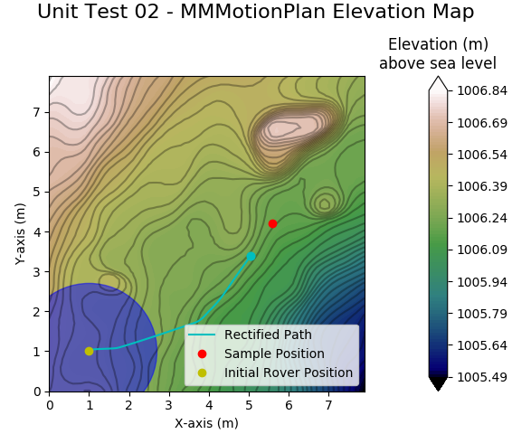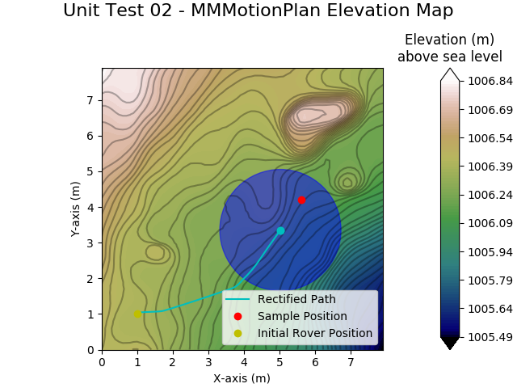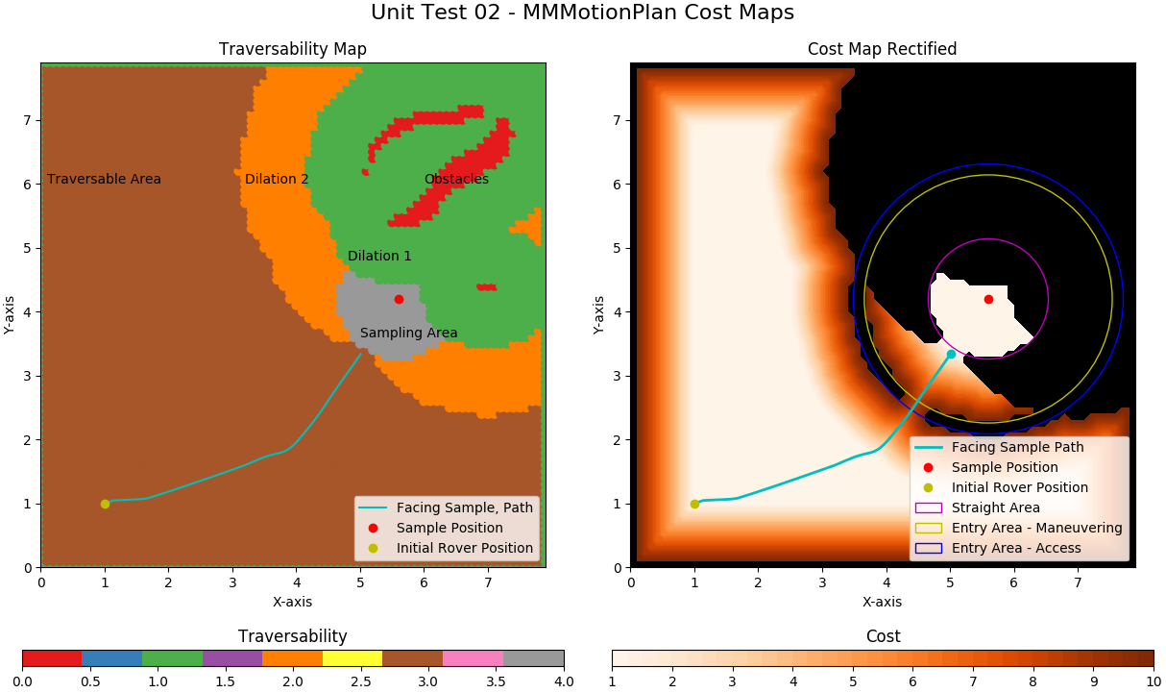

*Figure 1. Example case of FACE usage. (Above) The rover, depicted as a blue circle, follows the path towards the sample in the red dot. (Below) Corresponding Traversability and Cost maps created using the DEM.*