Tab 1

GroupPaperB - ExtrakPak
Alex Amadeo-Ranch ID#20008363
Jack Proctor ID#46407681
Ryan Seysha Muraliraj ID#81442040
E190W Hong

Editor:
Grading Categories:
- Critical thinking & analysis:
- Use of evidence/research:
- Development & structure:
- Language & style conventions:
Executive Summary
The United States military faces a solemn responsibility: bringing home fallen soldiers. As of 2025, the U.S. Department of Defense (DoD) reports that 38,000 deceased U.S. soldiers are recoverable, but mission risks prevent their return. For soldiers killed behind enemy lines, the military describes that manned recovery missions by foot, truck, or air expose the operators to enemy attacks or risk blockages from untraversable terrain. Recovery leaders express frustration in deciding whether to risk additional personnel or fail to adhere to their commitment to returning fallen soldiers to their families.
To alleviate these issues, ExtrakPak is a remotely operated drone that can fly over terrain and recover a fallen soldier to a secure location without exposing operators to enemy fire. The 100kg lithium-ion powered, carbon-fiber drone is 2m in diameter, 1.25m tall, and can lift up to 200kg for an hour on one charge using six brushless motors. Using GPS and LiDAR navigation, the operator uses a Remote Command Unit to securely operate the drone and grappling technology. The drone uses a unique grappling system beneath the airframe to pick up deceased soldiers. The system has four mechanized arms 0.6m long derived from the biomimicry of octopus arms, each capable of supporting 500kg and omnidirectionally pivoting in 10 locations. For mission success, ExtrakPak’s user manual states not to fly in heavy rain or attempt a live rescue.
No competitor can remotely recover diseased personnel due to nonexistent grappling technology. ExtrakPak satisfies all jurisdictional regulations, the strictest being the U.S. Occupational Safety and Health Administration’s workplace safety rules. Estimates show a two-year $3.25 million R&D timeline, $215,000/unit total cost, and a selling price of $265,000. The DoD, the sole customer, will issue ExtrakPak to its extraction teams. ExtrakPak allows the DoD to uphold its commitment to returning deceased soldiers to their families with guaranteed safety.

Table of Contents
- Introduction (Alex)…………………………………...…………….……………………..1
- Proposal Statement (Alex)…………………………..………………..…….……………..2
- Work Product (Alex)………………………………..…..………….………….…………..3
3.1 The Drone (Alex)…………..…………...……………………………………..3
3.2 The Grappling System (Alex)…………………………………………………7
3.3 The Remote Command Unit (RCU) (Alex).......................................................8
3.4 Regulatory Compliance (Alex)………………………..……………..…..…..11
- Target Customer (Jack)…………………………………………………………………..12
- Competition (Jack)………………………………………………...……………………..13
- Method (Jack and Ryan)……………………………………..…………………………..16
- User Risk Management (Alex)…………………..……..………………………………..22
- Conclusion (Ryan)…………………………………………….…………………………23
- Works Cited (Ryan)………………….……………………………..……………………25
List of Figures/Images
- ExtrakPak Side View……………………………………...………………………………4
- ExtrakPak Top-Down View…………………………………….…………………………5
2.1. ExtrakPak Data Flow Schematic…………………………………………………….…..6
2.2. ExtrakPak View of Grappling Technology from the Bottom…………………………....7
- Remote Command Unit………………………………...…………………………………9
- Aviation Griff 300 Heavy Lift Drone……………...…………………………………….15
- Huntress II VTOL Hybrid Electric Turbojet Drone………………………..……….……16
- ExtrakPak Development Gantt Chart First Half…………………...………...……look……..18
- ExtrakPak Development Gantt Chart Second Half…………………...……...…………..19
List of Tables
- Estimated Costs of ExtrakPak……………………………………………………………21

1. Introduction
The United States military faces a solemn responsibility: bringing home fallen soldiers. When a soldier loses their life in the line of duty, the military acts to recover their remains and deliver them to the soldier’s family as soon as possible [1]. For instances where the deceased is located within a secure region, the military simply recovers the body, processes the remains, and transports them to the soldier’s family. However, military leaders describe many circumstances where the deceased is located behind enemy lines, making recovery logistics more complicated and risky [2].
After a report of a fallen soldier behind enemy lines, recovering them begins with overhead drone reconnaissance to pinpoint the location of the remains. Unmanned drone surveillance is widely successful in locating deceased personnel and is broadly implemented [2]. Next, a manned extraction mission by foot, by ground, or by air is dispatched to the soldier’s location. Upon getting to the soldier, the extraction operators work to remove the deceased soldier from the battlefield and transport them to a secure location. Once the soldier is extracted to a secure location, the remains are then processed and transported accordingly.
However, the problem lies with the deadly risks that extraction operators face. Approximately 38,000 deceased U.S. soldiers have been identified by the U.S. Department of Defense (DoD) to be recoverable; the risks of sending additional personnel behind enemy lines to recover them have prevented many missions [3]. For ground or on-foot extractions, U.S. Army veteran Eric Blaser describes how terrain could be untraversable due to steep gradients, impassable obstacles, or dense foliage, risking stranding the team in enemy territory [2]. For air missions and all other methods, potential enemy attacks risk the lives of extraction operators [2]. Each mission profile elicits a difficult decision for extraction teams: deploy personnel into perilous conditions with the risk of death or leave the deceased behind [2]. Although the safest decision is to leave the deceased behind, it is unethical for the military not to adhere to their commitment to returning those who made the ultimate sacrifice back to their families [1]. The ethical dilemma and deadly risks of extracting deceased soldiers demand a safer solution for the military to protect operators and bring fallen soldiers home.

2. Proposal Statement
A groundbreaking solution addressing the risks of extraction missions behind enemy lines is ExtrakPak, a remotely controlled, heavy-lift drone designed to extract deceased individuals. ExtrakPak is engineered for maneuverability, power, and efficiency. It can precisely navigate kilometers of extreme terrain carrying a soldier with full combat gear, lifting up to 200 kilograms. A single pilot can remotely operate the drone with a Remote Command Unit (RCU). The drone serves as the first leg of transportation, removing and flying the deceased soldier from behind enemy lines so recovery operators can process the remains to the soldier’s family from a secure location. ExtrakPak can fly over obstacles, eliminating the danger of untraversable terrain stranding an extraction crew. The drone also eliminates the risk of extraction crews being attacked by the enemy as it is flown remotely by one pilot, allowing it to be shot down without casualties. With no crew for the first leg of the extraction mission, the mission does not pose a danger to operators.
At the core of ExtrakPak is the innovative grappling system, the mechanism the drone utilizes to secure the deceased soldier to the airframe. Based on the biomimicry of octopus arms, the system can collect and secure an individual regardless of their body type or condition. The system is used when ExtrakPak is hovering above the deceased soldier, where it opens the arms to secure the person to the bottom of the airframe. When the grappling system successfully secures the soldier to the airframe, ExtrakPak lifts off and flies to a recovery site. Once the drone lands at the designated recovery site, the grappling system gently releases the soldier to the ground. Upon successful release, ExtrakPak will fly away and land near the initial landing site, clearing the way for operators. The operators can then safely accept, process, and transport the remains to the soldier’s family.
By eliminating personnel exposure to enemy territory, ExtrakPak revolutionizes the military’s deceased soldier extraction operations, offering mission leaders a safer alternative.

3. Work Product

3.1 The Drone
ExtrakPak is a remotely controlled, heavy-lift drone engineered to extract deceased soldiers from enemy territories, minimizing risk to extraction personnel. ExtrakPak is designed with a lightweight carbon-fiber airframe, maintaining durability in extreme conditions, including high winds, debris impact, and severe temperatures. Its weather-resistant electronics are made possible by thoroughly sealing the system and electronics bay within the central airframe. The drone can hover with 200 kilograms of payload for one hour at sea level while utilizing all necessary systems, enough to lift a heavy-set individual with gear attached. The drone can fly in 60 kilometers per hour wind velocities and precipitation levels of 0.35 centimeters of rain per hour. The drone’s overall structure measures 2 meters long, 2 meters wide, and 1.25 meters tall and has a system weight of 100 kilograms, as shown in Figure 1. 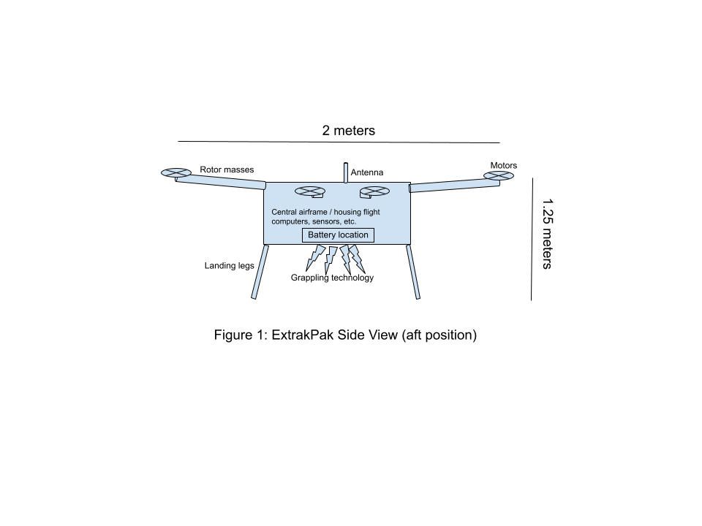
The drone’s propulsion system relies on six fully electric, high-torque brushless motors. These motors have precise thrust control, allowing them each to adjust between 0 newtons and 569 newtons of thrust [4]. With a maximum operational weight of 300 kilograms, including a 100-kilogram system weight and a 200-kilogram maximum payload, the six motors can exert a combined thrust of approximately 3400 newtons. The drone’s thrust-to-weight ratio is 1.16 under its maximum load, allowing it to accelerate upwards at 1.57 meters per square second. These motors are mounted on six hollow carbon-fiber rotor masts in radial symmetry, which protrude from the central airframe, allowing for precise drone control, see Figure 2. The motors are powered by lithium-ion batteries embedded within the central airframe, which can be physically swapped out for rapid mission turnaround; reference Figure 1 for the access point.
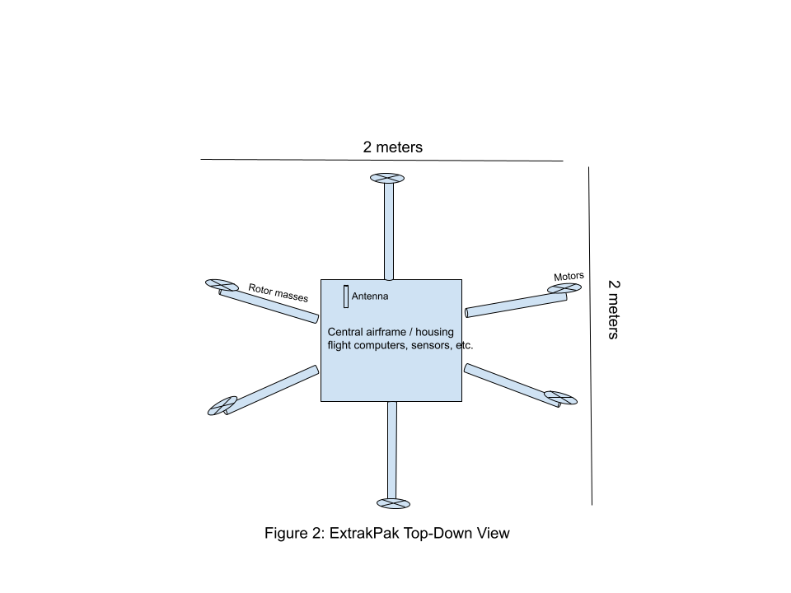
To ensure smooth operation, ExtrakPak integrates adaptive thrust vectoring by changing thrust for each motor, allowing precise maneuverability over difficult terrain and around debris [5]. When the operator sends a command to shift ExtrakPak’s pitch, yaw, or roll, the drone’s three independent flight computers interpret the command as changes in thrust across the six motors. With an asymmetric thrust profile, the drone can adjust course. ExtrakPak has GPS and LiDAR sensors on the central airframe that provide data for real-time terrain mapping, optimizing flight paths for efficient extractions [6]. Flight computers assess the raw data from these sensors, check for and correct computational errors or inconsistencies, and finally process the data into usable information. The processed data is sent securely to the remote operator. This system and live video feedback enable operators to guide the drone with high precision while minimizing human error, even in low-visibility conditions like heavy fog or moderate precipitation.
The antenna ensures encrypted, uninterrupted data transmission between the drone and operators, preventing signal interference and unauthorized access. Depending on signal strength, the antenna may route data through an internet satellite constellation or directly to the operators. A built-in emergency override system allows the drone to return to a designated safe zone autonomously in case of signal loss, going off data cached from the GPS and camera systems. Once the drone reconnects with the operators, it will terminate its autonomous return, settle into a hover, and await human input. See Figure 2.1 for the drone’s flight data flow schematic.
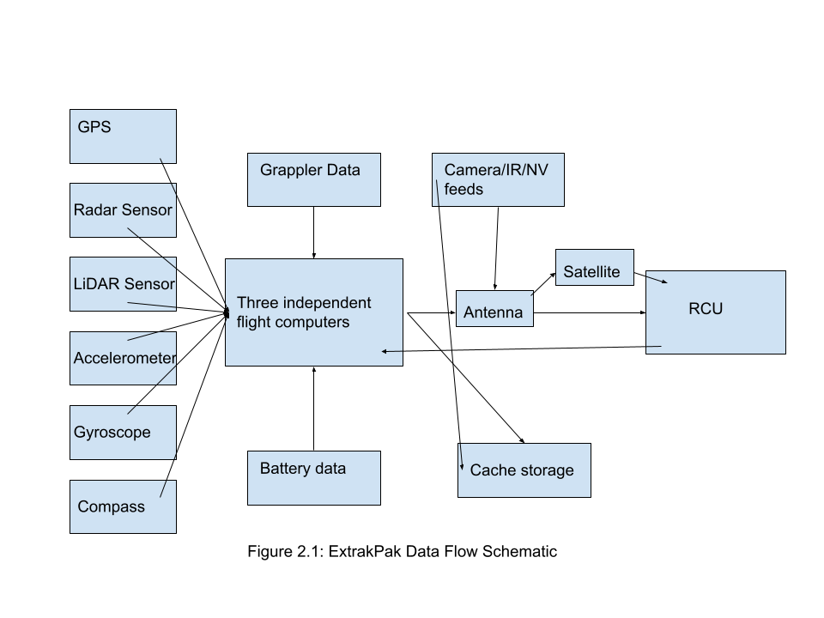

3.2 The Grappling System
A key feature of ExtrakPak is its never-before-seen grappling system. The grappling system retrieves and secures the individual beneath the airframe, regardless of their body type or condition. Based on the biomimicry of octopus arms, four mechanized grappling arms each use 10 adaptive servos that adjust to different body structures, ensuring a stable hold [7]; see Figure 2.2.

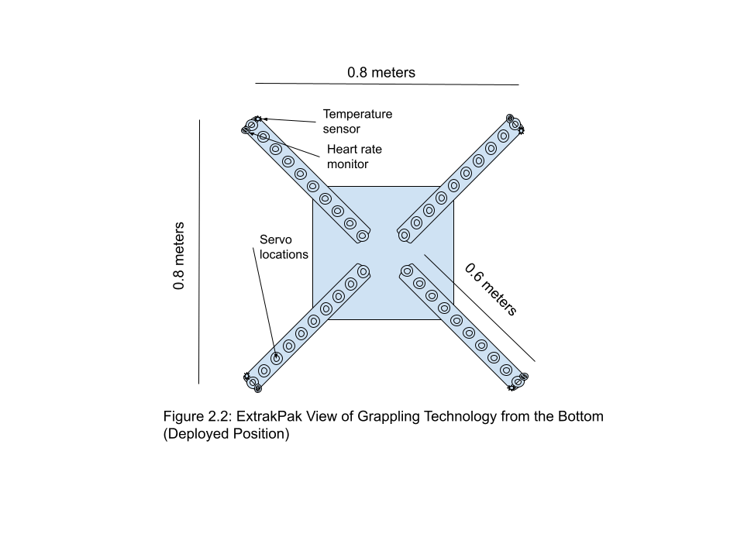
The grappling system weighs 11 kilograms, which is included in the 100-kilogram system weight. The grappling arms in the undeployed position cover the bottom of ExtrakPak’s airframe, measuring 0.8 meters long, 0.8 meters wide, and protruding 0.1 meters from the drone's bottom. In the deployed state, the arms can stretch 0.6 meters long in any direction. The arms are made of a hollow aluminum cylinder with 10 pivot points for adjusting orientation, with data and power wires running inside. The cylinder is covered with silicon material to protect the grappling arms from high forces and dampen vibrations. The arms and all of its electronics use power from ExtrakPak’s lithium-ion batteries to operate. Each arm can support 400 kilograms of force, accommodating the maximum payload of 200 kilograms.
Although ExtrakPak is designed to transport deceased individuals, the drone has systems in place in case the soldier is still alive. Integrated biometric monitoring sensors on the grappling arms track heart rate and body temperature in case the soldier is alive. Using sophisticated laser technology, the heart rate monitors on each grappling arm's tip can detect a potential heartbeat through clothing [8]. The temperature sensors are also at the ends of the grappling arms, returning victim temperature data if the sensor is in direct contact with skin. ExtrakPak transmits real-time medical data to extraction operators, enabling them to remotely assess the individual’s condition. The grappling system’s vibration-dampening silicon material minimizes excessive movement during flight, reducing the risk of exacerbating injuries. To further protect the individual, the grappling system can absorb heat from or radiate heat to the individual by changing the temperature of the arms through ExtrakPak’s cooling system, preventing the victim from overheating or getting hypothermia.

3.3 The Remote Command Unit (RCU)
To control ExtrakPak, a remote operator utilizes the Remote Command Unit (RCU), a portable control system housed within a rugged, waterproof briefcase. When closed, the briefcase resembles a large laptop, measuring 0.7 meters wide, 0.4 meters deep, 0.3 meters tall, and weighing 5 kilograms; reference Figure 3.
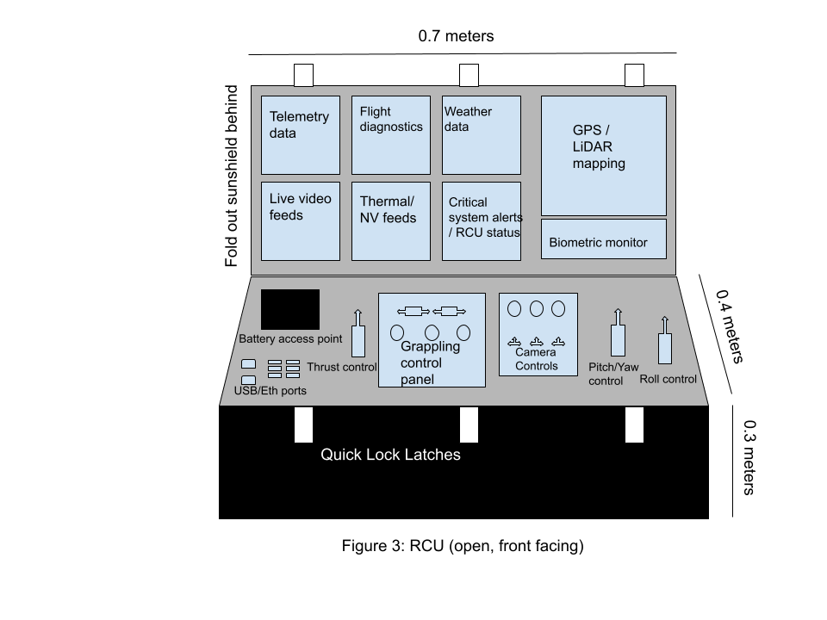
Designed for ease of deployment and operator efficiency, the briefcase remains completely sealed and waterproof when closed, protecting sensitive electronics from moisture, dust, and impact damage. Once opened, the inside of the lid functions as a comprehensive display hub, equipped with multiple high-resolution screens that provide real-time telemetry data, live video feedback, GPS mapping, flight diagnostics, and biometric monitoring of the extracted individual. The main display delivers a high-definition, low-latency video feed from ExtrakPak’s onboard cameras, including thermal and night vision imaging, allowing operators to assess conditions easily. Four 360-degree view cameras are located in radial symmetry outside the airframe, eliminating blindspots. These cameras can switch between standard, night vision, and thermal imaging on command, transmitting at 1440p resolution and 30 frames per second. Integrated GPS and LiDAR-based terrain mapping systems provide a top-down view of the drone’s location, enabling precise navigation down to the centimeter, even in environments with poor visibility. A dedicated weather and atmospheric analysis module continuously updates wind speed, temperature, and barometric pressure from onboard sensors near the flight computers, allowing operators to anticipate real-time flight challenges. The built-in antenna may route data through an internet satellite constellation like Starlink or directly to ExtrakPak, depending on signal strength.
The lower section of the briefcase serves as the primary control board, featuring an ergonomically designed interface. A custom-built joystick system provides smooth and responsive control over ExtrakPak’s altitude, speed, and directional movement, ensuring operators can maneuver the drone with centimeter accuracy, even in strong winds. Adjacent to the joysticks, tactile switches and rotary dials control functions such as camera angle adjustment and zoom levels. The grappling control system is managed through precision-actuated triggers, enabling operators to adjust to grip strength, stabilization, thermal management, and emergency release functions based on sensor feedback.
The ExtrakPak RCU is powered by a high-capacity, swappable lithium-ion battery system to enhance field usability, ensuring 4 hours of uninterrupted operation with quick-replacement capabilities for extended missions. The entire interface is backlit and night-vision compatible, allowing extraction teams to operate in low-light or nighttime conditions without compromising visibility. A fold-out sun shield prevents glare during daylight operations, improving screen readability. Built-in USB and Ethernet ports enable direct data transfer and software updates, ensuring the system utilizes the latest software. Designed for high-speed deployment, the briefcase utilizes quick-lock latches and an internal shock absorption system, preventing damage to delicate instrumentation when transported across rough terrain.

3.4 Regulatory Compliance
Given its specialized function in military extraction missions, ExtrakPak must comply with regulatory and safety standards before implementation. As an unmanned aerial vehicle (UAV), the drone must adhere to the Federal Aviation Administration’s (FAA) Part 107 regulations, which govern commercial UAV operations in U.S. airspace. Necessary Part 107 certifications for ExtrakPak include operation from a moving vehicle or aircraft §107.25 and operation at night §107.29(a)(2) and (b) as ExtrakPak will be operating at night for some missions [9]. ExtrakPak must also comply with FAA visual line of sight aircraft operation §107.31 and yielding the right of way §107.37(a) since the remote operator will be controlling the drone beyond their line of sight and must also yield to oncoming aircraft [9]. The drone also needs to adhere to FAA operation over human beings §107.39, operation in certain airspace §107.41, and operations over moving vehicles §107.145 since ExtrakPak may fly over populated regions [9] [10]. Also, under Part 107, drone pilots must be FAA-certified, and the drone must be registered with the FAA [9].
Furthermore, the biometric monitoring system is classified as a medical device due to its real-time medical diagnostic capabilities. It requires Federal and Drug Administration (FDA) approval under Class II as a medical device [10].
​To ensure the safe operation of ExtrakPak in military extraction missions, adherence to specific Occupational Safety and Health Administration (OSHA) Part 1910 regulations is essential. The Personal Protective Equipment (PPE) §1910.132 section mandates that operators and maintenance personnel have necessary protective gear, such as gloves and eye protection, to mitigate drone handling and operation risks [11]. Additionally, the Training Requirements §1910.132(f) requires that operators receive comprehensive training on safe operation procedures, hazard recognition, and emergency response protocols [11]. The Hazard Assessment and Equipment Selection §1910.132(d) states employers must assess the workplace to determine if hazards are present or are likely to be present [11]. In drone operations, this involves evaluating potential risks, such as mechanical failures or environmental factors that could impact safety.

4. Target Customer
According to the U.S. Department of Defense, “more than 80,000 American service personnel are missing from previous conflicts and 38,000 are estimated to be recoverable” [3]. ExtrakPak aims to accelerate and safeguard deceased soldier extraction operations for the United States military. Our targeted customer is solely the Department of Defense (DoD), which will purchase one or multiple ExtrakPak drones and their required RCUs. The DoD is responsible for reading documentation, following procedures, and adhering to all regulations before using the drone or its features. The DoD will issue ExtrakPak units to the end users, who will be the specialized extraction teams across all branches of the military.

5. Competition
Current extraction operations rely on human-crewed vehicles for the recovery of deceased soldiers. Today, drones are used heavily in military reconnaissance, but there is currently no use of UAVs in extracting or transporting deceased persons in any organization or military on the planet.
The gap in the market is due to the lack of existing grappling technology that can replace human operators who secure deceased soldiers for flight. Extraction teams are seeking robotics to fill this gap in disaster assistance. Some search and rescue agencies and militaries have tested non-traditional robotics during select crises, such as the “Fukushima nuclear disaster in 2011 and Mexico Earthquake disaster in 2017”[12], where “snake robots” were used for reconnaissance through hard-to-navigate rubble, and heavy-lift ground UVs acted as bulldozers to lift debris. However, these drones were designed with “limited performance capabilities”[12], and since then, tests with alternative UAVs in SAR missions have been limited. The lack of proper funding and design has faltered the progression of alternative UAVs in extraction missions, but since then, major strides in UAV technology have been made.
ExtrakPak does not claim to be able to assess a situation, carry out operations alone, or perform operations better than a specialized crew but to assist in the extraction process. ExtrakPak addresses previous UAV shortcomings with its aerial mobility and grappling technology, which these previous drones failed to utilize. Its advanced grappling system aims to replace the heavy lifting from extraction crews, allowing them to handle the deceased soldier from a secure location after extraction. Advancements in technology in the past decade allow a heavy-lift drone like ExtrakPak to supersede the capabilities of existing robotic solutions.
Helicopters remain a reliable staple for extraction. However, they have high operational costs and require substantial flight crew training and vehicle maintenance. The most common helicopter used in these missions is the Sikorsky UH-60 Blackhawk, which costs an average of “$25 million” [13]. The operating costs and crew requirements are also high, averaging “$2,200” per hour and requiring a crew minimum crew size of 6 people [14]. While costs are not a large issue for the U.S. military, one hundred ExtrakPak drones can be purchased for the same cost as one UH-60. Many ExtrakPak drones could be bought and used with several crews, allowing the U.S. military to allocate its more valuable assets, like its helicopters, to other missions while still providing a solution for extracting deceased soldiers.
While the ExtrakPak is not yet in production, drones with similar capabilities exist in the market. The Aviation Griff 300, as seen in Figure 4, is a drone that “can lift 225 kg (496 lbs)... [and] features a flight time of 30-45 mins” [15]. This drone sells for around $250,000 in the industry. However, the Griff 300 has no grappling technology, meaning it cannot extract deceased soldiers.
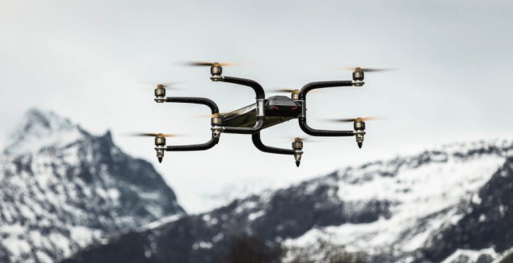
Figure 4: Aviation Griff 300 heavy lift drone [15]

Another drone, shown in Figure 5, is the Huntress II VTOL created by WaveAerospace. The aircraft is a “...hybrid electric turbojet drone with heavy payload capacity…” and is capable of operating “...on land or sea in Force 10 ocean conditions… ” [16]. While the cost of this drone is not publicly available, its estimated cost is similar to that of the Griff 300, and according to WaveAerospace, the “Huntress Turbojet can operate anywhere a helicopter can, in half the required footprint and at 5% the cost” [16]. They are a fraction of regular helicopter costs, allow for heavy payload transport, and can operate in extreme weather conditions. While the Huntress II has capabilities for heavy payload transport, its jet and propellor propulsion hybrid technology, and no grappling technology render it infeasible to secure an individual.
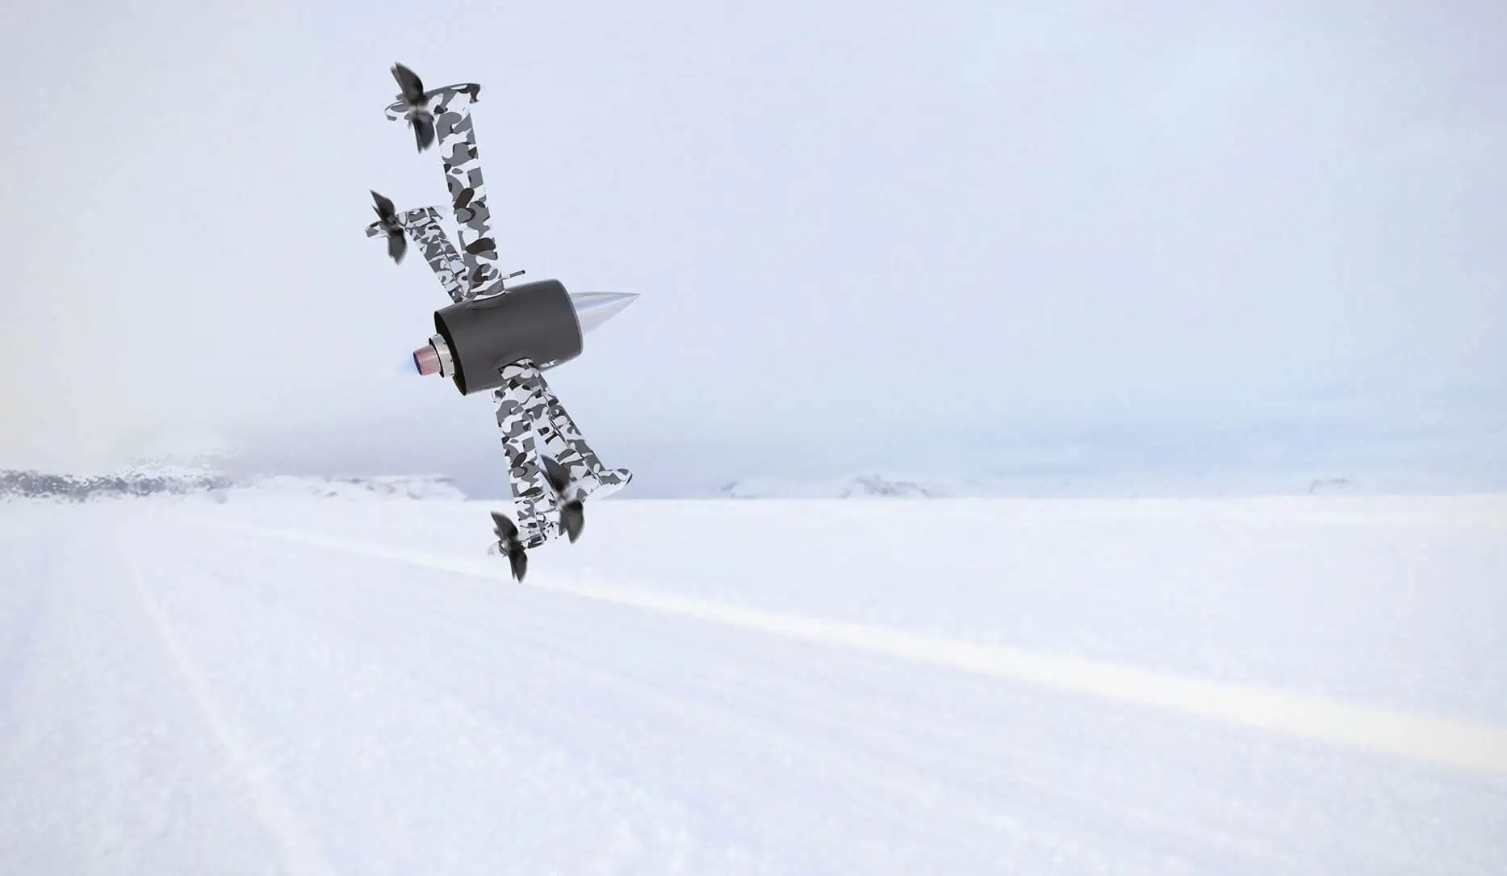
Figure 5: Huntress II VTOL hybrid electric turbojet drone [16]

6. Method
The development and launch of ExtrakPak will take an estimated two years. The first five to six months of development will include defining the project scope and completing the preliminary design of the drone. This includes gathering our core development crew, creating initial models, and completing studies on the best materials and mechanical and electronic systems for our drone.
Another five to six months are needed for detailed design of the drone and prototype manufacturing. Thorough design and frame grappling system research will be completed during this stage. A system that employs octopus-like silicon grappler arms will be developed for strength, maneuverability, and reliability. The vibration-dampening silicon material of the arms, biometric sensors, and thermal management system will be installed to protect the deceased during flight. Upon sufficient testing, the grappling system will be attached under the central airframe of the drone, facing the ground. Design RCU, which will be able to control ExtrakPak, track weather conditions, and monitor any potential biometric data of the grappled soldier. Design of the RCU, software for the RCU and drone, grappling and biometric monitoring systems, and failsafe procedures will be started during this time and continually researched throughout and after the completion of the first prototype. Our fifteen robotics engineers and five testing engineers will work hard to ensure we meet this deadline.
With a feasible prototype in place, another four to five months will be spent doing initial testing for the grappling technology and flight capabilities, followed by field testing on practice mannequins while continuing development based on experimentation results. Failsafe procedures will be greatly developed and finalized during this time to ensure field testing can occur with minimized risk to test engineers. Rigorous testing of software, RCU, biometric monitoring systems, and late-stage general modifications will be worked on.
The final six to seven months of development will include prototype adjustments for certification and compliance with FAA Part 107, FDA Class II, and OSHA Part 1910 regulations (as detailed in section 3.4), then scaling our production and manufacturing processes for industry. Thorough risk assessments must be conducted, and proper user manuals and documentation should be created and appended for the eventual maintenance and deployment of ExtrakPak.
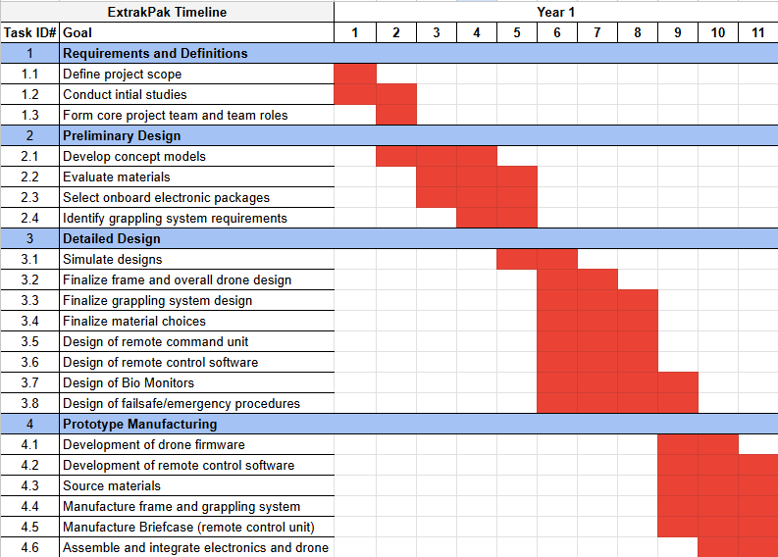
Figure 6. ExtrakPak Development Gantt Chart First Half

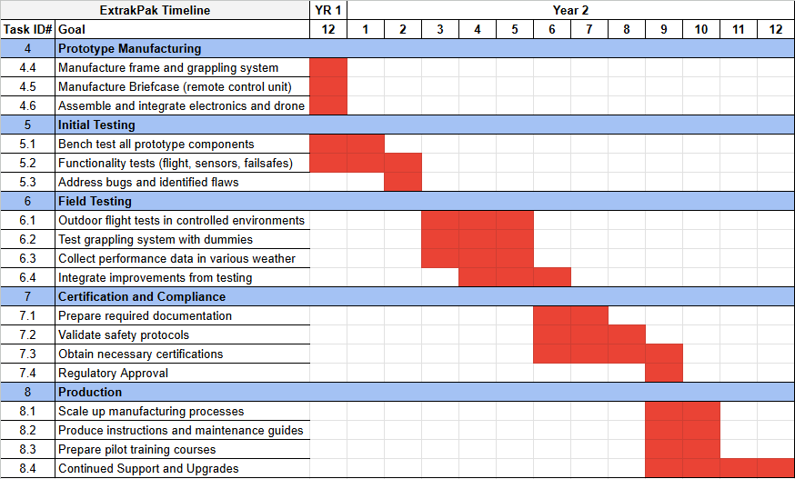
Figure 7. ExtrakPak Development Gantt Chart Second Half

The budget necessary to support a development program of ExtrakPak over the course of two years is estimated to cost approximately $3.25 million dollars. This valuation has been derived by examining the average salaries of engineers within the industry [17] and estimating the costs of materials and overhead needed for prototyping.
Heavy-lift drones in the industry are sold in the $100,000 - $200,000 range, which is the estimated cost for the base drone unit of ExtrakPak. Using current drone part quotes and looking at aerospace component vendors, costs such as airframe materials [18], the grappling system, sensor suite, electronics, software, and the RCU [19] have been estimated and scaled in the production cost of a single unit. The production cost comes to a total of $215,000 per ExtrakPak and RCU unit. Markups for R&D, distribution costs, and profit margins are added for an estimated $30,000 to $50,000 per unit. This brings the total selling price range to $245,000 - $265,000, as seen in Table 1 below.

Table 1: Estimated Costs of ExtrakPak
Cost Category | Description | Estimated Amount
Research and Development (R&D)
Labor | 15 Robotics Engineers | $150,000 per engineer per year of development (experience will make the amount vary slightly)
Materials and Prototyping | Materials needed to develop prototypes during development | $500,000
Testing | 5 Test Engineers | $100,000 per engineer per year of development  (experience will make the amount vary slightly)
Overhead | Insurance, software, legal, facilities, incorporation costs. | $200,000
Total Cost of R&D | Estimated total following a 2-year timeline | $3,450,000
Unit Costs
Drone Unit | Drone base | $150,000
Additional Airframe Materials | Protective coatings, carbon fiber, lightweight and durable materials | $25,000
Grappling Mechanism | Proprietary grappling technology | $15,000
Sensor Suite and Electronics | GPS, LiDAR, 4K camera to enable safe remote control.  Weather sensors, biometric sensors, PCB and microcontrollers to collect data seamlessly. | $10,000
Software | Custom firmware and user interface | $5,000
Remote Command Unit (RCU) |  | $10,000
Subtotal for Production of Single Unit | (Sum of above direct costs per unit) | $205,000
Markup for Profit Margin | Recouping R&D, warranty, distribution, and overheads costs. | $30,000-50,000
Total Estimated Unit Selling Price |  | $245,000-$265,000

7. User Risk Management
While ExtrakPak significantly enhances the safety and efficiency of military deceased soldier extraction operations, the system presents inherent risks from the user's perspective that must be carefully managed.
One primary concern is misapplication. For instance, operators may attempt to deploy the drone in conditions exceeding its operational limits, such as winds exceeding 60 kilometers per hour or rainfall exceeding 0.35 centimeters per hour. If deployed improperly, the drone’s flight stability or connection to the RCU could be compromised, potentially leading to mission failure. Strict operator training protocols and system safeguards must be enforced to mitigate this risk, ensuring that ExtrakPak is only used within its designated parameters. Built-in flight restrictions and automated safety alerts using real-time satellite weather data will notify operators of hazardous conditions and advise against usage.
A significant user concern is the failure to keep the drone and RCU’s software up-to-date. If the user fails to check for updates regularly, there could be cybersecurity issues. Since ExtrakPak relies on encrypted data transmission for vehicle control and biometric monitoring, signal interference and data leaks are risks from malicious cyber threats. These issues can result in unexpected flight behavior, compromised mission data, or even mission failure. The RCU will flash a critical alert to encourage users to update regularly if a new software update is available. If the user still forgets, ExtrakPak employs multi-channel encrypted transmissions with adaptive frequency hopping, reducing the likelihood of signal jamming or hacking attempts. Furthermore, in signal loss, the drone automatically executes the autonomous emergency return-to-base function, ensuring it can safely navigate back to a designated recovery point without connection.
ExtrakPak is not designed to extract or perform life-saving care for soldiers who are alive. The drone and its grappling technology are exclusively intended for extracting deceased personnel, and using ExtrakPak for live rescues may result in serious injury or death to the victim being extracted. However, there could be instances where the military inaccurately declares a soldier dead, and ExtrakPak is sent to recover their remains. For each extraction, the grappling technology employs its heart rate and body temperature sensors to check for signs of life. The data from these sensors are sent to the RCU so the operator can plan the recovery site accordingly, either proceeding with processing remains or emergency medical care.
By proactively addressing these risks through operator training, system safeguards, and cybersecurity measures, ExtrakPak can be deployed as a reliable extraction solution while ensuring the safety of the extraction operators and the success of their missions.

8. Conclusion
The retrieval of fallen soldiers from combat zones remains a solemn and critical mission for the United States military. However, the danger of enemy fire and untraversable terrain associated with traditional extraction operations place recovery teams in perilous situations, often forcing them to weigh the risk of their own lives against the duty to bring their comrades home [2].
The development of ExtrakPak offers a groundbreaking alternative that mitigates these risks while ensuring the dignified recovery of deceased soldiers. ExtrakPak revolutionizes military extraction operations by integrating cutting-edge drone technology and an advanced grappling system, all operated remotely by a single pilot. Its ability to transport individuals without a crew from behind enemy lines significantly reduces the need for personnel to enter hostile or treacherous zones. The robust design of ExtrakPak ensures a 200-kilogram payload capacity and durability in winds up to 60 kilometers per hour. At the same time, its secure communications provide reliability and operational security. Furthermore, the inclusion of biometric sensors allows for real-time assessment of a soldier’s condition, ensuring the possibility of immediate medical intervention if the individual is found to be alive. The system’s adaptability and remote-controlled functionality allow seamless integration into current military protocols while maintaining compliance with aviation and medical regulatory standards. As the first UAV explicitly designed for deceased soldier recovery, ExtrakPak surpasses existing UAV technologies limited to surveillance or cargo transport. The ability to conduct remote extractions without placing additional personnel in danger establishes ExtrakPak as a vital innovation in military operations.
Ultimately, the introduction of ExtrakPak not only enhances the safety and efficiency of recovery missions but also upholds the military’s unwavering commitment to honoring and protecting those who have made the ultimate sacrifice. Integrating advanced drone technology into extraction operations means the military can fulfill its solemn duty with greater safety, precision, and effectiveness.

9. Works Cited
[1] “Mortuary Affairs How To Guide”, Combined Arms Support Command. [Online] Available: https://cascom.army.mil/g_staff/g3/TTD/Products/QM-How-to-Handbook-MortuaryAffairs.pdf
[2] A. Amadeo-Ranch, “Customer Discovery Interviews”, Nov. 2024. [Online] Available: https://docs.google.com/document/d/1ZirRbLOfYkGK-BNwAkX_ILJF4KWJB5TB_YcX5NXzLk8/edit?tab=t.0, (accessed Feb. 2025).
[3] “POW MIA”, United States Department of Defense. [Online] Available: https://www.defense.gov/Multimedia/Experience/POW-MIA/, (accessed Mar. 2025).
[4] V. Joshi Manohar, “Advantages and disadvantages of brushless DC motor, ”Electrical Devices & Sys, Mar. 2023.
[5] J. S. Orr, N. J. Slegers, “High efficiency thrust vector control allocation”. Paper, Available: https://arc.aiaa.org/doi/full/10.2514/1.61644?casa_token=cpoeK8vhtKYAAAAA%3AplCuwx4wcCbLhy_z2wOFZKD3kjGuriUhapV-4LZEkwEZpsf6KCcT6ShT4GWKwYpOb5WIa3tV.
[6] K. Farsath, et al, “AI-Enhanced Unmanned Aerial Vehicles for Search and Rescue Operations”, 2024 5th International Conference on Innovative Trends in Information Technology, Mar. 2024.
[7] “Robotic Gripping Mechanism Mimics How Sea Anemones Catch Prey”, American Institute of Physics. [Online] Available: https://www.newswise.com/articles/robotic-gripping-mechanism-mimics-how-sea-anemones-catch-prey (accessed Feb. 2025).
[8] N. Molinario, et al, “Contactless Vital Signs Monitoring From Videos Recorded With Digital Cameras: An Overview”, Frontier in Physiology, Feb. 2022.
[9] “Certificated Remote Pilots including Commercial Operators”, Federal Aviation Administration. [Online] Available: https://www.faa.gov/uas/commercial_operators (accessed Feb. 2025).
[9] “Beyond Visual Line of Sight (BVLOS): What is it and how can it advance NOAA’s science?”, National Oceanic & Atmospheric Administration. [Online] Available: https://www.omao.noaa.gov/uncrewed-systems/news-media/article/beyond-visual-line-sight-bvlos-what-it-and-how-can-it-advance-noaa%E2%80%99s-science#:~:text=and%20transmitted%20securely.-,Beyond%20Visual%20Line%20of%20Sight%20(BVLOS)%3A%20What%20is%20it,can%20it%20advance%20NOAA's%20science%3F&text=In%20the%20United%20States%2C%20uncrewed,any%20activities%20in%20U.S.%20airspace, (accessed Feb. 2025).
[10] “Classify Your Medical Device”, Food and Drug Administration. [Online] Available: https://www.fda.gov/medical-devices/overview-device-regulation/classify-your-medical-device, (accessed Feb. 2025).
[11] “1910.132 - General requirements.”, Occupational Safety and Health Administration. [Online] Available: https://www.osha.gov/laws-regs/regulations/standardnumber/1910/1910.132, (accessed Mar. 2025)
[12] H. Chitikena, F. Sanfilippo, S. Ma, “Robotics in Search and Rescue (SAR) Operations: An Ethical and Design Perspective Framework for Response Phase”, in Advances in Intelligent Robotics in the Era 4.0, Jan. 2023.
[13] “How much does a Black Hawk helicopter cost and what’s the program budget?”, Intergalactic Space. [Online] Available: https://ig.space/commslink/uh-60-black-hawk-the-armys-workhorse-utility-helicopter#:~:text=Other%20resources%20 cite,around%20%2421.1%20million, (accessed Feb. 2025).
[14] United States Army, Black Hawk Budget Table, DACIS. [Online] Available: https://www.dacis.com/budget/budget_pdf/FY20/PROC/A/6773A05009_14.pdf, (accessed Feb. 2025).
[15] M. Ball, “GRIFF Aviation Announces New GRIFF 300 Heavy Lifting Drone”, Unmanned Systems Technology, Dec 2016. [Online] Available: https://www.unmannedsystemstechnology.com/2016/12/griff-aviation-announces-new-griff-300-heavy-lifting-drone/, (accessed Feb. 2025).
[16] ”Huntress II VTOL Turbojet”, Unmanned Systems Technology. [Online] Available: https://www.unmannedsystemstechnology.com/company/waveaerospace/huntress-ii-vtol-turbojet/, (accessed Feb. 2025).
[17] Hardware Engineer Salary, Levels.fyi. [Online] Available: https://www.levels.fyi/t/hardware-engineer?countryId=254, (accessed Feb. 2025).

[18] “Shop - Aero Systems West.” Aero Systems West, 27 Apr. 2023, [Online] Available:
https://aerosystemswest.com/shop/, (accessed Mar. 2025)
[19] P-Themes. “Aurelia X8 Max: Parts and Accessories.” UAV Systems International, [Online] Available: uavsystemsinternational.com/collections/aurelia-x8-max-parts-and-accessories, (accessed Mar. 2025)

