Raiders of the ARC
[A4-6]



December 12th, 2023

3. Final Project Report

3.1 Abstract
This project report details the development and outcomes of Group A4-6's final project, aimed at enhancing study efficiency for Chemistry students. Focused on creating an all-in-one database for the periodic table using MATLAB, the team addressed the challenge of studying for Chemistry classes by providing a user-friendly platform that eliminates the need for internet searches and presents standardized atomic data. The report highlights the solution's key features, such as graphing essential atomic properties and allowing users to retrieve detailed information about specific elements. The project's foundation lies in data analysis, where the team utilized a CSV file containing elemental properties. The team’s technical skills were honed through MATLAB programming, data visualization, and iterative code development. The document also outlines professional lessons learned, emphasizing effective communication, collaboration using Google Docs, and the importance of setting strict deadlines for future projects. In conclusion, Team A4-6 successfully delivered a comprehensive solution, providing Chemistry students with a valuable tool for efficient and standardized study while simultaneously acquiring technical and professional skills during the project's execution.

3.2 Nomenclature
This project report uses several terms and abbreviations to describe various concepts and elements related to developing and implementing the all-in-one periodic table database using MATLAB. This nomenclature section aims to provide a concise reference for terms and symbols used throughout the document, promoting clarity and facilitating a better understanding of the project's context and content.

- MATLAB: A high-performance programming language and environment primarily used for numerical computing, data analysis, and visualization.
- CSV: Comma-Separated Values: a plain text file format that stores tabular data (numbers and text) in a plain, human-readable form, each line representing a data record.
- UCI: University of California, Irvine, where the project originated and addressed the challenges of Chemistry students.
- Appendix B: Supplementary section containing additional information, specifically the data set used for the project, compiled by the National Library of Medicine.
- Atomic Properties:
  - Atomic Mass: The mass of an atom, expressed in atomic mass units (amu).
  - Electronegativity: The tendency of an atom to attract a bonding pair of electrons.
  - First Ionization Energy: The energy required to remove the outermost electron from an atom in its gaseous state.
  - Atomic Radius: The size of an atom, often measured as the distance from the nucleus to the outermost electron.
  - Electron Affinity: The energy change that occurs when an electron is added to a neutral atom to form a negative ion.
- Graphs (Figures 1-5):
  - Number vs. Mass Graph (Figure 1): Illustrates the linear relationship between atomic number and atomic mass.
  - Number vs. Electronegativity Graph (Figure 2): Represents the periodic trend of electronegativity.
  - Number vs. First Ionization Energy Graph (Figure 3): Depicts the trend of first ionization energy along the periods.
  - Number vs. Radius Graph (Figure 4): Shows the atomic radius trend along the periods.
  - Number vs. Electron Affinity Graph (Figure 5): Represents the electron affinity trend along the periods.
- User Input:
  - Atomic Symbol: A two-letter symbol representing a chemical element used as input to retrieve detailed information about a specific element in the database.
  - Escape Sequence: The input " -1" serves as a command to terminate the program's execution, specifically designed to exit the while loop and conclude the user's interaction with the database.

3.2 Introduction
This document serves as the final report for group A4-6’s final project, outlining its development and key takeaways for the team members. In the latter half of the Fall 2023 quarter, the group began work on a project that intended to improve study efficiency for Chemistry students. They completed a program in MATLAB that serves as a database for the periodic table, visually displaying atomic data and periodic trends while allowing users to learn more about a specific element.

3.3 Background of the project
Introductory Chemistry at the University of California, Irvine, is arduous for many students as Chemistry is taught in early high school and may not be regularly reviewed. Team A4-6 noticed their Chemistry classes generating failing averages on midterms, which indicated more effective and efficient studying is required. The team developed a plan for creating an all-in-one database for the periodic table, which intended to eliminate googling for atomic data and instead have it a few taps away. The program would eliminate the risk of internet buffering and have standardized and formatted atomic data. The program also would display atomic data in a form that would make periodic trends visually apparent.

3.4 Brief Overview of the Solution Using MATLAB
Team A4-6 developed an all-in database for the periodic table of elements to reduce time researching. Using MATLAB, they generated five figures that graphically represented periodic trends of different atomic properties with respect to atomic number. To supplement the program, the user can input an atomic symbol to display additional information about that element, such as atomic mass, electronegativity, ionization energy, atomic radius, and electron affinity. The solution of graphing these metrics successfully eliminated the need to google for the general periodic trends while also identifying the potential exceptions to these trends. The ability to gather additional information about a specific element also allows for quick reference to standardized data, eliminating the likely need to convert data units found online to be usable. As the team worked on the solution, they were thinking about graphing every atomic property; however, it was decided that doing so would be unnecessary as they needed to follow a meaningful trend that was relevant to introductory chemistry courses. Therefore, the team calibrated the functionality of the finished program to specifically benefit students taking introductory chemistry courses, settling on the aforementioned five figures.

3.5 Data Collection/Acquisition
The data set team A4-6 used is a CSV file found online containing the main properties of each element, including trends such as electronegativity, electron configuration, and electron affinity. The National Library of Medicine compiled the data set, linked to Appendix B.

3.6 Data Analysis
Team A4-6 analyzed the data by plotting five figures. The figures included atomic mass, electronegativity, first ionization energy, atomic radius, and electron affinity, all with respect to atomic number. Plotting this data on two-dimensional cartesian graphs makes periodic trends visually apparent. These periodic trends are fundamental knowledge for introductory Chemistry courses and are thoroughly tested on knowledge assessments. By providing a visual representation with actual data, the exceptions to these trends stand out on the graph, eliminating confusion and Google searches for lists of often incomplete trend exceptions.

3.7 Solution and Demonstration
Team A4-6’s solution to repetitive googling and scattered information provides an input field for the user to input an atomic symbol. The input prints detailed information about a specific element, allowing the user to have a standardized data set without searching through websites. The data displayed by the program includes the element’s name, symbol, atomic number, mass, electronegativity, first ionization energy, atomic radius, and electron affinity. The team’s solution also included plotting five figures upon the program's initiation, as displayed in Figures (1-5). These five cartesian figures graphed atomic mass, electronegativity, first ionization energy, atomic radius, and electron affinity, all with respect to atomic number.
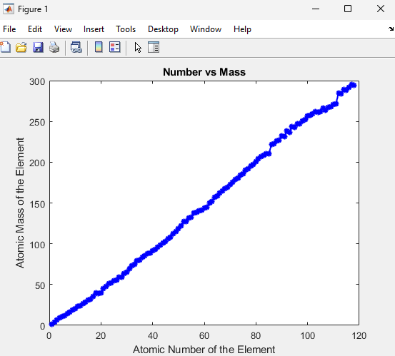

The Number vs. Mass graph (Figure 1) depicts the linear relationship between atomic number and atomic mass, representing the relation that an increasing atomic number is associated with a fairly proportional increase in atomic mass.

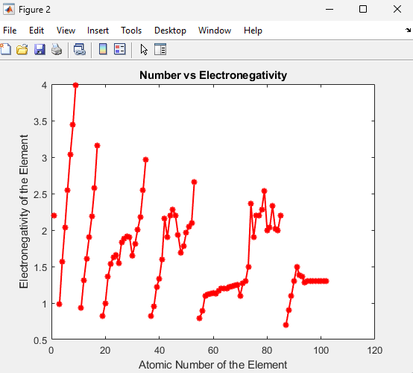
(Figure 1)
The Number vs. Electronegativity graph (Figure 2) represents the periodic trend of electronegativity slowly increasing along the periods and drastically decreasing once the atomic number reaches the next period. This enforces to students that once a valence shell is full, the element is very unlikely to attract electrons.

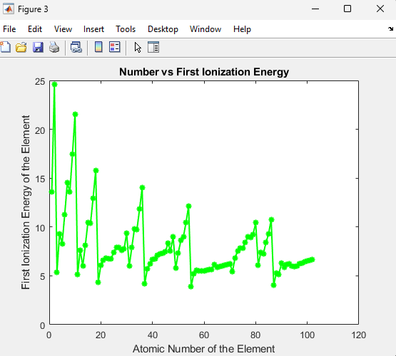
(Figure 2)
The Number vs. First Ionization Energy graph (Figure 3) shows the trend of first ionization energy slowly increasing along the periods and drastically decreasing once the atomic number reaches the next period, similar to the previous graph. This visually represents elements requiring substantial energy to ionize an electron once their valence shell is full.
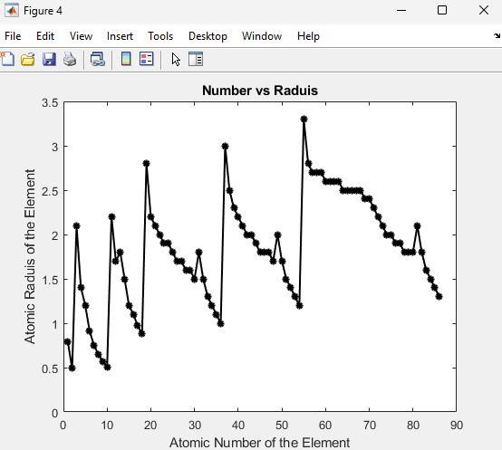

(Figure 3)
The Number vs. Radius graph (Figure 4) shows the trend of radius slowly decreasing along the periods and suddenly increasing once the atomic number has reached the next period. This trend depicts electrostatic forces between the protons and the addition of electron shells upon adding new periods.

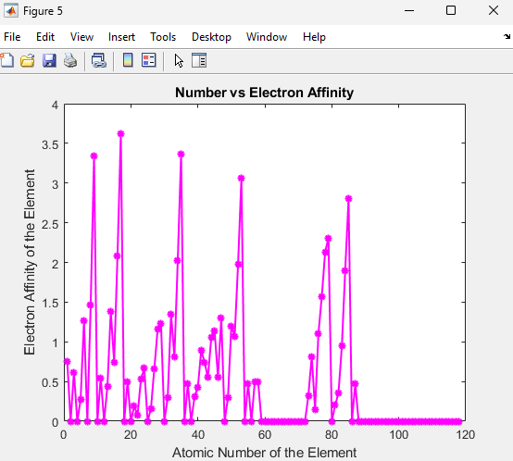
(Figure 4)
The Number vs. Electron Affinity graph (Figure 5) represents the trend of electron affinity increasing along the periods and drastically decreasing once the atomic number reaches the next period, similar to the other graphs. This means that an element is far less likely to attract additional electrons once a valence shell is full.

(Figure 5)

The four periodic trends above are all due to the combination of increased electrostatic forces between the protons and electron shells and the decreased electrostatic forces caused by the addition of electron shells upon adding new periods. The graph helps to supplement that idea and serves as a reference for problems a student studying these topics may encounter.

3.8 Technical Lessons Learned
As a result of this project, the team members of A4-6 developed their skills using computational logic, iterative code, and data visualization with MATLAB. The team learned how to convert the original .csv file to a compatible format for the built-in readtable() function within MATLAB. Additionally, the team refined their skills with vectors and printing information in the user-defined function by printing data in response to the user inputting a specific atomic symbol. The team also experimented with using a while loop in the main script to have the program run forever, allowing users to input as many atomic symbols as they wish to view more detailed information about those elements. To terminate the while loop and the program, the team programmed an escape sequence in the input field. If “-1” is inputted, the while loop is successfully terminated, and the program is finished.

3.9 Professional Lessons Learned
Overall, team A4-6’s members excellently contributed to the successful completion of the project. The team communication effectively got people working on tasks, and Google Docs facilitated programming collaboration. For future projects, the members agreed that setting stricter deadlines would allow us to incorporate advisor feedback in a timely manner. Regarding the team’s professional development, everyone got experience writing and reviewing collaborative documentation. They also exercised making decisions and taking leadership roles.

3.10 Summary and Conclusion
Team A4-6 successfully created an all-in database for the periodic table of elements. The database displayed five figures that included atomic mass, electronegativity, first ionization energy, atomic radius, and electron affinity, all with respect to atomic number. These graphs visually represented atomic trends, an essential concept for introductory Chemistry courses. The database also featured an input field where the user could input an atomic symbol to display additional information about that element. The database eliminated internet buffering and provided standardized atomic data with a library of information for Chemistry students to reference. The team learned many technical lessons, including visualizing data and writing logic sequences in MATLAB. Additionally, professional experience, such as writing reports and attending meetings, allowed the team to learn about decision-making and leadership.

Appendix A
Main Script (File 1 of 2):
% plot development was led and executed by Ethan H.
% periodic table data from https://pubchem.ncbi.nlm.nih.gov/periodic-table/#view=list
periodicTable = readtable('periodic_table2.csv'); % imports dataset
figure(1) % plots figure 1
plot(periodicTable.AtomicNumber,periodicTable.AtomicMass,'b*-',LineWidth=1.5) % determines x and y vectors of plot, and line options
xlabel('Atomic Number of the Element') % x-label
ylabel('Atomic Mass of the Element') % y-value
title('Number vs Mass') % graph title
figure(2) % plots figure 2
plot(periodicTable.AtomicNumber,periodicTable.Electronegativity,'r*-',LineWidth=1.5) % determines x and y vectors of plot, and line options
xlabel('Atomic Number of the Element') % x-label
ylabel('Electronegativity of the Element') % y-label
title('Number vs Electronegativity') % graph title
figure(3) % plots figure 3
plot(periodicTable.AtomicNumber,periodicTable.FirstIonization,'g*-',LineWidth=1.5) % determines x and y vectors of plot, and line options
xlabel('Atomic Number of the Element') % x-label
ylabel('First Ionization Energy of the Element') % y-label
title('Number vs First Ionization Energy') % graph title
figure(4) % plots figure 4
plot(periodicTable.AtomicNumber,periodicTable.AtomicRadius,'k*-',LineWidth=1.5) % determines x and y vectors of plot, and line options
xlabel('Atomic Number of the Element') % x-label
ylabel('Atomic Raduis of the Element') % y-label
title('Number vs Raduis') % graph title
figure(5) % plots figure 5
plot(periodicTable.AtomicNumber,periodicTable.ElectronAffinity,'m*-',LineWidth=1.5) % determines x and y vectors of plot, and line options
xlabel('Atomic Number of the Element') % x-label
ylabel('Electron Affinity of the Element') % y-label
title('Number vs Electron Affinity') % graph title
% while loop development led and executed by Alex A.
elementSymbol = 0; % initializes user-defined argument for the while loop conditional
while str2double(elementSymbol) ~= -1 % runs only if '-1' is not inputted
elementSymbol = input('Enter the element symbol (or enter -1 to end program): ', 's'); % gathers data from user
displayElementTrendInfo(elementSymbol); % calls user-defined function with user-inputted data as input argument
end % ends while loop

User-defined Function (file 2 of 2):
% user-defined function development led by Ethan M. and Adarsh R., Ethan H.
% assisted with development.
function displayElementTrendInfo(elementSymbol)
% Load the periodic table dataset (CSV format)
% Ensure that you have a periodic table dataset file in the current directory
% The dataset should contain columns like 'Symbol', 'Name', 'AtomicNumber', etc.
periodicTable = readtable('periodic_table2.csv');
% Search for the specified element
elementIndex = find(strcmpi(periodicTable.Symbol, elementSymbol));
if isempty(elementIndex)
disp('Element not found.');
else
% Display information about the specified element
fprintf('Element: %s\n', periodicTable.Element{elementIndex});
fprintf('Symbol: %s\n', periodicTable.Symbol{elementIndex});
fprintf('Atomic Number: %d\n', periodicTable.AtomicNumber(elementIndex));
fprintf('Atomic Mass: %.4f\n \n', periodicTable.AtomicMass(elementIndex));
% Add more information as needed, based on your dataset
% Display trend information (you can customize this based on requirements)
disp('Trend Information:');
disp('-----------------');
fprintf('Electronegativity: %.2f\n', periodicTable.Electronegativity(elementIndex));
fprintf('First Ionization Energy: %.2f kj/mol \n', periodicTable.FirstIonization(elementIndex));
fprintf('Atomic Radius: %.2f pm\n', periodicTable.AtomicRadius(elementIndex));
fprintf('Electron Affinity: %.2f kj/mol\n', periodicTable.ElectronAffinity(elementIndex));
end
end

Appendix B
The data set team A4-6 used is a CSV file found online containing the main properties of each element, including trends such as electronegativity, electron configuration, and electron affinity. The National Library of Medicine compiled the data set, linked at https://pubchem.ncbi.nlm.nih.gov/periodic-table/#view=list.

