

**SPACEXPLORER**

**UFMFGT-15-1 Programming for Engineers**



# **Structure Chart**

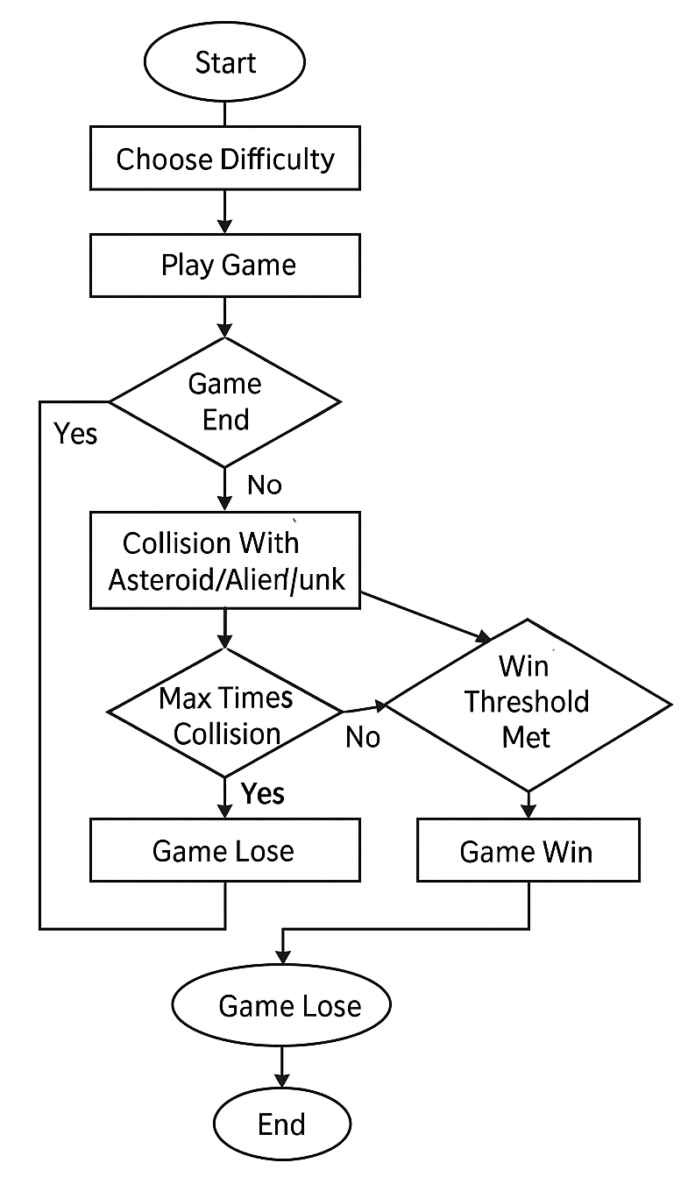

# **Source Code**

**// spacexplorer.h**

#ifndef SPACEXPLORER_H

#define SPACEXPLORER_H

#include <stdio.h>

#include <stdlib.h>

#include <time.h>

#include <string.h>

#include <ctype.h>

#define MIN_GRID 18

#define MAX_GRID 30

#define MAX_JUNK 50

#define MAX_NAME 50

#define MAX_ALIENS 5

// Player data

typedef struct {

    int x, y;

    int fuel;

    int health;

    int junk_collected;

    int score;

} Player;

// Asteroid structure

typedef struct {

    int x, y;

    int dx, dy;

} Asteroid;

// Junk structure

typedef struct {

    int x, y;

    int active;

} Junk;

// Alien structure

typedef struct {

    int x, y;

    int active;

} Alien;

// Game data

typedef struct {

    int grid_size;

    int difficulty;

    char grid[MAX_GRID][MAX_GRID];

    Player player;

    Asteroid asteroid;

    Junk junk[MAX_JUNK];

    int junk_count;

    Alien aliens[MAX_ALIENS];

    int win_threshold;

} Game;

// Core functions

void initialize_game(Game *game);

void setup_difficulty(Game *game);

void draw_game(Game *game);

void move_player(Game *game, char input);

void move_asteroid(Game *game);

int check_collision(Game *game);

void update_resources(Game *game);

void check_game_state(Game *game, int *game_over, int *won);

void clear_input_buffer();

// Utility

void display_status(Game *game);

void show_health(Game *game);

void save_score(Game *game, char *name);

void read_intro();

void display_end_message(Game *game, int won);

// Features

void place_junk(Game *game);

void place_asteroid(Game *game);

void recycle_junk(Game *game);

void handle_alien_encounters(Game *game);

void spawn_aliens(Game *game);

// New fixes

void clamp_fuel(Game *game);

void handle_fuel_starvation(Game *game);

void reposition_asteroid_after_collision(Game *game);

#endif // SPACEXPLORER_H

**// game.c**

#include "spacexplorer.h"

void initialize_game(Game *game) {

    srand(time(NULL));

    setup_difficulty(game);

    game->player.x = game->grid_size / 2;

    game->player.y = game->grid_size / 2;

    game->player.fuel = 100;

    game->player.health = 100;

    game->player.junk_collected = 0;

    game->player.score = 0;

    game->win_threshold = 10;

    place_junk(game);

    place_asteroid(game);

    spawn_aliens(game);

}

void draw_game(Game *game) {

    system("cls"); // Use for Windows

    memset(game->grid, '.', sizeof(game->grid));

    game->grid[game->player.y][game->player.x] = 'P';

    for (int i = 0; i < game->junk_count; i++) {

        if (game->junk[i].active)

            game->grid[game->junk[i].y][game->junk[i].x] = 'J';

    }

    game->grid[game->asteroid.y][game->asteroid.x] = 'X';

    for (int i = 0; i < MAX_ALIENS; i++) {

        if (game->aliens[i].active)

            game->grid[game->aliens[i].y][game->aliens[i].x] = 'A';

    }

    for (int y = 0; y < game->grid_size; y++) {

        for (int x = 0; x < game->grid_size; x++) {

            printf("%c ", game->grid[y][x]);

        }

        printf("\n");

    }

}

void setup_difficulty(Game *game) {

    int choice;

    do {

        printf("Choose difficulty (1=Easy, 2=Medium, 3=Hard): ");

        scanf("%d", &choice);

    } while (choice < 1 || choice > 3);

    switch (choice) {

        case 1: game->grid_size = 18; game->difficulty = 1; break;

        case 2: game->grid_size = 24; game->difficulty = 2; break;

        case 3: game->grid_size = 30; game->difficulty = 3; break;

    }

    game->junk_count = MAX_JUNK / game->difficulty;

}

void move_player(Game *game, char input) {

    int dx = 0, dy = 0;

    switch (input) {

        case 'W': dy = -1; break;

        case 'S': dy = 1; break;

        case 'A': dx = -1; break;

        case 'D': dx = 1; break;

    }

    int new_x = game->player.x + dx;

    int new_y = game->player.y + dy;

    if (new_x >= 0 && new_x < game->grid_size && new_y >= 0 && new_y < game->grid_size) {

        game->player.x = new_x;

        game->player.y = new_y;

    }

    game->player.fuel--;

    if (game->player.fuel < 0) {

        game->player.health -= 5;

    }

    for (int i = 0; i < game->junk_count; i++) {

        if (game->junk[i].active &&

            game->junk[i].x == game->player.x &&

            game->junk[i].y == game->player.y) {

            game->junk[i].active = 0;

            game->player.junk_collected++;

            game->player.score += 10;

        }

    }

    if (game->player.x == game->asteroid.x &&

        game->player.y == game->asteroid.y) {

        game->player.health -= 20;

        game->asteroid.x = rand() % game->grid_size;

        game->asteroid.y = rand() % game->grid_size;

    }

}

void move_asteroid(Game *game) {

    game->asteroid.x = rand() % game->grid_size;

    game->asteroid.y = rand() % game->grid_size;

}

void check_game_state(Game *game, int *game_over, int *won) {

    if (game->player.health <= 0 || game->player.fuel <= -50) {

        *game_over = 1;

        *won = 0;

    } else if (game->player.junk_collected >= game->win_threshold) {

        *game_over = 1;

        *won = 1;

    }

}

**// features.c**

#include "spacexplorer.h"

void place_junk(Game *game) {

    for (int i = 0; i < game->junk_count; i++) {

        game->junk[i].x = rand() % game->grid_size;

        game->junk[i].y = rand() % game->grid_size;

        game->junk[i].active = 1;

    }

}

void place_asteroid(Game *game) {

    game->asteroid.x = rand() % game->grid_size;

    game->asteroid.y = rand() % game->grid_size;

}

void recycle_junk(Game *game) {

    if (game->player.junk_collected > 0) {

        game->player.fuel += 10 * game->player.junk_collected;

        game->player.score += 5 * game->player.junk_collected;

        printf("Recycled %d junk into fuel and score!\n", game->player.junk_collected);

        game->player.junk_collected = 0;

    } else {

        printf("No junk to recycle!\n");

    }

}

void spawn_aliens(Game *game) {

    for (int i = 0; i < MAX_ALIENS; i++) {

        game->aliens[i].x = rand() % game->grid_size;

        game->aliens[i].y = rand() % game->grid_size;

        game->aliens[i].active = 1;

    }

}

void handle_alien_encounters(Game *game) {

    for (int i = 0; i < MAX_ALIENS; i++) {

        if (game->aliens[i].active &&

            game->aliens[i].x == game->player.x &&

            game->aliens[i].y == game->player.y) {

            game->player.health -= 10;

            game->player.score += 20;

            game->aliens[i].active = 0;

            printf("You encountered an alien! Health -10, Score +20\n");

        }

    }

}

**// utils.c**

#include "spacexplorer.h"

void display_status(Game *game) {

    printf("Fuel: %d | Health: %d | Junk: %d | Score: %d\n",

           game->player.fuel, game->player.health,

           game->player.junk_collected, game->player.score);

}

void show_health(Game *game) {

    printf("Health Check: %d\n", game->player.health);

}

void save_score(Game *game, char *name) {

    FILE *file = fopen("scores.txt", "a");

    if (file) {

        fprintf(file, "%s %d\n", name, game->player.score);

        fclose(file);

    } else {

        printf("Failed to save score.\n");

    }

}

void read_intro() {

    FILE *file = fopen("intro.txt", "r");

    if (file) {

        char line[256];

        while (fgets(line, sizeof(line), file)) {

            printf("%s", line);

        }

        fclose(file);

        printf("\n\n");

    } else {

        // Fallback message

        printf("Welcome to SpaceXplorer!\nCollect junk, dodge asteroids, and manage your resources!\n\n");

    }

}

void display_end_message(Game *game, int won) {

    if (won) {

        printf("Congratulations! You won with a score of %d!\n", game->player.score);

    } else {

        printf("Game Over. Better luck next time.\n");

    }

}

**// main.c**

#include "spacexplorer.h"

int main() {

    Game game;

    int game_over = 0, won = 0;

    char input;

    char name[MAX_NAME];

    read_intro();

    printf("Enter your name: ");

    fgets(name, MAX_NAME, stdin);

    name[strcspn(name, "\n")] = 0;

    initialize_game(&game);

    while (!game_over) {

        draw_game(&game);

        display_status(&game);

        printf("Move (WASD), Check Health (H), Recycle (R), Quit (Q): ");

        scanf(" %c", &input);

        input = toupper(input);

        if (input == 'Q') break;

        switch (input) {

            case 'W':

            case 'A':

            case 'S':

            case 'D':

                move_player(&game, input);

                move_asteroid(&game);

                handle_alien_encounters(&game);

                break;

            case 'H':

                show_health(&game);

                break;

            case 'R':

                recycle_junk(&game);

                break;

            default:

                printf("Invalid input!\n");

        }

        check_game_state(&game, &game_over, &won);

    }

    display_end_message(&game, won);

    save_score(&game, name);

    return 0;

}

# **Output**

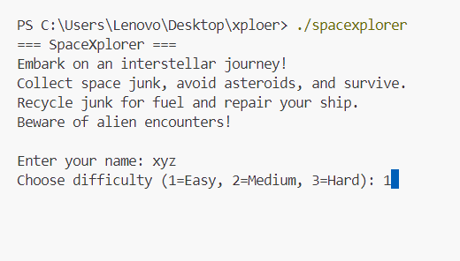

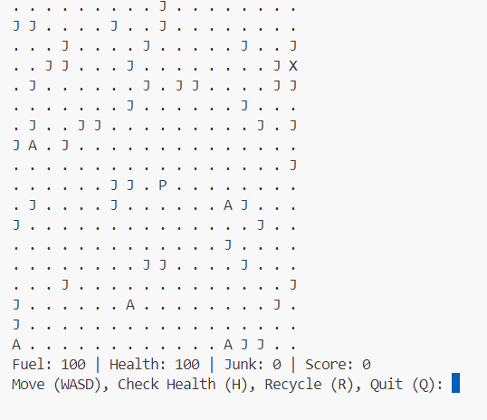

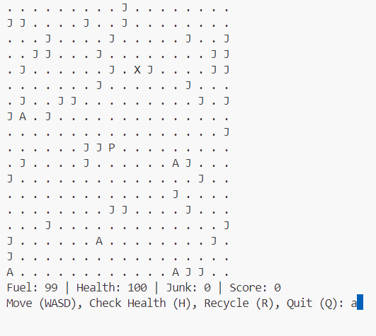

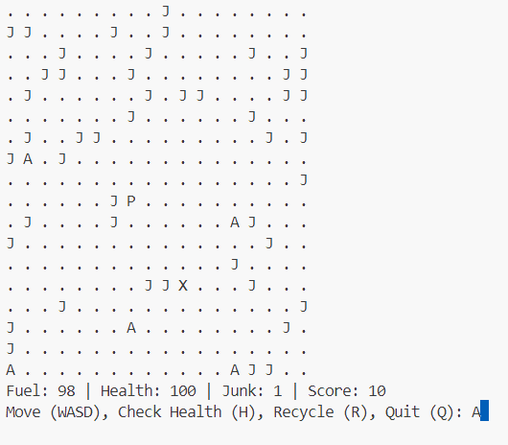

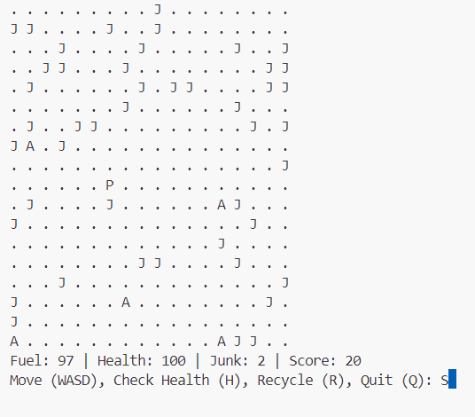

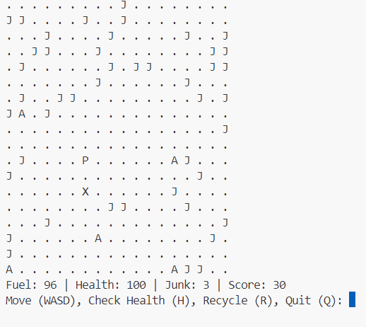

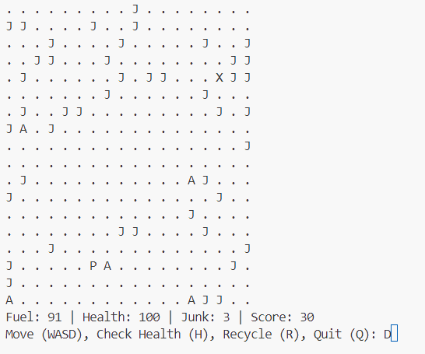

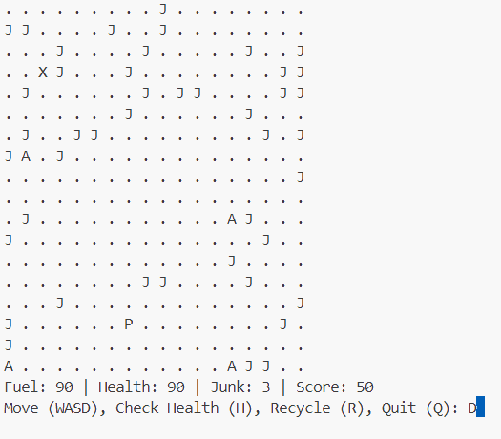

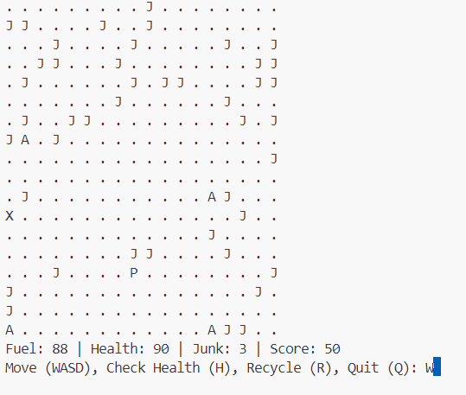

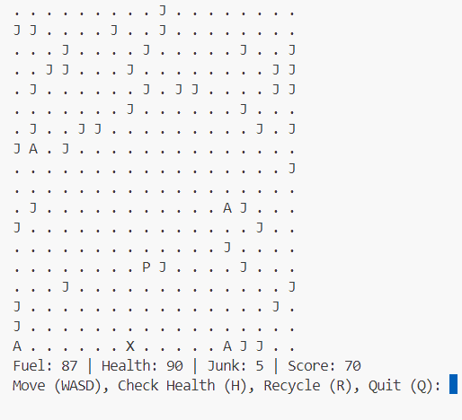

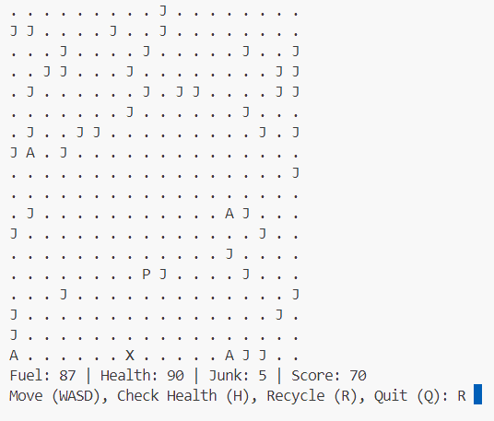

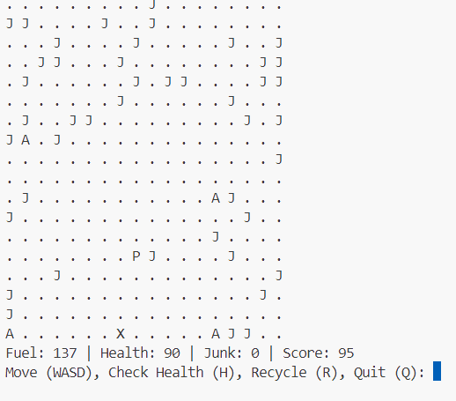

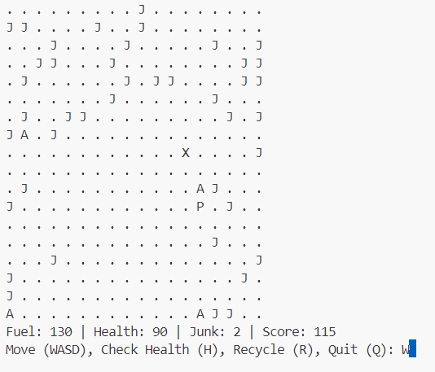

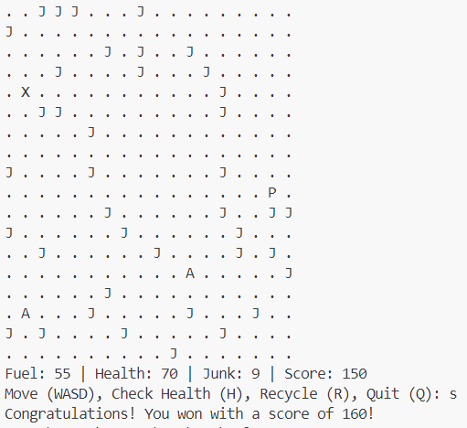

# **Functions**

* **Game Mechanics Functions**

1. **void initialize_game(Game *game);**  
   Initializes the game state, including player position, fuel, health, and grid setup.
2. **void setup_difficulty(Game *game);**  
   Lets the player select a difficulty level, which affects grid size and win conditions.
3. **void draw_game(Game *game);**  
   Renders the current state of the grid, showing the player, junk, asteroids, aliens, and empty spaces.
4. **void move_player(Game *game, char input);**  
   Handles movement logic based on WASD input and ensures player stays within bounds.
5. **void move_asteroid(Game *game);**  
   Moves the asteroid randomly within the grid to simulate a dynamic obstacle.
6. **int check_collision(Game *game);**  
   Checks if the player collides with junk, asteroid, or aliens and applies the appropriate effect.
7. **void update_resources(Game *game);**  
   Decreases fuel on every move and reduces health if fuel drops below zero.
8. **void check_game_state(Game *game, int *game_over, int *won);**  
   Determines if the player has won (by collecting enough junk) or lost (by running out of health).

* **Feature and Event Functions**

1. **void place_junk(Game *game);**  
   Randomly places collectible junk on the grid at the beginning of the game.
2. **void place_asteroid(Game *game);**  
   Randomly positions the asteroid on the grid as a moving obstacle.
3. **void spawn_aliens(Game *game);**  
   Spawns alien entities on the grid that can affect the player upon contact.
4. **void recycle_junk(Game *game);**  
   Converts collected junk into score, fuel, and possibly health boosts to encourage resource management.
5. **void handle_alien_encounters(Game *game);**  
   Random chance events are triggered when encountering aliens—either beneficial or harmful.

* **Utility & Display Functions**

1. **void display_status(Game *game);**  
   Shows real-time status of fuel, health, junk collected, and score at each turn.
2. **void show_health(Game *game);**  
   Provides a visual or textual health indicator upon request (pressing H in-game).
3. **void save_score(Game *game, char *name);**  
   Saves the player's score with their name to a file for leaderboard or record-keeping.
4. **void read_intro();**  
   Displays the game's introductory information and instructions at startup.
5. **void display_end_message(Game *game, int won);**  
   Shows a win or lose message along with stats when the game ends.
6. **void clear_input_buffer();**  
   Clears any leftover characters from input buffer to prevent input issues.

# **Full Program Flowchart**

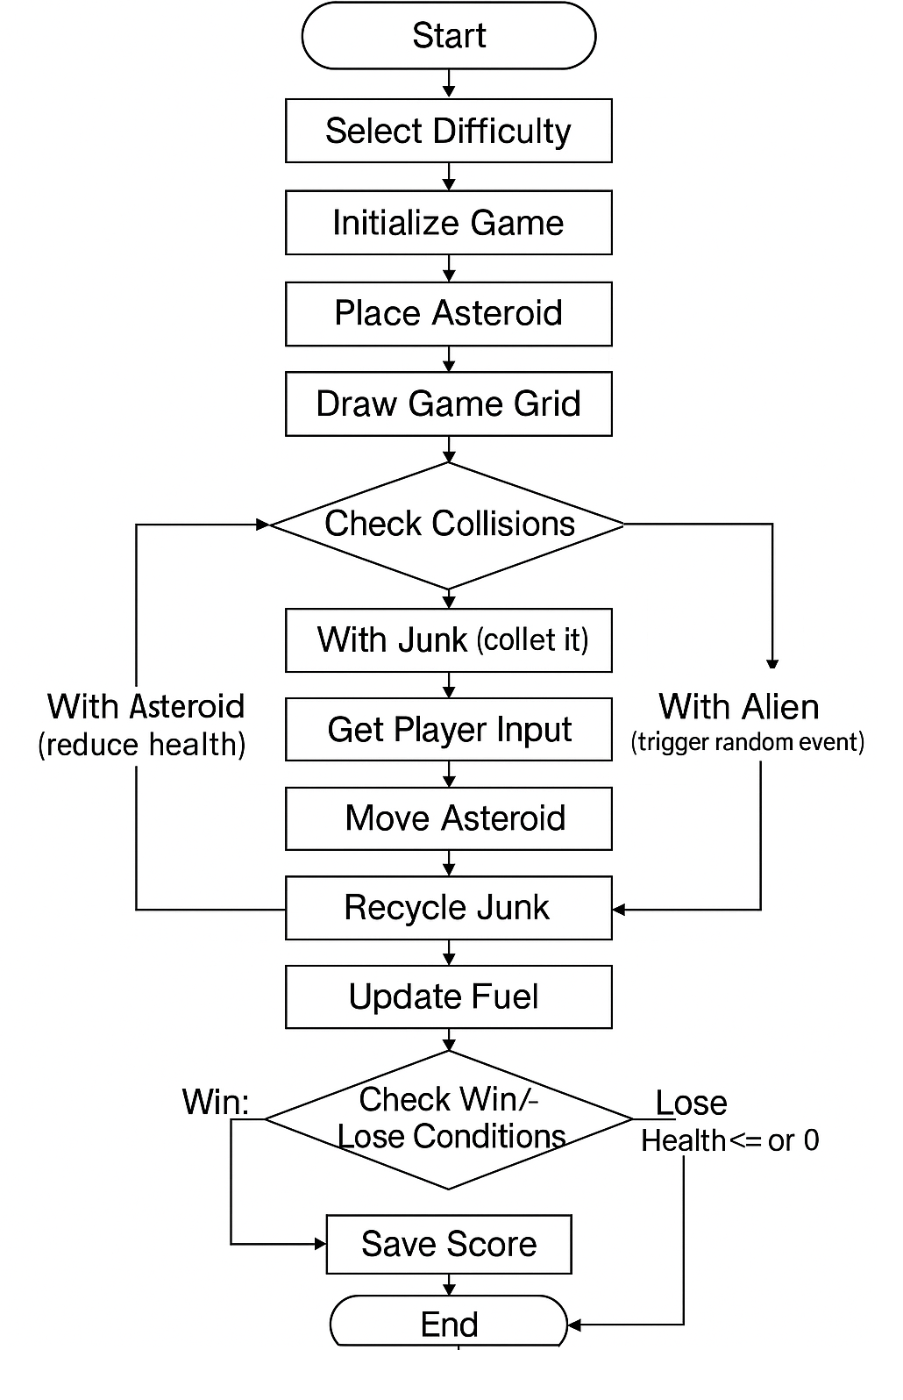

# **Functions Pseudocode**

1. **initialize_game(Game *game)**

// Initialize the game state and setup initial parameters

Function initialize_game(game)

Prompt user to select grid size

Initialize player position, health, fuel, score, and junk count

Place player in center of grid

Call place_junk(game)

Call place_asteroid(game)

Call spawn_aliens(game)

Fill rest of grid with empty symbols

EndFunction

1. **move_player(Game *game, char input)**

// Handle player movement based on WASD input

Function move_player(game, input)

Switch input

Case 'W':

If player can move up

Update player position

Case 'A':

If player can move left

Update player position

Case 'S':

If player can move down

Update player position

Case 'D':

If player can move right

Update player position

Default:

Print "Invalid input"

Subtract 1 from fuel

EndFunction

1. **move_asteroid(Game *game)**

// Move asteroid one step in its current direction

Function move_asteroid(game)

Clear asteroid's old position on grid

Update asteroid position based on dx, dy

If new position is out of bounds

Reverse direction

Clamp position within bounds

Draw asteroid at new position

EndFunction

1. **check_collision(Game *game)**

// Check collision between player and other objects

Function check_collision(game)

If player is on junk

Mark junk as inactive

Increase junk_collected and score

If player is on asteroid

If health not reduced recently

Reduce health by 20

Mark asteroid recently hit

Return 1

Else

Return 0

If player is on alien

Reduce health by 30

Mark alien as inactive

Return 1

Return 0

EndFunction

1. **recycle_junk(Game *game)**

// Convert junk into score and fuel

Function recycle_junk(game)

If junk_collected >= 3

Subtract 3 from junk_collected

Add 20 to fuel

Add 100 to score

Print "Recycling successful"

Else

Print "Not enough junk to recycle"

EndFunction

1. **check_game_state(Game *game, int *game_over, int *won)**

// Determine if game should end based on current stats

Function check_game_state(game, game_over, won)

If health <= 0

Set game_over = 1

Set won = 0

Return

If fuel <= 0

Set game_over = 1

Set won = 0

Return

If junk_collected >= game.win_threshold

Set game_over = 1

Set won = 1

EndFunction

1. **setup_difficulty(Game *game)**

// Lets player choose difficulty, which sets grid size and win threshold

Function setup_difficulty(game)

Prompt player to choose difficulty: Easy, Medium, Hard

Switch choice

Case Easy:

Set grid size = 10, win_threshold = 3

Case Medium:

Set grid size = 15, win_threshold = 5

Case Hard:

Set grid size = 20, win_threshold = 8

Allocate and initialize grid based on size

EndFunction

1. **draw_game(Game *game)**

// Displays the grid and game stats

Function draw_game(game)

Clear terminal screen

Print stats: fuel, health, junk collected, score

For each row in grid

For each column in grid

Print character for player, junk, asteroid, alien, or empty

EndFor

Print newline

EndFor

EndFunction

1. **update_resources(Game *game)**

// Adjusts fuel and applies health penalty if out of fuel

Function update_resources(game)

If fuel < 0

Subtract 5 from health

Print "You're burning health due to no fuel!"

Else

Subtract 1 from fuel

EndFunction

1. **check_game_state(Game *game, int *game_over, int *won)**

// Determines win/lose conditions

Function check_game_state(game, game_over, won)

If health <= 0

Set game_over = 1

Set won = 0

ElseIf fuel <= -50

Set game_over = 1

Set won = 0

ElseIf junk_collected >= win_threshold

Set game_over = 1

Set won = 1

EndFunction